

DESIGN AND SIMULATION OF A FIVE-FLOOR ENTERPRISE LAN FOR A NETWORK COMPANY
Final

local/wide area networks (lan/wan) & NETWork PROtocols 25cscn08I

ID:243700
Name: Abdelrahman Shehta

Table of Contents
Abstract 2
Introduction 2
Objectives 2
Scope of work & Methodology 3
Network Topology Design 4
IP Addressing Scheme 5
Device Configuration Details 6
Result & Testing 13
Conclusion & Reflection 19
References For Report Information 21

Abstract
Computer networks are essential for communication, resource sharing, and access to services in the modern organizations. However, as networks grow especially in a multi floor or multi building environments problems like excessive broadcast traffic and the decrease in performance may happen if the network is not designed properly.
To try and solve these problems virtual local area networks (VLAN) are used to logically segment networks, reduce the broadcast domain and improving overall efficiency [2] [5] this project focuses on the design and simulation of a multi building enterprise Local Area Network using vlan segmentation and ethernet technology.
The network is simulated using cisco packet tracer to simulate real world configuration and validate the connection between the devices across the different vlans. Additionally, adding services like DHCP, DNS, WEB, and FTP servers to enhance the network functionality the results demonstrate improved performance, scalability, and efficient traffic management within the network.

Introduction
Modern organizations rely on computer networks the most these days for daily work, including communication, file sharing, and access to services that are important for their work. A local area network connects between devices within a limited geographical area such as offices or buildings, furthermore ethernet is the most used in the LAN for its high speed, reliability and ease of implementation [5].
As networks expand across multiple floors or buildings, if that network is not well managed that could lead to congestion and decrease in the performance. The solution for that is the use of vlans by segmenting the networks into separate broadcast domains, even when using the same physical infrastructure this improves the network efficiency, enhances security, and makes the management easier.
Cisco packet tracer is known for its usage in simulating a network modeling, configuring and testing complex topologies before the deployment to the real world [1] [2]. In this project, it is used to design and validate a scalable enterprise network.

Objectives
The objectives of this project are:
- To design a scalable multi-building enterprise LAN
- To implement VLAN segmentation for different departments
- To configure inter-VLAN routing for communication between VLANs
- To deploy centralized services (DHCP, DNS, Web, FTP)
- To develop an efficient IP addressing scheme
- To test and validate network functionality using simulation tools

Scope of work & Methodology
Scope of Work:
The project involves:
- Designing a hierarchical network architecture
- Assigning VLANs to departments
- Configuring switches and routing
- Implementing centralized network services
- Testing and validating network performance
Methodology:
- Requirement Analysis:
Determining the number of devices, departments, and connectivity requirements.
- Topology Design:
A hierarchical structure (Core–Distribution–Access) was selected to improve scalability and performance.
- IP Address Planning:
Subnets were allocated for each VLAN with reserved ranges for servers and future expansion.
- Implementation:
VLANs, trunking, routing, and server configurations were implemented using Cisco Packet Tracer.
- Simulation and Testing:
Packet Tracer simulations were used to verify network functionality, which has been proven effective for network design and debugging [1] [2].

Network Topology Design
The network is designed using hierarchical architecture consisting of three layers:
- Core Layer: Responsible for routing and high-speed data transfer
- Distribution Layer: Aggregates access switches and manages traffic
- Access Layer: Connects end user devices
The network spans multiple buildings with access switches connected to distribution switches which are connected to the central core switch. A server network is implemented to host services.
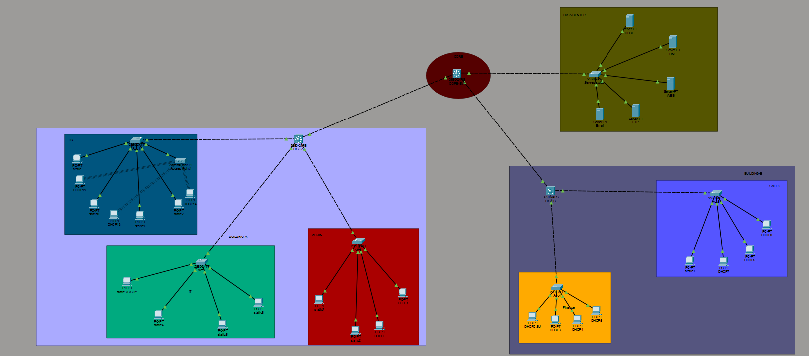
Figure 1: Network Topology.
Design Justification:
The hierarchical model was selected due to its effectiveness in enterprise environments.
Scalability and future expansion:
The proposed network design ensures scalability by following a hierarchical architecture, which allows the network to scale without the need for redesigning. As the organization grows additional access switches can be added to add more users and devices without affecting the infrastructure.
Each VLAN is assigned a separate subnet with sufficient unused IP addresses reserved for future expansion this approach ensures that new departments or new devices can be added easily into the network without causing IP conflict or requiring major configuration.
Furthermore, the use of a core the distribution then access model improves the performance by distributing the traffic efficiently across the network this design allows future addition of advanced services like dynamic routing protocols, redundancy mechanisms, and load balancing, which further enhances the reliability and scalability of the network [3] [4].
Advantages:
- Improved scalability and flexibility
- Reduced broadcast traffic through VLAN segmentation
- Enhanced security via network isolation
- Simplified troubleshooting and management
Disadvantages:
- Increased configuration complexity
- Requires careful planning and design
- Potential single point of failure at the core layer
Alternative design consideration:
A flat network design was considered but rejected because it lacks scalability, increases broadcast traffic, and provides limited security. Hierarchical designs are more suitable for enterprise networks due to their structured approach [3], [4].

IP Addressing Scheme
A structured IP addressing scheme was implemented:
VLAN | NETWORK | DEFAULT GATEWAY
10 | 192.168.10.0/24 | 192.168.10.1
20 | 192.168.20.0/24 | 192.168.20.1
30 | 192.168.30.0/24 | 192.168.30.1
40 | 192.168.40.0/24 | 192.168.40.1
50 | 192.168.50.0/24 | 192.168.50.1
60 | 192.168.60.0/24 | 192.168.60.1
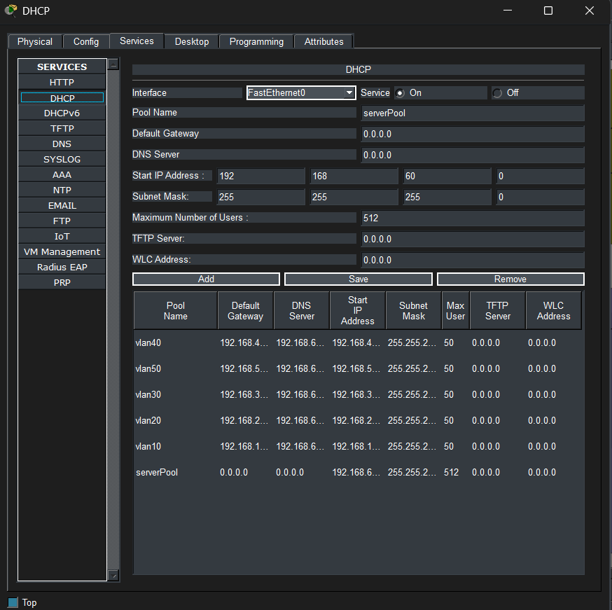
Figure 2: DHCP pools / IP configuration

Address Allocation Strategy:
.1 for default gateway
.2 till .10 reserved for servers and future use and static IP
.20 and higher assigned dynamically by DHCP
This ensures efficient utilization of IP addresses and prevents conflicts.

Device Configuration Details
Vlan configuration:
VLANs were created on all switches and assigned to ports based on department requirements. VLAN implementation improves LAN efficiency and reduces congestion [2], [5].
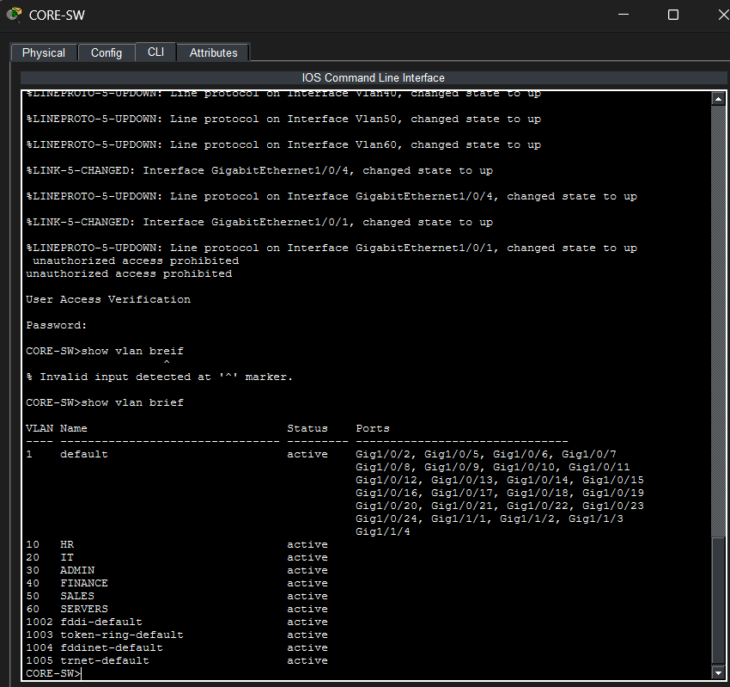
Figure 3: Vlan configuration.
Trunk configuration:
Trunk links were configured between switches to allow multiple VLANs to pass through a single link.
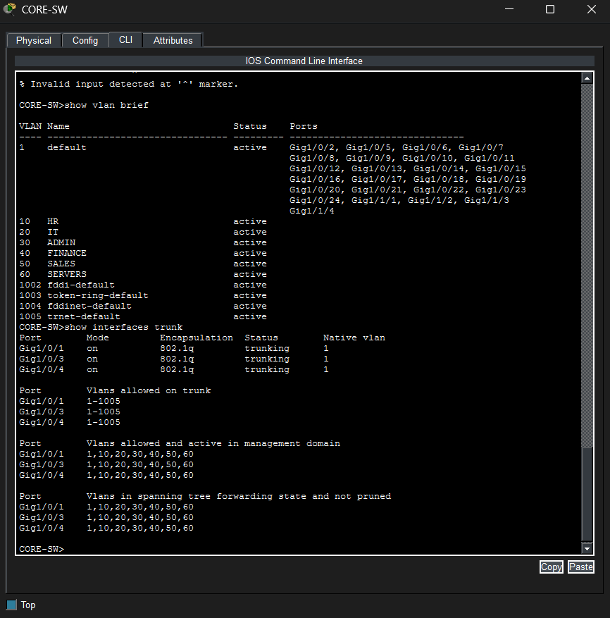
Figure 4: interfaces Trunk.

Inter vlan routing:
Inter-VLAN routing was enabled on the core switch using Switch Virtual Interfaces (SVIs), allowing communication between different VLANs.
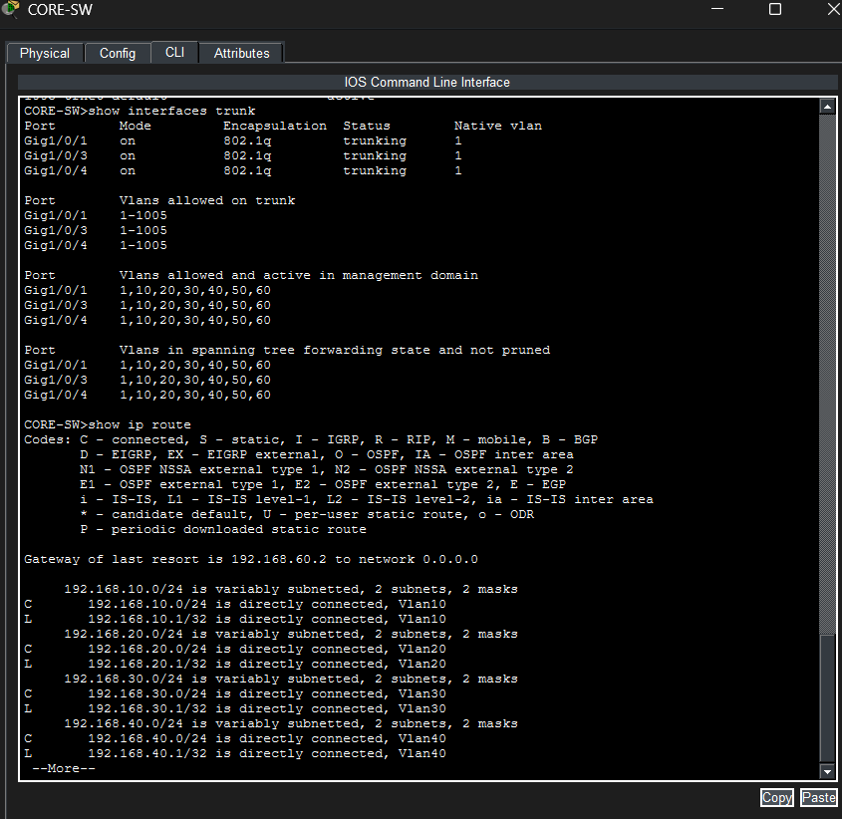
Figure 5: IP routing

Server configuration:
Four servers were deployed:
- DHCP Server: Automatically assigns IP addresses [3]
- DNS Server: Resolves domain names to IP addresses [4]
- Web Server: Hosts a company website
- FTP Server: Enables file transfer between devices
All servers were assigned static IP addresses within VLAN 60.
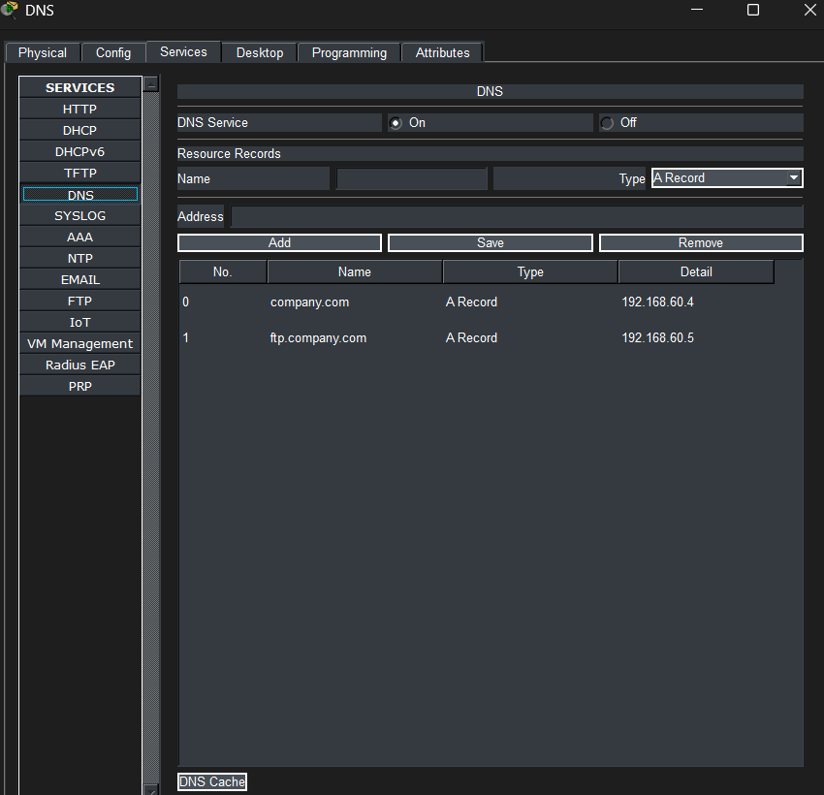
Figure 6: DNS configuration.

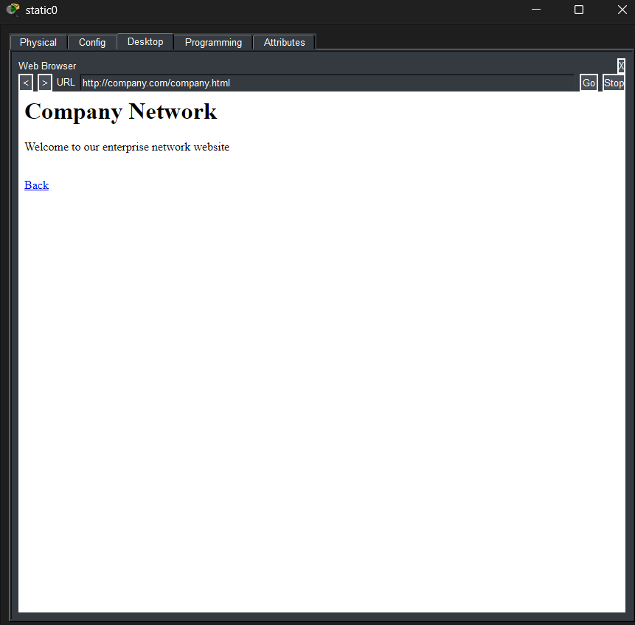
Figure 7: WEB page Output / DNS resolution.
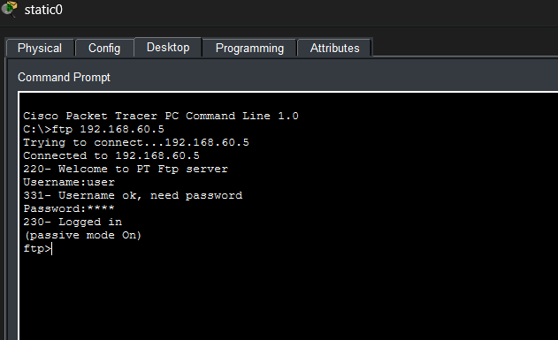
Figure 8: FTP login session.
Security Configuration:
Basic security measures were implemented:
- Enable secret password
- Console and VTY access control
- SSH for secure remote access
- Password encryption

DHCP config for wireless devices:
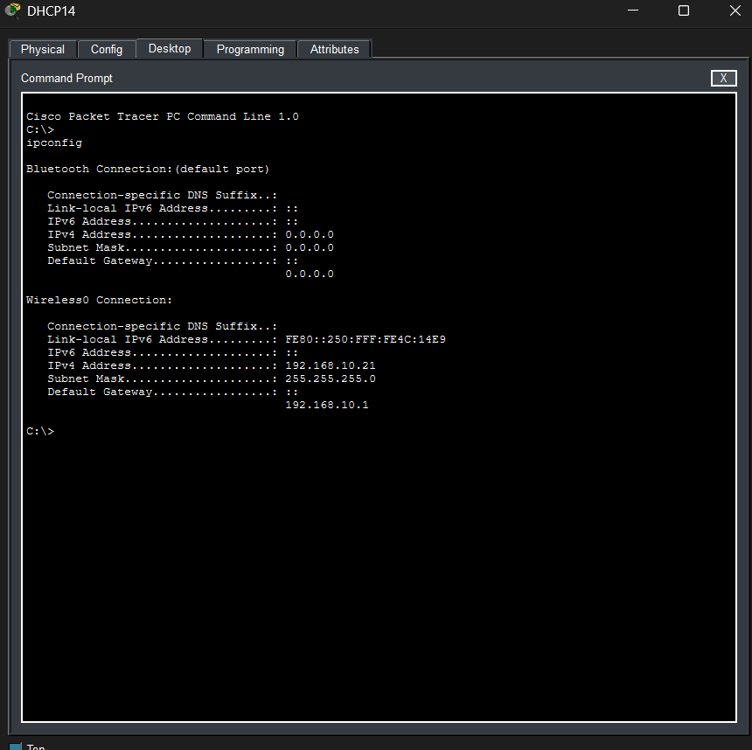
Ipconfig for wireless devices.

Result & Testing
A comprehensive testing strategy was implemented to validate the network.
Test plan:
Test | Expected result | Actual result
VLAN communication | Success | Success
Inter vlan routing | Success | Success
DHCP assignment | Success | Success
DNS resolution | Success | Success
Web access | Success | Success
FTP access | Success | Success

Testing description:
A structured approach was employed in testing the network to allow the network to be fully operational. Firstly, devices were given fixed IP addresses to test VLAN segmentation and inter-VLAN routing. Effective ping between VLANs was an indication that the core switch was properly set up to perform routing.
Basic connectivity was verified and then DHCP was activated to provide IP addresses dynamically to client devices. The ipconfig command verified that devices were assigned appropriate IP addresses, subnet masks, default gateways and DNS server values.
The DNS capability was also put to test by resolving domain names like company.com to ensure that the DNS server is properly configured to convert domain names into IP addresses. Web services were tested by opening the hosted site in a browser that verified that the HTTP communication is operating correctly.
FTP services were also put to the test by connecting a client/customer to the FTP server and was able to successfully log in and move data. These are the results that assure that application layer services are functional.
In general, the testing results reveal that the network works efficiently with the right work of VLANs, the correct distribution of IP addresses and the full functioning of network services. Testing is done through simulation which provides reliability prior to real world implementation [1], [4].
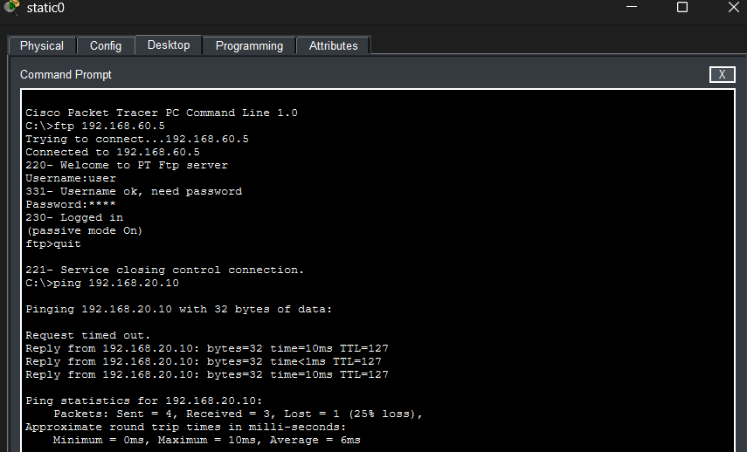
Figure 9: Ping test results.
This test result ensure the VLAN connection is valid.
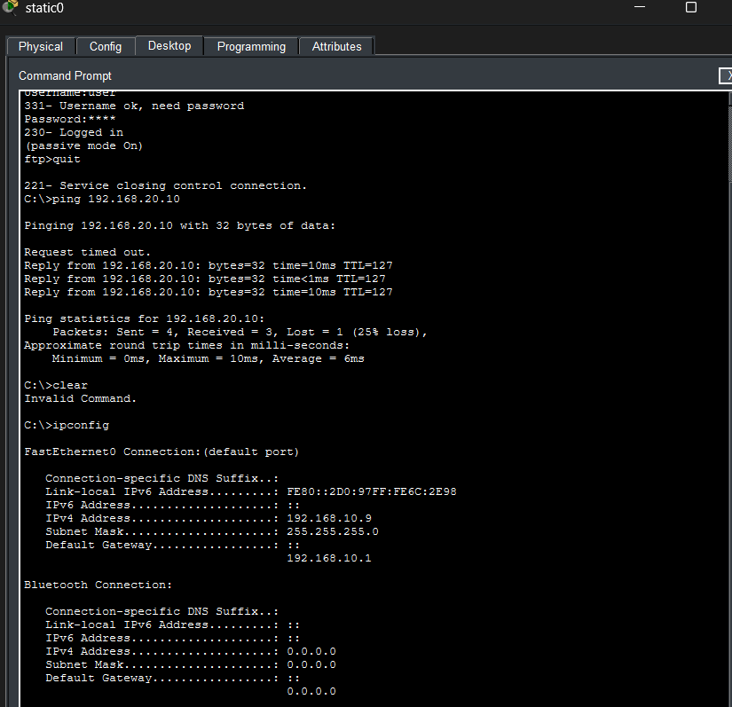
Figure 10: ipconfig output.
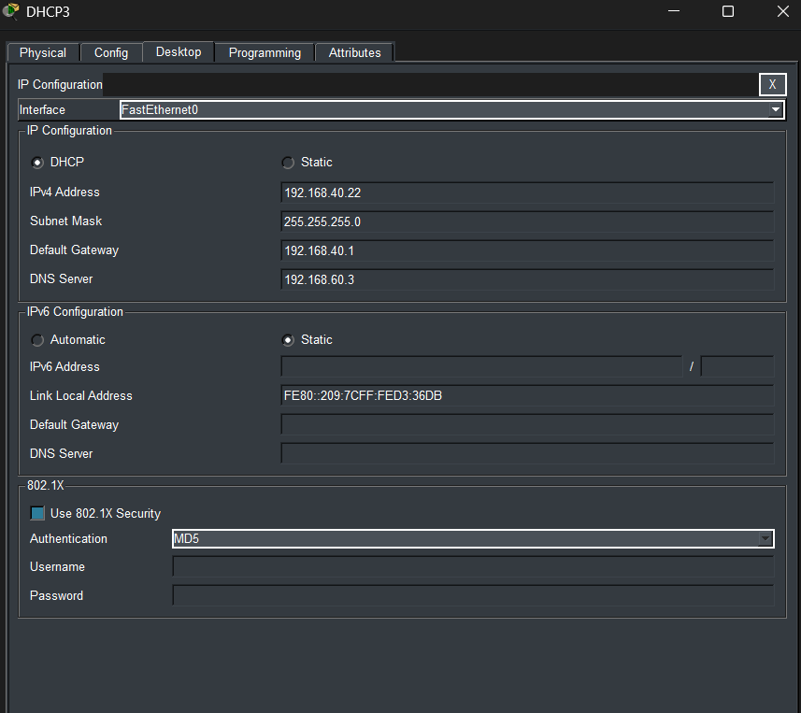
Figure 11: DHCP Assignment result.
This test result shows the functionality of the DHCP which is assigning dynamic IP addresses and configuration is successful.
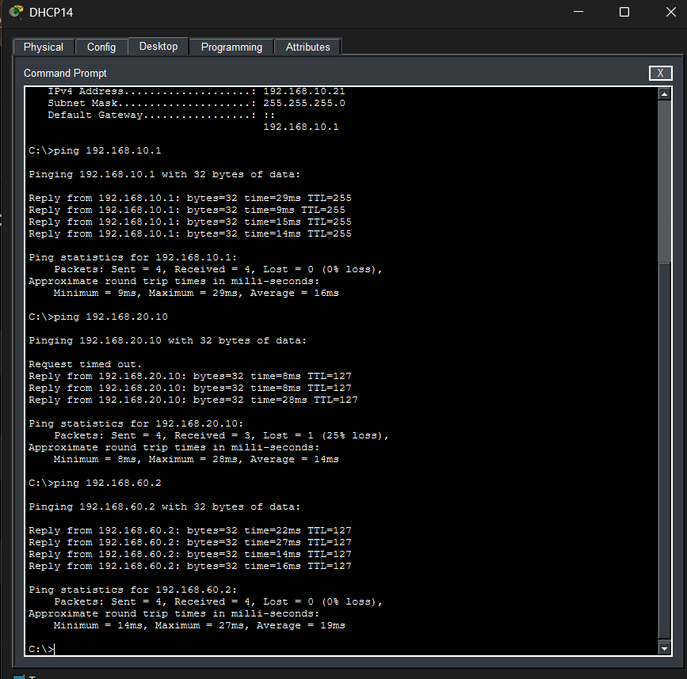
Figure 12: VLAN and servers connection of wireless devices.
Wireless Network Integration:
To add wireless connectivity to the network, an access point was added into the access layer. The access point was linked to a switch port that was set to a particular VLAN and the wireless devices were able to join the existing network infrastructure. The network was linked to wireless customers like laptops by a secure SSID and WPA2 authentication. These machines were configured dynamically to be given the IP address via DHCP and could communicate effectively with the wired devices that belong to different VLANs by inter- VLAN routing. This integration is an indication of how the network design is flexible to accommodate both wired and wireless communication without compromising on the performance and security.
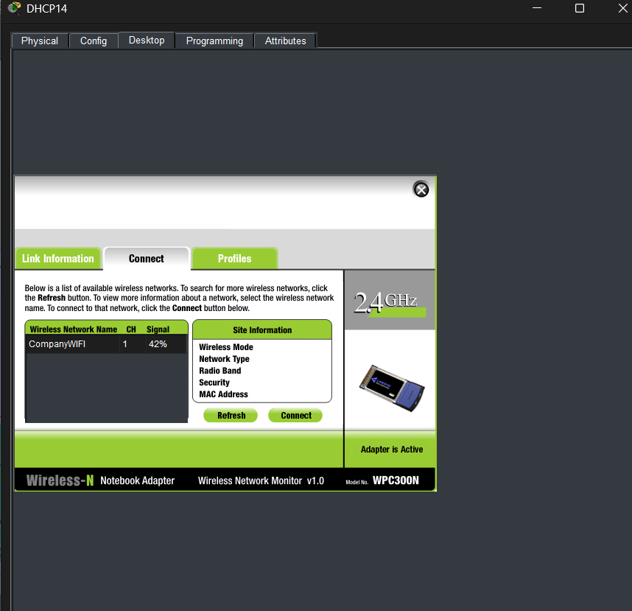
Figure 13: Device connected to the Accesspoint.

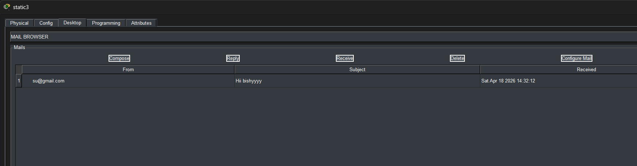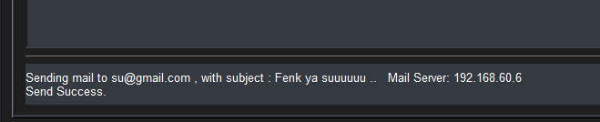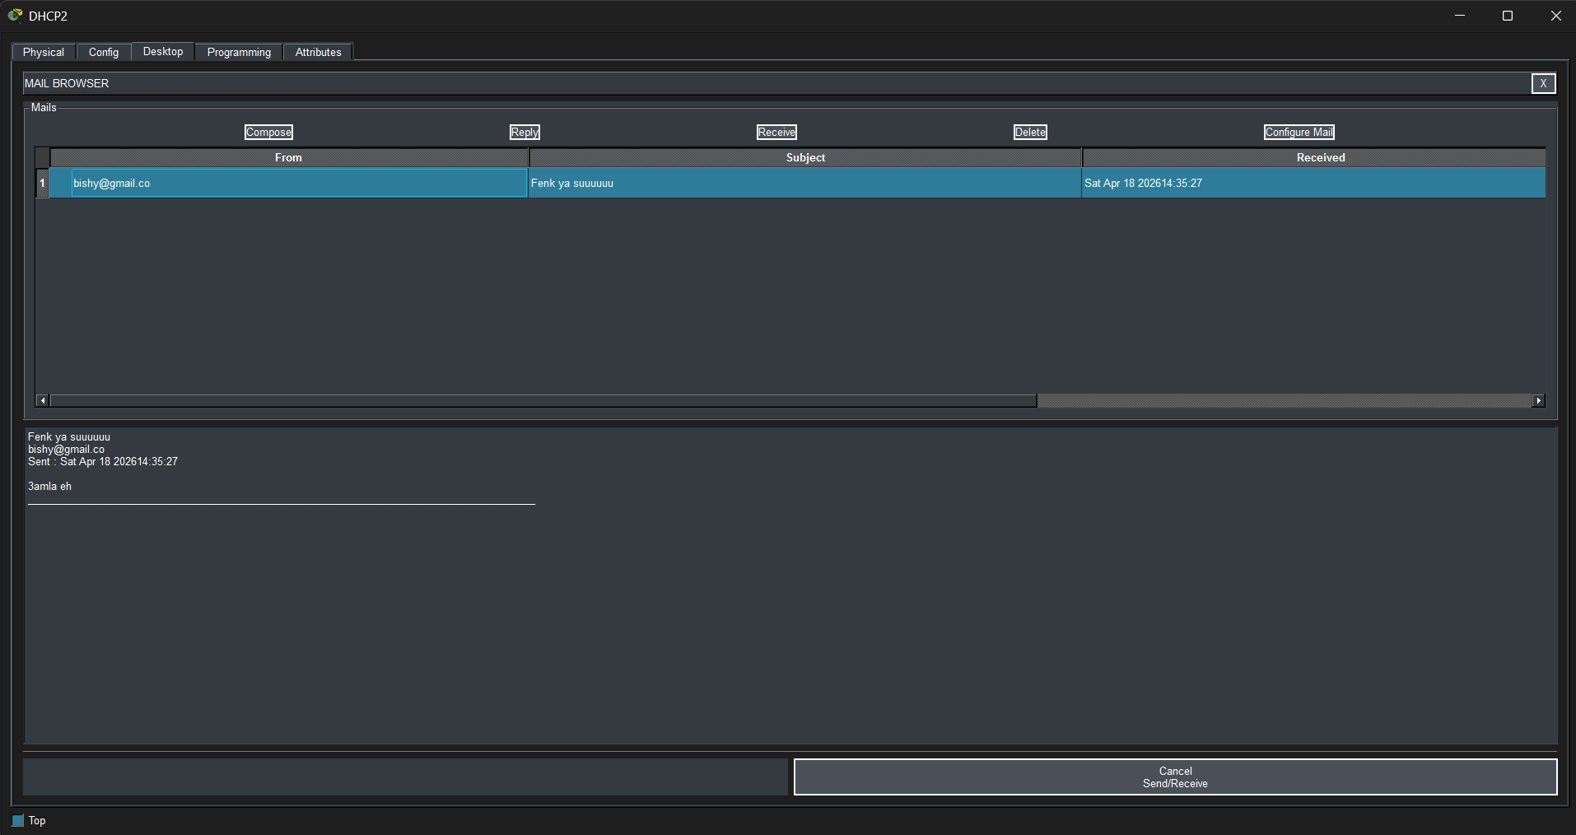

Figure 14: Bonus EMAIL server

Conclusion & Reflection
The project was able to meet its goals as it has designed and installed a scalable enterprise network based on VLAN segmentation and hierarchical architecture. Application of VLANs greatly enhanced the performance of the network by minimizing unnecessary broadcasts as well as improved security due to logical segregation. Also, the centralization of services, including DHCP, DNS, Web and FTP servers, enhanced the functionality of the network in general and made administration easier.
The hierarchical network structure guarantees high scalability and makes it possible to expand in future without significant structural modifications. The test results showed that every element of the proposed design, such as inter-VLAN routing and network services, is operating properly, proving that the proposed design is efficient and reliable.
More so, the network is not only able to meet the present-day needs of the organization but also gives a solid base of future growth. VLAN segmentation helps in minimizing broadcast traffic and maximizing bandwidth usage and efficiency. Centralized service management minimizes administrative complexity and enhances operational efficiencies.
Simulation tools allowed comprehensive testing and verification of the network prior to deployment, which guarantees that the design is feasible and effective to implement in real life. In general, the solution proposed is based on the industry best practices and provides a compromise between the performance, scalability, and manageability.
Future improvements:
Future enhancements may include:
- Implementing redundancy at the core layer
- Using dynamic routing protocols
- Adding advanced security features
- Integrating wireless networking
Reflection:
The project was a great hands-on experience in network design, configuration, and simulation. It highlighted the importance of proper planning, logical segmentation, and structured testing in building efficient and scalable enterprise networks. It also enhanced its practical skills in application tools like Cisco Packet Tracer which are vital in the real world networking situation.

References For Report Information
[1] H. Honni and J. F. Andry, “Design and Simulation VLAN Using Cisco Packet Tracer: A Case Study,” Proc. Int. Seminar on Mathematics, Science, and Computer Science Education (MSCEIS), Oct. 2016.
[2] A. H. Ahmed and M. N. A. Al-Hamadani, “Designing a secure campus network and simulating it using Cisco Packet Tracer,” Indonesian Journal of Electrical Engineering and Computer Science, vol. 23, no. 1, pp. 479–489, Jul. 2021.
[3] A. R. Delsouz et al., “Design and Implementation of a Secure and Scalable LAN for a Midsized Company Using Cisco Packet Tracer,” Preprints.org, May 2025.
[4] “Campus Network Design and Construction Using Cisco Packet Tracer Simulation,” Journal of Applied Informatics Research, Jul. 2025.
[5] N. Mahmoud and A. Eissa, “Improving the performance of LAN using VLAN: Case study,” Tarbawej Journal, vol. 26, pp. 778–785, 2025.

