HolistiLearn

By

Sundas Shahid 2022-GCUF-071998

BACHELOR OF SCIENCE
IN
COMPUTER SCIENCE



DEPARTMENT OF COMPUTER SCIENCE
Government College University, Faisalabad
Table of Contents
Revision History
- Introduction............................................................................................................ 1
  - General Information.......................................................................................... 1
  - Purpose.............................................................................................................. 1
  - Project Objective............................................................................................... 1
  - Project Scope .................................................................................................... 2
- Overall Description ............................................................................................... 2
  - Project Perspective ........................................................................................... 3
  - Project Features ................................................................................................ 3
  - Operating Environment .................................................................................... 4
  - Assumptions and Dependencies ....................................................................... 4
- System Features ..................................................................................................... 4
  - Functional Requirement .................................................................................... 4
  - Non-Functional Requirement ............................................................................ 4
- External Interface Requirements ......................................................................... 5
  - User Interfaces .................................................................................................. 5
  - Communications Interfaces .............................................................................. 5
- Analysis Models …………………….................................................................... 5
  - Use Case Diagram ………............................................................................... 5
  - Activity Diagram ............................................................................................. 5
  - ER Diagram ..................................................................................................... 5
  - Class Diagram .................................................................................................. 5
  - Object Diagram ................................................................................................ 5
  - Sequence Diagram ............................................................................................ 5
  - State Transition Diagram .................................................................................. 5
- WBS Project Management ................................................................................... 6
  - WBS Modules.................................................................................................... 6
7. Tools and Technologies ………………………………………………………. 7
7.1 Programming Languages ................................................................................. 7
7.2 Databases/Data Storages ................................................................................. 7
7.3 Operating System ............................................................................................ 7
Appendix A: Glossary ............................................................................................... 00
Appendix B: Check List ............................................................................................ 00
Appendix C: Supervisory Committee ...................................................................... 00

Revision History
Name | Date | Reason For Changes | Version

Introduction

1.1 General Information
Project Name: _____________________ Starting Date
Controlling Agency: _____________________ Final Date:
Prepared by:
Authorized by: ________________________________________
1.2 Project Introduction
The proposed project emphasis not only to the student’s academic abilities but also cares for their mental well-being. An intelligent platform that adjusts the teaching methods, learning pace, and content based on each student’s capabilities, weaknesses, and learning style. Instead of ‘one-size-fits-all’ education, it personalizes learning for every student.
This project focuses on integrating mental health awareness and support into the education system. It connects learning performance with mental well-being, because stress, anxiety, depression, or low self-esteem directly affect how students learn. This idea is to build a system that not only helps in education but also monitors and support student’s mental health. By combining education and mental health, you can create a holistic learning environment. A personalized AI-powered education system that adopts to each student’s learning speed, style, and strengths, while also monitoring and supporting their mental health. This ensures better learning outcomes and emotional balance.
Education has traditionally focused only on academic outcomes, often ignoring the mental health of students. With increasing academic pressure, exam stress, and competition, students struggle to balance learning performance with emotional well-being. At the same time, traditional classroom teaching follows a one-size-fits-all approach, where every student is taught the same way, regardless of their learning pace or style. This project proposes a web-based adaptive AI education system with mental health support, which combines the power of artificial intelligence and psychological well-being practices. The system personalizes the learning journey for each student while also monitoring and supporting their mental health through smart tools, emotional tracking, and wellness recommendations.
This project is a web-based intelligent education platform that combines adaptive AI learning with mental health monitoring and support.
It provides each student with a personalized learning path while also tracking their emotional well-being, ensuring not only academic success but also mental balance. The system continuously analyses a student’s academic performance and mental health indicators to adapt lessons and suggest well-being activities.
It supports 21st-century education needs where mental health is equally important as knowledge. It will reduce academic stress and burnout. It will build confidence in learners so that they can easily perform working on multiple topics. It promotes sustainable and balanced learning culture for the future. The main purpose of this project is to build a holistic education platform that improves academic learning by using adaptive AI. It will ensure students maintain good mental health while learning. The components used in this software are adaptive learning engine, mental health monitoring, AI chatbot Assistant, dashboards, gamification module and predictive analytics. It is a nationwide adoption to support millions of students in balancing education and mental health. We will build a software with various features and characteristics. It will support a student in education and mental health care.

1.2 Purpose
The purpose of this project is to design and develop a web-based adaptive AI education system integrated with mental health support that ensures holistic student growth. It is a platform designed to improve student’s learning and private progress tracking. The system ensures the complete privacy for academic and emotional insights. Traditional education systems often fail to provide personalized learning experiences and completely overlook the mental health challenges faced by students. This project aims to fill that gap by creating a platform that promotes both academic excellence and emotional well-being. It is used to transform education into a personalized, supportive, and holistic experience by combining adaptive AI learning with mental health monitoring, ensuring students achieve both academic success and emotional well-being.
The main aim is to ensure that students not only excel academically but also maintain strong mental and emotional well-being.
In today’s world, the education system largely focuses on grades and performance while neglecting the emotional challenges faced by learners. Academic pressure, peer competition, exam stress, and lack of personalized teaching approaches often lead to low motivation, anxiety, and even burnout among students. At the same time, the “one-size-fits-all” teaching method does not cater to the diverse learning needs of individual students. Some may find the material too difficult and struggle to keep up, while others may find it too easy and become disengaged.
The purpose of this project is to bridge the gap between traditional education and modern student needs by creating a system that values both knowledge acquisition and emotional stability. It aims to redefine education from being purely academic into a more human-centered learning journey, where the mental health of students is treated as important as their grades. The project is designed to empower students to take control of their own learning pace, while also equipping them with tools to manage stress, anxiety, and motivation levels.
The system focuses on empowering students to control their own learning journey. It adjusts difficulty levels intelligently based on performance, encourages productivity through positive reinforcement, and helps students maintain stable emotional well-being through stress-awareness features. Unlike conventional platforms, teachers do not have access to student performance or emotional analytics, ensuring a completely safe, judgment-free learning environment.
The system’s purpose is also to promote equality in education, ensuring that fast learners are challenged enough while struggling learners receive the extra support they need without judgment. Beyond academics, the project aims to foster lifelong learning habits, encouraging students to balance productivity with mindfulness, creating individuals who are both intellectually capable and emotionally strong.
The project is built with the purpose of preparing students for the real-world challenges of the 21st century, where success depends not only on knowledge but also on resilience, adaptability, and mental wellness. A key purpose is to destigmatize mental health in education, making it a normal and integrated part of the student experience rather than something hidden or ignored.

1.3 Project Objective
The main objectives of this project are as follows:
1.3.1 Personalized Learning Experience
It is used to develop an AI-driven adaptive learning system that adjusts the content, pace, and teaching method according to each student’s individual learning style and academic level. It will also ensure that students neither feel overwhelmed by difficult concepts nor disengaged due to simplicity.
1.3.2 Mental Health Support Integration
It incorporates mental health monitoring tools such as mood check-ins, stress level detection, and emotional feedback within the education platform. It is used to provide students with access to self-care exercises, mindfulness activities, and motivational reminders that help them maintain emotional balance alongside studies.
1.3.3 Holistic Student Development
It is used to create a platform that emphasizes not only academic success but also emotional resilience and confidence-building. It will prepare students for lifelong learning by promoting habits of self-discipline, stress management, and adaptability.
1.3.4 Early Intervention and Prediction
AI-based predictive models detect early signs of academic difficulty, burnout, or emotional distress. Instead of sharing personal data with others, the platform provides private alerts to students along with helpful recommendations. Students may voluntarily request external support, ensuring complete control over their privacy and well-being.
1.3.5 Gamification and Engagement
This project is used to enhance learning motivation by introducing gamified features such as badges, progress rewards, and personalized challenges. It is used to transform learning from a stressful task into an engaging and enjoyable journey.
1.3.6 Equal Opportunity in Education
It is used to reduce inequalities in education by ensuring that students of different academic abilities receive customized guidance tailored to their needs. It ensures that no student feels left behind in the learning process.
1.3.7 Data-Driven Decision Making
It is used to collect and analyze learning patterns, performance data, and wellness trends to help educators and institutions make informed decisions. It will continuously improve the education system through evidence-based insights.
1.3.8 Scalability and Future Readiness
It is used to build a system that can scale across schools, colleges, and universities. It will prepare the platform for integration with future technologies like virtual reality, augmented reality and advanced Natural Language Processing.
1.3.9 Destigmatizing Mental Health in Education
It will normalize the concept of discussing and managing mental health within the education system. It will ensure that mental well-being becomes an integral part of academic life rather than a hidden struggle.

1.4 Project Scope
The scope of this project extends beyond traditional e-learning platforms by integrating Adaptive AI technology with Mental Health Support features to create a holistic, student-centered web application. Unlike standard education systems that only deliver fixed content, this project ensures that each learner experiences a personalized journey based on their academic performance, learning style, and emotional well-being.
1.4.1. Educational Scope
This project is development of a personalized learning system that adopts the content, pace, and difficulty level according to each student’s needs. It is an integration of AI-driven adaptive quizzes, interactive lessons, and smart recommendations to ensure no student is left behind and advanced learners remain engaged. A focus on equal opportunity in education, ensuring accessibility for diverse learners, including slow learners, fast learners, and those needing special support.
1.4.2. Mental Health Scope
We will use built-in mental wellness tools such as mood check-ins, mindfulness activities, motivational reminders, and stress management exercises. Unlike conventional e-learning apps, this platform acknowledges that mental health and education are interconnected, making learning both effective and balanced. It will monitor emotional well-being that identifies when students are stressed, anxious, or disengaged, and provides early alerts for timely support.
1.4.3. Uniqueness of the Project
Unlike traditional platforms, this project uniquely combines academic personalization with mental health care in one application. While most adaptive learning system focus only on grades, this system also adapts based on the student’s emotional state. AI models not only track learning gaps but also predict risks of burnout, failure, or stress before they become severe. The project’s unique scope lies in preparing students to be both academically competent and mentally resilient, which is rarely addressed in current education technology. This system is designed with future technologies in mind, such as VR/AR immersive classrooms, AI tutors with natural language understanding, and biometric emotion detection. The scope of this project is not limited to digital learning. Its uniqueness lies in redefining education as a comprehensive ecosystem where knowledge and mental health go hand-in-hand, ensuring that students are not only successful learners but also mentally strong individuals.
2. Overall Description
2.1 Project Perspective
The perspective of this project is to look at education not just as a system of delivering knowledge but as a comprehensive experience that shapes both the mind and the mental health of learners. The outlook of the project emphasizes a holistic and student-centered approach, combining technology, psychology, and pedagogy into one integrated platform. The project is developed from a holistic perspective where education and mental health are not treated as separate entities but as two interconnected pillars of student success.
It embraces adaptive artificial intelligence to deliver customized learning experiences and ensures that no student is left behind about learning something. This perspective positions the project as a revolutionary shift in the way knowledge is imparted and consumed. It also plays an important role in student’s mental health. From the outlook of mental health, the project recognizes that learning cannot happen effectively when students struggle with stress, anxiety, or low motivation. By integrating wellness tools like mood check-ins, stress tips and motivational feedback, the system supports not only intellectual growth but also emotional resilience. This makes the project stand apart as an emotionally intelligent education system.
From a technological standpoint, the project reflects the growing role of AI-driven solutions in education. It is not about digital learning but also creating a self-evolving intelligent system that adapts to student needs in real time. In this project, we will use the web technologies to design a platform that is scalable, efficient and reliable and in the future, we can make further changes in this project with advanced features.
This project serves as a supportive tool in schools, colleges and universities that improves overall academic planning and student care. The platform serves as a supportive tool for students, helping them track their own progress, manage stress, and develop self-discipline. All academic and mental health data remains private, giving students full control over their information and who, if anyone, they choose to share it with. This project addresses two critical challenges of the modern era that ensures access to quality education and supporting mental health awareness. By combining these tow domains, it contributes to the creation of a balanced, and mentally healthy generation.
2.2 Project Features
The proposed web application offers a unique blend of adaptive education and mental health support. Unlike traditional e-learning platforms, it does not only focus on academic growth but also addresses student well-being, making it a holistic learning ecosystem. It is not just learning app; it is a complete platform that helps student’s study better and feel better at the same time.
2.2.1 Personalized Learning and Mental Health Support
The app uses AI to give lessons, quizzes, and study material according to each student’s level. If a student is weak in a subject, the system will give them easier steps and if they are intelligent and can easily perform their tasks, it will give them advanced tasks. Students can check in with their mood daily. The app suggests stress-relief activities like deep breathing or motivational quotes. It helps reduce anxiety and keeps students mentally fresh.
2.2.2 Progress Monitoring & Tracking Reports
Students can see their own performance clearly. Only the student should see private mental health and academic data; teachers/parents can see anonymized or voluntary shared data. The system gives early alerts if a student is struggling. The app includes rewards, badges, and goals to make learning exciting. It motivates students to stay consistent.
2.2.3 Customized Syllabus Preparation
This feature allows students and teachers to create or customize their syllabus according to their individual goals, academic needs, or exam preparation plans. Instead of following a fixed structure, users can add, remove, or rearrange topics within each subject to suit their pace and priorities. For example, a student preparing for an upcoming test can highlight only those chapters that are important, while teachers can design personalized study plans for different learning levels in the same class.
The AI system assists by analyzing the student’s previous performance and suggesting an optimized study sequence, ensuring better time management and balanced topic coverage. The customized syllabus is saved in the user’s dashboard, integrated with the Syllabus Progress Trackers, so learners can easily monitor which parts of their personalized plan are complete, pending or need revision. This feature promotes flexibility, self-directed learning, and efficiency making education more focused and adaptive to each learner’s unique needs.
2.2.4 Syllabus Progress Tracking
The Syllabus Progress Tracking feature helps students to monitor academic progress in real time. It ensures that learners stay on track with their study plans and understand exactly how much of the syllabus they have completed and what remains to be covered.
This feature displays a visual progress bar or percentage indicator for each subject or course module. As student’s complete lessons, assignments, or quizzes, the progress bar automatically updates to reflect their advancement.
The system uses AI-based analytics to identify learning gaps. For example, if a student frequently skips or struggles with specific topics, it highlights those areas and suggests focused study materials. This personalized feedback helps learners plan their study schedule more efficiently and reduces last-minute exam stress.
By combining visual clarity, personalized guidance, and real-time data, this feature transforms traditional study tracking into an interactive and motivating learning experience.
2.2.5 Student-to-Student Communication Dashboard
The student-to-student Communication Dashboard provides a safe and interactive space where students can connect, collaborate, and communicate with each other.
This feature allows learners to share ideas, discuss topics, exchange notes, and help one another in understanding difficult concepts promoting teamwork and peer learning.
Each student can create or join discussion groups, class forums, or study circles within the platform. They can chat through text messages, comment on shared resources, or even react to posts with likes or emojis, just like a mini academic social hub.
The communication dashboard also includes AI-powered suggestions, such as recommending peers with similar learning goals or subjects of interest, helping students build meaningful learning connections.
By enabling collaboration and emotional support among learners, this feature reduces isolation and improves both academic performance and mental well-being.
2.2.6 Student-to Teacher Communication Dashboard
The student-to-teacher Communication Dashboard provides a secure and private channel for students to communicate directly with their instructors. It allows students to ask questions, request guidance, seek feedback, or discuss academic and emotional concerns without automatically sharing sensitive data.
Students have full control over what information is shared with teachers. Only messages or progress details that the student chooses to share are visible to instructors, ensuring confidentiality of mental health and personal learning data.
Teachers can respond to student queries, provide study materials, personalized advice, and emotional encouragement based on the information the student has opted to share, supporting both academic and emotional development.
The dashboard includes an organized chat or messaging system where all conversations are securely stored for easy reference. Teachers can also schedule virtual office hours, send announcements, or share updates only with students who have opted in.
AI assistance can be integrated to prioritize important messages, suggest quick replies for teachers, or provide automated study tips for students when instructors are offline. Notifications and reminders ensure that student queries are addressed promptly, without compromising privacy.
This feature promotes two-way communication and collaboration while maintaining student control over personal and emotional data, creating a supportive and safe learning environment.
2.3 Operating Environment
The proposed system is a web-based client-server application. It requires a proper setup on the server side for hosting and database management, and compatibility on the client side for smooth access. Our project is a web-based client-server system. This means that on the server side, the application is hosted, processed, and stored while on the client-side, users access it through their devices using a browser. The operating environment covers all the hardware, software, and tools needed to run the system smoothly.
2.3.1. Server-Side
This defines the system setup needed to host and manage your web app, databases and APIs etc.
2.3.1.1 Operating system
Linux is the most common and secure for web hosting.
Window Server is the alternative if institutions prefer Microsoft-based systems.
2.3.1.2 Web Server
Apache or Nginx handles user requests and delivers web pages.
2.3.1.3 Database Engine
If we need flexibility for unstructured data like mood tracking logs etc., MongoDB will be used. We can also use MySQL for structured data like users, courses, reports etc.

2.3.1.4 Storage
The project uses a mix of database, file, and AI model storage systems with encryption, backup, and cloud integration to ensure data safety, speed, and reliability. SSD with 256GB or more for data hosting and AI logs.
2.3.2. Client-Side Environment
These are the requirements for users who will access your web application like students, teachers and admins etc.
2.3.2.1 Operating System
Web application is cross-platform, meaning it works on all major operating systems that support modern web browsers.
- Windows (10/11): Most common for students and teachers using desktop or laptop computers. It provides strong browser support and good performance for multimedia content.
- macOS: It is compatible with Safari and Chrome browsers, providing smooth performance for users on Apple devices like MacBooks or iMacs.
- Android: It allows students to access the web app through mobile browsers like Chrome or Samsung Internet. This makes learning and mental health tracking convenient anytime, anywhere.
- iOS: It supports iPhones and iPads through Safari or Chrome browsers. It ensures access and high-quality interface responsiveness.
2.3.2.2 Client Machine
The client machine acts as the user’s access point to the adaptive AI education system, requiring only a modern browser and a stable internet connection. It ensures fast, secure, and device-independent access to all application features. It requires minimum 2 Mbps speed for smooth AI data loading and media access.
2.4 Assumptions and Dependencies
2.4.1. User Access and internet Connectivity
The application is completely web-based, so it assumes that all users including students, teachers, parents, and administrators have continuous internet access. A stable and high-speed internet connection is necessary for smooth loading of web pages, quick responses from the server, and the real-time communication features such as chat or notifications. If the user has poor or no internet connectivity, some features like AI recommendations, mental health resources, or data synchronization will not work properly. Therefore, the success of this system highly depends on reliable internet availability for every user.
2.4.2. Device Availability and Performance
It is assumed that users will use modern digital devices like laptops, desktops, tablets, or smartphones with sufficient hardware specifications. The device should have a minimum of 2 GB RAM, a dual-core processor, and an updated operating system such as Window 10+, macOS, Android, or iOS. The system’s performance and user experience may depend on the processing power of the device.
2.4.3. Firewall and Network Security
It is assumed that the client and the server systems are protected by a properly configured firewall to block unauthorized access and malicious traffic. The firewall ensures that only safe and verified connections are allowed between users and server, reducing the risk of hacking or data breaches. If the firewall is not active or incorrectly configured, attackers could exploit security gaps to access sensitive user information or disrupt the system’s operation.
2.4.4. User Awareness and Proper Data Input
It is assumed that users have basic computer knowledge and will enter accurate data. The system depends on user input such as learning habits, test results, or emotional feedback to train the AI and provide personalized suggestions. If users give incorrect or incomplete information, the AI results will be less accurate. The project assumes the application will be hosted on a secure and high-performance cloud platform like AWS, Azure, or Google Cloud. It depends on the server to handle all requests, store files, and manage user data. If the hosting service goes down, users won’t be able to access the application or their records.
2.4.5. API Integration and Third-Party Services
The system depends on various APIs such as AI APIs, emotional analysis APIs and notification APIs. It is assumed that these APIs will remain available, functional, and regularly updated. If any external API service fails, specific features like chatbot or emotional insights may not function. The project assumes that the AI and machine learning models used for personalized education and emotional understanding are properly trained and maintained. It depends on continuous data input and model updates to stay accurate and improve over time. If the AI model or its dataset becomes outdated, the system’s recommendations may lose reliability.
2.4.6. Regular Maintenance and Updates
The developers will perform timely software maintenance to fix bugs, update security patches, and enhance AI logic. The system depends on these updates to remain compatible with new browsers, frameworks and devices. Without maintenance, the system could face downtime, errors or outdated features. The AI features will be used ethically and responsibly, respecting user privacy and emotional safety. The project depends on responsible data handling, ensuring AI insights are supportive and not judgmental. All recommendations made by AI will be transparent and focused on learning growth and well-being.
2.4.7. User Engagement and Device Compatibility Testing
The users will actively use the system and share regular feedback about their learning and emotional state. The project depends on this interaction to personalize learning paths and improve emotional support tools. Low engagement may affect the AI’s ability to adjust to the learners needs. The project assumes that compatibility testing will be performed on multiple devices and browsers. The system depends on this to ensure that all users regardless of their device get the same experience. Without testing, layout errors or functionality bugs may occur on some screens. There will be a support team for technical issues, bug fixing, and user queries. It depends on this team to maintain uptime and handle emergencies like server crashes or data recovery. Without technical support, even small issues could impact user trust and performance.
3. System Features
3.1 Functional Requirement
These modules ensure the system manages users effectively, delivers AI-driven personalized learning, tracks mental health, enables communication, and provides secure administration tools.
3.1.1 User Management Module
- FR1: The system shall allow user to register with the system.
- FR2: The system shall verify user identity through OTP verification.
- FR3: The system shall verify user email during registration.
- FR4: The system shall allow users to login securely.
- FR5: The system shall allow users to log out securely.
- FR6: The system shall allow users to update their profile information.
- FR7: The system shall allow users to change their profile picture.
- FR8: The system shall allow user(administrator) to delete user account permanently.
- FR9: The system shall allow user(administrator) to view the list of all registered users.
- FR10: The system shall allow user (administrator) to view details of individual users.
- FR11: The system shall ensure that all emotional and mental health data remains private and accessible only to the student unless voluntarily shared.
- 3.1.2 Learning Management Module
- FR12: The system shall allow users to create educational content.
- FR13: The system shall allow users to upload quizzes.
- FR14: The system shall allow users to upload assignments.
- FR15: The system shall allow users to delete uploaded assignments.
- FR16: AI algorithms to adjust difficulty level.
3.1.3 Performance and Progress tracking Module
- FR17: The system shall display a personalized progress dashboard for each student.
- FR18: The system shall allow students to view their own learning history and progress.
- FR19: The system shall visualize performance trends using graphs.
- FR20: Emotional and mental health data shall remain and accessible to the student unless they explicitly choose to share it with teachers or parents.
- FR21: The system shall collect emotional data via mood check-ins.
- FR22: The system shall analyze academic performance and emotional data with AI.
- FR23: The system shall generate personalized learning recommendations.
3.1.4 Communication and Support Module
- FR24: The system shall enable messaging between teachers and students, where students control which information is shared.
- FR25: The system shall allow teachers to post announcements.
- FR26: The system shall send automatic notifications for assignments.
- FR27: The system shall send automatic notifications for feedback.
- FR28: The system shall provide AI chatbot for academic and emotional support.
- FR29: The system shall allow users to report issues.
- FR30: The system shall allow support staff to respond to user queries.
- FR31: The system shall enable two-way communication in a secure, organized chat interface, with AI assistance for message prioritization, suggested replies, and automated study tips.
3.2 Non-Functional Requirements
These non-functional requirements ensure your project is secure, fast, scalable, reliable and user-friendly, providing an excellent learning experience supported by AI and mental health features.
3.2.1 Performance Requirements
- NFR1: The system shall load all pages and dashboards within 3 seconds under normal network conditions.
- NFR2: The application shall handle at least 500+ concurrent users without performance degradation.
- NFR3: The system shall ensure fast response time for AI recommendations and analytics processing.
- NFR4: The server shall maintain 99% uptime to provide uninterrupted access to users.
3.2.2 Reliability and Availability Requirements
- NFR5: The system shall perform regular auto-backups to prevent data loss.
- NFR6: The system shall recover from crashes or unexpected shutdowns automatically within a few minutes.
- NFR7: The web app shall be available 24/7 with minimal downtime for maintenance.
3.2.3 Security Requirements
- NFR8: All user data shall be transmitted using HTTPS and SSL encryption to ensure privacy.
- NFR9: The system shall require secure authentication.
- NFR10: User roles shall have restricted access based on permissions.
- NFR11: The system shall protect against common cyber threats such as SQL injection, and data breaches.
3.2.4 Usability Requirements
- NFR12: The user interface shall be simple, interactive, and mobile responsive for all screen sizes.
- NFR13: The platform shall provide user-friendly navigation with clear instructions for each module.
- NFR14: The design shall include accessibility features for users with visual or learning difficulties.
3.2.5 Scalability Requirements
- NFR15: The system shall support scaling of database and server resources as the number of users grows.
- NFR16: The application architecture shall allow easy integration of new features like AI tools or mental health trackers in the future.
3.2.6 Maintainability and Support Requirements
- NFR17: The system’s code shall be modular and well-documented to simplify maintenance.
- NFR18: The application shall support version control using tools like Git/GitHub.
- NFR19: The admin panel shall provide logs and analytics to help identify and resolve system issues quickly.
3.2.7 Compatibility Requirements
- NFR20: The web application shall be compatible with major browsers like Chrome, Edge etc.
- NFR21: The application shall support Windows, macOS, Android, and iOS platforms.
- NFR22: The system shall integrate smoothly with third-party APIs and cloud-based services.

5. Analysis Model
5.1 Use Case Diagram
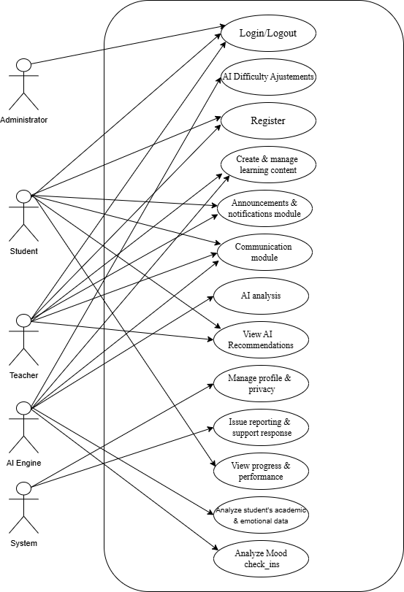
5.2 Activity Diagram
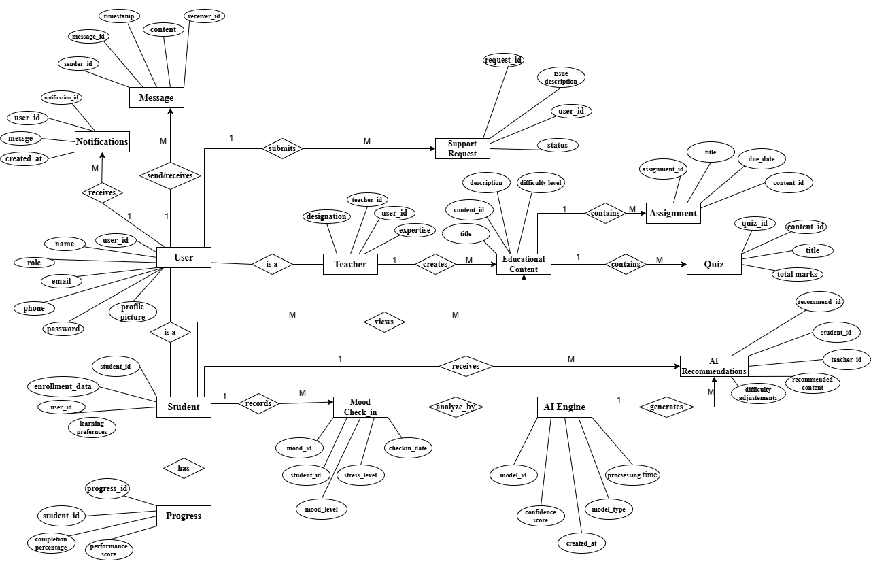

Context Diagram

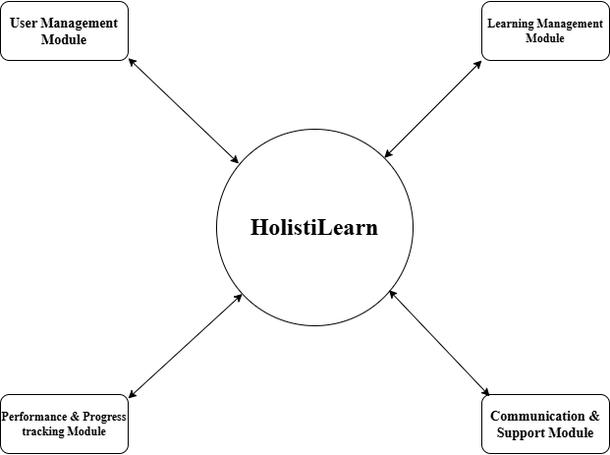

5.3 ER Diagram


5.4 Class Diagram
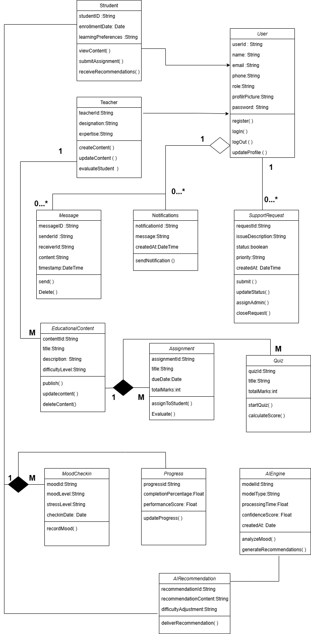

5.5 Object Diagram
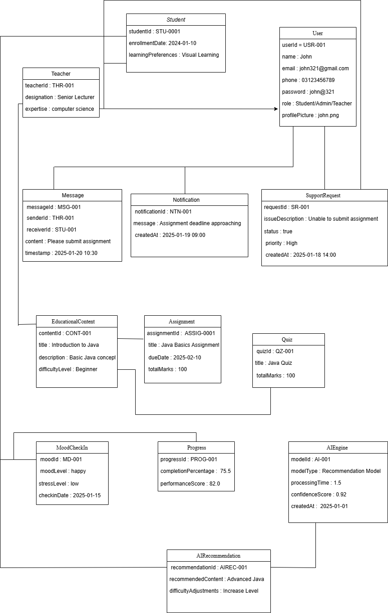

5.6 Sequence Diagram
