Jenkins

🡪Create docker compose script to run Jenkins

version: '1'

services:

  jenkins:

    image: jenkins/jenkins

    container_name: jenkins

    privileged: true

    user: root

    ports:

      - 8080:8080

      - 50000:50000

    volumes:

      - C:\Users\<user.name>\Downloads\MyRepository\Learning\jenkins-docker-compose:/var/jenkins_home

This script will run Jenkins docker image on port 8080

<http://localhost:8080>

and Jenkins will be configured inside Jenkins-docker-compose folder

Initial admin password will be at /Jenkins-docker-compose/secrets/initialAdminPassword

🡪Create your admin user

🡪Create first Job, provide git repository, add build script

🡪edit job, and “Additional behaviour” >Sparse Checkout path to required folder

🡪edit job, Select parameterized project > update build script

🡪Select build as periodical > provide cron expression

Continuous Integration (CI)

Continuous Delivery (CD)

Continuous Deployment (CD)

🡪Continuous Integration (CI)

On every commit Jenkins Build should gets triggered

Poll SCM:

Email Notification:

Configure Jenkins Server with SMTP server to send mail

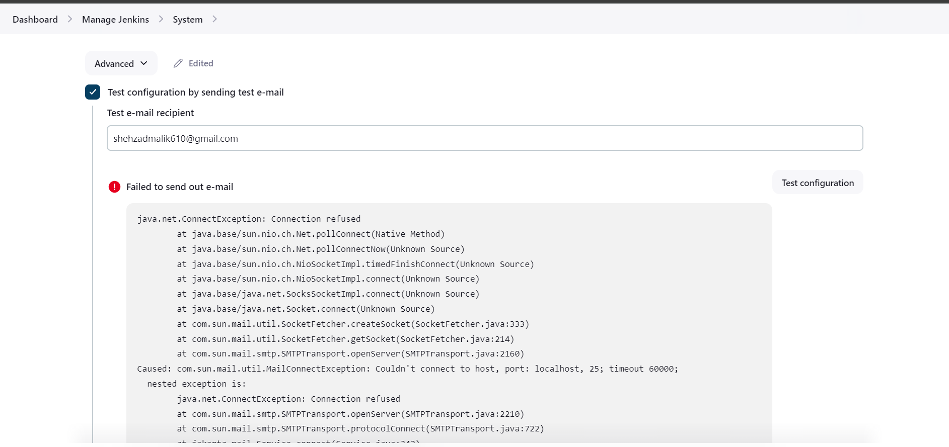

Add Plugin “Build Monitor View” and use it

Integration with Slack:

Install Slack plugin

Get Slack url and integration token from:

<https://my.slack.com/services/new/jenkins-ci>

Manage Jenkins>System Configuration>System

Add “Post Build Actions” as Slack Notification for your build:

🡺Pipeline as Code

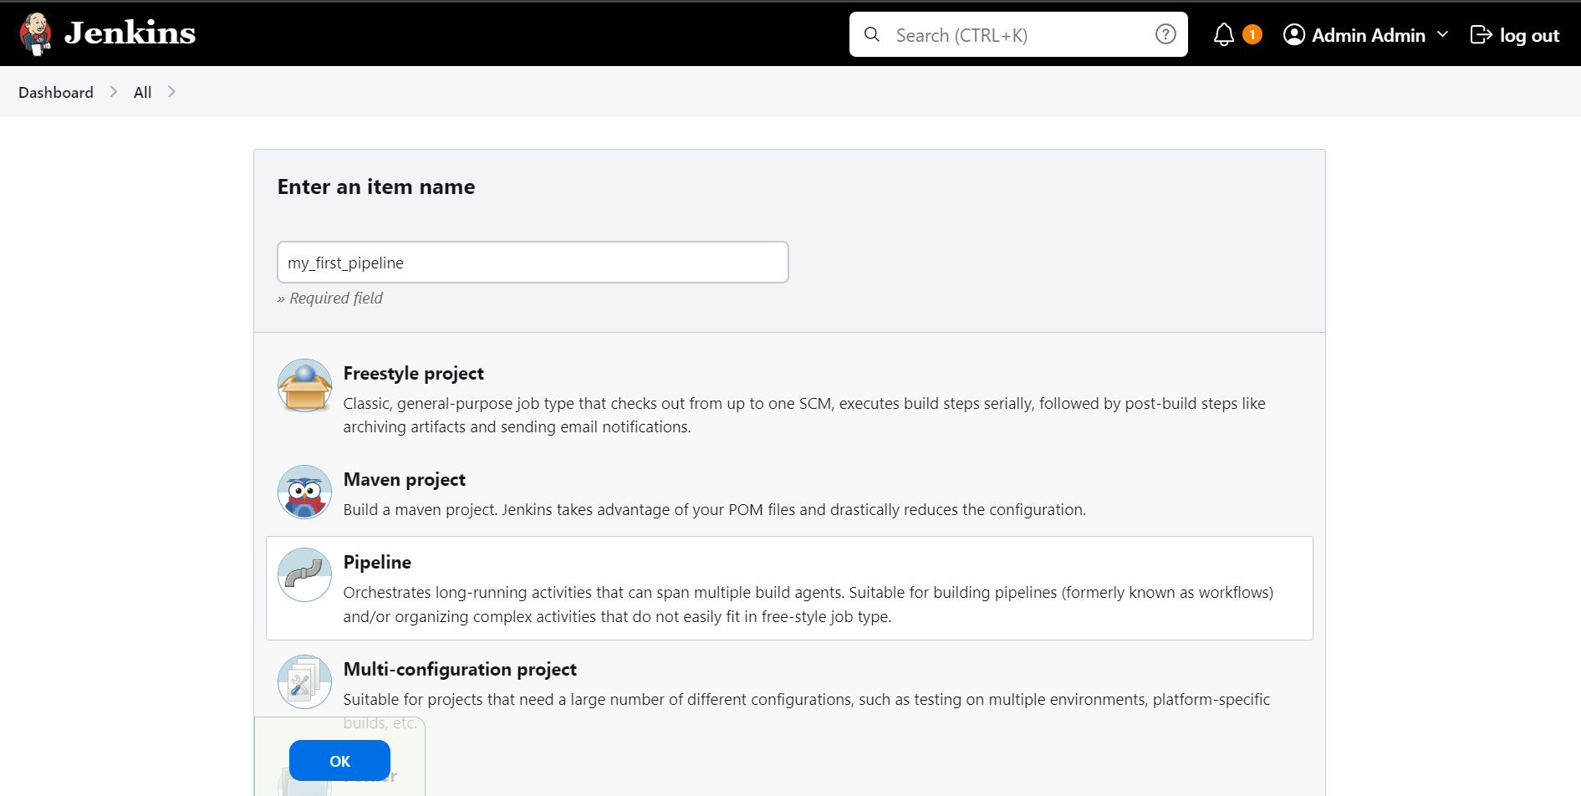

🡪Clone python project

🡪create Dockerfile

🡪build into docker image

🡪run container from image