

Dear Colleague,

**IMPORTANT PRODUCT RECALL NOTICE**: Wooden train set

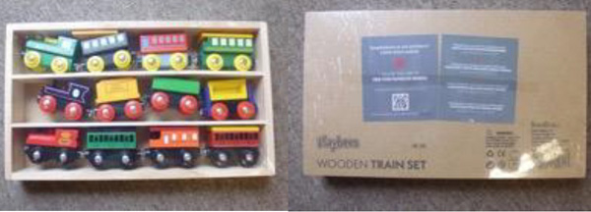

**Alert number:** A12/1462/19

**Category:** Toys

**Product:** Wooden train set

**Brand:** Playbees

**Name:** Wooden Train Set

**Type / number of model:** date of manufacture: 12/2017

**Batch number / Barcode:** 700358200717

**Risk type:** Choking, Injuries

Small parts with a high magnetic flux (carriage buffers) can easily be detached from the toy.

If a small child puts the small magnet in the mouth, it could lead to choking. If the small magnet and other metallic objects are swallowed, they could attract one another causing intestinal blockage or perforation.

The product does not comply with the requirements of the Toy Safety Directive and the relevant European standard EN 71-1.

**Measures ordered by public authorities (to: Retailer):** Withdrawal of the product from the market

**Description:** Wooden train set in a brown box. The product was also sold online, in particular via Amazon.

**Country of origin:** China

**Alert submitted by:** United Kingdom

**Type of alert:** Serious