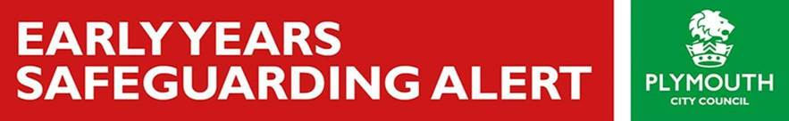

Dear Colleague,

**IMPORTANT PRODUCT RECALL NOTICE**: ARGOS – BABY SLEEP BAGS

The following notice appears on the Argos website:

Baby sleep bags – 134877764 and 134878142

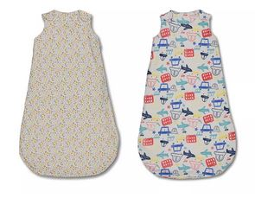

We want to bring to your attention a potential safety issue with the Baby Sleep Bags (style numbers 134877764 and 134878142). It has come to our attention that the level of insulation provided by these sleep bags exceeds the specified rating. This may cause an infant to overheat.

**What you need to do**  
Stop using the sleep bag immediately and return it to an Argos store or a Sainsbury’s click and collect store for a full refund of £14.

You will not need a proof of purchase.

If you do not have an Argos or Sainsbury’s click and collect store near to you, please contact us on 0800 028 6658 or email [tucustomerservices@sainsburys.co.uk](mailto:tucustomerservices@sainsburys.co.uk) and we will arrange for a returns label to be sent to you.

**Any questions?**  
The safety of our customers is our highest priority. We are very sorry for any inconvenience caused.

If you have any questions or concerns, please contact us on our dedicated helpline on: FREEPHONE 0800 028 6658  
Our helpline is open between 8am-8pm Monday to Sunday. We thank you for your cooperation and apologise for any inconvenience.