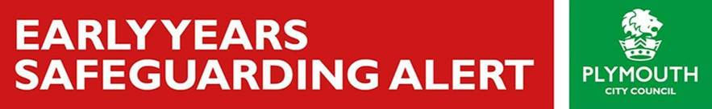

Dear Colleague,

**IMPORTANT PRODUCT RECALL NOTICE**: **KINGSPORT – CHILDREN’S SWING**

The following notice has been issued by the European Commission:

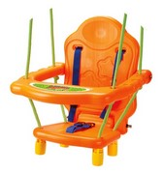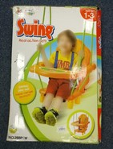**Alert number**  
A12/1635/19

**Category**  
Toys

**Product**  
Children’s swing

**Type / number of model**  
28881W

**Batch number / barcode**  
6906543512397

**Risk type**  
Strangulation

The product is incorrectly labelled as being suitable for small children.

The crotch strap can break and the seat back and bottom may come apart, causing the small child to slip down and become trapped by the neck where the two shoulder straps meet, leading to strangulation.

The product does not comply with the requirements of the Toy Safety Directive and the relevant European Standard EN 71-8.

**Description**  
Swing with metal shelf, labelled as being suitable for children 1-3 years. The product was (also) sold online.

**Country of origin**  
China