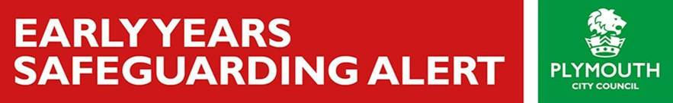

Dear Colleague,

**IMPORTANT PRODUCT RECALL NOTICE**: Cuggl – Safety Gates

The following notice appears on the **Argos website**:

We want to bring to your attention a potential safety issue with a number of Cuggl Safety Gates (descriptions and images below). Extensive testing has identified that some gates may **fail to consistently meet all the required safety standards, resulting in the brackets or wooden slats breaking under high impact** – for example, regular banging or kicking of the gate, failure of the auto-close feature and / or the gaps between metal bars being wider than the required standard, which may result in a child getting trapped.

**Cuggl Safety Gates affected:**

Cuggl Autoclose Metal Gate: **Cat no. 7076879**

Cuggl Metal and Wood Gate: **Cat no. 7025112**

Cuggl Wooden Extending Gate: **Cat no. 7065426**

Cuggl 7 cm Pressure Fit Extension Kit: **Cat no. 7063868**

Cuggl Pressure Fit Safety Gate: **Cat no. 7036613**

Cuggl Extra Wide Hallway Gate: **Cat no. 7060225**

Cuggl Extra Wide Adjustable Gate: **Cat no. 6879613**

