Oracle Customer Success Services (CSS)
Abu Dhabi Commercial Bank Oracle Root Cause Analysis (RCA)



Prepared by Customer Success Services.
Author:
Creation Date: 04-July-2026
1. Approvals 3
1.1. Author 3
1.2. Reviewer 3
1.3. Distribution 3
2. Executive Summary 4
3. Environment Details 5
3.1. Environment Details 5
4. Initial RCA Assessment 7
5. Oracle RCA Timeline and Investigation 8
5.1. Incident Overview 8
5.2. Incident – 27 June 8
5.3. Incident - 28 June 9
5.4. Incident – 29 June 9
Remediation Applied in Production 10
(1) MDB-Level Transaction Timeout 10
(2) WorkManager Thread Pool Increased to 64 10
(3) Datasource XA Transaction Timeout Alignment 10
(4) EMS Response Bridge Converted to Non-XA 11
5.5. Incident – 30 June 11
5.6. Incident – 1 July 11
5.7. Incident – 2 July 12
5.8. Incident – 3 July 12
5.9. Incident – 4 July 12
5.10. Incident – 7 July 12
5.11. Incident – 8 July 13
5.12. Incident – 9 July 14
6. Comprehensive Oracle Root Cause Analysis 17
6.1. Oracle Findings 17
6.2. Oracle Recommendations 18
Version: 6.0

Approvals

Author

Name | Position
Khurram Shahzad | Lead Principal Advanced Services Engineer
Yogesh Tripathi | Principal Advanced Services Engineer
Mohamed Bander | Lead Principal Advanced Services Engineer

Reviewer

Name | Position
Susan Alsisi | Lead Principal Advanced Services Engineer
Mohamed Farag | Lead Principal Advanced Services Engineer

Distribution

Name | Position

Executive Summary

The purpose of this document is to provide a comprehensive summary of the incident and the analysis performed following the Abu Dhabi Commercial Bank (ADCB) core banking service interruption that impacted multiple banking channels. It presents an overview of the incident timeline, including key events, business impact, and the response activities undertaken during the recovery process. The document outlines the technical analysis completed to identify potential contributing factors, highlights key observations and findings, and summarizes the production changes implemented to date to stabilize the environment. It also documents ongoing efforts to ensure business continuity, maintain service stability, and reduce operational risk. In addition, this document identifies the further investigation and corrective actions required to establish a comprehensive Root Cause Analysis (RCA), validate the underlying cause of the incident, and define long-term preventive measures to minimize the likelihood of recurrence. .

Environment Details
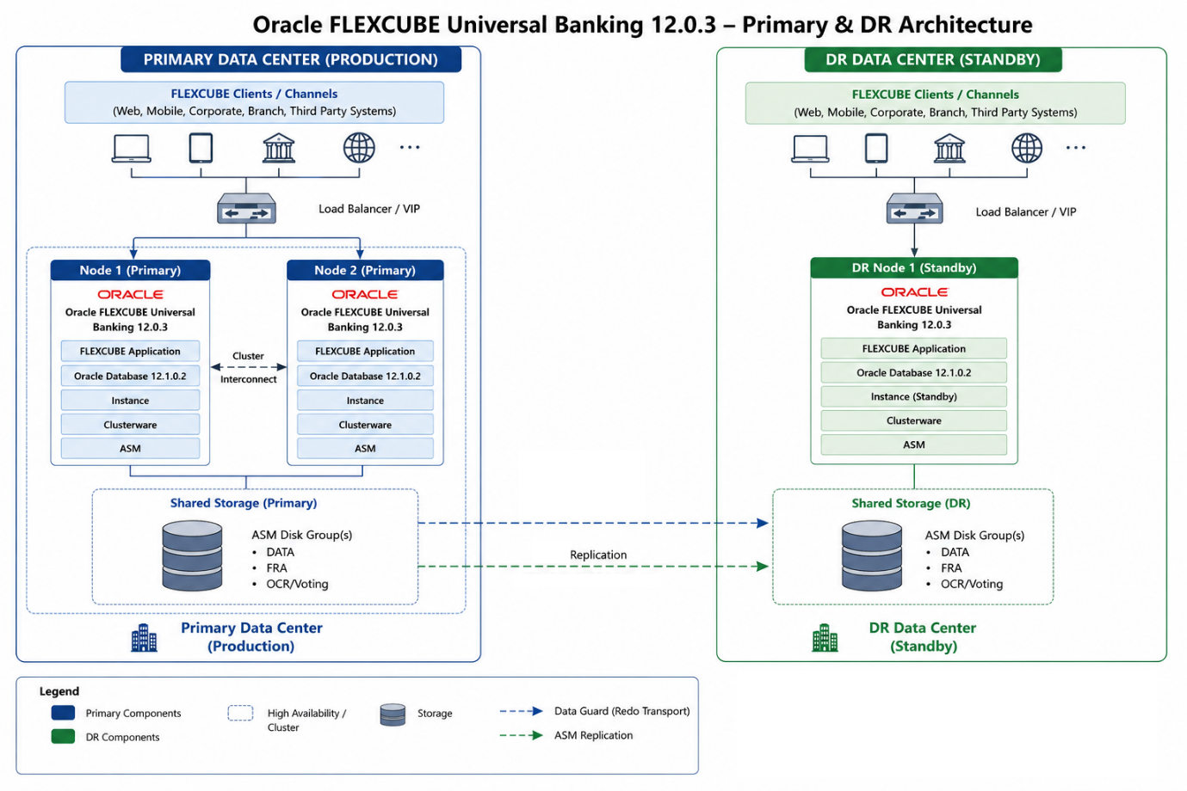

Environment Details
- IBM Power9 Server - Model: 9080-M9S AIX Version: 7.1
- Oracle FLEXCUBE Universal Banking 12.0.3 - sustaining support no MDS
- Oracle Database 12.1.0.2 - out of support no MDS
  - AIX 2 node RAC Primary location
  - AIX single node DR location
  - IBM storage replication solution PR→DR
- WLS 12.2.1.4.0 and 10.3.6
- TIBCO EMS
Notes:
- The environment is running Oracle Database 12.1.0.2, which has been in the Extended Support phase since July 2022. As there is no active Market-Driven Support (MDS) contract, the environment is not eligible to receive the latest security patches or regular product updates.
- Oracle FLEXCUBE Universal Banking 12.0.3 is currently under Sustaining Support. Since no MDS contract is in place, no new bug fixes, security updates, or product enhancements are available for this release.

Initial RCA Assessment
A new version of the mobile application was deployed into production on 11th of May. Following the deployment, the application traffic was gradually ramped up as additional users adopted the new release.
System monitoring indicates that transaction volumes began increasing significantly on 26 June, with a substantial surge observed on 1 July and 2 July.
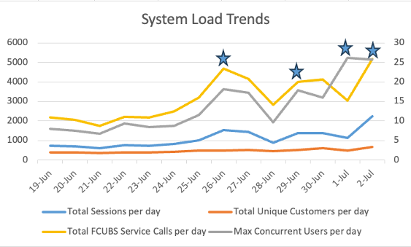
From a production perspective, the environment experienced a considerable increase in workload across multiple system layers. As transaction volumes grew, performance degradation became evident in several components of the application stack, including the application, middleware, database, and infrastructure layers.
Based on the observed workload patterns, the production environment encountered traffic levels significantly higher than the historical baseline. This suggests that the system may not have been fully validated under equivalent production-scale workloads prior to the increase in user traffic.
Since the incident was identified, Oracle has worked closely with ADCB to stabilize the production environment. A series of corrective actions and optimization activities have been implemented, including infrastructure tuning, database performance optimization, application configuration improvements, enhanced monitoring, workload management, and continuous health assessments. These efforts remain ongoing to ensure service stability, maintain business continuity, and support the completion of a comprehensive Root Cause Analysis (RCA).

Oracle RCA Timeline and Investigation

Incident Overview
Incident Summary
During production operations, intermittent transaction failures and XA timeouts were observed on weblogic. The issue resulted in transaction rollbacks and prevented the successful completion of inbound request/response processing, leading to service disruptions across impacted banking channels.

Incident – 27 June
Time: 2 PM
Identified overload across multiple JDBC data sources and observed TIBCO connection timeouts in the WebLogic Server logs.

Technical Findings
The transaction architecture required a two-phase commit (2PC) across three resource managers: TIBCO EMS, the FLEXCUBE database, and Oracle WebLogic Server. As a result any issues with the downstream resources, the XA transaction coordinator initiated a global rollback, causing request failures and transaction interruptions.
Recommendations
To address the issue and improve production stability, Oracle implemented a comprehensive optimization strategy that included the following actions:
• Protocol Optimization: Reconfigured the TIBCO EMS response bridge to operate in a non-XA mode where appropriate, eliminating unnecessary distributed transaction overhead and reducing transaction latency.
• Transaction Configuration Tuning: Reviewed and aligned all transaction timeout settings, including JTA, JDBC datasource, and XA timeout parameters, to ensure consistent transaction coordination across all participating components.
• Infrastructure Optimization: Reviewed and optimized the production infrastructure configuration, including CPU, memory allocation, connection pools, and thread pool capacities, to better support peak transaction volumes and high-concurrency workloads

Incident - 28 June
- Tested the recommended configuration changes in the UAT environment.
- Validation confirmed that the proposed changes resolved the identified middleware issues.

Production Issue : XA Transactions Rollbacks observed
<Jun 28, 2026 4:34:35,373 PM GST> <Debug> <JTA2PC> <BEA-000000> <Name=ContinuousJMSMessagePoller.GWMDB18,
Xid=BEA1-74700353E11CA2BEDFDE(-262484680),Status=Marked rollback. [Reason=weblogic.transaction.internal.
TimedOutException: Transaction timed out after 31 seconds

<Jun 28, 2026 4:34:40,384 PM GST> <Debug> <JTA2PC> <BEA-000000> <Still within transaction abandon grace
period. ... Name=ContinuousJMSMessagePoller.GWMDB18,Xid=BEA1-7B530353E11CA2BEDFDE(-214267568),Status=
Rolling Back. ... activeThread=Thread[ContinuousJMSMessagePoller :GWMDB18,5,Non-Pooled Threads],
XAServerResourceInfo[...GWMDB18]=(... xar=weblogic.deployment.jms.WrappedXAResource_com_tibco_tibjms_
TibjmsXAResource@d622185d ...), ... XAResources={FLEXTEST2.WORLD_Gateway_Domain, ...,
WLStore_Gateway_Domain_FileStore3, ...QueueConnectionXAFactory9...}

<Jun 28, 2026 4:37:57,380 PM GST> <Debug> <JTAXA> <BEA-000000> <BEA1-0C2736A0325AA2BEDFDE:
ContinuousJMSMessagePoller.GWMDB18: XAResource[...GWMDB18].rollback: FAILED (rm=...,
xar=weblogic.deployment.jms.WrappedXAResource_com_tibco_tibjms_TibjmsXAResource@a293d60d
javax.transaction.xa.XAException: XAException errorCode = -4, error code: XAER_NOTA :
The XID is not valid, message: null

Incident – 29 June
Successfully implemented the validated middleware recommendations in the Production environment to maintain system availability and process incoming payload volumes during the storage slowdowns, the following operational workarounds and configuration changes were addressed:
- Dynamic WebLogic Scaling: The middleware team manually scaled up WebLogic Work Manager execution threads to prevent server crashes.
- WebLogic Self-Tuning Thread Pool Implementation: The WebLogic Self-Tuning Thread Pool configuration has been successfully implemented across all WebLogic servers in the DR environment to optimize thread allocation under load.
- JDBC Pool Expansion: Data source limits were widened to capture and buffer incoming transaction requests.
- Timeout Strategy Coordination: Global JDBC transaction timeouts have been left unchanged. The Set XA Transaction Timeout flag at the WebLogic data source level has not been enabled, as business services have highly variable database execution thresholds. Applying a general timeout without synchronization risks breaking critical payment channels, such as DR Payments and Funds Transfers. Coordination remains open with the Core Banking and Business teams to map out specific service baselines before applying any automated cutoff rules.

Remediation Applied in Production
Each remediation activity below describes the implemented change, the technical rationale, supporting configuration evidence, and the corresponding Oracle documentation reference.

MDB-Level Transaction Timeout
An explicit transaction timeout was configured at the MDB level to ensure that delayed inbound transactions fail quickly instead of holding XA resources for the default timeout period.
Purpose
- Reduce transaction accumulation.
- Prevent prolonged XA branch retention.
- Minimize message redelivery storms.

WorkManager Thread Pool Increased to 64
A dedicated WorkManager with a MaxThreadsConstraint of 64 was configured for MDB processing.
Purpose
- Increase MDB concurrency.
- Improve throughput under heavy load.
- Allow inbound message backlogs to drain more efficiently.

Datasource XA Transaction Timeout Alignment
The datasource configuration was modified by enabling Set XA Transaction Timeout while maintaining the XA Transaction Timeout value of 0, allowing Oracle WebLogic Server to propagate the global JTA timeout automatically to the Oracle XA resource.
Purpose
- Eliminate timeout mismatches.
- Synchronize Oracle Database and WebLogic transaction timeouts.
- Prevent XAER_NOTA rollback failures.

EMS Response Bridge Converted to Non-XA
The outbound TIBCO EMS response bridge was reconfigured to use a non-XA connection factory with Duplicate-Okay quality of service.
Purpose
- Remove unnecessary XA coordination from the response path.
- Eliminate XA prepare and commit overhead.
- Improve response latency and transaction reliability.
The non-XA bridge has been operating successfully in the Production environment without XA transaction failures, confirming that non-XA communication with the TIBCO EMS infrastructure is stable.

Incident – 30 June
- Closely monitored the Production environment.
- The system remained stable with no reported application issues.

Incident – 1 July
Time 3:00 PM - The issue reoccurred in the Production environment.
- Database connections remained locked, incoming traffic from various channels immediately saturated WebLogic's infrastructure:
- JDBC Data Sources: Reached maximum capacity as connections remained trapped waiting for database responses.
- Work Manager Threads: Experienced massive spikes and thread utilization surges, causing transaction backlogs and eventual client-side timeouts.
- Root Cause Analysis (RCA) : Investigation concluded that Oracle database storage write latency delayed COMMIT operations, resulting in transaction backlogs, WebLogic JDBC connection pool exhaustion, thread saturation, and application timeouts.
####<Jul 01, 2026 15:04:12 UTC> <Error> <JDBC> <BEA-001129>
<Received no resources from data source “FEXTEST.WORLD".
Connections have reached the maximum capacity of the connection pool.
Applications are waiting for connections to become available.>

Incident – 2 July
- Prepared for the Production database migration and Disaster Recovery (DR) switchover.
- Applied all required WebLogic configuration changes in the DR environment.
- Completed pre-production validation and readiness checks.

Incident – 3 July
Time 3:00 AM - Successfully executed the Production database migration.
• Completed all planned WebLogic configuration changes in the Disaster Recovery (DR) environment.
Time 7:40 AM - Successfully switched Production services to the Disaster Recovery (DR) environment.
• Customer-facing banking services became fully operational following the database migration and middleware configuration updates.

Incident – 4 July
- Applications continued operating normally from the DR environment.
- Ongoing monitoring by the Database, Middleware, and Application Support teams continued.

Incident – 7 July
- Flexcube frontend FCUBS domain managed server observed JVM high heap utilization.
- Analyzed the domain and Weblogic 10.3.6.0.211019 PSU which has extended support ended in Dec 2021 and highly recommended to be upgraded, as confirmed in the SR 4-0003224399 as well by Oracle Support for limitations.
- Thread dumps show active SchedulerFactory workers executing com.ofss.scheduler.quartz.* jobs and Oracle JDBC operations from out and javacore.
Focus on:
FCJFCUBSCYTMRates
FCJOBPMReplQrtz
FCJOBLMReplQrtz
- Repeated SQL constraint violations observed in the server out logs ->
java.sql.SQLIntegrityConstraintViolationException:
ORA-00001: unique constraint (ADLMVM001.PK_CMC_TW_GLMASTER) violated

This exception appears repeatedly in Quartz scheduler job paths, including:
com.ofss.scheduler.quartz.FCJOBPMReplQrtz.insertIntoOBPM
com.ofss.scheduler.quartz.FCJOBPMReplQrtz.replicateOBPMCore
com.ofss.scheduler.quartz.FCJOBPMReplQrtz.execute
org.quartz.core.JobRunShell.run
org.quartz.simpl.SimpleThreadPool$WorkerThread.run
- Monitor Weblogic JVM for heap utilization and use explicit GC only as a controlled operational workaround if heap pressure approaches critical thresholds and avoid treating it as a permanent fix.
- Analyze the heap dumps during the high utilization and low utilization with IBM provided tools as IBM JDK is being used with JVM to understand memory consumption if issue persists after optimization of application.
- Flexcube application team is working on fixing the Quartz errors for the sql constraints and performance.

Incident – 8 July
- Oracle RWP observed there is at max 200 active sessions only found in the system and so having around 3000 sessions connected is of no use and would unnecessarily create CPU scheduling issues when many sessions become active.
- Oracle RWP recommended to reduce the WLS datasource connection pool size to avoid the connection oversubscription to CPU cores and its subsequent issues arising due to concurrency when many sessions contend for resources.
- Analysis performed for the current datasource connection pool size for min, max, initial and test connection pool parameters and shared with the Flexcube application team for feedback on the application performance and forecasted load to align with ADCB requirements to develop action plan for optimized pool size.

Incident – 9 July
- Morning timeout spikes observed between 3:00 AM – 4:00 AM which were concentrated in the duration 3:30 AM to 3:34 AM.
- Analyzed the weblogic and TIBCO logs and JMS integration it was observed that TIBCO producers are taking time during this window to write message in the inbound queues.
- Subsequently the timeouts configured for TIBCO are 5 seconds and the TIBCO producer itself takes more than 10 seconds. Hence the spike is observed and once the write to TIBCO store stabilizes the flows are normalized.
- TIBCO team confirmed they have backup job running at 3:30 AM.
- Recommended to ADCB and TIBCO team to optimize the backup jobs.
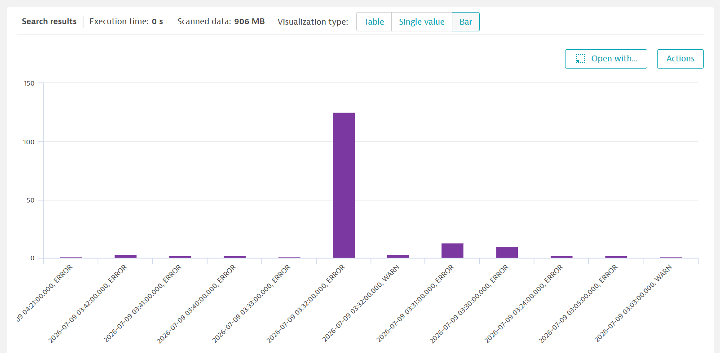
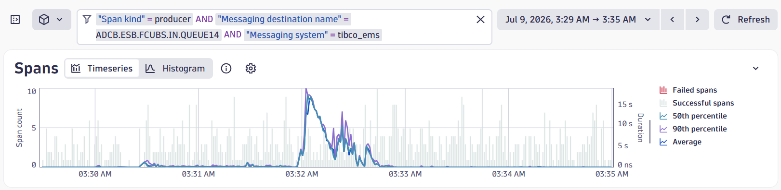
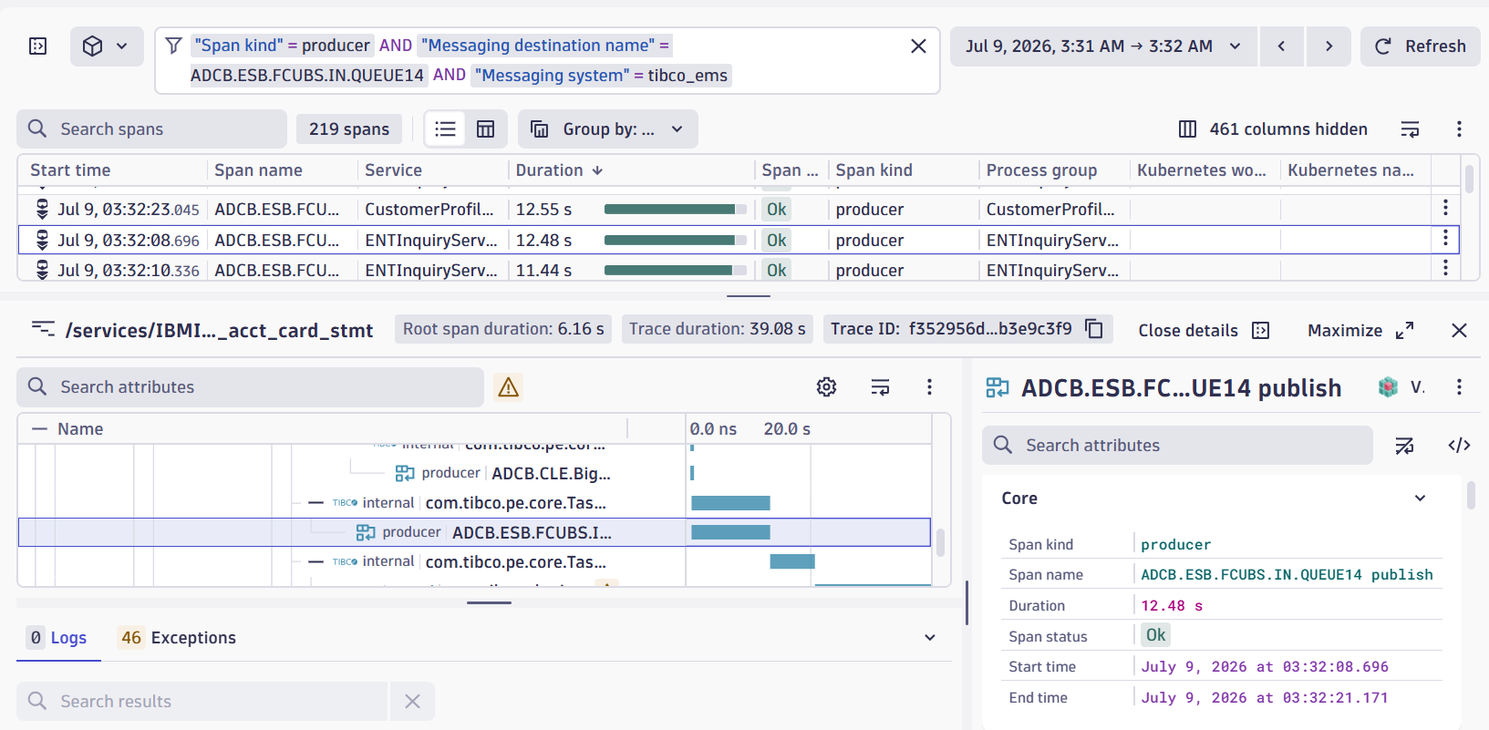

‘

Comprehensive Oracle Root Cause Analysis

An analysis of the database wait events showed a direct correlation between foreground session delays and background storage execution:
- Primary Database Bottleneck: High log file parallel write wait times on the Oracle Log Writer
- (LGWR) process. This confirmed that the database engine was stalling while waiting for physical
- Storage disk write acknowledgments during transaction COMMIT operations.
- Upstream Cascade: This storage latency triggered matching spikes in foreground log file sync waits.
- Several SQL queries taking long time to complete in DB.
Banking transactions could not complete their commits, holding database connections open indefinitely.

Oracle Findings
Middleware Tier (WebLogic)
Because database connections remained locked, incoming traffic from various channels immediately saturated WebLogic's infrastructure:
- JDBC Data Sources: Reached maximum capacity as connections remained trapped waiting for database responses.
- Work Manager Threads: Experienced massive spikes and thread utilization surges
- Transaction backlogs and eventual client-side timeouts.
- DR switchover reduced timeout but still DB side working on tuning
- Flexcube 11g weblogic domain is showing high heap and schedular threads hanging. ORA errors are also being worked on in SR with flexcube team
- Tibco Backup is causing timeouts at 3:30 to 4:00 AM daily.
- Oracle RWP has suggested to scale bank JDBC connection pools as they cause load on PGA

Oracle Recommendations

To maintain system availability and process incoming payload volumes during the storage slowdowns,the following operational workarounds and configuration changes were addressed:

Complete :
- The middleware team manually scaled up WebLogic Work Manager execution threads to prevent server crashes.
- WebLogic Self-Tuning Thread Pool Implementation: The WebLogic Self-Tuning Thread Pool configuration has been successfully implemented across all WebLogic servers in the DR environment to optimize thread allocation under load.
- JDBC Pool Expansion: Data source limits were widened to capture and buffer incoming transaction requests.
- Timeout Strategy Coordination: Global JDBC transaction timeouts have been left unchanged. The Set XA Transaction Timeout flag at the WebLogic data source level has not been enabled, as business services have highly variable database execution thresholds. Applying a general timeout without synchronization risks breaking critical payment channels, such as DR Payments and Funds Transfers. Coordination remains open with the Core Banking and Business teams to map out specific service baselines before applying any automated cutoff rules.
Pending
1.) Scale back of JDBC on MDB Domain
2.) Weblogic 10.3.6 JVM heap investigation
Database Optimization & Permanent Remediation Plan
To permanently eliminate transaction backlogs and improve structural performance at the data tier, the database and core banking teams are working on structural optimization plan targeting high-contention. Seperate RCA for DB will be shared.

Vendor Engagement Status
• Vendor Engagement: The bank has officially logged a high-priority technical ticket with IBM to investigate, profile, and remediate the underlying storage subsystem performance bottlenecks.
• Next Steps: IBM storage engineers, in coordination with the Global DB support team, are reviewing storage array latency logs, cache hit ratios, and physical I/O profiles during the exact timestamps of the July 1st channel failures.

