Project Report Template

# INTRODUCTION

* 1. fashion haven

The fashion and creative industries to build structures & cultures

* 1. 1.2 Purpose

We work with global brands and business across

1. **Problem Definition & Design Thinking**
   1. Empathy Map

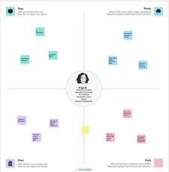

* 1. 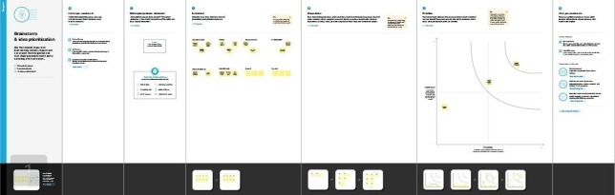Ideation & Brainstorming Map

# RESULT

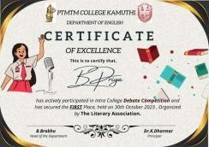

1. **ADVANTAGES & DISADVANTAGES**

It will be the token of Appreciation. It will be Useful for Students’ career.

Its disadvantage is It may not be useful all the Time.

# APPLICATIONS

It will be the token of Appreciation. It will be Useful for Students’ career.

# CONCLUSION

We Learn a lot of New things about Editing and make it useful for others.