PROGRAMMING FUNDAMENTALS (CS-1002)

ASSIGNMENT 1

Submitted by: Muhammad Hashir @ 26K-0057
Section: BAI-1B

PART A:

Question 1:

ALGORITHM:
- START
- Take input from user “n”
- Loop While n is greater than or equal to 1
  - Output n
  - decrement n by 1, n = n-1
- End Loop
- END

PSEUDOCODE:
- START
- INPUT INTEGER n from user
- WHILE LOOP, n >= 1
- PRINT n
- n = n – 1
- END LOOP
- END

-------------------------------------------------------------------------------------

Question 2:

ALGORITHM:
- START
- Take input from user “year”
- If year / 4 reminder is 0 and year / 100 reminder is non-zero
  - Then Output “Leap Year”
- Else If year / 400 reminder is 0,
  - Then Output “Leap Year”
- Else Output “Not a Leap Year”
- END

PSEUDOCODE:
- START
- INPUT INTEGER year from user
- IF year % 4 == 0 AND year % 100 != 0,
- THEN PRINT “Leap Year”
- ELSE IF year % 400 == 0
- THEN PRINT “Leap Year”
- ELSE PRINT “Not a Leap Year”
- END
Question 3:

ALGORITHM:
- START
- Take input number from user, num
- If num / 10 gives 0 Then output “single digit”
- Else If num / 100 gives 0 Then output “Double Digit”
- Else If num / 1000 gives 0 Then output “Triple Digit”
- Else Output “more than 3 digits”
- END

PSEUDOCODE:
- START
- INPUT INTEGER num from user
- IF num / 10 == 0
- THEN PRINT “Single Digit”
- ELSE IF num / 100 == 0
- THEN PRINT “Double Digit”
- ELSE IF num / 1000 == 0
- THEN PRINT “Triple Digit”
- ELSE PRINT “More than 3 Digits”
- END
----------------------------------------------------------------------------------------
Question 4:

ALGORITHM:
- START
- Set n = 1
- Loop While n is less than or equal to 10
  - Set i = 1
  - If n / 3 gives remainder non-zero
    - Then Loop While i <= 10
      - Set p = n*i
      - Output n x i = p
      - i = i + 1
    - End Loop
    - n = n + 1
  - Else n = n + 1
- End Loop
- END

PSEUDOCODE:
- START
- SET n = 1
- WHILE LOOP, n <= 10
- SET i = 1
- IF n % 3 != 0
- WHILE LOOP, i <= 10
- SET INTEGER p = n * i
- PRINT n x i = p
- i = i + 1
- END LOOP
- n = n + 1
- ELSE n = n + 1
- END LOOP
- END
-----------------------------------------------------------------------------
Question 5:

ALGORITHM:
- START
- Take input from user, num
- Set r = 0, sum = 0
- Loop While (num / 10) is not 0
- sum = 0
  - Loop while num is NOT 0
    - r = remainder of num / 10
    - num = num / 10
    - sum = sum + r
  - End Loop
  - Output sum
  - num = sum
- End Loop
- END

PSEUDOCODE:
- START
- INPUT INTEGER num from user
- SET r = 0, sum = 0
- WHILE LOOP, num / 10 != 0
- SET sum = 0
- WHILE LOOP, num != 0
- r = num % 10
- num = num / 10
- sum = sum + r
- END LOOP
- PRINT sum
- num = sum
- END LOOP
- END

PART B:

Question 1:

ALGORITHM:
- START
- Set total revenue = 0,
- Input number of Guests (n)
- Loop n times
  - Input nights staying
  - Input room type (1. Standard, 2. Deluxe, 3. Suite)
  - Input Season (1. Peak, 2. Off Peak)
  - Check season
    - for Peak Season(1), set standard rate = 5000, deluxe rate = 8000, suite rate = 12000
    - for Off Peak Season(2), set standard rate = 3000, deluxe rate = 5000, suite rate = 8000
  - Check room type
    - for Standard (1), set rate = standard rate
    - for Deluxe (2), set rate = deluxe rate
    - for Suite (3), set rate = suite rate
  - if nights staying is more than 7
    - then calculate discount = (rate*nights)*0.15
  - else set discount = 0
  - calculate final price = (rate * nights) – discount
  - Display final price
  - total revenue = total revenue + final price
- End loop
- Display total revenue
- END

PAC:
Given Inputs | Required Results
Number of Guests  Season (Peak/Off Peak)  Nights Staying  Room Type (Standard/Deluxe/Suite) | Final Price  Total Revenue
Processing Required | Alternate Solutions
- initialize variables, set total revenue = 0  - Loop for each guest (n)  - Input Season, Nights, room type  - identify rates using if-else statements  - apply discount if nights more than 7, otherwise set discount to 0  - calculate and Display final price = (rate × nights) − discount  - Total revenue = Total revenue + final price  (looped for N number of Guests)  - display total revenue after Loop Ends | - Use Switch-Case method for Season Identification and their respective calculation  - Calculate Final price with [(rate*nights)*0.85] for 7 or more nights

IPO CHART:
Input | Processing | Module Reference | Output
Number of Guests  Season (Peak/Off Peak)  Nights Staying  Room Type (Standard/Deluxe/Suite) | - Initialize total revenue = 0  - Input number of guests (n)  - Loop for each guest (n times):  - Input season, nights staying and room type  - Identify rates using the season  - Select the rate using the room type  - If nights > 7,  - discount = (rate × nights) × 0.15,  - otherwise discount = 0  - Final price = (rate × nights) − discount  - Display final price  - Total revenue = total revenue + final price  - After the loop ends, display total revenue | SET  READ  WHILE LOOP  READ  SWITCH-CASE  SWITCH-CASE  IF  CALC  ELSE  CALC  PRINT  CALC  PRINT | Final Price  Total Revenue
FLOWCHART:
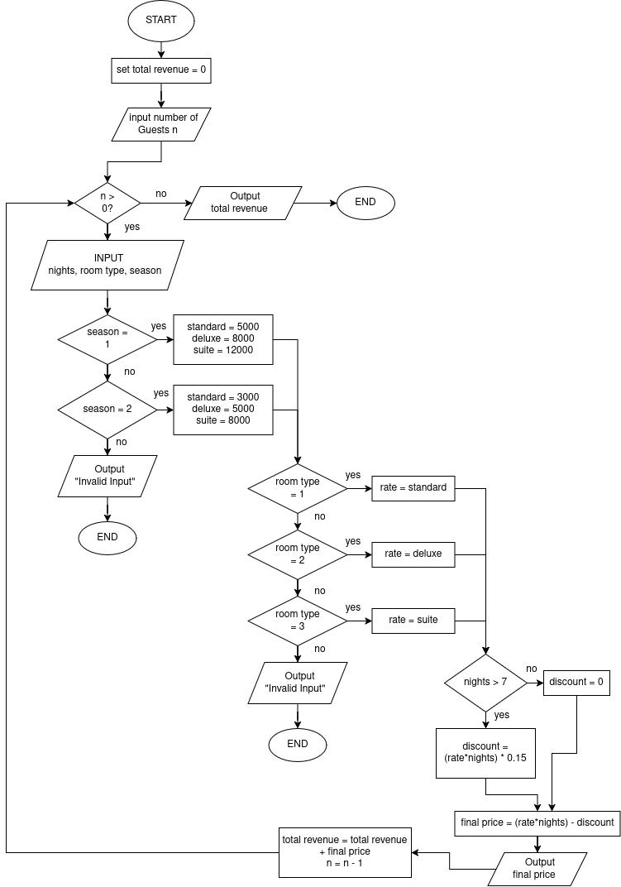

PSEUDOCODE:
- START
- SET total_revenue = 0
- INPUT INTEGER n from user
- WHILE LOOP, n > 0
- INPUT INTEGER nights from user
- INPUT INTEGER room_type from user
- INPUT INTEGER season from user
- SWITCH season
- CASE 1: SET standard = 5000, deluxe = 8000, suite = 12000
- CASE 2: SET standard = 3000, deluxe = 5000, suite = 8000
- END SWITCH
- SWITCH room_type
- CASE 1: SET rate = standard
- CASE 2: SET rate = deluxe
- CASE 3: SET rate = suite
- END SWITCH
- IF nights > 7
- SET discount = (rate * nights) * 0.15
- ELSE
- SET discount = 0
- END IF
- SET final_price = (rate * nights) - discount
- PRINT "Final price =", final_price
- total_revenue = total_revenue + final_price
- n = n - 1
- END LOOP
- PRINT "Total revenue =", total_revenue
- END

C CODE:
#include <stdio.h>

int main(){

int n, nights, room_type, season;
int standard, deluxe, suite, rate;
float discount, final_price;
float total_revenue = 0;
int i = 1;

printf("Enter number of guests: ");
scanf("%d", &n);

while (n > 0){
printf("-----GUEST %d-----\n", i);
printf("Enter nights staying: ");
scanf("%d", &nights);
printf("1. Standard\n2. Deluxe\n3. Suite\n");
printf("Enter the Room Type: ");
scanf("%d", &room_type);
printf("Enter season (1. Peak, 2. Off Peak): ");
scanf("%d", &season);

switch (season){
case 1:
standard = 5000; deluxe = 8000; suite = 12000;
break;
case 2:
standard = 3000; deluxe = 5000; suite = 8000;
break;
default:
printf("Invalid Input!");
break;
}

switch (room_type){
case 1:
rate = standard;
break;
case 2:
rate = deluxe;
break;
case 3:
rate = suite;
break;
default:
printf("Invalid Input!");
break;
}

if (nights > 7){
discount = (rate * nights) * 0.15;
}
else{
discount = 0;
}

final_price = (rate * nights) - discount;
printf("Final price = %.2f\n", final_price);
total_revenue = total_revenue + final_price;

n = n - 1;
i = i + 1;
}

printf("Total revenue = %.2f\n", total_revenue);
return 0;
}
-----------------------------------------------------------------------------
Question 2:

ALGORITHM:
- START
- Set current floor = 0
- Input number of requests (n)
- Loop While n > 0
- Input floor request
- If floor request is greater than current floor
- Then Output "Moving Up"
- Else If floor request is less than current floor
- Then Output "Moving Down"
- Else Output "Doors Opening"
- current floor = floor request
- n = n – 1
- End Loop
- END

PAC:
Given Inputs | Required Results
Floor request | Direction of elevator
Processing Required | Alternate Solutions
- Initialize floor 0  - input request amount n  - loop for n number of floor requests  - input floor request  - if floor request is greater than floor, say moving up and floor = floor request  - else if floor request is less than floor, say moving down and floor = floor request  - else floor request is same as floor, say doors opening  - n = n - 1  - end loop | 1. Store requests in an Array and process one by one  2. use a function move(floor, request) that changes the floor

IPO CHART:
Input | Processing | Module Reference | Output
Number of requests n  Floor Request(in each loop) | - Initialize floor = 0  - input number of requests n  - loop for n number of requests  - input floor request  - if request > floor  - then Display Moving Up  - floor = request  - else if request < floor  - then Display Moving Down  - floor = request  - else floor = request  - Display Doors Opening  - n = n - 1  - End Loop | ASSIGN  READ  WHILE LOOP  READ  IF  PRINT  ASSIGN  ELSE IF  PRINT  ASSIGN  ELSE  PRINT  CALC  END LOOP | Direction of Movement

FLOWCHART:
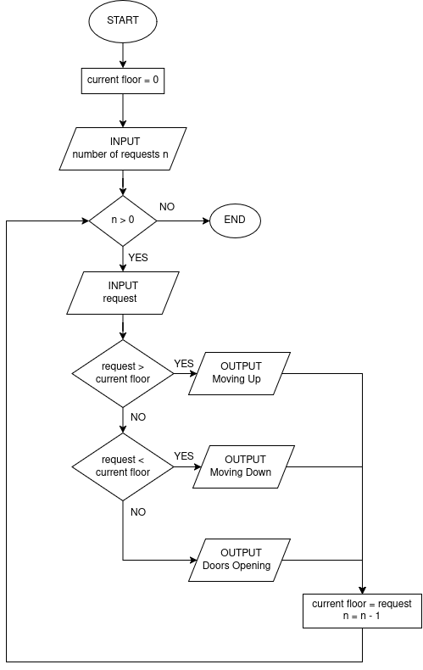

PSEUDOCODE:
- START
- SET current_floor = 0
- INPUT INTEGER n from user
- WHILE LOOP, n > 0
- INPUT INTEGER request from user
- IF request > current_floor
- PRINT "Moving Up"
- ELSE IF request < current_floor
- PRINT "Moving Down"
- ELSE
- PRINT "Doors Opening"
- END IF
- SET current_floor = request
- n = n - 1
- END LOOP
- END

C CODE

#include <stdio.h>

int main(){

int n, request;
int current_floor = 0;

printf("Enter number of requests: ");
scanf("%d", &n);

while (n > 0){
printf("Enter floor request: ");
scanf("%d", &request);

if (request > current_floor){
printf("Moving Up\n");
}

else if (request < current_floor){
printf("Moving Down\n");
}

else{
printf("Doors Opening\n");
}

current_floor = request;
n = n - 1;
}

return 0;
}
-----------------------------------------------------------
Question 3:

ALGORITHM
1. START
2. Input number of students (n)
3. Loop While n > 0
1. Set sum = 0, failed_subject = 0, count = 1
2. Loop While count <= 5
1. Input mark
2. sum = sum + mark
3. If mark < 33
1. Then failed_subject = 1
4. count = count + 1
3. End Loop
4. average = sum / 5
5. Output average
6. If failed_subject is 1
1. Then Output "Fail - Subject Deficiency"
7. Else If average >= 80
1. Then Output "Distinction"
8. Else If average >= 60
1. Then Output "Pass"
9. Else Output "Fail"
10. n = n - 1
4. End Loop
5. END

PAC:
Given Inputs | Required Results
number of students (N)  5 marks per student | average and result for each student
Processing Required | Alternate Solutions
- Input number of students
- loop for n students
- set sum = 0, failed subject = 0, count = 1
- loop for 5 marks
- input marks
- sum = sum + marks
- if marks < 33, failed subject = 1
- count = count + 1
- average = sum / 5
- display average
- if failed subject = 1, Display fail – SubjectDefeiciency
- Else if average >= 80, display distinction
- else if average >= 60, display Pass
- Else display fail
- n = n - 1

IPO CHART:
Input | Processing | Module Reference | Output
unmber of students (N)  5x marks per student | - Input number of students  - loop for n students  - set sum = 0, failed subject = 0, count = 1  - loop for 5 marks  - input marks  - sum = sum + marks  - if marks < 33, failed subject = 1  - count = count + 1  - average = sum / 5  - display average  - if failed subject = 1, Display fail – SubjectDefeiciency  - Else if average >= 80, display distinction  - else if average >= 60, display Pass  - Else display fail  - n = n - 1 | READ  WHILE LOOP  SET  WHILE LOOP  READ  CALC  IF  CALC  CALC  PRINT  IF  ELSE IF  ELSE IF  ELSE  CALC | average and result for each student

FLOWCHART:

PSEUDOCODE:

- START
- INPUT INTEGER n from user
- WHILE LOOP, n > 0
- SET sum = 0, failed_subject = 0, count = 1
- WHILE LOOP, count <= 5
- INPUT INTEGER mark from user
- sum = sum + mark
- IF mark < 33
- SET failed_subject = 1
- END IF
- count = count + 1
- END LOOP
- SET average = sum / 5
- PRINT "Average =", average
- IF failed_subject == 1
- PRINT "Fail - Subject Deficiency"
- ELSE IF average >= 80
- PRINT "Distinction"
- ELSE IF average >= 60
- PRINT "Pass"
- ELSE
- PRINT "Fail"
- END IF
- n = n - 1
- END LOOP
- END

C CODE:

#include <stdio.h>

int main(){
int n, mark, sum, failed_subject, count;
float average;

printf("Enter number of students: ");
scanf("%d", &n);

while (n > 0){
sum = 0;
failed_subject = 0;
count = 1;

while (count <= 5){
printf("Enter mark %d: ", count);
scanf("%d", &mark);
sum = sum + mark;

if (mark < 33)
{
failed_subject = 1;
}

count = count + 1;
}

average = sum / 5.0;
printf("Average = %.2f\n", average);

if (failed_subject == 1){
printf("Fail - Subject Deficiency\n");
}

else if (average >= 80){
printf("Distinction\n");
}

else if (average >= 60){
printf("Pass\n");
}

else{
printf("Fail\n");
}

n = n - 1;
}

return 0;
}
------------------------------------------------------------------------------------------
Question 4:

ALGORITHM
- START
- Input quantity (q), price per item (p), discount percentage (d), tax percentage (t)
- If q <= 0
- Then Output "Invalid quantity: must be greater than 0" and terminate
- Else If p <= 0
- Then Output "Invalid price: must be greater than 0" and terminate
- Else If d < 0 or d >= 100
- Then Output "Invalid discount: must be from 0 to below 100" and terminate
- Else If t < 0 or t >= 100
- Then Output "Invalid tax: must be from 0 to below 100" and terminate
- Else
- Calculate subtotal: s = q * p
- Calculate discounted amount: a = s - (s * d) / 100
- Calculate final bill = a + (a * t) / 100
- Display the bill document: subtotal, discount, discounted amount, tax, final bill
- End If
- END

PAC:
Given Inputs | Required Results
Quantity, q  price per item, p  discount percentage, d  tax percentage, t | Subtotal, s  Discounted Amount, a  Final Bill
Processing Required | Alternate Solutions
- Input quantity, price per item, discount %age and tax %age  - Validate the inputs  - If any value is invalid, display an error message and terminate  - Otherwise calculate the subtotal: s = q × p  - Calculate the discounted amount: a = s − (s × d) / 100  - Calculate the final bill: final bill = a + (a × t) / 100  - display the bill document (subtotal, discount, discounted amount, tax, final bill) | - Write each formula as a separate function: subtotal(q, p), discounted(s, d) and final_bill(a, t)  - Calculate the final bill in one combined statement

IPO CHART:
Input | Processing | Module Reference | Output
Quantity, q  price per item, p  discount percentage, d  tax percentage, t | - Input quantity, price per item, discount %age and tax %age  - Validate the inputs  - If any value is invalid, display an error message and terminate  - Else calculate the subtotal: s = q×p  - Calculate the discounted amount: a = s − (s × d) / 100  - Calculate the final bill: final bill = a + (a × t) / 100  - display the bill document (subtotal, discount, discounted amount, tax, final bill) | READ  IF  PRINT  ELSE, CALC  CALC  CALC  PRINT | Subtotal, s  Discounted Amount, a  Final Bill

FLOWCHART:
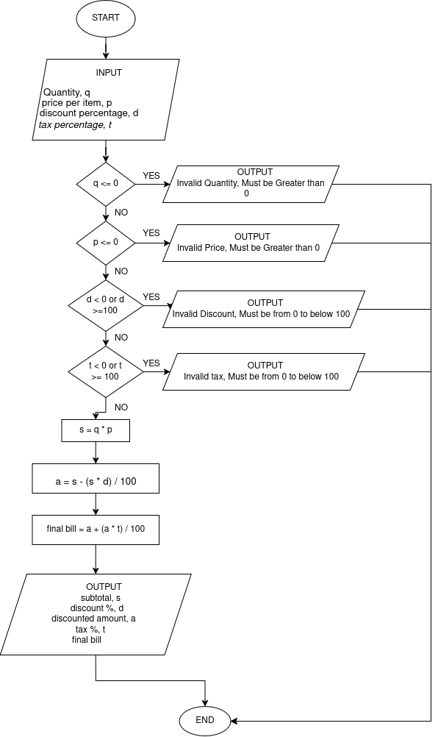

PSEUDOCODE:
- START
- INPUT INTEGER q from user
- INPUT FLOAT p from user
- INPUT FLOAT d from user
- INPUT FLOAT t from user
- IF q <= 0
- PRINT "Invalid quantity: must be greater than 0"
- ELSE IF p <= 0
- PRINT "Invalid price: must be greater than 0"
- ELSE IF d < 0 OR d >= 100
- PRINT "Invalid discount: must be from 0 to below 100"
- ELSE IF t < 0 OR t >= 100
- PRINT "Invalid tax: must be from 0 to below 100" D
- ELSE
- SET s = q * p
- SET a = s - (s * d) / 100
- SET final_bill = a + (a * t) / 100
- PRINT "Subtotal =", s
- PRINT "Discount (%) =", d
- PRINT "Discounted amount =", a
- PRINT "Tax (%) =", t
- PRINT "Final bill =", final_bill
- END IF
- END

C CODE:
#include <stdio.h>

int main(){
int q;
float p, d, t;
float s, a, final_bill;

printf("Enter quantity: ");
scanf("%d", &q);
printf("Enter price per item: ");
scanf("%f", &p);
printf("Enter discount percentage: ");
scanf("%f", &d);
printf("Enter tax percentage: ");
scanf("%f", &t);

if (q <= 0){
printf("Invalid quantity: must be greater than 0\n");
}

else if (p <= 0){
printf("Invalid price: must be greater than 0\n");
}

else if (d < 0 || d >= 100){
printf("Invalid discount: must be from 0 to below 100\n");
}

else if (t < 0 || t >= 100){
printf("Invalid tax: must be from 0 to below 100\n");
}

else{
s = q * p;
a = s - (s * d) / 100;
final_bill = a + (a * t) / 100;

printf("\n----- BILL -----\n");
printf("Subtotal = %.2f\n", s);
printf("Discount (%%) = %.2f\n", d);
printf("Discounted amount = %.2f\n", a);
printf("Tax (%%) = %.2f\n", t);
printf("Final bill = %.2f\n", final_bill);
}

return 0;
}

