
Muhammad Hashir
Roll No. 26K-0057

TASK 1

PAC
GIVEN INPUTS  Student Roll Number  Student Name  Subject 1 Marks  Subject 2 Marks  Subject 3 Marks  Subject 4 Marks  Subject 5 Marks | REQUIRED RESULTS  Total Obtained Marks  Percentage  Grade
PROCESSING REQUIRED  total_obtained_marks = subj_1_marks + subj_2_marks + subj_3_marks +  subj_4_marks + subj_5_marks  percentage = total_obtained_marks * 100 / 500  Grades Division (based on Percentage)  A: >=85  B: <85 and >=70  C: <70 and >=55  F: <55 | SOLUTION ALTERNATIVES  Percentage:  - Use the Given Formula to find Percentage  - Use total / 5 instead as simplified form  Grading  - *Use the Percentage for Grade Assigning  - Use the Total Marks for Grade Assignment

IPO
INPUT | PROCESSING | MODULE REFERENCE | OUTPUT
Student Roll Number  Student Name  Subject 1 Marks  Subject 2 Marks  Subject 3 Marks  Subject 4 Marks  Subject 5 Marks | Enter Student Roll Number  Enter Student Name  Enter Subject 1 Marks  Enter Subject 2 Marks  Enter Subject 3 Marks  Enter Suject 4 Marks  Enter Subject 5 Marks  Calculate Total Marks  Calculate Percentage  Find Grade  Output Total Marks  Output Percentage  Output Grade  END | Read  Read  Read  Read  Read  Read  Read  Calc  Calc  Calc  Print  Print  Print | Total Obtained Marks  Percentage  Grade

ALGORITHM
- Ask the user to enter their Roll Number
- Ask the user to enter their Name
- Ask the user to Enter Subject 1 Marks
- Ask the user to enter Subject 2 marks
- Ask the user to enter subject 3 marks
- ask the user to enter subject 4 marks
- ask the user to enter subjcet 5 marks
- set total_obtained_marks to (marks1+marks2+marks3+marks4+marks5)
- set percentage to (total_obtained_marks * 100 / 500)
- set grade to A if percentage is greater then or equal to 85
- set grade to B if percentage is less than 85 and greater than or equal to 70
- set grade to C if percentage is less than 70 and greater than or equal to 55
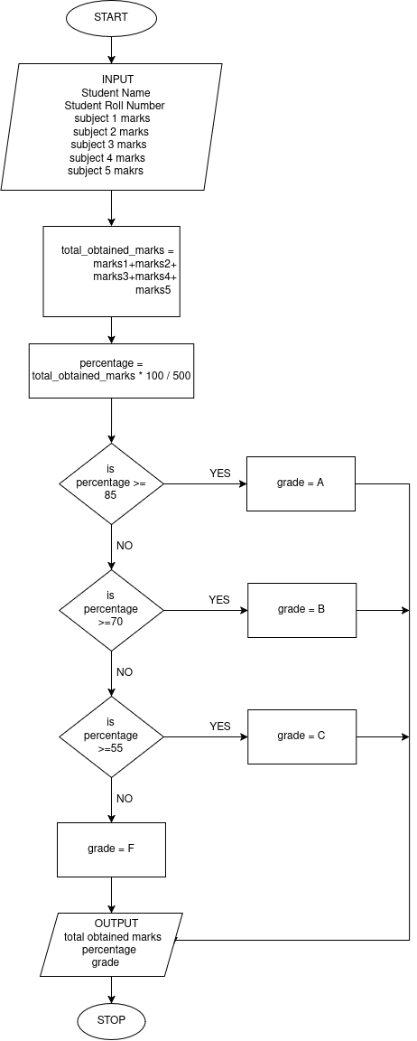
- set grade to F if percentage is less than 55
- display total_obtained_marks for the user
- display percentage for the user
- display grade for the user

FLOWCHART

TASK 2

PAC
GIVEN INPUTS  units | REQUIRED RESULTS  bill
PROCESSING REQUIRED  1. Determining Rate  IF units are less than or equal to 100  THEN rate = 15  ELSE rate = 20  2. Calculating Bill  bill = rate * units | SOLUTION ALTERNATIVES  Input Validation:  - The Original Solution can take any Integer value  - *We can Validate to exclude Negative Integers

ALGORITHM
- Ask the User to enter their consumed units
- set rate to 15 if units are less than or equal to 100
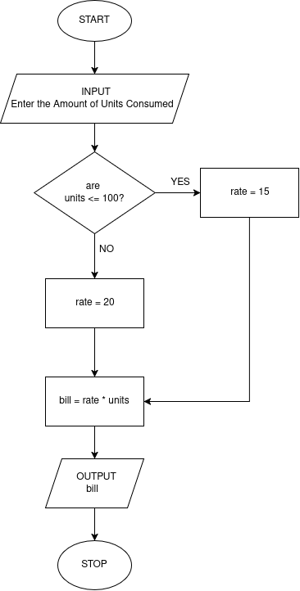
- set rate to 20 if units are greater than 100
- set bill = (rate * units)
- display bill for the user

FLOWCHART

TASK 3

IPO CHART
INPUT | PROCESSING | MODULE REFERENCE | OUTPUT
Name of Book  No. of Days Late | Enter the Book Name  Enter the No. of Days that  book is returned late  Calculate the Fine using  (fine = 25 * days)  Output fine  END | READ  READ  -  CALC  -  PRINT | fine

ALGORITHM
- Ask the user to enter the Name of their Book
- Ask the user to enter the number of days the book was returned late
- set (fine = 25 * days)
- display fine for the user
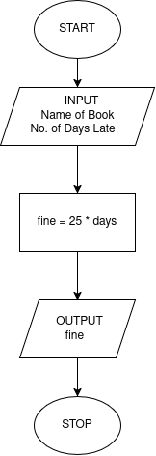
FLOWCHART

TASK 4

PAC CHART
GIVEN INPUTS  length  width | REQUIRED RESULTS  shape name  area
PROCESSING REQUIRED  1. Determining Shape  IF length is equal to width  THEN shape is square  ELSE shape = rectangle  2. Calculating Area  area = length * width | SOLUTION ALTERNATIVES  Determining Shape  - *Use the length = width logic  - Use the Property 2*(length + width) = 4*length AND 4*width  Input Validation:  - The Original Solution can take any Integer value  - *We can Validate to exclude Negative Integers

PSEUDOCODE

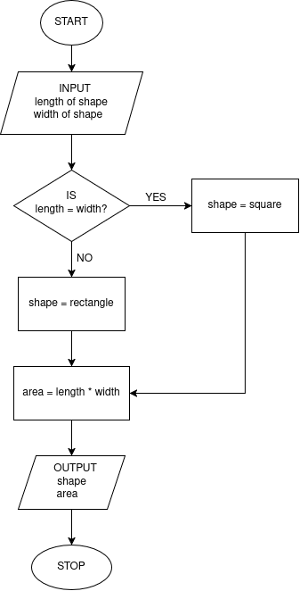
START
INPUT:
ASK the User “Enter the Length”
READ Input and store in length
ASK the user “Enter the Width”
READ Input and Store in width
PROCESSING:
IF length is equal to width
THEN shape is square
ELSE shape is rectangle
SET area to length * width
OUTPUT:
PRINT “shape is” shape
PRINT “area of the shape is” area
END

FLOWCHART

TASK 5

PAC CHART
GIVEN INPUTS  account holder’s name  current balance  deposit amount  withdraw amount | REQUIRED RESULTS  final balance
PROCESSING REQUIRED  1. Calculating Final Balance:  final balance =  current_balance + deposit_amount - withdraw_amount | SOLUTION ALTERNATIVES  Calculating Balance  - *use the complete formula  - find the net difference (deposit amount – withdraw amount) and then add that to current balance  Input Validation:  - The Original Solution can take any Integer value  - *We can Validate to exclude Negative Integers from deposit and withdrawal values

IPO CHART
INPUT | PROCESSING | MODULE REFERENCE | OUTPUT
Account holder’s name  current balance  deposit amount  withdrawal amount | Enter the Name of Account Holder  Enter the Current Balance  Enter the Deposit Amount  Enter the Withdrawal Amount  Calculate Final Balance  Output Final Balance  END | READ  -  READ  READ  READ  CALC  PRINT | Final Balance

ALGORITHM

- Ask the user to Enter the Name of Account Holder
- Ask the user to enter the Current Balance
- Ask the user to enter the Deposit Amount
- Ask the user to enter the Withdrawal Amount
- Set the final_balance = (current_balance + deposit_amount – withdraw_amount)
- Display the final_balance to the user

TASK 6

PAC CHART
GIVEN INPUTS  temperature in Celsius | REQUIRED RESULTS  temperature in Fahrenheit  temperature classification
PROCESSING REQUIRED  1. Converting Temperature:  tempF = (tempC * 9 / 5) + 32  2. Temperature CLassification  IF tempC is less than 15  temp_class is COLD  ELSEIF tempC is between or equal to 15 and 30  temp_class is MODERATE  ELSE tempC is greater than 30  temp_class is HOT | SOLUTION ALTERNATIVES  Calculating Temperature in Fahrenheit  - *use the given formula  - use alternate formula (tempC * 1.8) +32

PSEUDOCODE

START
INPUT
ASK the user “Enter the Temperature in Celsius”
READ the input and store in tempC
PROCESSING
SET Temperature in Fahrenheit to tempF = (tempC * 9 / 5) +32
IF Temperature in Celsius is less than 15
THEN SET temp_class to COLD
ELSE IF Temperature in Celsius is between or equal to 15 and 30
THEN SET temp_class to MODERATE
ELSE Temperature in Celsius is greater then 30
THEN SET temp_class to HOT
OUTPUT
PRINT “The Temperature in Fahrenheit is” tempF
PRINT “This Temperature is classified as” temp_class
STOP

FLOWCHART

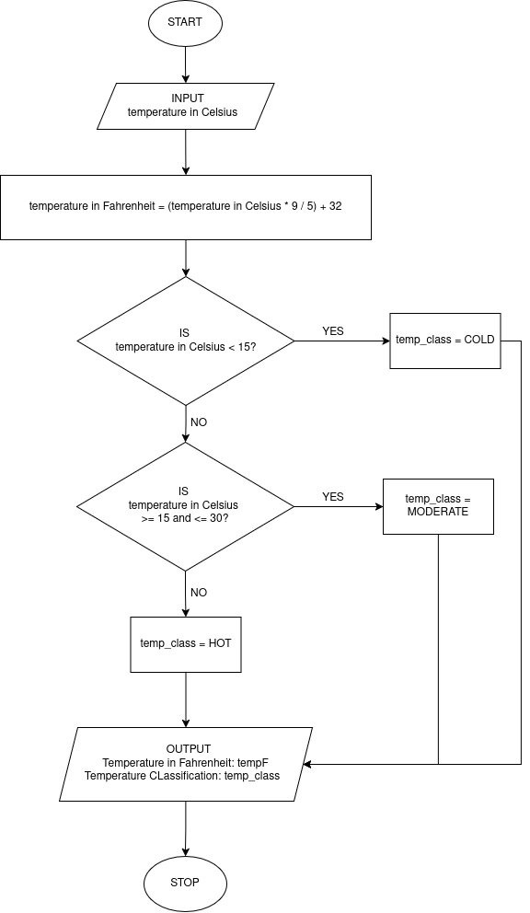

TASK 7

PAC CHART
GIVEN INPUTS  Price of Product 1  Price of Product 2  Price of Product 3  Price of Product 4 | REQUIRED RESULTS  Final AMount
PROCESSING REQUIRED  1. Total Price:  total = price1 + price2 + price3 + price4  2. Discount Applicable or not?  IF total is greater than 5000  THEN net cost = price – (0.1 * price)  ELSE net cost = price | SOLUTION ALTERNATIVES  - Fixed Discount for all costs above 5000  - Ability to Set a Custom Value for Discount based on changing conditions  Input Validation:  - The Original Solution can take any Integer value  - *We can Validate to exclude Negative Integers from prices

IPO CHART
INPUT | PROCESSING | MODULE REFERENCE | OUTPUT
Price of Product 1  Price of Product 2  Price of Product 3  Price of Product 4 | Enter the Price of product 1  Enter the Price of product 2  Enter the Price of product 3  Enter the Price of product 4  Calculate Total Price  IF total price is greater than 5000  net price = total price – (0.1 * total price)  ELSE net price = total price  output net price(Final Amount)  END | READ  READ  READ  READ  CALC  DECISION  CALC  CALC  PRINT | Final Amount

ALGORITHM

- Ask the user to enter the price of product 1: price1
- Ask the user to enter the price of product 2: price2
- Ask the user to enter the price of product 3: price3
- Ask the user to enter the price of product 4: price4
- Set total_price = price1 + price2 + price3 + price4
- IF total price is greater than 5000,
- THEN set net_price = total_price – (0.1 * total_price)
- ELSE set net_price = total_price
- Output Final Amount for the user: net_price

TASK 8

PAC CHART
GIVEN INPUTS  Applicant Name  Applicant Age | REQUIRED RESULTS  Eligibility to Drive
PROCESSING REQUIRED  1. Eligible or Not?  IF age is greater than or equal to 18  THEN eligibility = TRUE  ELSE eligibility = FALSE | SOLUTION ALTERNATIVES  1. Use Constant Standard Age at 18  2. Option to choose between 18 and 21

PSEUDOCODE

START
INPUT
ASK the user “Enter the Name of Applicant”
READ the input and store in name
ASK the user “Enter the age of Applicant”
READ the input and store in age
PROCESSING
IF age >= 18
THEN eligibility = TRUE
ELSE eligibility = FALSE
OUTPUT
PRINT “The Applicant” name “’s eligibilty for Driving is” eligibility
STOP
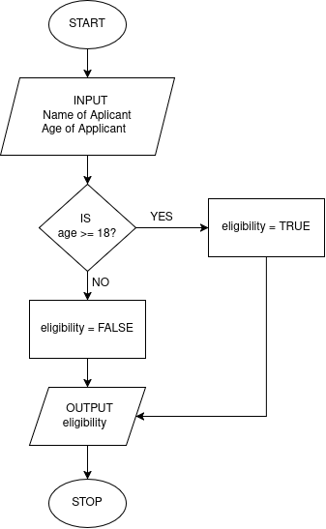
FLOWCHART

TASK 9

ALGORITHM

- START
- Ask the user to enter number 1; num1
- Ask the user to enter number 2; num2
- Ask the User to Enter 1 option from “+”, “-”, “*” and “/”; operation
- IF operation is “+”
- THEN result = num1 + num2
- PRINT for the user “The result of num1 + num2 is”; result
- ELSE IF operation is “-”
- THEN result = num1 – num2
- PRINT for the user “The result of num1 - num2 is”; result
- ELSE IF operation is “*”
- THEN result = num1 * num2
- PRINT for the user “The result of num1 * num2 is”; result
- ELSE IF operation is “/”
- THEN result = num1 / num2
- PRINT for the user “The result of num1 / num2 is”; result
- ELSE PRINT for the user “please enter a valid operator”
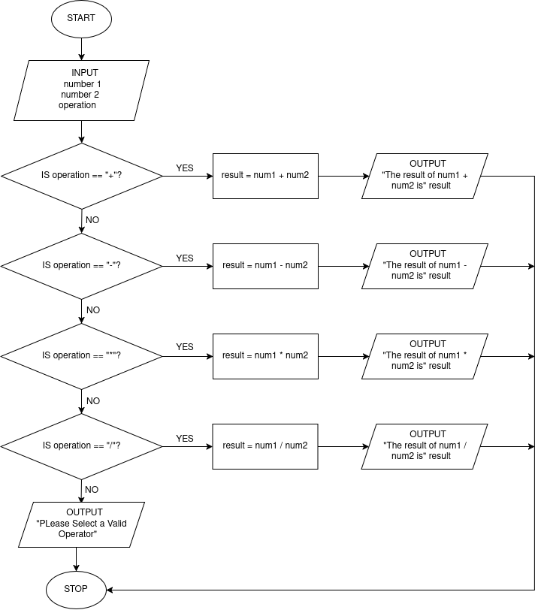
- END
FLOWCHART

SCRATCH
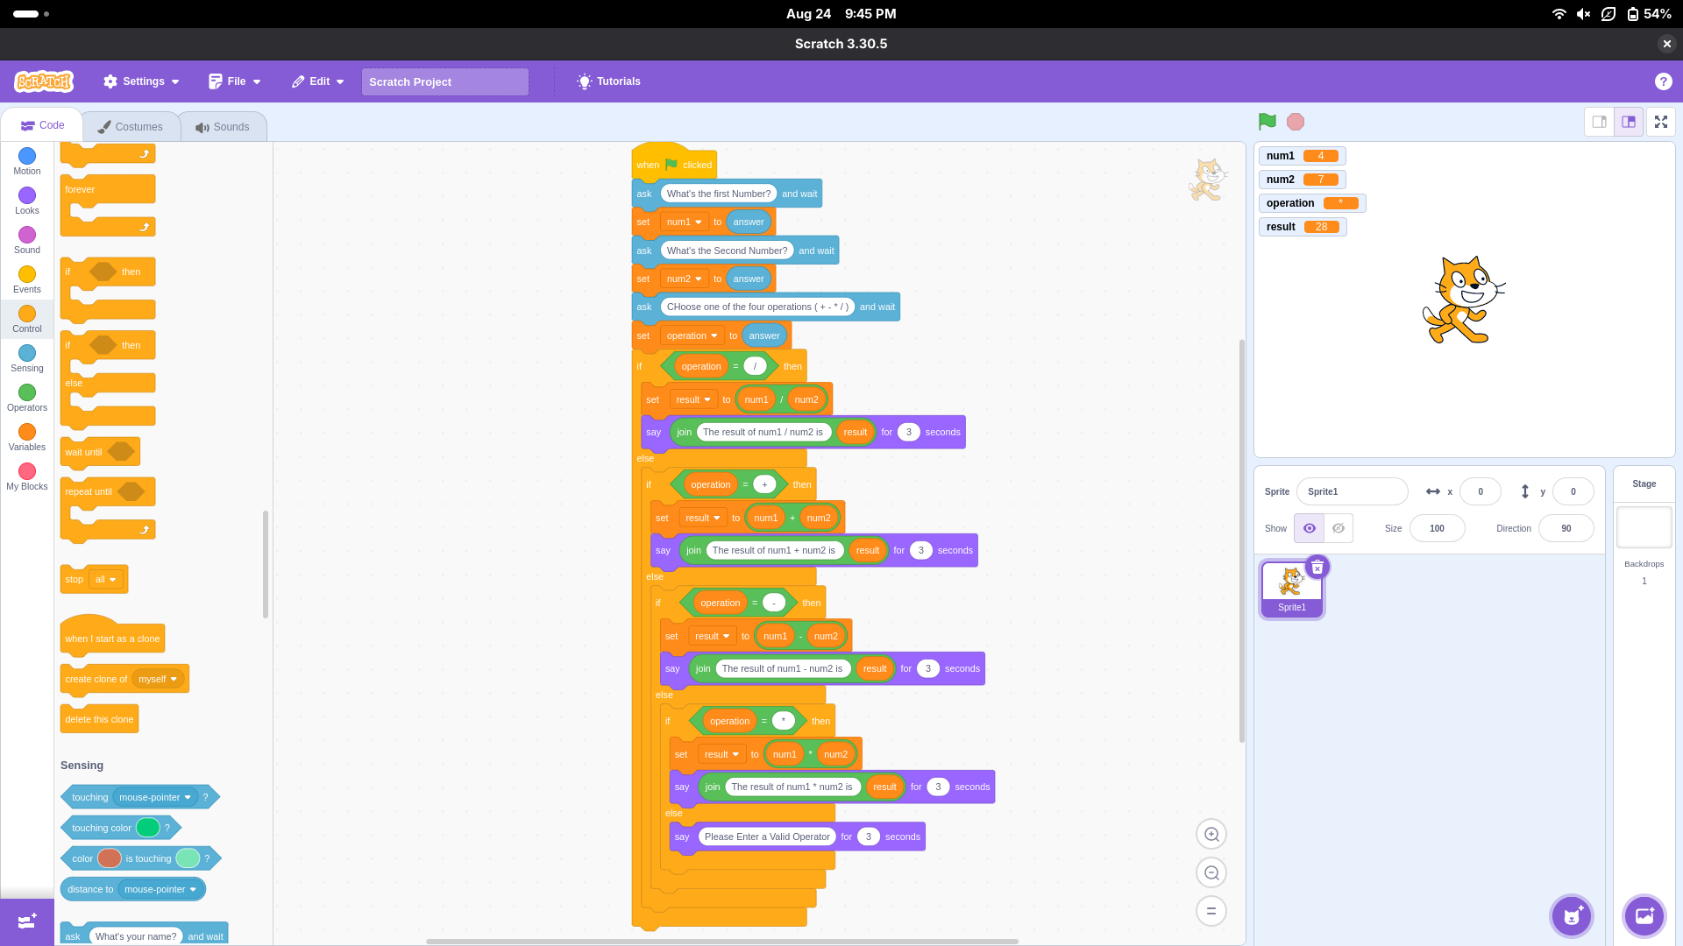

TASK 10

PAC CHART
GIVEN INPUTS  Student Name  Room Rent  Mess Charges  Laundry Charges | REQUIRED RESULTS  Final Fee
PROCESSING REQUIRED  1. Total Fee  total fee = room rent + mess charges + laundry charges  2. Final Fee  IF total fee is greater than 30000  THEN final fee = total fee – (0.05 * total fee)  ELSE final fee = total fee | SOLUTION ALTERNATIVES  Variable Discount  - Fixed Discount for all costs above 30000  - Ability to Set a Custom Value for Discount  Input Validation:  - The Original Solution can take any Integer value  - *We can Validate to exclude Negative Integers from the fees

IPO CHART
INPUT | PROCESSING | MODULE REFERENCE | OUTPUT
Student Name  Room Rent  Mess Charges  Laundry Charges | Enter the Name of Applicant  Enter the Room Rent  Enter the Mess Charges  Enter the Laundry Charges  Calculate Total Fee  IF total Fee is greater than 30000  final fee = total fee – (0.05 * total fee)  ELSE final fee = total fee  output final fee  END | READ  READ  READ  READ  CALC  DECISION  CALC  CALC  PRINT | Final Fee

ALGORITHM
- START
- Ask the User to Enter the Name of Applicant
- Ask the User to Enter the Room Rent
- Ask the User to Enter the Mess Charges
- Ask the User to Enter the Laundry Charges
- Set total fee = room rent + mess charges + laundry charges
- IF total fee is greater than 30000
- THEN final fee = total fee – (0.05 * total fee)
- ELSE final fee = total fee
- Output the final fee for the user

FLOWCHART
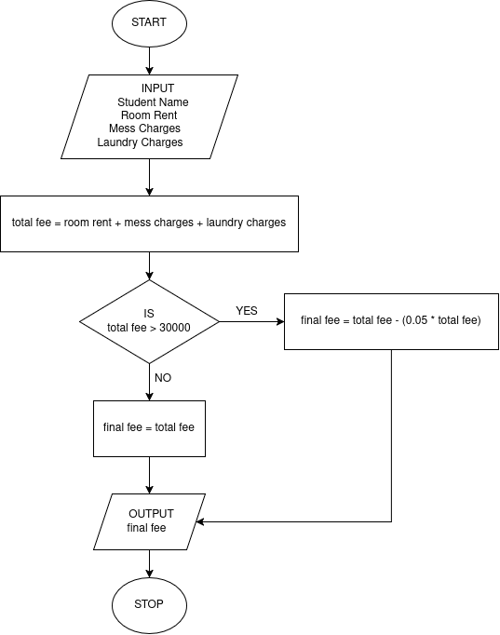

SCRATCH
