VISTA: Verification using Intelligent Systems for Test Automation

Final Year Project Report (Draft 2 — professional body)
This document follows the structure expected by the GIKI senior design report guidelines. Export to Microsoft Word for final typography (Times New Roman, 12 pt, 1.5 line spacing, institute margins). Source code listings are intentionally omitted; implementation remains available in the project repository for examination.

Title Page (content checklist)
Field | Entry
Title | VISTA: Verification using Intelligent Systems for Test Automation
Authors | Asad Ali; Sheikh Abbas; Mian Arqam (add registration numbers)
Advisor | Dr. Fahad Bin Muslim
Co-advisor | Dr. Waqar (if applicable)
Industrial mentors | Dr. Haroon; Dr. Majeed (NECOP)
Affiliation | Ghulam Ishaq Khan Institute of Engineering Sciences and Technology
Insert the official university logo and faculty name per the approved title page.

Certificate of Approval
It is certified that the work presented in this report was performed by Asad Ali, Sheikh Abbas, and Mian Arqam under the supervision of Dr. Fahad Bin Muslim, and is adequate for the degree of Bachelor of Science in Computer Engineering. Industrial perspective was provided through NECOP with mentorship from Dr. Haroon and Dr. Majeed. Signature blocks for advisor, co-advisor (if any), and the Dean should appear on the bound copy as prescribed by the faculty.

SDGs Inclusion
SDG 4 (Quality education). VISTA supports teaching and research on formal hardware verification by providing a reproducible pipeline from register-transfer level descriptions to assertions checked with open tools.
SDG 9 (Industry, innovation and infrastructure). Dependable digital systems require rigorous verification; lowering the cost of assertion authoring contributes to safer infrastructure.
SDG 12 (Responsible consumption and production). Parameter-efficient fine-tuning (QLoRA) reduces GPU memory and energy use relative to full model fine-tuning for comparable task quality.

Abstract
Hardware verification remains a major fraction of system-on-chip development effort. SystemVerilog assertions express temporal design intent for simulation and formal analysis, yet manual assertion writing is slow and requires specialized expertise. VISTA is an integrated framework that proposes assertions directly from RTL fragments by combining a QLoRA-adapted LLaMA 3.1 (8B) model with deterministic post-processing and a dynamic wrapping stage that produces tool-ready SystemVerilog modules. Training and evaluation use the VERT corpus (twenty thousand labeled pairs in this repository). On a fixed evaluation set of one hundred consecutive samples, all generated wrappers parsed successfully in the open-source front end, ninety-nine bounded model-checking runs completed with a pass verdict under SymbiYosys, and mean gold Jaccard similarity to reference assertions was 0.991. The single formal failure coincides with perfect lexical agreement but exposes a limitation of four-valued don’t-care bits in a case selector—a reminder that formal outcomes depend on encoding and assumptions, not token match alone. A web-based demonstration couples a Next.js interface to a Python service for interactive use. Future work includes counterexample-guided refinement and stronger treatment of unknown logic values.
Keywords: formal verification, SystemVerilog assertions, large language models, QLoRA, VERT, SymbiYosys, RTL wrapping.

Acknowledgements
The authors thank Dr. Fahad Bin Muslim and Dr. Waqar for academic supervision; NECOP and mentors Dr. Haroon and Dr. Majeed for industrial guidance; and the maintainers of open-source verification and machine-learning software used in this work.

Table of Contents
Chapter I — Introduction · Chapter II — Literature survey · Chapter III — Requirements and specifications · Chapter IV — Methodology and implementation · Chapter V — Results and discussion · Chapter VI — Conclusion and future work · Glossary · References · Appendices. (Replace this list with Word’s auto-generated table of contents and page numbers.)

List of Figures
Fig. | Description
1.1 | End-to-end system context
2.1 | Landscape of assertion-generation approaches
4.1 | VISTA processing pipeline
5.1 | Formal and syntax outcomes (n = 100)
5.2 | Distribution of gold Jaccard similarity
6.1 | Roadmap for future research

List of Tables
Table | Description
3.1 | Functional requirements
4.1 | Training hyperparameters (defaults used in this project)
5.1 | Aggregate evaluation metrics
5.2 | Gold Jaccard buckets
A.1 | Outlier cases (formal failure or Jaccard below 0.95)

Chapter I — Introduction

1.1 Motivation
Modern integrated circuits are verified through simulation, emulation, and increasingly through formal methods that search for counterexamples or construct proofs over finite or inductive horizons. SystemVerilog assertions (SVA) are a standard mechanism for capturing safety and bounded-liveness properties at the register-transfer level. In practice, the bottleneck is often not the availability of engines but the volume and quality of properties: engineers must translate intricate RTL behavior into concise, checkable assertions without introducing vacuity or contradictory constraints.

1.2 Problem statement
This project addresses RTL-fragment-to-assertion generation under the distribution induced by the VERT dataset: inputs are typically conditional snippets rather than complete modules, and formal tools expect elaboratable modules with explicit clocks and declared signals. A usable solution must therefore combine learned generation with tool-aware normalization and harness construction.

1.3 Contributions
The main contributions are: (1) an end-to-end pipeline from VERT-style fields to SymbiYosys-ready SystemVerilog; (2) a dynamic wrapper that infers interface signals and aligns assertion evaluation with clocking semantics; (3) post-processing that extracts clean property structure, adapts expressions for the open-source formal front end, and applies a greedy syntax filter; (4) a reproducible evaluation harness and frozen metrics on one hundred samples; (5) a demonstration web application for stakeholders.

1.4 Report organization
Chapter II surveys related work. Chapter III states requirements. Chapter IV presents methodology and system design. Chapter V reports experimental results. Chapter VI concludes and outlines future work.

Figure 1.1 — System context
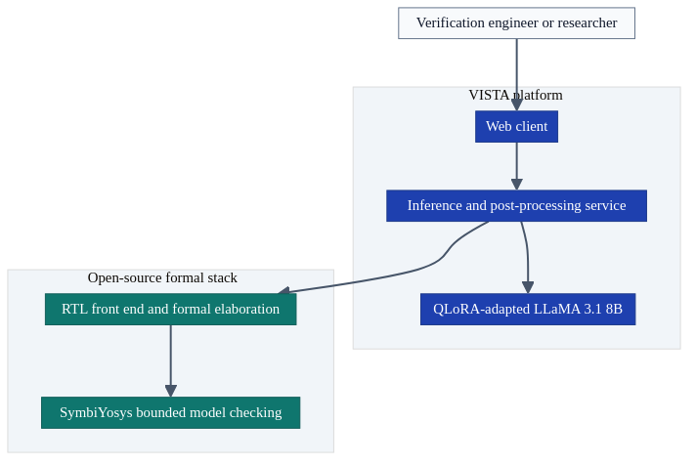
Figure 1 — diagram

Chapter II — Literature survey

2.1 Formal verification and assertions
Industrial practice combines property checking with simulation. Academic and open-source flows frequently target subsets of SystemVerilog that are well supported by elaboration tools; this influences how generated assertions must be shaped before any proof attempt.

2.2 Classical assertion mining
Historically, mining approaches inferred candidate properties from simulation traces or static structure. These methods can scale but may propose weak or redundant properties and can struggle with deep temporal relationships unless guided by strong coverage.

2.3 Language models for verification
Recent research explores large language models for translating natural language or auxiliary artifacts into assertions. Such pipelines depend on specification quality. VISTA deliberately operates in an RTL-only setting to study how much intent can be recovered from implementation text and VERT-style metadata (synchronous flag and clock).

2.4 Benchmarks
AssertionBench provides a controlled setting for comparing models on assertion generation. VERT offers large-scale RTL–assertion pairs at finer granularity, which motivates the wrapping and normalization stages central to this thesis.

2.5 Parameter-efficient adaptation
QLoRA enables fine-tuning large models under constrained GPU memory by training adapters on a quantized base representation, which is attractive for student and laboratory settings.

Figure 2.1 — Landscape of approaches
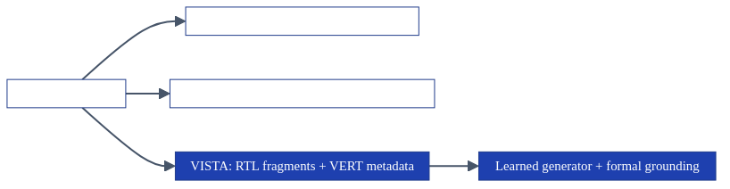
Figure 2 — diagram

Chapter III — Requirements and specifications

3.1 Scope
The system targets VERT-compatible JSON records, local or laboratory GPU inference, and evaluation with Yosys and SymbiYosys. Full-chip hierarchical verification and proprietary foundry timing sign-off are out of scope.

3.2 Functional requirements
ID | Requirement
FR-1 | Accept RTL text with synchronization and clock metadata.
FR-2 | Generate assertions aligned with the training instruction format.
FR-3 | Produce a single elaboratable wrapper module suitable for formal analysis.
FR-4 | Record syntax success, formal status, and similarity to reference assertions.
FR-5 | Provide a demonstration interface for interactive runs.

3.3 Non-functional requirements
Reproducibility (fixed decoding and logged configuration), local deployment to protect intellectual property, and maintainability through a single evaluation entry point are required. Latency should remain acceptable for interactive demonstration on a workstation-class GPU.

Chapter IV — Methodology and implementation

4.1 Dataset
The VERT-derived corpus in this repository contains twenty thousand labeled pairs. Supervised fine-tuning consumes the bulk of the set; the quantitative results in Chapter V use a deterministic slice of one hundred consecutive records to balance runtime with a stable snapshot.

4.2 Model training
The student implementation uses Unsloth-accelerated training with QLoRA adapters on a LLaMA 3.1 8B base. Representative defaults are: LoRA rank and scaling 256, learning rate 10⁻⁴, three epochs, micro-batch two with gradient accumulation thirty-two (effective batch sixty-four), and maximum sequence length 4096 tokens. An internal prose draft may cite different figures; the frozen training script defaults in the repository govern what was actually executed for this submission.

4.3 Inference and normalization
At inference time, the model receives a structured prompt containing the RTL fragment and metadata. The service extracts assertion regions, normalizes syntax for the target elaborator, lowers selected temporal forms where required, and applies a greedy filter that preserves as many clauses as possible while retaining a parseable wrapper. A dedicated component infers signal names from the RTL and generated text, filters language keywords, and constructs synchronous or combinational harness logic with first-cycle handling appropriate to bounded checks.

4.4 Demonstration application
A browser-based client provides editing and inspection of inputs and outputs; a Python service hosts the model and shared transformation logic so that demonstration behavior matches the evaluation harness where possible.

Figure 4.1 — Processing pipeline
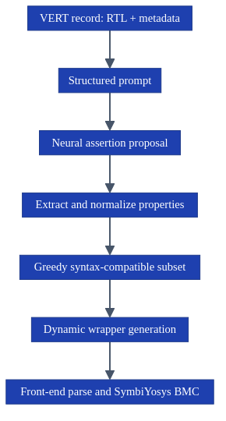
Figure 3 — diagram

Chapter V — Results and discussion

5.1 Experimental configuration
Results reported here correspond to run model_eval_v7_100: one hundred samples, greedy decoding, greedy assertion filtering enabled, and wrapper options that initialize state and omit an explicit reset driver where noted in the run manifest.

5.2 Aggregate outcomes
Metric | Value
Samples | 100
Yosys syntax success | 100 / 100
SymbiYosys pass | 99 / 100
SymbiYosys fail | 1
Mean gold Jaccard | 0.9914
Assertion clauses attempted (sum) | 472
Clauses after conversion (sum) | 472
Clauses dropped by greedy filter (sum) | 14

5.3 Distribution of gold Jaccard
Bucket | Count
0.900 – 0.949 | 9
0.950 – 0.998 | 1
≥ 0.999 | 89
< 0.900 | 1

5.4 Interpretation
The combination of perfect syntax rate and ninety-nine formal passes indicates that the learned model, training recipe, and normalization stack are well aligned with VERT’s distribution under the chosen proof bounds. Mean Jaccard near 0.99 indicates strong lexical overlap with reference assertions, which is appropriate for a dataset-supervised generator but must not be mistaken for unconditional semantic equivalence.

5.5 Case discussion: formal failure with identical gold similarity
Sample index 82 received a fail verdict from SymbiYosys while maintaining gold Jaccard 1.0. The RTL contains a case item keyed by a bit vector with don’t-care positions. Even when generated and reference assertions match as strings, bounded model checking may still fail depending on how unknown bits are encoded and which assumptions govern the harness. This case should be reported honestly as a formal encoding and data-semantics lesson rather than as a neural decoding defect.

Figure 5.1 — Syntax and formal outcomes
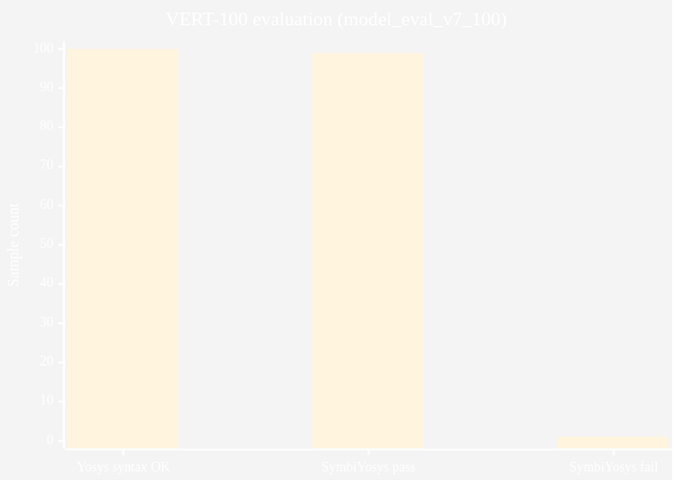
Figure 4 — diagram

Figure 5.2 — Gold Jaccard buckets
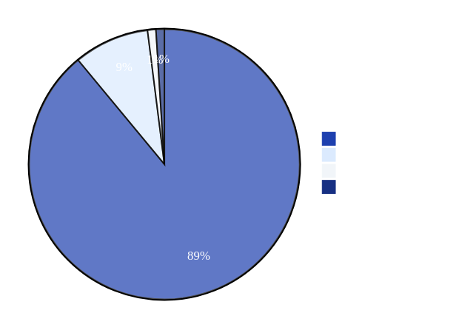
Figure 5 — diagram

Chapter VI — Conclusion and future work

6.1 Conclusion
VISTA demonstrates that a domain-adapted large language model, together with rigorous deterministic post-processing and a formal-tool-aware harness, can produce high-quality SystemVerilog assertions for VERT-style RTL fragments. Quantitative results on a fixed hundred-sample evaluation are strong, and the one formal failure highlights the continued need for careful treatment of unknowns and assumptions.

6.2 Future work
Planned extensions include counterexample-guided revision of assertions, stronger preprocessing of four-valued constructs, integration with commercial formal platforms, and scaling toward hierarchical modules and interface contracts.

Figure 6.1 — Research roadmap
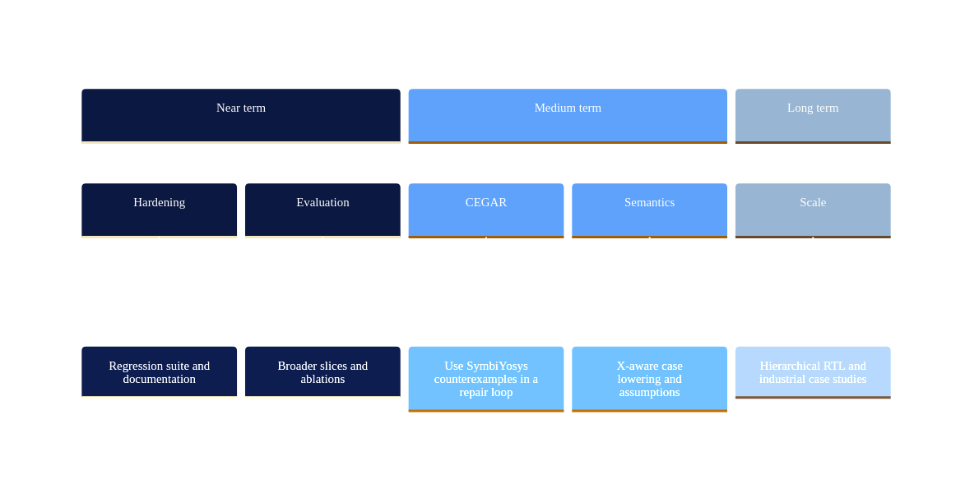
Figure 6 — diagram

Glossary
Term | Meaning
BMC | Bounded model checking over a finite horizon
Gold Jaccard | Token-set similarity between generated and reference assertions
QLoRA | Quantized low-rank adaptation for efficient fine-tuning
SVA | IEEE 1800 SystemVerilog assertions
VERT | Dataset of RTL–assertion pairs used for training and evaluation

References (IEEE style — complete in your reference manager)
[1] IEEE Standard for SystemVerilog—Unified Hardware Design, Specification, and Verification Language, IEEE Std 1800-2023.
[2] SymbiYosys (SBY) documentation. Available: https://symbiyosys.readthedocs.io
[3] YosysHQ, Yosys Open Synthesis Suite. Available: https://yosyshq.net/yosys/
[4] T. Dettmers et al., “QLoRA: Efficient Finetuning of Quantized LLMs,” arXiv:2305.14314, 2023.
[5] E. Halpern et al., “AssertionBench: A Benchmark to Evaluate Large Language Models for Assertion Generation in Verilog,” arXiv:2406.18627, 2024.
[6] Unsloth documentation. Available: https://github.com/unslothai/unsloth
[7] Cite the VERT dataset source and license you used, following the upstream project.

Appendix A — Reproducibility and artifacts
All quantitative claims in Chapter V are tied to a frozen evaluation directory under the project’s formal verification runs. The machine-readable summary lists configuration flags, adapter checkpoint path, per-sample statuses, and Jaccard scores. For examination, evaluators should consult that manifest alongside the bound thesis. No program listings are included in this document; source is retained only in the repository.

Appendix B — Ethics, risk, and responsible use
Generated assertions must be reviewed before use on safety-critical or high-value designs. Teams should document formal assumptions explicitly. Training and deployment must respect licenses for base models, datasets, and third-party IP.

Appendix C — Outlier summary (formal failure or gold Jaccard < 0.95)
Table A.1 consolidates cases that warrant discussion in defense or viva. The majority of samples lie outside this table because they both passed formal checking under the reported bounds and exhibited Jaccard ≥ 0.95.
Sample index | SymbiYosys | Gold Jaccard | Notes
82 | fail | 1.0000 | Formal fail; case with don’t-care selector (see §5.5)
52 | pass | 0.9487 | Below 0.95 Jaccard; review clause overlap
9 | pass | 0.9375 | Below 0.95 Jaccard; review clause overlap
41 | pass | 0.9355 | Below 0.95 Jaccard; review clause overlap
46 | pass | 0.9355 | Below 0.95 Jaccard; review clause overlap
86 | pass | 0.9333 | Below 0.95 Jaccard; review clause overlap
24 | pass | 0.9310 | Below 0.95 Jaccard; review clause overlap
67 | pass | 0.9310 | Below 0.95 Jaccard; review clause overlap
96 | pass | 0.9310 | Below 0.95 Jaccard; review clause overlap
23 | pass | 0.9286 | Below 0.95 Jaccard; review clause overlap
40 | pass | 0.7576 | Below 0.95 Jaccard; review clause overlap

