Software Requirements Specification (SRS)
QC Reporting Dashboard
Version 1.0 | Based on supplied QC issue catalogue and sample quality report

1. Purpose and Scope
The QC Reporting Dashboard is a web-based system for Quality Control engineers to record site observations, attach one or more photographs, reuse predefined QC issue descriptions, organize observations by project/package/location, submit grouped inspection reports for senior review, and generate a standardized quality report.
The supplied report demonstrates a document organized by observation number and location/floor headings, with each observation containing a title, descriptive rectification text and one or more annotated photographs. It also distinguishes critical and general observations. The supplied issue catalogue provides reusable issue titles together with auto-fill description, root-cause and severity/risk text. These source patterns drive the revised data model.

2. Objectives
- Replace manual compilation of QC reports with structured issue capture and automated document generation.
- Standardize issue wording while allowing engineers to edit the copied text for site-specific conditions.
- Support hierarchical locations including buildings, floors, rooms, roads, utilities and external works.
- Support multiple images per issue and preserve their display order and optional annotated version.
- Provide controlled senior engineer/manager review and a complete audit trail.
- Keep historical reports stable even when generic issue templates are later edited.

3. User Roles
Role | Primary capabilities | Typical scope
QC Engineer / Junior Engineer | Create issues, attach photos, use generic issue templates, build draft reports, submit reports. | Assigned projects/packages
Senior QC Engineer | Review submitted reports, comment, approve/reject, inspect issue history. | Assigned projects
QC Manager | Review/approve reports, view dashboards, reopen where authorized. | Multiple/all assigned projects
Project Manager / Viewer | Read approved reports and dashboards; no QC approval unless explicitly granted. | Assigned projects
Administrator | Manage users, roles, projects, master issue catalogue and report templates. | System-wide

4. Functional Requirements
FR-01 Authentication and authorization: The system shall authenticate users and enforce project-scoped roles.
FR-02 Project hierarchy: The system shall manage projects and optional packages.
FR-03 Site locations: The system shall support recursive locations so a project can contain buildings, floors, rooms, roads, utilities, drainage, boundaries, landscaping and other external works.
FR-04 Generic issue catalogue: Authorized users shall manage predefined QC issues with issue code, category, title, default description, default root cause, default risk text and optional default severity.
FR-05 Issue creation: An engineer shall create an issue against a site location, select an optional generic issue, and edit the copied title/description/root cause/risk/severity.
FR-06 Image attachments: An issue shall support multiple images. Each image shall have storage metadata, caption and display order; an annotated derivative may be stored for red-box/markup presentation.
FR-07 Report creation: An engineer shall create a report for a project and optional package, specify document number/title/site visit date, and select a report template.
FR-08 Report sections: A report shall support ordered sections such as CRITICAL OBSERVATIONS and GENERAL OBSERVATIONS, optionally tied to a site location/floor heading.
FR-09 Observation numbering: Issues added to a report shall receive a report-specific observation number and display order.
FR-10 Review workflow: Reports shall move through DRAFT, SUBMITTED, UNDER_REVIEW, APPROVED or REJECTED states. Authorized senior users shall approve/reject with comments.
FR-11 Audit trail: Issue status changes and report workflow actions shall be recorded with actor, timestamp and comments.
FR-12 Document generation: The system shall generate the standardized report in section/observation/image order using the selected template version.
FR-13 Dashboard: The system shall provide project/package metrics for open, in-progress, resolved, critical and report-status counts.
FR-14 Search/filter: Users shall filter issues/reports by project, package, location, issue category, severity, status, reporter and date.
FR-15 Historical integrity: Approved reports shall preserve the exact issue text and template version used at approval time.

5. Report Output Requirements
Generated reports shall preserve the structure seen in the supplied sample: organization/header branding, document/report identifier, project/site title, site visit date, section headings, location/floor headings, sequential OBSERVATION numbering, observation title, descriptive text and one or more photographs. The generator shall use annotated image versions when present and otherwise use originals.
The report engine shall not derive old report wording live from generic_issues. When a generic issue is selected, its defaults are copied into the issue record so later catalogue changes do not rewrite historical observations.

6. Revised Relational Data Model
The schema remains 3NF-oriented. Redundant project/package identifiers are avoided on issues because their scope is derived through site_locations. Reports retain project_id and optional package_id because a report can span several site locations. New entities were added for issue categories, report sections and report templates, and new snapshot fields were added to issues.
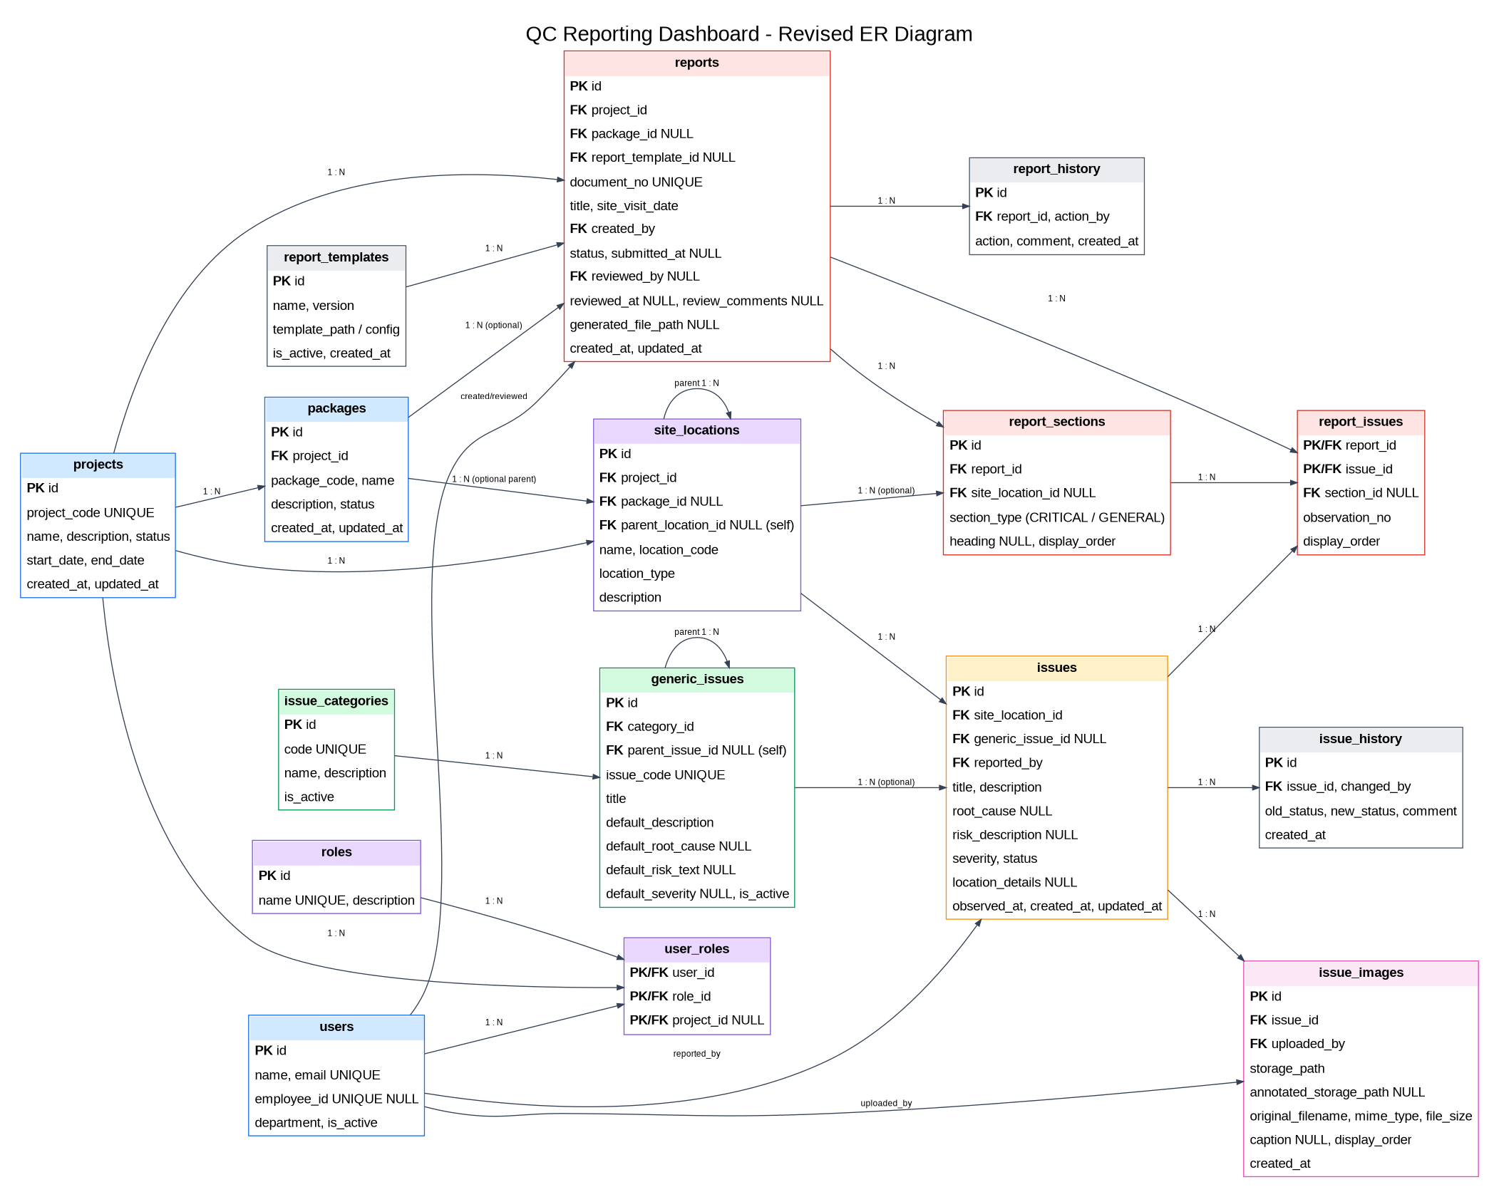

7. Data Dictionary - Key Tables
Table | Key fields
projects | id PK; project_code UNIQUE; name; description; status; start_date; end_date; timestamps
packages | id PK; project_id FK; package_code; name; description; status; timestamps
site_locations | id PK; project_id FK; package_id FK NULL; parent_location_id self-FK NULL; name; location_code; location_type; description
issue_categories | id PK; code UNIQUE; name; description; is_active
generic_issues | id PK; category_id FK; parent_issue_id self-FK NULL; issue_code UNIQUE; title; default_description; default_root_cause; default_risk_text; default_severity; is_active
issues | id PK; site_location_id FK; generic_issue_id FK NULL; reported_by FK; title; description; root_cause; risk_description; severity; status; location_details; observed_at; timestamps
issue_images | id PK; issue_id FK; uploaded_by FK; storage_path; annotated_storage_path NULL; original_filename; mime_type; file_size; caption; display_order; created_at
reports | id PK; project_id FK; package_id FK NULL; report_template_id FK NULL; document_no UNIQUE; title; site_visit_date; created_by FK; status; submitted_at; reviewed_by; reviewed_at; review_comments; generated_file_path; timestamps
report_sections | id PK; report_id FK; site_location_id FK NULL; section_type; heading; display_order
report_issues | report_id + issue_id PK/FK; section_id FK NULL; observation_no; display_order
report_templates | id PK; name; version; template_path/config; is_active; created_at
issue_history | id PK; issue_id FK; changed_by FK; old_status; new_status; comment; created_at
report_history | id PK; report_id FK; action_by FK; action; comment; created_at
users / roles / user_roles | User identity and project-scoped role assignment.

8. Database Logic
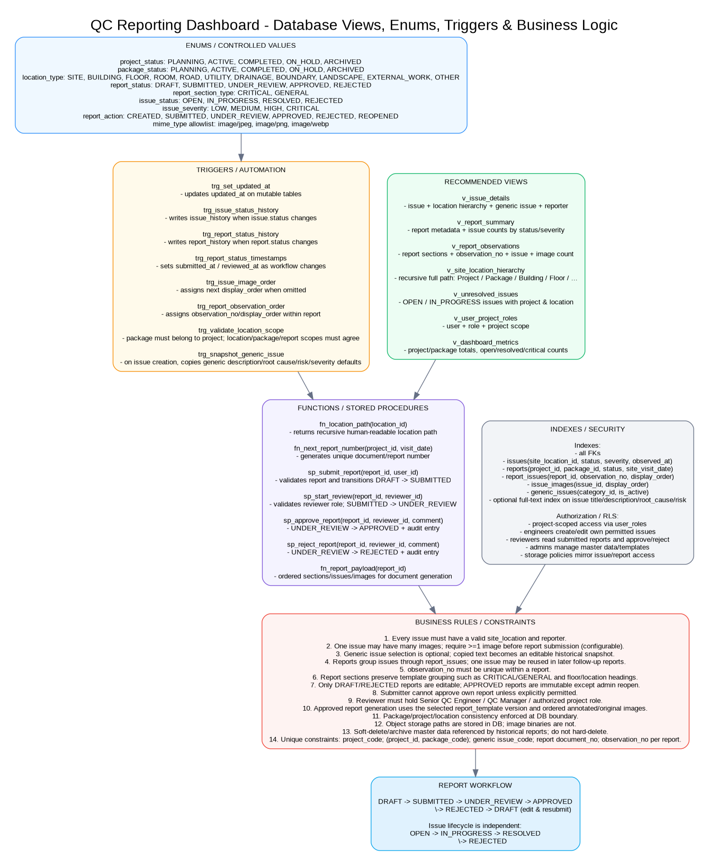

9. Validation and Business Rules
- An issue must reference a valid site location and reporting user.
- A report may contain issues from multiple locations but all must belong to the report's project and, where package_id is set, that package.
- At least one image should be required before report submission; this may be configurable if text-only observations are permitted.
- Observation numbers must be unique within a report and are independent of the global issue ID.
- Only DRAFT and REJECTED reports are editable. APPROVED reports are read-only unless explicitly reopened by an authorized user.
- A report creator shall not approve their own report unless an organization policy explicitly permits it.
- Only users holding an authorized review role for the project may start review, approve or reject.
- Generic issue text is copied into issues at creation; subsequent edits to the catalogue do not modify existing issues.
- Referenced projects, packages, locations, categories and generic issues should be archived/disabled rather than hard-deleted.
- Image binaries shall live in object storage; the database stores stable object keys/paths and metadata.

10. Recommended Views, Triggers and Procedures
Views: v_issue_details, v_report_summary, v_report_observations, v_site_location_hierarchy, v_unresolved_issues, v_user_project_roles and v_dashboard_metrics.
Triggers: updated_at maintenance, issue/report history creation, report workflow timestamps, image/observation ordering, location-scope validation and generic-issue snapshot copying.
Stored functions/procedures: recursive location path, next report number, submit report, start review, approve report, reject report and ordered report payload generation.

11. Non-Functional Requirements
Security: Use least-privilege authorization, project-scoped row-level security where supported, secure object-storage policies, and no public write access.
Performance: Dashboard/filter queries should normally return within 2 seconds for typical project datasets; report generation should be asynchronous if image-heavy.
Reliability: Database constraints and transactions shall prevent partial report submission/approval.
Auditability: All review transitions and issue status changes shall be attributable to a user and timestamp.
Scalability: Images remain outside the relational DB; indexed FKs and common filter columns support growth.
Usability: Mobile-friendly issue capture is required because engineers will upload site photographs.
Maintainability: Report templates and generic issue catalogue shall be versioned/managed independently from application code where practical.
Backup: Database and object storage shall be backed up according to organizational retention requirements.

12. Suggested API Surface
Endpoint | Purpose
POST /issues | Create issue; optionally snapshot a generic issue.
POST /issues/{id}/images | Upload/register one or more issue images.
PATCH /issues/{id} | Edit issue while permitted.
GET /issues | Filter/search issue register.
POST /reports | Create draft report.
POST /reports/{id}/issues | Add/reorder observations and sections.
POST /reports/{id}/submit | Validate and submit.
POST /reports/{id}/review | Start review.
POST /reports/{id}/approve | Approve with optional comment.
POST /reports/{id}/reject | Reject with required comment.
POST /reports/{id}/generate | Generate standardized report file.
GET /dashboard | Return project/package QC metrics.
GET /generic-issues | Search predefined issue catalogue.

13. Acceptance Criteria
- Engineer can create an issue at any site location and attach multiple photos.
- Selecting a predefined issue auto-fills description, root cause, risk text and optional severity, all editable before submission.
- Engineer can group issues into ordered Critical/General sections and location/floor headings.
- Generated report numbers observations sequentially and places all associated photos under the correct observation.
- Senior reviewer can approve or reject and the action appears in report history.
- Approved report is immutable and can be regenerated with the same issue content/template version.
- Dashboard accurately reports open/resolved/critical issue counts and report workflow counts.

14. Schema Changes Made After Reviewing the Supplied Files
- Added issue_categories instead of relying only on a fixed category enum, because the generic issue workbook is organized into coded issue families.
- Expanded generic_issues with issue_code, parent_issue_id, default_root_cause and default_risk_text to match the workbook's Main issue + subtype structure and Auto Fill columns.
- Added root_cause and risk_description snapshots to issues so selected generic content can be edited and preserved historically.
- Added report_sections to model Critical/General observation blocks and floor/location headings visible in the sample report.
- Added observation_no to report_issues because observation numbering is report-specific.
- Added report_templates and report_template_id so standardized document formatting can be versioned.
- Added annotated_storage_path to issue_images to support the red-box/markup style used throughout the sample report.
- Expanded location_type to include FLOOR/ROOM/SITE while retaining roads, utilities and external works.

15. Source Material Reviewed
1. QC Issues with description.xlsx - predefined QC issue catalogue with auto-fill description, root cause and severity/risk content.
2. Quality Report of Net Zero Energy Building Lhr (28-09-2026).pdf - sample standardized QC report used to infer report layout, observation grouping, numbering and photo presentation.

