Software Requirements Specification (SRS)
QC Reporting Dashboard
Version 2.0 - Revised after senior review of business logic

1. Revision Summary
- User authorization model changed from multi-role to exactly one QC department role per user.
- QC role hierarchy is now: General Manager (GM) > Manager (Mgr) > Assistant Manager (AM) > Assistant Engineer (AE) > Individual Consultant (IC).
- Only the General Manager can approve a report. This must be enforced at the database/service boundary, not only in the UI.
- Project assignment is separated from role through user_projects so a single-role user can still access multiple projects.
- Report sections are now nested and can contain narrative content, allowing Critical/General observations, floor/location subsections, Project Progress & Submittal Status, Risk Assessment and Recommendations.
- Self-approval prohibition from the previous draft has been removed because the revised approved logic only states that approval is GM-only; any additional self-approval rule requires explicit client confirmation.

2. Purpose and Scope
The QC Reporting Dashboard is a web-based system for the Quality Control Department to record site observations, attach photographic evidence, use predefined QC issue templates, organize observations by project/package/location, compile structured reports, route reports through review, and generate standardized PDF/Word outputs. The system must preserve an immutable audit trail and historical report content.

3. QC Department Roles and Access Model
Role | Enum value | Hierarchy | Core rule
General Manager | GENERAL_MANAGER | 1 - Highest | Only role permitted to approve a report.
Manager | MANAGER | 2 | Review permissions are policy-controlled; cannot approve.
Assistant Manager | ASSISTANT_MANAGER | 3 | Review permissions are policy-controlled; cannot approve.
Assistant Engineer | ASSISTANT_ENGINEER | 4 | Operational issue/report creation permissions as granted; cannot approve.
Individual Consultant | INDIVIDUAL_CONSULTANT | 5 | Operational/view permissions as granted; cannot approve.
Each user has exactly one role_name. Project access is independent of role and is represented through user_projects. Only active users may perform workflow actions.

4. Functional Requirements
FR-01 Authentication and active-user control: The system shall authenticate users and block workflow actions for inactive users.
FR-02 Single-role authorization: Each user shall have exactly one QC role: GM, Mgr, AM, AE or IC.
FR-03 Project assignment: A user may be assigned to one or more projects through user_projects without changing their role.
FR-04 Project/package hierarchy: Each package belongs to one project; a project may have zero or many packages.
FR-05 Recursive site locations: Locations shall support project/site/building/floor/room/road/utility/drainage/external-work hierarchies using parent_location_id.
FR-06 Generic issue catalogue: The system shall maintain issue categories and reusable generic issue templates containing title, description, root cause, risk text and optional default severity.
FR-07 Issue snapshot behavior: Selecting a generic issue shall copy its defaults into the issue; copied values are editable and must not later change if the template changes.
FR-08 Issue creation: Every issue shall reference a valid site location and reporting user.
FR-09 Issue images: Each issue shall support multiple ordered images, with optional captions and optional annotated image versions while preserving originals.
FR-10 Issue lifecycle audit: Issue status changes shall be written automatically to issue_history.
FR-11 Report creation: A report shall belong to one project and optionally one package, and may contain issues from multiple valid locations within that scope.
FR-12 Nested report sections: A report shall support ordered parent/child sections, including Critical Observations, General Observations, location/floor headings, Project Progress & Submittal Status, Risk Assessment and Recommendations.
FR-13 Narrative sections: A report section may contain body_text even when it contains no issue observations.
FR-14 Report observation mapping: Issues shall be linked to reports through report_issues with report-specific observation_no and display_order.
FR-15 Review workflow: Reports shall support DRAFT, SUBMITTED, UNDER_REVIEW, APPROVED and REJECTED states unless the final client enum set changes.
FR-16 GM-only approval: Only a user whose role_name is GENERAL_MANAGER may transition a report to APPROVED; approved_by must reference that GM.
FR-17 Rejection comments: A rejection action shall require a comment.
FR-18 Report history: Each report workflow transition shall create an immutable report_history entry with actor, action, timestamp and comment where applicable.
FR-19 Approved report immutability: Approved reports, their ordering, observation numbers, selected template version and generated artifact shall be frozen unless a formal reopen/supersede process is introduced.
FR-20 Report generation: The generator shall output report sections in order, then location headings, observation number/title/description and images in display order, using annotated images where available.
FR-21 Dashboard: Dashboard metrics shall be derived from source data and filterable by project/package/date/location.
FR-22 Search and filtering: Issues and reports shall be searchable/filterable by project, package, location, category, severity, status, reporter and date.

5. Report Structure Requirements
The report model must support both issue-bearing sections and narrative sections. report_sections therefore contains parent_section_id for nesting, site_location_id for structured location/floor headings, section_type for semantic classification, heading for display text, body_text for narrative content, and display_order for deterministic output.
Example structure: GENERAL OBSERVATIONS -> BASEMENT -> Observation 1..N; GENERAL OBSERVATIONS -> GROUND FLOOR -> Observation ...; followed by PROJECT PROGRESS & SUBMITTAL STATUS, RISK ASSESSMENT and RECOMMENDATIONS as ordered narrative sections.

6. Revised Relational Schema
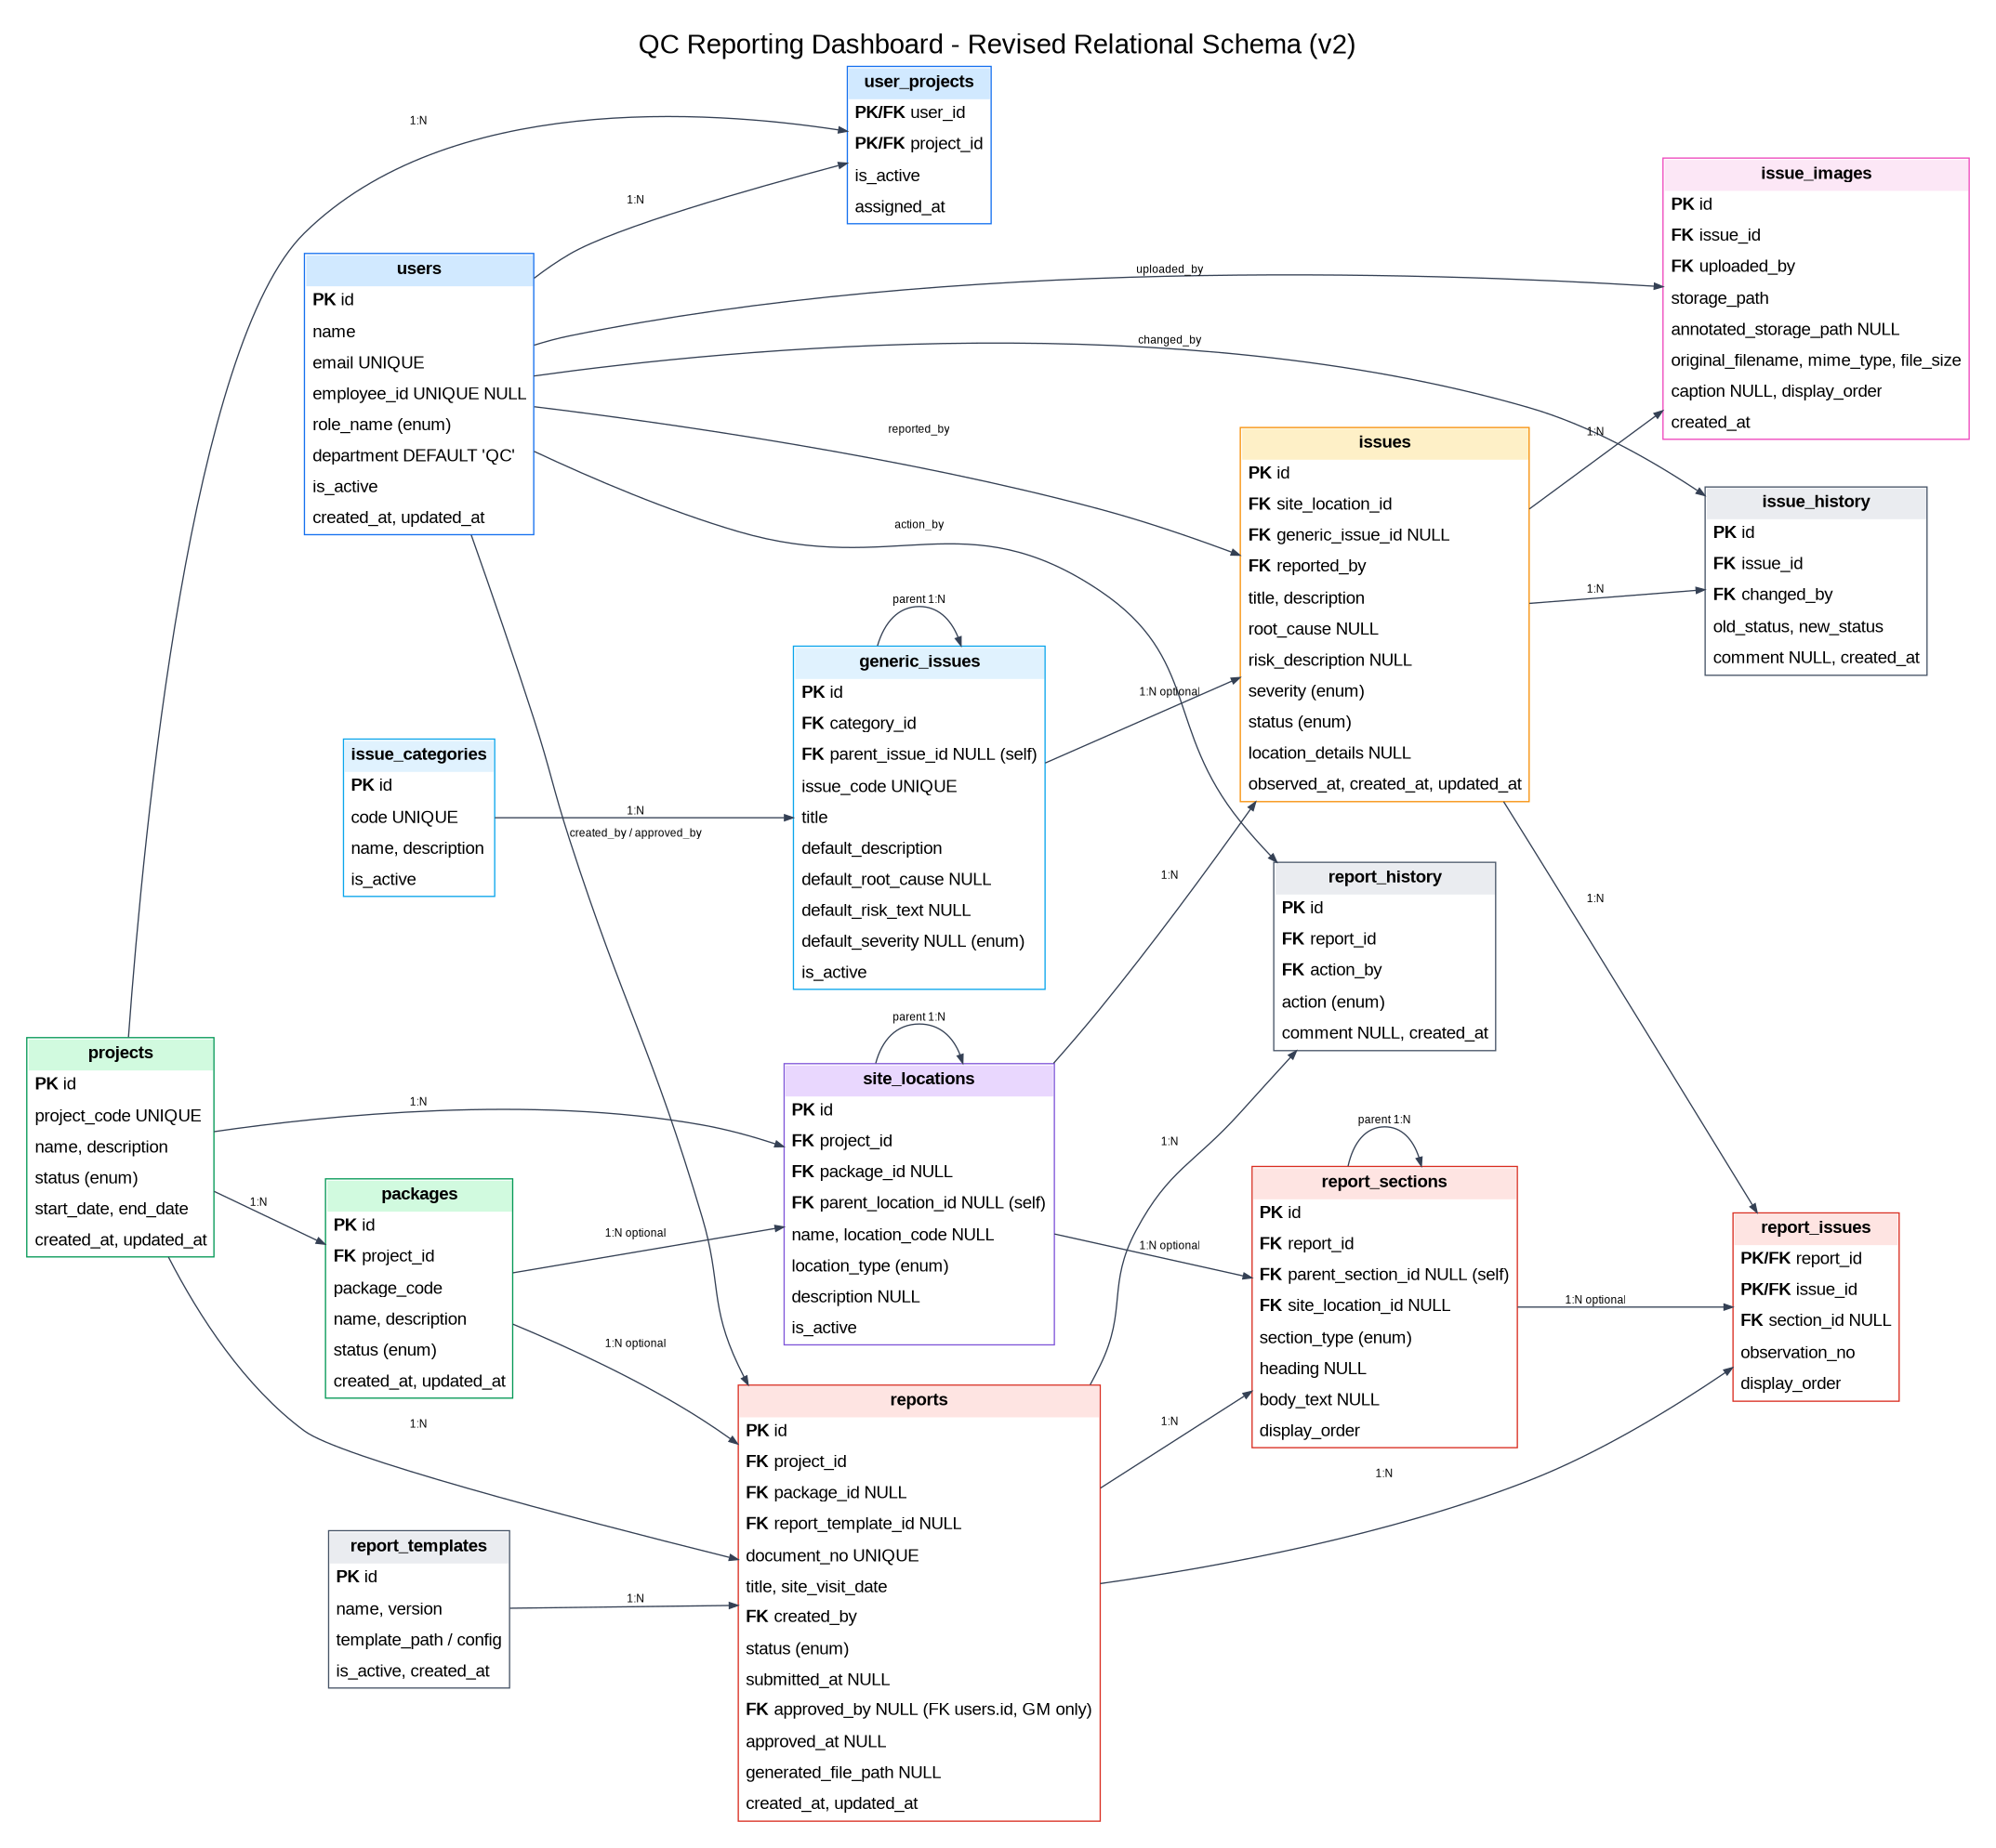

7. Data Dictionary - Key Tables
Table | Purpose / key fields
users | id PK; name; email; employee_id; role_name enum; department; is_active; timestamps. One role only.
user_projects | user_id + project_id composite PK/FKs; is_active; assigned_at. Separates project access from role.
projects | id; project_code; name; description; status; dates; timestamps.
packages | id; project_id; package_code; name; description; status; timestamps.
site_locations | id; project_id; optional package_id; optional parent_location_id; name; code; location_type; description; is_active.
issue_categories | id; code; name; description; is_active.
generic_issues | id; category_id; optional parent_issue_id; issue_code; title; default description/root cause/risk/severity; is_active.
issues | id; site_location_id; optional generic_issue_id; reported_by; title/description/root cause/risk; severity/status; location_details; observed_at; timestamps.
issue_images | id; issue_id; uploaded_by; original and optional annotated storage paths; file metadata; caption; display_order.
report_templates | id; name; version; template path/config; is_active.
reports | id; project_id; optional package_id; template_id; document_no; title; site_visit_date; created_by; status; submitted_at; approved_by GM only; approved_at; generated_file_path; timestamps.
report_sections | id; report_id; optional parent_section_id; optional site_location_id; section_type; heading; body_text; display_order.
report_issues | report_id + issue_id PK/FKs; optional section_id; observation_no; display_order.
issue_history | issue_id; changed_by; old/new status; comment; timestamp.
report_history | report_id; action_by; action; comment; timestamp.

8. Business Logic and Database Automation
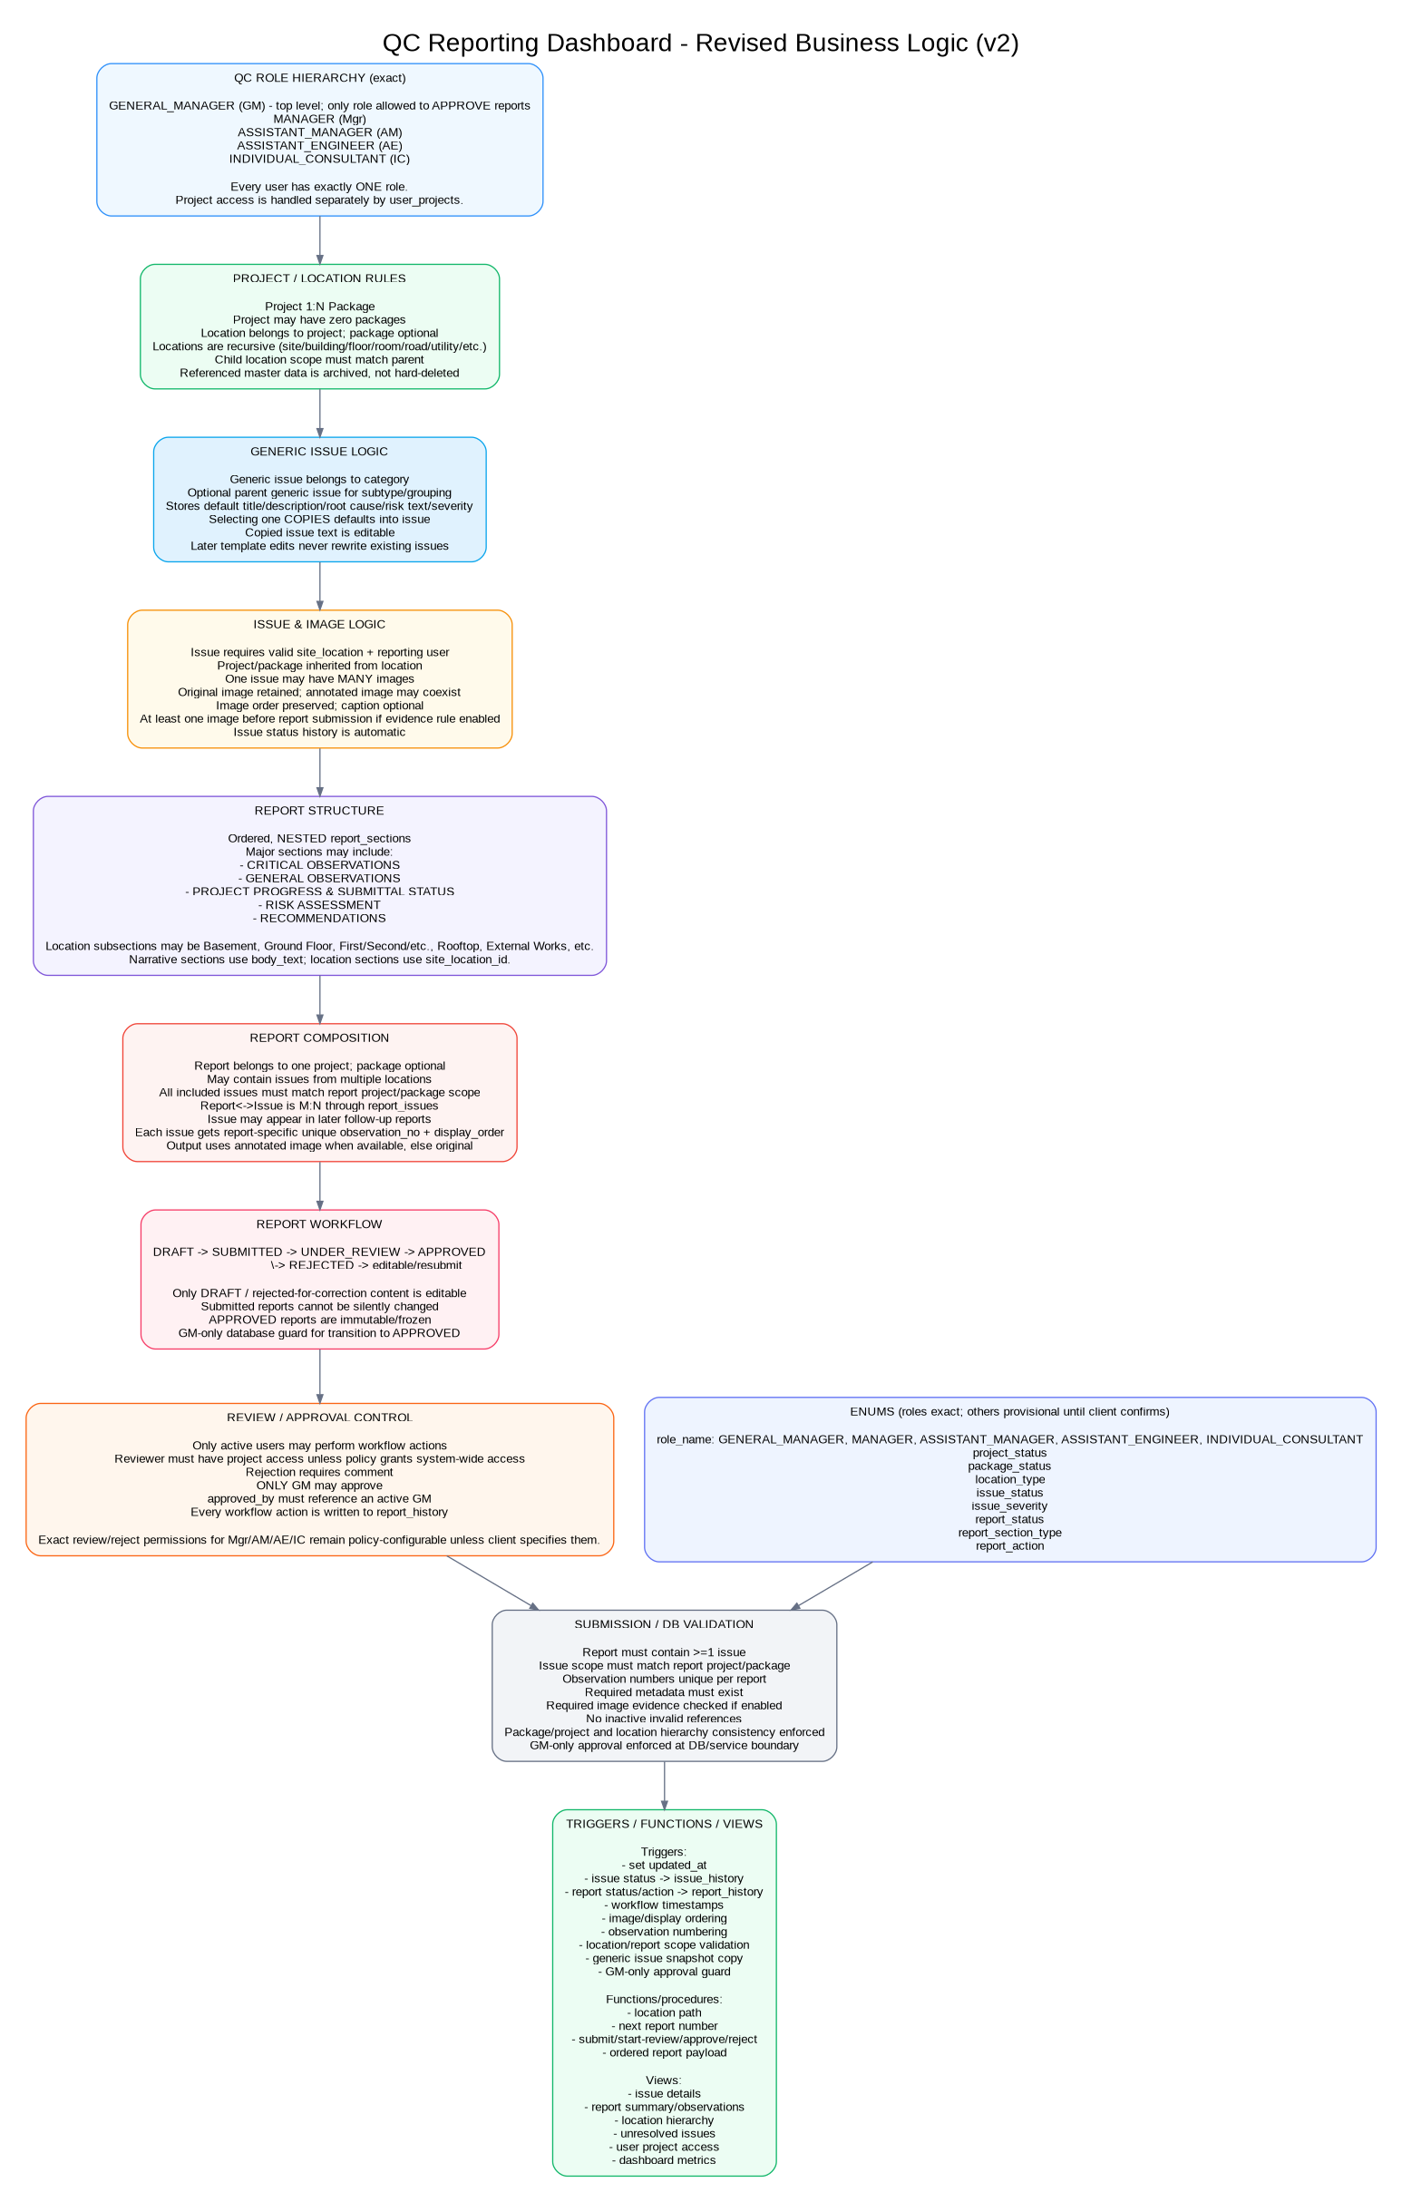

9. Database Business Rules
- Every user has exactly one role_name and may have multiple project assignments.
- Only an active GENERAL_MANAGER may approve a report. No other role may set report status to APPROVED.
- approved_by must be NULL unless status is APPROVED, and when populated must reference an active GM.
- Every package belongs to one project; a project may have zero packages.
- A site location belongs to a project and may optionally belong to a package; a child location must remain within its parent scope.
- Every issue has one site location and one reporting user; generic_issue_id is optional.
- Generic issue defaults are copied into the issue record and become a historical snapshot.
- One issue may have multiple images. Original images are retained; annotated derivatives are optional.
- A report may contain issues from multiple locations, but all included issues must match the report project and package scope where package_id is present.
- Observation numbers are unique within a report and independent from issue IDs.
- Report sections are ordered and may be nested. Narrative sections may exist without issues.
- Rejection requires a comment.
- Approved reports are immutable/frozen. Any future reopen/supersede behavior must be explicit and audited.
- Master data referenced by historical reports is archived/disabled rather than hard-deleted.
- History tables are append-only from the application perspective.

10. Recommended Enums
role_name is confirmed by the revised business logic. The remaining enum value sets are still provisional until the client confirms exact enumerations before DDL implementation.
Enum | Status | Current values / note
role_name | CONFIRMED | GENERAL_MANAGER, MANAGER, ASSISTANT_MANAGER, ASSISTANT_ENGINEER, INDIVIDUAL_CONSULTANT
project_status | TBD | Current draft: PLANNING, ACTIVE, ON_HOLD, COMPLETED, CANCELLED, ARCHIVED
package_status | TBD | Current draft: PLANNING, ACTIVE, ON_HOLD, COMPLETED, CANCELLED, ARCHIVED
location_type | TBD | Current draft: SITE, BUILDING, FLOOR, ROOM, ROAD, UTILITY, DRAINAGE, BOUNDARY, LANDSCAPE, EXTERNAL_WORK, OTHER
issue_status | TBD | Current draft: OPEN, IN_PROGRESS, RECTIFIED/RESOLVED, VERIFIED/CLOSED, REJECTED - exact workflow to confirm
issue_severity | TBD | Current draft: LOW, MEDIUM, HIGH, CRITICAL
report_status | TBD | Current draft: DRAFT, SUBMITTED, UNDER_REVIEW, APPROVED, REJECTED
report_section_type | TBD | Suggested semantic types: CRITICAL_OBSERVATIONS, GENERAL_OBSERVATIONS, LOCATION, PROJECT_PROGRESS_SUBMITTAL_STATUS, RISK_ASSESSMENT, RECOMMENDATIONS, OTHER
report_action | TBD | Current draft: CREATED, UPDATED, SUBMITTED, REVIEW_STARTED, APPROVED, REJECTED, REOPENED, GENERATED

11. Required Views
- v_issue_details - issue with full location hierarchy, generic issue/category and reporter.
- v_report_summary - report metadata and issue counts by status/severity.
- v_report_observations - ordered section/observation/image counts for generation and review.
- v_site_location_hierarchy - recursive project/package/location path.
- v_unresolved_issues - open/in-progress issues by project/location.
- v_user_project_access - user, single role and assigned projects.
- v_dashboard_metrics - derived project/package QC metrics.

12. Required Triggers / Guards
- trg_set_updated_at - maintain updated_at.
- trg_issue_status_history - insert issue_history when issue status changes.
- trg_report_status_history - insert report_history for workflow changes.
- trg_report_status_timestamps - set submitted_at/approved_at.
- trg_issue_image_order - assign image display_order when omitted.
- trg_report_observation_order - assign/check report observation numbers and display order.
- trg_validate_location_scope - enforce project/package/parent location consistency.
- trg_validate_report_issue_scope - enforce report vs issue project/package scope.
- trg_snapshot_generic_issue - copy default generic issue content on issue creation.
- trg_gm_only_report_approval - reject any APPROVED transition unless actor/approved_by is an active GENERAL_MANAGER.

13. Required Stored Procedures / Functions
- fn_location_path(location_id) - recursive human-readable location path.
- fn_next_report_number(project_id, visit_date) - generate a unique report/document number.
- sp_submit_report(report_id, user_id) - run submission validation and transition to SUBMITTED.
- sp_start_review(report_id, user_id) - transition to UNDER_REVIEW subject to review policy.
- sp_approve_report(report_id, gm_user_id, comment) - verify active GM and transition to APPROVED atomically.
- sp_reject_report(report_id, user_id, comment) - reject with mandatory comment subject to review policy.
- fn_report_payload(report_id) - return nested ordered sections, observations and images for generation.

14. Validation Before Submission
- Report has at least one issue.
- All included issues match project/package scope.
- Observation numbers are present and unique per report.
- Required report metadata is complete.
- Image evidence requirement is satisfied if enabled.
- Referenced users/projects/packages/locations/issues/templates are active and valid.
- Section ordering and parent-child references are valid.

15. Non-Functional Requirements
Security: Enforce least privilege, project access and GM-only approval in service/database logic; do not depend solely on frontend controls.
Auditability: Workflow and status changes must be attributable to user and timestamp.
Reliability: Submission/approval operations must be transactional.
Performance: Index foreign keys and common dashboard/filter columns; store images in object storage.
Historical integrity: Approved reports must regenerate from frozen issue/report/template/image references without pulling changed generic defaults.
Usability: Issue capture must be mobile-friendly for site engineers.
Maintainability: Enum sets other than role_name remain explicitly TBD until client confirmation before database DDL.

16. Open Items Before Database Build
- Confirm exact enum values for project_status, package_status, location_type, issue_status, issue_severity, report_status, report_section_type and report_action.
- Confirm which roles besides GM may START REVIEW and which may REJECT. Approval is already fixed to GM only.
- Confirm whether one report may span multiple packages; current design permits multiple locations but only one optional package_id.
- Confirm whether image evidence is mandatory for every report observation or only selected issue types.
- Confirm whether an approved report can ever be reopened, and if so which role may reopen it.
- Confirm whether a GM is allowed to approve a report they personally created; the revised logic does not currently define this.

