PERFORMING THE ALTER, UPDATE AND DELETE IN VIEW

1. View table successfully created in sum(sales) and min(sales)

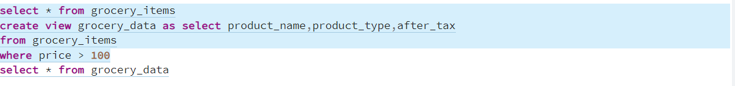

Crete view successfully

2)Error when using the adding a column

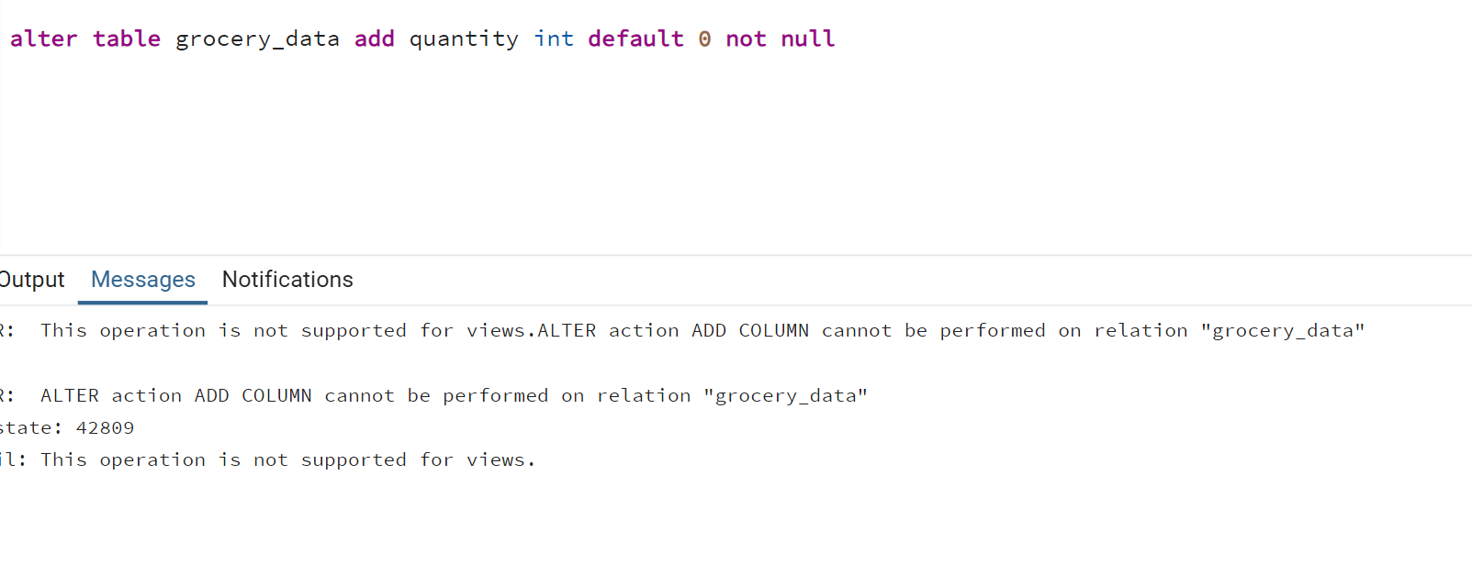

3)Successfully run the rename syntax

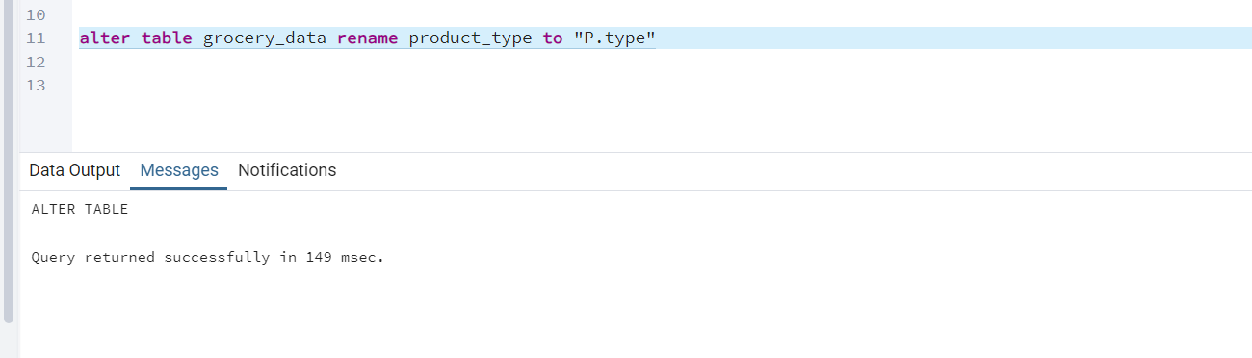

4)Update is not performing in view

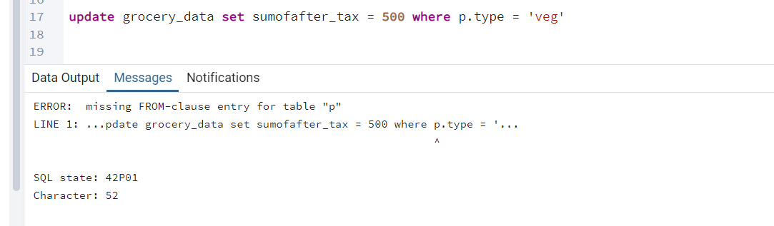

5)Delete is not performing in view

