**Online on Interpolation**

**Find the Gene Expression value**

Gene expression profile is defined by a time series that indicates the expression of a particular gene at different time points. Therefore, you can consider the gene expression as a 2D array with two columns. The first column represents different time points (in increasing order). The second column indicates the gene expression of that time.

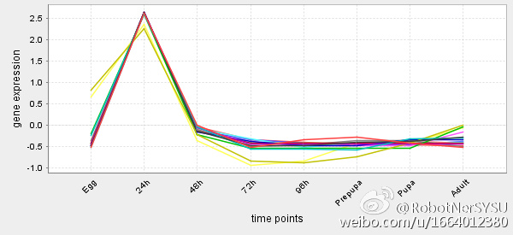

Gene expression values are calculated at regular interval or any specific moment of cell cycle development. However, these experiments are expensive and there are many noises/missing points. Therefore, interpolation is used to find the missing values in gene expression.

In this problem, you have been given a text file *gene.txt.* The first column represents the time points in increasing order. The second column represents the gene expression of corresponding time points.

* First you need to read the file from your program to store the values in an array.
* You need to take a time T as input from the user (the time will be between the range of given time points). Now you need to find the gene expression value at time point T using Newton Divided Difference Method for Cubic Interpolation.
* Also, find the absolute approximate relative error (For quadric interpolation, use the time points which are nearest to T. For example, for T=17, you need to consider 13, 16, 20 in the given example)
* Finally, plot a graph for showing the gene expression value over time and indicate the interpolated values in the graph.