Database First implementations:

**Database First** is one of the approaches used in software development, particularly within the context of building applications that interact with databases. It's part of the broader concept of "code-first" and "database-first" approaches in software development.

In the context of frameworks like Entity Framework in .NET or tools like Hibernate in Java, **Database First** refers to a methodology where developers create the database schema first (tables, relationships, constraints, etc.) and then generate the application code (such as classes, entities, and relationships) from that existing database schema.

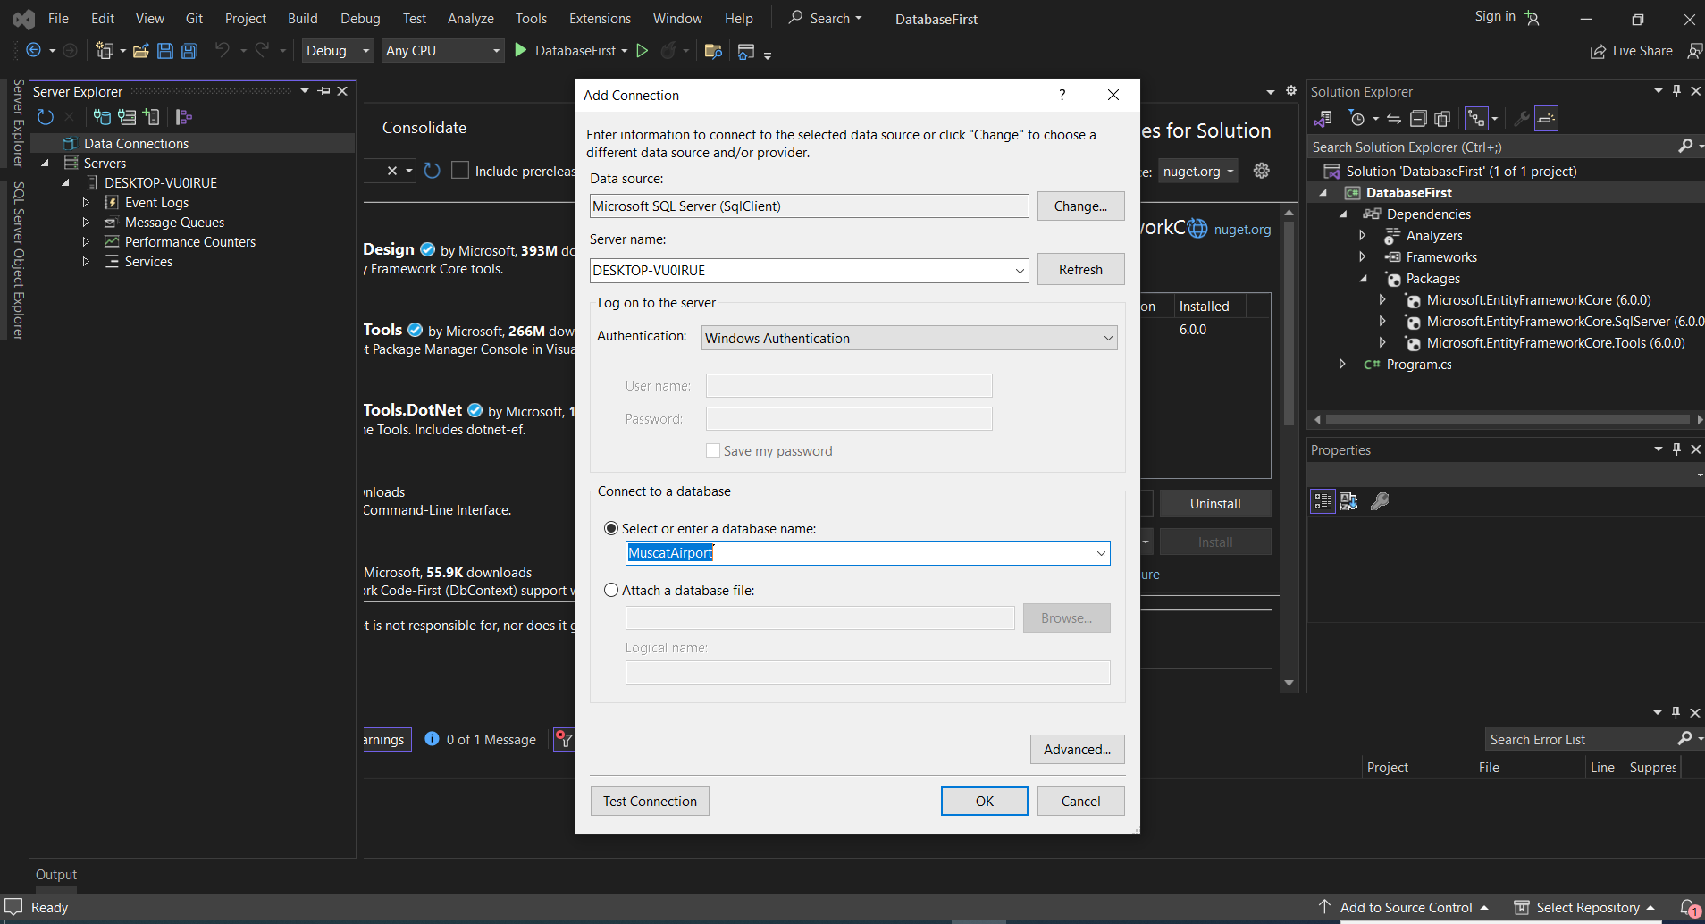

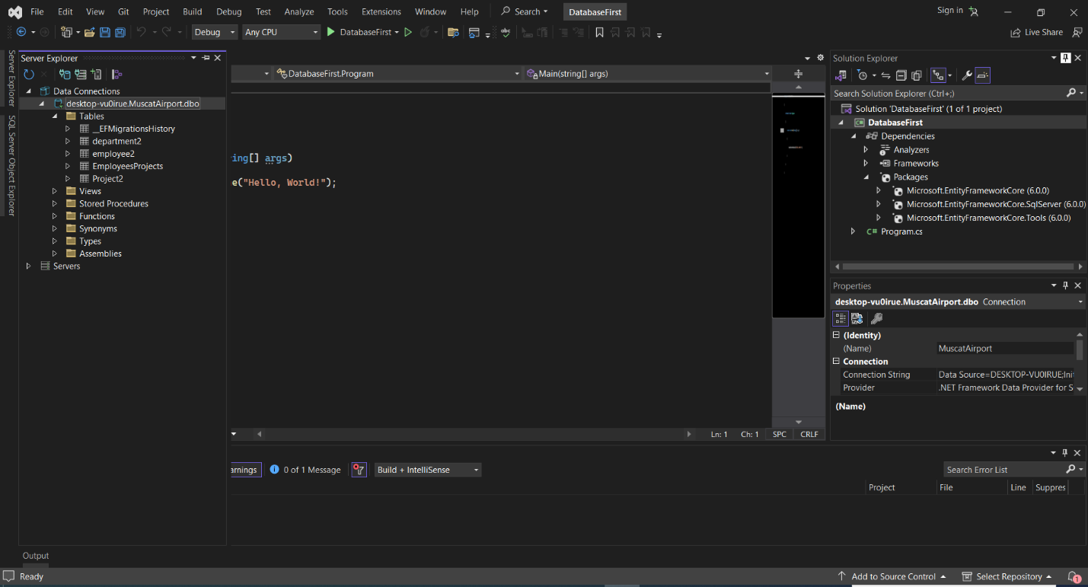first steps:

Command to retrieve data from database to visual Studie

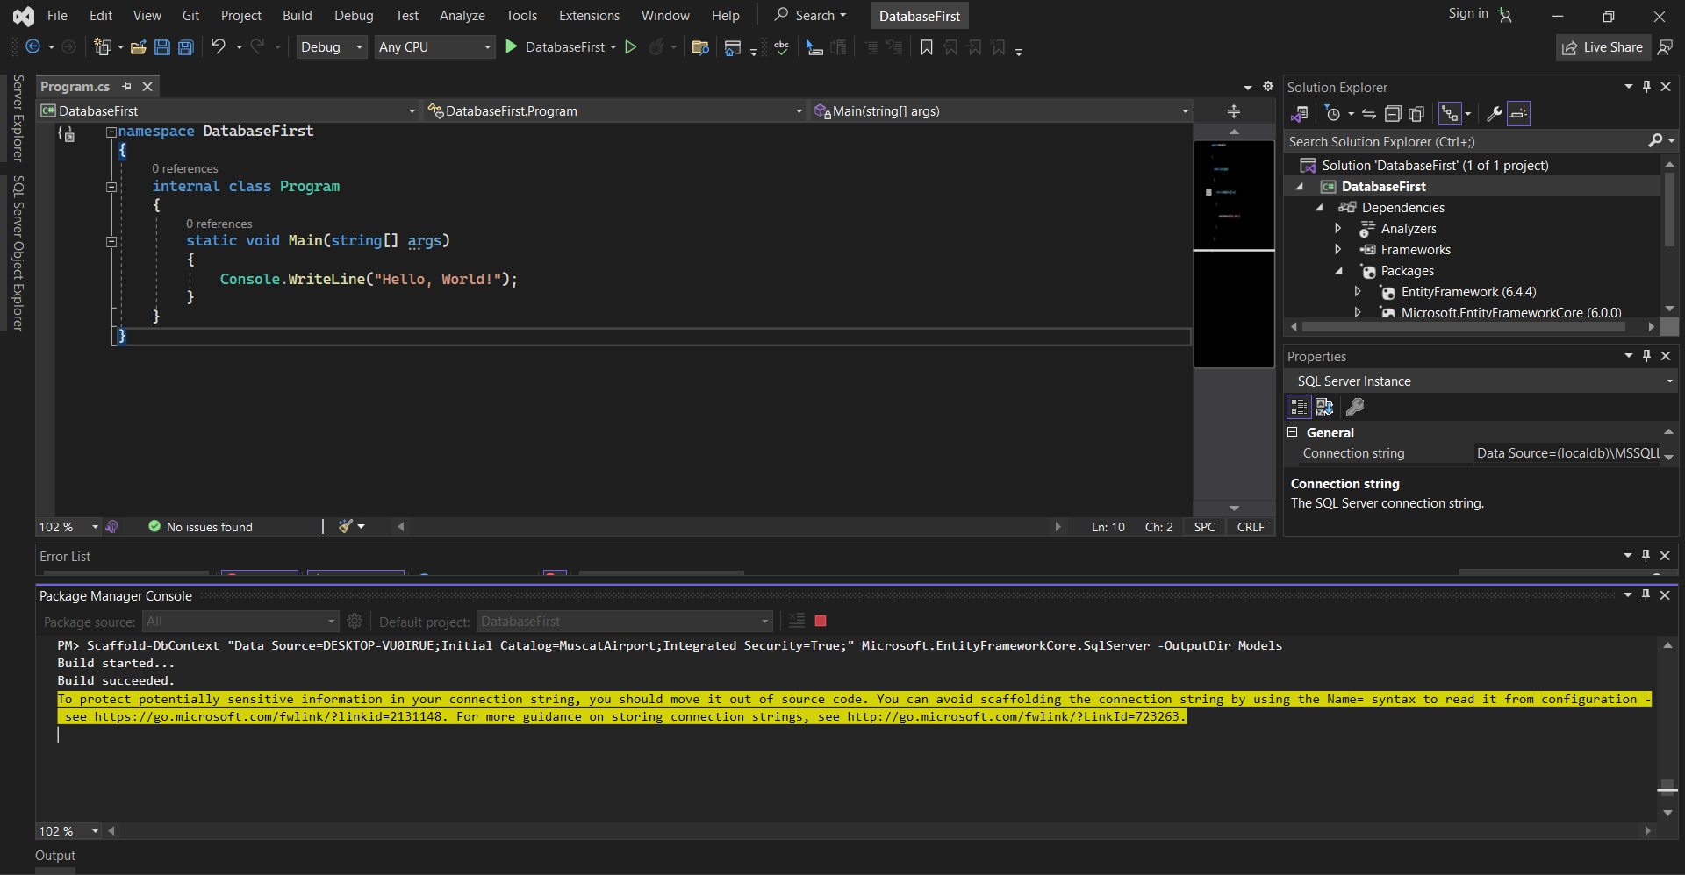

OUTPUT:

