**Random Generated Guessing Game with Hint Feedback:**

**creating an interactive guessing game using JavaScript and the DOM. The game should generate a random number between a specified range and allow the user to guess the number. The user should be provided with feedback on whether their guess is correct or not. Additionally, provide hints to the user based on whether their guess is too high or too low.**

1. 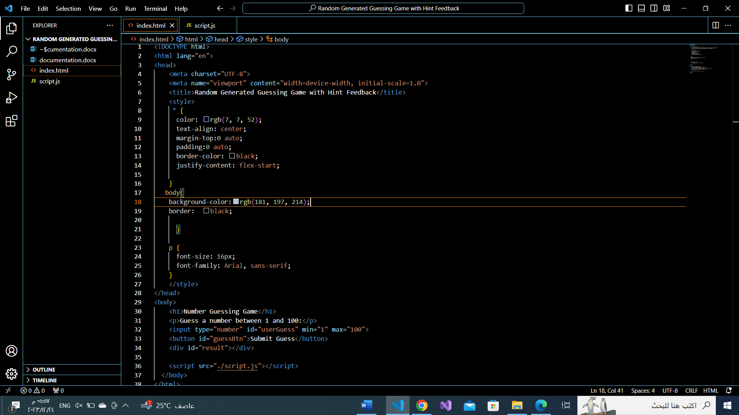**DESIGN HTML PAGE AND STYLE IT :**
2. **CREATING JAVASCRIPT:**

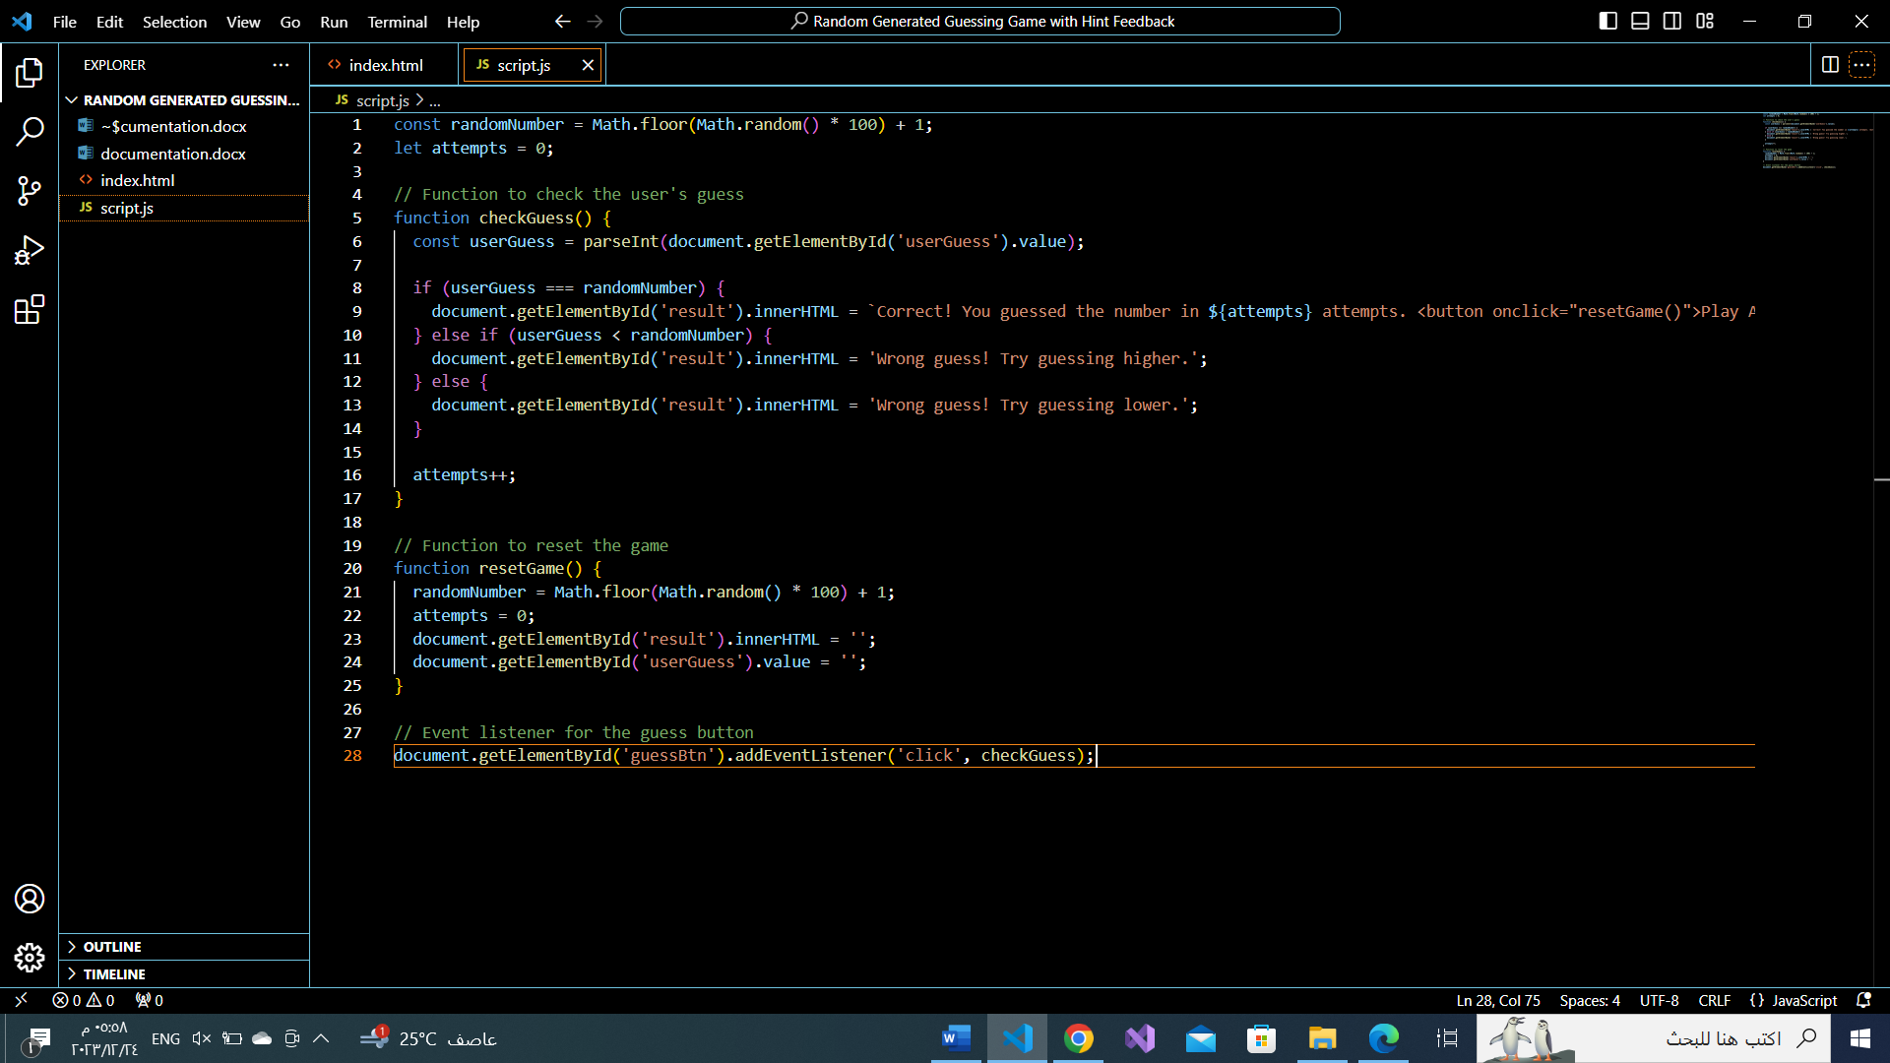

**OUTPUT SCREEN:**

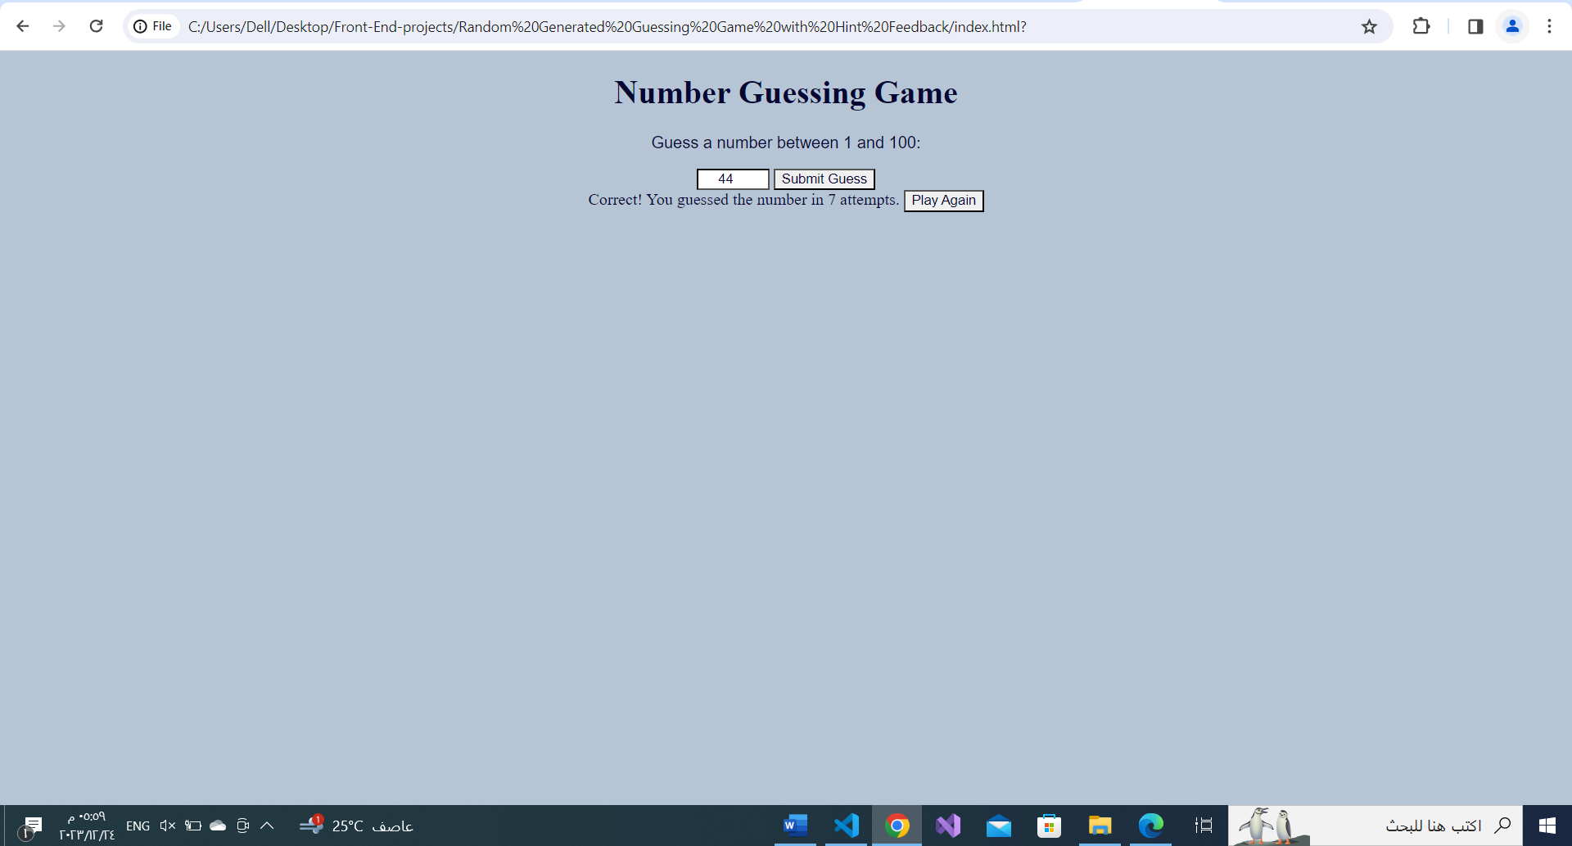

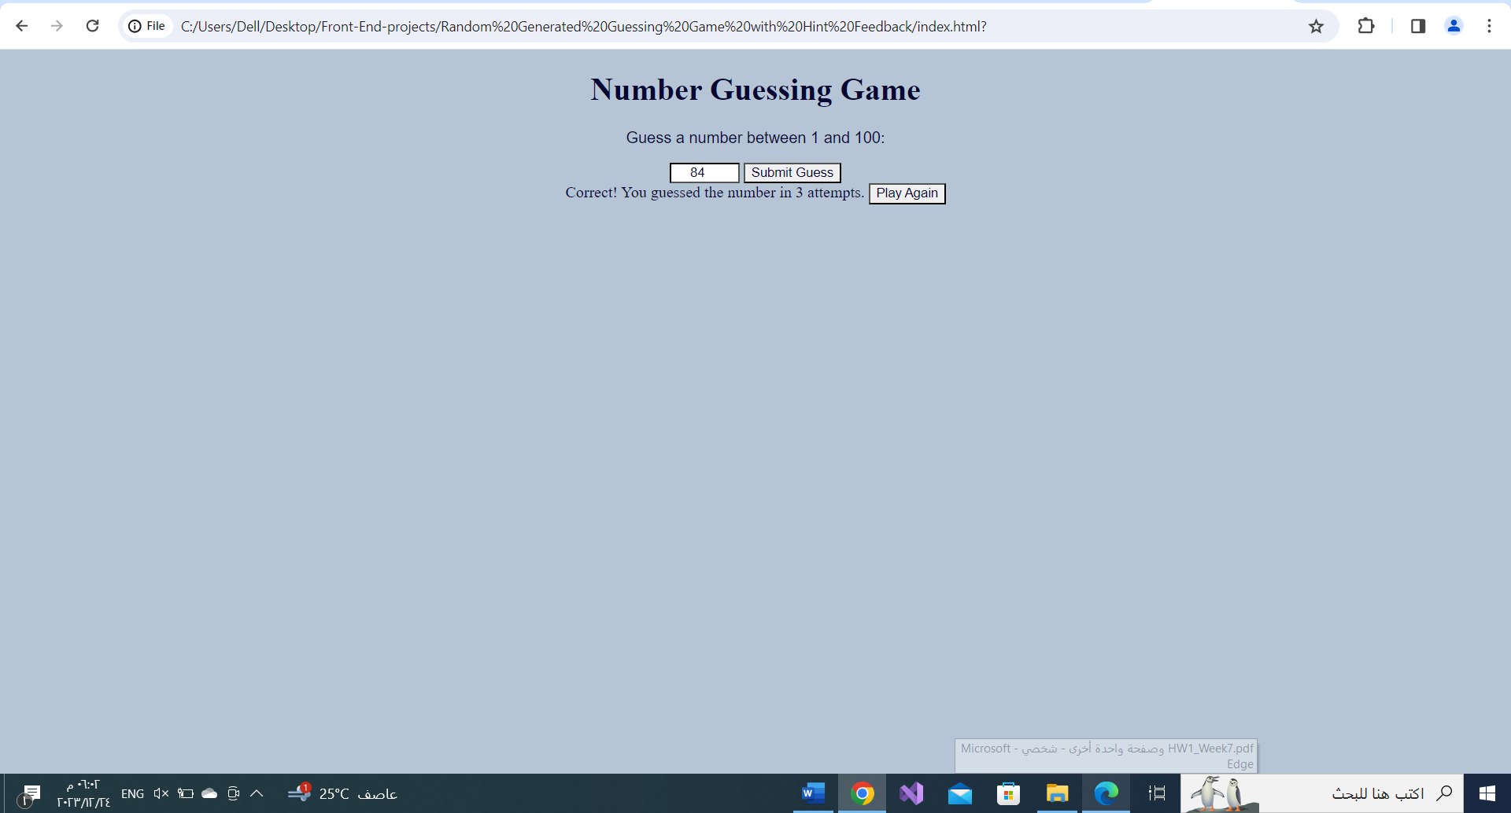

**Done By:Sheikha Al Quyudhi**