Experiment

**Using Logistic Regression without regularization:**

**For different values of iterations ( upto 500 ), it was observed that accuracy increases upto approximately 20 iterations and then it flattens, so optimal value of max-iter is taken as 20 and max acc achieved is 0.8462.  
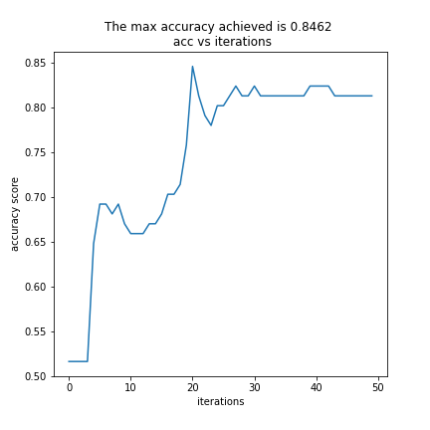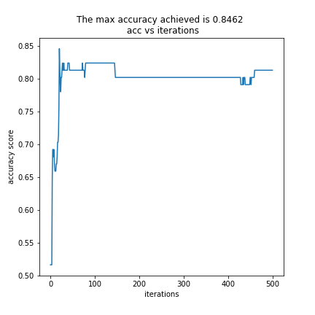**

**confusion Matrix, calculate Precision and Recall, and draw**

**corresponding ROC curve/AUC**

**Confusion Matrix**

**Actual**

**1 0**

|  |  |
| --- | --- |
| **44** | **11** |
| **3** | **33** |

**Predicted 1**

**0**

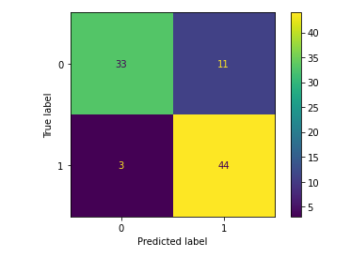

accuracy score is 0.846

The precision is 0.8

The recall is 0.936

The f1_score is 0.863

ROC 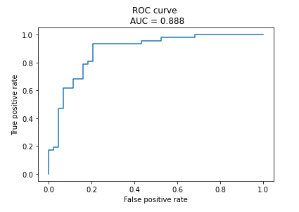

**observe accuracy by varying threshold.**

Threshold accuracy

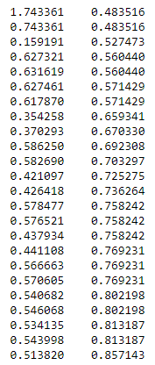

The max accuracy achieved is 0.857 at threshold 0.514

**Q4**

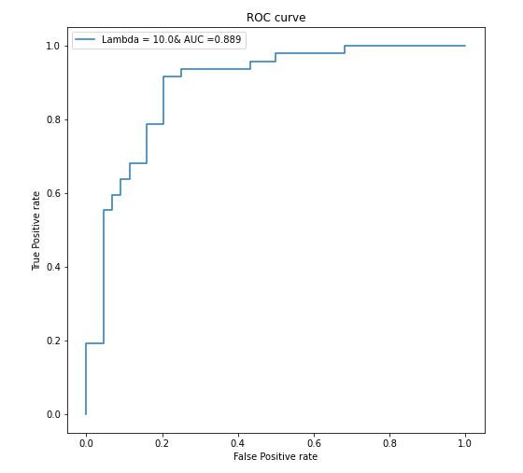

For lambda = 10.0 :

accuracy score is 0.846

f1_score is 0.863

Precision is 0.8

Recall is 0.936

**Confusion Matrix**

**Actual**

**1 0**

|  |  |
| --- | --- |
| **44** | **11** |
| **3** | **33** |

**Predicted 1**

**0**

**Q5**

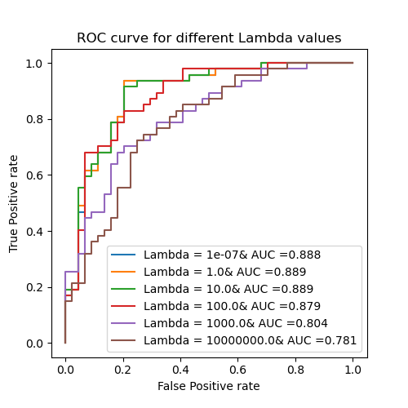

**For lambda = 1e-07 :**

accuracy score is 0.846

f1_score is 0.863

Precision is 0.8

Recall is 0.936

**Confusion Matrix**

**Actual**

**1 0**

|  |  |
| --- | --- |
| **44** | **11** |
| **3** | **33** |

**Predicted 1**

**0**

For lambda = 1.0 :

accuracy score is 0.846

f1_score is 0.863

Precision is 0.8

Recall is 0.936

**Confusion Matrix**

**Actual**

**1 0**

|  |  |
| --- | --- |
| **44** | **11** |
| **3** | **33** |

**Predicted 1**

**0**

For lambda = 10.0 :

Confusion matrix : [[33 11]

[ 3 44]]

accuracy score is 0.846

f1_score is 0.863

Precision is 0.8

Recall is 0.936

**Confusion Matrix**

**Actual**

**1 0**

|  |  |
| --- | --- |
| **44** | **11** |
| **3** | **33** |

**Predicted 1**

**0**

For lambda = 100.0 :

Confusion matrix : [[29 15]

[ 5 42]]

accuracy score is 0.78

f1_score is 0.808

Precision is 0.737

Recall is 0.894

**Confusion Matrix**

**Actual**

**1 0**

|  |  |
| --- | --- |
| **42** | **15** |
| **5** | **29** |

**Predicted 1**

**0**

For lambda = 10000000.0 :

Confusion matrix : [[ 0 44]

[ 0 47]]

accuracy score is 0.516

f1_score is 0.681

Precision is 0.516

Recall is 1.0

**Confusion Matrix**

**Actual**

**1 0**

|  |  |
| --- | --- |
| **47** | **44** |
| **0** | **0** |

**Predicted 1**

**0**