**fabrilife.com**

**1. Issue**: Eye icon is not added to the password field

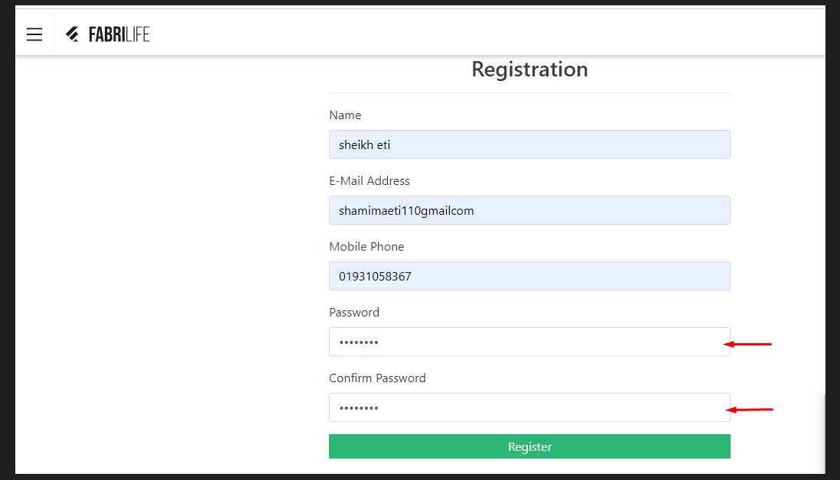

**2.** Description:

* Open any browser.
* Go to URL = <https://fabrilife.com/>
* Click on Register.
* Fill up all fields correctly with valid data.
* The user wants to see the password by clicking on the eye icon but the eye icon is not added to the password field.

\***Expected result**: The user can be able to view the password by clicking on the eye icon.

\***Actual result**: The eye icon is not added to the password field.

**3.** Create an issue, consisting with Project name, Issue type, Summary, Description, Assignee, Reporter, Attachment screenshots of bug and click on the Create button in JIRA.

*Create an issue

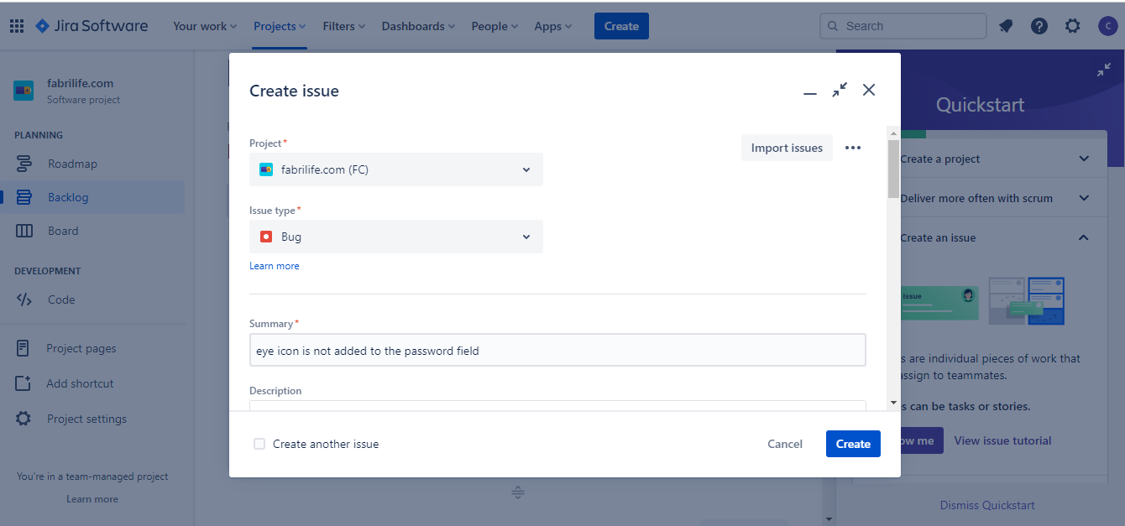

*Description

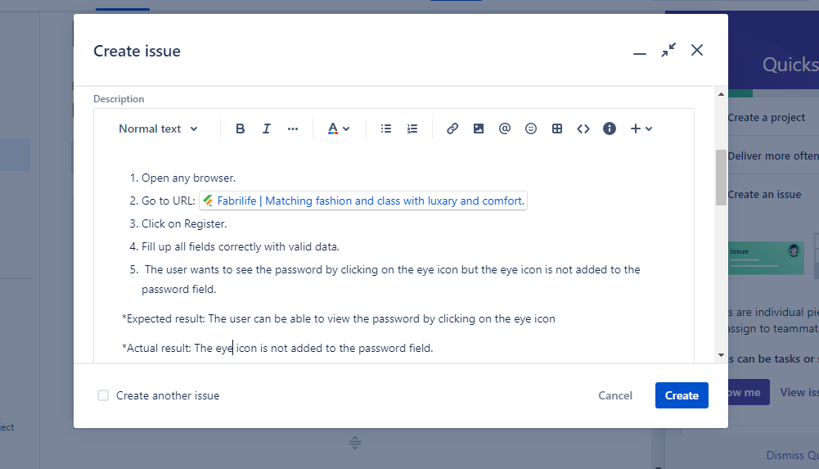

* The work is assigned to sheikh eti to solve this issue.

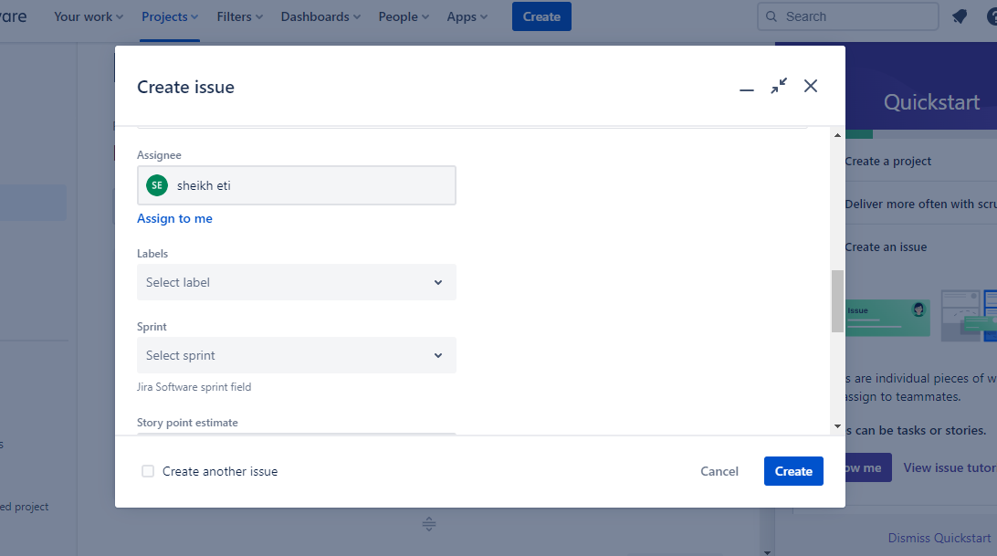

**\***Attachment screenshots of bug

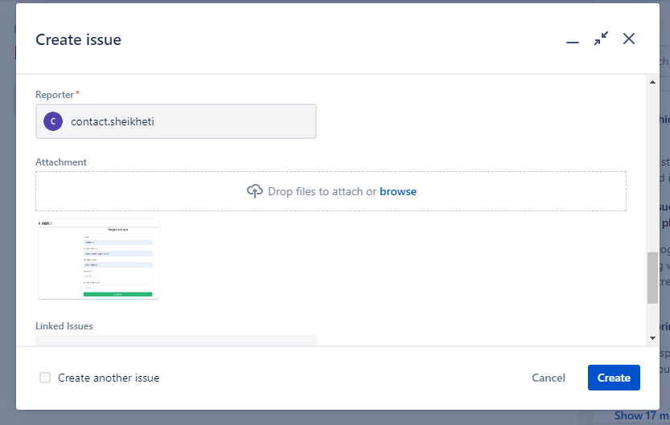

**5.** From the tester side, The bug will be in "to do mood".

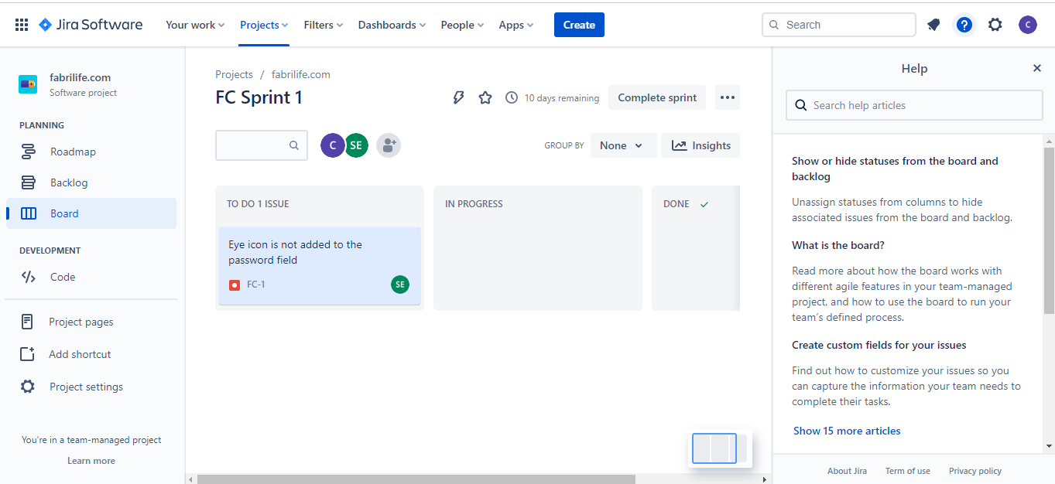

**6.** When the developer starts working on the bug this bug will be in a "progress mood".

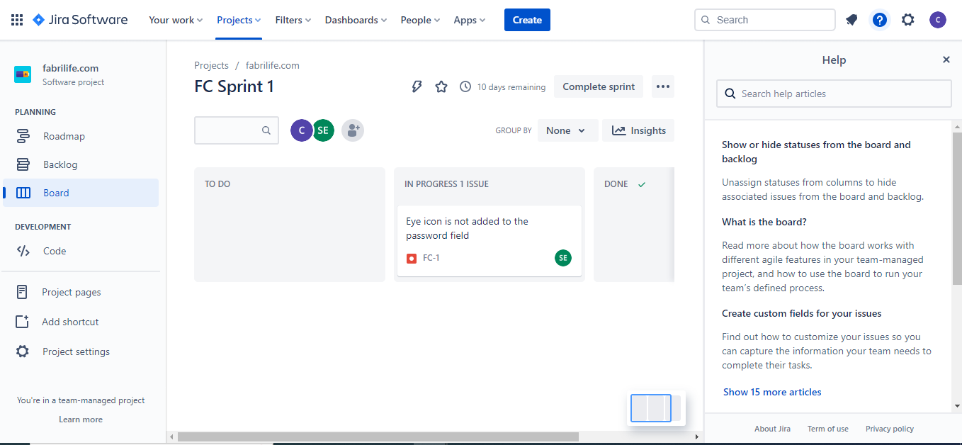

**7.** When the developer will fix the bug it will go to the "done mood" and This Bug will Automatically Vanish from Tester Side.

