Sudoku code assignment

Objectives

Your assignment is to develop a Sudoku solving application using web based technologies.

This assignment is intended to allow you to showcase your skills in the following areas:

* Project planning your assignment (you will have 1 week to complete, start to finish)
  + You will need to ensure that you allocate enough time and plan your project well
* Designing and implementing an application
* Designing and implementing a problem-solving algorithm
* Designing and implementing a basic UI

Additional information

Here is some additional information that provides further details on the Sudoku assignment.

* Here is a basic example of the application UI on a mobile platform:

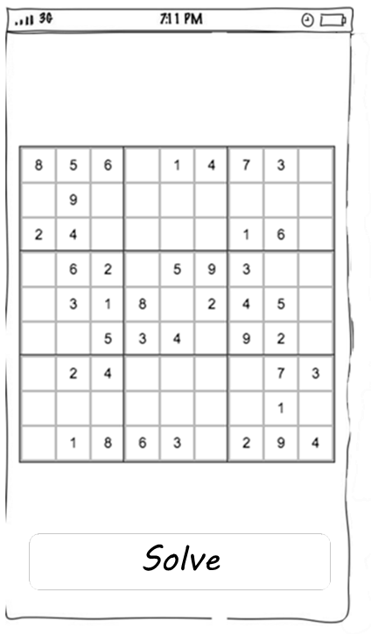

* Clicking on the “Solve” button shall update the board with the answer to the puzzle. The board UI can be read-only – with the initial puzzle hardcoded. However, there must be an easy way to add new puzzles to the app so that we can test your algorithm for more complex cases.
* The UI (minimal as it might be) needs to be visually appealing
* We strongly recommend that you attempt to write the initial Sudoku solving algorithm yourself before looking at any examples online. **This is important so that you can describe your thinking process about the problem and your understanding of the used algorithm.**
* There are generally many designs that are satisfactory solutions to the problem-solving algorithms. Recognizing design trade-offs, making reasonable design choices and being able to defend these choices are objectives of the assignment.
* Attention to detail, performance and robustness of the application as well as testability are important considerations.

Submission of the assignment

Code should be committed to a public GitHub or Bitbucket repository. Include a readme, a brief description of the implementation and information how to build, deploy and access the app. Make sure to also include any API documentation that is applicable.

You will have approximately one week to complete the assignment. After submission, we would like you to demo your work and do a code walkthrough with us (technical interview at our office or via webex). Your presentation will be followed by a technical discussion during which the panel will ask questions and you will have the opportunity to answer them and discuss technical details and design decisions.

You will be evaluated using the following criteria:

* Ability to describe the application and its architecture
* Code quality (i.e. style, complexity, best practices)
* Application architecture (i.e. design patterns, modularity)
* API design quality (i.e. following standards and best practices)
* Documentation quality (i.e. content quality, completeness and accuracy)

To give us time to review your code, please submit 24 hours prior to your technical interview.

**Note: If you submit an assignment that is not your own work, it will result in disqualification.**