Network Intrusion Detection on UNSW-NB15
Preprocessing, tabular models and a Graph Neural Network
CSE475 group project report

1. Overview
We classified network flows from UNSW-NB15 into 10 classes (Normal and nine attack types). We first built a preprocessing pipeline, then trained standard tabular models, tried several ways to improve them, and finally built a Graph Neural Network (GNN) that uses the connections between hosts. Each step was run on Kaggle and scored on the same held-out test set. When a result looked surprising, we added a control experiment before drawing a conclusion. Some of those controls corrected our own earlier readings, and this report includes those corrections.
What we observed, in short:
- The highest macro F1 we obtained was 0.670, from a two-stage LightGBM trained on the original (not resampled) data with balanced class weights.
- In our comparisons, class weighting made the largest difference (+0.076 for single-stage LightGBM). The two-stage design added a smaller gain (+0.011), and adding synthetic SMOTE rows lowered the score slightly (-0.011 to -0.015).
- Analysis and Backdoor stayed near F1 0.17 in every model. About 80% of their rows have another row with identical features but a different label. This lowers what any model can reach on these two classes, but it does not explain the whole gap: a rule that memorises the most common label of each group of identical rows reaches only about F1 0.37 (Analysis) and 0.36 (Backdoor) on the training data, while our models reach 0.17 and 0.18.
- The GNN scored 0.585, about 0.08 below the best tree model. When the training graph had the same density as the test graph, using the real graph gave the GNN a small gain over the same network without the graph (+0.017). Adding graph features to LightGBM gave no measurable change. A second GNN that follows the original E-GraphSAGE paper more closely scored 0.59 to 0.60 and showed no gain from the graph.
- We also repeated the setup of a published GNN paper (GTCN-G: 5:2:3 split, weighted F1) on our data (section 7). All our models scored a weighted F1 of 0.980 to 0.984 against the 0.9512 that paper reports, but the comparison is not like-for-like and a tree model without a graph scored the same.

2. Data and how we measure results
UNSW-NB15 comes as four raw CSV files with 2,540,047 flows and 49 columns. After removing duplicates, 2,042,340 flows remained. We split them 80/20 with stratification: 1,633,872 flows for training and 408,468 for testing. The test set was not used for any modelling decision except the final model choice described in section 5.2.
Class | Test rows | Share
Normal | 389,780 | 95.4%
Exploits | 5,489 | 1.3%
Fuzzers | 4,329 | 1.1%
Generic | 4,007 | 1.0%
Reconnaissance | 2,641 | 0.6%
DoS | 1,103 | 0.3%
Analysis | 407 | 0.1%
Backdoor | 376 | 0.1%
Shellcode | 302 | 0.07%
Worms | 34 | 0.008%

Metric. Normal is 95% of the test set, so accuracy is above 97% even for weak models. We therefore use macro F1, the plain average of the per-class F1 scores, so every class counts equally. We also looked at per-class precision, recall and F1 and at confusion matrices in the notebooks.
Uncertainty. Two kinds of noise matter here. Training randomness is shown by repeating each experiment with 3 to 5 seeds (± is the standard deviation over seeds). Test-set sampling noise is shown by a bootstrap: we resample the 408,468 test flows 1,000 times and report a 95% interval. Worms has only 34 test rows, so it moves macro F1 by several hundredths; for important comparisons we also give the result without Worms.

3. Preprocessing
The main rule was that the test set must not influence any step. Every value learned from data (medians, scaler, rare-level lists, feature rankings) is learned on the training set and then applied to the test set.
Step | What we did | Why
1. Load | Combined the 4 CSVs. Decoded hex ports (for example 0xc0a8) and treated blanks as missing. | Plain number conversion turns hex ports into missing values.
2. Remove duplicates | Removed rows with the same features and the same label (2,540,047 to 2,042,340). Done before the split. | A duplicate should not end up in both train and test.
3. Split | 80/20, stratified by class. | Keeps the class mix equal in train and test.
4. Clean | Dropped IP addresses, TCP sequence numbers, timestamps and the binary Label column. Filled missing values with the train median. Binned the source port into 4 ranges. Merged rare levels (under 0.5%) of proto, state and service into 'Other'. | Identifiers and timestamps look like testbed artifacts, and Label leaks the target. Medians come from train only.
5. Remove redundant features | Dropped one of each highly correlated pair (0.96 to 0.99): dwin/swin, dloss/dbytes, dloss/Dpkts, sloss, tcprtt, ct_ftp_cmd; one near-constant column; and state and is_ftp_login (lowest on all four ranking methods). | Correlations were measured. 41 columns became 33.
6. Transform | Skewed columns: log1p, then standardise. Other numeric columns: standardise. Categories: one-hot encoding. Result: 45 features. | Reduces heavy tails; needed for the neural models.
7. Check | A model on the 33 selected features scored 0.5954 validation macro F1, against 0.5924 for all candidates. | A sanity check that selection did not cost accuracy.
8. Oversampling | SMOTENC on the five smallest classes (up to 5,000 rows each); later BorderlineSMOTE. | The rare classes had few examples. Switching to BorderlineSMOTE changed no score to three decimals (two-stage 0.648 in both cases). Section 5.2 tests whether synthetic rows help at all.
9. Export | train, test, train_smote, graph endpoint files (IP and port) and the fitted transformers. | The GNN needs the original rows and their endpoints.

4. Starting point: baseline models
We trained four standard models on the oversampled training data and scored them on the untouched test set. A fixed 15% slice of the training data was used for validation and early stopping, with seed 42.
Model | Main settings | Reason for the choice
Random Forest | up to 200 trees (25, 50, 100, 150, 200 checked), max depth 20, class weight 'balanced_subsample' | Simple, strong baseline; the tree-count curve shows when more trees stop helping.
LightGBM | multiclass, learning rate 0.08, 63 leaves, up to 300 rounds, early stopping after 20 rounds without improvement | Fast gradient boosting for large data.
XGBoost | multi:softprob, learning rate 0.08, max depth 8, up to 300 rounds, early stopping 20, balanced sample weights | A second boosting method for comparison.
Neural network (MLP) | Dense 128, BatchNorm, Dropout 0.3, Dense 64, BatchNorm, Dropout 0.3, softmax; Adam; batch 2048; up to 30 epochs; early stopping patience 4; class weights | Shows how a neural network does on the same features; also the natural comparison for the GNN.

Model | Accuracy | Macro F1
Random Forest | 0.977 | 0.596
LightGBM | 0.983 | 0.600
XGBoost | 0.977 | 0.636
Neural network | 0.973 | 0.559

Accuracy was high but macro F1 was low. The per-class reports showed that the gap came mainly from precision on a few rare classes: Analysis 0.09 to 0.13, Backdoor 0.11 to 0.17 and DoS 0.27 to 0.44, with many of these rows predicted as Exploits.
Two weaknesses of this first baseline were only found later, and they matter for how the early numbers should be read. (1) The LightGBM was trained with lgb.train, which ignores the class_weight setting (it exists only in the scikit-learn wrapper), so this model was effectively unweighted. (2) Early stopping used a validation slice cut from the oversampled data, so some validation rows could have synthetic neighbours in the training data. Section 5.2 repeats the comparison without these two issues.

5. Improving the tabular models

5.1 Two-stage classification
To reduce the effect of the dominant Normal class, we split the task. Stage 1 is a binary LightGBM (attack or Normal). Stage 2 is a 9-class LightGBM trained only on attack rows, so Normal does not compete with the rare attacks for tree splits. A row reaches Stage 2 only if Stage 1 flags it. Both stages use the same settings as the LightGBM above. On the oversampled data this scored 0.648, above each single model (0.56 to 0.64). A soft-voting ensemble of Random Forest, LightGBM and XGBoost scored 0.627. Re-running the same notebook changed single-model scores by up to 0.03, mostly because of Worms, so we did not read small differences from single runs.

5.2 A controlled comparison: class weights, design and synthetic rows
Because the first baseline had the two weaknesses described in section 4, we trained five LightGBM variants with identical settings and 3 seeds. For every variant the validation slice is the same: 15% of the original training rows, real rows only. Synthetic rows, when used, are added to the training part only.
Variant | Macro F1 | 95% interval
Single-stage, no class weights | 0.582 ± 0.004 | 0.573 - 0.591
Single-stage, balanced weights | 0.658 ± 0.002 | 0.646 - 0.669
Two-stage, balanced weights | 0.670 ± 0.004 | 0.658 - 0.679
Single-stage, balanced weights + SMOTE rows | 0.648 ± 0.001 | 0.634 - 0.659
Two-stage, balanced weights + SMOTE rows | 0.654 ± 0.002 | 0.641 - 0.667

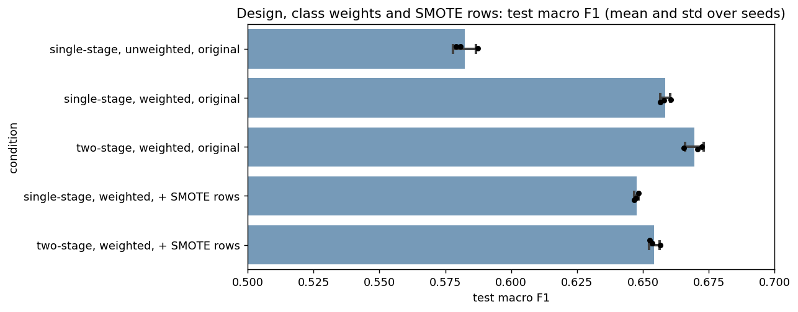
Figure 1. Test macro F1 of the five LightGBM variants (bars: mean over 3 seeds, dots: single seeds).
Paired differences (95% bootstrap interval in brackets):
- Class weights, single-stage: +0.076 (+0.065 to +0.087).
- Two-stage instead of single-stage, both weighted: +0.011 (+0.005 to +0.019). The difference was positive in all 3 seeds (+0.014, +0.007, +0.012).
- Original data instead of original plus SMOTE rows: +0.015 for the two-stage model (+0.007 to +0.024) and +0.011 for the single-stage model (+0.004 to +0.018).
- Without Worms the same differences are smaller (+0.036, +0.005, +0.007 and +0.004) but keep their sign.
In these runs, then, class weighting seems to account for most of the gap we had first attributed to the two-stage design, and the synthetic rows did not help. A possible reason is that balanced class weights already address the imbalance and the synthetic rows add some noise, but we did not test this directly.
Choosing the final model. We picked the two-stage weighted model on original data because it had the highest test macro F1 among these five variants. No hyper-parameter was tuned on the test set, but the choice itself used test scores, so 0.670 may be slightly optimistic. The intervals above reflect test-set sampling noise only.

5.3 Where the remaining errors are: identical features, different labels
After exact duplicates are removed, any remaining group of rows with identical features must carry different labels. For these rows, a model that only sees these features has no basis to prefer one label. We measured the share of each class's rows that have such a twin from another class (computed before feature selection):
Class | Rows with an identical-feature row of another class
Backdoor | 81.6%
Analysis | 78.3%
DoS | 33.9%
Reconnaissance | 11.9%
Fuzzers | 8.3%
Generic | 8.2%
Exploits | 7.4%
Worms | 7.0%
Shellcode, Normal | 0%

The ordering matches the F1 scores: the two classes with the highest overlap (Backdoor and Analysis) are the two with the lowest F1, about 0.17, in every model we tried. On the 45 model features in the training data the top three shares are almost the same: Backdoor 82.5%, Analysis 78.2%, DoS 33.2% (test data: 62.5%, 62.9% and 26.1%). We read this as one reason for the low scores of those two classes, but not the whole explanation: a rule that memorises the most common label of each group of identical rows reaches only about F1 0.37 (Analysis) and 0.36 (Backdoor) on the training data, while our models reach 0.17 and 0.18. This rule is an illustration, not a strict upper bound. We excluded identifiers and timestamps on purpose, so we cannot say whether they would help separate these rows. Sarhan et al. also report low F1 for Analysis (0.03) and Backdoor (0.08) with a different classifier.

5.4 Do the TTL features raise the score?
Some papers remove sttl, dttl and ct_state_ttl because they may be testbed artifacts. We trained the two-stage model with and without them (3 seeds):
Features | Macro F1 | Macro F1 excluding Normal
All 45 features | 0.670 ± 0.004 | 0.634
Without the 3 TTL features | 0.653 ± 0.003 | 0.615

Removing them lowered macro F1 by about 0.017, with the largest per-class drops for DoS (-0.04), Worms (-0.08, only 34 rows) and Exploits (-0.014). The model still works without them, but part of the score does depend on them, so we think both numbers should be reported. An earlier run on the oversampled data gave 0.653 and 0.632.

5.5 Per-class scores of the best tabular model
Class | F1 | Class | F1
Normal | 0.993 | Fuzzers | 0.611
Generic | 0.930 | DoS | 0.458
Shellcode | 0.879 | Backdoor | 0.179
Reconnaissance | 0.860 | Analysis | 0.172
Exploits | 0.827 | Worms | 0.787 (34 rows)

6. Graph Neural Network

6.1 Motivation and graph construction
The tabular models score each flow on its own. A graph lets a flow also use the flows around it, which might help with classes that look alike on their own features. We used edge classification: every flow is an edge, and every (IP address, port) pair is a node. We chose IP plus port because the data has only 49 distinct IP addresses; an IP-only graph would have 49 nodes with millions of edges each.
- Train graph: 1,633,872 edges and 1,017,538 nodes, built from training flows only.
- Test graph: 408,468 edges and 431,028 nodes, built from test flows only. The model never sees test flows during training (inductive setting). Labels are never used in message passing.
- The GNN trains on the original data, because SMOTE rows have no real endpoints.
- The full train graph is about 4 times denser than the test graph: 43% of its nodes have a single flow, against 78% in the test graph. We noticed this late, so we also trained on 4 random chunks of the train graph, each the size of the test set. These chunks match the test density (78% single-flow nodes).
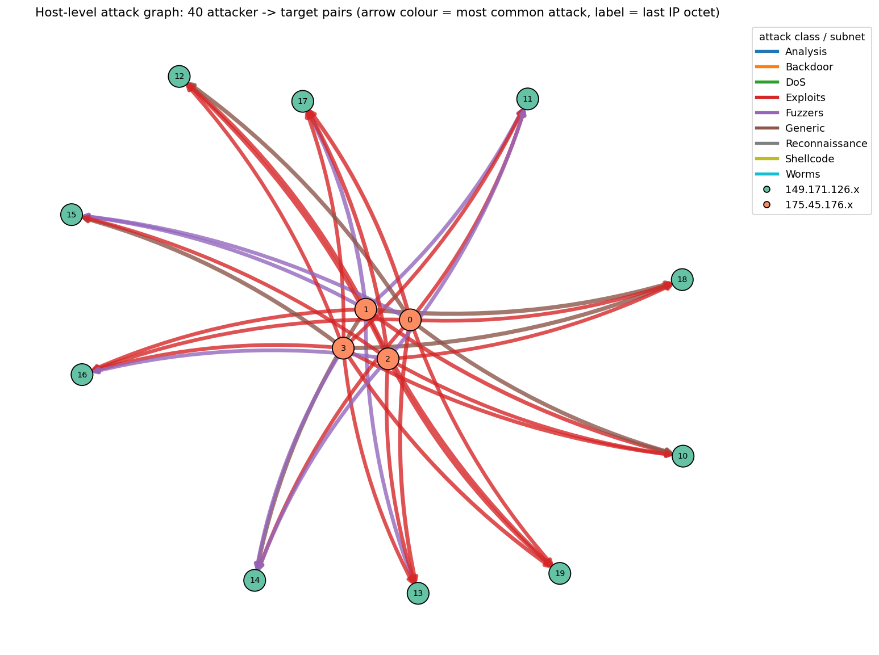
Figure 2. Who attacks whom in the train graph. Four attacker IPs (orange) reach ten targets (green); arrow colour is the most common attack on that pair.
Almost every attacker reaches every target, so the IP addresses alone do not separate the attack types. This was the reason for using (IP, port) nodes.

6.2 Model and training settings
The model is a 2-layer E-GraphSAGE written in PyTorch. A node starts with a constant value, so what it knows comes from the flows around it. Layer 1 averages a transform of the flows at the node; layer 2 averages the layer-1 results of neighbours together with the connecting flows. The classifier uses the source node embedding, the destination node embedding and the flow's own 45 features.
Setting | Value | Reason
Hidden size | 64 (about 46,000 parameters) | Small and fast; enough for 45 input features.
Neighbours sampled | 8 (second hop), 5 (first hop), with replacement | Standard GraphSAGE sampling; keeps hubs with thousands of flows affordable.
Optimiser | Adam, learning rate 0.002, weight decay 1e-5 | Common defaults.
Batch size | 2,048 flows | Fits on a T4 GPU.
Epochs | up to 12, early stopping after 3 epochs without gain | Stops when validation macro F1 stops improving.
Validation | 15% of training edges held out (labels hidden from the loss) | Early stopping without using the test set.
Class weights | Square root of the balanced weights | Full balanced weights would give Worms (137 training rows) a very large weight; we expected this to destabilise training. Section 6.5 checks it.
Test prediction | Average of 5 neighbour-sampling passes | Reduces sampling noise.
Dropout | 0.2 in the classifier (128 hidden units) | Light regularisation.

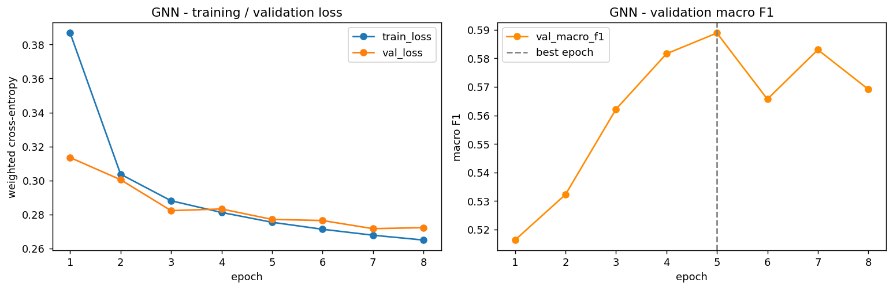
Figure 3. GNN training and validation loss (left) and validation macro F1 (right) in the first GPU run; best epoch 5.

6.3 First results
The first GPU run scored macro F1 0.571, while the tabular model scored 0.654 at that time. Averaging the GNN and tabular probabilities (50/50, chosen before looking at results) gave 0.651, and no weight in a sweep beat the tabular model alone. The GNN did better on Backdoor and Analysis, and worse on DoS and Worms. Since this was a single run on a graph denser than the test graph, we ran the controls below before reading much into it.

6.4 What does the graph contribute? Controlled experiments
We retrained the same GNN with one change at a time, using 5 seeds per condition and the same seeds across conditions. 'No graph' sets the node embeddings to zero so the network sees only the flow's own features. 'Shuffled edges' gives each flow another flow's endpoints, which keeps the graph's shape but removes the real connections.
Condition | Test macro F1 | Validation macro F1
No graph (own features only) | 0.569 ± 0.015 | 0.576
Shuffled edges, matched density | 0.562 ± 0.016 | 0.567
Real graph, dense (full) training graph | 0.579 ± 0.009 | 0.588
Real graph, matched density | 0.585 ± 0.010 | 0.594

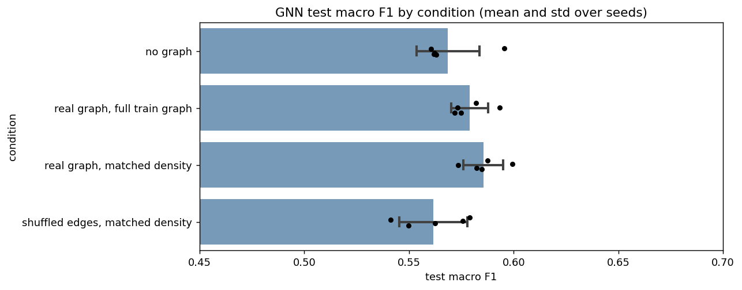
Figure 4. GNN test macro F1 by condition (bars: mean over 5 seeds, dots: single seeds).
- Real graph vs no graph: +0.017 (95% interval +0.008 to +0.024). The difference was positive in all 5 seeds on both test and validation. Without Worms it is +0.010.
- Real graph vs shuffled edges: +0.024 (+0.018 to +0.029).
- Matched density vs the dense training graph: +0.006 (+0.001 to +0.013), and no difference without Worms. An earlier 3-seed comparison on the dense graph had found +0.009 with one negative seed, which in hindsight was too small a test to be conclusive.
Our reading is that the real connections carry a small amount of useful information for this network, on the order of +0.01 to +0.02 macro F1. We cannot say how this would change with a different graph definition.

6.5 Why does the GNN score below the tree model?
The best tree model is 0.084 above the GNN (95% interval 0.073 to 0.095). We checked three possible explanations:
- Two-stage design. A weighted single-stage tree model, the closer comparison for a single-stage network, scores 0.090 above the GNN without a graph (0.076 to 0.103). So the two-stage design does not appear to explain the gap.
- Class-weight strength. We retrained the GNN with the full balanced weights that LightGBM uses. It scored lower (0.544 with graph, 0.521 without), so gentler weights do not appear to explain the gap. The graph still added +0.023 in that setting.
- Graph density. Matching the density changed the score by +0.006 (above), far less than the gap.
One class contributes a large part of the gap. Worms (34 test rows) scores 0.79 with the tree model and 0.31 with the GNN (0.23 without a graph). Without Worms, the gap is 0.040. What remains is probably due to the network itself being less suited than boosted trees to these tabular features, but we did not test this directly (we did not vary the architecture, optimiser or per-feature tuning).
Class | Tree model | GNN (matched density, mean of 5 seeds)
Normal | 0.993 | 0.992
Generic | 0.930 | 0.878
Shellcode | 0.879 | 0.790
Reconnaissance | 0.860 | 0.849
Exploits | 0.827 | 0.785
Worms | 0.787 | 0.305
Fuzzers | 0.611 | 0.582
DoS | 0.458 | 0.232
Backdoor | 0.179 | 0.232
Analysis | 0.172 | 0.211
Macro F1 | 0.670 | 0.585

The GNN scored higher than the tree model on Backdoor and Analysis. We first read this as an effect of neighbour information, but the same network without a graph already scores 0.21 on Backdoor, so most of that difference seems to come from how the network trades recall and precision, not from the graph. Merging or removing Analysis and Backdoor from the scores did not narrow the gap between the two models (it grew from 0.10 to about 0.13).

6.6 Giving the graph information to the tree model
If the graph holds information, a tree model might use it directly. For every flow we added the number of flows at its source and destination endpoint and the average of the other flows' features at each endpoint (92 extra columns, no labels). Train features were computed inside random chunks the size of the test set, so train and test graphs have the same density. We also computed the same columns on a shuffled graph as a control.
Condition | Test macro F1
Flow features only (45) | 0.6695 ± 0.0036
Plus graph features | 0.6709 ± 0.0069
Plus graph features from shuffled edges | 0.6649 ± 0.0058

The change from adding graph features was +0.001 and its sign differed between seeds (-0.005, +0.003, +0.006), so we saw no measurable benefit. In our experiments the graph helped the neural network a little and the tree model not at all.

6.7 A version closer to the original E-GraphSAGE paper
Lo et al. (2022) introduced E-GraphSAGE and tested it on four IoT datasets, not on UNSW-NB15. In the text we read, they compare their results with classifiers from other papers, but we did not find a run of their own model without the graph. We therefore built a second GNN that follows their design more closely than the network in 6.2, and added the same controls.
- The whole graph is processed at once (no neighbour sampling); each node averages over its full neighbourhood.
- 128 hidden units, dropout 0.2, a constant node feature, and a single linear classifier on the two node embeddings. The flow's own features reach the classifier only through the embeddings.
- Differences from the paper: at most 500 full-batch epochs with early stopping on validation macro F1 (the paper trains much longer), a learning rate of 0.003 that we chose without tuning, and our own split.
- Each condition was run with the plain cross-entropy loss used in the paper and with square-root class weights. 3 seeds per condition. 'No graph' means every flow is isolated, so its embedding depends on its own features only.
Condition | Macro F1, plain loss | Macro F1, class weights | Weighted F1
No graph | 0.523 ± 0.001 | 0.600 ± 0.004 | 0.981 / 0.980
Real graph, full train graph | 0.528 ± 0.006 | 0.594 ± 0.008 | 0.981 / 0.980
Real graph, matched density | 0.514 ± 0.007 | 0.592 ± 0.010 | 0.981 / 0.979
Shuffled edges, matched density | 0.511 ± 0.006 | 0.564 ± 0.019 | 0.980 / 0.978
Two-stage LightGBM (reference) | 0.670 | 0.670 | 0.9825

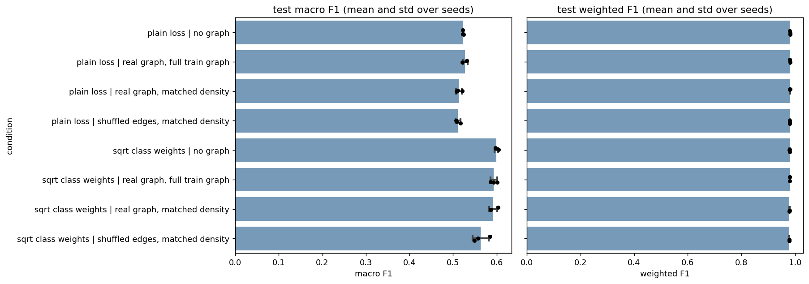
Figure 5. Paper-style E-GraphSAGE: test macro F1 (left) and weighted F1 (right) by condition; bars are means over 3 seeds, dots are single seeds.
- Real graph vs no graph: we saw no gain in this design. With class weights, matched density minus no graph is -0.008 (95% interval -0.016 to -0.001; -0.003 without Worms); with the plain loss it is -0.010 (-0.014 to -0.005). The earlier network (6.4) gained +0.017. Its classifier also receives the flow's own features and it uses sampled neighbours; we did not test which of these differences matters.
- Real graph vs shuffled edges: +0.029 with class weights (+0.014 to +0.041) and +0.002 with the plain loss (-0.001 to +0.007). The shuffled runs were still improving when training stopped, so part of the gap may be slower training on misleading neighbours rather than lower information.
- Class weights: for the no-graph network they add +0.076 macro F1 (+0.065 to +0.088), about the same size as the effect we measured for the tree model in section 5.2.
- Weighted F1 does not separate these models. It lies between 0.978 and 0.982 for every condition and is 0.9825 for the tree model, while macro F1 ranges from 0.51 to 0.67. The only 10-class GNN result on UNSW-NB15 we found in a paper's text (GTCN-G, 0.9512) is a weighted F1 on a 5:2:3 split, so it cannot be compared with our macro F1.
- Gap to the tree model: two-stage LightGBM is 0.070 above the weighted no-graph network (+0.060 to +0.081) and 0.077 above the weighted real-graph network (+0.067 to +0.088).
Our reading is that, with this design and training budget, the real neighbours did not help beyond a network that sees each flow alone. Many runs chose an epoch close to the 500-epoch limit, so longer training could raise all of these scores; we did not test that.

7. Replicating the setup of a published GNN paper
We asked how our results compare with the paper we had targeted, GTCN-G (Xu et al., arXiv 2510.07285). Its authors report weighted F1 on 10-class UNSW-NB15 with a 5:2:3 train/validation/test split, 10 epochs and mini-batches of 500. Its baselines score 0.8756 (E-GraphSAGE), 0.8934 (E-GraphSAGE-M) and 0.9178 (GAT), and GTCN-G scores 0.9512. The paper does not state how the split was made, how the data was preprocessed (duplicates, features, scaling), the loss, the optimizer or the baselines' learning rates, and we found no code. Its Table I gives 700,001 examples for UNSW-NB15 (96.83% Normal), about a third of our 2,042,340 flows (Normal is 95.4% of our test set). An exact replication is therefore not possible. We copied what is stated, chose the rest ourselves, and did not have the authors' GTCN-G (section 7.6 adds our own GTCN-G style implementation).

7.1 Setup
- Data and split: our deduplicated, preprocessed flows (the project's train and test files joined), split at random with stratification into 50% train (1,021,170 flows), 20% validation (408,468) and 30% test (612,702). Every model below uses this same split.
- The paper's UNSW-NB15 data has 700,001 examples (its Table I) and says only that 'the full set of provided instances is used'. Ours has 2,042,340 flows, so the data differs in size and class mix.
- Every choice (number of leaves, class scales, stopping epoch) was made on the validation set, and the test set was used once per model.
- The test set has 584,671 Normal rows and only 51 Worms rows.
- Feature selection and scaling had been fitted on the earlier 80% training part, so some of the new test flows took part in that fitting. We expect the effect to be small but did not measure it.
- We did not run a version that keeps duplicate rows, and only a stratified random split was tried; the paper states neither.

7.2 The paper's baseline on our data
We built an E-GraphSAGE-M style network: two layers, mean aggregation over 8 sampled neighbours per hop, batches of 500 flows, 128 hidden units, dropout 0.2, plain cross-entropy and the Adam optimizer. The paper gives a learning rate of 0.007 for UNSW-NB15 in its shared training settings, so it probably applies to its baselines too. With it, all three seeds collapsed within two epochs to predicting Normal for every flow (weighted F1 0.9319, macro F1 0.098), so we used 0.001, the value of the original E-GraphSAGE. We trained well past the paper's 10 epochs, halving the learning rate whenever validation weighted F1 stalled and stopping after 20 epochs without improvement. 3 seeds.
Test score (mean ± std over 3 seeds) | After epoch 10 | At best validation epoch (35 to 48)
Weighted F1 | 0.9808 ± 0.0009 | 0.9836 ± 0.0002
Macro F1 | 0.536 ± 0.001 | 0.581 ± 0.002
Accuracy | 0.9828 ± 0.0004 | 0.9839 ± 0.0001

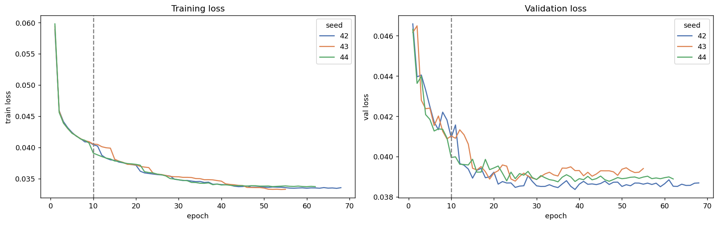
Figure 6. Training and validation loss of the E-GraphSAGE-M style network, 3 seeds. The dashed line marks epoch 10, where the paper stops.
- The losses and the validation F1 are still changing at epoch 10 and settle after roughly epoch 40, so a 10-epoch run stops before the model has converged.
- Weighted F1 is 0.981 to 0.984, far above the 0.8934 that the paper reports for its version of this baseline. We do not know why. Preprocessing, split type, loss and learning rate may all differ, so this should not be read as a better model.
- Per-class F1 at the best epoch: Normal 0.996, Generic 0.896, Shellcode 0.866, Reconnaissance 0.853, Exploits 0.807, Fuzzers 0.588, Worms 0.278, DoS 0.274, Backdoor 0.243, Analysis 0.008.

7.3 What improves on it
On the same split we trained LightGBM in four versions and an improved E-GraphSAGE-M with and without the graph. The improved network adds square-root class weights and gives the classifier the flow's own features; 'no graph' makes every flow isolated. The class scales in the last LightGBM row are per-class multipliers on the predicted probabilities, tuned on validation macro F1. All numbers are test scores, 3 seeds. The intervals are 95% bootstrap intervals over the test set, from the seed-42 predictions.
Model | Weighted F1 | Macro F1 | 95% interval, macro F1
GTCN-G as reported in the paper | 0.9512 | not reported
E-GraphSAGE-M style network (7.2, best epoch) | 0.9836 ± 0.0002 | 0.581 ± 0.002
LightGBM, no class weights | 0.9802 ± 0.0002 | 0.581 ± 0.003 | 0.572 - 0.590
LightGBM, class weights | 0.9815 ± 0.0003 | 0.655 ± 0.001 | 0.645 - 0.667
LightGBM, two-stage, class weights | 0.9820 ± 0.0005 | 0.655 ± 0.001 | 0.643 - 0.665
LightGBM, class weights + tuned class scales | 0.9831 ± 0.0005 | 0.667 ± 0.002 | 0.656 - 0.678
Improved GNN, real graph | 0.9804 ± 0.0000 | 0.610 ± 0.003 | 0.602 - 0.623
Improved GNN, no graph | 0.9809 ± 0.0001 | 0.623 ± 0.003 | 0.612 - 0.632

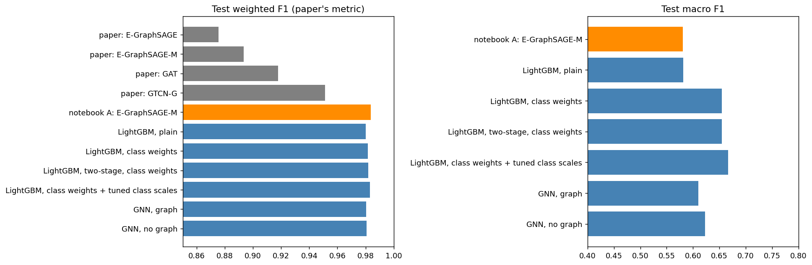
Figure 7. Test weighted F1 (left) and macro F1 (right) on the 5:2:3 split; grey bars are numbers reported in the paper.
Paired differences (bootstrap over the same test rows, seed-42 predictions):
Comparison | Weighted F1 | Macro F1
Class weights minus no class weights (LightGBM) | +0.0014 (+0.0010 to +0.0018) | +0.075 (+0.066 to +0.084)
Two-stage minus single-stage (both weighted) | +0.0006 (+0.0005 to +0.0007) | -0.002 (-0.009 to +0.006)
Tuned class scales minus class weights | +0.0018 (+0.0017 to +0.0020) | +0.012 (+0.006 to +0.017)
Real graph minus no graph (improved GNN) | -0.0006 (-0.0007 to -0.0004) | -0.010 (-0.018 to -0.002)
LightGBM with class weights minus improved GNN with graph | +0.0012 (+0.0010 to +0.0013) | +0.044 (+0.034 to +0.055)

- Weighted F1: every model we trained scores 0.980 to 0.984, above the 0.9512 reported for GTCN-G, including LightGBM without class weights and the network without the graph. The differences among our own models are at most 0.004, so weighted F1 does not separate them. The highest weighted F1 is the E-GraphSAGE-M style network of 7.2 (0.9836), not the tuned LightGBM (0.9831).
- Macro F1: the best model is LightGBM with class weights and tuned class scales (0.667), 0.086 above the network of 7.2. Of the gain over LightGBM without class weights (0.581), class weights give +0.075 and the tuned scales a further +0.012.
- Graph: the real graph did not help the improved GNN; it was slightly worse than the same network without the graph (-0.010 macro F1). This agrees with the paper-style network of section 6.7.
- Two-stage design: no gain on this split, while section 5.2 found +0.011 on the 80/20 split. The effect is not consistent across the two splits.
- Tuned class scales: validation-tuned multipliers added +0.012 macro F1. The Analysis and Normal multipliers reached the edge of the search grid (4.0) in all three seeds, so a wider grid might change the result; we did not test one. Analysis F1 rose from 0.175 to 0.244, while Backdoor fell from 0.182 to 0.176.
- GNN versus trees: LightGBM with class weights is 0.044 macro F1 above the improved GNN with graph. In every model Analysis stays below F1 0.25 and Backdoor below 0.29.

7.4 A stability check of LightGBM
In the unweighted LightGBM, validation log loss rose from the first tree, so early stopping kept only 1 tree in all seeds. A separate run on the same split shows that this is real instability, not an early-stopping artifact: test macro F1 of the unweighted model is 0.581 with 1 tree, 0.532 with 20 trees, 0.398 with 100 and 0.353 with 400. The class-weighted model reaches 0.655 with 200 trees, then collapses to 0.240 with 400 trees (validation log loss 3.86). Early stopping on validation prevents this in our runs. The class-weight gain of about +0.075 is therefore real under our LightGBM settings, but we did not test whether a smaller learning rate or stronger regularisation would stabilise the unweighted model and shrink the gap.

7.5 What we can and cannot say
- On a 5:2:3 split built like the paper's, our models score a weighted F1 of 0.980 to 0.984, above the 0.9512 reported for GTCN-G. A tree model with no graph is among them, so in our data this score does not need a graph.
- We cannot call this an improvement over GTCN-G. We could not reproduce its stated baselines (0.8934 for E-GraphSAGE-M against our 0.981), and the paper leaves out its preprocessing, split type and loss, and its data has about a third as many flows as ours. The gap probably reflects those differences.
- On macro F1, which the paper does not report, validation-tuned class scales on a class-weighted LightGBM gave the best result (0.667).
- Limits: one dataset, one stratified random split, no run with duplicate rows, the authors' GTCN-G not available (section 7.6 uses our own implementation), the three LightGBM seeds differ only through the histogram binning sample (there is no row or feature sampling), so their spread understates real variation.

7.6 The paper's own data, a GTCN-G style model and the minority classes
The paper's Table I lists 700,001 UNSW-NB15 flows with 96.83% Normal. The first raw file, UNSW-NB15_1.csv, has exactly 700,001 rows and the same class shares as the paper's Table II for all ten classes; the other three files do not match. We repeated the work on the flows of that file (637,891 after our duplicate removal, 97.9% Normal; stratified 5:2:3 split, 3 seeds). Full details are in UNSW-NB15-GTCN-G-Comparison.docx.
- Predicting Normal: a model that predicts Normal for every flow has a weighted F1 of about 0.953 on the paper's class mix (our calculation from 96.83%). The paper reports 0.9512 for GTCN-G and 0.8756 to 0.9178 for its baselines, all below that. This assumes the paper's test set has about its class mix.
- Baseline on the paper's data: our E-GraphSAGE-M style network scores weighted F1 0.9928 ± 0.0002 and macro F1 0.562 ± 0.008 (paper: 0.8934 for this baseline).
- A GTCN-G style model (our own implementation, simplified): weighted F1 0.9925 ± 0.0001 and macro F1 0.550 ± 0.004, not better than the simple network (full minus baseline -0.0002, interval -0.0004 to 0.0000). Without the residual branch, which carries the flow's own features, macro F1 falls by 0.11; attention, the temporal branch and the graph convolution show no measurable effect; real neighbours add about 0.001 weighted F1 over isolated flows.
- Loss changes for the minority classes: square-root weights, balanced weights and a logit-adjusted loss did not raise macro F1 beyond the noise of the seeds (0.549 to 0.567 against 0.554 for the plain loss; seed standard deviation 0.018). Analysis and Backdoor stay near 0.2.
- Possible reason: 81% of Analysis flows and 85% of Backdoor flows have an identical-feature twin of another class (paper subset), and no rule that uses only these features can exceed about 0.38 (Analysis) and 0.37 (Backdoor) F1 on them, in sample. A change of loss cannot recover information the features do not contain; our models reach about 0.2, so the overlap explains part of the shortfall, not all of it.
- Limits: the authors' model and code were not available; the paper's file is inferred from row count and class mix; duplicates were removed here and probably not in the paper (no run with duplicates kept); 3 seeds; Worms has 24 flows in the subset.

8. Summary of results
Model | Macro F1 | 95% interval
Two-stage LightGBM, original data, balanced weights | 0.670 ± 0.004 | 0.658 - 0.679
Single-stage LightGBM, balanced weights | 0.658 ± 0.002 | 0.646 - 0.669
Two-stage LightGBM + SMOTE rows | 0.654 ± 0.002 | 0.641 - 0.667
Two-stage LightGBM without the 3 TTL features | 0.653 ± 0.003
Single-stage LightGBM, no class weights (like the first baseline) | 0.582 ± 0.004 | 0.573 - 0.591
Two-stage LightGBM + graph features | 0.671 ± 0.007
GNN, real graph, matched density | 0.585 ± 0.010 | 0.576 - 0.595
GNN, graph switched off | 0.569 ± 0.015 | 0.556 - 0.581
GNN, shuffled edges | 0.562 ± 0.016 | 0.552 - 0.571
Paper-style E-GraphSAGE, class weights, no graph | 0.600 ± 0.004 | 0.589 - 0.610
Paper-style E-GraphSAGE, class weights, real graph (matched density) | 0.592 ± 0.010 | 0.581 - 0.601
Paper-style E-GraphSAGE, plain loss, no graph | 0.523 ± 0.001 | 0.517 - 0.529

What the evidence suggests
- On this data, a gradient-boosted tree model with class weights was the strongest approach we tried. Class weighting made the biggest difference, the two-stage design a smaller one, and synthetic rows did not help.
- Analysis and Backdoor stayed near F1 0.17 in all models. The high share of rows with identical features and different labels is one reason, but it does not explain everything: a rule that memorises the most common label of each group would reach only about F1 0.36 on them.
- The flow graph gave one GNN a small gain (+0.017) but gave a second, paper-style GNN none, and gave the tree model none. Any graph signal we found is small and depends on the design; both GNNs stayed below the best tree model.
- Weighted F1, the headline metric of three GNN papers we read in full, was 0.978 to 0.9825 for our paper-style GNN and best LightGBM and cannot tell them apart. Macro F1 and per-class F1 show the differences.
- On a 5:2:3 split like the one in the GTCN-G paper (section 7), all our models scored a weighted F1 of 0.980 to 0.984 against its reported 0.9512, including a tree model with no graph. We could not reproduce the paper's baselines (our E-GraphSAGE-M scored 0.981 where it reports 0.8934), so we do not call this an improvement. The best macro F1 on that split was 0.667.

Limits
- One train/test split. 3 seeds for the tree models and 5 for the GNN. The bootstrap intervals show test-set sampling noise, not the effect of a different split.
- The final model was chosen using test macro F1 among five variants, so 0.670 may be slightly optimistic. We did not keep a second untouched test set for the choice.
- Worms has 34 test rows, so its F1 is noisy; we give results without Worms where it matters.
- We tried one graph definition ((IP, port) nodes, no time information) and two GNN designs without tuning; the paper-style one was trained for at most 500 full-batch epochs and many runs stopped near that limit. We ruled out three explanations for the gap to the tree model but did not identify the remaining cause.
- Our scores are not directly comparable with published numbers, because protocols differ (we remove duplicates, use all 2.5M flows and a random split).
- Section 7 uses a different split (5:2:3) from the rest of the report (80/20), so its numbers cannot be set beside the table above. It is not an exact replication of the paper, because several settings are not stated, and the authors' GTCN-G was not available (section 7.6 uses our own implementation).

Appendix: notebooks (all run on Kaggle)
Notebook | Purpose
unsw-nb15-preprocessing | Cleaning, feature selection, transforms, label-overlap check, export
unsw-nb15-baseline | RF, LightGBM, XGBoost, MLP, two-stage model, ensemble
unsw-nb15-gnn | Graph building, graph visuals, E-GraphSAGE, fusion
unsw-nb15-design-controls | Class weights, two-stage design and SMOTE rows compared
unsw-nb15-ttl-ablation | Best tabular model with and without the TTL features
unsw-nb15-gnn-density | GNN with matched train/test graph density; no-graph and shuffled controls
unsw-nb15-gnn-weights | GNN with full balanced class weights
unsw-nb15-egraphsage | Paper-style E-GraphSAGE with no-graph, shuffled and matched-density controls
unsw-nb15-graph-features | Graph features for LightGBM
unsw-nb15-bootstrap | Test-set bootstrap intervals and paired differences
unsw-nb15-paper-split-replication | E-GraphSAGE-M style baseline on the 5:2:3 split of the GTCN-G paper, with training curves
unsw-nb15-paper-split-improved | LightGBM variants and an improved E-GraphSAGE-M (with and without the graph) on the same split, with bootstrap intervals
unsw-nb15-plain-lightgbm-check | Test macro F1 of LightGBM against the number of trees, with and without class weights
unsw-nb15-gnn-vs-tabular, unsw-nb15-gnn-ablation | Earlier GNN analyses (the second superseded by gnn-density)

A longer chronological log of every trial is in analysis.md.

