📘 CLIPORA.AI
AI Video Repurposing SaaS
Platform: Replit Core
Stack: React + Tailwind + FastAPI + Open Source AI
🔵 1. Project Overview
1.1 Vision
Clipora.ai is an AI-powered web SaaS that automatically converts long-form videos into short-form viral clips with subtitles, highlights, and optimized formatting for social platforms. It is built entirely on free and open-source tools with Replit as the platform.
1.2 Objectives
The primary objectives of Clipora.ai are:
- O1 — Automate conversion of long-form videos into short-form clips using AI.
- O2 — Provide automatic transcription using open-source speech models.
- O3 — Detect highlight moments using AI-based scoring.
- O4 — Auto-generate vertical (9:16) optimized social-ready videos.
- O5 — Generate subtitles, captions, titles, and hashtags automatically.
- O6 — Implement a scalable job queue system for video processing.
- O7 — Provide secure user authentication and role-based access.
- O8 — Deliver a production-ready SaaS architecture deployable on Replit.
- O9 — Enable monetization via subscription plans.
1.3 Core Features
- Accept video uploads (MP4, MOV, MKV).
- Process video using AI models.
- Generate short clips automatically.
- Add dynamic captions.
- Auto crop to vertical (9:16) format.
- Generate titles & descriptions.
- Allow export & download.
1.4 Target Users
Clipora.ai is designed for:
- Content Creators
- YouTubers
- Podcasters
- Social Media Influencers
- Marketing Agencies
- Educational Creators
- Streamers
- Startup Marketing Teams
Target Segment:
- Small & Medium Creators
- Budget-conscious users
- Users who cannot afford expensive tools like Opus or Descript
1.5 Business Model
- Free: 3 videos per month.
- Pro: Unlimited, Priority processing.
- Future/Enterprise: API access, White label license.

🔵 2. System Architecture
2.1 High-Level Architecture Diagram
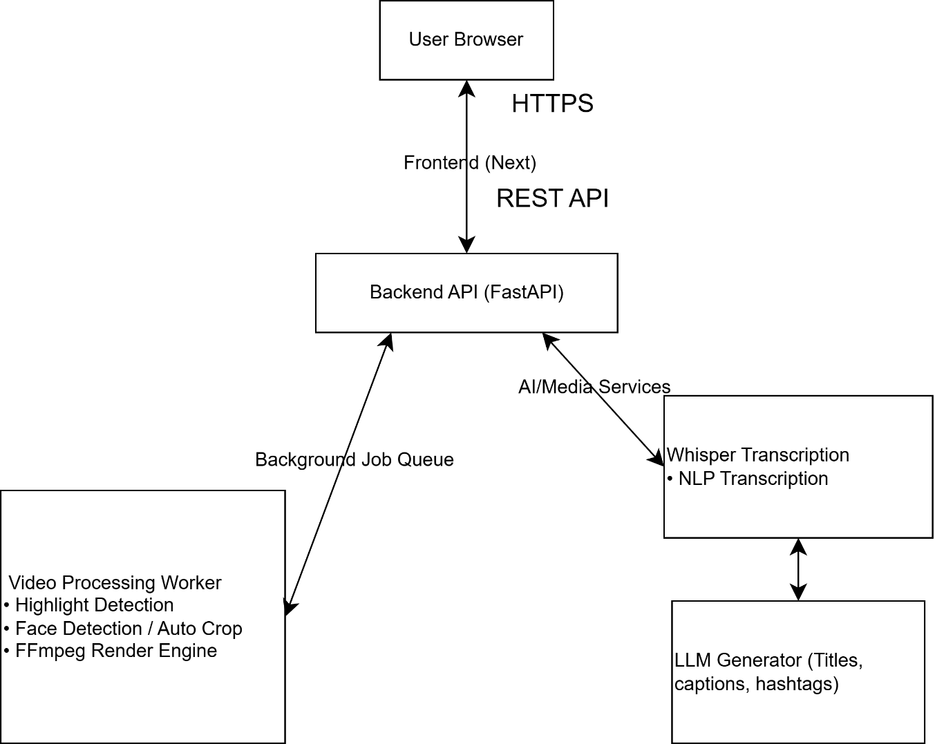
2.2 System Flow (Upload → AI → Process → Render → Download)
- User uploads video.
- Job created in DB (status=pending).
- Background Worker checks job table.
- Worker processes video (Transcription → Highlight Detection → FFmpeg Rendering).
- Job updated → completed.
- Temporary File Download link generated (expires after 24 hours).
2.3 Component Interaction
System components interact as follows:
Component Communication:
- Frontend → Sends API Requests
- Backend → Creates Job
- Worker → Processes Job Async
- Worker → Updates Job Status
- Frontend → Polls Job Status

2.4 Infrastructure Design (Replit Based)
- Public Domain: https://clipora.repl.co (or custom domain attached later).
- Networking: Uses Replit's built-in networking.
- Security: HTTPS enabled by default via Replit firewall.
- Execution: No manual server config needed; modular processing and Docker-compatible background task queue.

🔵 3. Technology Stack
3.1 Frontend Stack
- React
- Next.js
- TailwindCSS
- Axios (API calls)
- React Context (State/Auth)
3.2 Backend Stack
- Python
- FastAPI
- Uvicorn
3.3 AI Tools & Models
- Speech to Text: Whisper (OpenAI open-source model run locally).
- LLM: Mistral 7B / Llama (local via Ollama) or HuggingFace inference API.
- Face/Focus: OpenCV, MediaPipe.
3.4 Video Processing Tools
- FFmpeg (Installed in Replit environment via ffmpeg-python).
3.5 Database
- PostgreSQL (Best Option) OR SQLite (Selected for MVP).
3.6 Storage
- Replit File System (temporary storage for uploads & clips).
- Later move to cloud storage.
3.7 Authentication
- JWT (JSON Web Tokens via python-jose).
- Password Hashing (bcrypt).
3.8 Networking
- Replit Core (built-in HTTPS).

🔵 4. Technical Architecture
4.1 Folder Structure (Frontend + Backend)
Plaintext
clipora.ai/
│
├── backend/
│ ├── main.py
│ ├── config.py
│ ├── database.py
│ ├── models.py
│ ├── schemas.py
│ ├── auth.py
│ ├── worker.py
│ ├── routes/
│ │ ├── auth_routes.py
│ │ ├── video_routes.py
│ │ └── clip_routes.py
│ ├── services/
│ │ ├── user_service.py
│ │ ├── video_service.py
│ │ └── clip_service.py
│ ├── ai/
│ │ ├── transcribe.py
│ │ ├── highlight.py
│ │ └── renderer.py
│ └── utils/
│ └── security.py
│
├── frontend/src/
│ ├── api/
│ ├── context/
│ ├── pages/
│ ├── components/
│ ├── App.jsx
│ └── main.jsx
│
├── storage/
│ ├── uploads/
│ ├── transcripts/
│ ├── clips/
│
├── requirements.txt
├── .env
└── README.md
4.2 Project Directory Explanation
backend/
Folder/File | Purpose
main.py | Entry point of API
database.py | DB connection
models.py | ORM table definitions
schemas.py | API request/response models
worker.py | Background job processor
auth.py | JWT auth logic
routes/ | API route handlers
services/ | Business logic
ai/ | AI processing modules
utils/ | Helper functions

4.3 API Design Structure
- Authentication: /api/auth/register, /api/v1/auth/login, /api/auth/me
- Video APIs: /api/videos/upload, /api/videos/list, /api/videos/{id}, /api/videos/{id}/process
- Clip APIs: /api/videos/{id}/clips, /api/videos/{id}/clips/download/{clipId}, /api/clips/{id}, /api/clips/{id}/delete
4.4 Background Worker Design
Operates via worker.py that continuously checks the DB for pending jobs every 5 seconds, processes the transcription, highlight detection, and rendering, and updates the database record upon completion or failure.
4.5 Job Queue System
Prevents API freezing and server crashing by moving heavy processing (Whisper, FFmpeg) into an async background worker using a database-tracked pending/processing/completed queue.

🔵 5. Frontend System (React + Tailwind)
5.1 Frontend Setup Instructions
Bash
cd frontend
npm create vite@latest .
npm install
npm install axios react-router-dom jwt-decode
npm install -D tailwindcss postcss autoprefixer
npx tailwindcss init -p
Tailwind Config Setup:
JavaScript
// tailwind.config.js
export default {
content: ["./index.html", "./src/**/*.{js,jsx}"],
theme: { extend: {} },
plugins: [],
}
5.2 Routing Structure
Uses react-router-dom in App.jsx with routes mapped to:
- /login
- /register
- /dashboard (Protected)
- /upload (Protected)
5.3 Authentication System
Authentication is handled using JWT tokens issued by the backend.
Tokens are stored inside HttpOnly, Secure cookies to prevent XSS attacks.
The frontend does NOT store tokens in localStorage.
Instead:
- Browser automatically sends cookies with each request.
- Backend validates the token on every protected API call.
Authentication state in the frontend is determined by calling:
GET /api/auth/me
to verify the session.
5.4 Dashboard UI
Fetches the user's uploaded videos from /videos/list on mount and maps them into a CSS grid. Includes basic Tailwind styling.
5.5 Upload Interface
A file selector that uses FormData to append the file and post it to the /videos/upload API.
5.6 Video Detail Page
The Video Detail Page displays:
- Video Preview
- Processing Status
- Job Progress
- Generated Transcript
- Generated Clips
- Download Button
Features:
✔ Shows job status (pending / processing / completed / failed)
✔ Displays progress percentage
✔ Shows detected clips
✔ Allows user to edit clip start/end time
✔ Allows manual clip regeneration
UI Elements:
- Video Player
- Transcript Viewer
- Clip Timeline
- Refresh Button
API Used:
GET /api/videos/{id}
GET /api/videos/{id}/clips
GET /api/jobs/{job_id}
5.7 Clip Gallery Page
Purpose:
Display all processed clips for a specific video.
Features:
- Grid layout of clips
- Preview each clip
- Download individual clip
- Delete clip
- Edit clip metadata
UI:
Clip Thumbnail
Score
Duration
Download Button
Delete Button
API:
GET /api/videos/{id}/clips
DELETE /api/clips/{clip_id}
5.8 API Integration Layer
Centralized in src/api/axios.js using axios.create(). Configures a baseURL and attaches an interceptor to insert the Bearer token from localStorage into all headers automatically.
5.9 State Management
Uses standard React Context API (AuthContext) combined with localized component state (useState, useEffect).
5.10 UI Components Architecture
Components referenced include Navbar.jsx, PrivateRoute.jsx, and Loader.jsx. Incorporates Tailwind for gradient backgrounds, hover animations, and toast notifications.

🔵 6. Backend System (FastAPI)
6.1 Backend Setup Instructions
Bash
pip install fastapi uvicorn whisper openai opencv-python ffmpeg-python python-multipart sqlalchemy bcrypt python-jose
sudo apt install ffmpeg
6.2 Application Entry Point
backend/main.py defines the FastAPI app, attaches routing prefixes (/api/auth, /api/videos, /api/clips), and sets up a root testing endpoint.
6.3 Routing Architecture
Routers are broken up logically into auth_routes.py, video_routes.py, and clip_routes.py and included in main.py using app.include_router().
6.4 Authentication Module
Handled securely with bcrypt for password hashing and python-jose for JWT signing. Exposes /register and /login via auth_routes.py.
router = APIRouter(prefix="/api/v1/auth")
router = APIRouter(prefix="/api/v1/videos")
router = APIRouter(prefix="/api/v1/jobs")
6.5 User Management
Managed via SQLAlchemy ORM mapped to the users table.
6.6 Video Management
Managed via SQLAlchemy ORM mapped to the videos table. Connects to temporary storage routing.
6.7 Clip Management
Managed via SQLAlchemy ORM mapped to the clips table.
6.8 Processing Controller
Exposed at /{video_id}/process in video_routes.py. It instantiates a new pending Job in the database to be picked up by the worker.
6.9 Service Layer Structure
We separate business logic from API routes.
Structure:
services/
File | Purpose
user_service.py | User creation/login
video_service.py | Video processing logic
clip_service.py | Clip creation/update
job_service.py | Job lifecycle handling
Why?
✔ Clean architecture
✔ Easy testing
✔ Scalable
Routes call services — Services call DB + AI.

🔵 7. Database Design
7.1 Database Type (SQLite / PostgreSQL)
During MVP development, SQLite is used for rapid prototyping.
However, before production deployment, the system will migrate to PostgreSQL to handle:
- Concurrent writes from background workers
- Multi-user access
- Production-level scalability
- Transaction safety
Migration Strategy:
- Develop using SQLite
- Replace connection engine with PostgreSQL
- Use Alembic for schema migrations
- Test concurrency with simulated worker load
7.2 ER Diagram
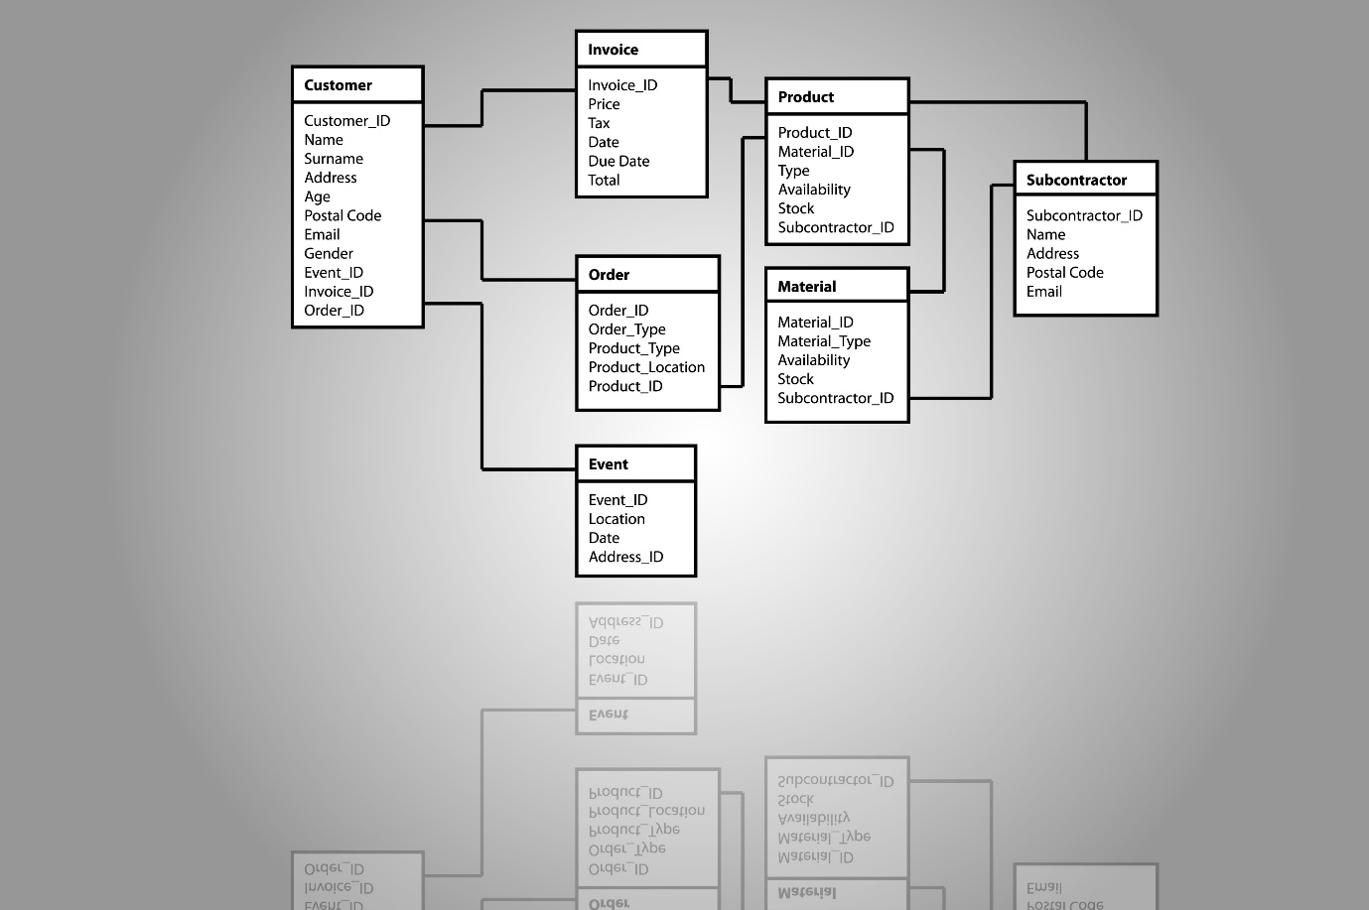
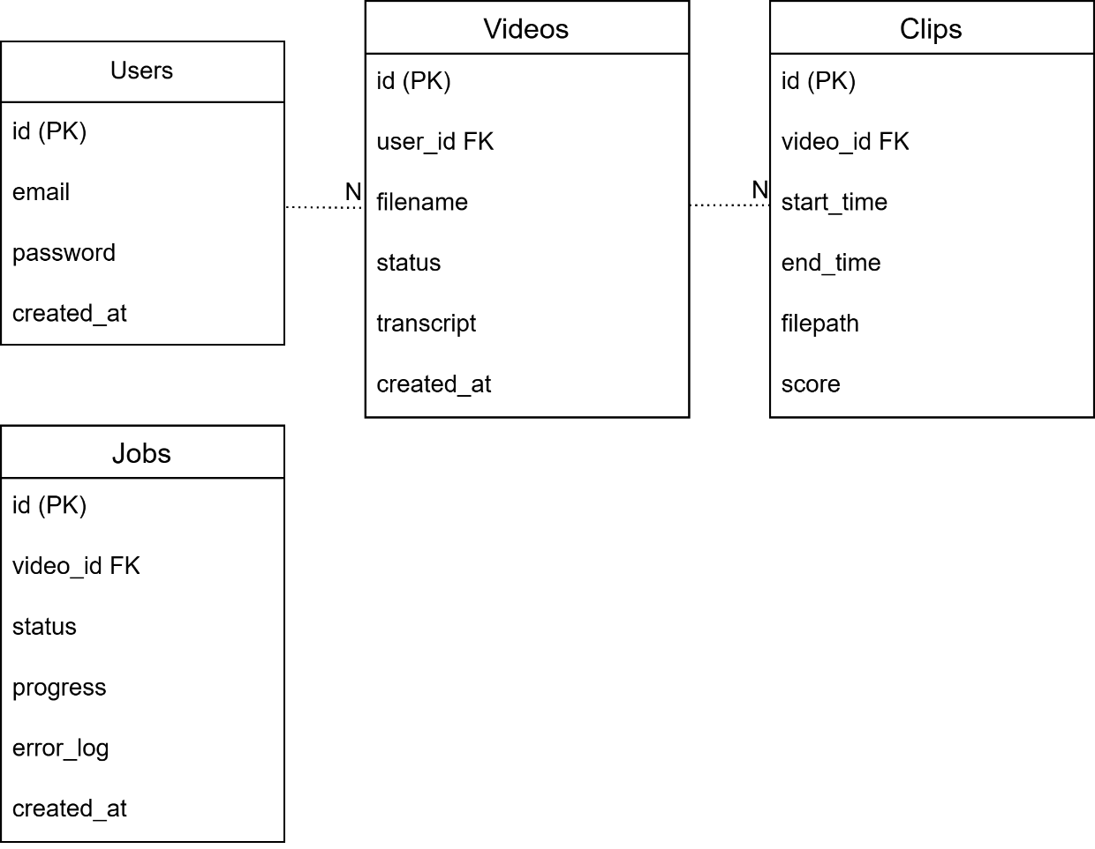
7.3 Table Definitions
- Users: Stores authentication credentials and timestamps.
- Videos: Stores upload metadata, processing status, and transcript paths. Maps to user.
- Clips: Stores generated clip metadata, start/end times, internal file paths, and algorithmic score.
- Jobs: Tracks asynchronous worker progress and error logs.
7.4 Schema Models
Defined in backend/models.py using SQLAlchemy declarative_base(). It features standard relationships using back_populates between User, Video, Clip, and Job.
7.5 Migrations Strategy
Since we use SQLite (MVP):
During MVP development, SQLite is used for fast iteration.
However, before scaling, migration to PostgreSQL will be performed.
Migration Process:
- Freeze current schema version.
- Generate migration files using Alembic.
- Export data from SQLite.
- Import into PostgreSQL.
- Test concurrency with simulated worker jobs.
All future schema changes will use Alembic migration scripts instead of manual edits.

Phase 2 — Production
Use:
Alembic
Migration workflow:
alembic revision --autogenerate -m "add column"
alembic upgrade head
Benefits:
✔ Safe schema updates
✔ Version control for database

🔵 8. AI Processing Engine
8.1 Transcription Engine (Whisper)
Uses the whisper library locally (model = whisper.load_model("base")) to transcribe video and return text.
8.2 Highlight Detection Algorithm
Splits transcripts by sentences and loops through arrays checking for keyword matches to extract highly engaging quotes, returning a list of clips.
Future Upgrade:
Highlight detection will incorporate visual signal analysis including:
- Frame difference detection
- Motion intensity scoring
- Scene change detection
- Face tracking confidence
These visual metrics will be combined with transcript keyword scoring to improve accuracy.
8.3 Keyword Scoring Logic
Simple NLP scoring checks for words like ["important", "crazy", "amazing", "insane"], assigning arbitrary scores (e.g., 80) if matched. Intended to be improved with heavier NLP sentence emotion weighting.
8.4 Silence Detection
Achieved via FFmpeg capabilities.
8.5 LLM Title Generation
Uses Mistral 7B or Llama (local via Ollama) or HuggingFace inference API to generate titles, hashtags, and descriptions.
8.6 Subtitle Generator
Subtitle Generator Workflow:
Input:
- Transcript with timestamps
Process:
- Split transcript into chunks
- Assign timestamp to each sentence
- Convert to SRT format
Example Output:
1
00:00:01,000 --> 00:00:04,000
This is a subtitle example
Implementation:
Generate transcript
→ Convert to timestamp format
→ Write .srt file
→ Attach to video via FFmpeg
8.7 Auto Caption Formatting
Enhancements:
- Break long sentences into readable chunks
- Limit words per line (max 5–7 words)
- Highlight keywords
- Animate words individually
Tech:
- Text parsing
- Word grouping
- Subtitle styling
Rendering:
FFmpeg filter:
subtitles=subtitle.srt:force_style='FontSize=24'
8.8 Virality Scoring Engine
Goal:
Score each clip based on potential virality.
Scoring Factors:
- Emotional words frequency
- Loudness spikes
- Audience engagement keywords
- Sentence intensity
- Duration (30s–90s ideal)
Algorithm:
Score = (EmotionWeight * 0.3)
+ (KeywordScore * 0.3)
+ (AudioSpikeScore * 0.2)
+ (RetentionScore * 0.2)
Output:
Clip gets:
virality_score: 82/100
Displayed in Clip Gallery.

🔵 9. Video Processing Engine
9.1 FFmpeg Integration
Integrates using the ffmpeg-python wrapper. Utilized for cropping, audio extraction, encoding, and subtitle overlay.
9.2 Auto Crop to 9:16
Uses FFmpeg scaling filters (.filter('scale', 1080, 1920)) in combination with OpenCV and MediaPipe for face tracking/focus.
9.3 Subtitle Overlay
Executed natively via FFmpeg command: ffmpeg -i video.mp4 -vf "subtitles=transcript.srt" clip_out.mp4
9.4 Audio Extraction
Supported natively via FFmpeg module.
9.5 Clip Rendering
Controlled via renderer.py. Loops through the detected clips array, trims using .trim(start, duration), and runs overwrite_output=True to save discrete .mp4 chunks.
9.6 File Compression
Before serving download:
Use FFmpeg:
ffmpeg -i input.mp4 -vcodec libx264 -crf 28 output.mp4
Compression Goals:
- Reduce file size
- Maintain quality
- Optimize for social media
Auto compression after clip rendering.
9.7 Temporary File Cleanup
Temporary files (uploads, intermediate renders, transcripts) are automatically deleted after 24 hours or after successful processing.
Additionally:
- A background cleanup task runs every 6 hours.
- It scans storage folders for expired files.
- Deletes orphaned files if job status = completed.

🔵 10. Background Job & Queue System
10.1 Why Async Processing is Required
Video processing (Transcription, highlight detection, rendering) is extremely heavy. If run in the request thread, it will freeze the API and crash the server.
10.2 Job Lifecycle
- User uploads video.
- Job is initialized as pending.
- Worker picks it up, updates to processing.
- Finishes tasks, updates to completed (or failed).
Job state transitions are strictly controlled:
- pending → processing → completed
- pending → processing → failed
The worker updates progress in the database every processing stage so the frontend can poll live status.
10.3 Job Status Tracking
Handled inside the SQLite database via the Jobs table utilizing the status, progress (Float), and error_log fields.
10.4 Worker Implementation
A standalone script (backend/worker.py) that runs an infinite while True: loop, querying the database every 5 seconds for pending jobs and orchestrating the AI processing engine. Run separately via python backend/worker.py.
10.5 Error Handling
Handled inside worker.py utilizing a try/except block. If an exception is caught, the job status is updated to failed and the exception string is saved directly to the database error_log column.
Error Codes Table:
Code | Meaning
4001 | Invalid file
4002 | Upload failed
5001 | Worker crash
4010 | Authentication expired

10.6 Retry Mechanism
Used in Job Worker.
If processing fails:
Retry Strategy:
Attempt 1 → Wait 5s
Attempt 2 → Wait 10s
Attempt 3 → Wait 30s
If still failing:
→ Mark job as FAILED
→ Log error
Implementation:
max_retries = 3
retry_count += 1
10.7 Worker Scaling Strategy
Currently, the worker runs as a single background process polling the database.
Future Scaling:
- Multiple worker instances can run simultaneously.
- Each worker locks a job before processing.
- PostgreSQL row-level locking prevents double processing.
Long-term upgrade:
- Replace polling with Redis-based queue.
- Or migrate to Celery distributed task system.

🔵 11. Security Architecture
11.1 Authentication (JWT)
Clipora.ai uses JWT-based authentication. Tokens are generated on successful login and stored inside HttpOnly, Secure cookies to prevent XSS attacks.
The cookie is:
- HttpOnly → Not accessible via JavaScript
- Secure → Sent only over HTTPS
- SameSite=Strict → Protects against CSRF
Backend validates the token on every protected API request.
11.2 Password Hashing (bcrypt)
Users are protected by never storing plain passwords. Handled by the backend bcrypt library.
11.3 File Validation
Backend enforces checks on file type (MP4/MOV/MKV), file size limits (2GB default), and scans for malicious scripts prior to processing.
11.4 Upload Security
Ensured via file size limits configured in backend middleware.
11.5 API Protection
APIs are protected using a JWT verification middleware shield, allowing only authorized requests.
11.6 Rate Limiting
Enforces a maximum of 5 uploads per hour per user using request middleware.
11.7 CORS Policy
Restricts API requests strictly to the defined frontend domain to prevent outside execution.
11.8 Secret Management
Secrets like the JWT_SECRET are kept strictly in the Replit Secrets Manager and pulled securely into the environment.
11.9 File Expiry Strategy
Generated temporary file links are programmed to expire/auto-delete after 24 hours.
11.10 Session Management Strategy
Clipora.ai uses cookie-based session authentication.
Token Handling:
- JWT is generated on login.
- Stored inside HttpOnly cookie.
- Cookie is Secure and SameSite=Strict.
- Expiration set to 1 hour (configurable).
Session Validation:
- Backend middleware validates cookie token.
- Invalid tokens are rejected with 401 error.
This prevents token theft via JavaScript injection.
11.11 Rate Limiting Implementation
Rate limiting prevents abuse of upload and processing APIs.
Strategy:
- Maximum 5 uploads per hour per user.
- Implemented via middleware.
- Stored counters in memory (MVP) or Redis (future upgrade).
If user exceeds limit:
- API returns 429 Too Many Requests.
- User receives error message in frontend.

🔵 12. Networking & Deployment
12.1 Replit Deployment
- Create Python Repl. Enable "Always On".
- Add environment dependencies via requirements.txt.
- Set secrets in the Secrets Manager.
- Setup folder structure properly and initialize the background worker script alongside the web server.
12.2 HTTPS Configuration
Automatically provided by Replit. No manual SSL certification setup is needed.
12.3 Custom Domain Setup
Default domain is .repl.co. Custom domains can be attached easily through the Replit workspace networking tab.
12.4 Environment Variables
Keys like JWT_SECRET are defined securely in Replit.
12.5 Production Mode Setup
Executed via: uvicorn backend.main:app --host 0.0.0.0 --port 8080
12.6 Scaling Strategy
When users grow:
Phase 1 — Single Server
Phase 2 — Separate Worker Server
Phase 3 — Add GPU Instance
Phase 4 — Add Load Balancer
Improvements:
- Move to PostgreSQL
- Add Redis Queue
- Use Docker Containers
- Horizontal Scaling
12.7 Database Production Upgrade
Before public launch, the database will be migrated from SQLite to PostgreSQL.
PostgreSQL will be hosted either:
- On a managed cloud database service
- Or inside a separate containerized instance
Benefits:
- Better concurrency handling
- Improved write performance
- Better reliability for async workers
12.8 CI/CD Pipeline
Clipora.ai will implement automated deployment via:
- GitHub Actions
- Automatic testing before deployment
- Auto build verification
Deployment Flow:
Code pushed → Tests run → Build validated → Deployed to Replit

🔵 13. API Documentation
13.1 Authentication APIs
- POST /api/v1/auth/register
- POST /api/v1/auth/login
- GET /api/v1/auth/me
13.2 Video APIs
- POST /api/v1/videos/upload
- GET /api/v1/videos/list
- GET /api/v1/videos/{id}
- POST /api/v1/videos/{id}/process
13.3 Clip APIs
- GET /api/v1/videos/{id}/clips
- GET /api/v1/videos/{id}/clips/download/{clipId}
- GET /api/v1/clips/{id}
- DELETE /api/v1/clips/{id}/delete
13.4 Job APIs
Missing APIs:
GET /api/v1/jobs/{job_id}
GET /api/v1/jobs/user
GET /api/v1/jobs/status/{job_id}
DELETE /api/v1/jobs/{job_id}
Purpose:
Allow frontend to poll job status.
Response:
{
"id": 1,
"status": "processing",
"progress": 45
}
13.5 Error Response Format
Standard Error Format:
{
"success": false,
"error": "Invalid token",
"code": 401
}
Rules:
- Always include error message
- Always include HTTP status
- Never return stack traces in production
13.6 Success Response Format
Standard Response:
{
"success": true,
"data": {},
"message": "Video processed successfully"
}
Uniform API structure.
13.7 API Versioning Policy
Clipora.ai APIs follow versioning to prevent breaking changes.
Current Version:
/api/v1/
Future API versions:
/api/v2/
Versioning ensures backward compatibility when updating authentication or processing logic.

🔵 14. Frontend–Backend Communication
14.1 Axios Configuration
Configured in src/api/axios.js to create a standard base instance using the Replit URL backend string.
14.2 Token Handling
Utilizes Axios interceptors to automatically check localStorage for token and attach it as a Bearer token into the Authorization header of outgoing requests.
14.3 Error Handling Strategy
Backend:
- Try / Except blocks
- Log errors
- Update job status = failed
- Store error_log in DB
Frontend:
- Show toast message
- Retry button
Never crash application.
14.4 Loading States
Implemented visually utilizing loading spinners and component toast notifications.
14.5 Real-Time Job Polling
Frontend:
Every 3 seconds:
GET /api/jobs/{job_id}
Update:
- Progress bar
- Status
- UI
Future Upgrade:
Replace polling with WebSockets.

🔵 15. Performance Optimization
15.1 Processing Optimization
Processes video asynchronously utilizing background thread workers and chunk video processing.
15.2 Caching Strategy
Cache:
- Transcripts
- Highlight results
- Generated titles
Use:
- Redis (Future)
- Or Memory Cache (MVP)
Benefit:
Reduce AI recomputation.
15.3 Memory Management
Important for video processing.
Rules:
- Delete temporary files after processing
- Delete raw uploads after 24h
- Clear FFmpeg temp buffers
- Free model memory after use
Prevents RAM overflow.
15.4 File Storage Optimization
Deletes temporary files actively after processing to prevent filling up Replit volume thresholds.
15.5 API Optimization
Protects standard thread blocks by passing heavy logic to an Async task queue.
15.6 Storage Capacity Management
To prevent uncontrolled disk usage:
- Each user has a storage quota limit.
- Uploaded files are auto-deleted after processing.
- Temporary files expire after 24 hours.
- Background cleanup job runs every 6 hours.
Future Upgrade:
- Implement per-user storage quota tracking.
- Block uploads if user exceeds allocated storage.
🔵 16. Testing Strategy
16.1 Backend Unit Testing:
Using pytest.
Test:
- User registration
- Login
- Video upload
- Job creation
Command:
pytest backend/tests/
16.2 API Testing (Postman):
Test:
- All endpoints
- Authentication
- Job polling
Export collection for documentation
16.3 AI Engine Testing:
Test:
- Transcription accuracy
- Highlight detection
- Virality scoring
Input: Sample video
Output: Validate manually
16.4 Video Processing Testing:
Test:
- FFmpeg rendering
- Subtitle overlay
- Compression
- Corrupted file handling
16.5 Frontend Testing:
Test:
- Navigation
- Auth protection
- Upload flow
- Job polling
- Error handling
Use:
- Manual testing
- Jest (Future upgrade)

🔵 17. Monitoring & Logging
17.1 Error Logging:
Log:
- API errors
- Worker failures
- AI errors
Store logs in:
logs/app.log
17.2 System Logs:
Track:
- CPU usage
- Memory
- Job duration
Use:
- Replit logs
- Or custom logging system
17.3 Performance Monitoring:
Monitor:
- Processing time
- Queue delay
- Memory spikes
Future:
Use Prometheus + Grafana.
17.4 Crash Handling:
If worker crashes:
- Auto restart
- Detect incomplete jobs
- Resume processing
17.5 Debug Mode:
Environment variable:
DEBUG=True
When enabled:
- Print logs
- Show stack traces
- Disable production security filters

🔵 18. Monetization Model
18.1 Free Plan
3 videos per month.
18.2 Pro Plan
Unlimited capacity with Priority processing.
18.3 Subscription Logic
Plan Table:
Plan | Limits
Free | 3 videos
Pro | Unlimited
Enterprise | API access
Backend:
Store plan in user table.
Check before processing:
If user.plan == "free":
Check usage count
18.4 Payment Integration (Future)
Integrate:
Stripe
- LemonSqueezy
Flow:
User clicks upgrade
→ Redirect to payment
→ Payment success webhook
→ Upgrade plan
18.5 API Monetization
Future plans include offering developer API access and White label software licensing.

🔵 19. Future Enhancements
19.1 Multi-Language Support
Implement:
- Language JSON files
- Translation dictionary
- UI toggle
Future:
Auto subtitle translation.
19.2 Auto Publishing to Social Media
Enable multi-platform publishing directly from the dashboard.
19.3 AI Virality Predictor
Implement predictive Virality scoring engines and advanced analytics for output clips.
19.4 Template-Based Editing
Users can choose:
- TikTok style template
- Podcast template
- Gaming template
- Education template
Template includes:
- Font
- Animation
- Color
- Subtitle style
Template Engine:
Apply FFmpeg overlay configs.
19.5 Cloud GPU Migration
Migrate heavy processing from local/Replit instances off to Cloud storage / GPU acceleration APIs.

