- Phonebook management application
Source-code:
Filename (main.py):
import add_contact,update_contact,delete_contact,search,display_contact,store_contact

#Empty list
contact_list=[]

print("..........................Contacts.............................")
while True:

promt=("..........................Menu.................................")
promt +=("\n Welcome user.")
promt +=("\n Enter '+' to add contact")
promt +=("\n Enter '-' to delete contact")
promt +=("\n Enter 'x' to update contact")
promt +=("\n Enter '?' to search contact")
promt +=("\n Enter '.' to show contact list")
promt +=("\n Enter 's' to save contact list in a file")
promt +=("\n Enter 'quit' to quit the system\n")
user_input=input(promt)
if user_input=='+':
add_contact.add_contact(contact_list)
elif user_input=='x':
update_contact.update(contact_list)
elif user_input=="-":
delete_contact.delete(contact_list)
elif user_input=="?":
search.search(contact_list)
elif user_input==".":
display_contact.display_list(contact_list)
elif user_input=="s":
store_contact.write(contact_list)
print("Successfully saved contact")
store_contact.read(contact_list)
elif user_input=="quit":
break
else:
print("Enter correct option.")

Filename (add_contact.py):

def add_new(list,contact_name="",contact_address="",contact_email="",contact_numbers=[]):
contact={"Name":contact_name,"Address":contact_address,"Email":contact_email,"Number":contact_numbers}

confirmation_message=input("Do you want to save the contact? Y/N: ")
if confirmation_message=="Y" or confirmation_message=="y":
list.append(contact)
print(list)
print("Contact added.")
else:
print("Cancelled.")

def add_existing(list,required_name,new_number):
confirmation_message=input("Do you want to save the contact? Y/N: ")
if confirmation_message=="Y" or confirmation_message=="y":
for index,item in enumerate(list):
if item["Name"]==required_name:
item["Number"].append(new_number)
print("Contact added.")
print(list)
break
else:
print("Contact not found")

else:
print("Cancelled.")

def add_contact(list):
print("........................Add Contact.............................")
p=("\n Enter 'n' to add new contact")
p +=("\n Enter 'e' to add existing contact\n")
u_input=input(p)
if u_input=="n":
print("....................Add New Contact..........................")
contact_name=input("Enter contact Name:")
contact_address=input("Enter Address:")
contact_email=input("Enter Email:")
contact_number=input("Enter Phone Number:")

add_new(list,contact_name,contact_address,contact_email,[contact_number])
elif u_input=="e":
print("....................Add Existing Contact..........................")
required_name=input("Enter name to add contact:")
number=input("Enter Phone :")
add_existing(list,required_name,number)

Filename (update_contact.py):
def update_list(required_number,list,contact_name="",contact_address="",contact_email="",contact_number=[]):
#contact={"Name":contact_name,"Address":contact_address,"Email":contact_email,"Number":contact_number}

confirmation_message=input("Do you want to update the contact? Y/N: ")
if confirmation_message=="Y" or confirmation_message=="y":
for i,item in enumerate(list):
for number in (item["Number"]):
if(number == required_number):
item["Name"]=contact_name
item["Email"]=contact_email
item["Address"]=contact_address
item["Number"]=[contact_number]
list[i] = item
print("Contact updated.")
print(list)
break
else: #end of list
print("Contact not found")

else:
print("Cancelled.")

def update(list):
print("....................Update Contact..........................")
number_searched=input("Enter Phone Number To Update:")

print("................Update Contact Information...............")
contact_name=input("Enter New contact Name:")
contact_address=input("Enter New Address:")
contact_email=input("Enter New Email:")
contact_number=input("Enter New Phone Number:")
update_list(number_searched,list,contact_name,contact_address,contact_email,[contact_number])

Filename (delete_contact.py):
def delete_list(required_number,list):
confirmation_message=input("Do you want to delete the contact? Y/N: ")
if confirmation_message=="Y" or confirmation_message=="y":

for index,item in enumerate(list):
for i,number in enumerate(item["Number"]):
if(number == required_number)and(len(item["Number"])<=1):#for single contact number

del list[index]
print(f"Current Contact List:\n{list}")
print("Contact deleted.")
break
elif(number == required_number)and(len(item["Number"])>=2):#for multiple contact number
del item["Number"][i]
print(f"Current Contact List:\n{list}")
print("Contact deleted.")
break
else:
print("Contact not found")

else:
print("Cancelled.")
""" for item in range(len(list)):
if list[item]["Number"]==required_number:
del list[item]
break
"""

def delete(list):
if list:
print("....................Delete Contact..........................")
print(f"Previous Contact List:\n{list}")
number_searched=input("Enter Phone Number to delete:")
delete_list(number_searched,list)
else:
print("Can not delete from empty contact list.")
#add_contact.add_new()

Filename (display_contact.py):
def display_list(list):
print(f"Current contact list: \n {list}")

Filename (search.py):
import add_contact
def search_by_name(list,searched_name):
print("....................Search Contact..........................")
for index,item in enumerate(list):

if(item["Name"] == searched_name):
print("Contact Found.")
print(list[index])
break

else:#end of loop reached
print("Contact not found.")
# add_contact.add_contact(list)
def search(list):
if list:
print("....................Search Contact..........................")
required_keyword=input("Enter contact to search:")
search_by_name(list,required_keyword)
else:
print("Can not search from empty contact list.")
#add_contact.add_contact(list)

Filename (store_contact.py):
file_name=file_name="E:\\AIUB\\Semester-10\\midterm\\Python\\Practice\\Virtual-environment\\Project\\Phonebook_Management\\stored_file.txt"

def write(list):

with open(file_name,'w') as f:
for item in list:#saving each list elements in new line as string

f.write("%s \n" %item)
"""
with open(file_name,'w') as f:
for item in list:#saving each list elements in new line as string

json.dump(list,f)
"""
def read(list):

if list:
try:
with open(file_name,'r') as f:
for line in f:#reading line by line
print(line.rstrip())
except FileNotFoundError:
print("File not found")
else:
print("Can not read empty list.")
"""
try:
with open(file_name, 'r') as j:
contents = json.load(j)
print(contents)

except FileNotFoundError:
print("File not found")
except json.JSONDecodeError:
print("There is a problem accessing the saved contact list")
"""

Filename (stored_file.txt):
[{"Name": "sdf", "Address": "fds", "Email": "sdf", "Number": ["43r"]}]

Output & functionality:
This is a console-based program where main.py controls other functionalities. When the program starts first its prompts some option from where the user has to select desired functionality.
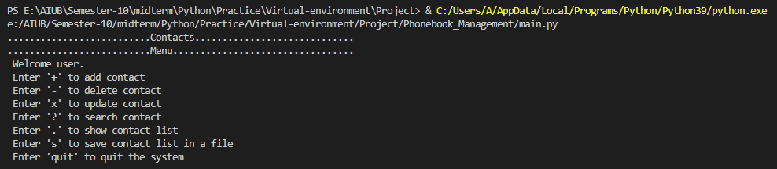
Add Contact:
The user has to choose either the contact is new or existing
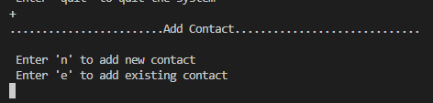
If the user wants to create a new contact the user has to provide new name, email(optional), address(optional), phone number. And the user has to enter y/Y to save contact
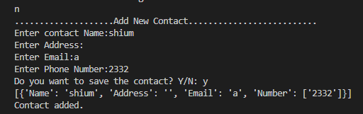
If the user wants to create an existing contact the user has to provide contact name to search from contact list. If the contact is found the user has to provide new phone number.
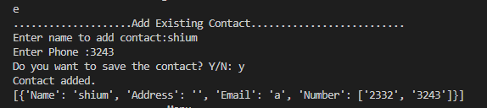
If the contact is not found in the contact list a message will be provided
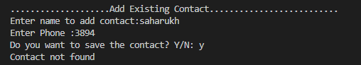
Update Contact:
The user has to provide phone number to search contact in list. If the contact is found the user has to provide new information to update.
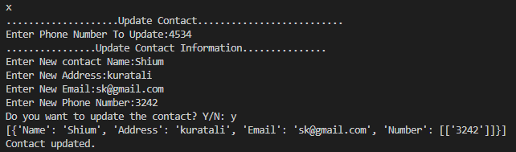
If there is no contact found a message will be provided.
Delete Contact:
User can delete unwanted contact by entering the phone number.
If the list is empty a message will be provided.
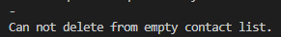
If the number matches all the information of the contact will be removed from the contact list.
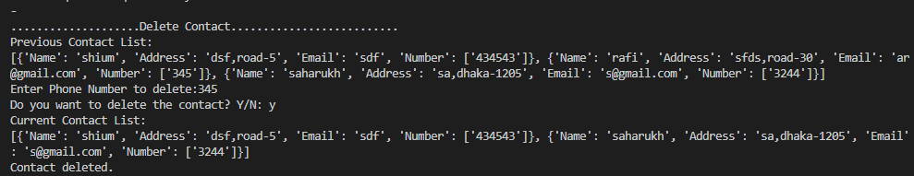
If there is no phone number as the given number exists a message will be provided.
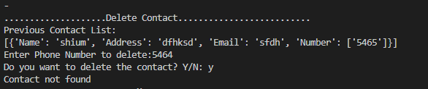
Search Contact:
If the contact list is empty user cannot search any information.
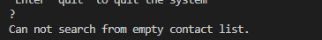
If the contact is found, then all the information of the contact will be provided.
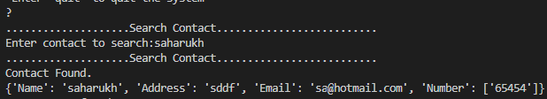
If the contact is not found, a message will be provided
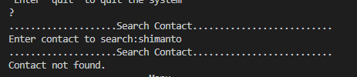
Display Contact:
The user can see the current contact list in display contact option.
Store Contact:
The user can store a copy of current contact list into a file and after saving the file, the file can be read and displayed.
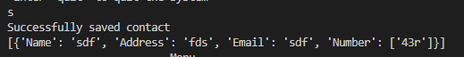

Quit:
The system will continuously ask for input unless quit is entered. If the user enters the quit option, the program will be terminated.
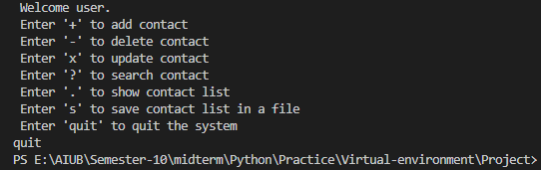
- To-do list application
Source-code:
Filename (main.py):
import add_task,update_task,delete_task,check_immidiate_task,display_task,conflict_task

#Empty list
task_list=[]

print("..........................tasks.............................")
while True:

promt=("..........................Menu.................................")
promt +=("\n Welcome user.")
promt +=("\n Enter '+' to add task")
promt +=("\n Enter '-' to delete task")
promt +=("\n Enter 'x' to update task")
promt +=("\n Enter '?' to search immidiate task")
promt +=("\n Enter '!' to search conflicting task")
promt +=("\n Enter '.' to show task list")
promt +=("\n Enter 'quit' to quit the system\n")
user_input=input(promt)
if user_input=='+':
add_task.add(task_list)

elif user_input=='x':
update_task.update(task_list)
elif user_input=="-":
delete_task.delete(task_list)
elif user_input=="?":
print("....................Search Immidiate task/s..........................")
check_immidiate_task.check(task_list)
elif user_input=="!":
conflict_task.check(task_list)

elif user_input==".":
display_task.display(task_list)
elif user_input=="quit":
break
else:
print("Enter correct option.")

Filename (add_task.py):
from datetime import datetime
def add_new(task_list,task_description,task_location,task_time):
task={"description":task_description,"location":task_location,"time":task_time}
confirmation_message=input("Do you want to save the task? Y/N: ")
if confirmation_message=="Y" or confirmation_message=="y":
task_list.append(task)
print(task_list)
print("Task added.")
else:
print("Cancelled.")

def add(task_list):
print("....................Add New task..........................")
task_description=input("Enter task description:")
task_location=input("Enter location:")
try:
task_time_string=str(input("Enter time in (yyyy-mm-dd hh:mm) format: "))
task_time=str(datetime.strptime(task_time_string, "%Y-%m-%d %H:%M"))
add_new(task_list,task_description,task_location,task_time)
except ValueError:
print("Follow the datetime format carefully")

Filename (update_task.py):
from datetime import datetime
import add_task
def update_task(task_list,required_description,task_location,task_time):
for index,item in enumerate(task_list):
if(item["description"]==required_description):
item["description"]=required_description
item["location"]=task_location
item["time"]=task_time
task_list[index]=item
def update(task_list):
print("....................Update task..........................")

print("................Update task Information...............")
required_description=input("Enter description to add task :")
for index,item in enumerate(task_list):
if(item["description"]==required_description):

task_location=input("Enter location:")
try:
task_time_string=str(input("Enter New Time in (yyyy-mm-dd hh:mm) format:"))
task_time=datetime.strptime(task_time_string, "%Y-%m-%d %H:%M")
except:
print("Follow the datetime format carefully")

update_task(task_list,required_description,task_location,task_time)
print("Task updated.")
break
else:
print("Task not found")
user_input=input("Do you want to add new task?(y/n)")
if(user_input=='y' or user_input=='Y'):
add_task.add(task_list)
else:
print("Cancelled")

Filename (delete_task.py):
import add_task
def delete_task(task_list,task_description):
confirmation_message=input("Do you want to delete the task? Y/N: ")
if confirmation_message=="Y" or confirmation_message=="y":

for index,item in enumerate(task_list):
if item["description"]==task_description:

del task_list[index]

print(f"Current task List:\n{task_list}")
print("task deleted.")
else:
print("Cancelled.")
def delete(task_list):
if task_list:
print("....................Delete task..........................")
print(f"Previous task List:\n{task_list}")
task_description=input("Enter description to delete:")
for index,item in enumerate(task_list):
if item["description"]==task_description:

delete_task(task_list,task_description)
break
else:
print("task not found.")
user_input=input("Do you want to add new task?(y/n)")
if(user_input=='y' or user_input=='Y'):
add_task.add(task_list)
else:
print("Cancelled")
else:
print("Can not delete from empty task list.")

Filename (display_task.py):
def display(list):
print(f"All task list: \n {list}")

Filename (check_immidiate_task.py):

def check(task_list):
if task_list:
print("Upcoming immidiate task/s:\n")

upcoming = min(item['time'] for item in task_list)
for i,item in enumerate(task_list):
if item['time']==upcoming:
print(task_list[i])
else:
print("Can not search from empty task list.")

Filename (conflict_task.py):
def check(task_list):
if task_list:
print(".....................Check Schedule Clashed......................\n")

clashed_scedule_list=[]

for i in range(len(task_list)):
for j in range(len(task_list)):
if i!=j:
if task_list[i]["time"]==task_list[j]["time"]:
clashed_scedule_list.append(task_list[i])
print(clashed_scedule_list)
# else: # end of list reached
if clashed_scedule_list: #if empty list
print("No clash found.")
else:
print(clashed_scedule_list)

else:
print("Can not search from empty task list.")

Filename(store_task.py):
file_name=file_name="E:\\AIUB\\Semester-10\\midterm\\Python\\Practice\\Virtual-environment\\Project\\To-Do_list\\stored_file.txt"

def write(list):

with open(file_name,'w') as f:
for item in list:#saving each list elements in new line as string

f.write("%s \n" %item)
"""
with open(file_name,'w') as f:
for item in list:#saving each list elements in new line as string

json.dump(list,f)
"""
def read(list):

if list:
try:
with open(file_name,'r') as f:
for line in f:#reading line by line
print(line.rstrip())
except FileNotFoundError:
print("File not found")
else:
print("Can not read empty list.")
"""
try:
with open(file_name, 'r') as j:
contents = json.load(j)
print(contents)

except FileNotFoundError:
print("File not found")
except json.JSONDecodeError:
print("There is a problem accessing the saved contact list")
"""

Output & functionality:

This is a console-based program where main.py controls other functionalities. When the program starts first its prompts some option from where the user has to select desired functionality.
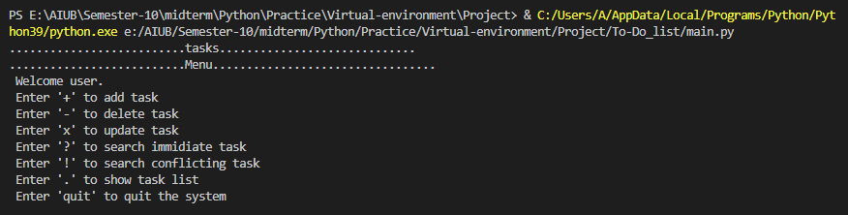
Add task:
The user has to provide the required information to add existing keyword. The date should be provided according to the given structure.
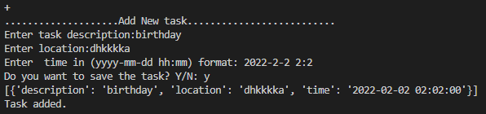
If the date time format is not given in correct format, the user will not be allowed to add task and try again.
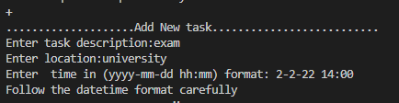

Update task:
The user has to provide correct description to search task in list. If the task is found the user has to provide new information to update.
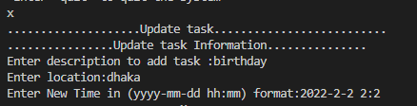
If there is no task having the description found a message the system will provide add task option.
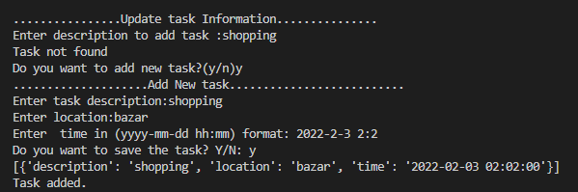
Delete task:
User can delete unwanted task by entering the description name.
Initially when there is no task in the list, the user will not be able to delete anything.
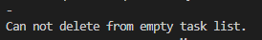
If the description matches all the information of the task will be removed from the task list.
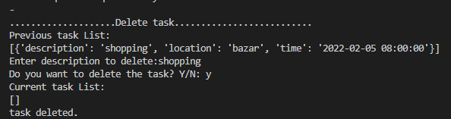
If there is no description as the given description exists a message will be provided and add option will be provided.
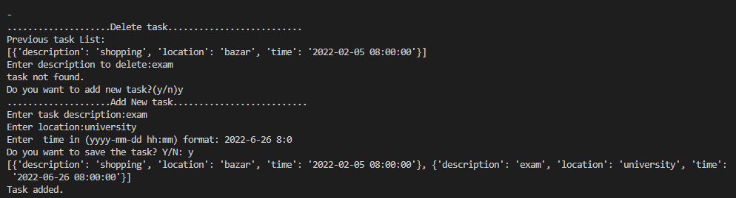
Check Immediate task:
User can check most immediate task from task list from here.
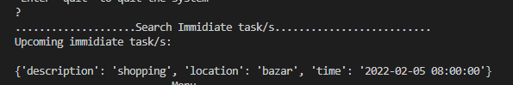

Check Conflicting task:
User can check the conflicting tasks from the task list from here. If there are no clash found in the list the system will provide message.
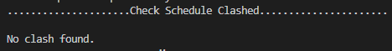
If there are conflict found in the list the system will show all the information of clash schedule.

Display task:
The user can see all the current task list in display task option.
Store Keyword:
The user can store a copy of current contact list into a file and after saving the file, the file can be read and displayed.
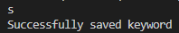
Quit:
The system will continuously ask for input unless quit is entered. If the user enters the quit option, the program will be terminated.
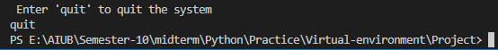

- Reserved keyword application

Source-code:
Filename (main.py):
Reserved keyword application
Source-code:
Filename (main.py):
import python_keywords,add_keyword,search_keyword,update_keyword,display_keywords,delete_keyword,store_keywords
keywords=python_keywords.keyword_list

print("..........................keywords.............................")
while True:

promt=("..........................Menu.................................")
promt +=("\n Welcome user.")
promt +=("\n Enter '+' to add keyword")
promt +=("\n Enter '-' to delete keyword")
promt +=("\n Enter 'x' to update keyword")
promt +=("\n Enter '?' to search keyword")
promt +=("\n Enter '.' to show keyword list")
promt +=("\n Enter 's' to save keyword list in a file")
promt +=("\n Enter 'quit' to quit the system\n")
user_input=input(promt)
if user_input=='+':
add_keyword.add_keyword(keywords,False)
elif user_input=='x':
update_keyword.update_keyword(keywords)
elif user_input=="-":
delete_keyword.delete(keywords)
elif user_input=="?":
flag=search_keyword.search(keywords)

elif user_input==".":
display_keywords.display_list(keywords)
elif user_input=="s":
store_keywords.write(keywords)
print("Successfully saved keyword")
store_keywords.read(keywords)
elif user_input=="quit":
break
else:
print("Enter correct option.")

Filename (python_keywords.py):
#all the key info is collected from https://realpython.com/python-keywords/

keyword_list=[
{"name":"and", "details":"The Python keyword and is used to determine if both the left and right operands are truthy or falsy. If both operands are truthy, then the result will be truthy. If one is falsy, then the result will be falsy","sample_code":"x = y and z"}
,{"name":"or", "details":"Python’s or keyword is used to determine if at least one of the operands is truthy. An or statement returns the first operand if it is truthy and otherwise returns the second operand","sample_code":"x = y or z"}
,{"name":"not","details":"Python’s not keyword is used to get the opposite Boolean value of a variable","sample_code":'>>> val = "" # Truthiness value is `False` \n >>> not val \n True \n >>> val = 5 # Truthiness value is `True`\n >>> not val\n False"'}
,{"name":"in","details":"Python’s in keyword is a powerful containment check, or membership operator. Given an element to find and a container or sequence to search, in will return True or False indicating whether the element was found in the container","sample_code":">>> name = 'Chad'\n>>> 'c' in name\nFalse\n>>> 'C' in name\nTrue"}
,{"name":"is","details":"Python’s is keyword is an identity check. This is different from the == operator, which checks for equality. Sometimes two things can be considered equal but not be the exact same object in memory. The is keyword determines whether two objects are exactly the same object:","sample_code":"<obj1> is <obj2>"}
,{"name":"if","details":"The if keyword is used to start a conditional statement. An if statement allows you to write a block of code that gets executed only if the expression after if is truthy.The syntax for an if statement starts with the keyword if at the beginning of the line, followed by a valid expression that will be evaluated for its truthiness value","sample_code":"if <expr>:\n\t<statements>"}
,{"name":"elif","details":"The elif statement looks and functions like the if statement, with two major differences:Using elif is only valid after an if statement or another elif.You can use as many elif statements as you need.In other programming languages, elif is either else if (two separate words) or elseif (both words mashed together). When you see elif in Python, think else if","sample_code":"if <expr1>:\n\t<statements>\nelif <expr2>:\n\t<statements>\nelif <expr3>:\n\t<statements>"}
,{"name":"else","details":"The else statement, in conjunction with the Python keywords if and elif, denotes a block of code that should be executed only if the other conditional blocks, if and elif, are all falsy","sample_code":"if <expr>:\n\t<statements>\nelse:\n\t<statements>"}
,{"name":"for","details":"The most common loop in Python is the for loop. It’s constructed by combining the Python keywords for and in explained earlier. The basic syntax for a for loop is as follows","sample_code":'>>> people = ["Kevin", "Creed", "Jim"]\n>>> for person in people:\n\tprint(f"{person} was in The Office.")\nKevin was in The Office.\nCreed was in The Office.\nJim was in The Office.'}
,{"name":"while","details":"Python’s while loop uses the keyword while and works like a while loop in other programming languages. As long as the condition that follows the while keyword is truthy, the block following the while statement will continue to be executed over and over again","sample_code":'>>> while True:\n\tprint("working...")'}
,{"name":"break","details":"If you need to exit a loop early, then you can use the break keyword. This keyword will work in both for and while loops","sample_code":'>>> nums = [1, 2, 3, 4, 5, 6, 7, 8, 9, 10]\n>>> sum = 0\n>>> for num in nums:\n\t sum += num\n\t if sum > 10:\n\t break\n sum\n 15'}
,{"name":"continue","details":"Python also has a continue keyword for when you want to skip to the next loop iteration. Like in most other programming languages, the continue keyword allows you to stop executing the current loop iteration and move on to the next iteration","sample_code":'for <element> in <container>:\n\tif <expr>:\n\t\tcontinue'}
,{"name":"def","details":"Python’s keyword def is used to define a function or method of a class. This is equivalent to function in JavaScript and PHP. The basic syntax for defining a function with def looks like this","sample_code":'def <function>(<params>):\n\t<body>'}
,{"name":"class","details":"To define a class in Python, you use the class keyword. The general syntax for defining a class with class is as follows:","sample_code":'class MyClass(<extends>):\t\n<body>'}
,{"name":"with","details":"Context managers are a really helpful structure in Python. Each context manager executes specific code before and after the statements you specify. To use one, you use the with keyword","sample_code":'with <context manager> as <var>:\n\t<statements>'}
,{"name":"as","details":"If you want access to the results of the expression or context manager passed to with, you’ll need to alias it using as. You may have also seen as used to alias imports and exceptions, and this is no different. The alias is available in the with block","sample_code":'with <expr> as <alias>:\n\t<statements>'}
,{"name":"pass","details":"Since Python doesn’t have block indicators to specify the end of a block, the pass keyword is used to specify that the block is intentionally left blank. It’s the equivalent of a no-op, or no operation. Here are a few examples of using pass to specify that the block is blank","sample_code":'def my_function():\n\tpass\nclass MyClass:\n\tpass\nif True:\n\tpass'}
,{"name":"lamda","details":"The lambda keyword is used to define a function that doesn’t have a name and has only one statement, the results of which are returned. Functions defined with lambda are referred to as lambda functions","sample_code":'>>> ids = ["id1", "id2", "id30", "id3", "id20", "id10"]\n>>> sorted(ids)\n["id1", "id10", "id2", "id20", "id3", "id30"]\n>>> sorted(ids, key=lambda x: int(x[2:]))\n["id1", "id2", "id3", "id10", "id20", "id30"]'}
,{"name":"return","details":"Python’s return keyword is valid only as part of a function defined with def. When Python encounters this keyword, it will exit the function at that point and return the results of whatever comes after the return keyword","sample_code":'>>> def return_none():\n\treturn\n>>> return_none()\n>>> r = return_none()\n>>> print(r)None'}
,{"name":"yield","details":"Python’s yield keyword is kind of like the return keyword in that it specifies what gets returned from a function. However, when a function has a yield statement, what gets returned is a generator. The generator can then be passed to Python’s built-in next() to get the next value returned from the function.When you call a function with yield statements, Python executes the function until it reaches the first yield keyword and then returns a generator. These are known as generator functions:","sample_code":'def <function>():\n\tyield <expr>'}
,{"name":"import","details":"Python’s import keyword is used to import, or include, a module for use in your Python program. Basic usage syntax looks like this","sample_code":'import <module>'}
,{"name":"from","details":"The from keyword is used together with import to import something specific from a module","sample_code":'>>> from collections import Counter\n>>> Counter()\nCounter()'}
,{"name":"try","details":"Any exception-handling block begins with Python’s try keyword. This is the same in most other programming languages that have exception handling.The code in the try block is code that might raise an exception. Several other Python keywords are associated with try and are used to define what should be done if different exceptions are raised or in different situations. These are except, else, and finally:","sample_code":'def mpg(miles, gallons):\n\t try:\n\t\t mpg = miles / gallons\n\t except ZeroDivisionError:\n\t\t mpg = None\n\treturn mpg'}
,{"name":"except","details":"Python’s except keyword is used with try to define what to do when specific exceptions are raised. You can have one or more except blocks with a single try. The basic usage looks like this","sample_code":'try:\n\t <statements>\n except <exception>:\n\t <statements>'}
,{"name":"raise","details":"The raise keyword raises an exception. If you find you need to raise an exception, then you can use raise followed by the exception to be raised","sample_code":'raise <exception>'}
,{"name":"finally","details":"Python’s finally keyword is helpful for specifying code that should be run no matter what happens in the try, except, or else blocks. To use finally, use it as part of a try block and specify the statements that should be run no matter what:","sample_code":'try:\n\t <statements>\nfinally:\n\t <statements>'}
,{"name":"assert","details":"The assert keyword in Python is used to specify an assert statement, or an assertion about an expression. An assert statement will result in a no-op if the expression (<expr>) is truthy, and it will raise an AssertionError if the expression is falsy. To define an assertion, use assert followed by an expression:","sample_code":'assert <expr>'}
,{"name":"del","details":"del is used in Python to unset a variable or name. You can use it on variable names, but a more common use is to remove indexes from a list or dictionary. To unset a variable, use del followed by the variable you want to unset:","sample_code":'del <variable>'}
,{"name":"global","details":"If you need to modify a variable that isn’t defined in a function but is defined in the global scope, then you’ll need to use the global keyword. This works by specifying in the function which variables need to be pulled into the function from the global scope:","sample_code":'global <variable>'}
,{"name":"print","details":"When print was a keyword, the syntax to print something to the screen looked like this:","sample_code":'print "Hello, World"'}
,{"name":"exec","details":"In Python 2.7, the exec keyword took Python code as a string and executed it. This was done with the following syntax:","sample_code":'exec "<statements>"'}]

Filename (add_keyword.py):
import search_keyword
def add_keyword(list,is_from_search):
confirmation_message=input("Do you want to save the contact? Y/N: ")
if confirmation_message=="Y" or confirmation_message=="y":

if(is_from_search==False):
print("....................Add Keyword..........................")
key_name=input("Enter keyword name:")
search_keyword.search_list(list,key_name)
print("Can not add the key that already exists")

elif(is_from_search==True):
print("....................Add New Keyword..........................")
key_name=input("Enter keyword name:")
details=input("Enter keyword's details:")
code=input("Enter keyword's sample code:")
keyword_info={"name":key_name,"details":details,"sample_code":code}
list.append(keyword_info)

print("Keyword added")
print(list)
else:
print("Cancelled.")

Filename (update_keyword.py):
import search_keyword,add_keyword
def update_keyword(list):
print("....................Update Keyword..........................")
required_keyword=input("Enter keyword to search:")
flag=search_keyword.search_list(list,required_keyword)
if flag==True:
new_name=input("Enter new keyword name to update:")
new_details=input("Enter new keyword details to update:")
new_sample=input("Enter new keyword sample code to update:")
for i, item in enumerate(list):
if item["name"]==required_keyword:
item["name"]=new_name
item["details"]=new_details
item["sample_code"]=new_sample
list[i]=item
break

else:
print("Keyword Updated.")
if flag==False:
add_keyword.add_keyword(list,flag)

Filename (delete_keyword.py):
import search_keyword
def delete(list):
print("....................Delete Keyword..........................")
required_key_name=input("Enter keyword name:")
flag=search_keyword.search_list(list,required_key_name)
if flag==True:
for i,item in enumerate(list):
if item["name"]==required_key_name:
del list[i]
else: #end of list reached
print("deleted")
print(f"current keywords: \n{list}")

Filename (search_keyword.py):
import add_keyword
def search_list(key_list,required_keyword):
for i,item in enumerate(key_list):
if(item["name"]==required_keyword):
print("Keyword Found")
print(key_list[i])
return True #if searched result exists, can update/delete
break

else:#end of list reached
print("No such a key found")
is_from_search=True
add_keyword.add_keyword(key_list,is_from_search)
def search(list):
if list:
print("....................Search Keyword..........................")
u_input=input("Enter Keyword Name to Search: ")
search_list(list,u_input)
else:
print("Can not search from empty contact list.")

Filename (store_keyword.py):
import json #helps to store and use the file contatints as it is
def write(list):
file_name=file_name="E:\\AIUB\\Semester-10\\midterm\\Python\\Practice\\Virtual-environment\\Project\\Phonebook_Management\\stored_file.json"
"""
with open(file_name,'w') as f:
for item in list:#saving each list elements in new line as string

f.write("%s \n" %item)
"""
with open(file_name,'w') as f:
for item in list:#saving each list elements in new line as string

json.dump(list,f)
def read(list):
file_name=file_name="E:\\AIUB\\Semester-10\\midterm\\Python\\Practice\\Virtual-environment\\Project\\Python_keyword_Dictionary\\stored_file.json"
"""
try:
with open(file_name,'r') as f:
for line in f:#reading line by line
print(line.rstrip())
except FileNotFoundError:
print("File not found")

"""
try:
with open(file_name, 'r') as j:
contents = json.load(j)
print(contents)

except FileNotFoundError:
print("File not found")
""" except json.JSONDecodeError:
print("There is a problem accessing the saved contact list")
"""

Output & functionality:
This is a console-based program where main.py controls other functionalities. When the program starts first its prompts some option from where the user has to select desired functionality.
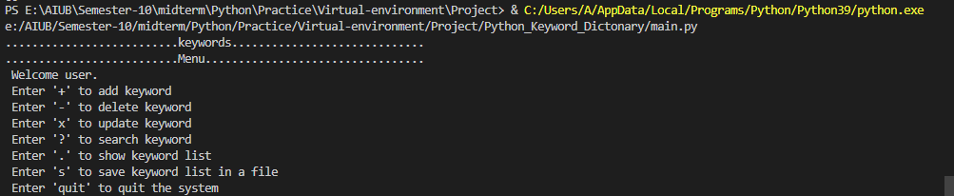
Add Keyword:
The user has to provide the new keyword to search either the keyword exists or not. If it exists, the system will not allow to add existing keyword.
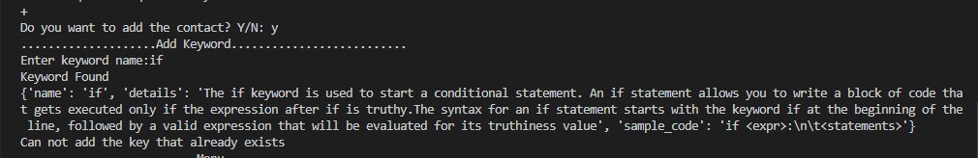
If the keyword does not exist, the user will be allowed to add contact by giving required information.
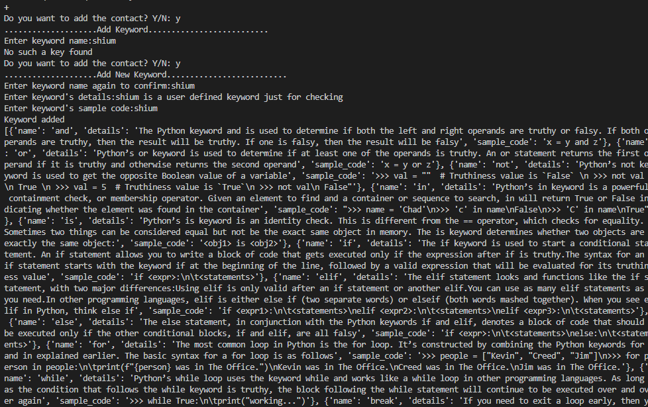
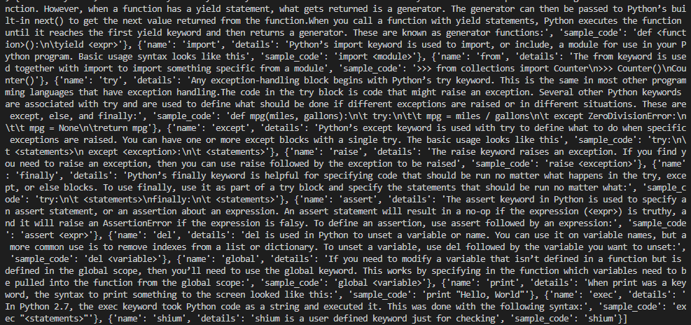
Update Keyword:
The user has to provide keyword to search contact in list. If the contact is found the user has to provide new information to update.
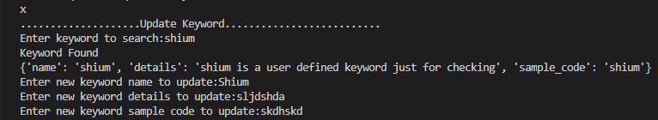
If there is no contact found a message the system will provide add keyword option.
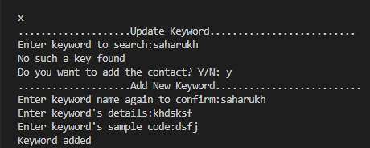
Delete Keyword:
User can delete unwanted keyword by entering the keyword name.
If the keyword matches all the information of the keyword will be removed from the keyword list.
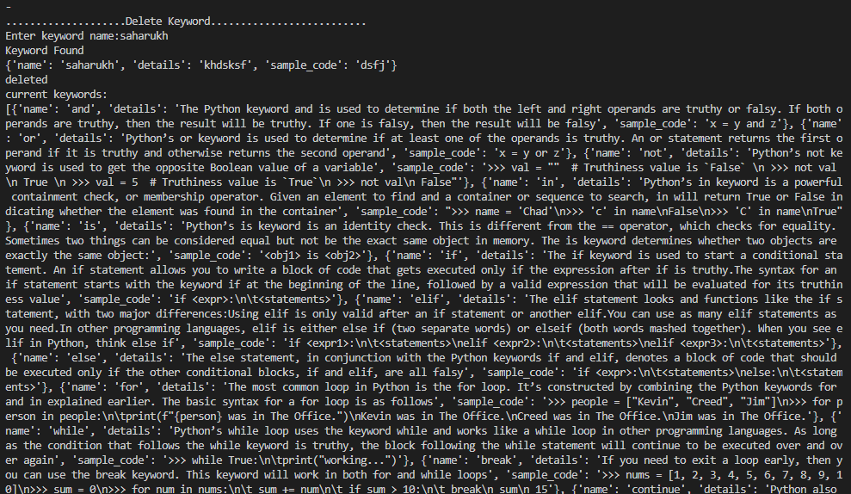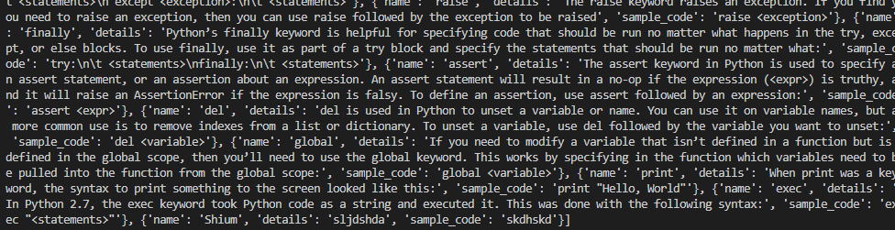
If there is no keyword as the given number exists a message will be provided and add option will be provided.
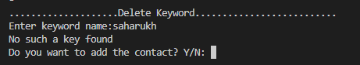
Search Keyword:
If the keyword list is empty user cannot search any information.
If the keyword is found, then all the information of the keyword will be provided.
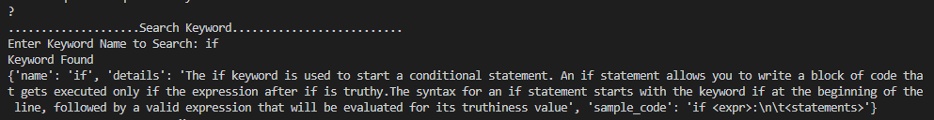
If the keyword is not found, a message will be provided and add keyword option will be provided.
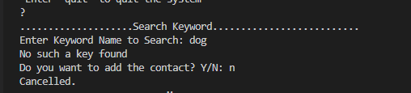
Display keyword:
The user can see the current contact list in display contact option.
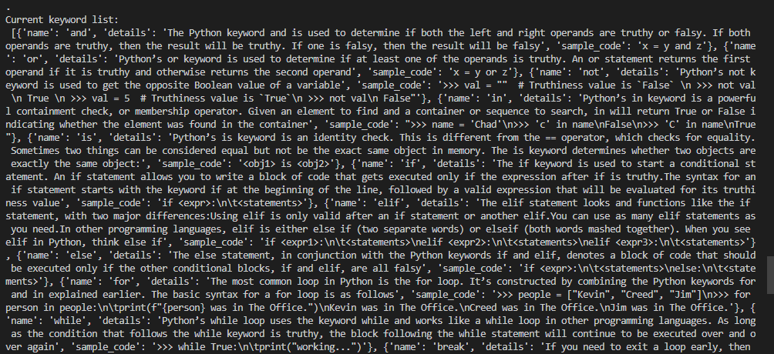
Store Keyword:
The user can store a copy of current contact list into a file and after saving the file, the file can be read and displayed.

Quit:
The system will continuously ask for input unless quit is entered. If the user enters the quit option, the program will be terminated.
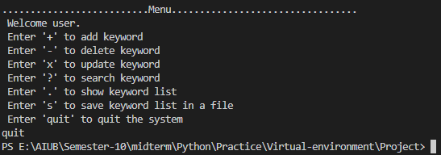

The End

