**Designing a Static Page with HTML**

# Goal(s)

* Designing Three Forms using HTML.

# What You Should Already Know

Before starting this assignment, you should have the basic knowledge of the followings:

* HTML

# Academic Honesty

All the work that you do toward the fulfilment of this assignment must be your own unless collaboration is explicitly allowed (e.g., by some problem set or the final project). Viewing or copying another individual's work (even if left by a printer, stored in an executable directory, or accidentally shared in the course's virtual classroom) or lifting material from a book, magazine, website or from other sources, even partially and presenting it as your own, constitutes academic dishonesty, as does showing or giving your work, even in part, to another student.

Similarly, dual submission academic dishonesty: you may not submit the same or similar work to this course that you have submitted or will submit to another. You should not provide or make available your assignments to individuals who have taken this course or may take this course in the future.

You are welcome to discuss the course's material with others in order to better understand it. You may even discuss problem sets with classmates, but you should not share code. You may also turn to the Web for instruction beyond the course's lectures, for references, and for solutions to technical difficulties, but not for outright solutions to problems on projects. However, failure to cite (as with comments) the origin of any code or technique that you do discover outside of the course's lectures and (even while respecting these constraints) and then integrate into your own work may be considered academic dishonesty.

All forms of academic dishonesty will be dealt very harshly.

# Grades

Your work will be evaluated along the following axes.

**Correctness**: Consistency with the given specifications and free of bugs.

**Design:**Well written code (i.e., clearly, efficiently, elegantly, and/or logically)

**Style:**Readable and modifiable code (commented, aptly named variables etc.)

# Static HTML Page 1

An HTML page is used to display information to user. An HTML document is referred as static when the content of the document never changes. In this assignment, you have to design a static HTML document that looks like a registration form of any popular email provider (Google, Yahoo, Hotmail etc.).

# 

# Static HTML Page 2

An HTML page is which looks just like this.

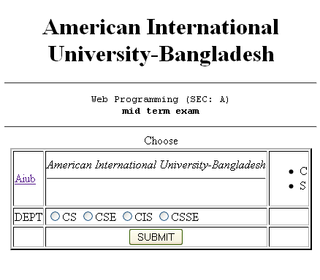

# Static HTML Page 3 (Home Assignment)

An HTML page is which looks just like this

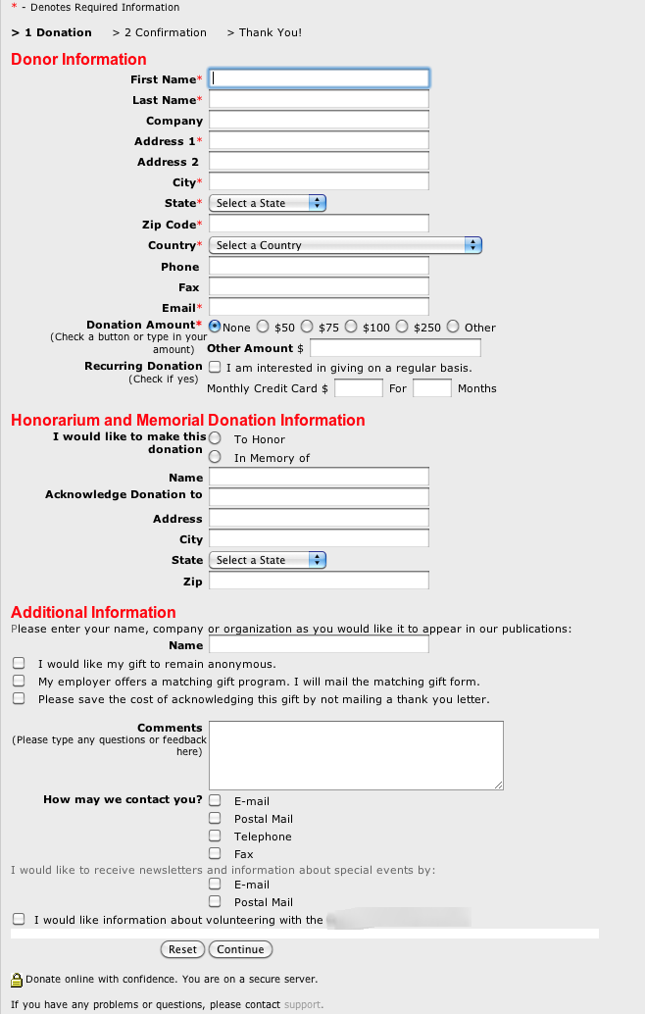

# Technical Requirements

* Your HTML should be well-formed that follows the basic syntax of HTML. Explain any intentional invalidity in details in HTML comments.
* You should not use an intelligent text editor to generate HTML.

# Submission

* Github

**Submission Deadline: This Lab**