**ReadMe**

**The Python program will calculate the weather of a particular location based on suns position in a particular time of the year (Latitude of the Location).**

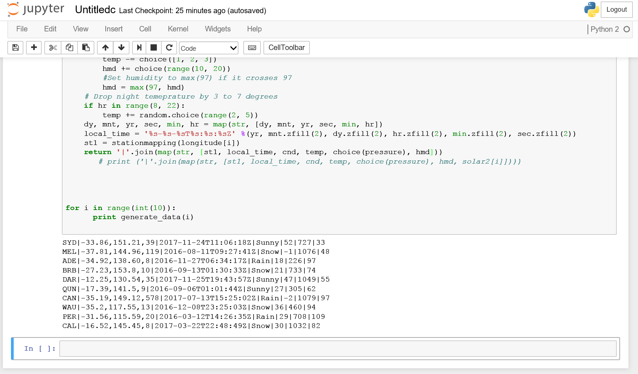

**Random values will be calculated each time the program is Run.**

**Further 1000 of random values will be calculated at any time of the year and location.**

**The model evolves with time and location .Can work for any at any time. Taking atmosphere , Geography and topography in consideration**

**We can take out sunset and sunrise and tell about temperature length of the day .**

**But due to time constraint completed a single part**

**Variation by Latitude**

The solar altitude varies significantly by your latitudinal position on Earth. If you are at or near the equator, the sun will be high in the sky in the middle of the day. Therefore, the solar altitude will be fairly great. The Earth is tilted at an angle of 23.5 degrees with respect to the plane of the solar system. Hence, the sun is not always directly overhead at the equator. When the sun is directly overhead, the solar altitude is 90 degrees. This occurs at the equator during the vernal and autumnal equinoxes. At the Tropics of Cancer and Capricorn, the sun will have an altitude of 90 degrees during their respective summer solstices.

**Variation over the Year**

The Earth progresses through its seasons due to its 23.5-degree tilt. During the summer, the solar altitude will be at its maximum. During the winter, the solar altitude will be at its minimum. The change in solar altitude throughout the seasons results in hotter temperatures in the summer and cooler temperatures in the winter. Furthermore, because of the tilt of the Earth, the Southern Hemisphere experiences winter and summer at the opposite times of the year than the Northern Hemisphere.

**Variation by Day**

Throughout the course of the day, the sun changes its position in the sky. At sunrise, the solar altitude increases from zero degrees. At sunset, the solar altitude decreases toward zero degrees. The instance of the sun's daily maximum altitude is called solar noon, which does not typically coincide with clock noon. Again, this exact measurement of solar altitude varies depending on your latitude and the time of year. If your latitude is 44 degrees north, the solar altitude at solar noon during an equinox will be 90 minus 44, or 46 degrees. During the summer solstice, the solar altitude at solar noon will be 69.5 degrees. During the winter solstice, the solar altitude at solar noon will be 22.5 degrees.

**Zenith and Azimuth**

The measurements of zenith and azimuth are closely related to the measurement of solar altitude. The solar zenith angle of the sun is relative to the zenith, or directly overhead. This is the complement to solar altitude. Hence, if the solar altitude is 46 degrees, the solar zenith angle will be 44 degrees. Azimuth, on the other hand, measures the sun's angle relative to north, in the eastward direction. If the sun is due north in the sky, the azimuth will be zero. If the sun is due east in the sky, the azimuth angle will be 90 degrees. Solar altitude, zenith and azimuth all change throughout the day and year