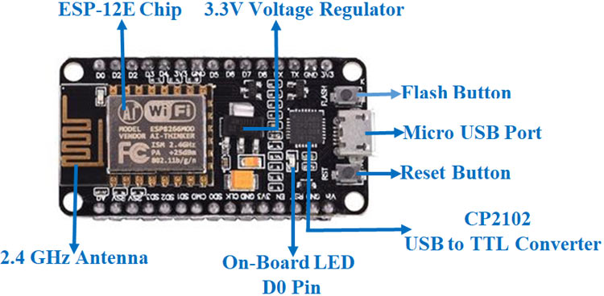

http://arduino.esp8266.com/stable/package_esp8266com_index.json