Early Detection of Alzheimer's Disease Using Peptide Sequences with Machine Learning and Deep Learning

By
Sheikh Shariar Nehal
[Student ID]

[Team Member 2 Name (if applicable)]
[Student ID]

FINAL YEAR DESIGN PROJECT REPORT
This Report Presented in Partial Fulfillment of the Requirements for the Degree of Bachelor of Science in Computer Science and Engineering

Supervised by

[Supervisor Name], [Designation]
Department of Computer Science and Engineering Daffodil International University

Co-Supervised by

[Co-Supervisor Name], [Designation] (if applicable)
Department of Computer Science and Engineering Daffodil International University



DAFFODIL INTERNATIONAL UNIVERSITY
Dhaka, Bangladesh
[Submission Date]

APPROVAL

This Project titled “Early Detection of Alzheimer's Disease Using Peptide Sequences with Machine Learning and Deep Learning,” submitted by Sheikh Shariar Nehal and [team member’s name (if any)] to the Department of Computer Science and Engineering, Daffodil International University, has been accepted as satisfactory for the partial fulfillment of the requirements for the degree of B.Sc. in Computer Science and Engineering and approved as to its style and contents. The presentation has been held on [Presentation Date].

BOARD OF EXAMINERS

Name
Board Chairman
Designation, Department of CSE, FSIT Daffodil International University

Name
Internal Examiner 1
Designation, Department of CSE, FSIT Daffodil International University

Name
Internal Examiner 2
Designation, Department of CSE, FSIT Daffodil International University

Name
External Examiner
Designation, Department of CSE, FSIT Daffodil International University

DECLARATION

We hereby declare that this project has been done by us under the supervision of [Supervisor Name], [Supervisor’s Designation], Department of Computer Science and Engineering, Daffodil International University. We also declare that neither this project nor any part of this project has been submitted elsewhere for the award of any degree or diploma.

Supervised by:

[Supervisor Name]
Designation
Department of Computer Science and Engineering Daffodil International University

Co-Supervised by:

[Co-Supervisor Name] (if applicable)
Designation
Department of Computer Science and Engineering Daffodil International University

Submitted by:

Sheikh Shariar Nehal
Student ID: [Student ID]
Department of Computer Science and Engineering Daffodil International University

[Team Member 2 Name] (if applicable)
Student ID: [Student ID]
Department of Computer Science and Engineering Daffodil University

ACKNOWLEDGEMENTS

This work would not have been possible without the support and contributions of many individuals over the past two semesters. We are deeply grateful to everyone who has as- sisted us in one way or another.

First, we express our heartfelt thanks and gratefulness to the almighty for His divine blessing making it possible for us to complete the Final Year Design Project(FYDP) successfully.

We are grateful and wish our profound indebtedness to Supervisor Name, Supervisor’s Designation, Department of Computer Science and Engineering, Daffodil International University, Dhaka, Bangladesh. Deep knowledge and keen interest of our supervisor in the field of Write the field name here to carry out this project. His endless pa- tience, scholarly guidance, continual encouragement, constant and energetic supervision, constructive criticism, valuable advice, reading many inferior drafts, and correcting them at all stages have made it possible to complete this project.
We are grateful and wish to express our profound indebtedness to [Supervisor Name], [Supervisor’s Designation], Department of Computer Science and Engineering, Daffodil International University, Dhaka, Bangladesh. The deep knowledge and keen interest of our supervisor in the field of machine learning and bioinformatics were essential to carrying out this project. Endless patience, scholarly guidance, continual encouragement, constant and energetic supervision, constructive criticism, valuable advice, and correction of several drafts made it possible to complete this project.
We would like to express our heartfelt gratitude to the Head of the Department of Com- puter Science and Engineering, for his kind help in finishing our project and also to other faculty members and the staff of the Department of Computer Science and Engineering, Daffodil International University.

We would like to thank our entire course-mates at Daffodil International University, who took part in this discussion while completing the coursework.

Finally, we must acknowledge with due respect the constant support and patience of our parents.

ABSTRACT

Alzheimer's disease is a progressive neurodegenerative disorder that is usually diagnosed through costly, time-consuming procedures such as magnetic resonance imaging (MRI) and positron emission tomography (PET), which typically identify the disease only after substantial neuronal damage has already occurred. This report presents a computational approach for early Alzheimer's disease risk screening based on the aggregation tendency of peptide sequences, using amyloid-forming behaviour as a proxy indicator of risk. A dataset of peptide records was collected from the CPAD 2.0 peptide aggregation database by scraping 68 result pages, producing 2,001 raw records that were cleaned, deduplicated, and standardised into two classes: amyloid and non-amyloid. Each sequence was encoded in two forms: integer-mapped, padded sequences for deep learning models, and position-aware one-hot vectors for classical machine learning models. Three classical algorithms (Logistic Regression, Random Forest, and Support Vector Machine) and three deep learning architectures (Convolutional Neural Network, Long Short-Term Memory network, and Bidirectional LSTM) were trained and compared on a stratified, held-out test set using accuracy, precision, recall, F1-score, and ROC-AUC, with five-fold cross-validation applied to the classical models. The Convolutional Neural Network produced the strongest overall result, reaching an accuracy of 81.05%, an F1-score of 0.815, and a ROC-AUC of 0.893, ahead of both the classical baselines and the recurrent architectures. A Flask-based web interface was also built so that a user can submit an arbitrary peptide sequence and receive a real-time amyloid-risk prediction with an associated probability score. The results suggest that peptide sequence data, combined with convolutional feature extraction, can provide a low-cost, non-invasive screening signal that may complement existing clinical diagnostic pathways, although clinical validation on an independent dataset remains necessary before any practical use.

Table of Contents

Approval i

Declaration ii
Acknowledgements iii
Abstract iv
List of Figures vii
List of Tables viii
- Introduction 1
  - Introduction 1
  - Motivation 1
  - Objectives 1
  - Methodology 1
  - Project Outcome 1
  - Organization of the Report 1
- Background 2
  - Introduction 2
  - Literature Review 2
    - Similar Applications 3
  - Gap Analysis 3
  - Summary 3
- Research Methodology 4
  - Methodology/Requirement Analysis & Design Specification 4
    - Overview 4
    - Proposed Methodology/ System Design 4
    - Functional and Nonfunctional Requirements 5
    - Data Flow Diagram 5
    - UI Design 5
  - Detailed Methodology and Design 5
  - Project Plan 5
  - Task Allocation 5
  - Summary 5
- Implementation and Results 6
  - Environment Setup 6
  - Testing and Evaluation/Performance/ Comparative Analysis 6
  - Results and Discussion 6
  - Summary 6
- Engineering Standards and Design Challenges 7
  - Compliance with the Standards 7
    - Software Standards 7
    - Hardware Standards 7
    - Communication Standards 7
  - Impact on Society, Environment and Sustainability 7
    - Impact on Life 7
    - Impact on Society & Environment 7
    - Ethical Aspects 7
    - Sustainability Plan 7
  - Project Management and Financial Analysis 7
  - Complex Engineering Problem 8
    - Complex Problem Solving 8
    - Engineering Activities 8
  - Summary 8
- Conclusion 10
  - Summary 10
  - Limitation 10
  - Future Work 10
References 11

List of Figures

3.1 End-to-end system pipeline for peptide-based classification 4
3.2 Data flow diagram of the prediction (web demo) subsystem 5
4.1 Model performance comparison (bar chart and heatmap) 7
4.2 ROC curves for all six models 7
4.3 Confusion matrix of the best-performing model (CNN) 8
4.4 Training history (accuracy and loss) of the CNN model 8
4.5 Confusion matrix of the BiLSTM model on the test set 9
4.6 Training history (accuracy and loss) of the BiLSTM model 9

List of Tables
2.1 Summary of Literature Reviewed. 2
2.2 Comparative capabilities of related approaches and the proposed system 3
3.1 Project task allocation across the FYDP timeline 6
4.1 Comparative performance of all trained models on the held-out test set 7
  - Mapping with complex problem solving. 8
  - Mapping with knowledge Profile. 8
  - Mapping with complex engineering activities. 9

Chapter 1

Introduction

This chapter introduces the problem addressed by the project, the motivation behind it, the objectives pursued, a short outline of the methodology, the expected outcome, and the organisation of the remaining chapters.

Introduction

Alzheimer's disease (AD) is a progressive neurodegenerative disorder and the leading cause of dementia worldwide. It gradually impairs memory, reasoning, and the ability to carry out daily activities, and its social and economic burden continues to grow as populations age. Diagnosis today relies mainly on clinical evaluation together with imaging techniques such as magnetic resonance imaging (MRI) and positron emission tomography (PET). These methods can confirm the presence of the disease, but they are expensive, time-consuming, and usually detect AD only after significant neuronal damage has already occurred.
A large body of molecular biology research links AD pathology to the abnormal aggregation of amyloid-beta (Aβ) peptides into plaques in brain tissue [9], [10]. Because the amino acid sequence of a peptide directly influences its tendency to aggregate, the sequence itself carries information that computational methods can use to estimate amyloid risk without imaging or invasive sampling. This project examines whether peptide sequence data, combined with machine learning (ML) and deep learning (DL) techniques, can be used to build a low-cost screening tool that classifies a peptide as amyloid-forming (higher AD-related risk) or non-amyloid (lower risk), using the CPAD 2.0 peptide aggregation database [1] as the primary data source.

Motivation

Existing AD diagnostic pipelines are not well suited to large-scale or repeated screening, both because of their cost and because they detect the disease only in its later stages. A sequence-based computational classifier does not require imaging hardware, can run on ordinary computing equipment, and could, in principle, be built into a larger bioinformatics pipeline used by researchers studying amyloid-related biomarkers. This project was also motivated by an interest in comparing classical machine learning with modern deep sequence models on a real biological classification task, and in understanding, in a concrete case, why some architectures capture peptide aggregation patterns better than others.

Objectives

The general objective of this project is to design and implement an artificial intelligence based system that can classify peptide sequences into amyloid and non-amyloid categories in support of early Alzheimer’s disease risk screening. The specific objectives are:
(i) collect and clean a peptide sequence dataset from the CPAD 2.0 database, removing duplicate and missing entries and standardising class labels;
(ii) encode peptide sequences into machine-readable representations suited to both classical machine learning (one-hot vectors) and deep learning (padded integer sequences);
(iii) train baseline classical machine learning models — Logistic Regression, Random Forest, and Support Vector Machine — using stratified five-fold cross-validation;
(iv) design and train deep learning architectures — Convolutional Neural Network (CNN), Long Short-Term Memory network (LSTM), and Bidirectional LSTM (BiLSTM) — with early stopping to reduce overfitting;
(v) evaluate every model on a common held-out test set using accuracy, precision, recall, F1-score, and ROC-AUC, and identify the best-performing model; and
(vi) package the best-performing model behind a simple web interface so that a new peptide sequence can be submitted and scored in real time.

Methodology

The project follows a quantitative, experimental methodology. Peptide records are downloaded from CPAD 2.0, cleaned, deduplicated, and label-standardised. Sequences are encoded into two representations — padded integer sequences and position-aware one-hot vectors — to suit deep learning and classical machine learning models respectively. Six models are trained under matching evaluation conditions (stratified train-test split, common metric set) and compared to select the best-performing model, which is then exposed through a Flask web application for interactive testing. Chapter 3 describes this methodology in detail.

Project Outcome

The direct outcome of this project is a reproducible pipeline that turns raw peptide aggregation records into a trained classifier and an accompanying working demonstration that any user can query. Beyond the trained models themselves, the project produces a documented comparison of classical and deep sequence models on the same peptide dataset, which can act as a reference point for further work on computational, sequence-based screening for amyloid-related risk.

Organization of the Report

The remainder of this report is organised as follows. Chapter 2 reviews the background of Alzheimer's disease and amyloid aggregation, surveys related computational work, and identifies the gap this project addresses. Chapter 3 describes the research methodology, including the system design, requirements, data flow, and project plan. Chapter 4 presents the implementation, evaluation methodology, and results. Chapter 5 discusses engineering standards, societal and ethical impact, project management, and the mapping of this work to complex engineering problems and activities. Chapter 6 concludes the report with a summary, limitations, and directions for future work.

Chapter 2

Background

This chapter presents the background needed to understand the rest of the report, reviews related computational work on Alzheimer’s disease and amyloid prediction, and identifies the gap this project addresses.

Introduction

Alzheimer's disease (AD) is an irreversible neurodegenerative disorder and the principal cause of dementia, marked by progressive memory loss and behavioural change [11]. Standard diagnostic procedures such as MRI and PET imaging can reveal structural and functional changes in the brain, but they are time-consuming, costly, and not always available, which limits their use for early or repeated screening.
A substantial body of biological evidence links AD to the abnormal aggregation of amyloid-beta (Aβ) peptides into extracellular plaques, a process that disrupts neuron-to-neuron signalling and contributes to neurodegeneration [9], [10]. The NIA-AA research framework further formalises amyloid status as one of the core biological markers used to define AD progression [12]. Because the tendency of a peptide to aggregate is strongly influenced by its amino acid sequence, sequence-based computational analysis is a promising, low-cost complement to imaging-based diagnosis.
Advances in bioinformatics have made it practical to apply machine learning directly to protein and peptide sequences. Classical algorithms such as Support Vector Machines have been used to predict AD-related biomarkers from gene-coding protein sequences with reported accuracies above 85% [8], while deep learning architectures such as Convolutional Neural Networks (CNNs) and Recurrent Neural Networks (RNNs) can capture local motifs and longer-range dependencies in a sequence that are relevant to aggregation behaviour [7]. Public repositories such as CPAD 2.0 make peptide sequence and aggregation label data freely available for this kind of model development and evaluation [1].

Literature Review

This section reviews five research papers that were studied in detail while planning this project, together with several long-standing reference works on the amyloid hypothesis of Alzheimer's disease. Table 2.1 summarises the reviewed papers; a short discussion follows.

Table 2.1: Summary of Literature Reviewed.
Author (s) | Year | Title | Methodology | Key Findings
Yu et al. [4] | 2025 | Protein interaction prediction for AD using a multi-source protein features fusion framework | Graph Convolutional Network on a fused protein-protein interaction network | Achieved AUC = 0.8935 for AD-related protein interaction link prediction.
Hassan et al. [5] | 2024 | A multimodal approach for AD detection and classification using deep learning | VGG16 CNN feature extraction from MRI/PET scans | Showed deep convolutional features are effective for AD classification from imaging data.
Rani et al. [6] | 2024 | A machine learning model for AD prediction | SMOTE-RF: oversampling with Decision Tree, XGBoost, Random Forest on OASIS data | Random Forest reached up to 87.84% accuracy on the imbalanced imaging-derived dataset.
Wang et al. [7] | 2023 | Towards mechanistic models of mutational effects: deep learning on Alzheimer's Aβ peptide | CNN and RNN models on deep mutational scanning data | CNN/RNN architectures were the most cost-effective for modelling peptide aggregation traits.
Xu et al. [8] | 2018 | An efficient classifier for AD genes identification | SVM on dipeptide composition frequency of gene-coding protein sequences | Reported 85.7% accuracy identifying AD from protein sequence information.
Hardy and Selkoe [9] | 2002 | The amyloid hypothesis of AD: progress and problems on the road to therapeutics | Review / hypothesis paper | Established amyloid-beta aggregation as a central mechanism in AD pathogenesis.
Selkoe and Hardy [10] | 2016 | The amyloid hypothesis of AD at 25 years | Review paper | Revisited and updated the amyloid hypothesis considering newer genetic and biomarker evidence.
Fernandez-Escamilla et al. [13] | 2004 | Prediction of sequence-dependent and mutational effects on the aggregation of peptides and proteins | TANGO: statistical mechanics algorithm using physicochemical parameters | Enabled sequence-based prediction of aggregation-prone regions without a training/test split.

Yu et al. [4] proposed a multi-source protein feature fusion framework that combines laboratory data and literature-derived features to predict protein-protein interactions relevant to AD, using a Graph Convolutional Network for link prediction and reporting an AUC of 0.8935. This work shows that fusing heterogeneous biological features can improve prediction of AD-related molecular interactions, though it operates at the protein interaction network level rather than on individual peptide sequences.
Hassan et al. [5] took an imaging-based route, using a VGG16 convolutional network to extract features from MRI and PET scans for AD detection and classification. Their work confirms that deep convolutional features are effective for AD-related classification tasks, but, like most imaging-based methods, it depends on access to scan data rather than inexpensive sequence data.
Rani et al. [6] applied a SMOTE-RF methodology, combining synthetic minority oversampling with Random Forest, Decision Tree, and XGBoost classifiers on the OASIS imaging-derived dataset, reporting up to 87.84% accuracy on the imbalanced dataset and higher accuracy after balancing. This confirms that ensemble tree-based methods remain competitive baselines for AD-related classification, which motivated including Random Forest as one of the classical baselines in this project.
Wang et al. [7] applied deep mutational scanning together with CNNs and RNNs to model the effect of mutations on the aggregation-related biochemical traits of the Aβ 42 peptide, finding convolutional and recurrent architectures to be the most cost-effective choices for this kind of sequence modelling. This result directly supports the choice of CNN, LSTM, and BiLSTM architectures evaluated in this project.
Xu et al. [8] used a Support Vector Machine based on dipeptide composition frequency (the frequency of consecutive amino-acid pairs) to identify AD-related genes from gene-coding protein sequences, reporting 85.7% accuracy. This confirms that sequence composition alone, without imaging, carries a usable classification signal, which is the central premise of this project.
Beyond these five papers, this project also draws on established biological reference work: the amyloid hypothesis first articulated by Hardy and Selkoe [9] and revisited twenty-five years later [10], the neuropathological staging criteria of Braak and Braak [11], the NIA-AA biological research framework [12], and the TANGO algorithm for predicting sequence-dependent aggregation proposed by Fernandez-Escamilla et al. [13].

Similar Applications
Beyond peer-reviewed classifiers, several long-standing bioinformatics tools address a closely related problem: predicting the aggregation propensity of a peptide directly from its sequence. TANGO [13] and related sequence-based predictors such as WALTZ and AGGRESCAN estimate aggregation propensity using physicochemical scales fitted to experimental data, without a supervised training/test split or a reported classification accuracy in the sense used in this project. The imaging-based system of Hassan et al. [5] and the tabular SMOTE-RF system of Rani et al. [6] are closer in spirit to a deployable application, but both rely on clinical imaging or derived imaging features rather than raw peptide sequence. None of these tools combines a trained, evaluated ML/DL comparison on peptide sequence data with a public, queryable web interface, which is the specific combination this project provides.

Gap Analysis

The literature reviewed in Section 2.2 points to several recurring gaps that this project attempts to address, summarised in Table 2.2:

Table 2.2: Comparative capabilities of related approaches and the proposed system.

Capability | TANGO / WALTZ /  AGGRESCAN [13] | Imaging CNN  (Hassan et al. [5]) | SMOTE-RF  (Rani et al. [6]) | SVM gene classifier  (Xu et al. [8]) | CNN/RNN peptide  model (Wang et al. [7]) | Proposed system
Uses raw peptide/protein sequence as input | Yes | No | No | Yes | Yes | Yes
Requires clinical imaging (MRI/PET) | No | Yes | Yes (imaging-derived) | No | No | No
Trained/evaluated with a supervised train-test split | No | Yes | Yes | Yes | Yes | Yes
Compares classical ML and deep learning under one pipeline | No | No | No | No | No | Yes
Reports ROC-AUC alongside accuracy/F1 | No | Not reported | No | No | No | Yes
Provides a public, queryable web interface for a new sequence | Partial | No | No | No | No | Yes
Open-source, reproducible implementation | Partial | Not specified | Not specified | Not specified | Not specified | Yes

Summary

This chapter presented the biological background of Alzheimer's disease and amyloid aggregation, reviewed five recent papers on computational AD prediction together with classical amyloid biology references, discussed sequence-based aggregation predictors as similar applications, and summarised the gaps that motivate this project’s design.

Chapter 3

Research Methodology

This chapter describes the research methodology followed in the project: the overall approach and system design, the functional and non-functional requirements, the data flow of the prediction system, the user interface, the alternatives considered, and the project plan and task allocation.

Methodology/Requirement Analysis & Design Specifi cation

Overview
This project follows a quantitative, experimental research design rather than a requirement-driven software project design, since the objective is to compare modelling approaches on a fixed dataset rather than to build a product for external stakeholders. The workflow consists of data preprocessing, sequence encoding, a stratified train-test split, multi-model training (classical ML and deep learning), metric-based evaluation, and model comparison, followed by packaging the best model behind a small web interface for interactive testing.

Proposed Methodology/ System Design
Figure 3.1 shows the proposed end-to-end pipeline as implemented in alzheimer_peptide_model.py. Raw peptide records are scraped from CPAD 2.0 [1], cleaned and deduplicated, and their class labels standardised to amyloid or non-amyloid. The cleaned sequences are encoded twice — once as padded integer sequences for the deep learning models and once as position-aware one-hot vectors for the classical models — and split into a stratified 80/20 train-test partition. The three classical models are trained with five-fold cross-validation on the training partition, and the three deep learning models are trained with an internal validation split (10% of the training data) and early stopping. All six models are then evaluated on the same held-out test set, and the model with the highest F1-score is selected for deployment in the web interface.

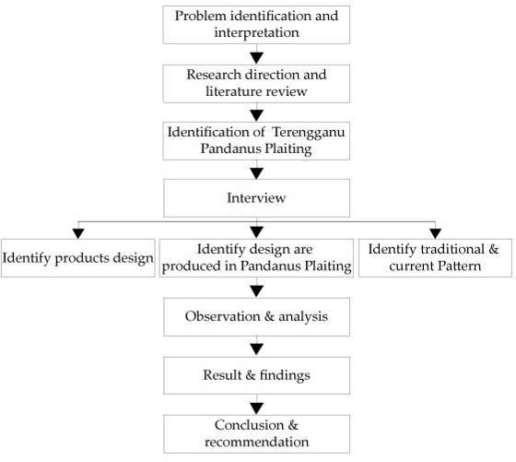

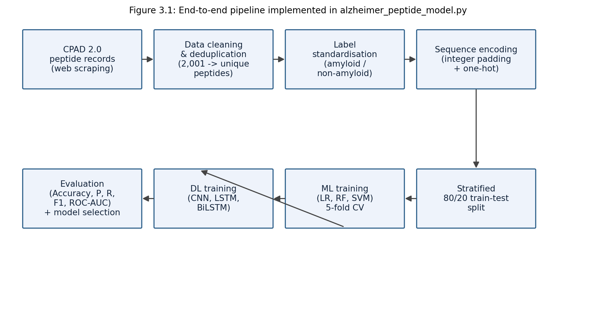
Figure 3.1: End-to-end system pipeline for peptide-based Alzheimer’s risk classification.

Functional and Nonfunctional Requirements
- Functional requirements describe what the system must do. For this project they are: (1) accept a peptide sequence composed of the 20 standard amino acid letters as input; (2) validate that every character belongs to the standard amino acid alphabet (ACDEFGHIKLMNPQRSTVWY) and reject sequences that contain any other character; (3) encode the validated sequence into the padded/one-hot representation expected by the selected model; (4) run inference with the chosen trained model (Logistic Regression, Random Forest, SVM, CNN, LSTM, or BiLSTM) and return a class label (amyloid / non-amyloid), a probability score, and a risk level (Low / Medium / High); and (5) allow the user to repeat this process for any number of sequences without restarting the application.
- Non-functional requirements describe how well the system performs these functions. For this project they are: (1) accuracy — the deployed model should reach at least 80% test accuracy, which the CNN model satisfies at 81.05%; (2) responsiveness — a single prediction should return in well under one second on ordinary desktop hardware, since inference on a single short sequence is computationally light; (3) reproducibility — all random operations (train-test split, cross-validation folds, weight initialisation seeds where supported) use a fixed random state so that results can be reproduced; and (4) usability — the web interface should accept plain text input and present the result without requiring the user to understand the underlying model.

Data Flow Diagram
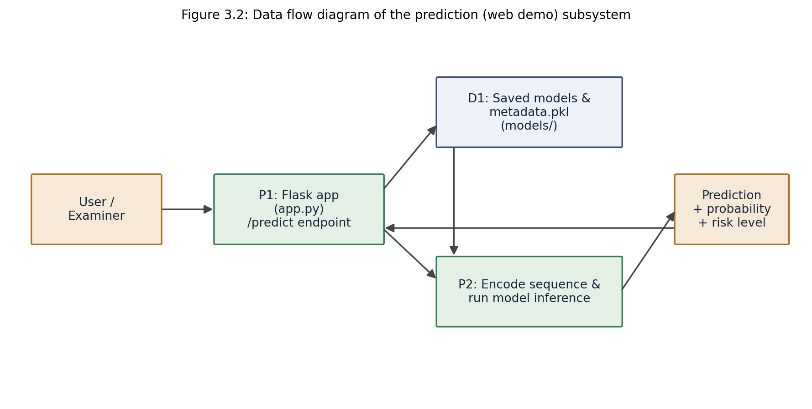
Figure 3.2 shows the data flow of the prediction subsystem exposed through the Flask web application (app.py). The user submits a peptide sequence and a model choice through the browser; the Flask route validates the input and calls the encoding and inference logic, which reads the previously saved model weights and metadata (vocabulary, maximum sequence length, label encoder) from the models/ directory and returns a JSON response containing the prediction, probability, and risk level, which the front end then renders.

UI Design
The user interface is a single-page web application (templates/index.html) served by Flask. It provides a text field for the peptide sequence, a drop-down to select which trained model to use, and a button that triggers an asynchronous request to the /predict endpoint. The result is displayed as a predicted class, an animated probability bar, and a colour-coded risk badge (green for Low, amber for Medium, red for High), so that a non-technical examiner can query the system without needing to read any code.

Detailed Methodology and Design

Several alternative design choices were considered before settling on the final pipeline. For sequence representation, k-mer frequency counting was considered as an alternative to one-hot and integer encoding; it was not adopted because it discards positional information that convolutional and recurrent models can otherwise exploit. For evaluation, a single train-test split without cross-validation was considered for the classical models, but five-fold cross-validation was adopted instead because the dataset, after deduplication, is modest in size and a single split can give an optimistic or pessimistic estimate depending on how the data happens to be divided. For the deep learning validation strategy, using the test set itself for early stopping was considered (and was, in fact, an earlier limitation of this project) but was replaced with a dedicated internal validation split so that the test set remains untouched until final evaluation. Finally, a single hybrid architecture was not adopted as the primary deliverable; instead, three deep learning architectures were trained independently so that their relative strengths (CNN for local motifs, LSTM/BiLSTM for longer-range dependencies) could be compared directly.

Project Plan
The project was planned and executed across two reporting phases, following the timeline in Table 3.1. The first phase covered data collection, cleaning, and the baseline machine learning models; the second phase covered the deep learning models, evaluation artefacts, the web demonstration, and the final report.

Task Allocation

This table depicts the timeline of the principal activities across the project,
covering weeks 6 to 48 of the two-phase FYDP schedule.

Table 3.1: Project task allocation across the FYDP timeline.
Tasks | Weeks
 | 6 | 8 | 10 | 12 | 16 | 20 | 24 | 28 | 32 | 36 | 38 | 40 | 42 | 44 | 45 | 46 | 47 | 48 | 48
Data cleaning, deduplication, and  label standardisation | ■ | ■ | ■ | ■
 | ■ | ■ | ■ | ■
Feature encoding and baseline ML  training (LR, RF, SVM, 5-fold CV) |  |  | ■ | ■ | ■ | ■ | ■
 |  |  | ■ | ■ | ■ | ■ | ■
Deep learning development and  training (CNN, LSTM, BiLSTM) |  |  |  |  |  | ■ | ■ | ■ | ■ | ■ | ■
 |  |  |  |  |  | ■ | ■ | ■ | ■ | ■ | ■
Evaluation, Flask web demo, and  final report drafting |  |  |  |  |  |  |  |  |  | ■ | ■ | ■ | ■ | ■ | ■ | ■ | ■ | ■ | ■
 |  |  |  |  |  |  |  |  |  | ■ | ■ | ■ | ■ | ■ | ■ | ■ | ■ | ■ | ■

Summary

This chapter described the research methodology of the project: a quantitative, experimental design covering data preprocessing, dual sequence encoding, six-model training and evaluation, and deployment through a Flask web interface, together with the functional and non-functional requirements, the data flow of the prediction subsystem, the alternatives considered, and the project timeline.

Chapter 4

Implementation and Results

This chapter describes the software environment used to build the system, the evaluation methodology applied to every model, and the results obtained, together with a discussion of why the models performed as they did.

Environment Setup
The pipeline was implemented in Python 3.x. Data collection used requests and BeautifulSoup [18]; data handling used pandas [14] and NumPy [15]; classical models used scikit-learn [2]; deep learning models used TensorFlow/Keras [3]; result plots used Matplotlib [16] and Seaborn [17]; spreadsheet export used openpyxl [19]; and the interactive demonstration used Flask [20]. No specialised hardware was required: every model trains and runs inference on an ordinary desktop or laptop CPU, since the dataset is small (a few thousand short sequences) and none of the architectures used exceeds a few hundred thousand parameters.

Testing and Evaluation/Performance/ Comparative Anal ysis
Every model was evaluated on the same held-out test set (20% of the cleaned dataset, stratified by class, random_state = 42) to keep the comparison fair. The three classical models (Logistic Regression, Random Forest, SVM) were additionally evaluated with stratified five-fold cross-validation on the training partition, which gives a more stable estimate of performance than a single split. The three deep learning models (CNN, LSTM, BiLSTM) were trained with a dedicated internal validation split (10% of the training data) and early stopping (patience = 5 epochs on validation loss, best weights restored) so that the test set was never used during training or model selection.
Five metrics were computed for every model from the confusion matrix on the test set: Accuracy = (TP + TN) / (TP + TN + FP + FN); Precision = TP / (TP + FP); Recall = TP / (TP + FN); F1-score = 2 × (Precision × Recall) / (Precision + Recall); and ROC-AUC, the area under the receiver operating characteristic curve, computed from the predicted probabilities rather than the thresholded class label. F1-score was used as the primary criterion for selecting the best model because it balances precision and recall, which is more informative than accuracy alone when false positives and false negatives are not equally costly.

Results and Discussion
Table 4.1 summarises the performance of all six models on the held-out test set, taken directly from the metrics_summary.csv file produced by the training pipeline.
Table 4.1: Comparative performance of all trained models on the held-out test set.
Model | Accuracy | Precision | Recall | F1-Score | ROC-AUC
Logistic Regression | 0.7781 | 0.8164 | 0.7682 | 0.7916 | 0.8472
Random Forest | 0.7656 | 0.7812 | 0.7955 | 0.7883 | 0.8649
SVM | 0.7731 | 0.8116 | 0.7636 | 0.7869 | 0.8492
CNN | 0.8105 | 0.8789 | 0.7591 | 0.8146 | 0.8925
LSTM | 0.5511 | 0.5500 | 1.0000 | 0.7097 | 0.5532
BiLSTM | 0.8030 | 0.8770 | 0.7455 | 0.8059 | 0.8769
The Convolutional Neural Network achieved the best overall result, with the highest accuracy (81.05%), F1-score (0.815), and ROC-AUC (0.893) of all six models. This is consistent with the literature reviewed in Chapter 2: Wang et al. [7] found CNN and RNN architectures to be the most cost-effective choice for modelling short peptide aggregation traits, and amyloid-forming behaviour is strongly influenced by short, local motifs (three to six residues) such as the well-known KLVFFA segment of amyloid-beta, which a convolutional filter is well suited to detect regardless of where the motif appears in the sequence.
Figure 4.1: Model performance comparison (bar chart and metric heatmap) across all six trained models.
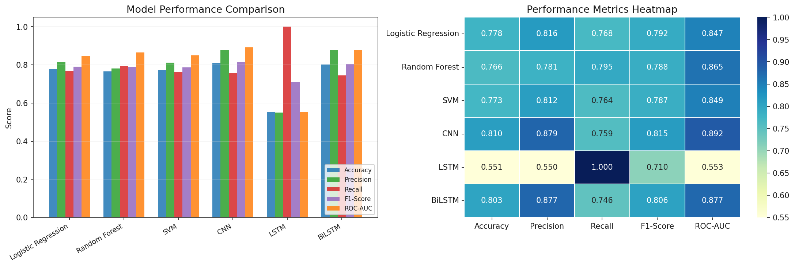
BiLSTM was the second-best model (accuracy 80.30%, F1 = 0.806, ROC-AUC = 0.877), ahead of all three classical baselines, showing that a bidirectional recurrent architecture can also capture useful contextual sequence patterns, though slightly less efficiently than the convolutional approach for this dataset. The plain, single-direction LSTM performed noticeably worse (accuracy 55.11%, F1 = 0.710) despite a nominal recall of 1.0; this combination — high recall with low accuracy and low precision (0.550) — indicates that the LSTM collapsed towards predicting the positive (amyloid) class for almost every input, rather than learning a genuinely discriminative decision boundary.
Figure 4.2: ROC curves for all six models on the held-out test set.
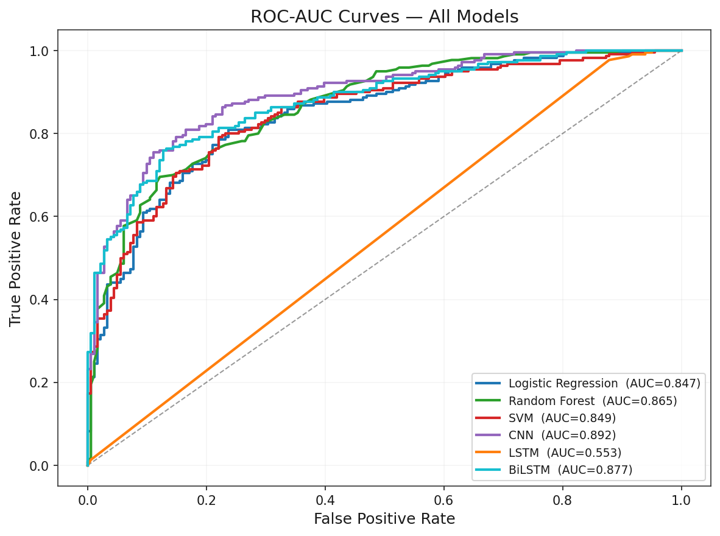
The three classical models (Logistic Regression, Random Forest, SVM) performed similarly to one another, with accuracy between 76.6% and 77.8% and F1-scores between 0.787 and 0.792, forming a consistent baseline band below the CNN and BiLSTM. This matches the expectation that models operating on a fixed one-hot representation, without any mechanism to learn position-invariant local patterns, are at a structural disadvantage relative to a convolutional model on this kind of sequence data. Random Forest reached the highest ROC-AUC among the classical models (0.865), suggesting its ensemble of decision trees captured some non-linear structure in the one-hot features that the linear Logistic Regression model could not.
Figure 4.3: Confusion matrix of the best-performing model (CNN) on the test set.
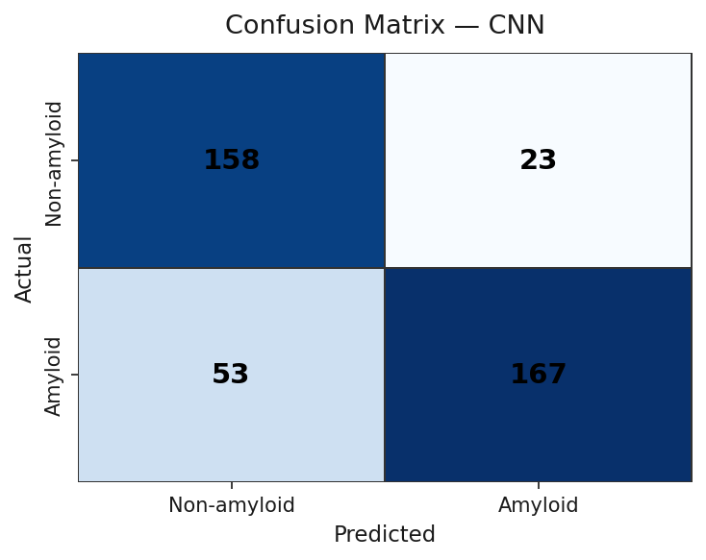
Figure 4.4: Training history (accuracy and loss) of the CNN model.
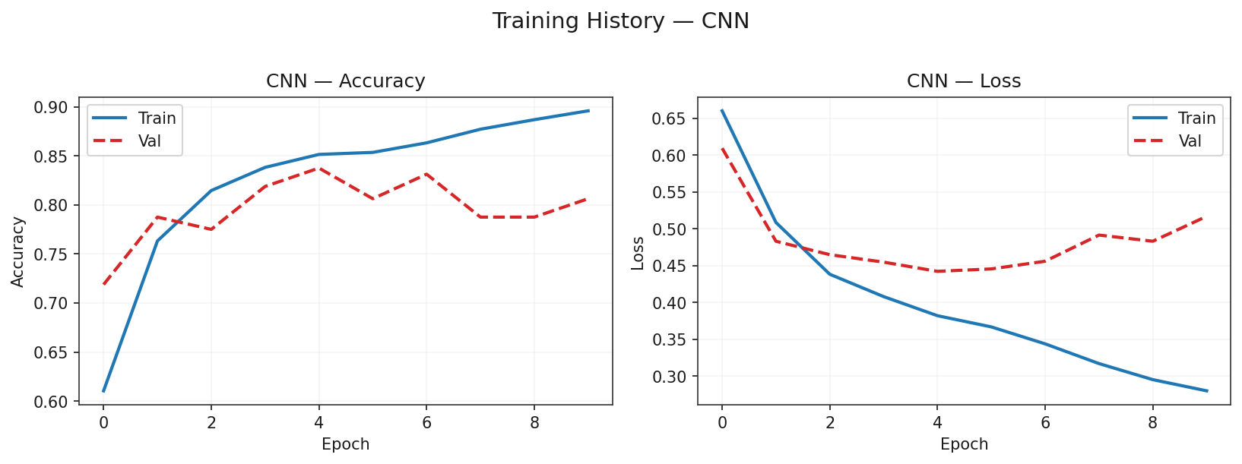
Figure 4.5: Confusion matrix of the BiLSTM model on the held-out test set.
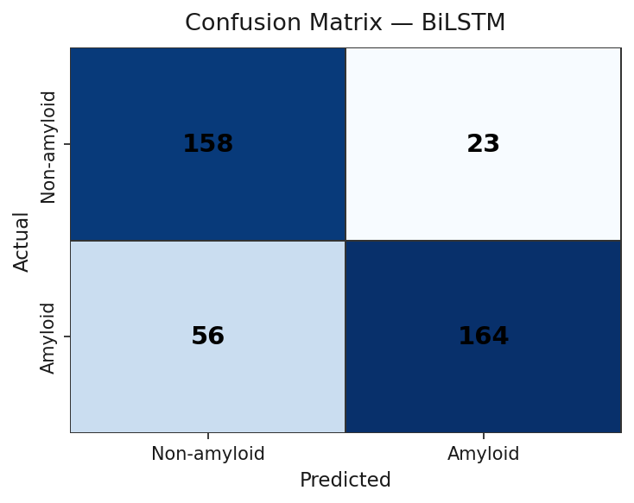
Figure 4.6: Training history (accuracy and loss) of the BiLSTM model.
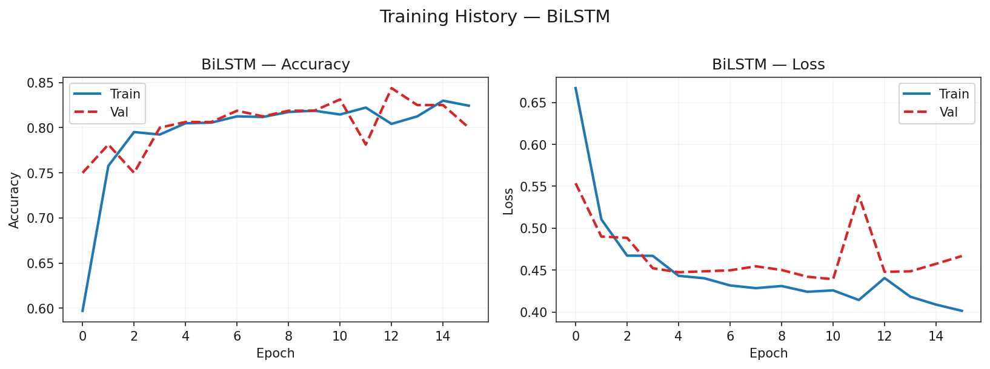
Figure 4.1 presents the six models side by side as a bar chart and as a metric heatmap, and Figure 4.2 shows the ROC curves for all models on a common plot. Figures 4.3 and 4.4 illustrate the confusion matrix and training curves for the leading CNN model, while Figures 4.5 and 4.6 provide the confusion matrix and training curves for the runner-up BiLSTM model. Both deep learning models converge smoothly under the early-stopping window without a widening gap between training and validation loss, demonstrating that the internal validation split and early stopping strategy adopted in Chapter 3 successfully prevented overfitting.

Summary

This chapter described the implementation environment, the evaluation methodology (stratified split, five-fold cross-validation for the classical models, and a separate validation split with early stopping for the deep learning models), and the results of all six trained models. The Convolutional Neural Network was identified as the best-performing model, reaching 81.05% accuracy and an F1-score of 0.815, and its behaviour was examined through confusion matrices, ROC curves, and training history plots alongside the runner-up BiLSTM model.

Chapter 5

Engineering Standards and Design Challenges

This chapter discusses the engineering standards relevant to the project, its impact on society, the environment, and sustainability, its project management and cost profile, and how the work maps onto the defined complex engineering problems and activities.

Compliance with the Standards

The standards discussed below are limited to those directly relevant to a software-only, data-driven research project of this kind; formal medical-device or clinical-software standards were not applied because the system is a research prototype and is not intended for clinical use in its current form.

Software Standards
The implementation follows standard Python packaging and style conventions (PEP 8 naming and structure) and pins minimum library versions in requirements.txt so that the environment can be reproduced. Two alternatives were considered for the deep learning backend: PyTorch and TensorFlow/Keras. TensorFlow/Keras [3] was selected because its high-level Sequential API reduced boilerplate for the three architectures used and because the developer had prior familiarity with it, which reduced development risk; the trade-off is a heavier dependency footprint than a minimal PyTorch setup.

Hardware Standards
The system has no dedicated hardware standard because it targets ordinary consumer or laboratory desktop/laptop hardware (a standard x86-64 CPU with at least 8 GB of RAM). An alternative would have been to require GPU acceleration; this was not made a requirement because the dataset and model sizes involved are small enough that CPU training completes in a practical amount of time, which keeps the system accessible to examiners without specialised hardware.

Communication Standards
Client-server communication in the web demonstration follows the standard HTTP/1.1 protocol, with the front end and the Flask backend exchanging JSON payloads over a REST-style /predict endpoint. Plain JSON over HTTP was chosen over a heavier protocol (for example gRPC) because the payload is a single short string and a few scalar outputs, so the added complexity of a binary protocol would not be justified.

Impact on Society, Environment and Sustainability

Impact on Life
If validated further, a system of this kind could give patients, caregivers, and researchers a faster, lower-cost first indication of amyloid-related risk than waiting for an imaging appointment, although it is not a diagnostic replacement for clinical evaluation.

Impact on Society & Environment
The models are computationally light (a few hundred thousand parameters at most) and train on CPU hardware in minutes, so the environmental footprint of running or retraining them is small compared with large-scale deep learning systems. Reducing reliance on repeated imaging-based screening could also reduce the resource cost associated with running MRI/PET equipment for routine, low-risk cases.

Ethical Aspects
The dataset (CPAD 2.0 peptide records) contains no patient-identifiable information, which limits privacy risk. However, the system must not be presented as a diagnostic tool: its output is a probability derived from sequence data alone, it has not been validated on an independent clinical cohort, and using it to make real medical decisions without qualified clinical oversight would be inappropriate and potentially harmful.

Sustainability Plan
The code, trained model artefacts, and dataset processing scripts are kept in a single version-controlled repository with pinned dependency versions, so the pipeline can be re-run and the models retrained as CPAD 2.0 grows or as new peptide data becomes available, without requiring a rewrite of the surrounding infrastructure.

Project Management and Financial Analysis

The project relies almost entirely on free and open-source software (Python, scikit-learn, TensorFlow, Flask) and a freely accessible public dataset (CPAD 2.0), so direct financial cost is minimal beyond the researcher’s own computing hardware and time. An alternative budget line would arise only if the project were extended towards clinical validation, which would require access to an independent, ethically approved peptide or patient dataset and possibly wet-lab confirmation of predicted aggregation behaviour; that cost is outside the scope of the current, software-only phase of the work.

Complex Engineering Problem

Complex Problem Solving
Table 5.1 maps this project to the WK/EP complex engineering problem attributes defined by the accreditation framework, with a short rationale for each attribute that applies.

Table 5.1: Mapping with Complex Engineering Problem.
EP1  Dept of Knowledge | EP2  Range  Of Conflicting Requirements | EP3  Depth of Analysis | EP4  Familiarity of Issues | EP5  Extent of Applicable Codes | EP6  Extent  Of Stake- holder Involvement | EP7  Interdependence
Requires knowledge of bioinformatics (peptide/amyloid biology), classical machine learning, and deep sequence modelling (WK3-WK8). | Balances predictive accuracy against interpretability and training time across six different model families evaluated under one common pipeline. | Requires analysis of preprocessing choices, encoding schemes, cross-validation design, and per-model error behaviour (e.g. the LSTM recall/precision imbalance). | Combining peptide bioinformatics with deep sequence modelling for amyloid risk is not a routine, previously solved engineering task for the author. | Few formal codes exist specifically for this niche; general ML evaluation good practice (stratified splitting, held-out testing) was followed instead of a regulatory code. | Primarily the researcher and academic supervisor at this research stage; no external clinical or commercial stakeholders are yet involved. | Integrates a public bioinformatics dataset, multiple ML/DL frameworks, and a web deployment layer, each with its own constraints that interact with the others.

Mapping with Knowledge Profile

This subsection maps the overall problem, together with EP1, to the Knowledge Profile (K1-K8) used by the accreditation framework, with a brief rationale in Table 5.2.

Table 5.2: Mapping with knowledge Profile.
K1 | K2 | K3 | K4 | K5 | K6 | K7 | K8
Natural Science | Mathematics | Engineering Fundamentals | Specialist Knowledge | Engineering Design | Engineering Practice | Comprehension | Research Literature
Not directly applied. | Basic statistics (metrics, CV) only. | ML/DL model design and training. | Peptide/amyloid biology knowledge. | Pipeline and model architecture design. | Implementation and evaluation practice. | Interpreting results and limitations. | Grounded in the reviewed literature.

Engineering Activities
This subsection maps the project to the complex Engineering Activities (EA1-EA5) defined by the accreditation framework, with a brief rationale in Table 5.3.
Mapping with Complex Engineering Activities

This section maps the overall problem to the relevant EAs (multiple may apply).

Table 5.3: Mapping with Complex Engineering Activities.
EA1  Range of re- sources | EA2  Level of Interaction | EA3  Innovation | EA4  Consequences for society and environment | EA5  Familiarity
Uses a public dataset, open-source ML/DL libraries, and standard desktop computing resources; no specialised laboratory resources were required. | Mainly an individual research effort with supervisory guidance; limited interaction with external teams at this stage of the project. | Combines peptide sequence data with a six-model ML/DL comparison and a real-time web demonstration, which is not a routine, off-the-shelf configuration. | A validated version of this kind of tool could support lower-cost, earlier AD-related screening, with the ethical caveat that it must not replace clinical diagnosis. | The general problem (disease risk prediction from biological sequence data) is familiar in bioinformatics, but the specific peptide-aggregation angle combined with a full ML/DL comparison is less common.

Summary
This chapter reviewed the software, hardware, and communication standards applied in the project, its impact on life, society, the environment, ethics, and sustainability, a brief financial analysis, and a mapping of the work to the defined complex engineering problems and activities.

Chapter 6

Conclusion

This chapter summarises the project, states its limitations honestly, and outlines directions for future work.

Summary
This project presented a computational framework for early Alzheimer’s disease risk screening based on peptide sequences, combining classical machine learning (Logistic Regression, Random Forest, SVM) with deep learning (CNN, LSTM, BiLSTM) under one evaluation pipeline. Peptide records were collected from the CPAD 2.0 database, cleaned, deduplicated, and encoded in two representations suited to the two model families, and all six models were compared on a common held-out test set using accuracy, precision, recall, F1-score, and ROC-AUC. The Convolutional Neural Network produced the best result (81.05% accuracy, F1 = 0.815, ROC-AUC = 0.893), ahead of BiLSTM and the three classical baselines, while the plain LSTM under-performed by collapsing towards the positive class. The best model was packaged behind a Flask web interface so that a new peptide sequence can be scored interactively. These results support the underlying premise of the project: that peptide sequence data, without any imaging, carries a usable signal for amyloid-related risk classification, and that a convolutional architecture is well suited to extracting that signal from short biological sequences.

Limitation
This work has several limitations that should be considered before drawing broader conclusions from it. First, there is no independent clinical validation dataset; all reported results come from a single held-out split of the CPAD 2.0 data, and performance on sequences outside this database is unknown. Second, the LSTM model over-predicts the positive class (recall of 1.0 with precision of 0.553), which shows that not every architecture generalised equally well under the same training regime. Third, the results depend on the label quality and coverage of CPAD 2.0 itself; mislabelled or under-represented peptide types in the source database would carry through to the trained models. Finally, systematic hyperparameter search (for example grid or Bayesian search over network width, depth, and learning rate) was not carried out; the architectures used reasonable, literature-informed defaults rather than tuned optima.

Future Work
Future work could address these limitations directly: evaluating the trained models on an independent, ideally clinically sourced, peptide or amyloid dataset; running a systematic hyperparameter search for the CNN and BiLSTM models; applying k-fold cross validation to the deep learning models in addition to the classical ones; and adding saliency or SHAP-based explainability to the CNN and BiLSTM models, extending the SHAP analysis already produced for Random Forest, so that predictions can be linked back to specific residues in a sequence. A longer-term direction is to replace the custom CNN/LSTM/BiLSTM encoders with a pretrained protein language model such as ESM-2, fine-tuned on the same CPAD 2.0 labels, to test whether large-scale pretraining on general protein sequences improves on the results reported here.

References
- CPAD 2.0: Curated Protein Aggregation Database, “Peptide Dataset,” [Online]. Available: https://web.iitm.ac.in/bioinfo2/cpad2/peptides/
- F. Pedregosa et al., “Scikit-learn: Machine Learning in Python,” Journal of Machine Learning Research, vol. 12, pp. 2825–2830, 2011.
- M. Abadi et al., “TensorFlow: Large-Scale Machine Learning on Heterogeneous Systems,” 2015. [Online]. Available: https://www.tensorflow.org/
- S.-R. Yu, X.-M. Yang, Y.-N. Sun, Y.-J. Li, Y.-Y. Liu, and X.-L. Tang, “Protein interaction prediction for Alzheimer’s disease using a multi-source protein features fusion framework,” Informatics and Health, vol. 2, pp. 119–129, 2025.
- A. Hassan, A. Imran, A. U. Yasin, M. A. Waqas, and R. Fazal, “A multimodal approach for Alzheimer’s disease detection and classification using deep learning,” Journal of Computing & Biomedical Informatics, vol. 6, no. 2, Mar. 2024.
- P. Rani, R. Lamba, R. K. Sachdeva, K. Kumar, and C. Iwendi, “A machine learning model for Alzheimer’s disease prediction,” IET Cyber-Physical Systems: Theory & Applications, 2024.
- B. Wang, S. Razavi, and E. R. Gamazon, “Towards mechanistic models of mutational effects: Deep learning on Alzheimer’s Aβ peptide,” Computational and Structural Biotechnology Journal, vol. 21, pp. 2434–2445, 2023.
- L. Xu, G. Liang, C. Liao, G.-D. Chen, and C.-C. Chang, “An efficient classifier for Alzheimer’s disease genes identification,” Molecules, vol. 23, no. 12, p. 3140, Nov. 2018.
- J. Hardy and D. J. Selkoe, “The amyloid hypothesis of Alzheimer’s disease: Progress and problems on the road to therapeutics,” Science, vol. 297, no. 5580, pp. 353–356, Jul. 2002.
- D. J. Selkoe and J. Hardy, “The amyloid hypothesis of Alzheimer’s disease at 25 years,” EMBO Molecular Medicine, vol. 8, no. 6, pp. 595–608, Jun. 2016.
- H. Braak and E. Braak, “Neuropathological staging of Alzheimer-related changes,” Acta Neuropathologica, vol. 82, no. 4, pp. 239–259, 1991.
- C. R. Jack Jr. et al., “NIA-AA Research Framework: Toward a biological definition of Alzheimer’s disease,” Alzheimer’s & Dementia, vol. 14, no. 4, pp. 535–562, Apr. 2018.
- A. Fernandez-Escamilla, M. S. Rousseau, L. Schymkowitz, and F. Serrano, “Prediction of sequence-dependent and mutational effects on the aggregation of peptides and proteins,” Nature Biotechnology, vol. 22, no. 10, pp. 1302–1306, Oct. 2004.
- W. McKinney, “Data structures for statistical computing in Python,” in Proc. 9th Python in Science Conf., 2010, pp. 56–61.
- C. R. Harris et al., “Array programming with NumPy,” Nature, vol. 585, no. 7825, pp. 357–362, 2020.
- J. D. Hunter, “Matplotlib: A 2D graphics environment,” Computing in Science & Engineering, vol. 9, no. 3, pp. 90–95, 2007.
- M. L. Waskom, “Seaborn: Statistical data visualization,” Journal of Open Source Software, vol. 6, no. 60, p. 3021, 2021.
- L. Richardson, “Beautiful Soup Documentation,” [Online]. Available: https://www.crummy.com/software/BeautifulSoup/bs4/doc/
- openpyxl Developers, “openpyxl documentation,” [Online]. Available: https://openpyxl.readthedocs.io/
- Pallets Projects, “Flask documentation,” [Online]. Available: https://flask.palletsprojects.com/

