SignSync AI: An AI-Powered Bidirectional Sign Language Communication Platform



FYP Team
Sheikh Umar Younas 23F-0506
Burhan Raza 23F-0703
Muhammad Saad 23F-0526

Supervised by
Mr. M Shahbaz Ayyaz

Co-Supervised by
Dr. Awais Azam

Department of Computer Science
National University of Computer and Emerging Sciences
Chiniot, Pakistan.
Fall 2026

Anti-Plagiarism Declaration
This is to declare that the above publication produced under the:
Title: SignSync AI: An AI-Powered Bidirectional Sign Language Communication Platform, is the sole contribution of the author(s) and no part hereof has been reproduced on an as-is basis (cut and paste) which can be considered as plagiarism. All referenced parts have been used to argue the idea and have been cited properly. I/We will be responsible and liable for any consequence if a violation of this declaration is determined.
Date: 07-10-2026

Student 1
Name: Sheikh Umar Younas
Signature: ____________________
Student 2
Name: Burhan Raza
Signature: ____________________
Student 3
Name: Muhammad Saad
Signature: ____________________
Supervisor (Faculty) Name: Mr. M Shahbaz Ayyaz
Signature: ____________________

Intellectual Property Right Declaration
This is to declare that the above publication produced under the:
Title: SignSync AI: An AI-Powered Bidirectional Sign Language Communication Platform, is the solely property of the National University of Computer and Emerging Sciences, and is protected under the intellectual property laws applicable. No part of this work may be reproduced, distributed, or transmitted without the prior written permission of the university and the author(s).
Date: 07-10-2026

Student 1
Name: Sheikh Umar Younas
Signature: ____________________
Student 2
Name: Burhan Raza
Signature: ____________________
Student 3
Name: Muhammad Saad
Signature: ____________________
Supervisor (Faculty) Name: Mr. M Shahbaz Ayyaz
Signature: ____________________

Abstract
Communication remains a fundamental human need, yet millions of Deaf and non-speaking individuals face daily difficulty interacting with people who do not understand sign language. In Pakistan alone, a large Deaf and hard-of-hearing community exists, but no regional application currently provides real-time, two-way translation between sign language and spoken or written language. Available solutions are largely limited to static dictionaries, human-interpreter marketplaces, or one-directional avatar translators built for other sign languages. SignSync AI is proposed to fill this gap as an AI-powered bidirectional mobile communication platform that uses OpenCV, MediaPipe and deep learning to recognize sign-language gestures from an ordinary mobile camera and convert them into text and speech in real time. In the reverse direction, spoken or typed input is converted into sign-language output through an animated 3D avatar. Camera input is preprocessed on-device through an edge-based preprocessing module that extracts lightweight hand, body and facial landmarks locally before they are sent to the backend for recognition, reducing data transmission and improving user privacy. Beyond isolated gesture recognition, the platform incorporates a rule-based Sign Sequence Engine and an external language-correction layer so that keyword-level signs can be reconstructed into natural, grammatically correct sentences in Urdu or English. By combining a curated multi-source gesture dataset with a complete mobile application, backend services and an edge-based preprocessing pipeline, SignSync AI aims to deliver a practical, deployable accessibility solution rather than a laboratory prototype.

Table of Contents
List of Figures viii
List of Tables ix
1. Introduction 1
2. Vision Document 1
2.1. Problem Statement 1
2.2. Objectives 1
2.3. Overview 2
2.4. Scope 2
2.5. Constraints 3
2.5.1. Hardware and Device Limitations 3
2.5.2. Model Size and On-Device Performance 3
2.5.3. Connectivity Requirements 3
2.5.4. Platform Constraint 3
2.5.5. Security and Privacy 3
2.5.6. Regulatory and Ethical Compliance 3
2.5.7. Resource Constraint 4
2.5.8. Dataset and Localization 4
2.6. Stakeholder and User Description 4
2.6.1. Market Demographics 4
2.6.2. User Environment 4
2.6.3. Stakeholder Profiles 4
2.6.3.1. Supervisor Team 4
2.6.3.2. Development Team 5
2.6.3.3. End Users 5
2.6.3.4. Administrator 5
3. System Requirements Specification 6
3.1. System Features 6
3.1.1. Sign-to-Text & Speech Translation Module 6
3.1.2. Speech-to-Sign Avatar Translation Module 6
3.1.3. Edge-Based Preprocessing Module 6
3.1.4. Sign Sequence & Language Correction Engine 6
3.1.5. Confidence-Based Error Recovery 6
3.1.6. Accessibility & Feedback Layer 6
3.1.7. Account, Preference & History Management 7
3.1.8. Administrator Console & Performance Monitoring 7
3.2. Functional Requirements 7
3.2.1. Account Registration & Authentication 7
3.2.2. Sign-to-Text & Speech Recognition 7
3.2.3. Confidence Evaluation & Error Recovery 7
3.2.4. Sign Sequence & Language Correction 7
3.2.5. Speech-to-Sign & Text-to-Sign Avatar Translation 7
3.2.6. Accessibility & Preference Configuration 8
3.2.7. Communication History 8
3.2.8. Administrative Management 8
3.3. Non-Functional Requirements 8
3.3.1. Performance 8
3.3.2. Reliability 8
3.3.3. Usability 8
3.3.4. Security and Privacy 9
3.3.5. Scalability 9
3.3.6. Maintainability 9
3.3.7. Portability 9
4. Artifacts 9
5. Use Case Models 9
6. Expanded Use Cases 11
6.1. Sign-to-Text & Speech Translation 11
6.2. Speech-to-Sign Avatar Translation 13
6.3. Manage Preferences & Accessibility 14
6.4. Performance Monitoring Dashboard 16
6.5. User Registration & Secure Login 18
6.6. Text-to-Sign Avatar Translation 20
6.7. Low-Confidence Sign Recovery 22
6.8. View Communication History 24
6.9. Manage Supported Vocabulary & Dataset 26
7. High-Level Use Cases 27
7.1. Register / Login 27
7.2. View Communication History 28
7.3. Extract Landmarks On-Device (Edge Preprocessing) 28
7.4. Recognize Sign Gesture 28
7.5. Convert to Speech (TTS) 29
7.6. Prompt to Repeat Sign (Low-Confidence Recovery) 29
7.7. Transcribe Speech to Text 29
7.8. Text-to-Sign Avatar Translation 30
7.9. Display 3D Sign Avatar 31
7.10. Manage Supported Vocabulary & Dataset 31
8. Activity Diagram 31
9. System Sequence Diagram (SSD) 33
9.1. SSD-1: Account Registration & Secure Login 33
9.2. SSD-2: Sign-to-Text & Speech Translation 34
9.3. SSD-3: Speech-to-Sign Avatar Translation 34
9.4. SSD-4: Text-to-Sign Avatar Translation 35
9.5. SSD-5: Accessibility & Preference Configuration 36
9.6. SSD-6: Communication History & Preference Management 37
9.7. SSD-7: Performance Monitoring Dashboard (Admin) 37
9.8. SSD-8: Manage Supported Vocabulary & Dataset 38
10. Sequence Diagram 39
11. Design Phase 41
11.1. Domain Model 41
11.2. Class Diagram 42
11.3. Entity Relationship (ER) Diagram 43
11.5. System Architecture Diagram 44
11.6. Deployment Diagram 45
11.7. Data Flow Diagram (Level 0) 45
11.8. Data Flow Diagram (Level 1) 46
12. References 47

List of Figures
Figure 5.1 Use Case Diagram 10
Figure 8.1 Activity Diagram: Bidirectional Communication Flow 32
Figure 9.1.1 SSD-1: Account Registration & Secure Login 33
Figure 9.2.1 SSD-2: Sign-to-Text & Speech Translation 34
Figure 9.3.1 SSD-3: Speech-to-Sign Avatar Translation 35
Figure 9.4.1 SSD-4: Text-to-Sign Avatar Translation 36
Figure 9.5.1 SSD-5: Accessibility & Preference Configuration 36
Figure 9.6.1 SSD-6: Communication History & Preference Management 37
Figure 9.7.1 SSD-7: Performance Monitoring Dashboard (Admin) 38
Figure 9.8.1 SSD-8: Manage Supported Vocabulary & Dataset 39
Figure 10.1 Sequence Diagram: SignSync AI Communication Flow 40
Figure 11.1.1 Domain Model 41
Figure 11.2.1 Class Diagram 42
Figure 11.3.1 Entity Relationship Diagram 43
Figure 11.4.1 System Architecture Diagram 44
Figure 11.5.1 Deployment Diagram 45
Figure 11.6.1 Data Flow Diagram (Level 0) 46
Figure 11.7.1 Data Flow Diagram (Level 1) 46

List of Tables
Table 2.6.3.1 Supervisor Team 4
Table 2.6.3.2 Development Team 5
Table 2.6.3.3 End Users 5
Table 2.6.3.4 Administrator 5
Table 6.1.1 Sign-to-Text & Speech Translation 11
Table 6.2.1 Speech-to-Sign Avatar Translation 13
Table 6.3.1 Manage Preferences & Accessibility 15
Table 6.4.1 Performance Monitoring Dashboard 17
Table 6.5.1 User Registration & Secure Login 18
Table 6.6.1 Text-to-Sign Avatar Translation 20
Table 6.7.1 Low-Confidence Sign Recovery 22
Table 6.8.1 View Communication History 24
Table 6.9.1 Manage Supported Vocabulary & Dataset 26
Table 7.1.1 Register / Login 28
Table 7.2.1 View Communication History 28
Table 7.3.1 Extract Landmarks On-Device (Edge Preprocessing) 28
Table 7.4.1 Recognize Sign Gesture 29
Table 7.5.1 Convert to Speech (TTS) 29
Table 7.6.1 Prompt to Repeat Sign (Low-Confidence Recovery) 29
Table 7.7.1 Transcribe Speech to Text 30
Table 7.8.1 Text-to-Sign Avatar Translation 30
Table 7.9.1 Display 3D Sign Avatar 31
Table 7.10.1 Manage Supported Vocabulary & Dataset 31

1. Introduction
Communication is a fundamental human need, yet deaf and non-speaking individuals around the world can face daily difficulty communicating with people who do not understand sign language. In hospitals, universities, banks, workplaces and public offices, the absence of a shared communication medium can create persistent barriers and may force a person to depend on a family member or interpreter simply to be understood.
SignSync AI is proposed as a mobile application that uses computer vision and deep learning to translate sign-language gestures into text and speech in real time, and to translate spoken or typed language back into sign-language output through an animated avatar: a complete, two-way accessibility platform rather than a one-directional translator dependent on constant connectivity.

2. Vision Document

2.1. Problem Statement
There remains a need for affordable systems that enable reliable, real-time, two-way communication between sign-language users and the general public. Existing solutions are often limited to static dictionaries, a single sign language, one-directional translation, or restricted vocabularies. A practical communication platform should also address uncertain recognition, sentence reconstruction and multilingual output. Recognition accuracy can be affected by variations in hand position, movement, lighting and other real-world conditions, making confidence-based error handling important for dependable communication. Furthermore, recognized signs are often produced as individual words or gestures, so a useful system must combine them into meaningful sequences and natural sentences rather than presenting isolated predictions. The lack of accessible and flexible communication outputs can further limit interaction between Deaf and hearing users in everyday situations. [1], [2], [7]

2.2. Objectives
- Design an AI pipeline capable of recognizing sign-language gestures in real time using an ordinary mobile camera.
- Convert recognized signs into readable text and natural speech output, and convert speech or typed text back into sign language through an animated 3D avatar.
- Combine individually recognized signs into meaningful sequences through a rule/dictionary-based Sign Sequence Engine, refined into natural sentences using an external Language Correction API.
- Incorporate an edge-based preprocessing module so that camera frames are processed locally on the device using MediaPipe to extract lightweight hand and body landmarks before they are sent to the backend for recognition.
- Construct a curated, labelled gesture dataset of 20 to 30 commonly used signs by combining ethically collected project data with relevant public datasets across different regions as a reusable research contribution. [1], [4], [5], [6], [8]
- Deliver a complete, deployable accessibility platform: mobile app, backend, database and testing pipeline, rather than a research prototype.

2.3. Overview
SignSync AI is a mobile application that translates sign-language gestures into text and speech, and translates spoken or typed language back into sign language through an animated avatar. A phone camera captures the user's hand and body movements, which are processed through an on-device edge-based preprocessing module to extract lightweight hand and body landmarks before the extracted data is sent to the backend for recognition. Recognized signs are assembled into natural sentences through a rule-based Sign Sequence Engine and an external language-correction step, with output delivered in Urdu or English according to user preference. [1], [2], [5], [8]
SignSync AI consists of five main layers:
- Capture & Edge Layer: Captures camera/microphone input and performs on-device landmark extraction using MediaPipe before any data leaves the device.
- Recognition Layer: Runs the PyTorch-based deep-learning model that recognizes the performed sign from the extracted landmark sequence, together with a confidence evaluator.
- Language & Sequencing Layer: Combines recognized signs into sequences through the Sign Sequence Engine and refines them into natural sentences through an external Language Correction API.
- Bidirectional Output Layer: Delivers text and speech output for the sign-to-text direction and drives the 3D avatar renderer for the speech/text-to-sign direction.
- Backend & Storage Layer: Handles authentication, preference storage, communication history and performance/usage logging through FastAPI, PostgreSQL and Supabase.

2.4. Scope
SignSync AI is a bidirectional, AI-powered mobile accessibility platform that translates sign-language gestures into text and speech, and translates spoken or typed language into sign language through a 3D avatar. The system is built around a limited, curated vocabulary of 20 to 30 commonly used signs rather than unrestricted recognition [3], so that the recognition model can be trained and validated within the academic timeline while still demonstrating a complete, usable communication pipeline.
The platform targets Deaf/Mute, Blind/Hearing and Normal users through a single mobile application, and supports Urdu and English as bilingual output languages. Camera frames are preprocessed on-device to extract landmarks before backend recognition, reducing bandwidth use and improving privacy. An administrator console allows the supported vocabulary/dataset and the recognition model's accuracy and latency to be monitored and maintained. Recognized sign sequences and spoken/typed input are reconstructed into grammatically correct sentences through a rule-based Sign Sequence Engine and an external Language Correction API, with results delivered through visual, audio and haptic feedback channels.

2.5. Constraints

2.5.1. Hardware and Device Limitations
The system relies on the camera and microphone of an ordinary mid-range Android smartphone. Recognition accuracy and landmark-extraction quality may vary with device camera quality, lighting conditions and processor capability.

2.5.2. Model Size and On-Device Performance
The on-device edge-preprocessing component must remain lightweight enough to run in real time on a mid-range smartphone, while the heavier recognition and language-correction models remain on the backend to keep inference latency within acceptable limits.

2.5.3. Connectivity Requirements
Sign recognition, language correction and avatar mapping depend on the FastAPI backend and external Language Correction and Whisper APIs, so a working internet connection is required for full functionality. Only edge-based landmark extraction happens fully offline.

2.5.4. Platform Constraint
The application targets Android smartphones through React Native and Expo EAS. iOS support may be considered in a future release depending on time and resources.

2.5.5. Security and Privacy
All data in transit shall be encrypted using TLS, and account/preference data at rest shall be protected through the Supabase/PostgreSQL security model. Only extracted landmark data, not raw video, is transmitted to the backend for recognition, in line with the project's privacy-by-design goal.

2.5.6. Regulatory and Ethical Compliance
The gesture dataset must be collected and curated ethically, with consent obtained from any human subjects recorded for training data, and public datasets used only within their licensing terms.

2.5.7. Resource Constraint
The project is developed within an academic FYP timeline and budget, using available GPU resources (including cloud GPU credits where required) for model training, and limited free-tier cloud hosting for backend deployment.

2.5.8. Dataset and Localization
Recognition accuracy depends on the diversity of the curated 20–30-sign vocabulary dataset; performance may degrade for signs, signers or dialectal variations outside the trained data. [1], [2], [3], [4], [5], [6], [8]

2.6. Stakeholder and User Description

2.6.1. Market Demographics
SignSync AI is built for Deaf, Mute, Blind and Hearing individuals, along with their families, educators, and public-service staff (hospitals, banks, universities, workplaces) who need a practical way to communicate across the sign-language barrier. It is aimed primarily at the Pakistani Deaf and hard-of-hearing community, for whom no existing regional application offers real-time, bidirectional sign-language translation.

2.6.2. User Environment
SignSync AI is a mobile application for Android smartphones, used with the built-in camera and microphone. Users interact with the app directly, without needing any specialized hardware, gloves or external sensors. The application is designed to work in everyday public and private settings, homes, classrooms, hospitals, offices and public counters, with a working internet connection for backend recognition and language-correction services.

2.6.3. Stakeholder Profiles

2.6.3.1. Supervisor Team
Table 2.6.3.1 Supervisor Team
Name | Role | Responsibility
Mr. M Shahbaz Ayyaz | Supervisor | Guides technical direction, reviews AI pipeline and system design, and evaluates project milestones.
Dr. Awais Azam | Co-Supervisor | Provides research guidance on sign-language recognition, dataset curation and academic evaluation.

2.6.3.2. Development Team
Table 2.6.3.2 Development Team
Name | Roll Number | Primary Focus
Sheikh Umar Younas | 23F-0506 | Mobile application (React Native), UI/UX and accessibility layer.
Burhan Raza | 23F-0703 | Computer vision, sign-recognition model and edge-preprocessing pipeline.
Muhammad Saad | 23F-0526 | Backend services, database, avatar/animation integration and deployment.

2.6.3.3. End Users
Table 2.6.3.3 End Users
User Type | Description
Deaf / Mute User | Communicates primarily through sign language; uses the camera-based sign-to-text/speech pipeline and receives speech/text-to-sign avatar output.
Blind / Hearing User | Communicates through speech; relies on audio feedback and the speech-to-sign translation pipeline to communicate with a Deaf/Mute user.
Normal User | A hearing, sighted user who communicates via chat/text input and reads translated output, e.g. for casual or public-counter interactions.

2.6.3.4. Administrator
Table 2.6.3.4 Administrator
Responsibility | Description
Vocabulary & Dataset Management | Adds, updates or retires supported signs and manages the curated gesture dataset used for training.
Performance Monitoring | Reviews recognition accuracy, precision/recall/F1-score, latency and inference-time metrics through the monitoring dashboard.

3. System Requirements Specification

3.1. System Features

3.1.1. Sign-to-Text & Speech Translation Module
Captures live camera frames of a performed sign, extracts hand/body/facial landmarks, runs the PyTorch recognition model, and outputs the recognized sign as readable text and synthesized speech [1], [5].

3.1.2. Speech-to-Sign Avatar Translation Module
Converts a hearing user's spoken input (via Whisper) or typed text into a supported sign sequence, rendered through a 3D avatar for the Deaf/Mute user [9].

3.1.3. Edge-Based Preprocessing Module
Performs lightweight, on-device hand/body/facial landmark extraction using MediaPipe so that raw video never leaves the phone, reducing bandwidth usage and improving privacy.

3.1.4. Sign Sequence & Language Correction Engine
Combines individually recognized or mapped signs into meaningful sequences through a rule/dictionary-based engine, then refines the sequence into a natural, grammatically correct Urdu or English sentence via an external Language Correction API.

3.1.5. Confidence-Based Error Recovery
Evaluates a confidence score for every recognized sign; predictions below the acceptance threshold are rejected and the user is prompted to repeat the sign rather than risk a misleading translation.

3.1.6. Accessibility & Feedback Layer
Delivers visual, audio and haptic feedback so the same translation workflow is usable by Deaf, Blind and Hearing users alike, configurable per user through the preferences screen.

3.1.7. Account, Preference & History Management
Provides secure registration/login, stores output-language and feedback preferences, and keeps a communication history so returning users can continue with their saved configuration.

3.1.8. Administrator Console & Performance Monitoring
Allows administrators to manage the supported sign vocabulary/dataset and to monitor recognition accuracy, precision, recall, F1-score, latency and inference time through a dashboard.

3.2. Functional Requirements

3.2.1. Account Registration & Authentication
- The system shall allow a User to register and log in with a valid email/phone and password.
- The system shall associate stored preferences and communication history with the authenticated account.

3.2.2. Sign-to-Text & Speech Recognition
- The system shall capture real-time camera frames and extract hand, body and facial landmarks using MediaPipe.
- The system shall send the extracted landmark sequence (not raw video) to the backend recognition model.
- The system shall display the recognized sign as text and shall convert it to speech through the TTS engine.
- The system shall accumulate multiple recognized signs into a sequence rather than showing isolated gestures only.

3.2.3. Confidence Evaluation & Error Recovery
- The system shall compute a confidence value for every recognized sign.
- The system shall prompt the user to repeat a sign whenever confidence falls below the defined acceptance threshold.

3.2.4. Sign Sequence & Language Correction
- The system shall assemble recognized/mapped signs into a keyword-level sequence through the Sign Sequence Engine.
- The system shall send the sequence to the external Language Correction API to produce a grammatically correct sentence in the user's selected language.

3.2.5. Speech-to-Sign & Text-to-Sign Avatar Translation
- The system shall transcribe a hearing user's spoken input to text using Whisper.
- The system shall map input text (spoken or typed) to a supported sign sequence and render it through the 3D avatar.
- The system shall display an “unsupported vocabulary” message when input text cannot be mapped to a known sign.

3.2.6. Accessibility & Preference Configuration
- The system shall allow the user to select Urdu, English, or a bilingual output preference.
- The system shall allow the user to enable/disable visual, audio and haptic feedback independently.
- The system shall persist these preferences with the user's profile for future sessions.

3.2.7. Communication History
- The system shall store completed communication sessions, including translated text and modality used.
- The system shall allow the user to view past communication history from the dashboard.

3.2.8. Administrative Management
- The system shall allow administrators to add, update or retire entries in the supported sign vocabulary/dataset.
- The system shall allow administrators to view recognition accuracy, precision, recall, F1-score, latency and inference-time metrics.

3.3. Non-Functional Requirements

3.3.1. Performance
- On-device edge landmark extraction shall complete within 200 ms per frame on a mid-range smartphone.
- End-to-end sign recognition (capture to displayed text) shall complete within 3 seconds under normal connectivity.

3.3.2. Reliability
- The system shall maintain at least 98% uptime for backend recognition and language-correction services.
- Failed API calls (recognition, language correction, TTS/STT) shall be retried automatically before surfacing an error to the user.

3.3.3. Usability
- The interface shall be bilingual (Urdu/English) and shall follow WCAG 2.1 accessibility guidelines for Deaf, Blind and Hearing users.
- Visual, audio and haptic feedback shall be independently configurable, so the interface adapts to different user needs.

3.3.4. Security and Privacy
- All data in transit between the mobile app and backend shall be encrypted using TLS.
- Only extracted landmark data, not raw video, shall be transmitted off device for recognition.

3.3.5. Scalability
- The supported sign vocabulary shall be extendable without redesigning the recognition pipeline.
- The backend shall be horizontally scalable to accommodate a growing number of concurrent communication sessions.

3.3.6. Maintainability
- The codebase shall be modular (mobile app, backend, AI pipeline as separate components) with documented REST APIs.
- Git/GitHub shall be used for version control, branching and code review across the team.

3.3.7. Portability
- The mobile application shall run on Android 9.0 and above via React Native, with the codebase structured to allow a future iOS release.

4. Artifacts
The following artifacts support the requirements captured in this document: the curated gesture-vocabulary dataset (20–30 signs, ethically collected and combined with relevant public datasets), the trained PyTorch sign-recognition model and its versioned checkpoints, the React Native mobile application, the FastAPI backend services, and the diagrams and test cases presented in the following sections. [1], [3], [4], [6], [9]

5. Use Case Models
The use case diagram below captures SignSync AI's actors: User (specialized as Normal User, Deaf/Mute User and Blind/Hearing User), Administrator, and the AI Engine, and the core use cases spanning registration, bidirectional translation, preference/accessibility management, communication history and administrative monitoring.
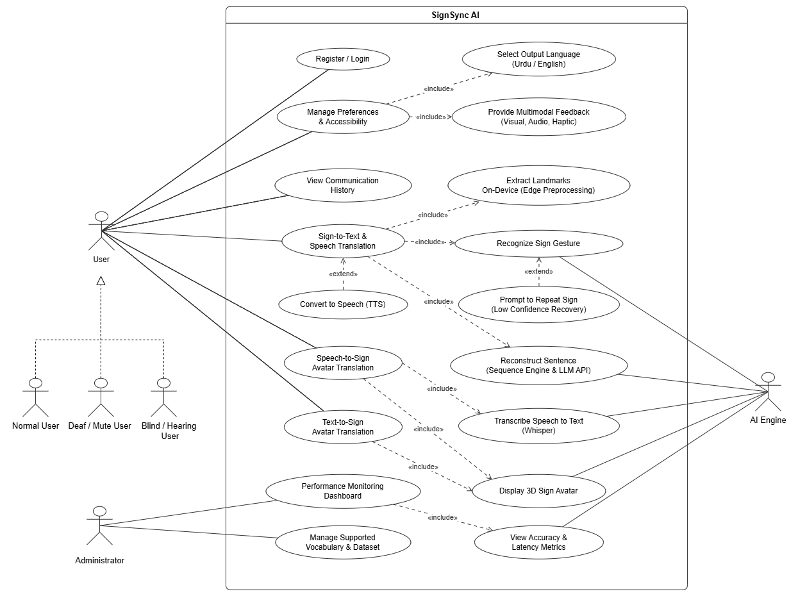
Figure 5.1 Use Case Diagram

6. Expanded Use Cases

6.1. Sign-to-Text & Speech Translation
Table 6.1.1 Sign-to-Text & Speech Translation
ID: | EUC1
Name: | Sign-to-Text & Speech Translation
Created By: | Burhan Raza | Last Updated By: | Burhan Raza
Date Created: | 05-09-2026 | Date Last Updated: | 20-09-2026
Actors: | Deaf/Mute User, AI Engine
Description: | This use case allows a Deaf/Mute user to point the mobile camera at themselves and perform a sign. The application captures the video stream, extracts hand, body and facial landmarks on-device, and sends the landmark sequence to the backend recognition model. The recognized sign is displayed as text and can be converted to speech so a Hearing/Blind user can understand it. [1], [2], [5], [8]
Trigger: | 1. The user selects “Sign” communication mode and performs a gesture in front of the camera.
Preconditions: | 1. The user is logged in and camera permission has been granted.  2. The performed sign belongs to the supported 20–30-sign vocabulary.  3. The AI Engine and backend services are reachable.
Post-conditions: | 1. The recognized sign is displayed as text and/or spoken through TTS.  2. The sign is appended to the current communication sequence.  3. The session and its confidence score are logged for performance monitoring.
Normal Flow: | 1. The user opens the app and selects sign-to-text communication mode.  2. The mobile app captures camera frames of the user performing a sign.  3. The Edge-Preprocessing module extracts hand, body and facial landmarks locally using MediaPipe.  4. The extracted landmark sequence is sent to the FastAPI backend.  5. The Sign Recognition Engine (PyTorch model) predicts the most likely sign and a confidence score.  6. The Confidence Evaluator checks the score against the acceptance threshold.  7. The recognized sign is added to the Sign Sequence Engine's running sequence.  8. The sequence is sent to the external Language Correction API to form a natural sentence.  9. The generated sentence is displayed as text on the communication screen.  10. If speech output is enabled, the Text-to-Speech engine plays the sentence aloud.
Alternative Flows: | 6.1. If confidence is below the threshold, the system extends to “Prompt to Repeat Sign” instead of accepting the prediction.  9.1. If the language-correction service is unavailable, the raw keyword sequence is shown instead of the corrected sentence.
Exceptions: | 1. Camera permission denied → the system displays a message requesting permission before continuing.  2. Backend/AI Engine timeout → the system notifies the user and allows the sign to be retried.  3. Unsupported gesture → the system shows “sign not recognised, please try a supported sign.”
Includes: | Extract Landmarks On-Device (Edge Preprocessing); Recognize Sign Gesture; Prompt to Repeat Sign; Convert to Speech (TTS).
Priority: | High
Frequency of Use: | Very frequently used every time a Deaf/Mute user communicates through the app.
Business Rules: | 1. Only signs within the supported vocabulary can be recognized.  2. A prediction below the confidence threshold must never be shown as a confirmed result.  3. Raw video frames must never be transmitted off-device — only extracted landmarks.
Special Requirements: | 1. On-device landmark extraction latency ≤ 200 ms per frame.  2. End-to-end recognition-to-text latency ≤ 3 seconds under normal connectivity.
Assumptions: | 1. The user performs the sign within the camera's field of view under reasonable lighting.  2. The recognition model version deployed on the backend is up to date.
Notes & Issues: | 1. Evaluate expanding the vocabulary size in future iterations.  2. Consider caching the last few recognized signs for offline review.

6.2. Speech-to-Sign Avatar Translation
Table 6.2.1 Speech-to-Sign Avatar Translation
ID: | EUC2
Name: | Speech-to-Sign Avatar Translation
Created By: | Muhammad Saad | Last Updated By: | Muhammad Saad
Date Created: | 08-09-2026 | Date Last Updated: | 21-09-2026
Actors: | Blind/Hearing User, Normal User, AI Engine
Description: | This use case allows a Hearing/Blind or Normal user to speak or type a message, which the system converts into a sign sequence performed by a 3D avatar, so that a Deaf/Mute user can understand the communication without needing a human interpreter. [9]
Trigger: | 1. The user selects “Speech-to-Sign” or “Text-to-Sign” communication mode and speaks or types a message.
Preconditions: | 1. The user is logged in and microphone permission is granted (for speech input).  2. The AI Engine, Whisper service and avatar rendering module are available.
Post-conditions: | 1. The 3D avatar performs the mapped sign sequence for the input message.  2. The session (input text and mapped sequence) is saved to communication history.
Normal Flow: | 1. The user speaks into the microphone, or types a message into the text field.  2. If speech was used, Whisper transcribes the spoken audio into text.  3. The Communication Engine checks whether the vocabulary needed for the message is supported.  4. The Sign Sequence Engine maps the text into an ordered sequence of supported signs.  5. The mapped sequence is sent to the Avatar Animation Engine.  6. The 3D avatar renders and performs the corresponding signs in order.  7. The Deaf/Mute user views the signed output on screen.  8. The completed session is saved to the user's communication history.
Alternative Flows: | 3.1. If part of the vocabulary is unsupported, the system signs the supported portion and displays an “unsupported vocabulary” note for the rest.  1.1. If typed text is provided instead of speech, steps 1–2 are skipped and text is used directly.
Exceptions: | 1. Speech-to-text failure → the system asks the user to retype the message.  2. Avatar rendering failure → the system falls back to displaying the sign names as text.  3. Vocabulary fully unsupported → the system informs the user that the message cannot be signed.
Includes: | Transcribe Speech to Text (Whisper); Reconstruct Sentence (Sequence Engine & LLM API); Display 3D Sign Avatar.
Priority: | High
Frequency of Use: | Frequent — used whenever a Hearing/Blind or Normal user initiates communication toward a Deaf/Mute user.
Business Rules: | 1. Only text mappable to the supported sign vocabulary can be fully avatar-rendered.  2. The avatar must render signs in the grammatically correct order produced by the Sequence Engine.
Special Requirements: | 1. Speech-to-text transcription latency ≤ 2 seconds for a typical sentence.  2. Avatar animation shall play smoothly at a minimum of 24 frames per second.
Assumptions: | 1. The spoken input is reasonably clear and in a supported language (Urdu/English).  2. The 3D avatar asset library covers the full supported sign vocabulary.
Notes & Issues: | 1. Consider allowing playback speed control for the avatar for new learners.  2. Evaluate adding regional sign-dialect variants in a future release.

6.3. Manage Preferences & Accessibility
Table 6.3.1 Manage Preferences & Accessibility
ID: | EUC3
Name: | Manage Preferences & Accessibility
Created By: | Sheikh Umar Younas | Last Updated By: | Sheikh Umar Younas
Date Created: | 10-09-2026 | Date Last Updated: | 22-09-2026
Actors: | User (Normal, Deaf/Mute, Blind/Hearing)
Description: | This use case allows any user to configure the output language (Urdu/English/bilingual) and the visual, audio and haptic feedback channels that best match their communication needs, and to have those settings restored automatically in future sessions.
Trigger: | 1. The user opens “Preferences & Accessibility” from the settings menu or is prompted during first use.
Preconditions: | 1. The user is logged in.  2. The user's profile record exists in the database.
Post-conditions: | 1. The selected output language and feedback settings are saved to the user's profile.  2. Subsequent communication sessions use the updated preferences automatically.
Normal Flow: | 1. The user opens the Preferences & Accessibility screen.  2. The system displays the current output-language and feedback settings.  3. The user selects the desired output language (Urdu, English or bilingual).  4. The user enables or disables visual, audio and haptic feedback independently.  5. The user optionally adjusts the confidence-recovery sensitivity.  6. The user saves the changes.  7. The system validates and stores the updated preferences in the database.  8. The system confirms the update and applies it to the active session immediately.
Alternative Flows: | 6.1. If the user cancels instead of saving, the previous preferences remain unchanged.  3.1. If this is the user's first use, default preferences are pre-filled based on the account type selected at registration.
Exceptions: | 1. Save failure due to connectivity loss → the system retries automatically and warns the user if it cannot save.  2. Invalid combination (e.g., all feedback channels disabled) → the system requires at least one feedback channel to remain enabled.
Includes: | Select Output Language (Urdu/English); Provide Multimodal Feedback (Visual, Audio, Haptic).
Priority: | Medium
Frequency of Use: | Occasional — typically set once at onboarding and revisited infrequently thereafter.
Business Rules: | 1. At least one feedback channel (visual, audio or haptic) must remain enabled at all times.  2. Preference changes must apply to the current session without requiring a re-login.
Special Requirements: | 1. Preference screens must meet WCAG 2.1 accessibility guidelines.  2. Saving preferences shall complete within 1 second under normal connectivity.
Assumptions: | 1. The user's device supports the haptic feedback API where haptic feedback is enabled.  2. The account already has a valid stored profile to update.
Notes & Issues: | 1. Consider adding per-contact preference overrides in a future version.  2. Evaluate adding a confidence-threshold slider for advanced users.

6.4. Performance Monitoring Dashboard
Table 6.4.1 Performance Monitoring Dashboard
ID: | EUC4
Name: | Performance Monitoring Dashboard
Created By: | Burhan Raza | Last Updated By: | Muhammad Saad
Date Created: | 12-09-2026 | Date Last Updated: | 23-09-2026
Actors: | Administrator, AI Engine
Description: | This use case enables an administrator to review the technical and AI performance of SignSync AI, including recognition accuracy, precision, recall, F1-score, latency and inference time, so that model degradation can be detected and model versions can be compared over time.
Trigger: | 1. The administrator opens the Performance Monitoring Dashboard from the admin console.
Preconditions: | 1. The administrator is logged in with valid administrative privileges.  2. At least one completed recognition session has been logged.
Post-conditions: | 1. Up-to-date accuracy, latency and confidence metrics are displayed to the administrator.  2. A record of the dashboard view is logged for audit purposes.
Normal Flow: | 1. The administrator logs in and opens the Performance Monitoring Dashboard.  2. The system requests the latest performance logs from the database.  3. The AI Engine aggregates recognition accuracy, precision, recall and F1-score across recent sessions.  4. The system computes average latency and inference time across the selected time window.  5. The dashboard renders the aggregated metrics as charts and summary tables.  6. The administrator filters by date range or model version to compare performance.  7. The administrator reviews flagged sessions with unusually low confidence for further inspection.
Alternative Flows: | 2.1. If no logs exist for the selected window, the dashboard displays “no data available for this period.”  6.1. If two model versions are selected, the system displays a side-by-side comparison instead of a single summary.
Exceptions: | 1. Metrics service timeout → the system shows the last successfully cached metrics with a stale-data notice.  2. Insufficient privileges → access is denied and the attempt is logged as a security event.
Includes: | View Accuracy & Latency Metrics.
Priority: | Medium
Frequency of Use: | Regular — reviewed periodically by administrators, and after every model update.
Business Rules: | 1. Only administrators may access aggregated performance metrics.  2. Every metrics view must be attributable to the model version active at the time of logging.
Special Requirements: | 1. Dashboard queries over 30 days of data shall render within 2 seconds.  2. Metrics must be refreshed at least once every 24 hours.
Assumptions: | 1. Performance logs are consistently written for every completed recognition session.  2. Model version identifiers are recorded correctly at inference time.
Notes & Issues: | 1. Consider adding automated alerts when accuracy drops below a defined threshold.  2. Evaluate exporting metrics reports as downloadable PDFs in a future release.

6.5. User Registration & Secure Login
Table 6.5.1 User Registration & Secure Login
ID: | EUC5
Name: | User Registration & Secure Login
Created By: | Muhammad Saad | Last Updated By: | Muhammad Saad
Date Created: | 12-09-2026 | Date Last Updated: | 12-09-2026
Actors: | New User, Registered User, Authentication Service
Description: | This use case allows a new user to create a SignSync AI account and a registered user to log in securely, so that preferences, communication history and personal settings remain private to each account.
Trigger: | 1. The user opens the app without an active session and selects Register or Login.
Preconditions: | 1. For registration: no account exists for the entered email address.  2. For login: a registered account exists for the entered email address.
Post-conditions: | 1. A new account record is created, or an authentication token is issued for the session.  2. The user is taken to the communication dashboard with their saved preferences loaded.
Normal Flow: | 1. The user selects Register and enters name, email and password.  2. The system validates the email format and password strength.  3. The system creates the account and returns accountCreated().  4. For login, the user enters email and password.  5. The system verifies the credentials and returns loginSuccess(authToken).  6. The system loads the user profile, preferences and history.
Alternative Flows: | 2.1. If the email format is invalid, the system shows an inline error and blocks submission.  2.2. If the email is already registered, the system offers the login screen instead.  5.1. If the credentials are invalid, the system returns loginError(message) and stays on the login screen.
Exceptions: | 1. Backend unreachable during registration or login → the system retries once, then shows a connectivity error.  2. Session token expires mid-use → the system asks the user to log in again.
Includes: | Validate Credentials; Issue Auth Token; Load User Profile.
Priority: | High
Frequency of Use: | Occasional: once per installation for registration, then once per session for login.
Business Rules: | 1. Passwords must be at least 8 characters and stored only as salted hashes.  2. Authentication tokens expire after 24 hours of inactivity.
Special Requirements: | 1. All authentication traffic shall use TLS encryption.  2. Failed login attempts shall be rate-limited to 5 per 15 minutes per account.
Assumptions: | 1. The device has connectivity at the moment of registration or login.  2. The user has access to the email address used for the account.
Notes & Issues: | 1. Consider adding biometric login (fingerprint/face) in a future release.  2. Evaluate social-login providers if requested by end users.

6.6. Text-to-Sign Avatar Translation
Table 6.6.1 Text-to-Sign Avatar Translation
ID: | EUC6
Name: | Text-to-Sign Avatar Translation
Created By: | Burhan Raza | Last Updated By: | Burhan Raza
Date Created: | 12-09-2026 | Date Last Updated: | 12-09-2026
Actors: | Hearing User, Deaf/Mute User, AI Engine
Description: | This use case allows a hearing user to type a message that the 3D avatar translates into Pakistan Sign Language gestures, so a Deaf/Mute user can understand spoken-language input visually.
Trigger: | 1. The hearing user selects the text-to-sign mode and types a message.
Preconditions: | 1. The user is logged in.  2. The 3D avatar component is loaded and visible.  3. The typed message uses the supported vocabulary.
Post-conditions: | 1. The avatar performs the mapped sign sequence for the typed message.  2. The exchange is stored in the communication history.
Normal Flow: | 1. The hearing user types a message and selects the output language.  2. The system calls typeMessage(text, language).  3. The Sign Sequence Engine maps the text through mapTextToSignSequence(text).  4. The system renders the result via renderAvatarAnimation(signSequence).  5. The Deaf/Mute user watches the avatar perform the signs.
Alternative Flows: | 3.1. If a typed word is outside the supported vocabulary, the system fingerspells it or flags it as unsupported.  4.1. If the avatar engine fails to load, the system falls back to showing the text with an error notice.
Exceptions: | 1. Empty message submitted → the system prompts the user to type something first.  2. Language Correction API timeout → the system renders the uncorrected sequence and notifies the user.
Includes: | Map Text to Sign Sequence; Render 3D Avatar Animation.
Priority: | High
Frequency of Use: | Very frequent: core mode for hearing-to-deaf communication.
Business Rules: | 1. Only words in the supported vocabulary produce full sign animations; others are fingerspelled or flagged.  2. The avatar shall begin animating within 2 seconds of submission.
Special Requirements: | 1. Avatar animations must be smooth (minimum 30 fps) on mid-range devices.  2. Text input shall support both Urdu and English keyboards.
Assumptions: | 1. The typed message is in the language selected by the user.  2. The device GPU can render the 3D avatar in real time.
Notes & Issues: | 1. Consider predictive text suggestions limited to the supported vocabulary.  2. Evaluate adding an avatar speed control for accessibility.

6.7. Low-Confidence Sign Recovery
Table 6.7.1 Low-Confidence Sign Recovery
ID: | EUC7
Name: | Low-Confidence Sign Recovery
Created By: | Sheikh Umar Younas | Last Updated By: | Sheikh Umar Younas
Date Created: | 14-09-2026 | Date Last Updated: | 14-09-2026
Actors: | Deaf/Mute User, AI Engine
Description: | This use case handles signs the recognizer cannot identify with sufficient confidence: instead of guessing, the system asks the user to repeat the sign, keeping the conversation reliable.
Trigger: | 1. A performed sign scores below the configured confidence threshold during recognition.
Preconditions: | 1. The user is in sign-to-text mode with the camera active.  2. A confidence threshold is configured for the session.
Post-conditions: | 1. The unclear sign is either re-captured with sufficient confidence or explicitly skipped by the user.  2. The confidence outcome is logged for monitoring.
Normal Flow: | 1. The user performs a sign in front of the camera.  2. The system extracts landmarks and runs recognizeSign(landmarkSequence).  3. The returned confidence score is below the threshold.  4. The system displays a "please repeat the sign" prompt with guidance.  5. The user repeats the sign more clearly.  6. The system re-evaluates and accepts the sign once confidence is sufficient.
Alternative Flows: | 5.1. If the repeated sign still scores below the threshold, the system offers to skip the sign or switch to typing.  4.1. If the user dismisses the prompt, the sign is dropped from the sequence without breaking the session.
Exceptions: | 1. Camera feed lost during recovery → the session pauses and the user is asked to re-enable the camera.  2. Repeated failures (3 attempts) → the system logs the event and suggests checking lighting conditions.
Includes: | Compute Recognition Confidence; Prompt to Repeat Sign.
Priority: | High
Frequency of Use: | Frequent: depends on signing clarity and lighting conditions.
Business Rules: | 1. The system shall never silently accept a sign below the confidence threshold.  2. After 3 failed attempts the system must offer an alternative input mode.
Special Requirements: | 1. The repeat prompt shall appear within 500 ms of the low-confidence result.  2. The confidence threshold shall be tunable by the administrator.
Assumptions: | 1. The user can see the repeat prompt on the device screen.  2. Lighting and camera angle are within the supported operating range.
Notes & Issues: | 1. Consider visual guides (hand-position overlay) to help users re-perform unclear signs.  2. Evaluate adaptive thresholds based on per-user history.

6.8. View Communication History
Table 6.8.1 View Communication History
ID: | EUC8
Name: | View Communication History
Created By: | Muhammad Saad | Last Updated By: | Muhammad Saad
Date Created: | 14-09-2026 | Date Last Updated: | 14-09-2026
Actors: | Registered User
Description: | This use case allows a logged-in user to review past communication sessions and to re-apply a saved preference profile, so frequent conversations do not need to be reconfigured each time.
Trigger: | 1. The user opens Communication History from the main menu.
Preconditions: | 1. The user is logged in.  2. At least one completed session exists for the account, or the empty state applies.
Post-conditions: | 1. The selected session detail or saved preference profile is displayed or applied.  2. No history records are modified by viewing.
Normal Flow: | 1. The user opens Communication History.  2. The system calls openCommunicationHistory() and fetchHistory(userId).  3. The system displays the sessions via displayHistory(conversationRecords) in reverse chronological order.  4. The user selects a past session to view its messages.  5. Optionally, the user selects a saved preference profile.  6. The system applies it through applySavedPreferences().
Alternative Flows: | 3.1. If no sessions exist, the system shows a friendly empty-state message instead of a list.  4.1. If a session detail fails to load, the system shows an error and returns to the list.
Exceptions: | 1. History database unavailable → the system shows a retry option and a cached notice if offline data exists.  2. Corrupted session record → the system skips the record and logs the incident for the administrator.
Includes: | Fetch History Records; Apply Saved Preference Profile.
Priority: | Medium
Frequency of Use: | Occasional: typically reviewed after conversations or when reconfiguring settings.
Business Rules: | 1. A user can only view history records belonging to their own account.  2. Viewing history shall never modify or delete stored records.
Special Requirements: | 1. History lists shall load within 2 seconds for up to 500 records.  2. Session timestamps shall display in the device locale.
Assumptions: | 1. The backend database retains history for the configured retention period.  2. The user understands that deleted accounts lose their history.
Notes & Issues: | 1. Consider adding search and filter by date or contact in a future release.  2. Evaluate export-to-text for users who want offline records.

6.9. Manage Supported Vocabulary & Dataset
Table 6.9.1 Manage Supported Vocabulary & Dataset
ID: | EUC9
Name: | Manage Supported Vocabulary & Dataset
Created By: | Burhan Raza | Last Updated By: | Sheikh Umar Younas
Date Created: | 16-09-2026 | Date Last Updated: | 16-09-2026
Actors: | Administrator, AI Engine
Description: | This use case allows the administrator to add, update or retire signs in the supported vocabulary and to manage the gesture dataset, so the recognition model stays accurate as the sign collection grows.
Trigger: | 1. The administrator opens Vocabulary & Dataset Management from the admin dashboard.
Preconditions: | 1. The user is logged in with the administrator role.  2. The vocabulary and dataset services are reachable.
Post-conditions: | 1. The vocabulary list and dataset reflect the approved changes.  2. The change is logged with the administrator identity and timestamp.
Normal Flow: | 1. The administrator opens the vocabulary management screen.  2. The system lists the current signs with their sample counts and status.  3. The administrator adds a new sign with reference videos, or edits or retires an existing sign.  4. The system validates the entry (duplicate check, sample quality).  5. The system saves the change and queues the dataset for the next training cycle.  6. The system confirms the update to the administrator.
Alternative Flows: | 4.1. If the entry duplicates an existing sign, the system blocks the save and highlights the conflict.  3.1. If the administrator retires a sign, the system warns that the sign will stop being recognized and asks for confirmation.
Exceptions: | 1. Dataset service unavailable → the change is queued locally and synced when the service recovers.  2. Invalid reference video format → the system rejects the upload with a format error.
Includes: | Validate Vocabulary Entry; Queue Dataset for Training.
Priority: | Medium
Frequency of Use: | Occasional: vocabulary updates happen in planned batches, not daily.
Business Rules: | 1. Only administrators may modify the vocabulary or dataset.  2. A sign may only be retired after confirmation; retired signs stop being recognized immediately.  3. Every change must record the administrator identity and timestamp.
Special Requirements: | 1. Reference video uploads shall accept MP4 up to 50 MB per sample.  2. The vocabulary list shall support at least 500 entries without performance degradation.
Assumptions: | 1. The administrator understands Pakistan Sign Language vocabulary structure.  2. Reference videos are recorded under adequate lighting.
Notes & Issues: | 1. Consider a review workflow where dataset changes require a second approver.  2. Evaluate active-learning suggestions that propose new signs from unrecognized gestures.

7. High-Level Use Cases

7.1. Register / Login
Table 7.1.1 Register / Login
Use Case ID: | UC1
Use Case Name: | Register / Login
Type: | Primary
Actors: | User (Normal, Deaf/Mute, Blind/Hearing)
Description: | Allows a new user to create a SignSync AI account, or an existing user to log in, so that preferences and communication history can be associated with the correct account.

7.2. View Communication History
Table 7.2.1 View Communication History
Use Case ID: | UC2
Use Case Name: | View Communication History
Type: | Secondary
Actors: | User
Description: | Allows a logged-in user to browse previously translated conversations, including the text and modality (sign, speech, avatar) used in each session.

7.3. Extract Landmarks On-Device (Edge Preprocessing)
Table 7.3.1 Extract Landmarks On-Device (Edge Preprocessing)
Use Case ID: | UC3
Use Case Name: | Extract Landmarks On-Device (Edge Preprocessing)
Type: | Primary
Actors: | AI Engine
Description: | Performs lightweight, on-device extraction of hand, body and facial landmarks from camera frames using MediaPipe, so raw video never has to leave the phone.

7.4. Recognize Sign Gesture
Table 7.4.1 Recognize Sign Gesture
Use Case ID: | UC4
Use Case Name: | Recognize Sign Gesture
Type: | Primary
Actors: | AI Engine
Description: | Uses the PyTorch sign-recognition model to classify an extracted landmark sequence as a specific sign from the supported vocabulary, together with a confidence score.

7.5. Convert to Speech (TTS)
Table 7.5.1 Convert to Speech (TTS)
Use Case ID: | UC5
Use Case Name: | Convert to Speech (TTS)
Type: | Secondary
Actors: | User, AI Engine
Description: | Converts recognized or corrected text into natural spoken audio through the text-to-speech engine for Hearing/Blind users.

7.6. Prompt to Repeat Sign (Low-Confidence Recovery)
Table 7.6.1 Prompt to Repeat Sign (Low-Confidence Recovery)
Use Case ID: | UC6
Use Case Name: | Prompt to Repeat Sign (Low-Confidence Recovery)
Type: | Secondary
Actors: | User, AI Engine
Description: | Detects when a recognised sign's confidence is below the acceptance threshold and asks the user to repeat the sign rather than showing an unreliable prediction.

7.7. Transcribe Speech to Text
Table 7.7.1 Transcribe Speech to Text
Use Case ID: | UC7
Use Case Name: | Transcribe Speech to Text
Type: | Secondary
Actors: | User, AI Engine
Description: | Converts a Hearing/Blind user's spoken audio into text using Whisper, feeding the speech-to-sign translation pipeline.

7.8. Text-to-Sign Avatar Translation
Table 7.8.1 Text-to-Sign Avatar Translation
Use Case ID: | UC8
Use Case Name: | Text-to-Sign Avatar Translation
Type: | Primary
Actors: | User, AI Engine
Description: | Maps typed text directly into a supported sign sequence and renders it through the 3D avatar, without requiring speech input.

7.9. Display 3D Sign Avatar
Table 7.9.1 Display 3D Sign Avatar
Use Case ID: | UC9
Use Case Name: | Display 3D Sign Avatar
Type: | Secondary
Actors: | AI Engine
Description: | Renders the mapped sign sequence as an animated 3D avatar so a Deaf/Mute user can view the signed output.

7.10. Manage Supported Vocabulary & Dataset
Table 7.10.1 Manage Supported Vocabulary & Dataset
Use Case ID: | UC10
Use Case Name: | Manage Supported Vocabulary & Dataset
Type: | Primary
Actors: | Administrator
Description: | Allows an administrator to add, update or retire entries in the supported sign vocabulary and the underlying curated gesture dataset used for model training.

8. Activity Diagram
The activity diagram below traces the full bidirectional communication flow: login and preference loading, sign-to-text capture through edge preprocessing and confidence-based recovery, sentence reconstruction via the Sign Sequence Engine and Language Correction API, text/speech output with multimodal feedback, and the reverse speech/text-to-sign path through vocabulary mapping and 3D avatar rendering.
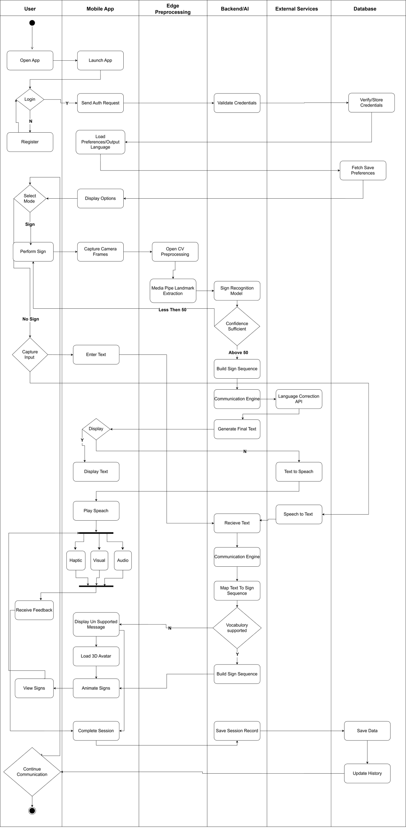
Figure 8.1 Activity Diagram: Bidirectional Communication Flow

9. System Sequence Diagram (SSD)
The system sequence diagrams in this section describe the ordered interactions between the actors and the SignSync AI system for the principal use cases. Each diagram shows the messages exchanged with the system boundary, including the alternative flows for error and recovery paths.

9.1. SSD-1: Account Registration & Secure Login
The diagram shows the account lifecycle at the system boundary: registerAccount(name, email, password) returns accountCreated(), and login(email, password) returns loginSuccess(authToken) when the credentials are valid or loginError(message) otherwise.

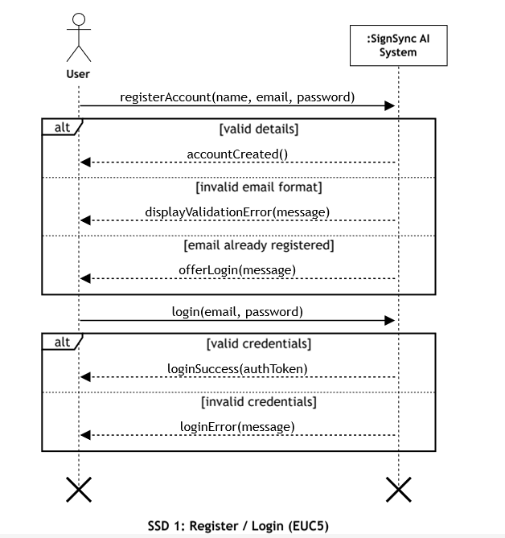
Figure 9.1.1 SSD-1: Account Registration & Secure Login

9.2. SSD-2: Sign-to-Text & Speech Translation
The diagram traces the sign-to-text path for a Deaf user: startSignCapture() and performSign(videoFrame) are followed by on-device extractHandBodyLandmarks() and recognizeSign(landmarkSequence). When confidence meets the threshold, the system builds the sign sequence, applies language correction, and returns the recognized text with speech output; otherwise it prompts the user to repeat the sign.

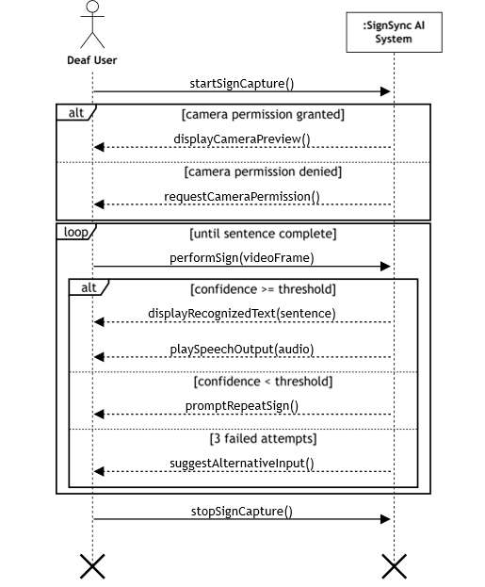
Figure 9.2.1 SSD-2: Sign-to-Text & Speech Translation

9.3. SSD-3: Speech-to-Sign Avatar Translation
The diagram shows the speech-to-sign path for a Blind user: speakMessage(audio, language) is transcribed by transcribeSpeech(audio), mapped to a sign sequence by mapTextToSignSequence(text), and rendered through renderAvatarAnimation(signSequence).
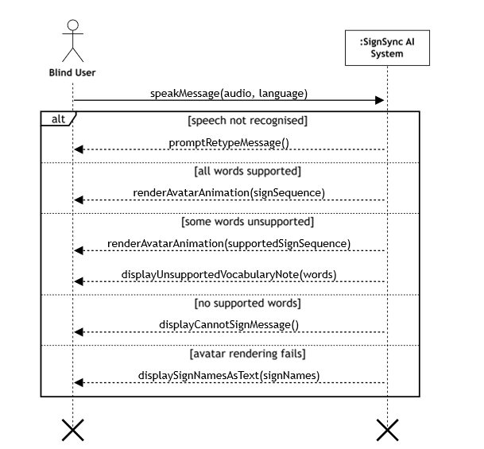
Figure 9.3.1 SSD-3: Speech-to-Sign Avatar Translation

9.4. SSD-4: Text-to-Sign Avatar Translation
The diagram shows the text-to-sign path for a Hearing user: typeMessage(text, language) is mapped to a sign sequence by mapTextToSignSequence(text) and rendered through renderAvatarAnimation(signSequence) for the Deaf user.
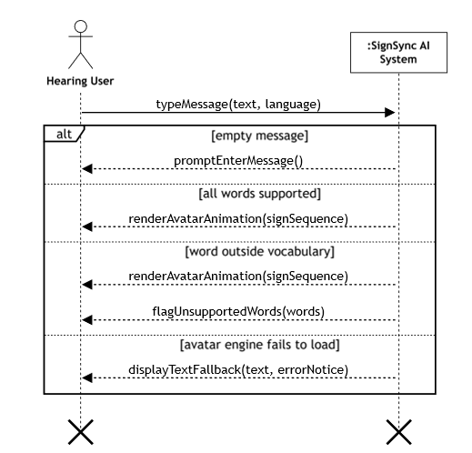
Figure 9.4.1 SSD-4: Text-to-Sign Avatar Translation

9.5. SSD-5: Accessibility & Preference Configuration
The diagram shows preference management at the system boundary: openSettings() displays the current language and feedback-mode preferences, updatePreferences() persists the changes through savePreferences(userId), and the system confirms with confirmPreferencesSaved().
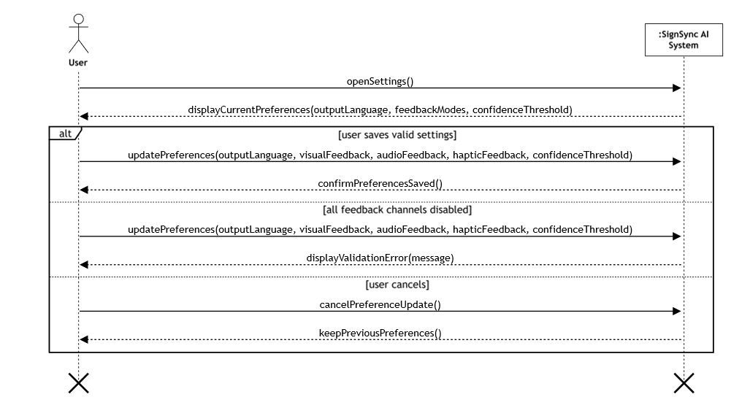
Figure 9.5.1 SSD-5: Accessibility & Preference Configuration

9.6. SSD-6: Communication History & Preference Management
The diagram shows history retrieval at the system boundary: openCommunicationHistory() triggers fetchHistory(userId) and displayHistory(conversationRecords), while selectSavedPreferenceProfile() applies a stored profile through applySavedPreferences().
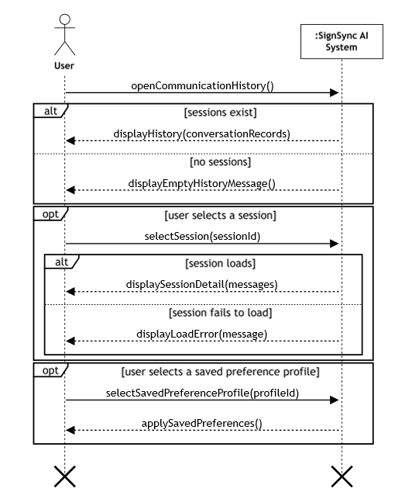
Figure 9.6.1 SSD-6: Communication History & Preference Management

9.7. SSD-7: Performance Monitoring Dashboard (Admin)
The diagram shows the administrator flow: openMonitoringDashboard() triggers computeMetrics(accuracy, precision, recall, f1Score, latency) and returns the performance metrics for display, while compareModelVersions(versionA, versionB) produces a comparison report across model versions.

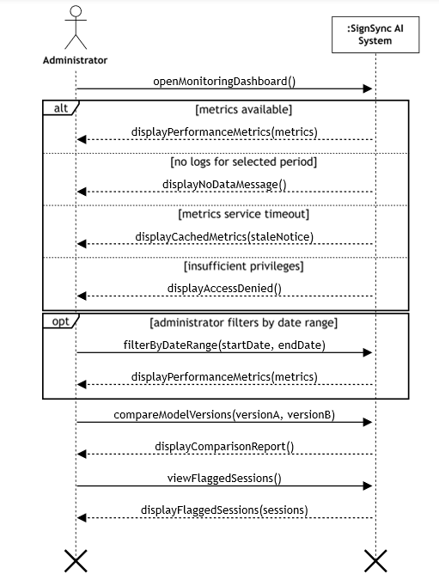
Figure 9.7.1 SSD-7: Performance Monitoring Dashboard (Admin)

9.8. SSD-8: Manage Supported Vocabulary & Dataset
The diagram shows the administrator’s vocabulary management flow: openVocabularyManager() displays the current vocabulary through displayVocabularyList(signs); saveSign(label, language, category, referenceVideos) adds or edits a sign, confirmed by confirmVocabularyUpdated(), while duplicate signs, invalid video formats, and dataset-service outages are reported through displayDuplicateConflict(label), displayFormatError(message), and confirmChangeQueued(); retiring a sign uses retireSign(signId) with displayRetireWarning(label), confirmRetire(signId), and confirmSignRetired().

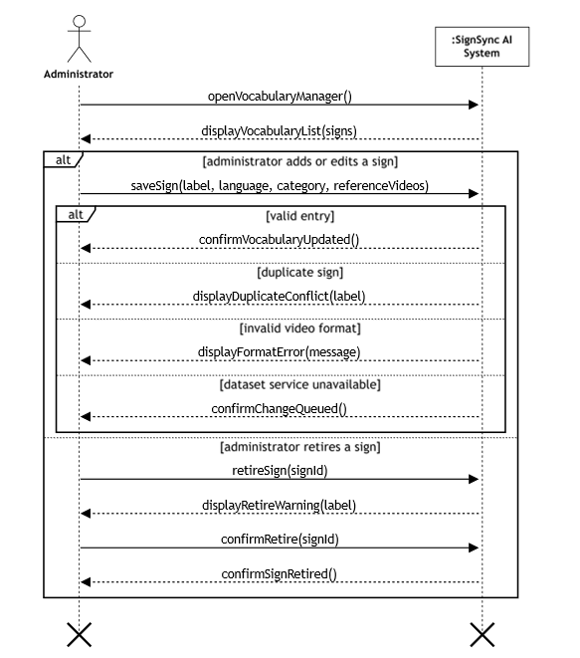
Figure 9.8.1 SSD-8: Manage Supported Vocabulary & Dataset

10. Sequence Diagram
The sequence diagram below traces the complete bidirectional communication flow across the SignSync AI components: the MobileAppUI, EdgePreprocessor, APIController, SignRecognitionModel, SignSequenceEngine, LanguageCorrectionAPI, TTSEngine, WhisperService, AvatarRenderer and the Database. It covers preference loading, sign capture with on-device landmark extraction, confidence-gated recognition, sentence correction, multimodal feedback, and the reverse speech/text-to-sign path.
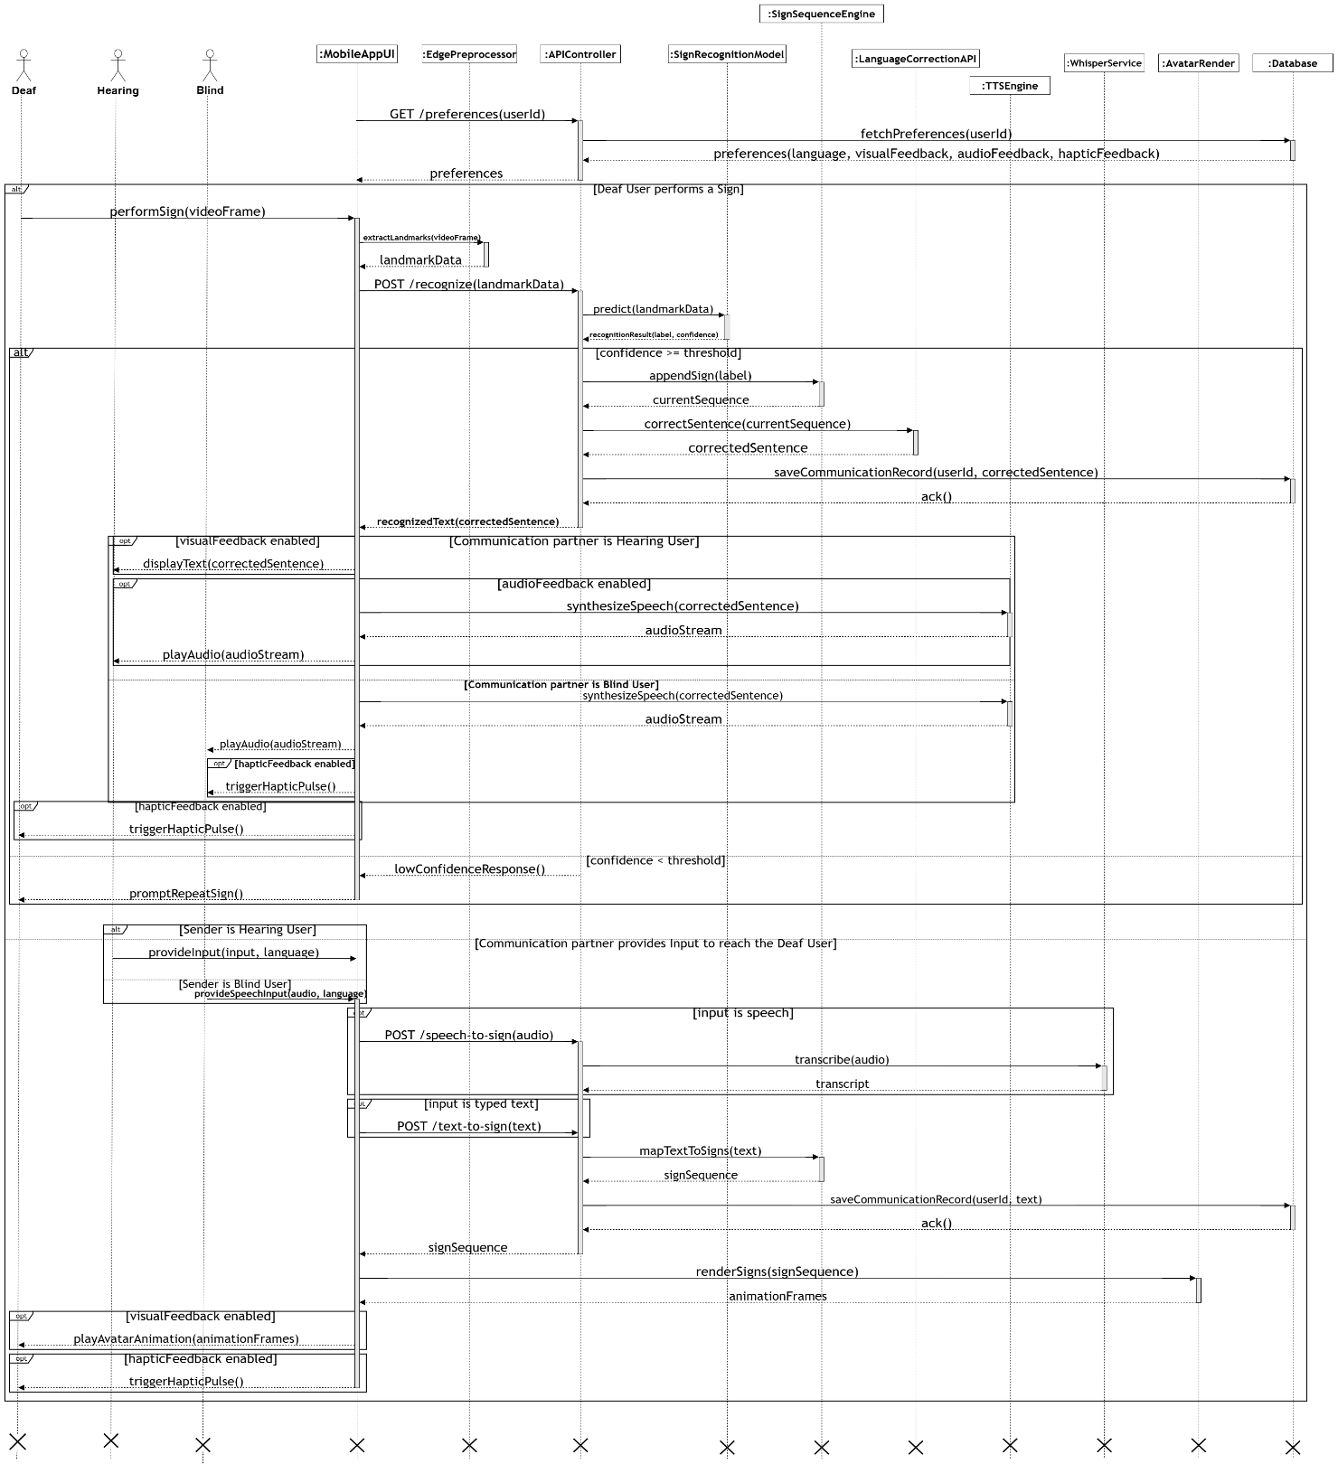
Figure 10.1 Sequence Diagram: SignSync AI Communication Flow

11. Design Phase

11.1. Domain Model
The domain model below captures the key conceptual classes of the SignSync AI system and their relationships.

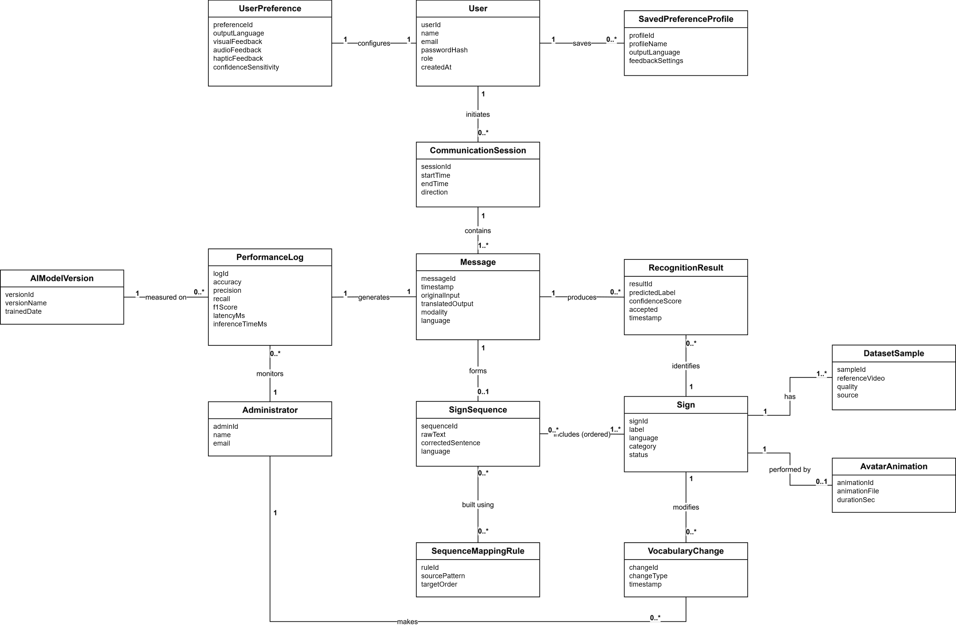
Figure 11.1.1 Domain Model

11.2. Class Diagram
The class diagram models the core domain and service classes: User and UserPreference for account/accessibility settings; CommunicationSession, Message and RecognitionResult for conversation data; SignRecognitionEngine, ConfidenceEvaluator, SignSequenceEngine and LanguageCorrectionService (with an ExternalLLMAdapter) for the AI pipeline; and EdgePreprocessingService, SpeechToTextService, TextToSpeechService and AvatarAnimationEngine for the bidirectional translation interfaces, all coordinated by a central CommunicationController.
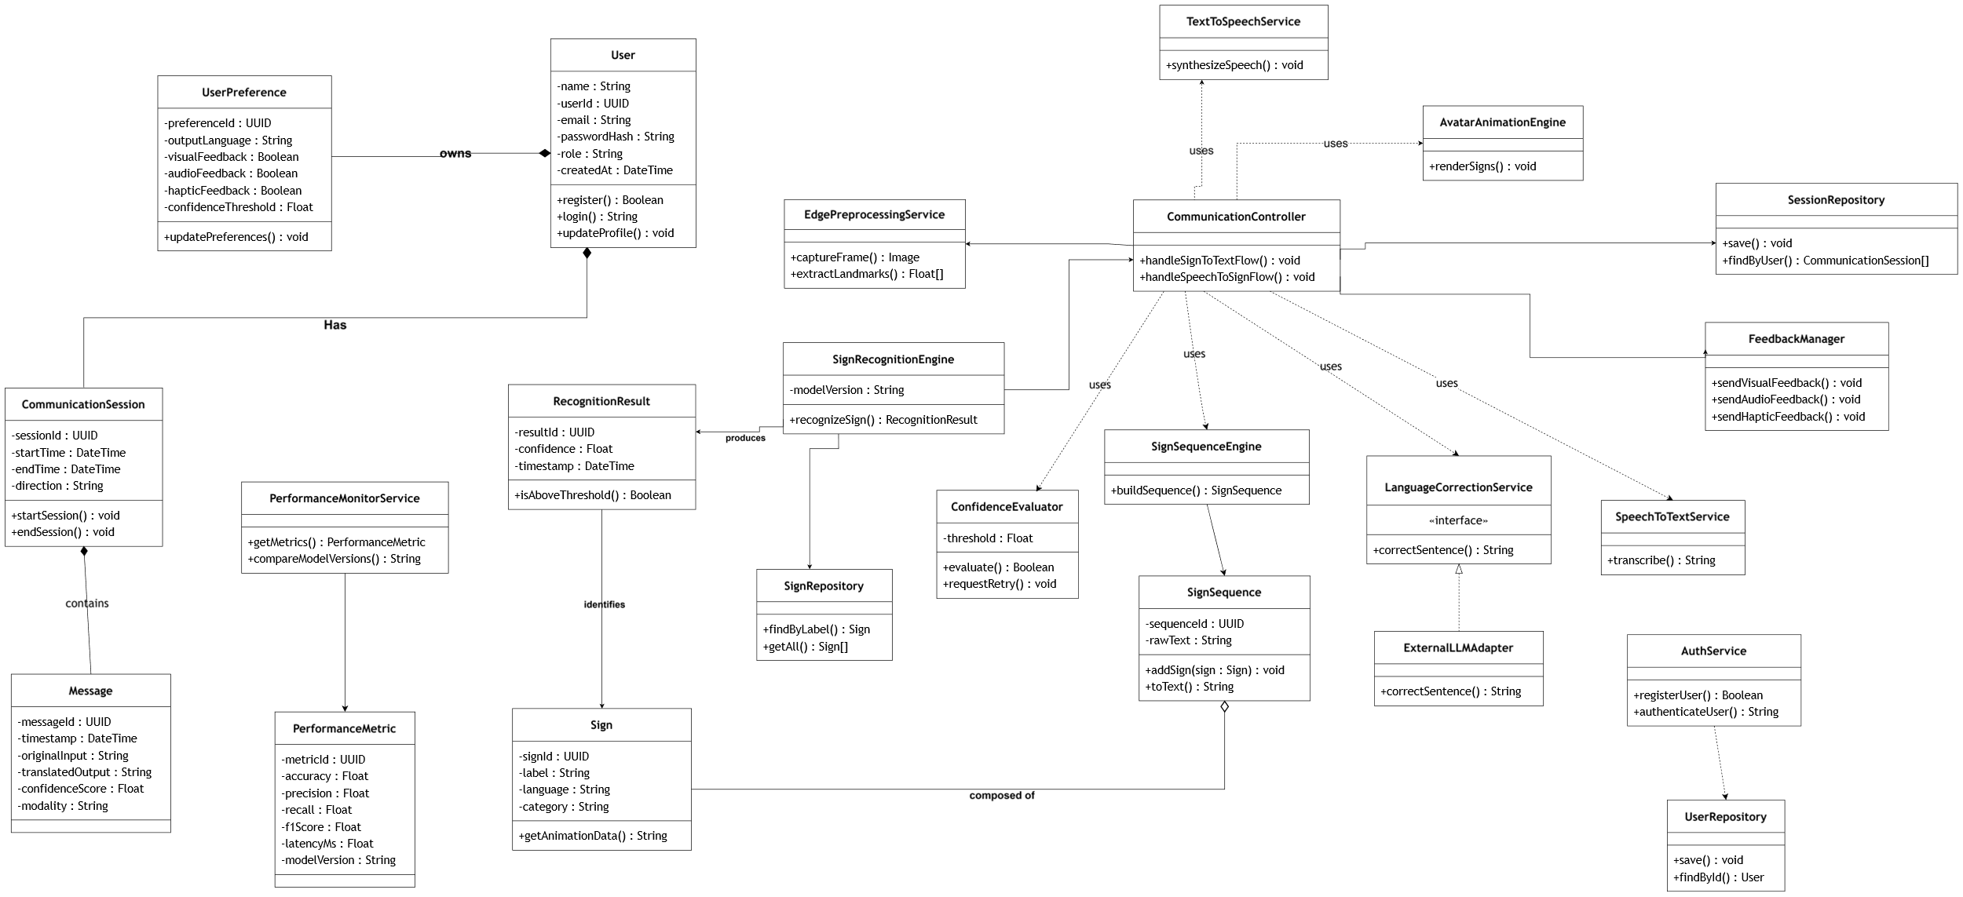
Figure 11.2.1 Class Diagram

11.3. Entity Relationship (ER) Diagram
The ER diagram captures how a USER initiates COMMUNICATION_SESSIONs and configures a USER_PREFERENCE; each session contains TRANSLATION_RECORDs, which include RECORD_GESTURE_ITEMs that identify entries from the GESTURE_VOCABULARY. Vocabulary entries have associated DATASET_SAMPLEs and AVATAR_ANIMATIONs, and utilize SEQUENCE_MAPPING_RULEs for sentence reconstruction. Every translation record generates a PERFORMANCE_LOG entry, which tracks the AI_MODEL_VERSION used for that inference.

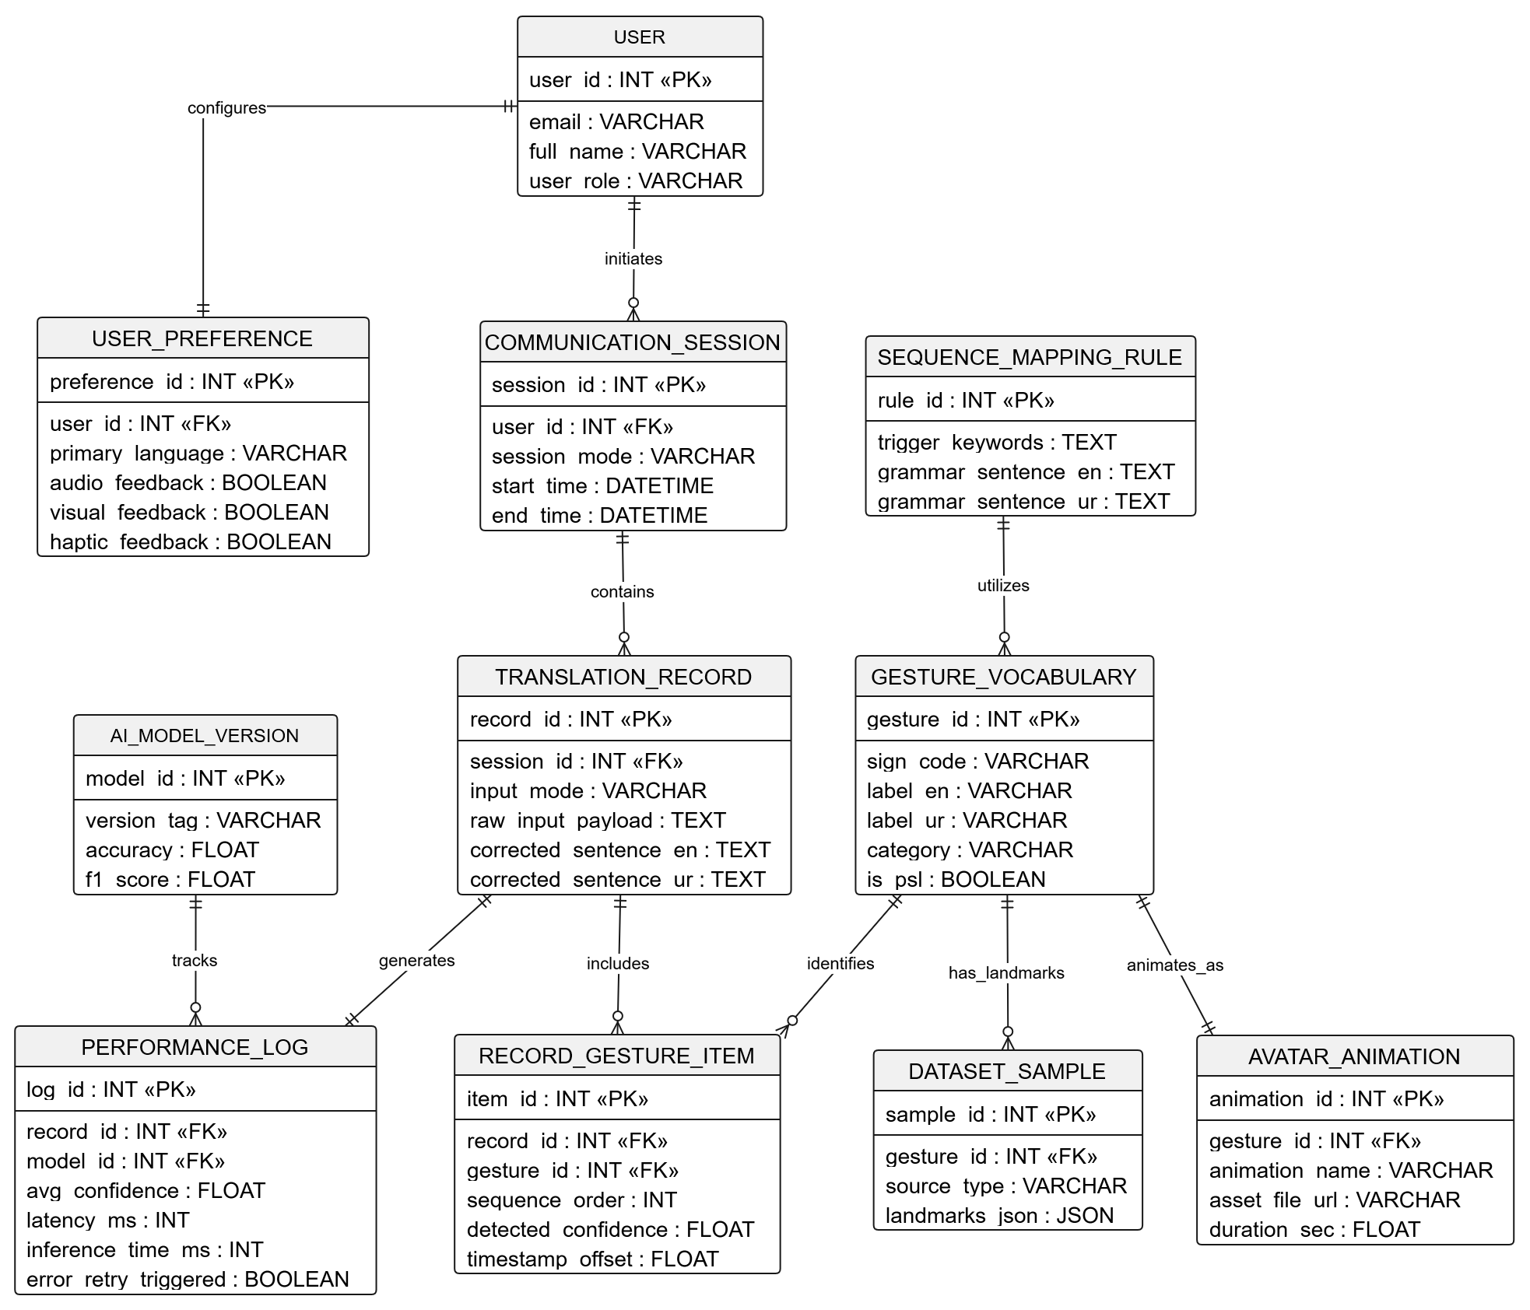
Figure 11.3.1 Entity Relationship Diagram

11.4. System Architecture Diagram
The architecture diagram shows how Normal, Deaf/Mute and Blind/Hearing users interact with the React Native mobile application, which communicates with a FastAPI application server. The server routes sign input through the PyTorch-based Sign Language Recognition model backed by a PostgreSQL gesture database, routes speech through Whisper (Speech-to-Text) and a TTS engine (Text-to-Speech), and drives the 3D Sign Avatar for signed output. Supabase stores user data, an external LLM API performs language correction, and a Node.js-based Sign Sequence Engine handles grammar checking, while progress/accuracy logs feed the user dashboard.
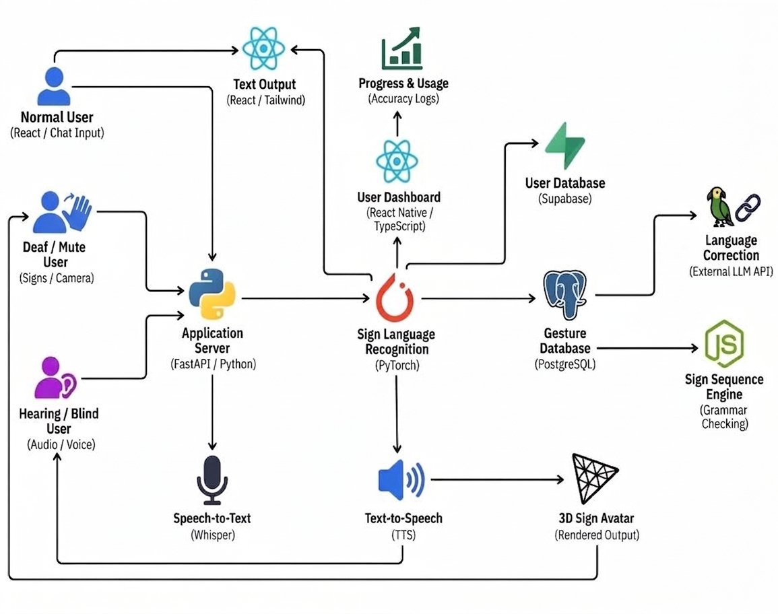
Figure 11.4.1 System Architecture Diagram

11.5. Deployment Diagram
The deployment diagram below shows the runtime allocation of SignSync AI: the Android mobile device hosts the camera, microphone and on-device edge preprocessing, while the backend server hosts the recognition API, language services and database. The external Language Correction API is consumed as a third-party service.

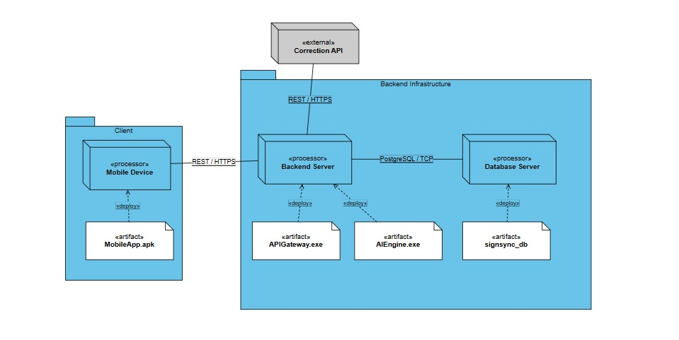
Figure 11.5.1 Deployment Diagram

11.6. Data Flow Diagram (Level 0)
The data flow diagram below shows SignSync AI as a single process exchanging data with its external entities: the Deaf/Mute User, the Hearing/Blind User, the Administrator, and the external AI/LLM Service.
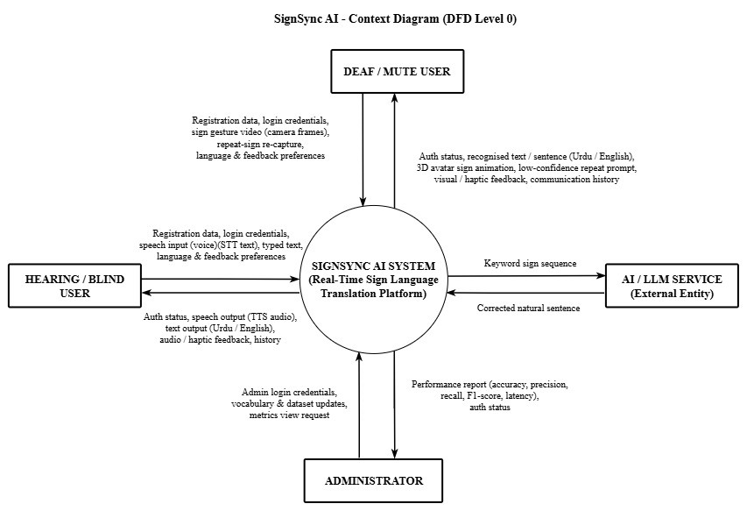
Figure 11.6.1 Data Flow Diagram (Level 0)

11.7. Data Flow Diagram (Level 1)
The Level 1 data flow diagram decomposes the SignSync AI system into its core processes: account and preference management (1.0), edge-based sign preprocessing (2.0), sign recognition with confidence checking (3.0), natural sentence construction through the external AI/LLM service (4.0), translation output generation (5.0), speech/text-to-sign avatar synthesis (6.0), and performance and vocabulary management (7.0). Four data stores — User Accounts, Preferences & History (D1); Sign Vocabulary, Dataset & Phrase Rules (D2); Performance Logs & Metrics (D3); and the Avatar Sign Library (D4) hold the persistent data exchanged between these processes.
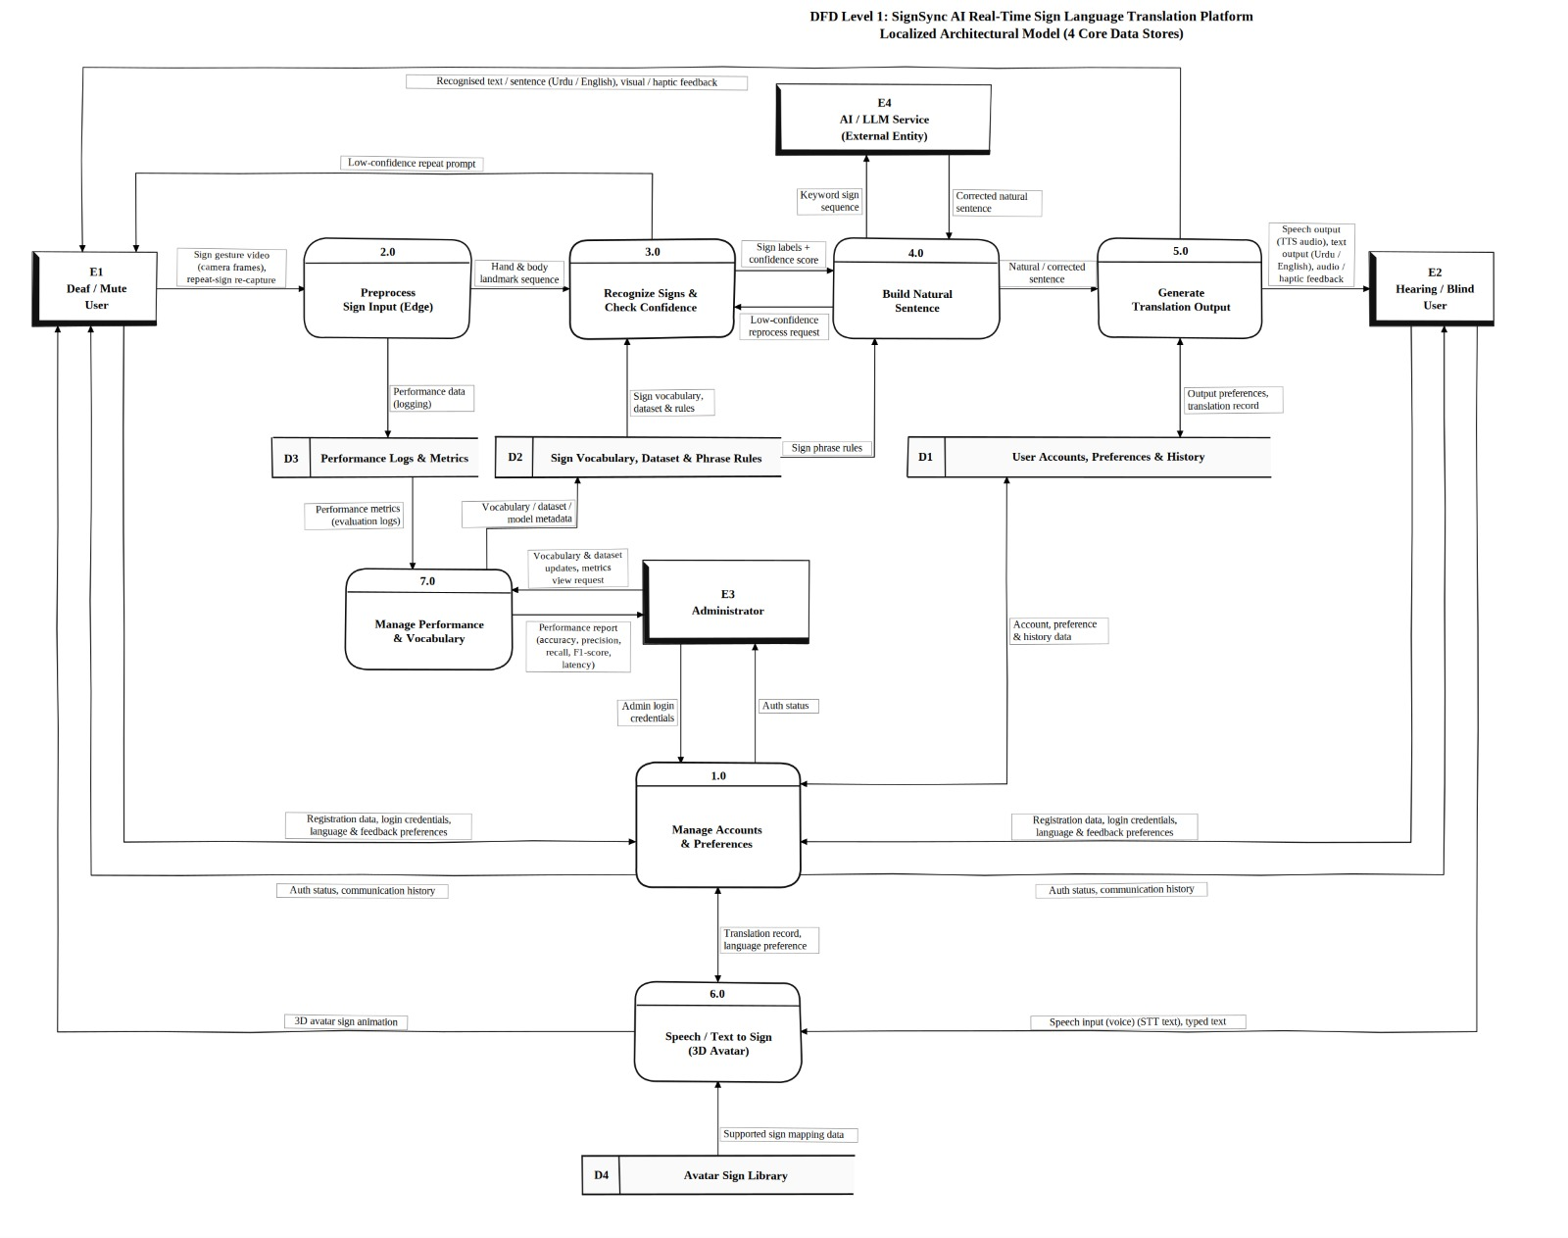
Figure 11.7.1 Data Flow Diagram (Level 1)

12. References
[1] A. A. Mujeeb, A. H. Khan, S. Khalid, M. S. Mirza, and S. J. Khan, “A Deep Learning Approach to Pakistani Sign Language Recognition,” in Proc. 2023 20th Int. Bhurban Conf. Applied Sciences and Technology (IBCAST), IEEE, 2023. doi: 10.1109/IBCAST59916.2023.10712904.
[2] H. M. Hamza and A. Wali, “Pakistan sign language recognition: leveraging deep learning models with limited dataset,” Machine Vision and Applications, vol. 34, 2023. doi: 10.1007/s00138-023-01429-8.
[3] D. Li, C. Rodriguez, X. Yu, and H. Li, “Word-level Deep Sign Language Recognition from Video: A New Large-scale Dataset and Methods Comparison,” in IEEE/CVF Winter Conference on Applications of Computer Vision (WACV), 2020, pp. 1459–1469.
[4] A. Imran, A. Razzaq, I. A. Baig, A. Hussain, S. Shahid, et al., “Dataset of Pakistan Sign Language and Automatic Recognition of Hand Configuration of Urdu Alphabet through Machine Learning,” Data in Brief, vol. 36, 2021, Art. 107021.
[5] K. Bantupalli and Y. Xie, “American Sign Language Recognition using Deep Learning and Computer Vision,” in 2018 IEEE International Conference on Big Data (Big Data), Seattle, WA, USA, 2018, pp. 4896–4899. doi: 10.1109/BigData.2018.8622141.
[6] O. Mercanoglu Sincan and H. Yalim Keles, “AUTSL: A Large Scale Multi-modal Turkish Sign Language Dataset and Baseline Methods,” arXiv preprint arXiv:2008.00932, 2020.
[7] T. Riaz, A. Anjum, A. Anjum, and M. A. Khan Khattak, “Echoes in Silence: A Technological Leap for Pakistan Sign Language Translation and Recognition,” in 2023 IEEE 20th International Conference on Smart Communities (HONET), 2023. doi: 10.1109/HONET59747.2023.10374883.
[8] B. Alsharif, E. Alalwany, A. Ibrahim, I. Mahgoub, and M. Ilyas, “Real-Time American Sign Language Interpretation Using Deep Learning and Keypoint Tracking,” Sensors, vol. 25, no. 7, p. 2138, 2025. doi: 10.3390/s25072138.
[9] Z. Yu, S. Huang, Y. Cheng, and T. Birdal, “SignAvatars: A Large-scale 3D Sign Language Holistic Motion Dataset and Benchmark,” in Computer Vision: ECCV 2024, Springer, 2024, pp. 1–19. doi: 10.1007/978-3-031-72652-1_1.

