**The mini project report is submitted to** **Yeshwantrao Chavan College Of Engineering**

**(An Autonomous Institution Affiliated to Rashtrasant Tukadoji Maharaj Nagpur University)**

**OFFICE NETWORKING AUTOMATION**

**by**

**Sheikh Wasimuddin - 73**

**Under the guidance of Prof. Kiran S. Khandare**



**Department of Computer Science & Engineering-IOT**

**Nagar Yuwak Shikshan Sanstha’s YESHWANTRAO CHAVAN COLLEGE OF ENGINEERING,**

**(An Autonomous Institution Affiliated to Rashtrasant Tukadoji Maharaj Nagpur University, Nagpur)**

**NAGPUR – 441 110**

### 2024-25

**CONTENTS**

* Introduction to IoT Networking
* Software Used
* Components Used in the Network
* Requirements for This Network
* Functions of Components
* Working Of the Project
* Diagrams of the Connections and its Output
* Use Cases of This IoT Network
* Challenges and Considerations
* Future Improvements and
* Enhancements Conclusion

***OFFICE NETWORKING AUTOMATION***

## Introduction to IoT Networking:

The Internet of Things (IoT) is a system of interrelated devices that communicate over a network to collect and exchange data. IoT networks improve automation, efficiency, and remote accessibility in various applications, including smart homes, office networking, industrial automation, and healthcare. This report focuses on a simulated IoT network using Cisco Packet Tracer, demonstrating its structure, components, functionality, and use cases.

**Software Used:**

The given network simulation is designed in Cisco Packet Tracer, a network simulation software widely used for network design, testing, and education. Cisco Packet Tracer allows users to create network topologies, configure devices, and simulate their behavior in real-time.

## Components Used in the Network:

1. **Entrance:**

* RFID Card (Fake and Original): Simulates secure access scenarios, allowing testing of authentication systems.
* RFID Reader: Scans the card and sends data to control the main door.
* Main Door: Integrates with the RFID system for secure entry and exit.

**2. Main Room:**

* Solar Panel: Harnesses solar energy to power devices sustainably.
* Battery: Stores solar energy for continuous usage during low sunlight.
* Cable Modem: Provides internet connectivity for networked devices.
* Smart Office Setup (VRT Room): Uses virtual reality technology to enhance productivity and collaboration.

**3. Server Room:**

* Cluster0: A server handling data computation and storage.
* Smart Office Server: Facilitates communication and automation across the network.

**4. Break Room:**

* Solar Power Appliance: Operates on solar energy for efficient usage.
* Smart Fan with Motion Detector: Activates when motion is detected, ensuring energy conservation.
* Coffee Maker: A solar-powered machine for preparing beverages.
* Portable Music Player & Bluetooth Speaker: Entertainment devices offering wireless connectivity.

**5. Conference Room:**

* Solar Power MCU: A microcontroller unit managing solar-powered devices.
* Solar Fan & Lamp: Eco-friendly appliances for lighting and cooling.
* Laptop Controller: Provides control and data analysis.
* Smartphone: Allows remote monitoring and device control.

**6. Safety Room:**

* Siren: Alerts users during emergencies.
* Fire Monitor: Detects smoke or fire for immediate response.
* Fire Sprinkler: Automatic system for extinguishing fire hazards.
* Custom MCU: Tailored microcontroller for managing safety protocols

## Requirements for This Network:

## Infrastructure:

## Power Source: Solar panels and batteries for sustainable energy supply.

## Connectivity: Routers, modems, and servers for reliable internet and data management.

## IoT Devices: Smart appliances and sensors for automation and monitoring.

## Hardware Components:

## RFID system for secure access.

## IoT-enabled fire safety equipment like sprinklers and detectors.

## Smart devices such as fans, lamps, and motion sensors.

## Software & Configuration:

## Firmware for IoT devices.

## Networking software for server and router configuration.

## User authentication protocols for RFID system.

## Maintenance & Security:

## Regular updates for IoT devices and networking software.

## Monitoring tools to ensure seamless operation.

## Strong encryption for data security and access control.

## Functions of Components in the Network:

1. **Entrance:**

* RFID Card & Reader: Ensure secure access to the premises by verifying credentials.
* Main Door: Grants or denies entry based on RFID authentication.

1. **Main Room:**

* Solar Panel & Battery: Provide eco-friendly power and store energy for uninterrupted use.
* Cable Modem: Connects the network to the internet via the ISP.
* Smart Office Router: Distributes internet access across connected devices.

1. **Server Room:**

* Cluster0: Handles distributed computing tasks for efficiency.
* Smart Office Server: Centralizes data storage, applications, and device management.

1. **Break Room:**

* Solar Power Unit: Powers the room independently using solar energy.
* Smart Fan & Motion Detector: Maintain a comfortable environment by detecting room occupancy.
* Coffee Maker Appliance: Prepares beverages, potentially remotely controlled.
* Music Player & Bluetooth Speaker: Enhance relaxation with audio streaming.

1. **Conference Room:**

* Solar Power MCU: Manages solar power for the devices.
* Smart Devices: Include fans, lamps, and laptops to support meetings and productivity.
* Smartphone: Acts as a controller for various IoT devices.

1. **Safety Room:**

* Siren & Fire Monitor: Alert and detect emergencies such as fire or unauthorized access.
* Fire Sprinkler: Activates during fire incidents to suppress flames.
* Custom MCU: Monitors and controls safety equipment.
* IoT Thing.

# Working of the IoT Network in Cisco Packet Tracer:

The IoT network integrates secure access, sustainable energy, and efficient data management through RFID systems, solar panels, and central servers. Devices communicate via automation protocols, dynamically responding to environmental conditions for convenience and energy conservation. Safety features like fire monitors and sprinklers ensure rapid emergency responses. Users can remotely control and monitor the network using smartphones and laptops. Overall, it creates a smart, reliable, and energy-efficient system.

1. **Device Connectivity:**

* IoT devices (e.g., RFID readers, motion detectors, and fire monitors) are connected to the network through routers or hubs. Each device is assigned an IP address for unique identification.

1. **Data Collection & Transmission:**

* Sensors like motion detectors and fire monitors collect data and send it to the IoT server or control devices over the network.

1. **Automation:**

* Devices such as the smart fan or fire sprinklers are configured with automation rules. For example, the fan may turn on when the motion detector senses activity, or sprinklers activate when the fire monitor detects smoke.

1. **Server Management:**

* The IoT server (e.g., Smart Office Server) coordinates communication between devices, stores data, and processes user commands.

1. **Energy Efficiency:**

* Solar panels and batteries ensure an uninterrupted power supply for IoT devices and reduce dependence on external electricity sources.

1. **User Interaction:**

* Devices like the smartphone or laptop act as controllers, allowing users to manage and monitor IoT devices remotely via dashboards or apps.

# Diagrams of the Connections and its Output:

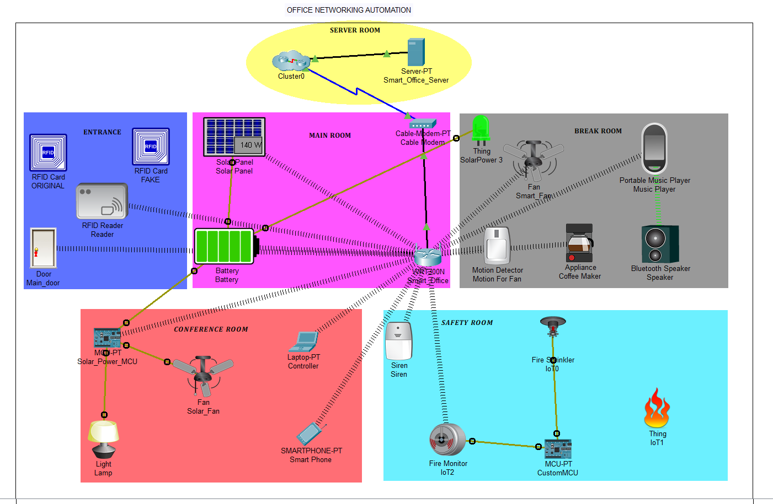

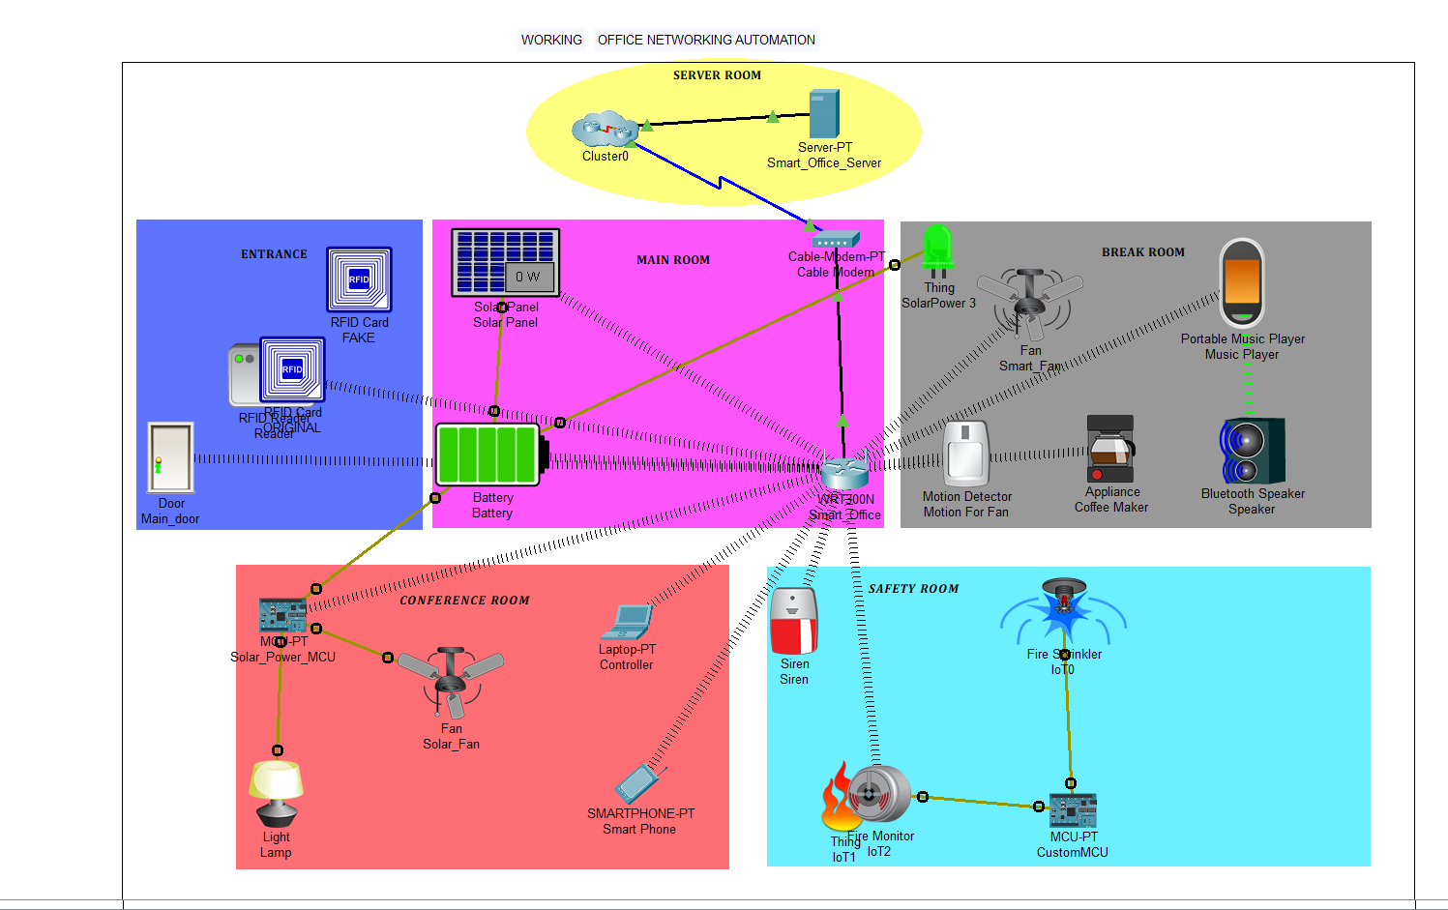

### Use Cases of This IoT Network:

### Smart Access Control

### The RFID-based entrance system can be used to regulate secure access to offices, homes, or restricted areas.

### It helps in tracking attendance or access logs for better monitoring.

### 2. Energy Management and Sustainability

### Solar panels and batteries demonstrate how renewable energy can power IoT networks, reducing dependency on traditional power sources.

### This setup is ideal for green buildings or smart cities aiming for energy efficiency.

### 3. Automation and Remote Control

### Smart office setups and integrated appliances (like fans, lamps, and coffee makers) showcase how automation enhances convenience.

### Devices controlled via laptops and smartphones provide remote management capabilities for businesses or homes.

### 4. Safety and Emergency Response:

### The fire monitoring system, sprinklers, and sirens contribute to real-time emergency alerts and automatic responses, critical for fire-sensitive areas.

### The system can be implemented in public spaces, schools, or industrial facilities.

### 5. Data Management and Connectivity:

### The server room handles data processing and communication between devices, showing how centralized systems can streamline operations for businesses.

### It's a practical setup for IoT-based data hubs or command centers.

### 6. Smart Living and Entertainment:

### The break room’s motion-detecting fan, portable music player, and Bluetooth speaker highlight smart home entertainment and comfort.

### This use case suits modern homes seeking customized automation.

### Challenges and Considerations:

### Security Risks:

* Unauthorized access to IoT devices can compromise security.
* Encryption and authentication must be implemented for secure communication.

### Connectivity Issues:

* Wireless IoT devices rely on stable internet connections.
* Proper configuration of the home gateway is necessary to avoid downtime.

1. **Cost Management:**

* Balancing between high-end solutions and affordable alternatives requires careful planning.
* Implementing and maintaining a robust IoT office network can be expensive, especially for small or medium-sized businesses.

1. **Privacy Concerns:**

* Transparency in data usage policies is essential to maintain trust.
* Collecting and managing data from IoT devices must comply with privacy regulations to protect employee information.

### Future Improvements and Enhancements:

1. **Advanced Cloud Integration:**

* Leveraging cloud platforms for data analysis, storage, and management enables real-time insights and scalability.
* Cloud services can facilitate remote collaboration and centralized monitoring across multiple office locations.

### AI-Driven Optimization:

* Implementing AI algorithms can predict employee preferences for lighting, temperature, or workspace arrangements to enhance comfort and productivity.
* AI-powered security systems can improve threat detection, such as identifying unauthorized access or unusual activity in the network.

1. **Energy-Efficient Solutions:**

* Upgrading to smarter energy management systems that automatically adjust lighting and climate controls based on usage patterns can minimize power consumption.

### Network Expansion:

### Integrating additional sensors to monitor parameters like air quality, noise levels, or energy usage can create a healthier and more efficient work environment.

* Expanding to include smart security systems, such as biometric access controls or surveillance cameras, can enhance safety.

### Conclusion:

This IoT network simulation in Cisco Packet Tracer demonstrates how smart office networking can be implemented using connected devices. The integration of smart gateways, PCs, smartphones, and sensors facilitates an efficient, remotely accessible system for managing energy, security, and automated office functions. Such simulations are invaluable for learning, testing, and designing smart office environments before deployment. By identifying and addressing challenges and incorporating future improvements, IoT-enabled office networks can become more reliable, secure, and efficient, paving the way for enhanced productivity and sustainable practices in real-world applications.