The Truth is Revealed: Identity of the Fish Fry “Teti” Fishery in Eastern Cuba

Sheila Rodriguez-Machado1,✉, and Tomas M. Rodriguez-Cabrera2

24 November, 2020

Text of abstract

1 Museum of Natural Sciences, Louisiana State University  
2 Sociedad Cubana de Zoologia

✉ Correspondence: [Sheila Rodriguez-Machado <[srodr62@lsu.edu](mailto:srodr62@lsu.edu)>](mailto:srodr62@lsu.edu)

Keywords: amphidromy; Busck’s Stone-Biting Goby; COI; Gobiidae

# 1 Introduction

Here is a citation (Marwick, 2017)

# 2 Methods

Tetis (19–28 mm standard length) were collected 400 m from the river mouth of Río Yumurí (Figure 2.1), eastern Cuba, in December, 2018. Samples were collected using hand nets (1 mm mesh size) 2 m from the riverbank. Specimens were anesthetized using MS 222 (Tricaine Methanesulphonate) and immediately preserved in 80% ethanol. Voucher specimens were deposited in the collection of the Acuario Nacional de Cuba (catalog number: ANC-xxxx).

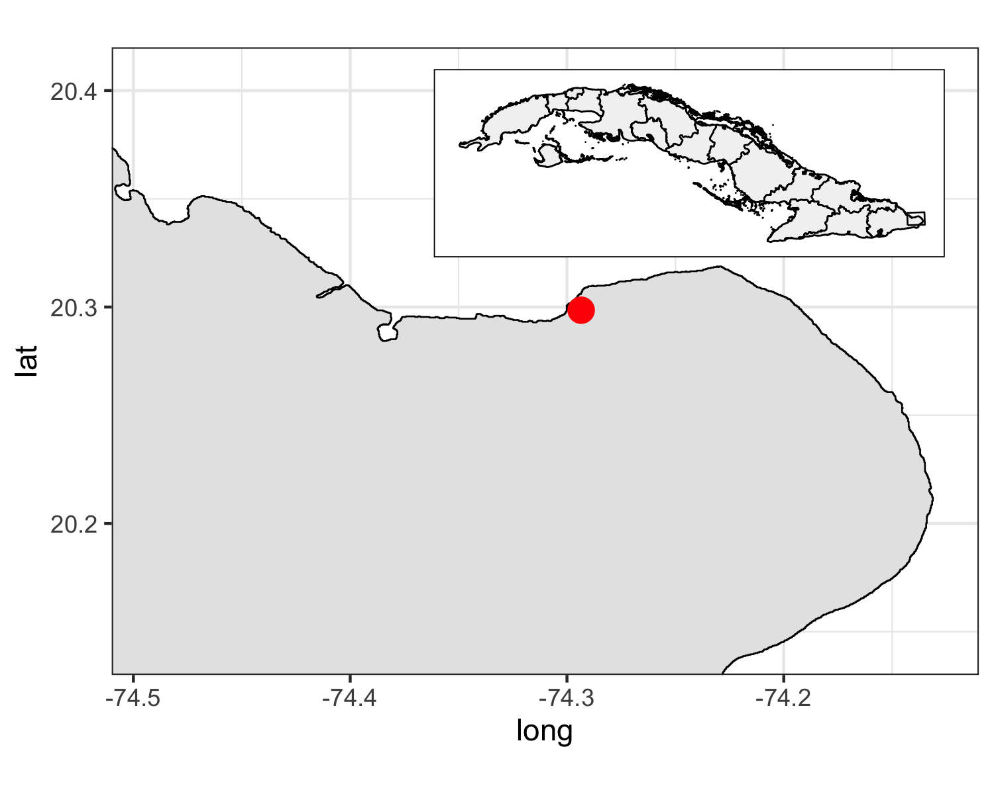

Figure 2.1: Sampling site at Yumuri river mouth, Eastern Cuba

Total DNA was extracted from caudal peduncle muscle tissues using the DNAeasy tissue kit (QIAGEN). Partial sequences of the mitochondrial gene cytochrome oxidase I (COI) were amplified through the polymerase chain reaction in 20 μL of reaction volume (one unit of GoTaq DNA polymerase-Promega, 0.2 nM of each primer, 0.2 μM dNTPs, and 1.5 mM MgCl2) (Lara et al., 2010). We used the primers COIf (5´-AAYCAYAAAGAYGGYACCCT-3´) and COIr (3´-CCTCNGGRTGNCCRAAGAAYCA-5´) (Palumbi, 1991).

PCR products were purified using ExoSAP-IT™ PCR Product Cleanup Reagent (Affymetrix Inc./ USB, Cleveland, OH, USA), and then sequenced on an ABI 3100 automated sequencer (Applied Biosystems). Raw sequence files were edited and aligned with the software Geneious v.9.1 (Kearse et al., 2012), and submitted to GenBank database (accession numbers #####). We used sequences of the genus *Sicydium* as reference for recovering the taxonomic identity of the “tetis”. Sequences of *Awaous banana* and *A. ocellaris* were used as outgroup. All non-Cuban sequences were recovered from GenBank using the R package *rentrez* (Winter, 2017). Duplicated sequences and sequences with missing data were excluded. Sequences were edited using the R packages *seqinr* (Charif and Lobry, 2007), *ape* (Paradis et al., 2015), and *biostrings* (Pages et al., 2013). Final alignment was obtained with the algorithm ClustalOmega (Sievers et al. (2011)) using the R package *msa* (Bodenhofer et al., 2015).

The nucleotide substitution model that best explained our data was estimated using the function modelTest from the R package phangorn (Schliep, 2011). The phylogenetic tree was reconstructed following a maximum mikelihood approach (Felsenstein, 1981) using the functions optim.pml and bootstrap.pml, also from the package phangorn. The tree was generated and visualized using the R package ggtree (Yu et al., 2017).

# 3 Results

(Figure 3.1)

hshdhdhdh

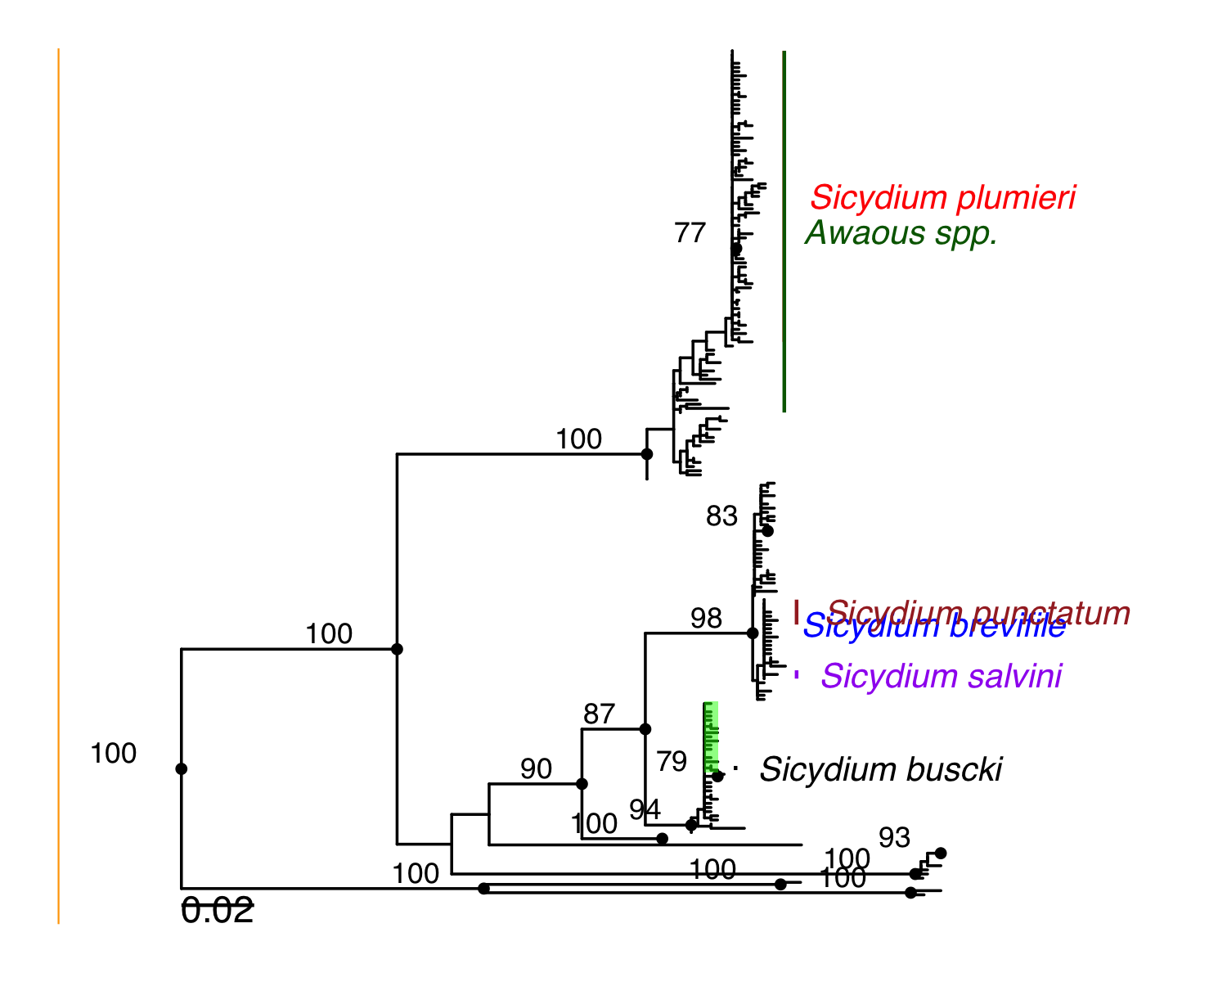

(#fig:figure_2)ML phylogenetic tree (-lnL = 3959.17 ) depicting the relationships among all available COI sequences of the genus Sicydium (n=197). Sequences highlited in green represent samples from Cuba (n=6). Numbers on branches represent boostrap values higher than 70.

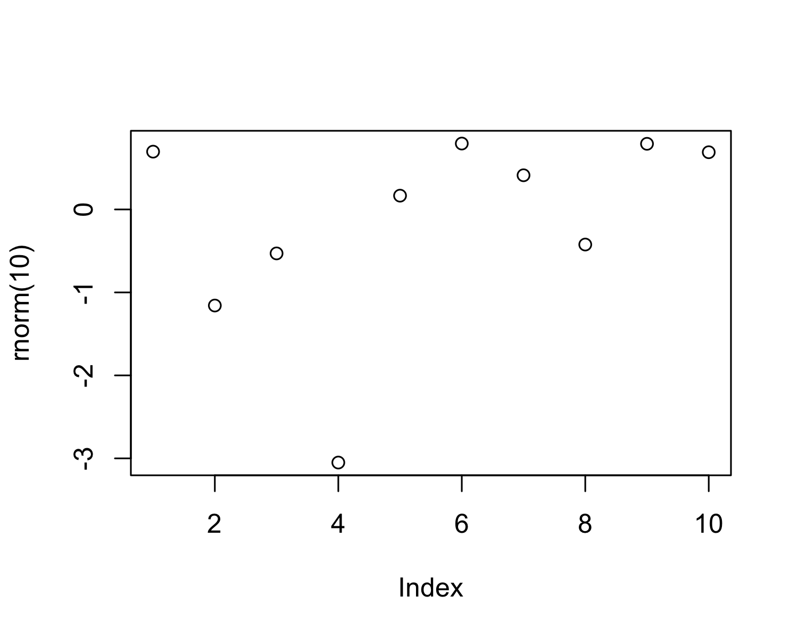

Figure 3.1: A plot of random numbers

Figure 3.1 shows how we can have a caption and cross-reference for a plot

Here is an example of inline code 3.14 in the middle of a sentence.

# 4 Discussion

# 5 Conclusion

Busck´s Stone-Biting Goby, *Sicydium buscki*, is a component of the fish fry “teti” fishery in Eastern Cuba. This species represents the only taxa of the orden Gobiiformes confirmed by molecular tools as part of such a fishery. More thorough investigations and identification of the species comprising the “teti” fishery are needed. It is imperative to include them in local management plans and to avoid overfishing this resource.

# 6 Acknowledgements

# 7 References

Bodenhofer, U., Bonatesta, E., Horejš-Kainrath, C., Hochreiter, S., 2015. Msa: An r package for multiple sequence alignment. Bioinformatics 31, 3997–3999.

Charif, D., Lobry, J.R., 2007. SeqinR 1.0-2: A contributed package to the r project for statistical computing devoted to biological sequences retrieval and analysis, in: Structural Approaches to Sequence Evolution. Springer, pp. 207–232.

Felsenstein, J., 1981. Evolutionary trees from dna sequences: A maximum likelihood approach. Journal of molecular evolution 17, 368–376.

Kearse, M., Moir, R., Wilson, A., Stones-Havas, S., Cheung, M., Sturrock, S., Buxton, S., Cooper, A., Markowitz, S., Duran, C., others, 2012. Geneious basic: An integrated and extendable desktop software platform for the organization and analysis of sequence data. Bioinformatics 28, 1647–1649.

Lara, A., PONCE de LEÓN, J.L., Rodriguez, R., Casane, D., Cote, G., Bernatchez, L., GARCÍA-MACHADO, E., 2010. DNA barcoding of cuban freshwater fishes: Evidence for cryptic species and taxonomic conflicts. Molecular ecology resources 10, 421–430.

Marwick, B., 2017. Computational reproducibility in archaeological research: Basic principles and a case study of their implementation. Journal of Archaeological Method and Theory 24, 424–450. <https://doi.org/10.1007/s10816-015-9272-9>

Pages, H., Aboyoun, P., Gentleman, R., DebRoy, S., Pages, M.H., DataImport, D., BSgenome, S., XStringSet-class, R., MaskedXString-class, R., XStringSet-io, R., 2013. Package “biostrings”.

Palumbi, S., 1991. Simple fool’s guide to pcr.

Paradis, E., Blomberg, S., Bolker, B., Brown, J., Claude, J., Cuong, H.S., Desper, R., 2015. Package “ape”. Analyses of phylogenetics and evolution, version 2, 4–1.

Schliep, K.P., 2011. Phangorn: Phylogenetic analysis in r. Bioinformatics 27, 592–593.

Sievers, F., Wilm, A., Dineen, D., Gibson, T.J., Karplus, K., Li, W., Lopez, R., McWilliam, H., Remmert, M., Söding, J., others, 2011. Fast, scalable generation of high-quality protein multiple sequence alignments using clustal omega. Molecular systems biology 7, 539.

Winter, D.J., 2017. Rentrez: An r package for the ncbi eUtils api. PeerJ Preprints.

Yu, G., Smith, D.K., Zhu, H., Guan, Y., Lam, T.T.-Y., 2017. Ggtree: An r package for visualization and annotation of phylogenetic trees with their covariates and other associated data. Methods in Ecology and Evolution 8, 28–36.

### 7.0.1 Colophon

This report was generated on 2020-11-24 11:47:17 using the following computational environment and dependencies:

#> ─ Session info ───────────────────────────────────────────────────────────────  
#> setting value   
#> version R version 4.0.2 (2020-06-22)  
#> os macOS Mojave 10.14.6   
#> system x86_64, darwin17.0   
#> ui X11   
#> language (EN)   
#> collate en_US.UTF-8   
#> ctype en_US.UTF-8   
#> tz America/Chicago   
#> date 2020-11-24   
#>   
#> ─ Packages ───────────────────────────────────────────────────────────────────  
#> package * version date lib source   
#> ade4 1.7-16 2020-10-28 [1] CRAN (R 4.0.2)  
#> annotate 1.66.0 2020-04-28 [1] Bioconductor   
#> AnnotationDbi 1.50.3 2020-07-25 [1] Bioconductor   
#> AnnotationForge 1.30.1 2020-04-30 [1] Bioconductor   
#> ape * 5.4-1 2020-08-13 [1] CRAN (R 4.0.2)  
#> aplot 0.0.6 2020-09-03 [1] CRAN (R 4.0.2)  
#> askpass 1.1 2019-01-13 [1] CRAN (R 4.0.2)  
#> assertthat 0.2.1 2019-03-21 [1] CRAN (R 4.0.2)  
#> backports 1.1.10 2020-09-15 [1] CRAN (R 4.0.2)  
#> base64url 1.4 2018-05-14 [1] CRAN (R 4.0.2)  
#> batchtools 0.9.14 2020-10-21 [1] CRAN (R 4.0.2)  
#> Biobase * 2.48.0 2020-04-27 [1] Bioconductor   
#> BiocFileCache 1.12.1 2020-08-04 [1] Bioconductor   
#> BiocGenerics * 0.34.0 2020-04-27 [1] Bioconductor   
#> BiocManager 1.30.10 2019-11-16 [1] CRAN (R 4.0.2)  
#> BiocParallel * 1.22.0 2020-04-27 [1] Bioconductor   
#> biomaRt 2.44.4 2020-10-13 [1] Bioconductor   
#> Biostrings * 2.56.0 2020-04-27 [1] Bioconductor   
#> bit 4.0.4 2020-08-04 [1] CRAN (R 4.0.2)  
#> bit64 4.0.5 2020-08-30 [1] CRAN (R 4.0.2)  
#> bitops 1.0-6 2013-08-17 [1] CRAN (R 4.0.2)  
#> blob 1.2.1 2020-01-20 [1] CRAN (R 4.0.2)  
#> bookdown 0.21 2020-10-13 [1] CRAN (R 4.0.2)  
#> brew 1.0-6 2011-04-13 [1] CRAN (R 4.0.2)  
#> BSgenome 1.56.0 2020-04-27 [1] Bioconductor   
#> callr 3.5.1 2020-10-13 [1] CRAN (R 4.0.2)  
#> Category 2.54.0 2020-04-27 [1] Bioconductor   
#> checkmate 2.0.0 2020-02-06 [1] CRAN (R 4.0.2)  
#> cli 2.1.0 2020-10-12 [1] CRAN (R 4.0.2)  
#> codetools 0.2-16 2018-12-24 [1] CRAN (R 4.0.2)  
#> colorspace 1.4-1 2019-03-18 [1] CRAN (R 4.0.2)  
#> crayon 1.3.4 2017-09-16 [1] CRAN (R 4.0.2)  
#> curl 4.3 2019-12-02 [1] CRAN (R 4.0.1)  
#> data.table 1.13.2 2020-10-19 [1] CRAN (R 4.0.2)  
#> DBI 1.1.0 2019-12-15 [1] CRAN (R 4.0.2)  
#> dbplyr 1.4.4 2020-05-27 [1] CRAN (R 4.0.2)  
#> DelayedArray * 0.14.1 2020-07-14 [1] Bioconductor   
#> desc 1.2.0 2018-05-01 [1] CRAN (R 4.0.2)  
#> devtools 2.3.2 2020-09-18 [1] CRAN (R 4.0.2)  
#> digest 0.6.27 2020-10-24 [1] CRAN (R 4.0.2)  
#> DOT 0.1 2016-04-16 [1] CRAN (R 4.0.2)  
#> dplyr 1.0.2 2020-08-18 [1] CRAN (R 4.0.2)  
#> edgeR 3.30.3 2020-06-02 [1] Bioconductor   
#> ellipsis 0.3.1 2020-05-15 [1] CRAN (R 4.0.2)  
#> evaluate 0.14 2019-05-28 [1] CRAN (R 4.0.1)  
#> fansi 0.4.1 2020-01-08 [1] CRAN (R 4.0.2)  
#> farver 2.0.3 2020-01-16 [1] CRAN (R 4.0.2)  
#> fastmatch 1.1-0 2017-01-28 [1] CRAN (R 4.0.2)  
#> fs 1.5.0 2020-07-31 [1] CRAN (R 4.0.2)  
#> genefilter 1.70.0 2020-04-27 [1] Bioconductor   
#> generics 0.0.2 2018-11-29 [1] CRAN (R 4.0.2)  
#> GenomeInfoDb * 1.24.2 2020-06-15 [1] Bioconductor   
#> GenomeInfoDbData 1.2.3 2020-10-28 [1] Bioconductor   
#> GenomicAlignments * 1.24.0 2020-04-27 [1] Bioconductor   
#> GenomicFeatures 1.40.1 2020-07-14 [1] Bioconductor   
#> GenomicRanges * 1.40.0 2020-04-27 [1] Bioconductor   
#> ggplot2 * 3.3.2 2020-06-19 [1] CRAN (R 4.0.2)  
#> ggthemes * 4.2.0 2019-05-13 [1] CRAN (R 4.0.2)  
#> ggtree * 2.2.4 2020-07-28 [1] Bioconductor   
#> glue 1.4.2 2020-08-27 [1] CRAN (R 4.0.2)  
#> GO.db 3.11.4 2020-10-28 [1] Bioconductor   
#> GOstats 2.54.0 2020-04-27 [1] Bioconductor   
#> graph 1.66.0 2020-04-27 [1] Bioconductor   
#> GSEABase 1.50.1 2020-05-29 [1] Bioconductor   
#> gtable 0.3.0 2019-03-25 [1] CRAN (R 4.0.2)  
#> highr 0.8 2019-03-20 [1] CRAN (R 4.0.2)  
#> hms 0.5.3 2020-01-08 [1] CRAN (R 4.0.2)  
#> htmltools 0.5.0 2020-06-16 [1] CRAN (R 4.0.2)  
#> httr 1.4.2 2020-07-20 [1] CRAN (R 4.0.2)  
#> hwriter 1.3.2 2014-09-10 [1] CRAN (R 4.0.2)  
#> igraph 1.2.6 2020-10-06 [1] CRAN (R 4.0.2)  
#> IRanges * 2.22.2 2020-05-21 [1] Bioconductor   
#> jpeg 0.1-8.1 2019-10-24 [1] CRAN (R 4.0.2)  
#> jsonlite 1.7.1 2020-09-07 [1] CRAN (R 4.0.2)  
#> knitr 1.30 2020-09-22 [1] CRAN (R 4.0.2)  
#> labeling 0.4.2 2020-10-20 [1] CRAN (R 4.0.2)  
#> lattice 0.20-41 2020-04-02 [1] CRAN (R 4.0.2)  
#> latticeExtra 0.6-29 2019-12-19 [1] CRAN (R 4.0.2)  
#> lazyeval 0.2.2 2019-03-15 [1] CRAN (R 4.0.2)  
#> lifecycle 0.2.0 2020-03-06 [1] CRAN (R 4.0.2)  
#> limma 3.44.3 2020-06-12 [1] Bioconductor   
#> locfit 1.5-9.4 2020-03-25 [1] CRAN (R 4.0.2)  
#> magrittr 1.5 2014-11-22 [1] CRAN (R 4.0.2)  
#> mapproj 1.2.7 2020-02-03 [1] CRAN (R 4.0.2)  
#> maps 3.3.0 2018-04-03 [1] CRAN (R 4.0.2)  
#> MASS 7.3-53 2020-09-09 [1] CRAN (R 4.0.2)  
#> Matrix 1.2-18 2019-11-27 [1] CRAN (R 4.0.2)  
#> matrixStats * 0.57.0 2020-09-25 [1] CRAN (R 4.0.2)  
#> memoise 1.1.0 2017-04-21 [1] CRAN (R 4.0.2)  
#> msa * 1.20.1 2020-09-01 [1] Bioconductor   
#> munsell 0.5.0 2018-06-12 [1] CRAN (R 4.0.2)  
#> nlme 3.1-150 2020-10-24 [1] CRAN (R 4.0.2)  
#> openssl 1.4.3 2020-09-18 [1] CRAN (R 4.0.2)  
#> patchwork 1.0.1 2020-06-22 [1] CRAN (R 4.0.2)  
#> phangorn * 2.5.5 2019-06-19 [1] CRAN (R 4.0.2)  
#> pheatmap 1.0.12 2019-01-04 [1] CRAN (R 4.0.2)  
#> pillar 1.4.6 2020-07-10 [1] CRAN (R 4.0.2)  
#> pkgbuild 1.1.0 2020-07-13 [1] CRAN (R 4.0.2)  
#> pkgconfig 2.0.3 2019-09-22 [1] CRAN (R 4.0.2)  
#> pkgload 1.1.0 2020-05-29 [1] CRAN (R 4.0.2)  
#> png 0.1-7 2013-12-03 [1] CRAN (R 4.0.2)  
#> prettyunits 1.1.1 2020-01-24 [1] CRAN (R 4.0.2)  
#> processx 3.4.4 2020-09-03 [1] CRAN (R 4.0.2)  
#> progress 1.2.2 2019-05-16 [1] CRAN (R 4.0.2)  
#> ps 1.4.0 2020-10-07 [1] CRAN (R 4.0.2)  
#> purrr 0.3.4 2020-04-17 [1] CRAN (R 4.0.2)  
#> quadprog 1.5-8 2019-11-20 [1] CRAN (R 4.0.2)  
#> R6 2.5.0 2020-10-28 [1] CRAN (R 4.0.2)  
#> rappdirs 0.3.1 2016-03-28 [1] CRAN (R 4.0.2)  
#> raster * 3.3-13 2020-07-17 [1] CRAN (R 4.0.2)  
#> RBGL 1.64.0 2020-04-27 [1] Bioconductor   
#> RColorBrewer 1.1-2 2014-12-07 [1] CRAN (R 4.0.2)  
#> Rcpp 1.0.5 2020-07-06 [1] CRAN (R 4.0.2)  
#> RCurl 1.98-1.2 2020-04-18 [1] CRAN (R 4.0.2)  
#> remotes 2.2.0 2020-07-21 [1] CRAN (R 4.0.2)  
#> rentrez * 1.2.2 2019-05-02 [1] CRAN (R 4.0.2)  
#> rgdal 1.5-18 2020-10-13 [1] CRAN (R 4.0.2)  
#> Rgraphviz 2.32.0 2020-04-27 [1] Bioconductor   
#> rjson 0.2.20 2018-06-08 [1] CRAN (R 4.0.2)  
#> rlang 0.4.8 2020-10-08 [1] CRAN (R 4.0.2)  
#> rmarkdown 2.5 2020-10-21 [1] CRAN (R 4.0.2)  
#> rprojroot 1.3-2 2018-01-03 [1] CRAN (R 4.0.2)  
#> Rsamtools * 2.4.0 2020-04-27 [1] Bioconductor   
#> RSQLite 2.2.1 2020-09-30 [1] CRAN (R 4.0.2)  
#> rsvg 2.1 2020-05-19 [1] CRAN (R 4.0.2)  
#> rtracklayer 1.48.0 2020-07-14 [1] Bioconductor   
#> rvcheck 0.1.8 2020-03-01 [1] CRAN (R 4.0.2)  
#> S4Vectors * 0.26.1 2020-05-16 [1] Bioconductor   
#> scales 1.1.1 2020-05-11 [1] CRAN (R 4.0.2)  
#> seqinr * 4.2-4 2020-10-10 [1] CRAN (R 4.0.2)  
#> sessioninfo 1.1.1 2018-11-05 [1] CRAN (R 4.0.2)  
#> ShortRead * 1.46.0 2020-04-27 [1] Bioconductor   
#> sp * 1.4-4 2020-10-07 [1] CRAN (R 4.0.2)  
#> stringi 1.5.3 2020-09-09 [1] CRAN (R 4.0.2)  
#> stringr 1.4.0 2019-02-10 [1] CRAN (R 4.0.2)  
#> SummarizedExperiment * 1.18.2 2020-07-14 [1] Bioconductor   
#> survival 3.2-7 2020-09-28 [1] CRAN (R 4.0.2)  
#> systemPipeR * 1.22.0 2020-04-27 [1] Bioconductor   
#> testthat 2.3.2 2020-03-02 [1] CRAN (R 4.0.2)  
#> tibble 3.0.4 2020-10-12 [1] CRAN (R 4.0.2)  
#> tidyr 1.1.2 2020-08-27 [1] CRAN (R 4.0.2)  
#> tidyselect 1.1.0 2020-05-11 [1] CRAN (R 4.0.2)  
#> tidytree 0.3.3 2020-04-02 [1] CRAN (R 4.0.2)  
#> treeio 1.12.0 2020-04-27 [1] Bioconductor   
#> usethis 1.6.3 2020-09-17 [1] CRAN (R 4.0.2)  
#> V8 3.3.1 2020-10-26 [1] CRAN (R 4.0.2)  
#> VariantAnnotation 1.34.0 2020-04-27 [1] Bioconductor   
#> vctrs 0.3.4 2020-08-29 [1] CRAN (R 4.0.2)  
#> withr 2.3.0 2020-09-22 [1] CRAN (R 4.0.2)  
#> xfun 0.18 2020-09-29 [1] CRAN (R 4.0.2)  
#> XML 3.99-0.5 2020-07-23 [1] CRAN (R 4.0.2)  
#> xml2 1.3.2 2020-04-23 [1] CRAN (R 4.0.2)  
#> xtable 1.8-4 2019-04-21 [1] CRAN (R 4.0.2)  
#> XVector * 0.28.0 2020-04-27 [1] Bioconductor   
#> yaml 2.2.1 2020-02-01 [1] CRAN (R 4.0.2)  
#> zlibbioc 1.34.0 2020-04-27 [1] Bioconductor   
#>   
#> [1] /Library/Frameworks/R.framework/Versions/4.0/Resources/library

The current Git commit details are:

#> Local: master /Users/sheila_ffish/Documents/rrcompendium  
#> Remote: master @ origin (https://github.com/sheilarm23/rrcompendium.git)  
#> Head: [0af83dd] 2020-11-23: file description updated