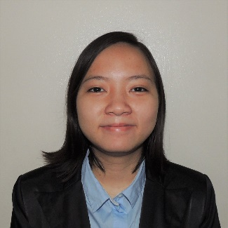**SHEILA P. ZAGUIRRE**

Address: 506 Seafront Garden Roxas Blvd. Pasay City

Contact No: +63 9159050303

Email: zaguirre.sheila@gmail.com

Social Media: https://www.facebook.com/szaguirre1

**SKILLS & COMPETENCIES:**

Management:

* *Tech Team - Blaze I.T. Battle of the Nerds* Mar 2016

http://www.facebook.com/BLAZEIT2016/

* + Handle the Lights and the visual for the game.

Technologies:

HTML | Bootstrap | PHP | Java | C# | Python | ASP.net | SQL | Oracle DB | SAP

**EDUCATIONAL ATTAINMENT:**

Bachelor of Science in Information SystemsMar 2018

De La Salle - College of Saint Benilde (Metro Manila, PH)

**EXTRACURRICULAR ACTIVITIES:**

Thinkathon (Design Thinking Workshop, DLS-CSB) Nov 2016

* *Participant -* Conceptualized the idea with students from different degree programs. Won 3rd Place

Computer Business Association (School Organization, DLS-CSB) Nov 2016

* *Member*

Association of Information Management (School Organization, DLS-CSB) Jan-Apr 2016

* *Member*

What The Hack (Hackathon, DLS-CSB) Apr 2015

* *Participant* - Collaborated with Information System students to create a Unity game named *Papel de Lipad*. Main role: Developer

**SEMINARS ATTENDED:**

Practicum Preparation Seminar Workshop (DLS-CSB) Jun 2017

* A module designed to prepare students for professional life, including how to go about their on-the-job training requirements.

React From Hackathons to Startups (Bitspace Makati) Jan 2017

* An event by the Facebook Developer Circle in Manila. Two developers share their experience in implementing ReactJS in their company.

React From Hackathons to Startups (Bitspace Makati) July 2017

* An event by the Facebook Developer Circle in Manila. Two developers share their experience in implementing ReactJS in their company.

**CERTIFICATIONS:**

SAP Business One Certification Apr 2017

**POSITION APPLIED FOR:**

Web Developer Carmudi Philippines

Web Developer CSS CORP