<https://docs.scipy.org/doc/scipy/reference/generated/scipy.signal.convolve2d.html>

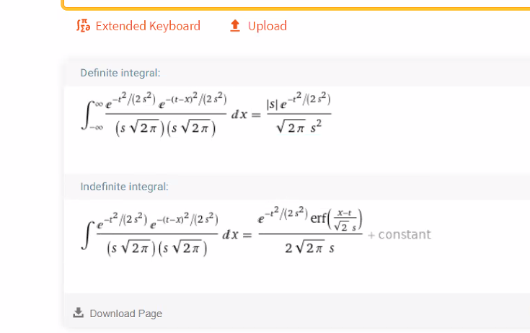

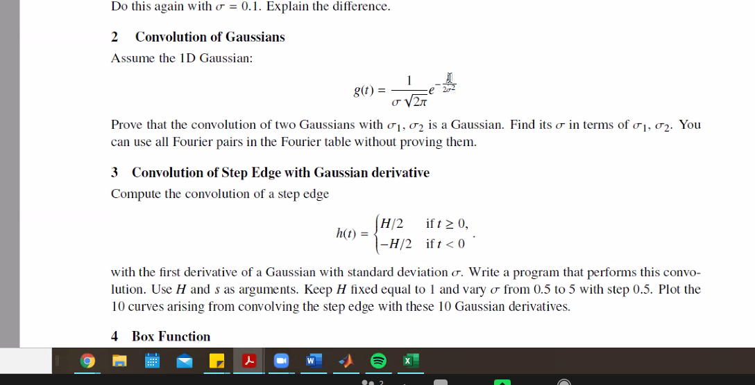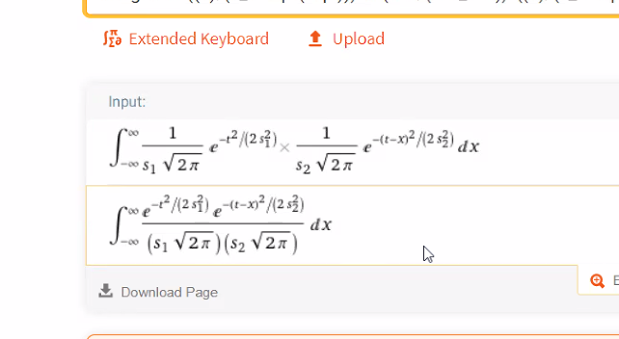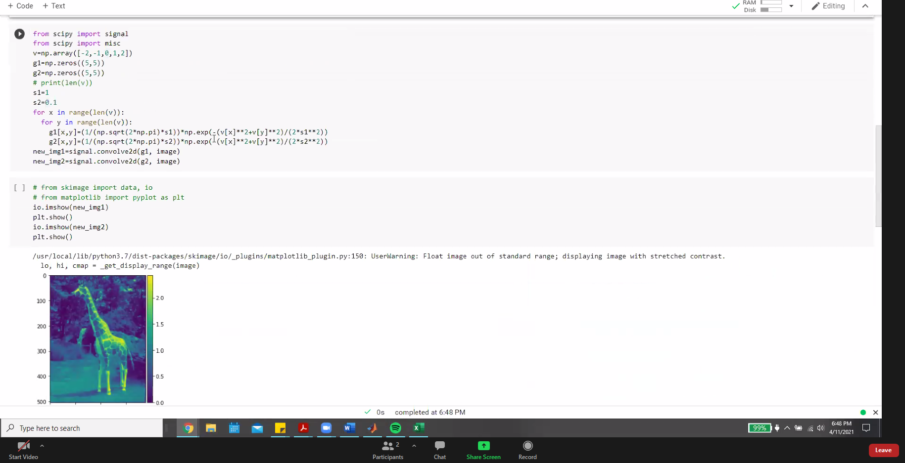

Sigma for q2 is the sum of sigmas: proved via calculus in mathematica

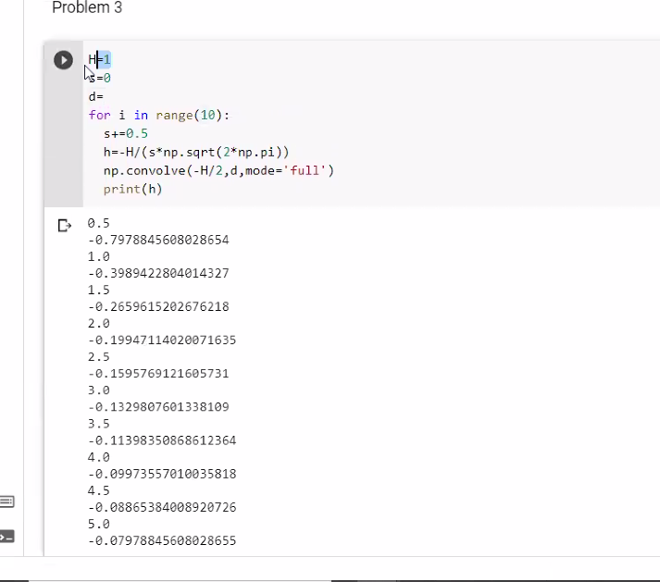

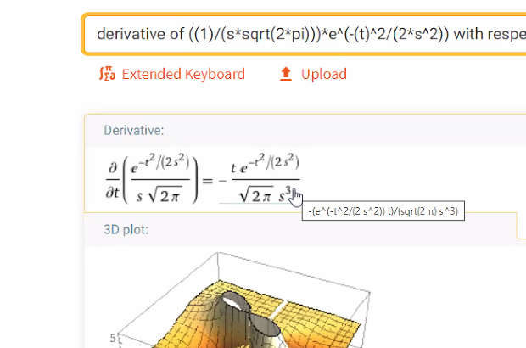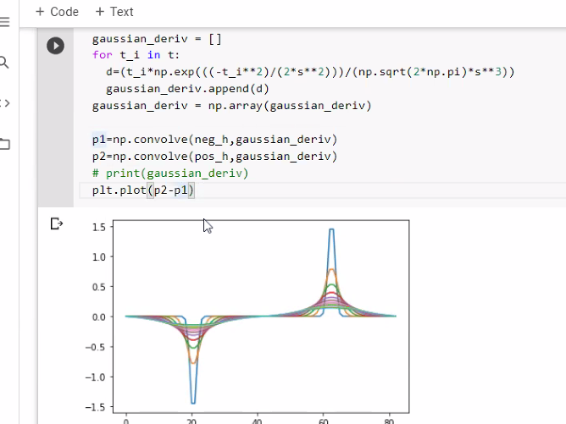

-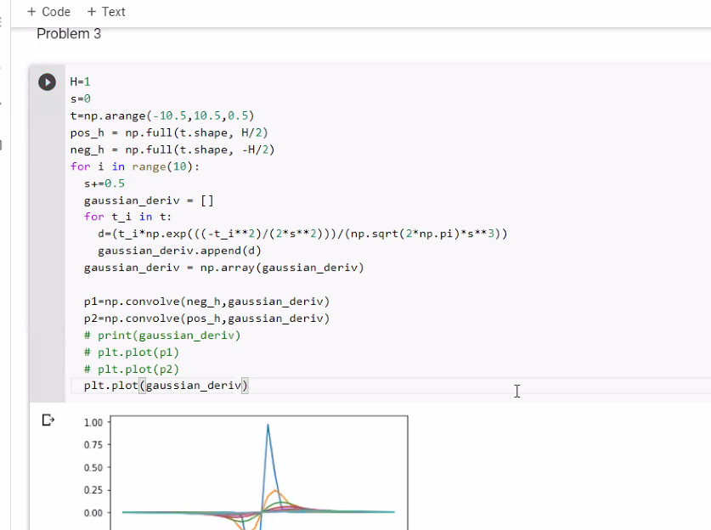

N

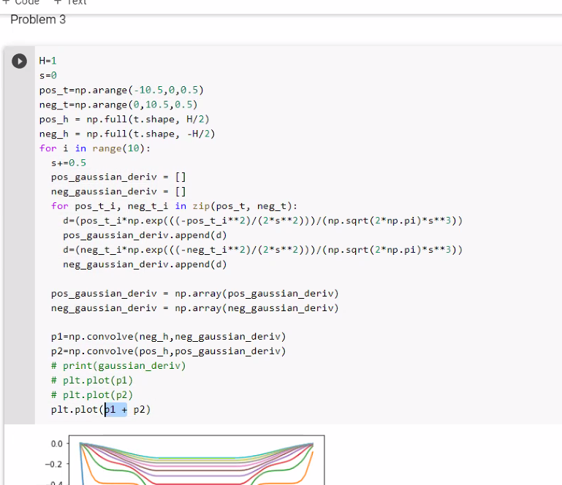

H=1s=0pos_t=np.arange(-10.5,0,0.5)neg_t=np.arange(0,10.5,0.5)pos_h = np.full(t.shape, H/2)neg_h = np.full(t.shape, -H/2)for i in range(10): s+=0.5 pos_gaussian_deriv = [] neg_gaussian_deriv = [] for pos_t_i, neg_t_i in zip(pos_t, neg_t): d=(pos_t_i*np.exp(((-pos_t_i**2)/(2*s**2)))/(np.sqrt(2*np.pi)*s**3)) pos_gaussian_deriv.append(d) d=(neg_t_i*np.exp(((-neg_t_i**2)/(2*s**2)))/(np.sqrt(2*np.pi)*s**3)) neg_gaussian_deriv.append(d) pos_gaussian_deriv = np.array(pos_gaussian_deriv)

neg_gaussian_deriv = np.array(neg_gaussian_deriv)

p1=np.convolve(neg_h,neg_gaussian_deriv)

p2=np.convolve(pos_h,pos_gaussian_deriv)

# print(gaussian_deriv)

plt.plot(p1)

# plt.plot(p2)

# plt.plot(p1 + p2)

