Shrinking:
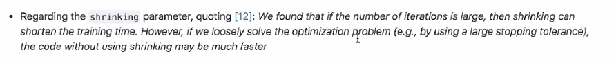


LIBSVM considers an SMO-type decomposition method proposed in Fan et al. (2005).
Sequential Minimal optimization


How SVM handles multiple classes:
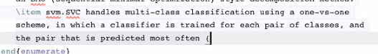
One-vs-One (OvO for short) is another heuristic method for using binary classification algorithms for multi-class classification.

Like one-vs-rest, one-vs-one splits a multi-class classification dataset into binary classification problems. Unlike one-vs-rest that splits it into one binary dataset for each class, the one-vs-one approach splits the dataset into one dataset for each class versus every other class.

For example, consider a multi-class classification problem with four classes: ‘red,’ ‘blue,’ and ‘green,’ ‘yellow.’ This could be divided into six binary classification datasets as follows:

Binary Classification Problem 1: red vs. blue
Binary Classification Problem 2: red vs. green
Binary Classification Problem 3: red vs. yellow
Binary Classification Problem 4: blue vs. green
Binary Classification Problem 5: blue vs. yellow
Binary Classification Problem 6: green vs. yellow
This is significantly more datasets, and in turn, models than the one-vs-rest strategy described in the previous section.

The formula for calculating the number of binary datasets, and in turn, models, is as follows:

(NumClasses * (NumClasses – 1)) / 2
We can see that for four classes, this gives us the expected value of six binary classification problems:

(NumClasses * (NumClasses – 1)) / 2
(4 * (4 – 1)) / 2
(4 * 3) / 2
12 / 2
6
Each binary classification model may predict one class label and the model with the most predictions or votes is predicted by the one-vs-one strategy.

An alternative is to introduce K(K − 1)/2 binary discriminant functions, one for every possible pair of classes. This is known as a one-versus-one classifier. Each point is then classified according to a majority vote amongst the discriminant functions.

— Page 183, Pattern Recognition and Machine Learning, 2006.

Similarly, if the binary classification models predict a numerical class membership, such as a probability, then the argmax of the sum of the scores (class with the largest sum score) is predicted as the class label.

Classically, this approach is suggested for support vector machines (SVM) and related kernel-based algorithms. This is believed because the performance of kernel methods does not scale in proportion to the size of the training dataset and using subsets of the training data may counter this effect.

The support vector machine implementation in the scikit-learn is provided by the SVC class and supports the one-vs-one method for multi-class classification problems. This can be achieved by setting the “decision_function_shape” argument to ‘ovo‘.

The example below demonstrates SVM for multi-class classification using the one-vs-one method.

In the event of a tie (among two classes with an equal number of votes), it selects the class with the highest aggregate classification confidence by summing over the pair-wise classification confidence levels computed by the underlying binary classifiers.

Alternative is one-vs-rest

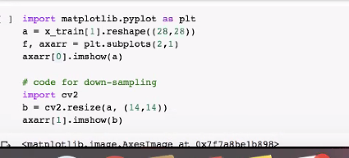
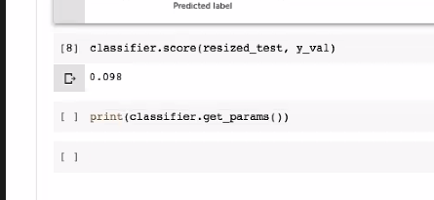
Use SVC with ‘scale’ instead of auto

