**1.) What does “InitializeSerialConsole()” do? In said function, what is “cbufRx” and “cbufTx”?**

It initializes the circular buffers handlers cbufRx, cbufTx as 8-bit integer buffers that use the underlying arrays rxCharacterBuffer and txCharacterBuffer while using 2 pointers to access different parts of the array. These circular buffers can hold at most 256 elements each.

**2.) How are “cbufRx” and “cbufTx” initialized? Where is the library that defines them (please tell the *C file they come from).**

They are initialized in the InitializeSerialConsole function inside SerialConsole.c

The function used to initialize them is called circular_buf_init, which is located in circular_buffer.c

In the initialization, we malloc and return a pointer to the space for the circular_buf_t struct, which contains the local variables necessary to implement the interface of the circular buffer using an underlying char array.

**3.) Where are the character arrays where the RX and TX characters are being stored on at the end?**

SerialConsole.c contains rxCharacterBuffer and txCharacterBuffer, which is where the RX and TX characters are being stored via the Circular Buffer interface

4.) Please draw a diagram that explain the program flow for UART reception – starting at the user typing a character and ending on how that characters ends up in the circular buffer “cbufRx”. Please make reference to specific functions in the starter code.

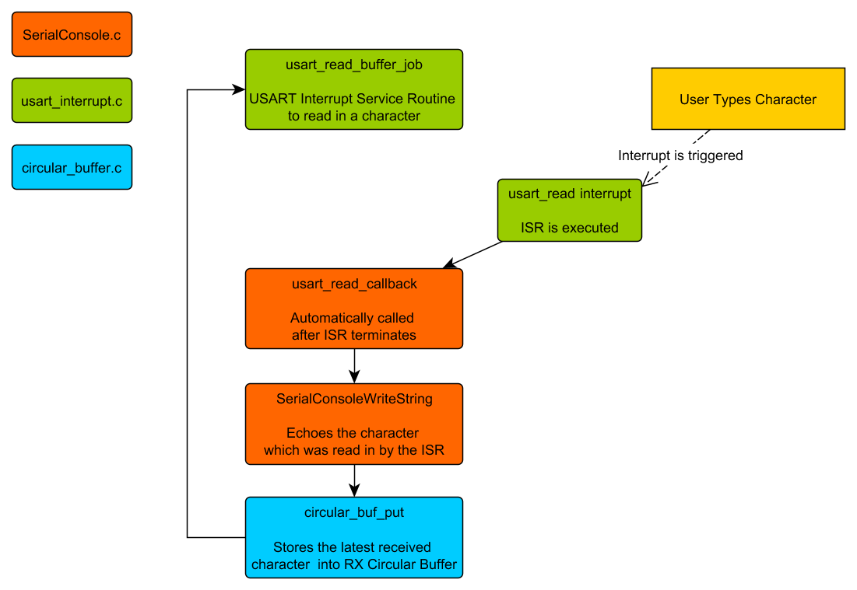

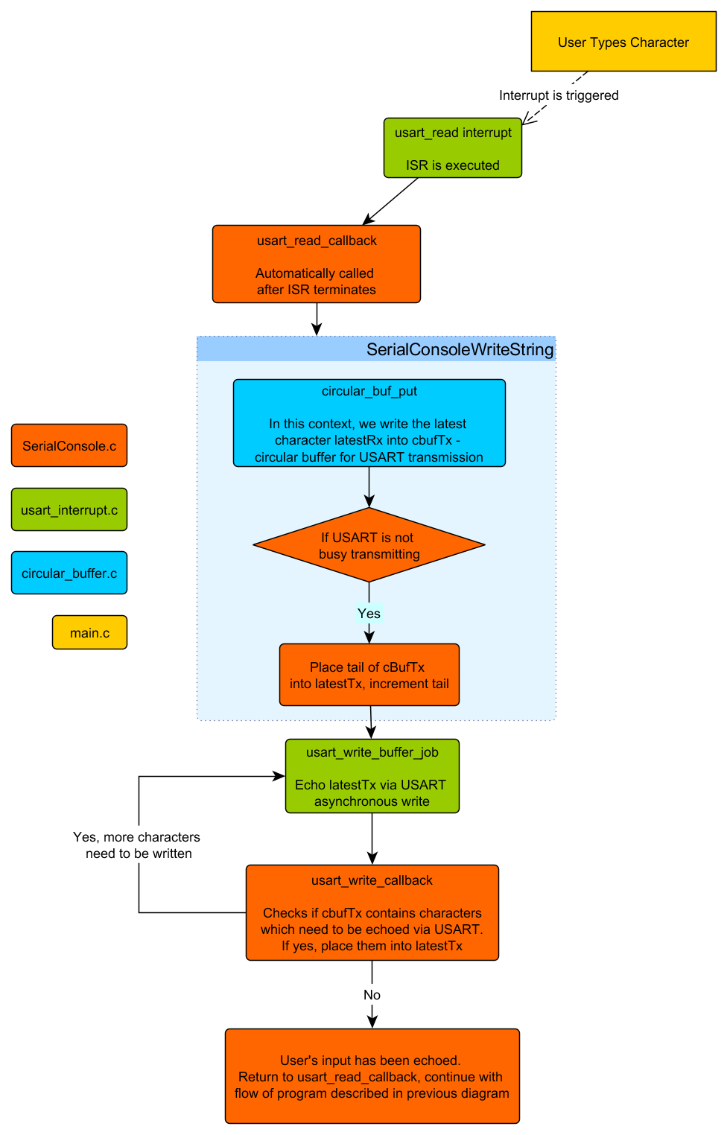5.) Please draw a diagram that explain the program flow for the UART transmission – Starting from a string added by the program to the circular buffer “cbufTx” and ending on characters being shown on the screen of a PC (On Teraterm, for example). Please make reference to specific functions in the starter code.