**Problem 1**

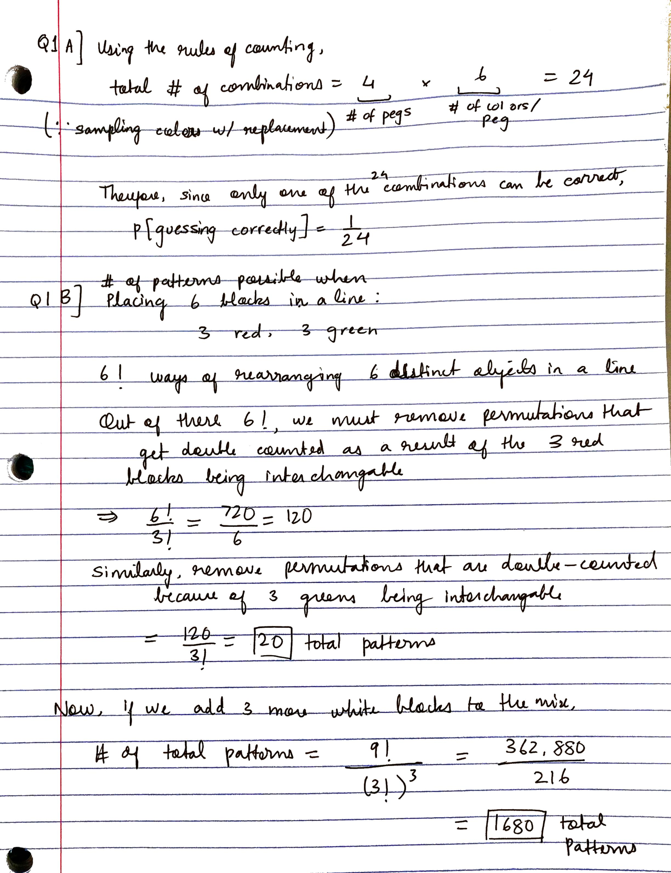

**Problem 2A**

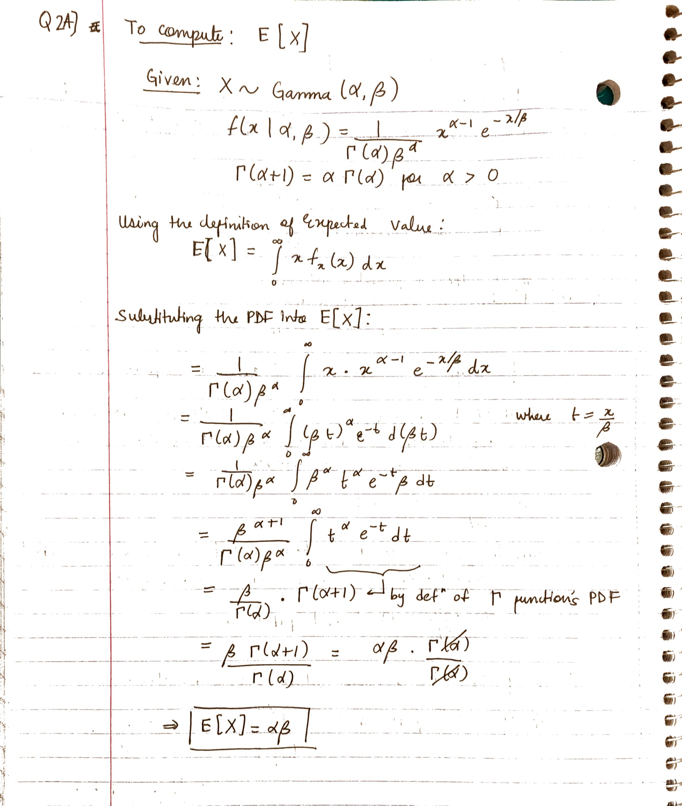

**Problem 2B**

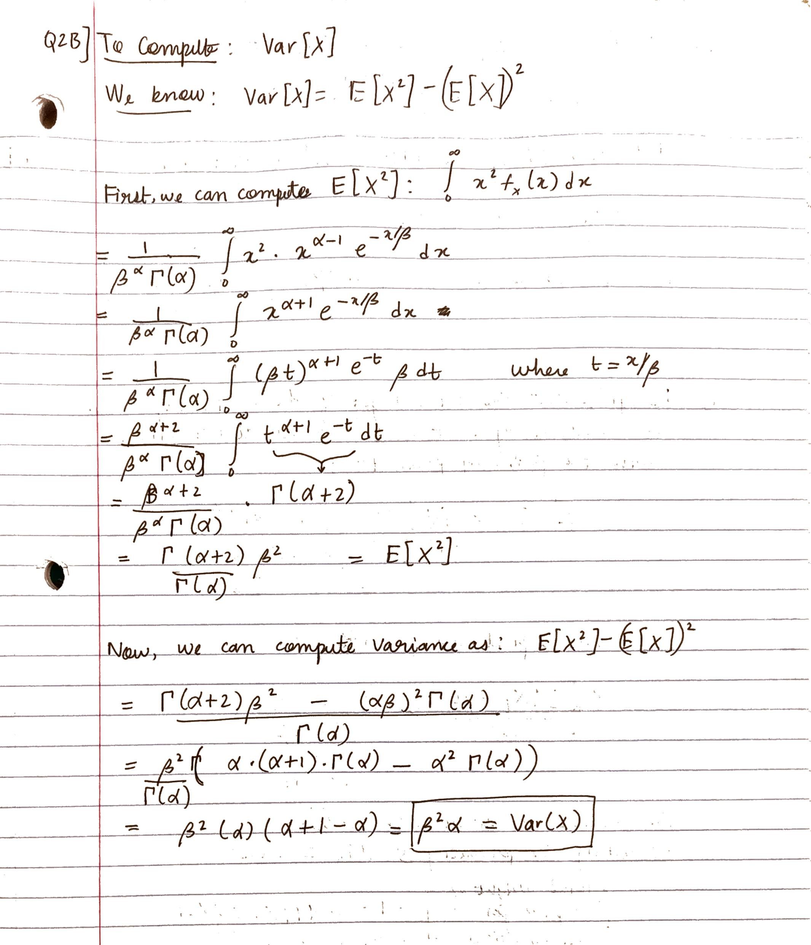

**Problem 2C**

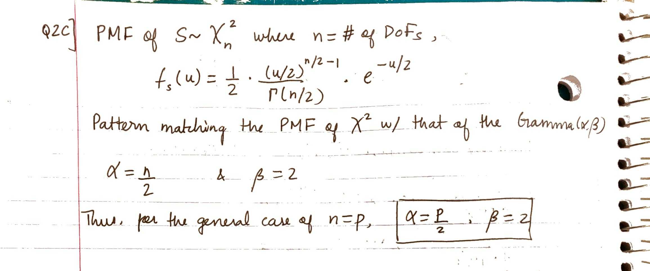

**Problem 3**

Determining MGF

Mean

Variance

Third Moment

**Problem 4**

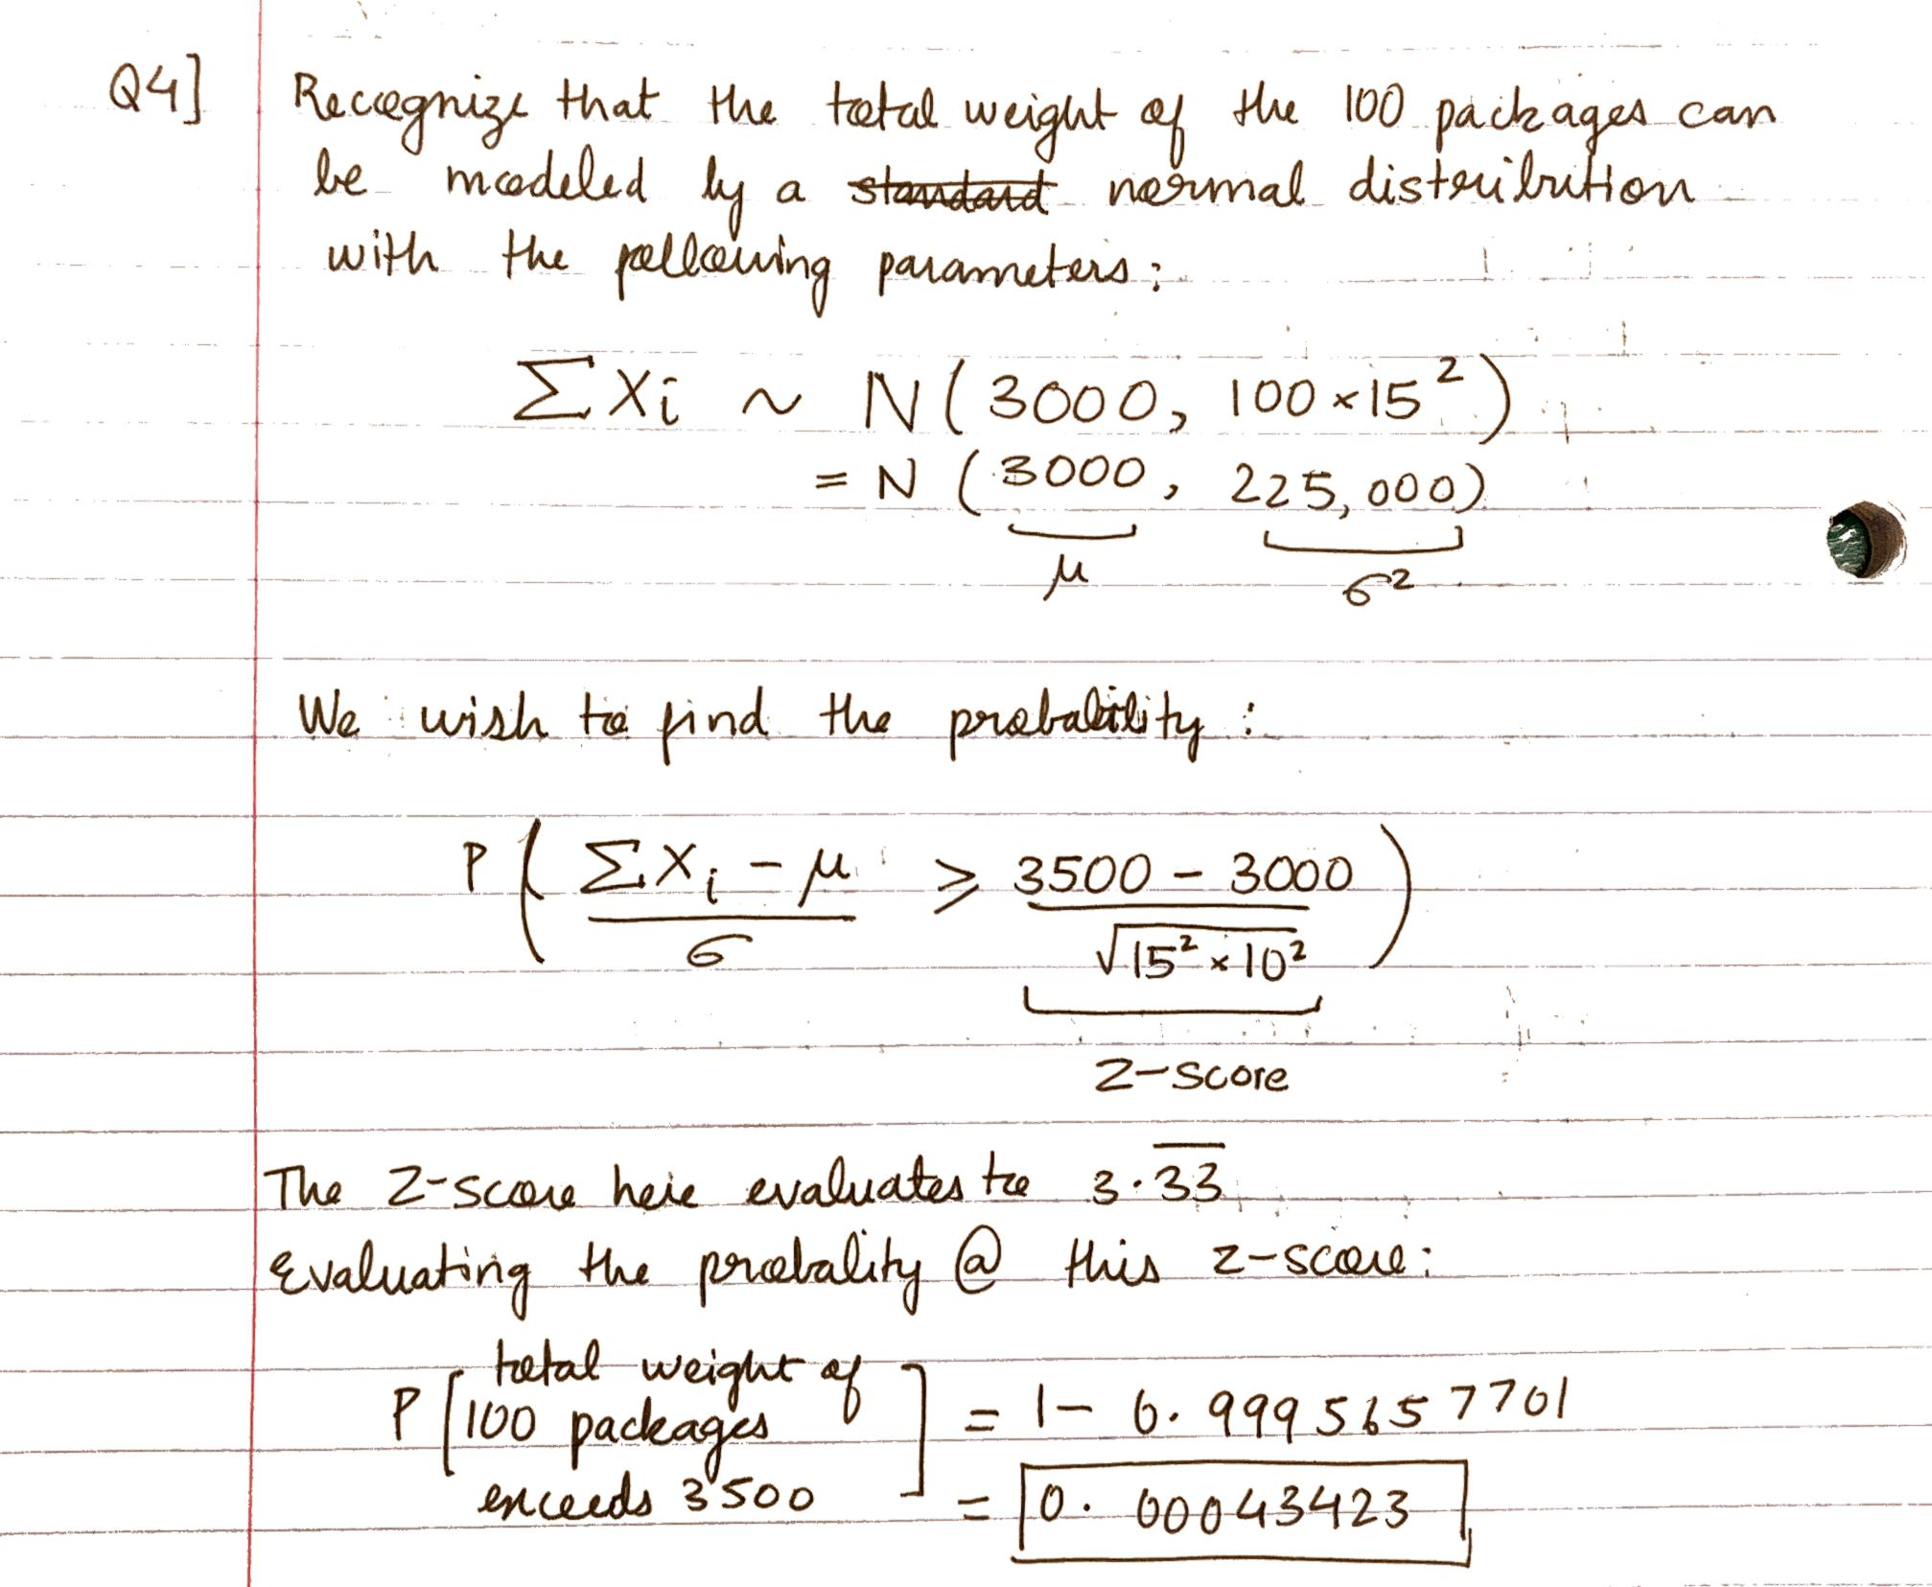

**Problem 5A and Problem 5B**

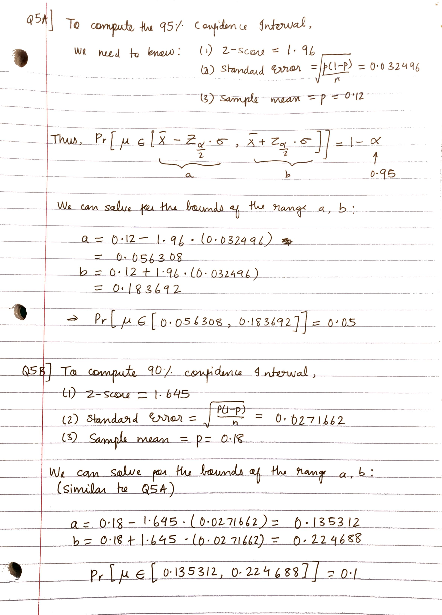

**Problem 5C and Problem 5D**

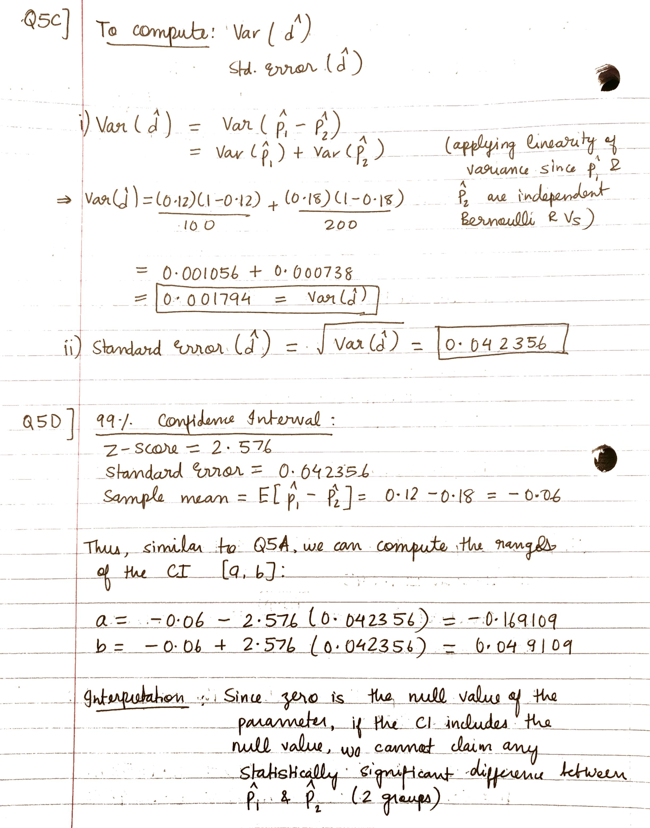

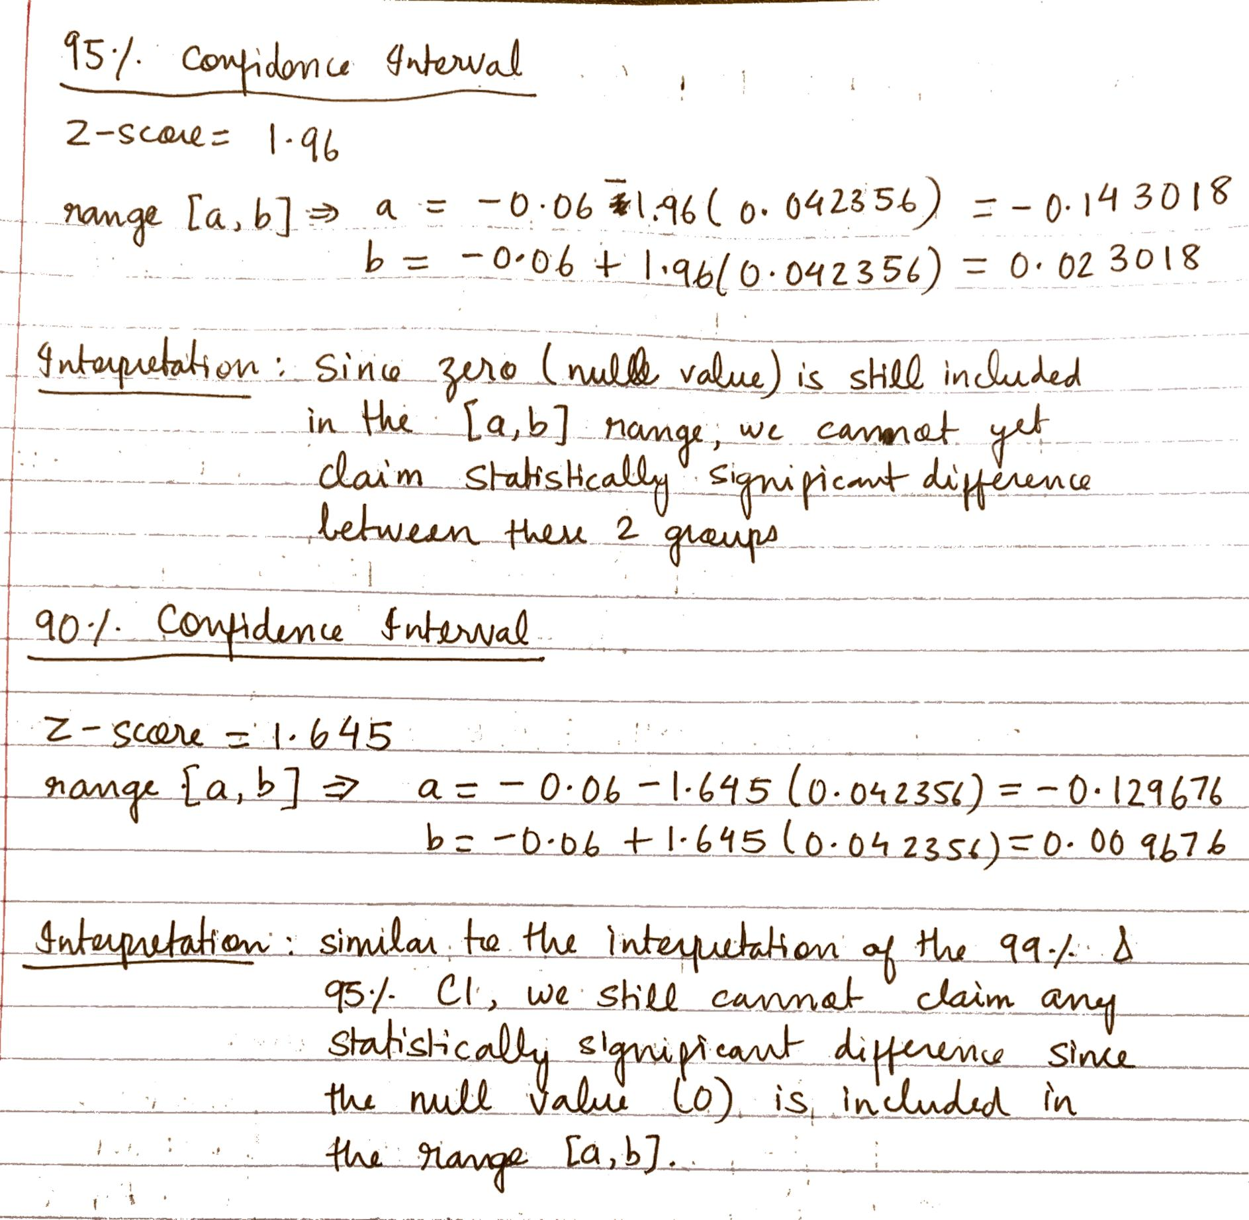

**Problem 6**

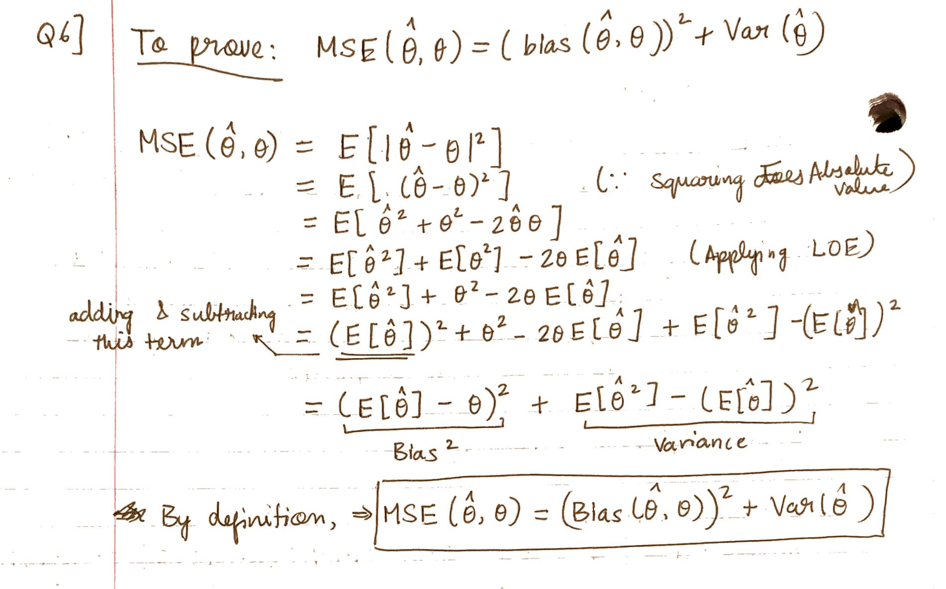

**Problem 7A**

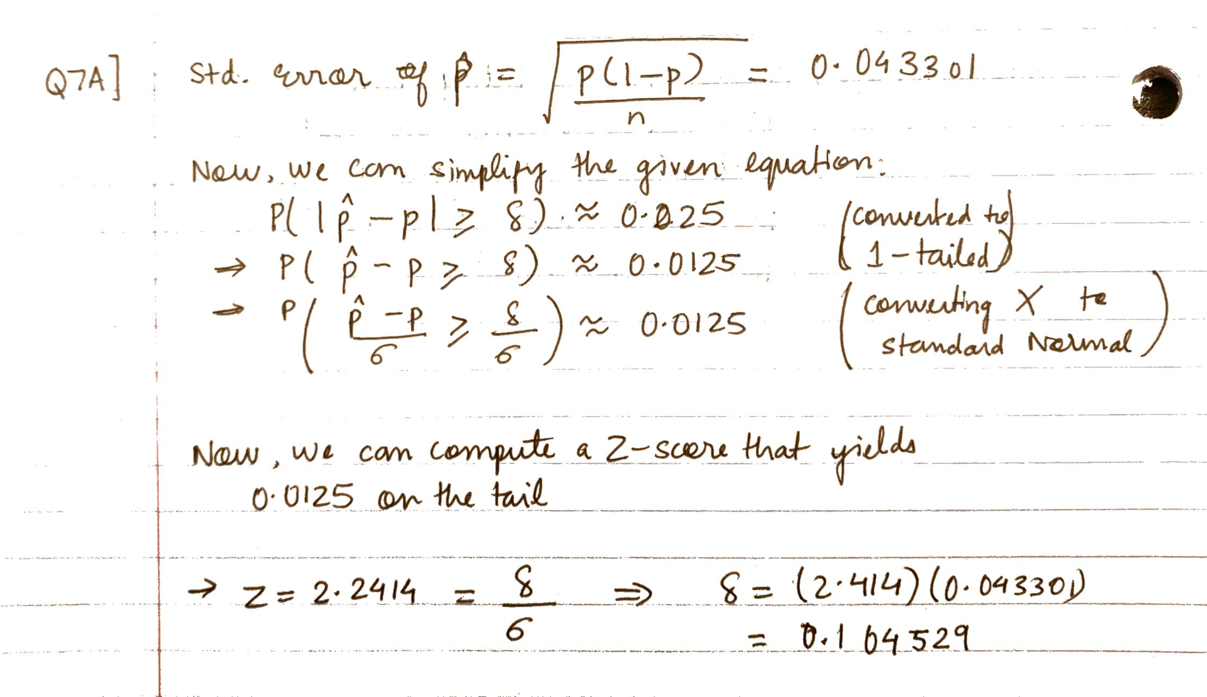

**Problem 7B**

