**Problem 1A & 1B**

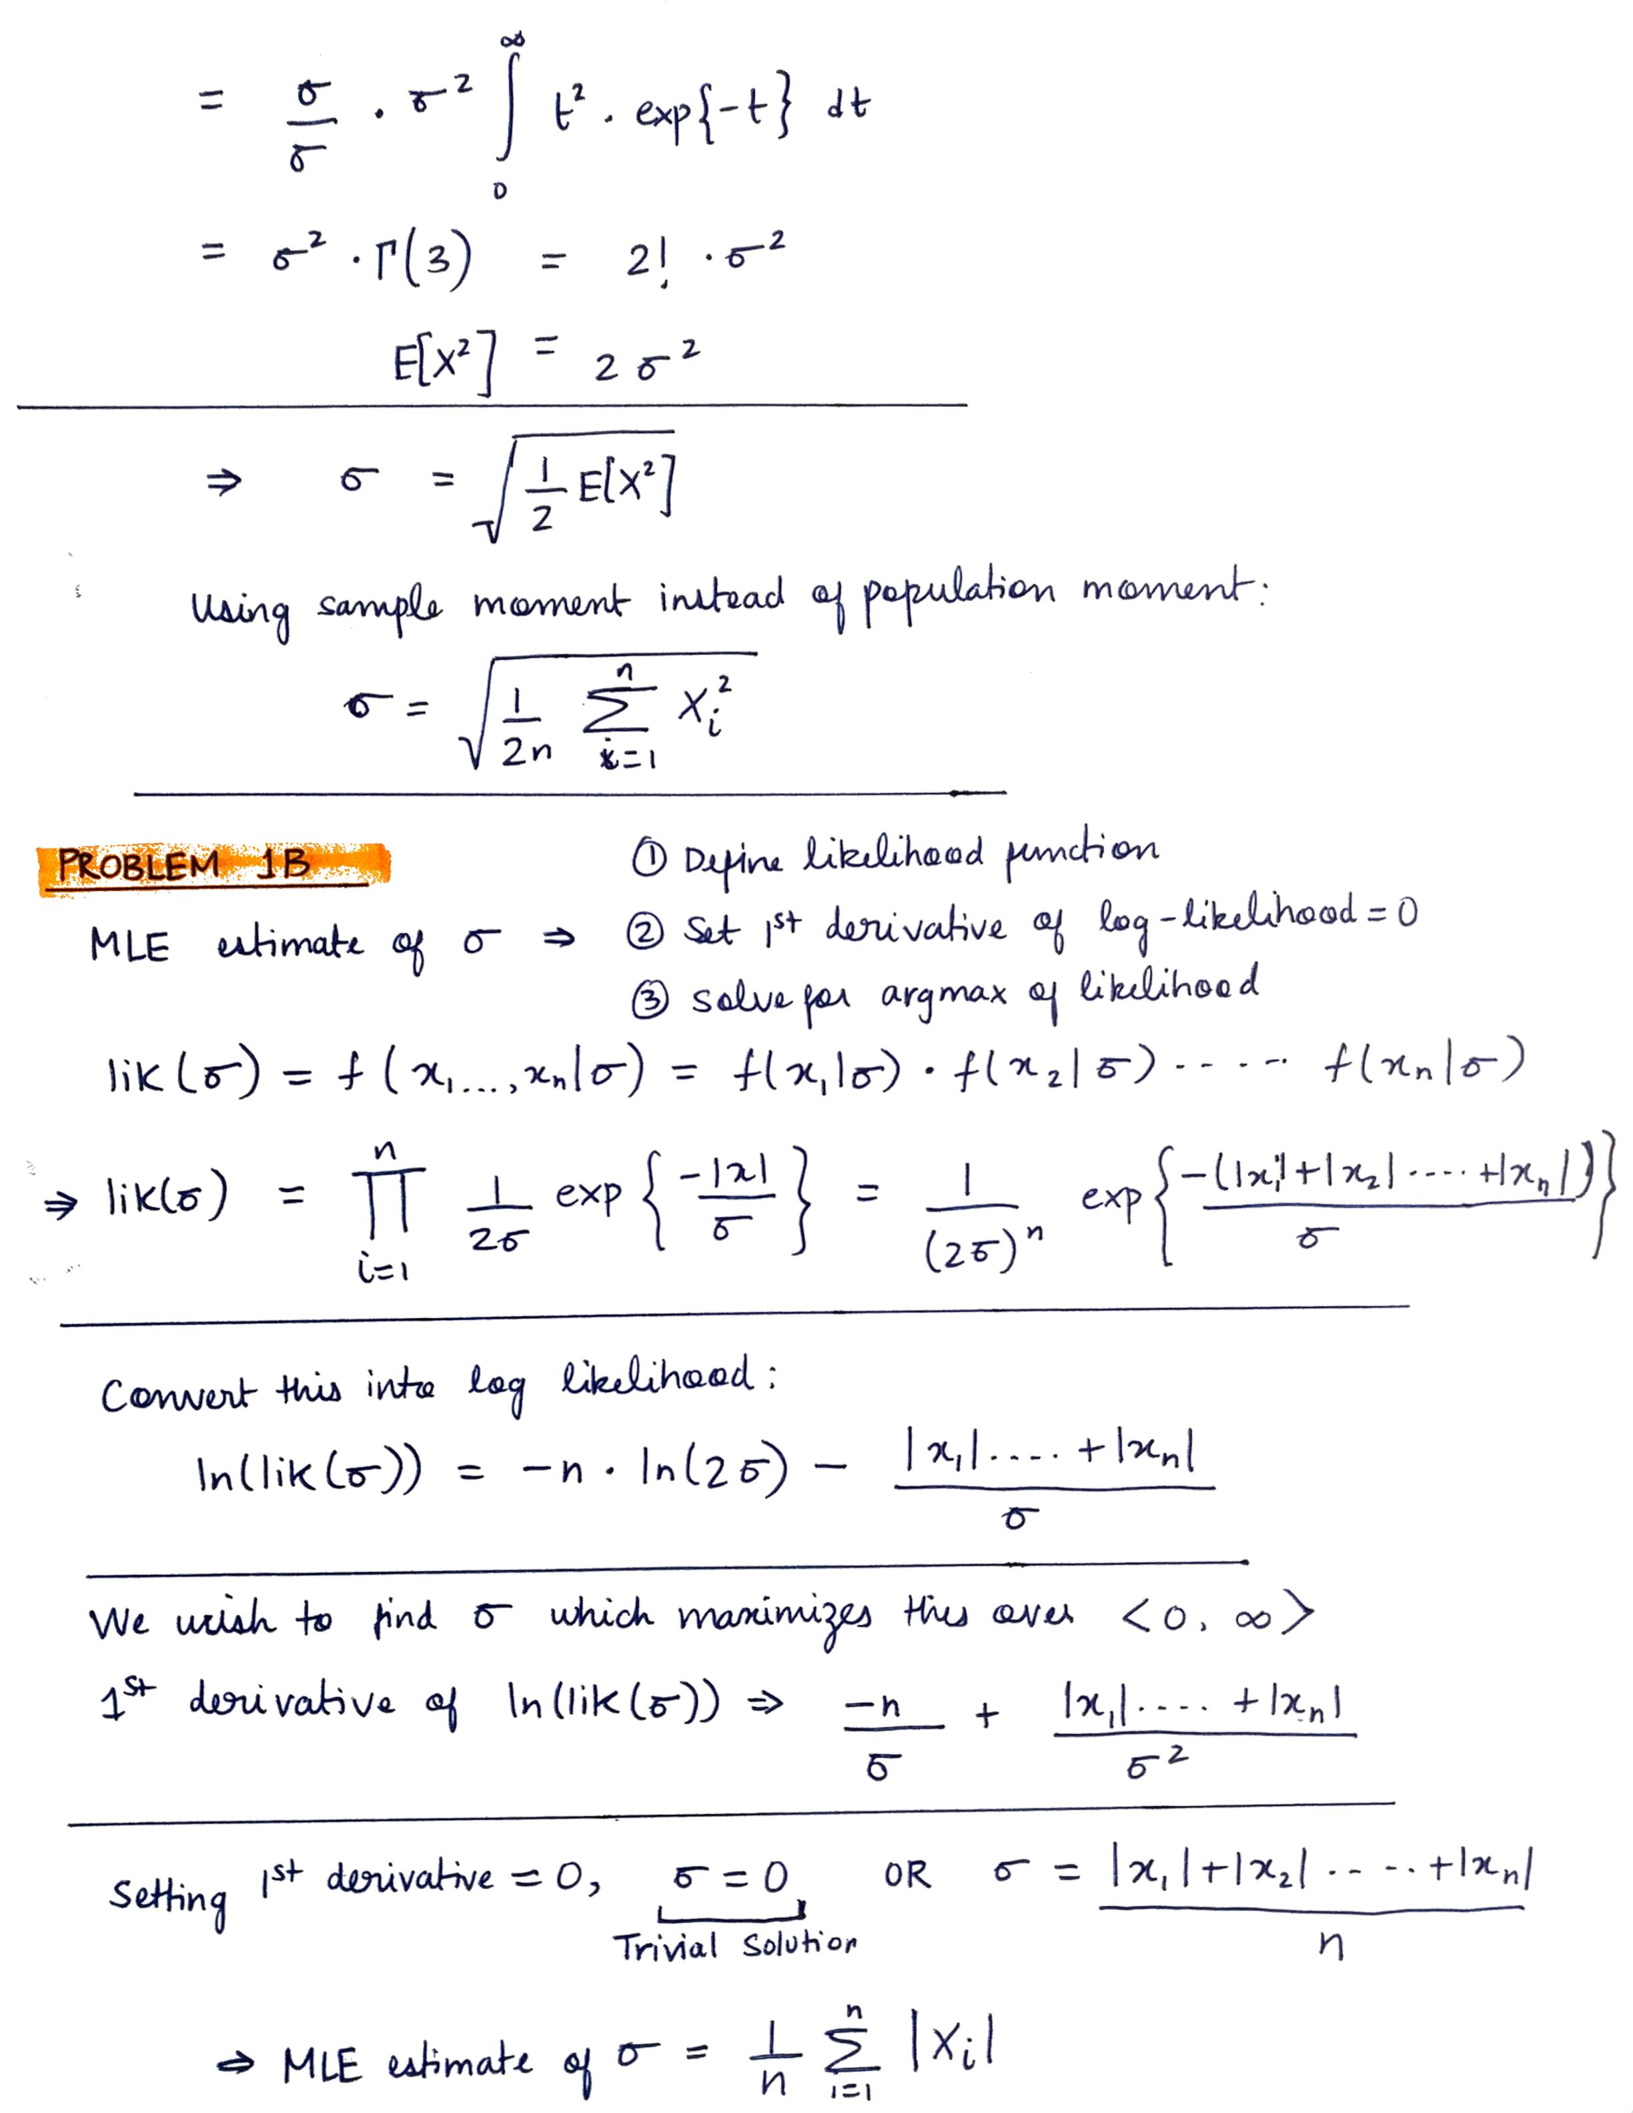

**Problem 1C**

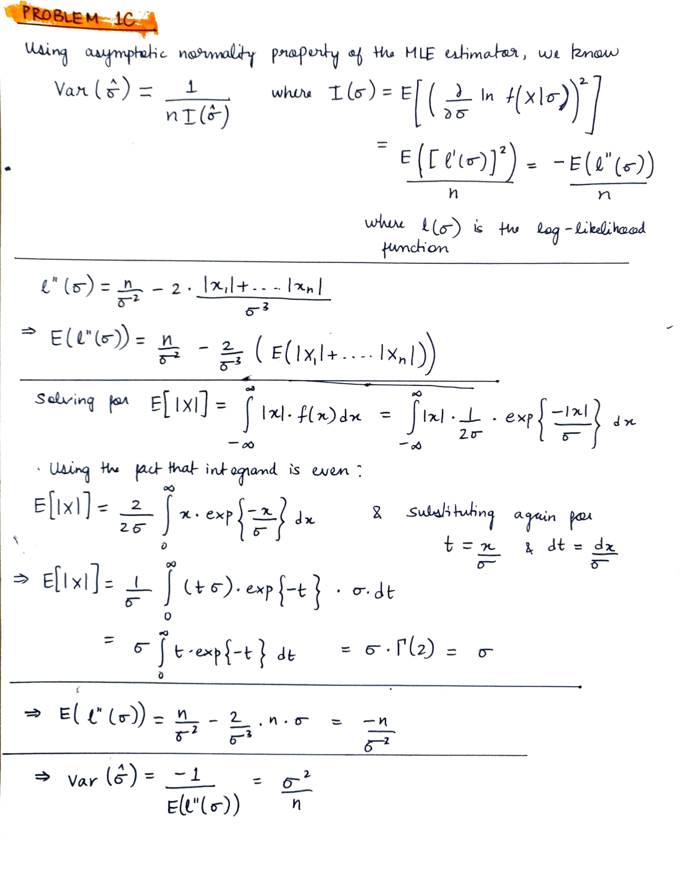

**Problem 2A**

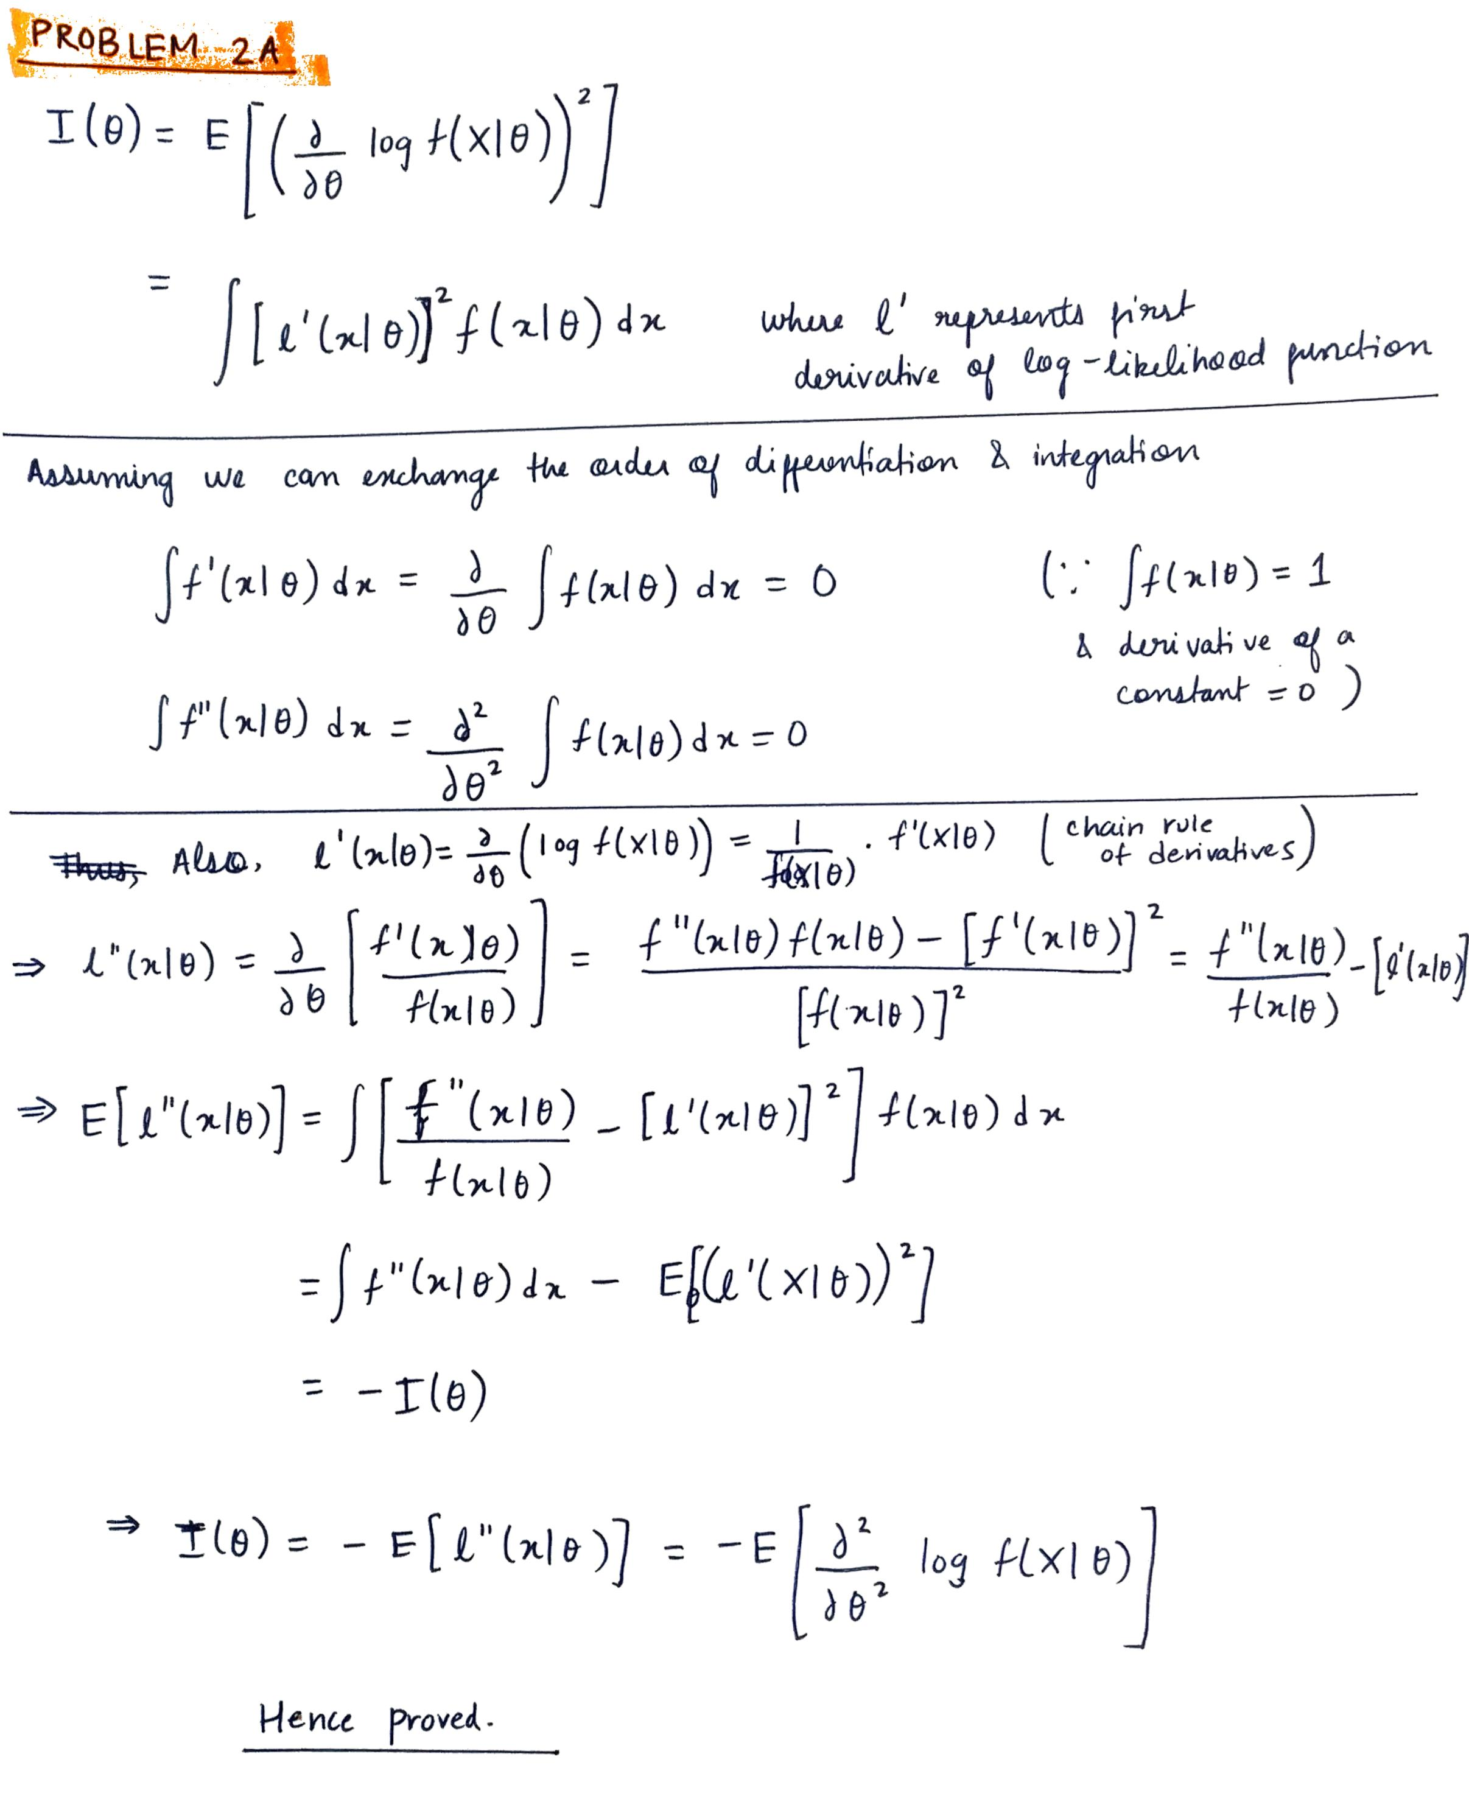

**Problem 2B & 2C**

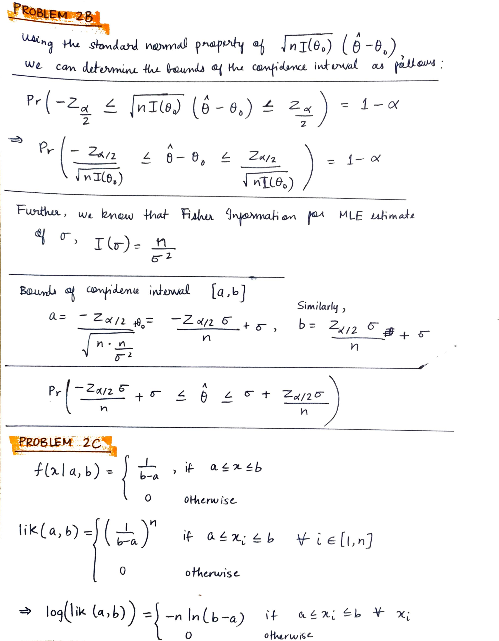

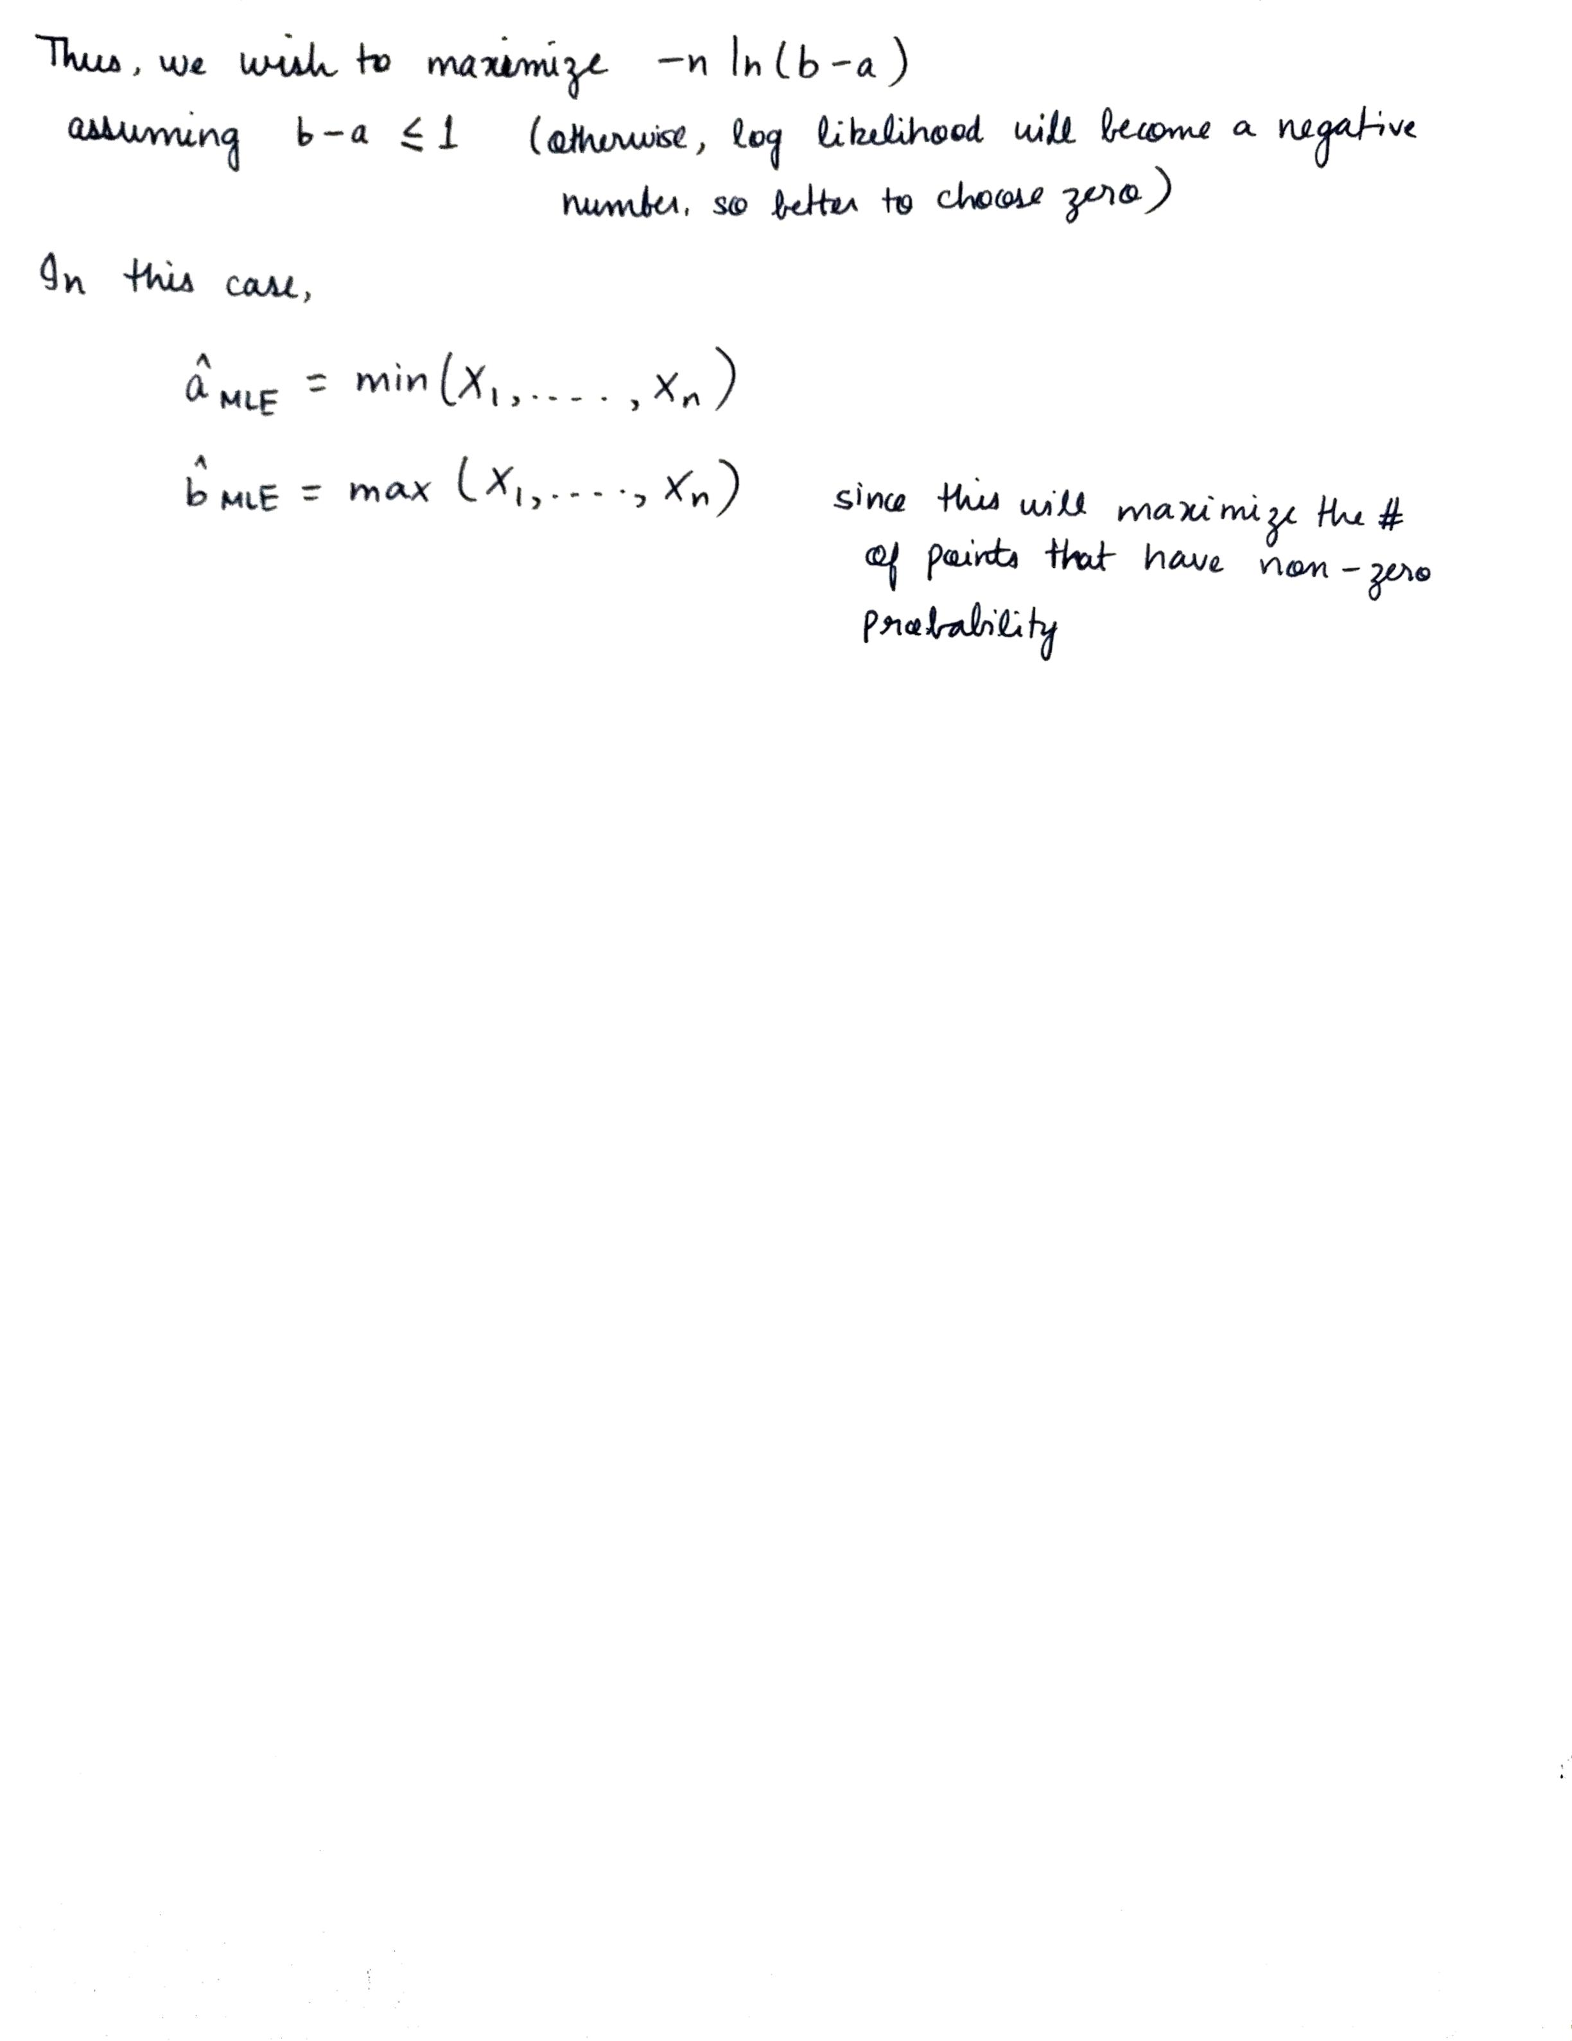

**Problem 3A**

**Problem 3B**

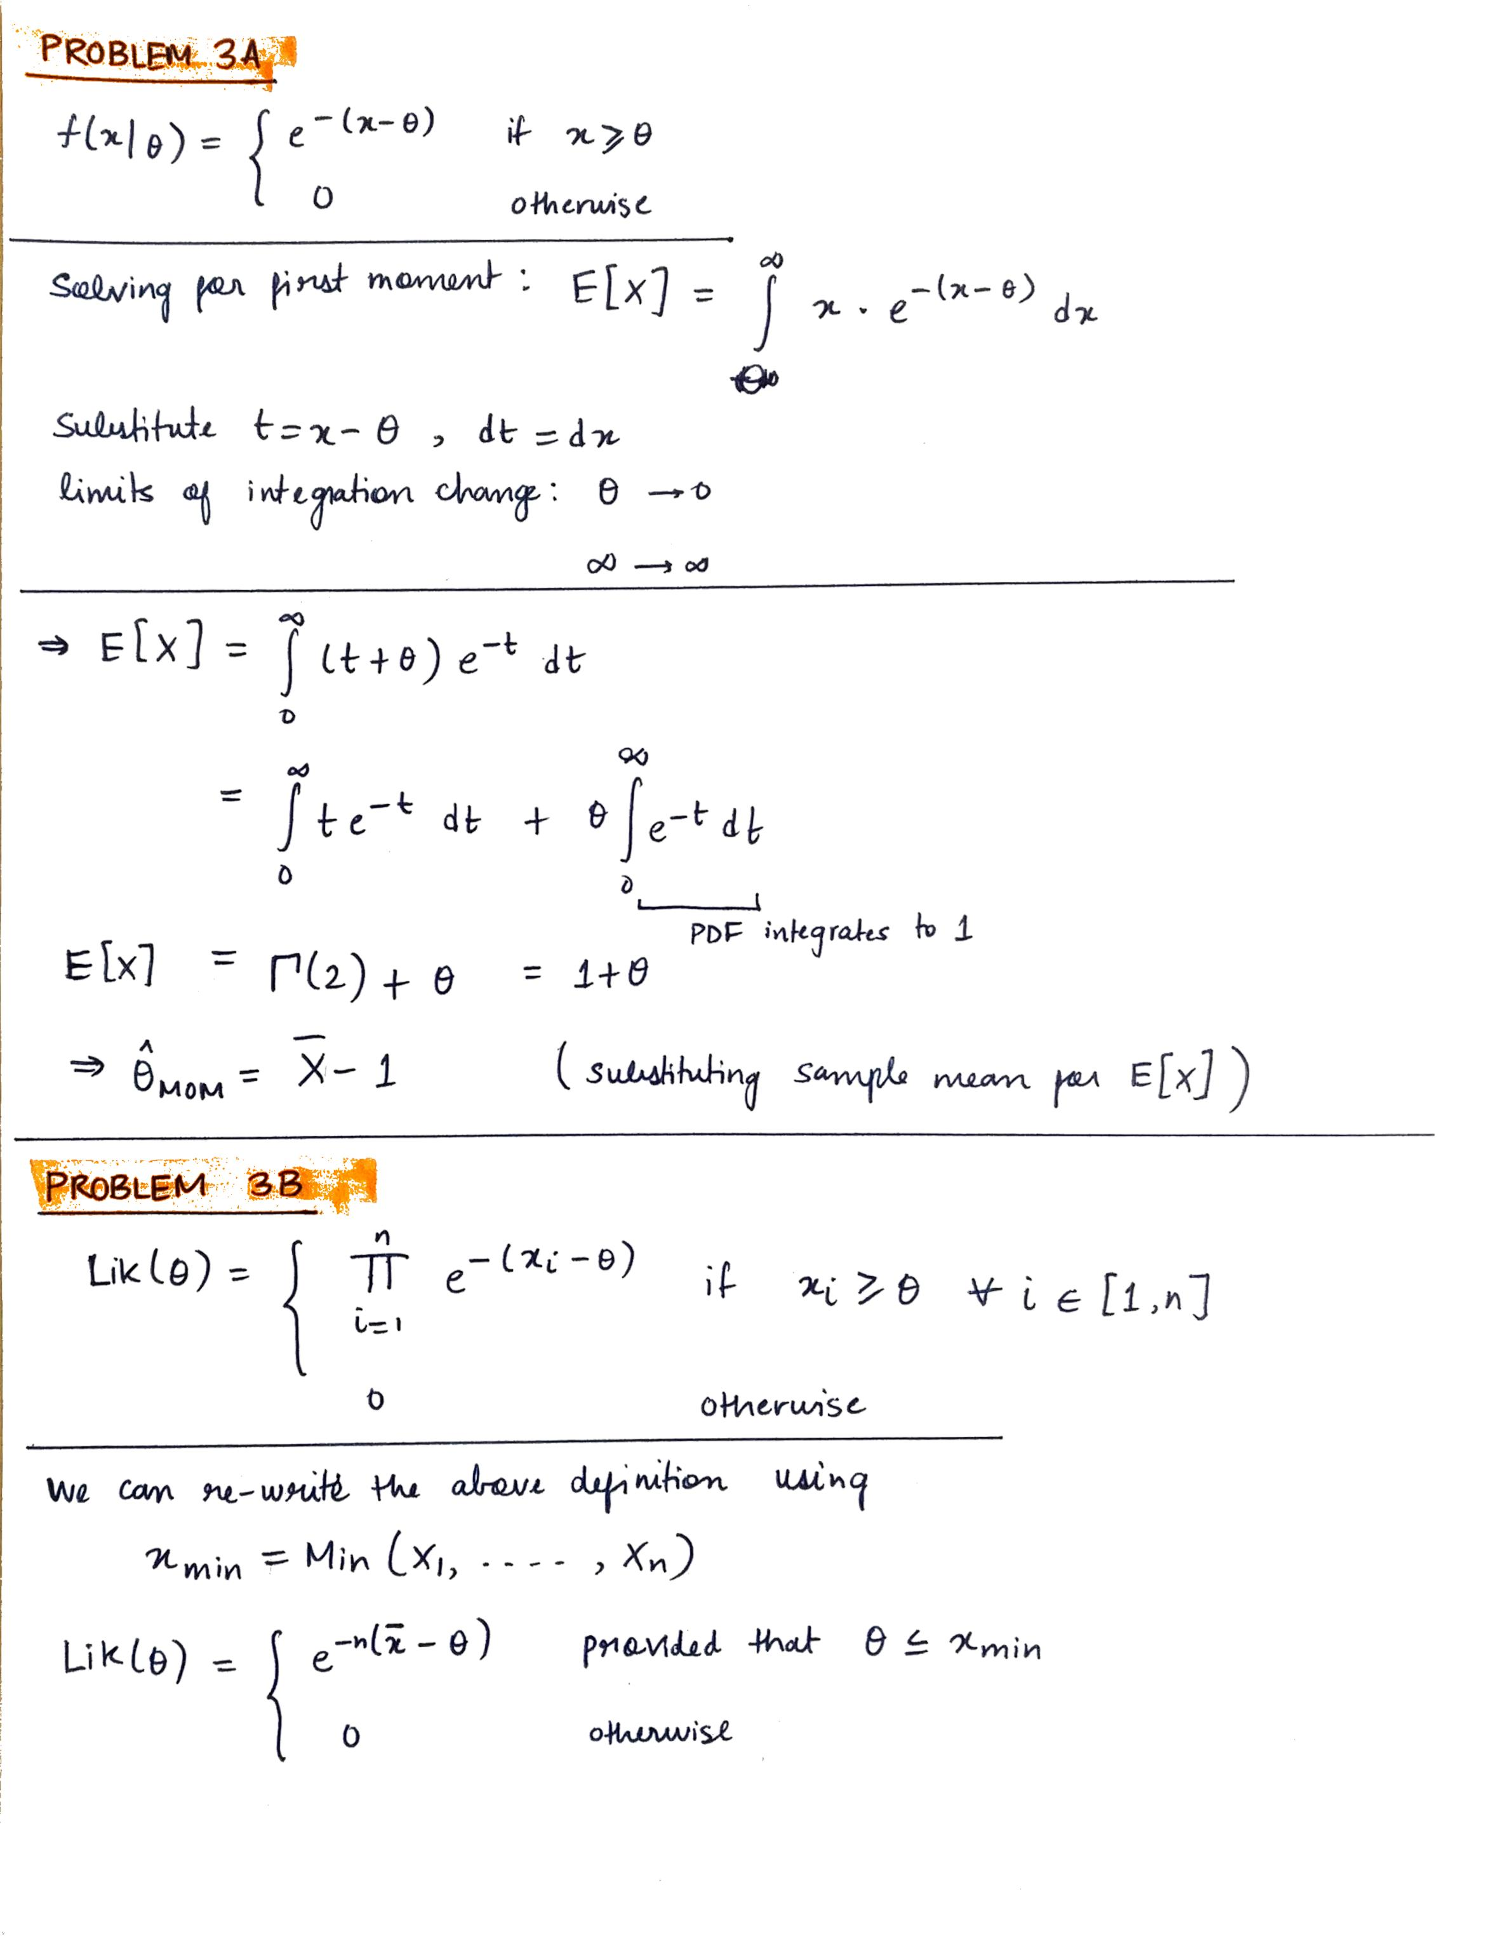

**Problem 4A**

**Problem 4B**

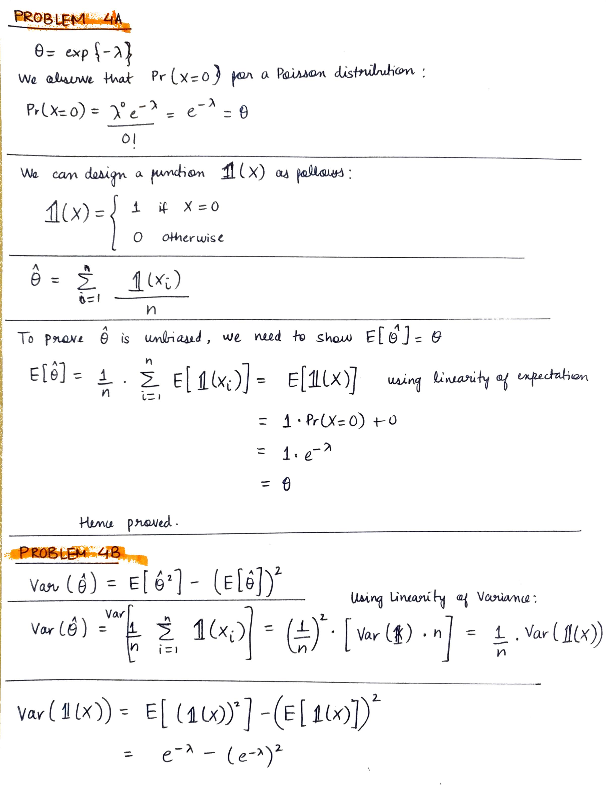

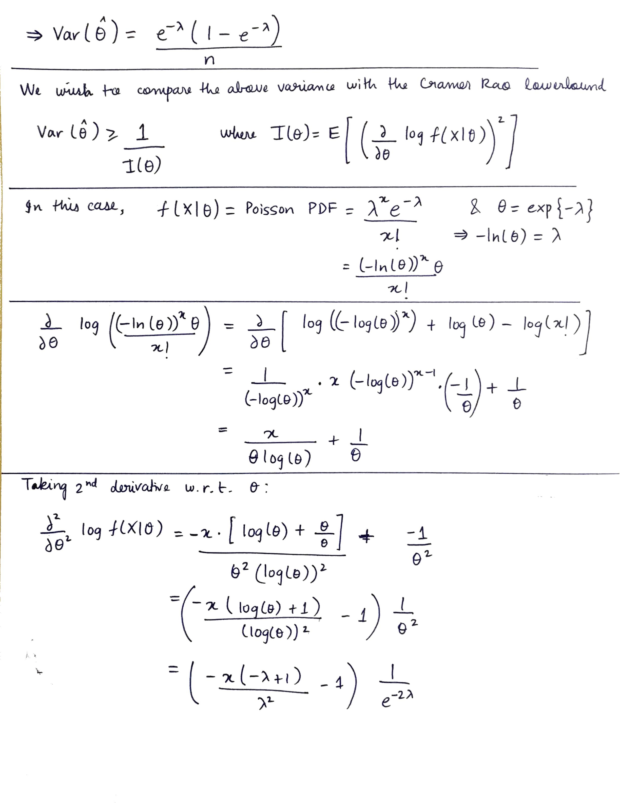

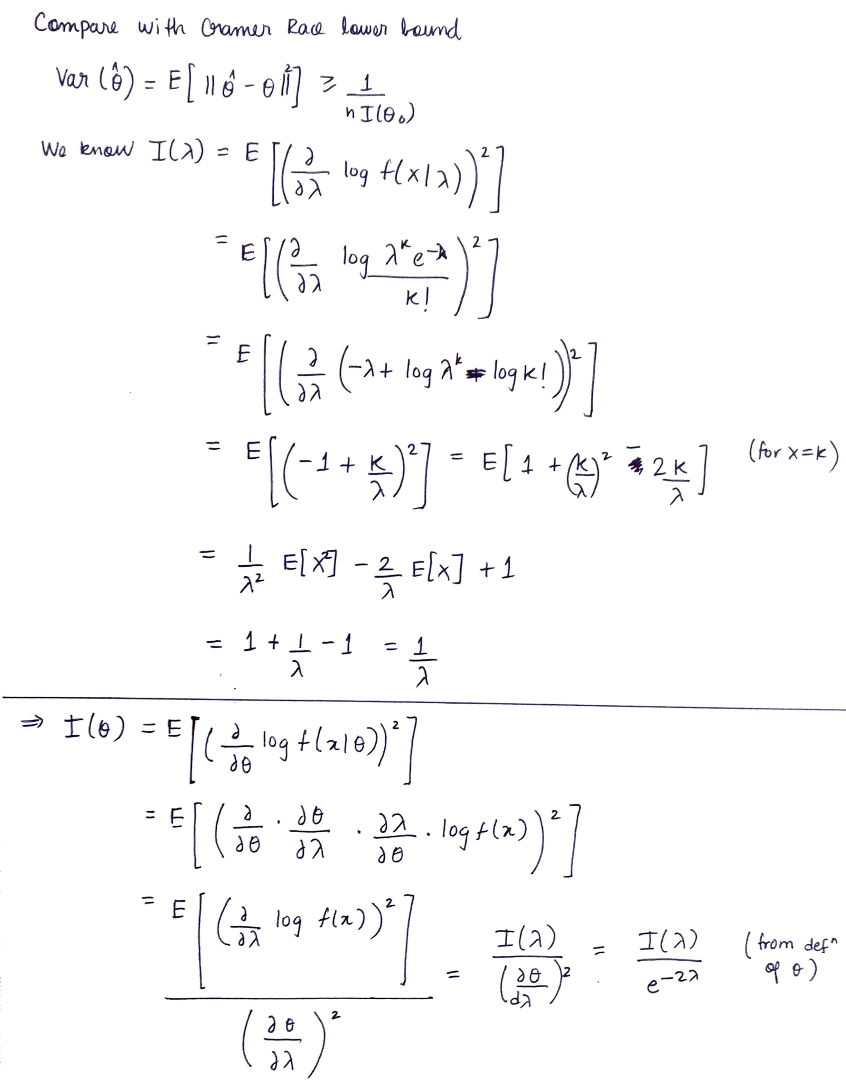

**Problem 5A**

/100 = 1.97

/100 = 1.94

/100

**Problem 5B**

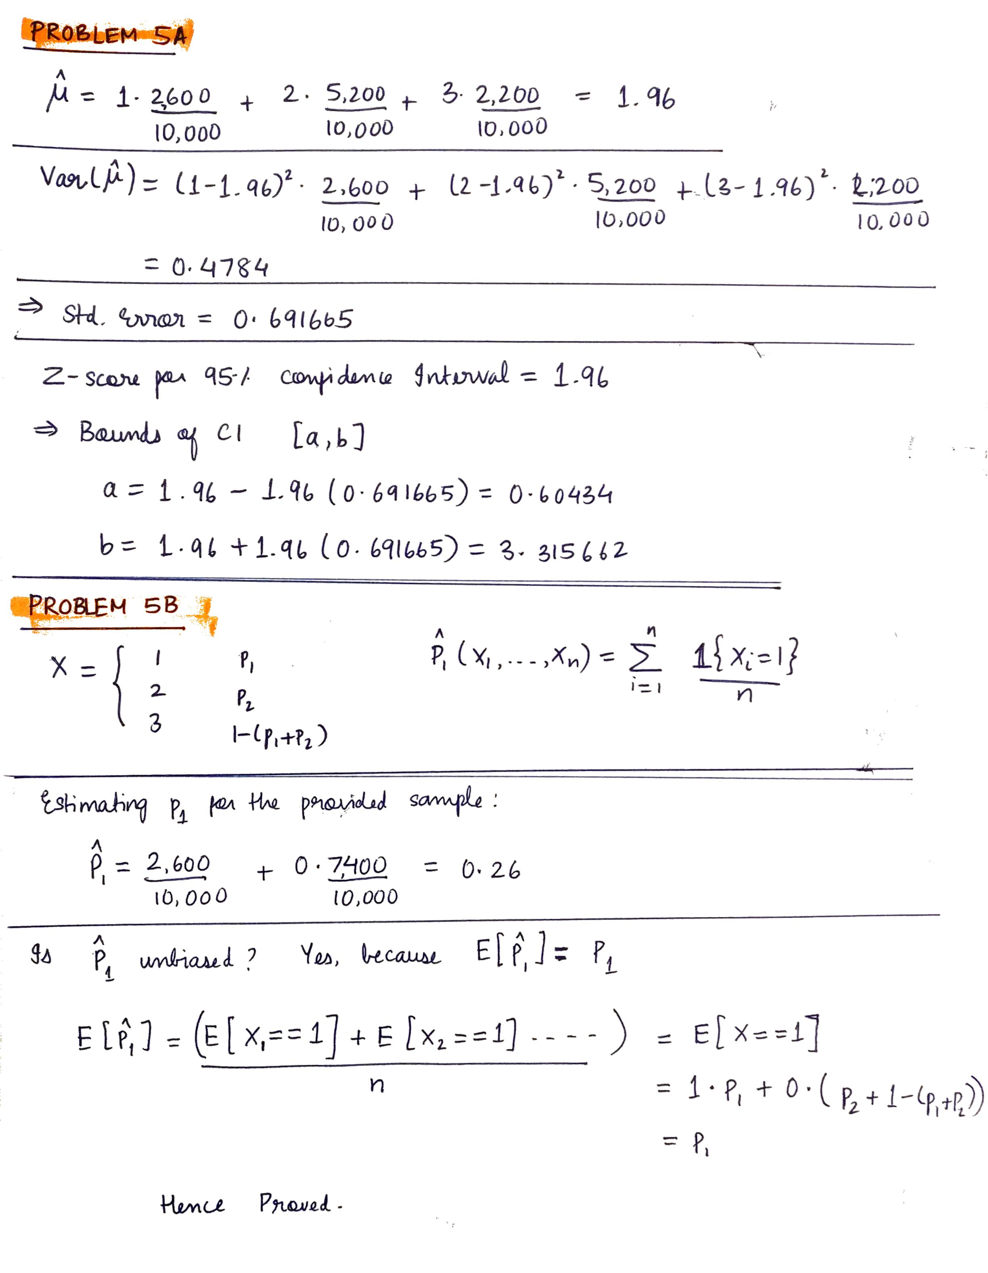

**Problem 5C**

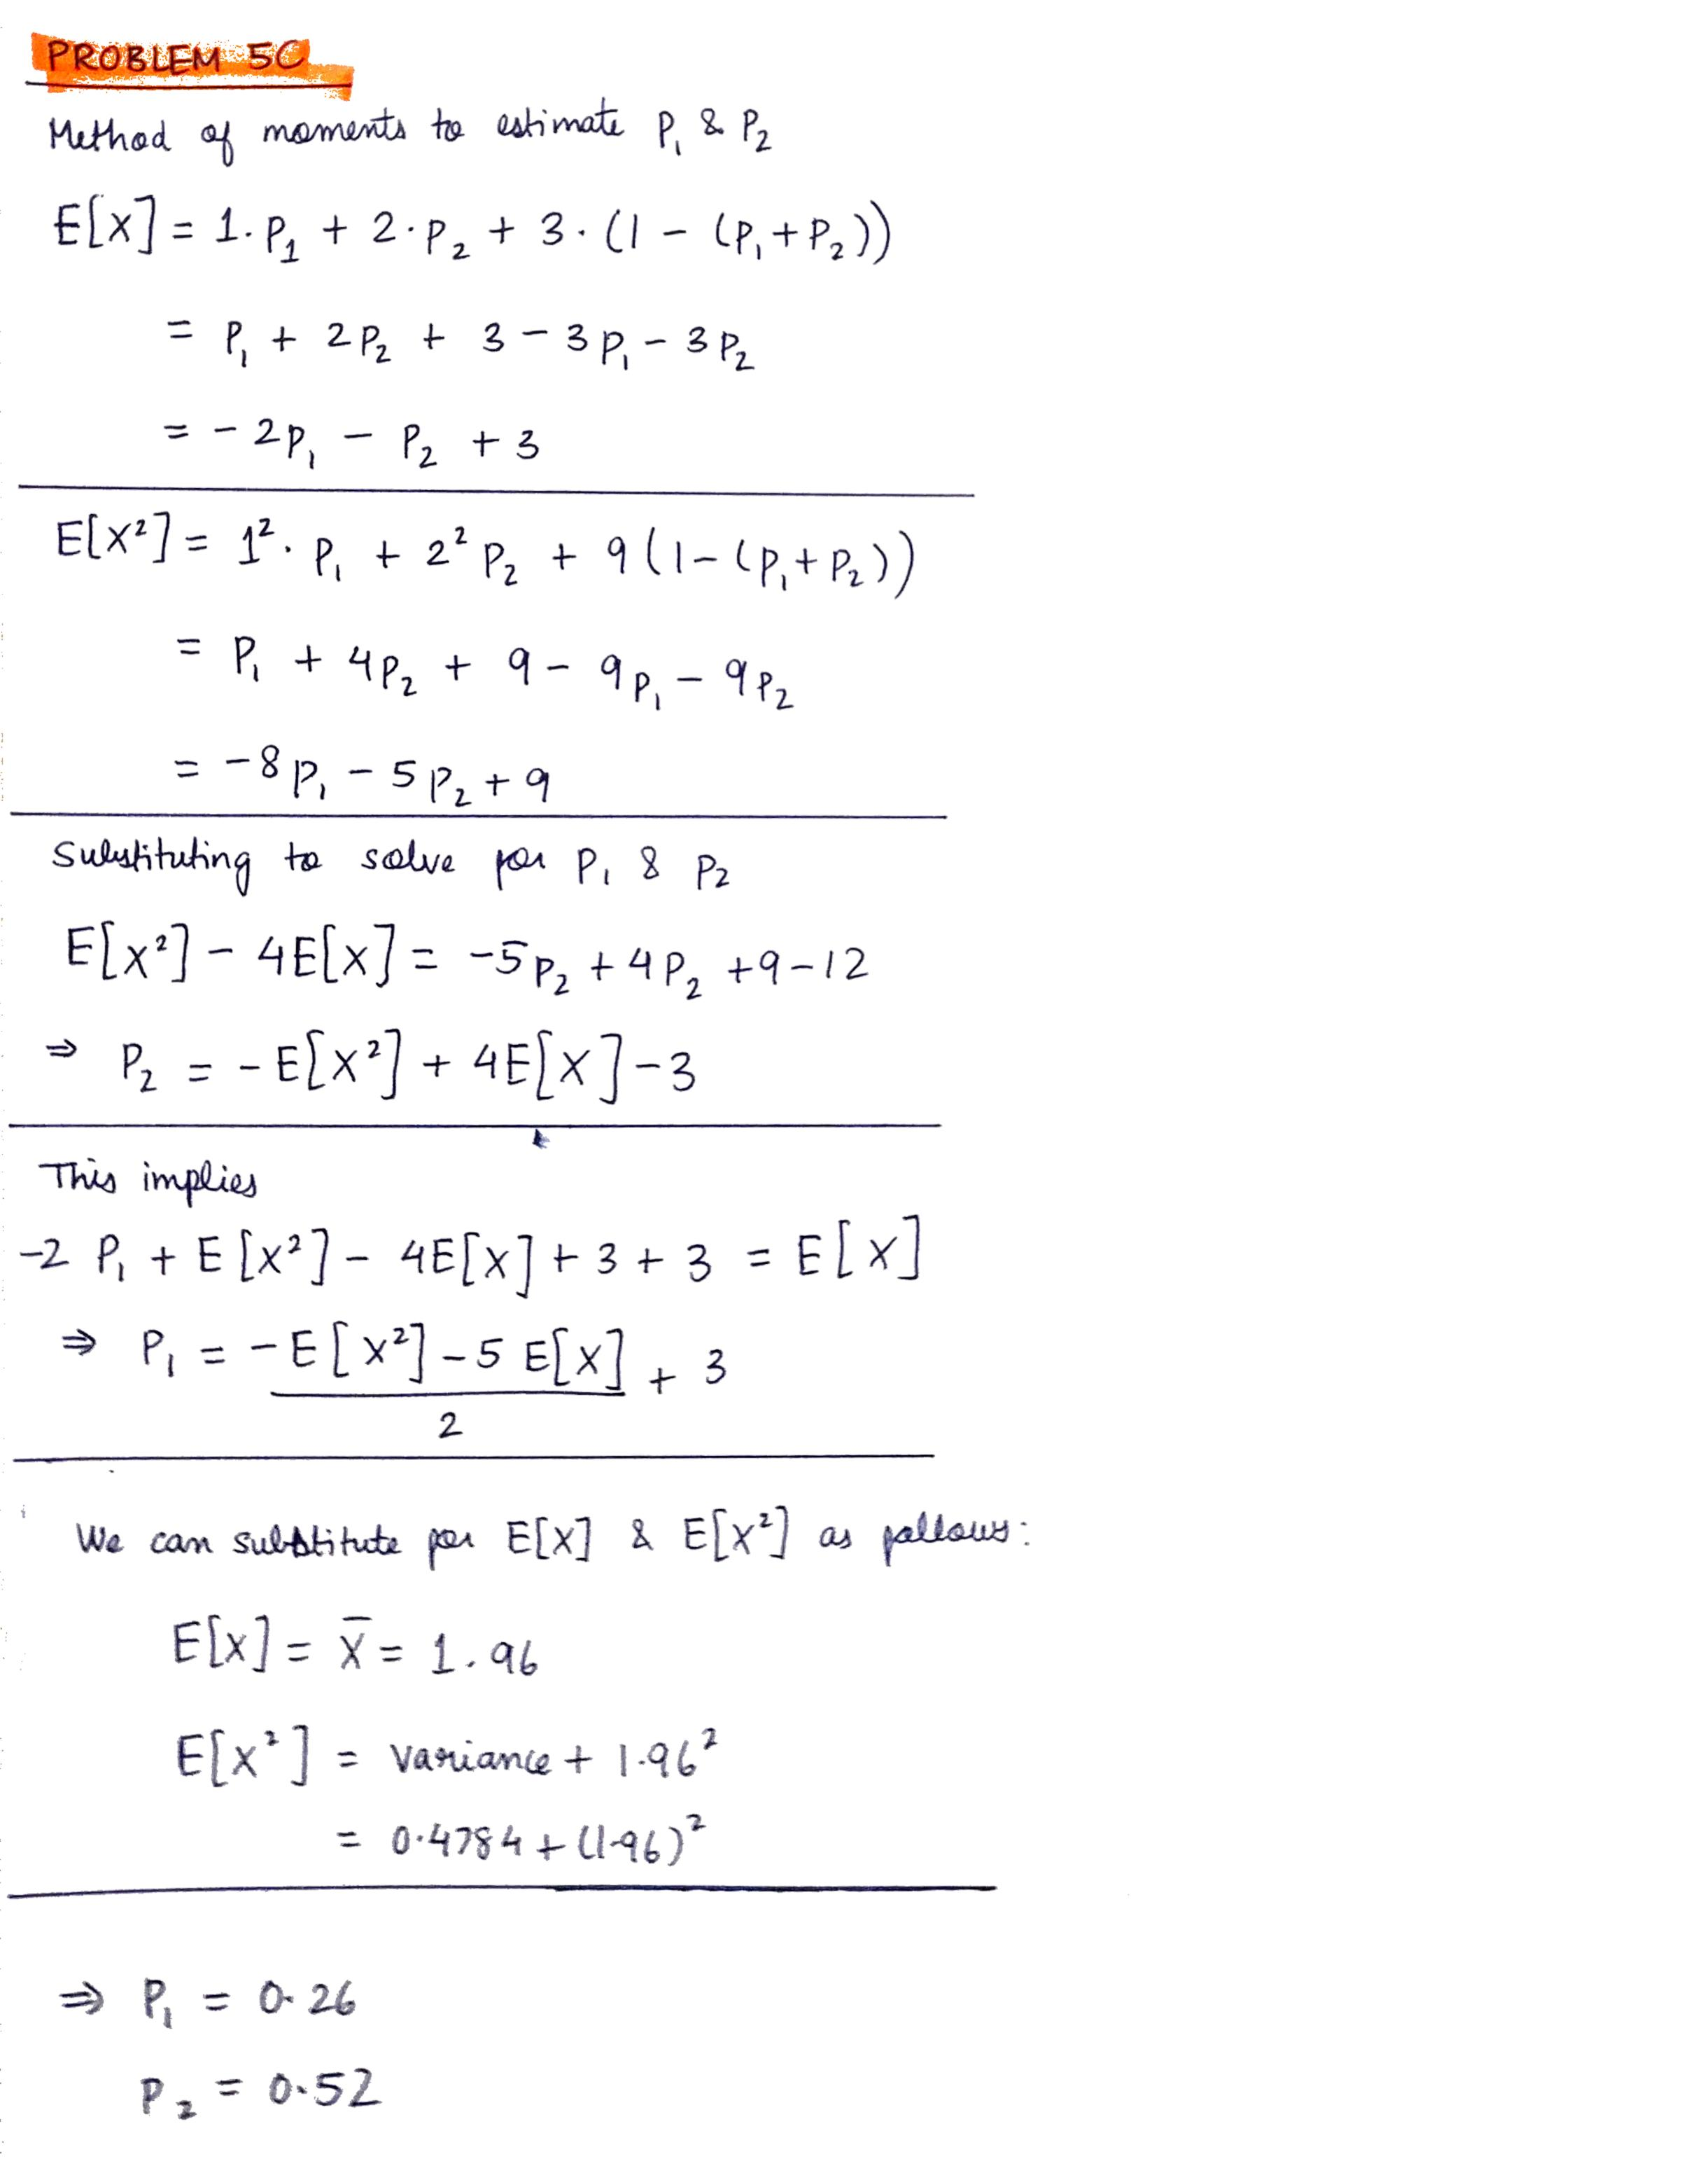

**Problem 5D**

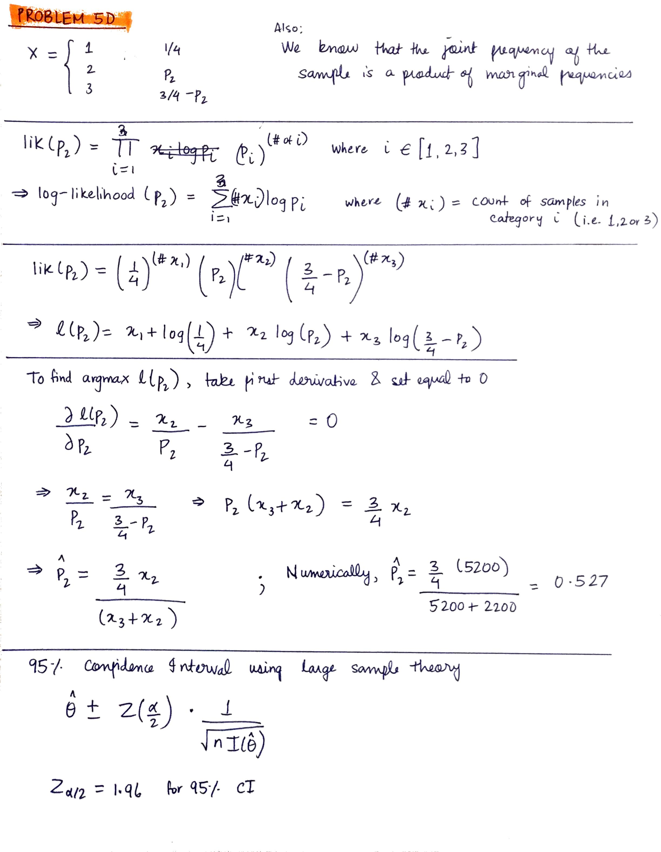

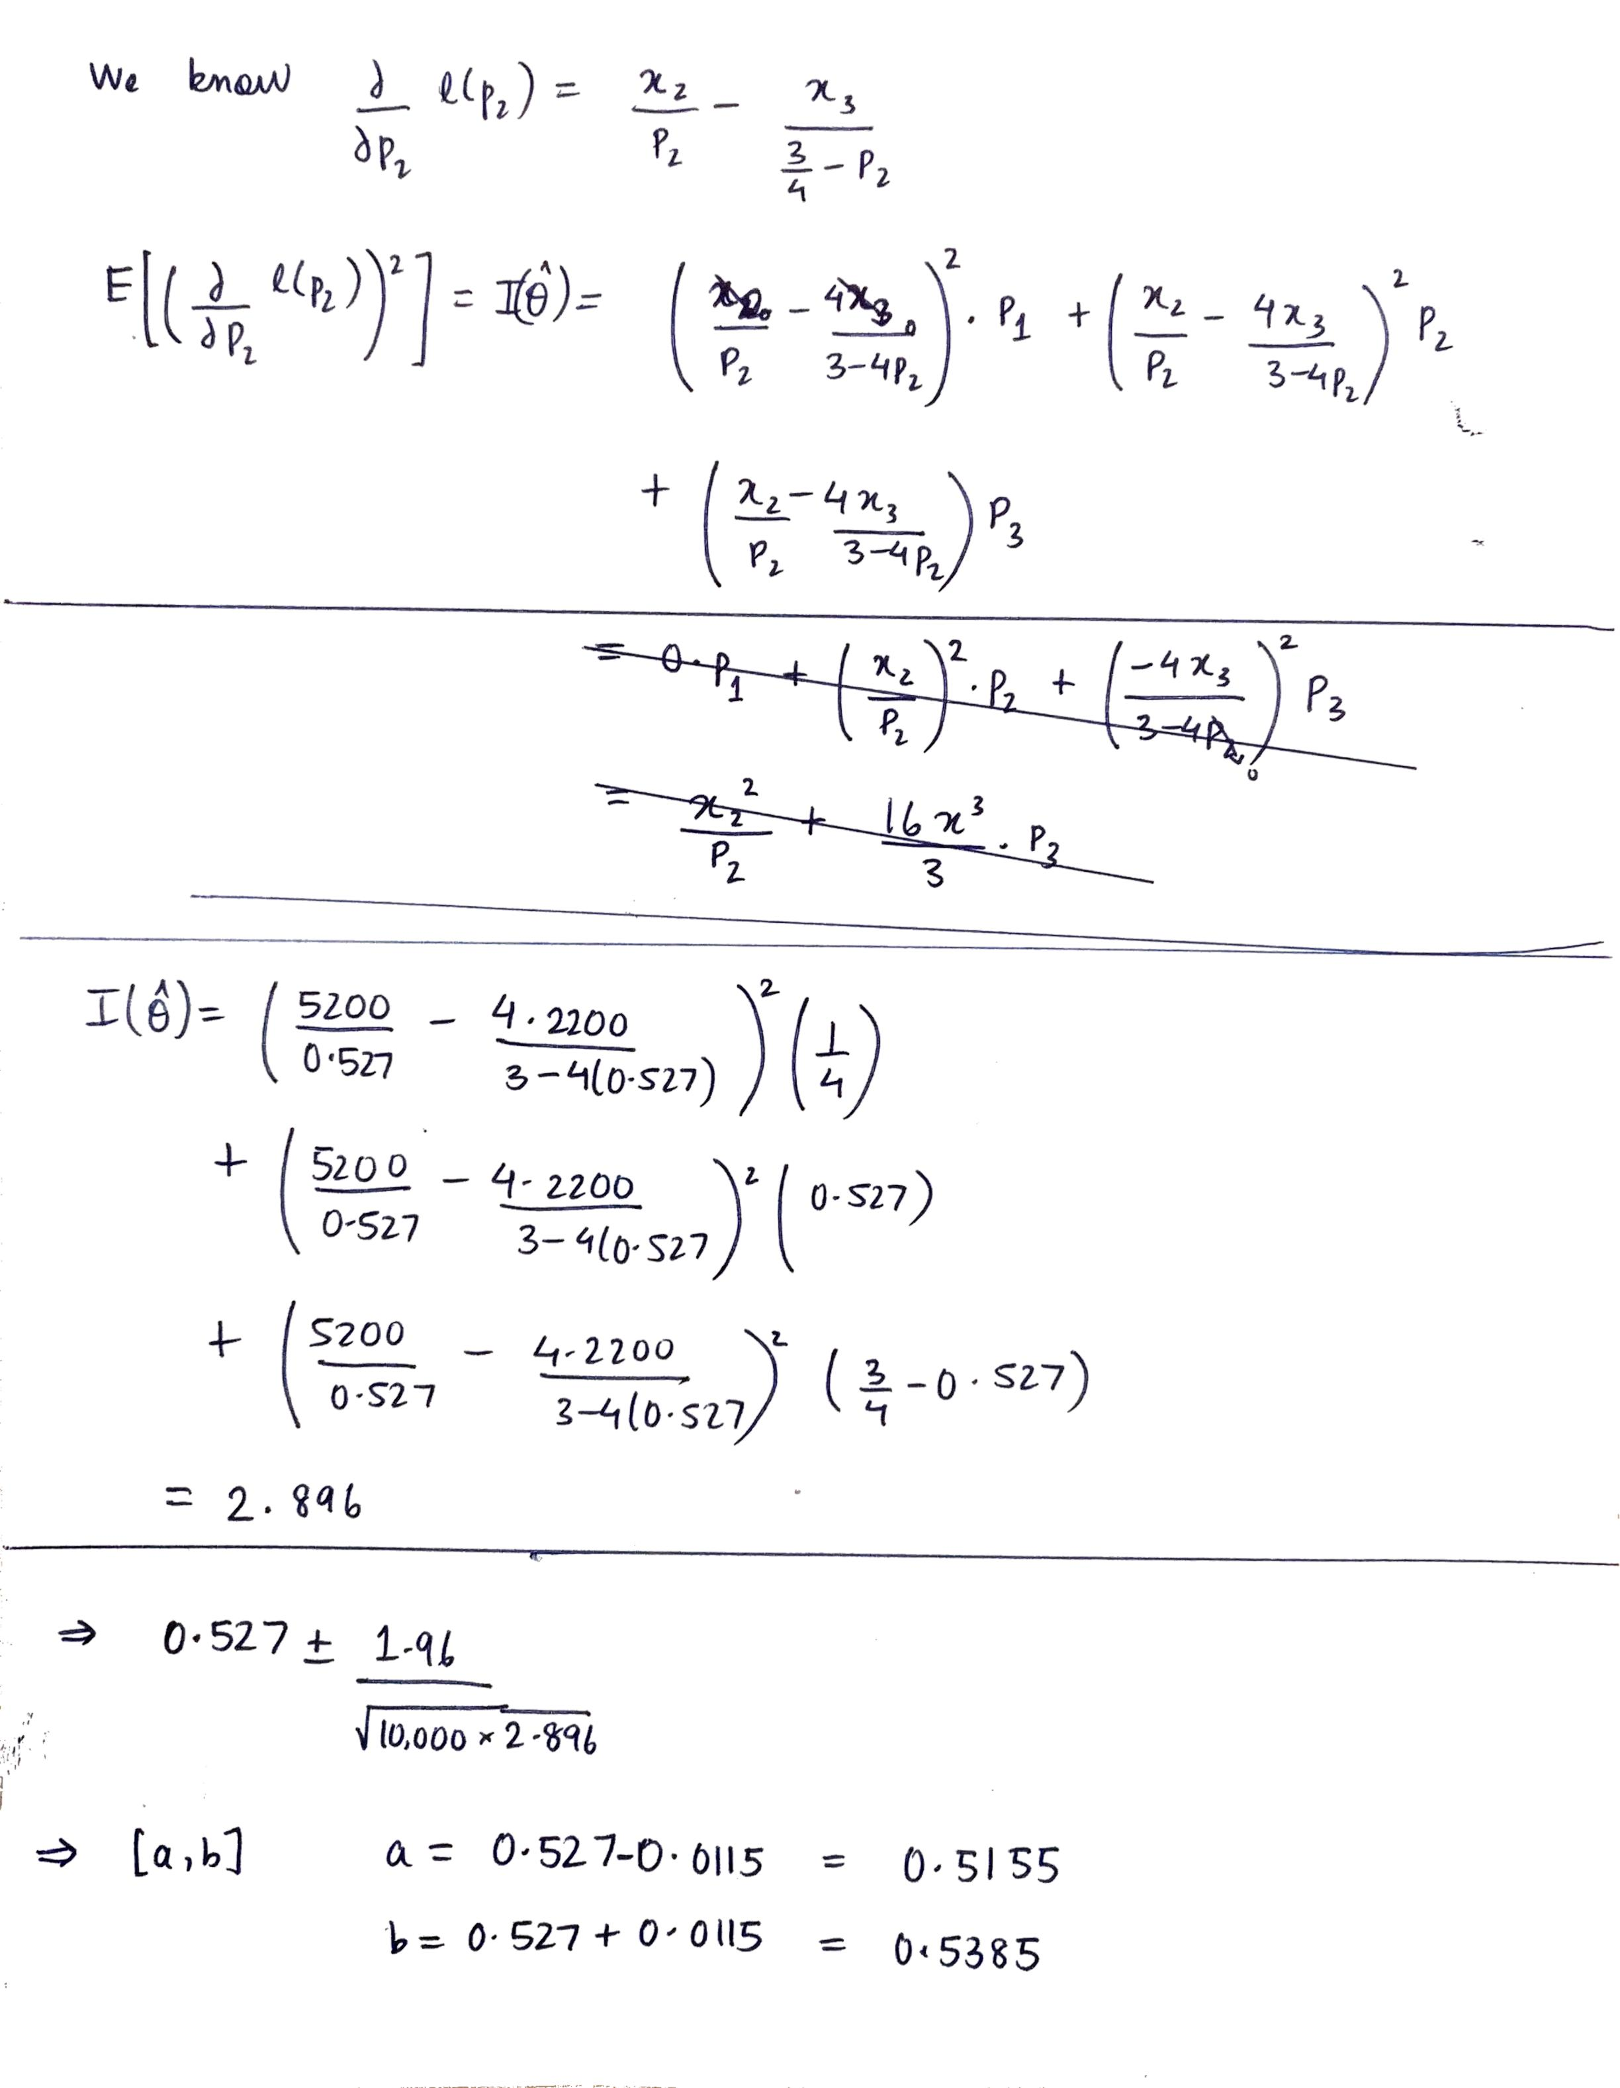

**Problem 6A & 6B**

import csv  
import numpy as np  
import scipy.stats as st  
  
fname = "data_HW2.csv"  
  
  
def computeMeanWithoutInbuilt(data_array):  
 sum = 0.0  
 for d in data_array:  
 sum += d  
 sample_mean = sum / len(data_array)  
 return sample_mean  
  
  
def computeVarianceWithoutInbuilt(data_array):  
 sample_mean = computeMeanWithoutInbuilt(data_array)  
 total_squared_deviation = 0.0  
 for d in data_array:  
 total_squared_deviation += (d - sample_mean) ** 2  
 sample_variance = total_squared_deviation / len(data_array)  
 return sample_variance  
  
  
with open(fname) as f:  
 reader = csv.reader(f)  
 next(reader) *# skip header* string_data = [r[0] for r in reader]  
 data_array = np.asarray(string_data, dtype=np.float64, order="C")  
  
 sample_mean_without_inbuilt = computeMeanWithoutInbuilt(data_array)  
 sample_mean_with_inbuilt = np.mean(data_array)  
 sample_mean_deviation = np.abs(sample_mean_without_inbuilt - sample_mean_with_inbuilt)  
  
 sample_variance_without_inbuilt = computeVarianceWithoutInbuilt(data_array)  
 sample_variance_with_inbuilt = np.nanvar(data_array)  
 sample_variance_deviation = np.abs(sample_variance_without_inbuilt - sample_variance_with_inbuilt)  
  
 ninety_percent_confidence_interval = st.t.interval(alpha=0.90, df=len(data_array) - 1, loc=np.mean(data_array),  
 scale=0.25)  
  
 print("Mean computed without inbuilt functions : " + str(sample_mean_without_inbuilt))  
 print("Mean using inbuilt numpy function : " + str(sample_mean_with_inbuilt))  
 print("Deviation between both methods : " + str(sample_mean_deviation))  
 print("==========")  
 print("Variance computed without inbuilt functions: " + str(sample_variance_without_inbuilt))  
 print("Variance using inbuilt numpy function : " + str(sample_variance_with_inbuilt))  
 print("Deviation between both methods : " + str(sample_variance_deviation))  
 print("==========")  
 print("90% Confidence Interval Bounds : " + str(ninety_percent_confidence_interval))