<https://www.mathworks.com/help/nnet/ug/long-short-term-memory-networks.html>

<https://github.com/huashiyiqike/LSTM-MATLAB>

<https://www.mathworks.com/matlabcentral/answers/83322-does-anyone-know-of-code-for-building-an-lstm-recurrent-neural-network>

<http://bigml.cs.tsinghua.edu.cn/~jun/pub/lstm-parallel.pdf>

<https://www.mathworks.com/help/nnet/examples/classify-sequence-data-using-lstm-networks.html>

<file:///C:/Users/AT121-HB/Documents/IndependentWork/OpportunityUCIDataset/doc/documentation.html>

<http://localhost:8888/notebooks/Documents/IndependentWork/Deep-Learning-for-Sensor-based-Human-Activity-Recognition-master/analyze_datasets.ipynb>

<http://localhost:8888/notebooks/Documents/IndependentWork/LSTM-Human-Activity-Recognition-master/LSTM.ipynb>

<https://becominghuman.ai/deep-learning-for-sensor-based-human-activity-recognition-970ff47c6b6b>

<https://www.ncbi.nlm.nih.gov/pmc/articles/PMC3023457/>

https://github.com/hyperopt/hyperopt

re-write the code in python 3.6

feature engineering

feature_normalize

missing value handle: % Omitting sensors (columns) which have NaN more than threshold (0.9 of total number of columns)

PCA

segment method: 50% overlap

epoch: 50 overfit, plot loss/accuracy against epoch

input_width = 23 (creates approximately 650k samples)

features/measurements = 77

2 stacked forward layers of 64 neurons each.

Add accuracy over time and plot the graph

self.n_hidden = 32 # nb of neurons inside the neural network

forget_bias=1.0

output test accuracy and loss in each training epoch

out put best accuracy

add test_losses = []

test_accuracies = []

train_losses = []

train_accuracies = [] and output in the same graph

|  |  |  |  |  |
| --- | --- | --- | --- | --- |
| segment method: | 50% | 50% | 50% | 50% |
| training epochs | 30 | 30 | 30 | 50 |
| Input_width | 23 | 15 | 10 | 23 |
| features | 77 | 77 | 77 | 77 |
| batch size | 64 | 64 | 64 | 64 |
| Learning rate | 0.001 | 0.001 | 0.001 | 0.001 |
| dropout rate | 0.5 | 0.5 | 0.5 | 0.5 |
| Optimization function | Adam Optimizer minimizing negative log likelihood | Adam Optimizer minimizing negative log likelihood | Adam Optimizer minimizing negative log likelihood | Adam Optimizer minimizing negative log likelihood |
| Training shape | ('train_x shape =', (63650, 23, 77))  ('train_y shape =', (63650,))  ('test_x shape =', (10955, 23, 77))  ('test_y shape =', (10955,)) | ('train_x shape =', (100022, 15, 77))  ('train_y shape =', (100022,))  ('test_x shape =', (17215, 15, 77))  ('test_y shape =', (17215,)) | ('train_x shape =', (140032, 10, 77))  ('train_y shape =', (140032,))  ('test_x shape =', (24102, 10, 77))  ('test_y shape =', (24102,)) | ('train_x shape =', (63650, 23, 77))  ('train_y shape =', (63650,))  ('test_x shape =', (10955, 23, 77))  ('test_y shape =', (10955,)) |
| result | Final test accuracy: 0.858877241611  Best epoch's test accuracy: 0.859881341457  ('Validation accuracy:', 0.85887724)  ('f1_score_w', '0.8562546061277474')  ('f1_score_m', '0.48095736162416686') | Final test accuracy: 0.868428707123  Best epoch's test accuracy: 0.88027882576  ('Validation accuracy:', 0.8684287)  ('f1_score_w', '0.8673383184266678')  ('f1_score_m', '0.5218344785593494') | Final test accuracy: 0.848809242249  Best epoch's test accuracy: 0.856941342354  ('Validation accuracy:', 0.84880924)  ('f1_score_w', '0.8516209672462138')  ('f1_score_m', '0.4819468873890055') | **Final test accuracy: 0.849748969078064**  **Best epoch's test accuracy: 0.8731173276901245**  **Validation accuracy: 0.84974897**  **f1_score_w 0.8563390894988817**  **f1_score_m 0.49470539789009177** |

model ensemble

self.learning_rate = 0.001  
self.lambda_loss_amount = 0.0015  
self.training_epochs = 10  
self.batch_size = 64

input_width = 23

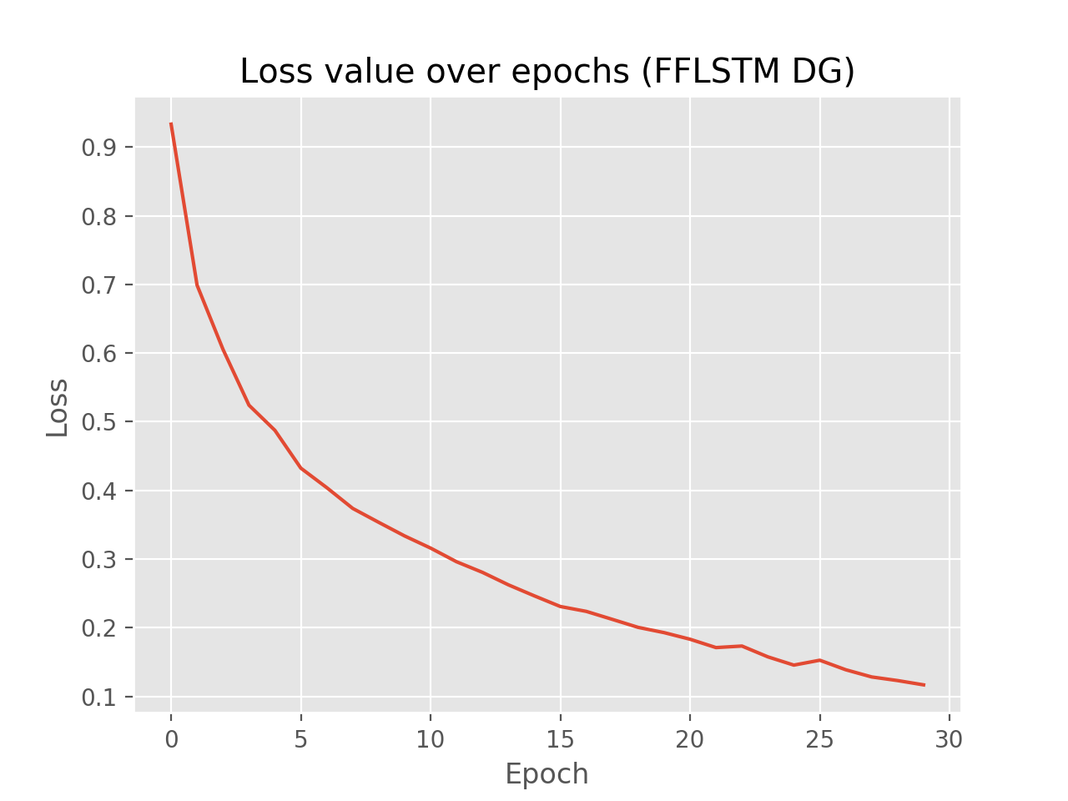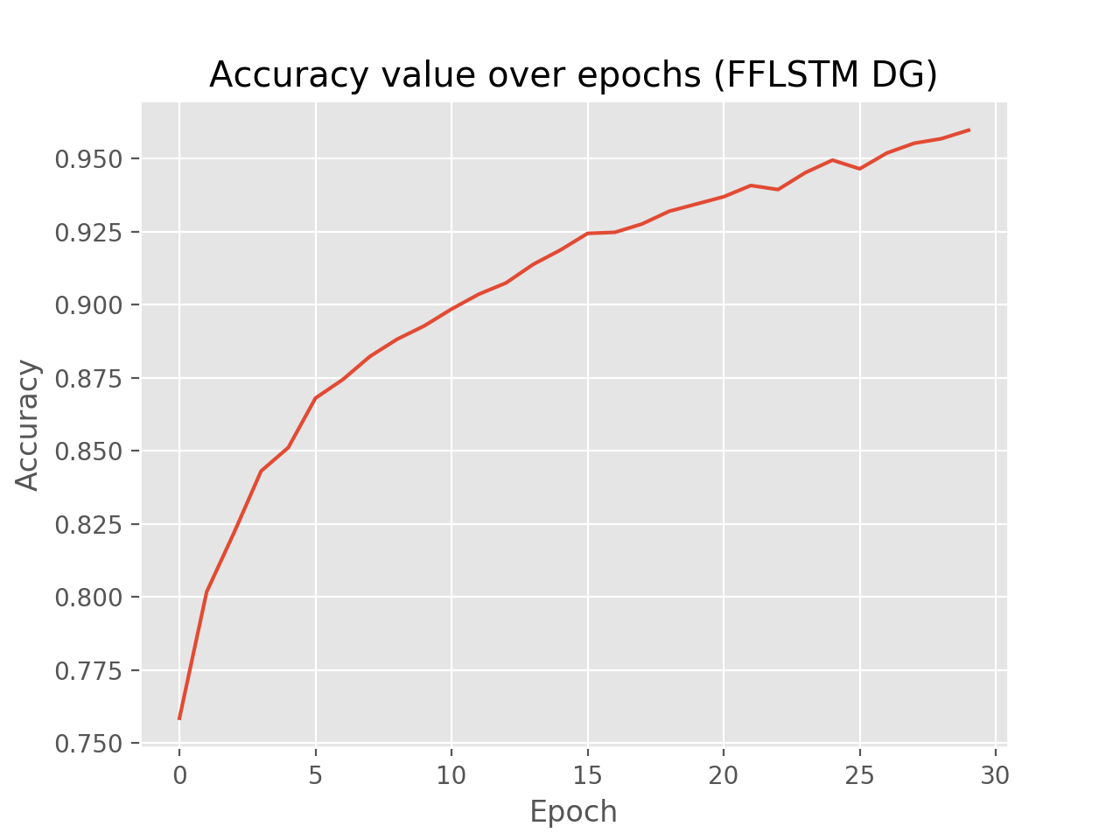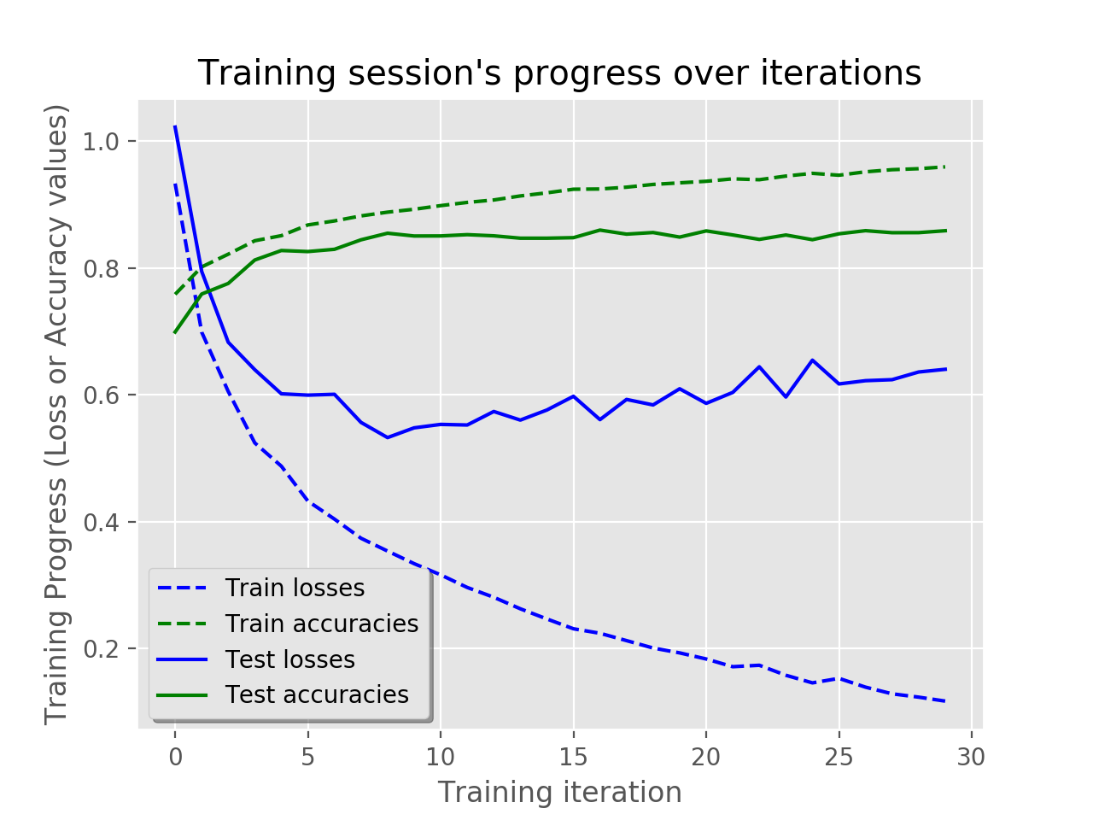

('x_train shape = ', (700165, 77))

('y_train shape =', (700165,))

Some useful info to get an insight on dataset's shape and normalisation:

features shape, labels shape, each features mean, each features standard deviation

((120516, 77), (120516,), '-0.025180602413949066', '0.6998221188698709')

('x_test shape =', (120516, 77))

('y_test shape =', (120516,))

the dataset is therefore properly normalised, as expected.

segmenting signal...

signal segmented.

('train_x shape =', (63650, 23, 77))

('train_y shape =', (63650,))

('test_x shape =', (10955, 23, 77))

('test_y shape =', (10955,))

('unique test_y', array([0, 1], dtype=uint8))

('unique train_y', array([0, 1], dtype=uint8))

('test_y[1]=', array([1, 0, 0, 0, 0, 0, 0, 0, 0, 0, 0, 0, 0, 0, 0, 0, 0, 0], dtype=uint8))

('train_y shape(1-hot) =', (63650, 18))

('test_y shape(1-hot) =', (10955, 18))

('len(x_train[0])', 23)

Final test accuracy: 0.858877241611

Best epoch's test accuracy: 0.859881341457

('Validation accuracy:', 0.85887724)

('f1_score_w', '0.8562546061277474')

('f1_score_m', '0.48095736162416686')

confusion_matrix

[[8400 38 26 23 19 49 27 5 6 3 5 3 4 20

36 3 374 10]

[ 14 57 0 14 0 0 0 0 0 0 0 0 0 0

0 0 0 0]

[ 3 1 88 0 16 0 0 0 0 0 0 0 0 0

0 0 0 0]

[ 14 14 0 37 0 0 0 0 0 0 0 0 0 0

0 0 6 0]

[ 5 0 5 1 86 0 0 0 0 0 0 0 0 0

0 0 2 0]

[ 97 0 0 0 0 126 20 1 0 0 1 0 0 0

0 0 4 0]

[ 43 0 0 0 0 10 106 0 0 0 0 0 0 0

0 0 1 9]

[ 89 0 0 0 0 6 0 10 0 1 2 0 0 6

2 0 7 1]

[ 52 0 2 0 0 3 2 3 23 2 0 0 1 0

11 1 0 4]

[ 24 0 0 0 0 0 0 0 0 8 3 2 1 0

1 0 0 6]

[ 12 0 0 0 0 1 0 0 0 0 9 0 5 0

0 0 0 4]

[ 17 0 0 0 0 0 1 0 0 3 0 7 3 9

4 0 0 0]

[ 7 0 0 0 0 0 0 0 0 0 0 0 7 2

16 0 1 5]

[ 15 0 0 0 0 0 0 0 0 1 0 0 0 34

17 0 0 0]

[ 12 0 0 0 0 0 1 0 0 0 0 0 1 13

34 0 0 0]

[ 48 1 0 3 0 0 0 0 0 0 0 0 0 0

0 38 20 0]

[ 94 2 0 0 0 0 0 0 0 0 0 0 0 0

0 0 290 0]

[ 53 0 8 1 1 0 0 0 0 0 0 0 0 0

0 0 1 49]]

Confusion matrix (normalised to % of total test data):

[[7.66773148e+01 3.46873581e-01 2.37334549e-01 2.09949791e-01

1.73436791e-01 4.47284341e-01 2.46462807e-01 4.56412584e-02

5.47695085e-02 2.73847543e-02 4.56412584e-02 2.73847543e-02

3.65130082e-02 1.82565033e-01 3.28617066e-01 2.73847543e-02

3.41396618e+00 9.12825167e-02]

[1.27795517e-01 5.20310342e-01 0.00000000e+00 1.27795517e-01

0.00000000e+00 0.00000000e+00 0.00000000e+00 0.00000000e+00

0.00000000e+00 0.00000000e+00 0.00000000e+00 0.00000000e+00

0.00000000e+00 0.00000000e+00 0.00000000e+00 0.00000000e+00

0.00000000e+00 0.00000000e+00]

[2.73847543e-02 9.12825204e-03 8.03286195e-01 0.00000000e+00

1.46052033e-01 0.00000000e+00 0.00000000e+00 0.00000000e+00

0.00000000e+00 0.00000000e+00 0.00000000e+00 0.00000000e+00

0.00000000e+00 0.00000000e+00 0.00000000e+00 0.00000000e+00

0.00000000e+00 0.00000000e+00]

[1.27795517e-01 1.27795517e-01 0.00000000e+00 3.37745309e-01

0.00000000e+00 0.00000000e+00 0.00000000e+00 0.00000000e+00

0.00000000e+00 0.00000000e+00 0.00000000e+00 0.00000000e+00

0.00000000e+00 0.00000000e+00 0.00000000e+00 0.00000000e+00

5.47695085e-02 0.00000000e+00]

[4.56412584e-02 0.00000000e+00 4.56412584e-02 9.12825204e-03

7.85029650e-01 0.00000000e+00 0.00000000e+00 0.00000000e+00

0.00000000e+00 0.00000000e+00 0.00000000e+00 0.00000000e+00

0.00000000e+00 0.00000000e+00 0.00000000e+00 0.00000000e+00

1.82565041e-02 0.00000000e+00]

[8.85440409e-01 0.00000000e+00 0.00000000e+00 0.00000000e+00

0.00000000e+00 1.15015972e+00 1.82565033e-01 9.12825204e-03

0.00000000e+00 0.00000000e+00 9.12825204e-03 0.00000000e+00

0.00000000e+00 0.00000000e+00 0.00000000e+00 0.00000000e+00

3.65130082e-02 0.00000000e+00]

[3.92514825e-01 0.00000000e+00 0.00000000e+00 0.00000000e+00

0.00000000e+00 9.12825167e-02 9.67594683e-01 0.00000000e+00

0.00000000e+00 0.00000000e+00 0.00000000e+00 0.00000000e+00

0.00000000e+00 0.00000000e+00 0.00000000e+00 0.00000000e+00

9.12825204e-03 8.21542665e-02]

[8.12414408e-01 0.00000000e+00 0.00000000e+00 0.00000000e+00

0.00000000e+00 5.47695085e-02 0.00000000e+00 9.12825167e-02

0.00000000e+00 9.12825204e-03 1.82565041e-02 0.00000000e+00

0.00000000e+00 5.47695085e-02 1.82565041e-02 0.00000000e+00

6.38977587e-02 9.12825204e-03]

[4.74669099e-01 0.00000000e+00 1.82565041e-02 0.00000000e+00

0.00000000e+00 2.73847543e-02 1.82565041e-02 2.73847543e-02

2.09949791e-01 1.82565041e-02 0.00000000e+00 0.00000000e+00

9.12825204e-03 0.00000000e+00 1.00410774e-01 9.12825204e-03

0.00000000e+00 3.65130082e-02]

[2.19078034e-01 0.00000000e+00 0.00000000e+00 0.00000000e+00

0.00000000e+00 0.00000000e+00 0.00000000e+00 0.00000000e+00

0.00000000e+00 7.30260164e-02 2.73847543e-02 1.82565041e-02

9.12825204e-03 0.00000000e+00 9.12825204e-03 0.00000000e+00

0.00000000e+00 5.47695085e-02]

[1.09539017e-01 0.00000000e+00 0.00000000e+00 0.00000000e+00

0.00000000e+00 9.12825204e-03 0.00000000e+00 0.00000000e+00

0.00000000e+00 0.00000000e+00 8.21542665e-02 0.00000000e+00

4.56412584e-02 0.00000000e+00 0.00000000e+00 0.00000000e+00

0.00000000e+00 3.65130082e-02]

[1.55180290e-01 0.00000000e+00 0.00000000e+00 0.00000000e+00

0.00000000e+00 0.00000000e+00 9.12825204e-03 0.00000000e+00

0.00000000e+00 2.73847543e-02 0.00000000e+00 6.38977587e-02

2.73847543e-02 8.21542665e-02 3.65130082e-02 0.00000000e+00

0.00000000e+00 0.00000000e+00]

[6.38977587e-02 0.00000000e+00 0.00000000e+00 0.00000000e+00

0.00000000e+00 0.00000000e+00 0.00000000e+00 0.00000000e+00

0.00000000e+00 0.00000000e+00 0.00000000e+00 0.00000000e+00

6.38977587e-02 1.82565041e-02 1.46052033e-01 0.00000000e+00

9.12825204e-03 4.56412584e-02]

[1.36923775e-01 0.00000000e+00 0.00000000e+00 0.00000000e+00

0.00000000e+00 0.00000000e+00 0.00000000e+00 0.00000000e+00

0.00000000e+00 9.12825204e-03 0.00000000e+00 0.00000000e+00

0.00000000e+00 3.10360581e-01 1.55180290e-01 0.00000000e+00

0.00000000e+00 0.00000000e+00]

[1.09539017e-01 0.00000000e+00 0.00000000e+00 0.00000000e+00

0.00000000e+00 0.00000000e+00 9.12825204e-03 0.00000000e+00

0.00000000e+00 0.00000000e+00 0.00000000e+00 0.00000000e+00

9.12825204e-03 1.18667275e-01 3.10360581e-01 0.00000000e+00

0.00000000e+00 0.00000000e+00]

[4.38156068e-01 9.12825204e-03 0.00000000e+00 2.73847543e-02

0.00000000e+00 0.00000000e+00 0.00000000e+00 0.00000000e+00

0.00000000e+00 0.00000000e+00 0.00000000e+00 0.00000000e+00

0.00000000e+00 0.00000000e+00 0.00000000e+00 3.46873581e-01

1.82565033e-01 0.00000000e+00]

[8.58055711e-01 1.82565041e-02 0.00000000e+00 0.00000000e+00

0.00000000e+00 0.00000000e+00 0.00000000e+00 0.00000000e+00

0.00000000e+00 0.00000000e+00 0.00000000e+00 0.00000000e+00

0.00000000e+00 0.00000000e+00 0.00000000e+00 0.00000000e+00

2.64719319e+00 0.00000000e+00]

[4.83797342e-01 0.00000000e+00 7.30260164e-02 9.12825204e-03

9.12825204e-03 0.00000000e+00 0.00000000e+00 0.00000000e+00

0.00000000e+00 0.00000000e+00 0.00000000e+00 0.00000000e+00

0.00000000e+00 0.00000000e+00 0.00000000e+00 0.00000000e+00

9.12825204e-03 4.47284341e-01]]

Confusion matrix for test run 2

[[13262 63 32 77 36 168 59 24 36 6 29 2

1 26 40 8 333 15]

[ 28 83 1 18 0 2 0 0 0 0 0 0

0 0 0 0 1 0]

[ 17 0 102 0 52 0 0 0 0 0 0 0

0 0 0 0 0 0]

[ 20 17 4 69 1 0 0 0 0 0 0 0

0 0 0 0 1 0]

[ 14 0 4 1 137 0 0 0 0 0 0 0

0 0 0 0 0 0]

[ 79 0 1 0 1 269 28 8 1 0 0 0

0 0 0 0 2 1]

[ 64 0 2 0 0 18 173 2 0 1 1 0

0 0 0 0 0 5]

[ 90 0 0 0 2 15 2 56 6 6 0 0

0 6 1 0 8 5]

[ 71 0 0 0 0 2 2 10 50 5 2 0

3 2 7 0 0 7]

[ 30 0 1 0 0 0 0 1 0 25 6 2

0 0 0 0 0 8]

[ 21 0 0 0 0 0 0 0 0 1 20 1

0 1 0 0 0 5]

[ 25 0 0 0 0 0 0 2 3 5 1 25

1 10 0 0 0 0]

[ 15 0 0 0 0 1 1 0 4 5 5 2

10 3 13 0 0 0]

[ 22 0 0 0 0 0 0 2 0 1 0 6

0 61 11 1 0 0]

[ 17 0 0 0 0 0 0 0 0 0 0 0

0 27 53 0 0 0]

[ 96 2 0 4 0 0 0 0 0 0 0 0

0 0 0 57 13 0]

[ 177 12 0 1 0 0 0 0 1 0 0 0

0 1 0 0 418 0]

[ 90 0 4 0 2 0 0 0 0 0 0 0

0 0 0 0 0 80]]

Confusion matrix (normalised to % of total test data):

[[7.7037468e+01 3.6595991e-01 1.8588440e-01 4.4728434e-01 2.0911996e-01

9.7589314e-01 3.4272438e-01 1.3941330e-01 2.0911996e-01 3.4853324e-02

1.6845775e-01 1.1617775e-02 5.8088875e-03 1.5103108e-01 2.3235551e-01

4.6471100e-02 1.9343596e+00 8.7133311e-02]

[1.6264886e-01 4.8213768e-01 5.8088875e-03 1.0455998e-01 0.0000000e+00

1.1617775e-02 0.0000000e+00 0.0000000e+00 0.0000000e+00 0.0000000e+00

0.0000000e+00 0.0000000e+00 0.0000000e+00 0.0000000e+00 0.0000000e+00

0.0000000e+00 5.8088875e-03 0.0000000e+00]

[9.8751090e-02 0.0000000e+00 5.9250653e-01 0.0000000e+00 3.0206215e-01

0.0000000e+00 0.0000000e+00 0.0000000e+00 0.0000000e+00 0.0000000e+00

0.0000000e+00 0.0000000e+00 0.0000000e+00 0.0000000e+00 0.0000000e+00

0.0000000e+00 0.0000000e+00 0.0000000e+00]

[1.1617775e-01 9.8751090e-02 2.3235550e-02 4.0081325e-01 5.8088875e-03

0.0000000e+00 0.0000000e+00 0.0000000e+00 0.0000000e+00 0.0000000e+00

0.0000000e+00 0.0000000e+00 0.0000000e+00 0.0000000e+00 0.0000000e+00

0.0000000e+00 5.8088875e-03 0.0000000e+00]

[8.1324428e-02 0.0000000e+00 2.3235550e-02 5.8088875e-03 7.9581755e-01

0.0000000e+00 0.0000000e+00 0.0000000e+00 0.0000000e+00 0.0000000e+00

0.0000000e+00 0.0000000e+00 0.0000000e+00 0.0000000e+00 0.0000000e+00

0.0000000e+00 0.0000000e+00 0.0000000e+00]

[4.5890212e-01 0.0000000e+00 5.8088875e-03 0.0000000e+00 5.8088875e-03

1.5625907e+00 1.6264886e-01 4.6471100e-02 5.8088875e-03 0.0000000e+00

0.0000000e+00 0.0000000e+00 0.0000000e+00 0.0000000e+00 0.0000000e+00

0.0000000e+00 1.1617775e-02 5.8088875e-03]

[3.7176880e-01 0.0000000e+00 1.1617775e-02 0.0000000e+00 0.0000000e+00

1.0455998e-01 1.0049375e+00 1.1617775e-02 0.0000000e+00 5.8088875e-03

5.8088875e-03 0.0000000e+00 0.0000000e+00 0.0000000e+00 0.0000000e+00

0.0000000e+00 0.0000000e+00 2.9044438e-02]

[5.2279991e-01 0.0000000e+00 0.0000000e+00 0.0000000e+00 1.1617775e-02

8.7133311e-02 1.1617775e-02 3.2529771e-01 3.4853324e-02 3.4853324e-02

0.0000000e+00 0.0000000e+00 0.0000000e+00 3.4853324e-02 5.8088875e-03

0.0000000e+00 4.6471100e-02 2.9044438e-02]

[4.1243103e-01 0.0000000e+00 0.0000000e+00 0.0000000e+00 0.0000000e+00

1.1617775e-02 1.1617775e-02 5.8088876e-02 2.9044437e-01 2.9044438e-02

1.1617775e-02 0.0000000e+00 1.7426662e-02 1.1617775e-02 4.0662214e-02

0.0000000e+00 0.0000000e+00 4.0662214e-02]

[1.7426662e-01 0.0000000e+00 5.8088875e-03 0.0000000e+00 0.0000000e+00

0.0000000e+00 0.0000000e+00 5.8088875e-03 0.0000000e+00 1.4522219e-01

3.4853324e-02 1.1617775e-02 0.0000000e+00 0.0000000e+00 0.0000000e+00

0.0000000e+00 0.0000000e+00 4.6471100e-02]

[1.2198664e-01 0.0000000e+00 0.0000000e+00 0.0000000e+00 0.0000000e+00

0.0000000e+00 0.0000000e+00 0.0000000e+00 0.0000000e+00 5.8088875e-03

1.1617775e-01 5.8088875e-03 0.0000000e+00 5.8088875e-03 0.0000000e+00

0.0000000e+00 0.0000000e+00 2.9044438e-02]

[1.4522219e-01 0.0000000e+00 0.0000000e+00 0.0000000e+00 0.0000000e+00

0.0000000e+00 0.0000000e+00 1.1617775e-02 1.7426662e-02 2.9044438e-02

5.8088875e-03 1.4522219e-01 5.8088875e-03 5.8088876e-02 0.0000000e+00

0.0000000e+00 0.0000000e+00 0.0000000e+00]

[8.7133311e-02 0.0000000e+00 0.0000000e+00 0.0000000e+00 0.0000000e+00

5.8088875e-03 5.8088875e-03 0.0000000e+00 2.3235550e-02 2.9044438e-02

2.9044438e-02 1.1617775e-02 5.8088876e-02 1.7426662e-02 7.5515538e-02

0.0000000e+00 0.0000000e+00 0.0000000e+00]

[1.2779552e-01 0.0000000e+00 0.0000000e+00 0.0000000e+00 0.0000000e+00

0.0000000e+00 0.0000000e+00 1.1617775e-02 0.0000000e+00 5.8088875e-03

0.0000000e+00 3.4853324e-02 0.0000000e+00 3.5434213e-01 6.3897759e-02

5.8088875e-03 0.0000000e+00 0.0000000e+00]

[9.8751090e-02 0.0000000e+00 0.0000000e+00 0.0000000e+00 0.0000000e+00

0.0000000e+00 0.0000000e+00 0.0000000e+00 0.0000000e+00 0.0000000e+00

0.0000000e+00 0.0000000e+00 0.0000000e+00 1.5683997e-01 3.0787104e-01

0.0000000e+00 0.0000000e+00 0.0000000e+00]

[5.5765319e-01 1.1617775e-02 0.0000000e+00 2.3235550e-02 0.0000000e+00

0.0000000e+00 0.0000000e+00 0.0000000e+00 0.0000000e+00 0.0000000e+00

0.0000000e+00 0.0000000e+00 0.0000000e+00 0.0000000e+00 0.0000000e+00

3.3110660e-01 7.5515538e-02 0.0000000e+00]

[1.0281731e+00 6.9706649e-02 0.0000000e+00 5.8088875e-03 0.0000000e+00

0.0000000e+00 0.0000000e+00 0.0000000e+00 5.8088875e-03 0.0000000e+00

0.0000000e+00 0.0000000e+00 0.0000000e+00 5.8088875e-03 0.0000000e+00

0.0000000e+00 2.4281149e+00 0.0000000e+00]

[5.2279991e-01 0.0000000e+00 2.3235550e-02 0.0000000e+00 1.1617775e-02

0.0000000e+00 0.0000000e+00 0.0000000e+00 0.0000000e+00 0.0000000e+00

0.0000000e+00 0.0000000e+00 0.0000000e+00 0.0000000e+00 0.0000000e+00

0.0000000e+00 0.0000000e+00 4.6471101e-01]]