**Prep Blog Post:**

Who is your site [for](https://muchmoreafake.com/VIDEO/Prep-Blog-Post-Video.mp4)?

Most of the time I enjoy boredom like this color.

My personal homepage is named muchmoreafake.com

I don’t feel obligated to update my personal homepage much.

Because I will be putting more time towards my self-interested pursuits.

My self-interested pursuits require periods of solitude. Which feel like this.

Friends might think the art I make during the periods of solitude is boring.

But, that is okay.

If they are bored of the art, friends might be motivated to do something else around town.

Going to a park instead, Asking themselves important questions instead, Going to visit their sisters instead.

I will be trying to stay warm during the periods of solitudes. Since, I am so bored, I can decide to take of photo of me trying to stay warm. I believe that’s what’s cool.

Thank you for listening to my presentation. I hope to be muchmoreafake.

Inspirations

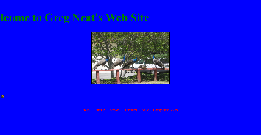<https://drneato.com/>

Classification(s): Surf Blog, Class Website, Family Photo Album.

I like this site because Dr.Neato is a kind person. He always wears a USB drive around his neck, eats Peanut Butter Jelly Sandwiches, and told me to hike in the mountains nearby.

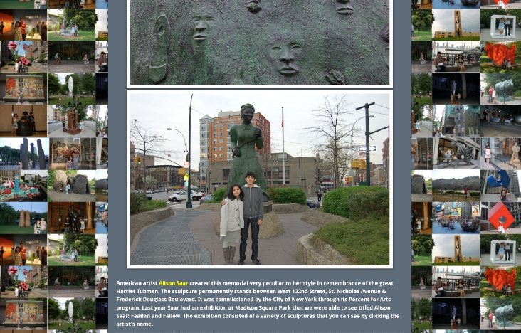<https://sculptureadventures.blogspot.com/>

Classification(s): Familial Bonding, Sculpture Archive.

I like this site because Gino & Leslie: Sculpture Obsessed Siblings are curious people. Gino and Leslie have lots of patience to visit many sculptures and write about many sculptures.

Learning and Challenge

Translating my headspace into a genuine website will be a challenge.

When I say ‘genuine website’, I mean a website that is attempting to express my personality.

I hope to not become a worse person; Making a website is difficult with my personality.

-

Michael

**Blog Post 1:**

I like flat internet things. Not pancake flat, not waffle flat, neither a cracker flat. Perhaps just into flat internet things such as what paper looks like on screens. A non-food to be exact. Paper is a non-food.

‘what paper’ looks like on screens isn’t just a photo taken of a piece of paper one can buy from an office store,

It can be a white rectangle such as the one I am typing into now. An Ultra precise (could be a lotion name) white rectangle.

Talking about what I dislike about the internet is far high in a BMI. I do not want to calculate or evaluate all the bad, cause frankly I rather be sat in a corner of a room with artificial turf and eat salmon for a minute. Then, only after having eaten I can create an airline to fly to Yugoslavia called Albatross Airlines, and the spirit animal of Albatross Airlines is the Albatross’ uncle. The uncle looks familiar to the humans, think industry film person with grey hair tied back into ponytail, plaid, jeans, ppp.

As for learning about the internet, hopefully more than a flat internet things one. Maybe eating online -a not flat internet things- will be possible instead of sat in the corner of a room with fake grass. Off to catch the flight. Will update you all after having brunch with the albatross’ uncle in NewYorkBerlin.

-

Michael

**Blog Post 2:**

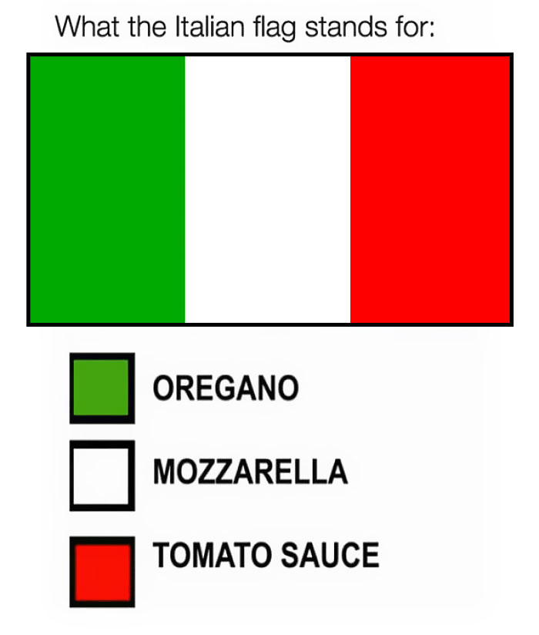I enjoy the simplicity of a flag meme.

This flag meme (e.g. ITALIAN FLAG) creates an association between a thing (TOMATO SAUCE) I might be familiar with and a colour (RED) from the Italian flag.

The association between a thing and a colour is completed, until all the colours of a(n) [insert name of a nation] flag are used.

I will ask friends if they think a flag meme helps educate themselves about a nation’s culture.

If you have opinions about a flag meme, feel free to send me an electronic mail: michael [at] muchmoreafake [dot] com. If not, talk to you next weekend.

Peace, love, and smiles.

-

Michael