  
 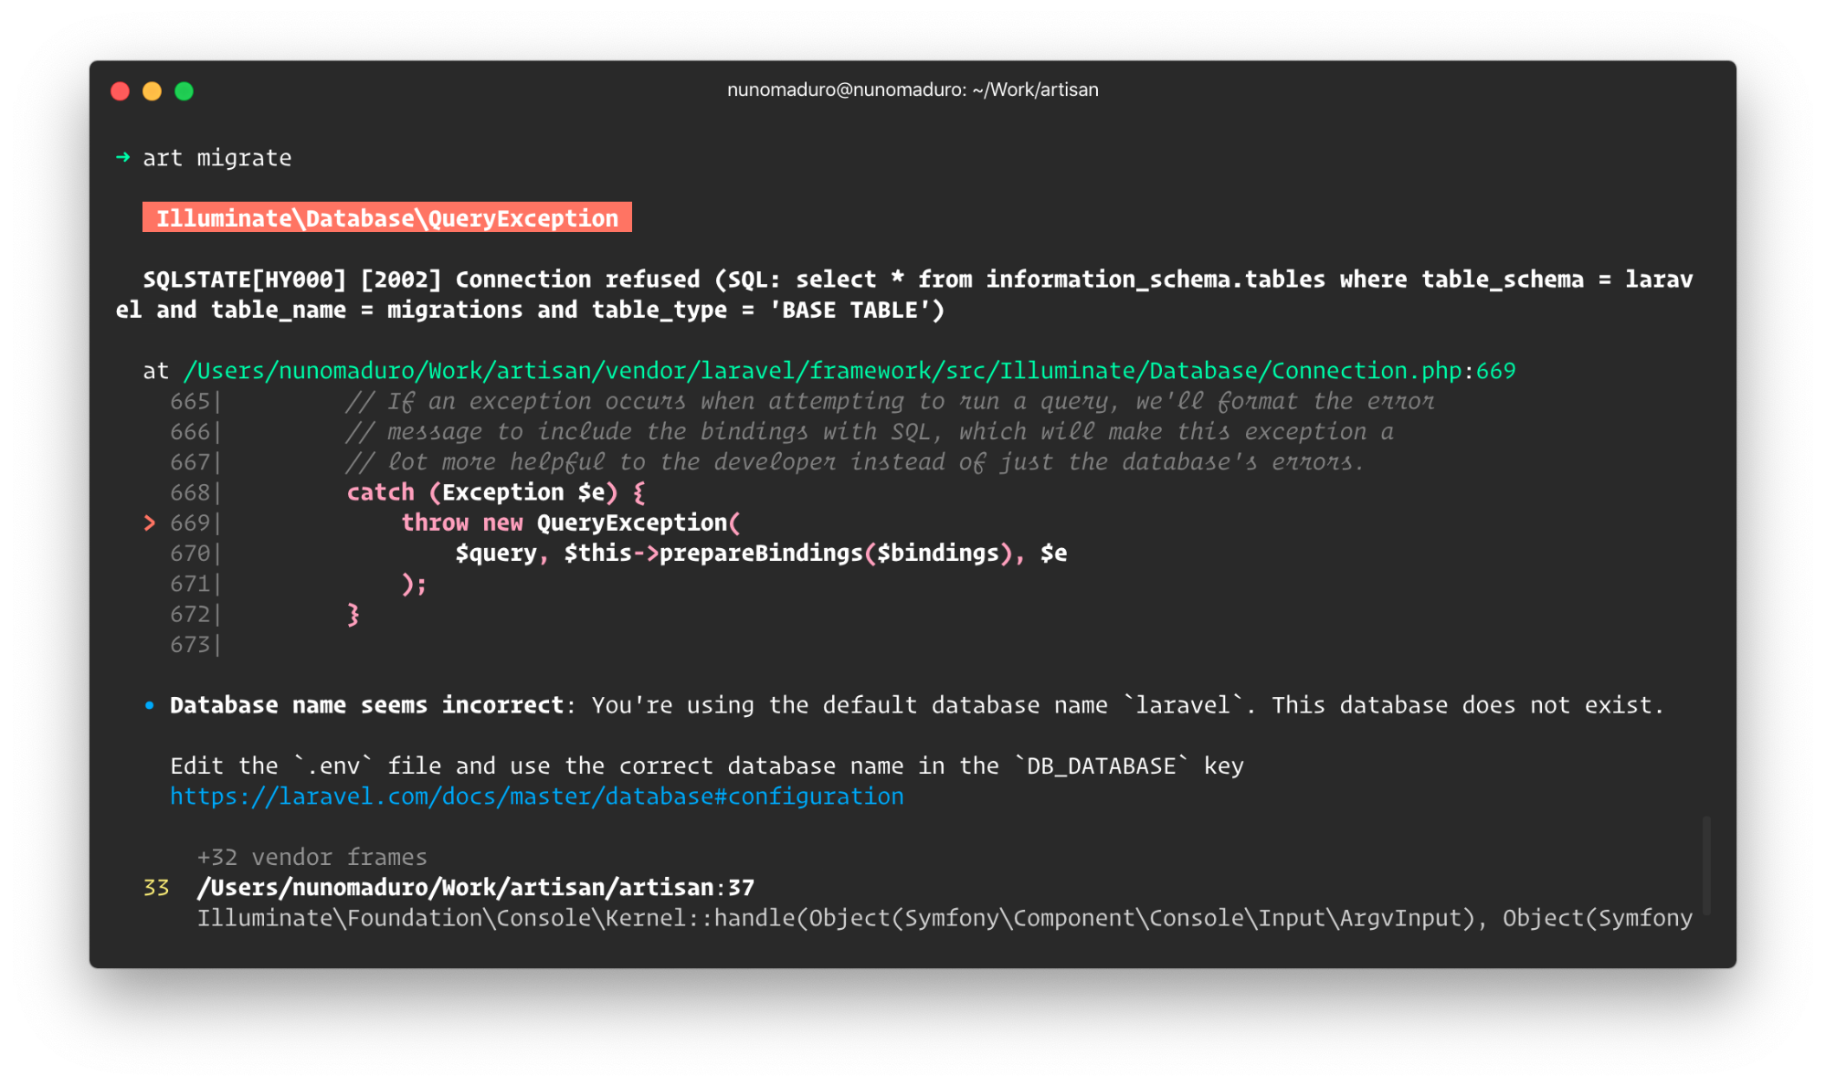

Build Status [Quality Score](https://scrutinizer-ci.com/g/nunomaduro/collision) [Total Downloads License](https://packagist.org/packages/nunomaduro/collision)

Collision was created by, and is maintained by [**Nuno Maduro**](https://github.com/nunomaduro), and is a package designed to give you beautiful error reporting when interacting with your app through the command line.

* It's included on [**Laravel**](https://laravel.com), the most popular free, open-source PHP framework in the world.
* Built on top of the [**Whoops**](https://github.com/filp/whoops) error handler.
* Supports [Laravel](https://github.com/laravel/laravel), [Symfony](https://symfony.com), [PHPUnit](https://github.com/sebastianbergmann/phpunit), and many other frameworks.

## Installation & Usage

**Requires** [**PHP 8.2+**](https://php.net/releases/)

Require Collision using [Composer](https://getcomposer.org):

composer require nunomaduro/collision --dev

## Version Compatibility

| **Laravel** | **Collision** | **PHPUnit** | **Pest** |
| --- | --- | --- | --- |
| 6.x | 3.x |  |  |
| 7.x | 4.x |  |  |
| 8.x | 5.x |  |  |
| 9.x | 6.x |  |  |
| 10.x | 6.x | 9.x | 1.x |
| 10.x | 7.x | 10.x | 2.x |
| 11.x | 8.x | 10.x | 2.x |
| 11.x | 8.x | 11.x | 3.x |

As an example, here is how to require Collision on Laravel 8.x:

composer require nunomaduro/collision:^5.0 --dev

## No adapter

You need to register the handler in your code:

(new \NunoMaduro\Collision\Provider)->register();

## Contributing

Thank you for considering to contribute to Collision. All the contribution guidelines are mentioned [here](http://contributing.md).

You can have a look at the [CHANGELOG](http://changelog.md) for constant updates & detailed information about the changes. You can also follow the twitter account for latest announcements or just come say hi!: [@enunomaduro](https://twitter.com/enunomaduro)

## License

Collision is an open-sourced software licensed under the [MIT license](http://license.md).

Logo by [Caneco](https://twitter.com/caneco).