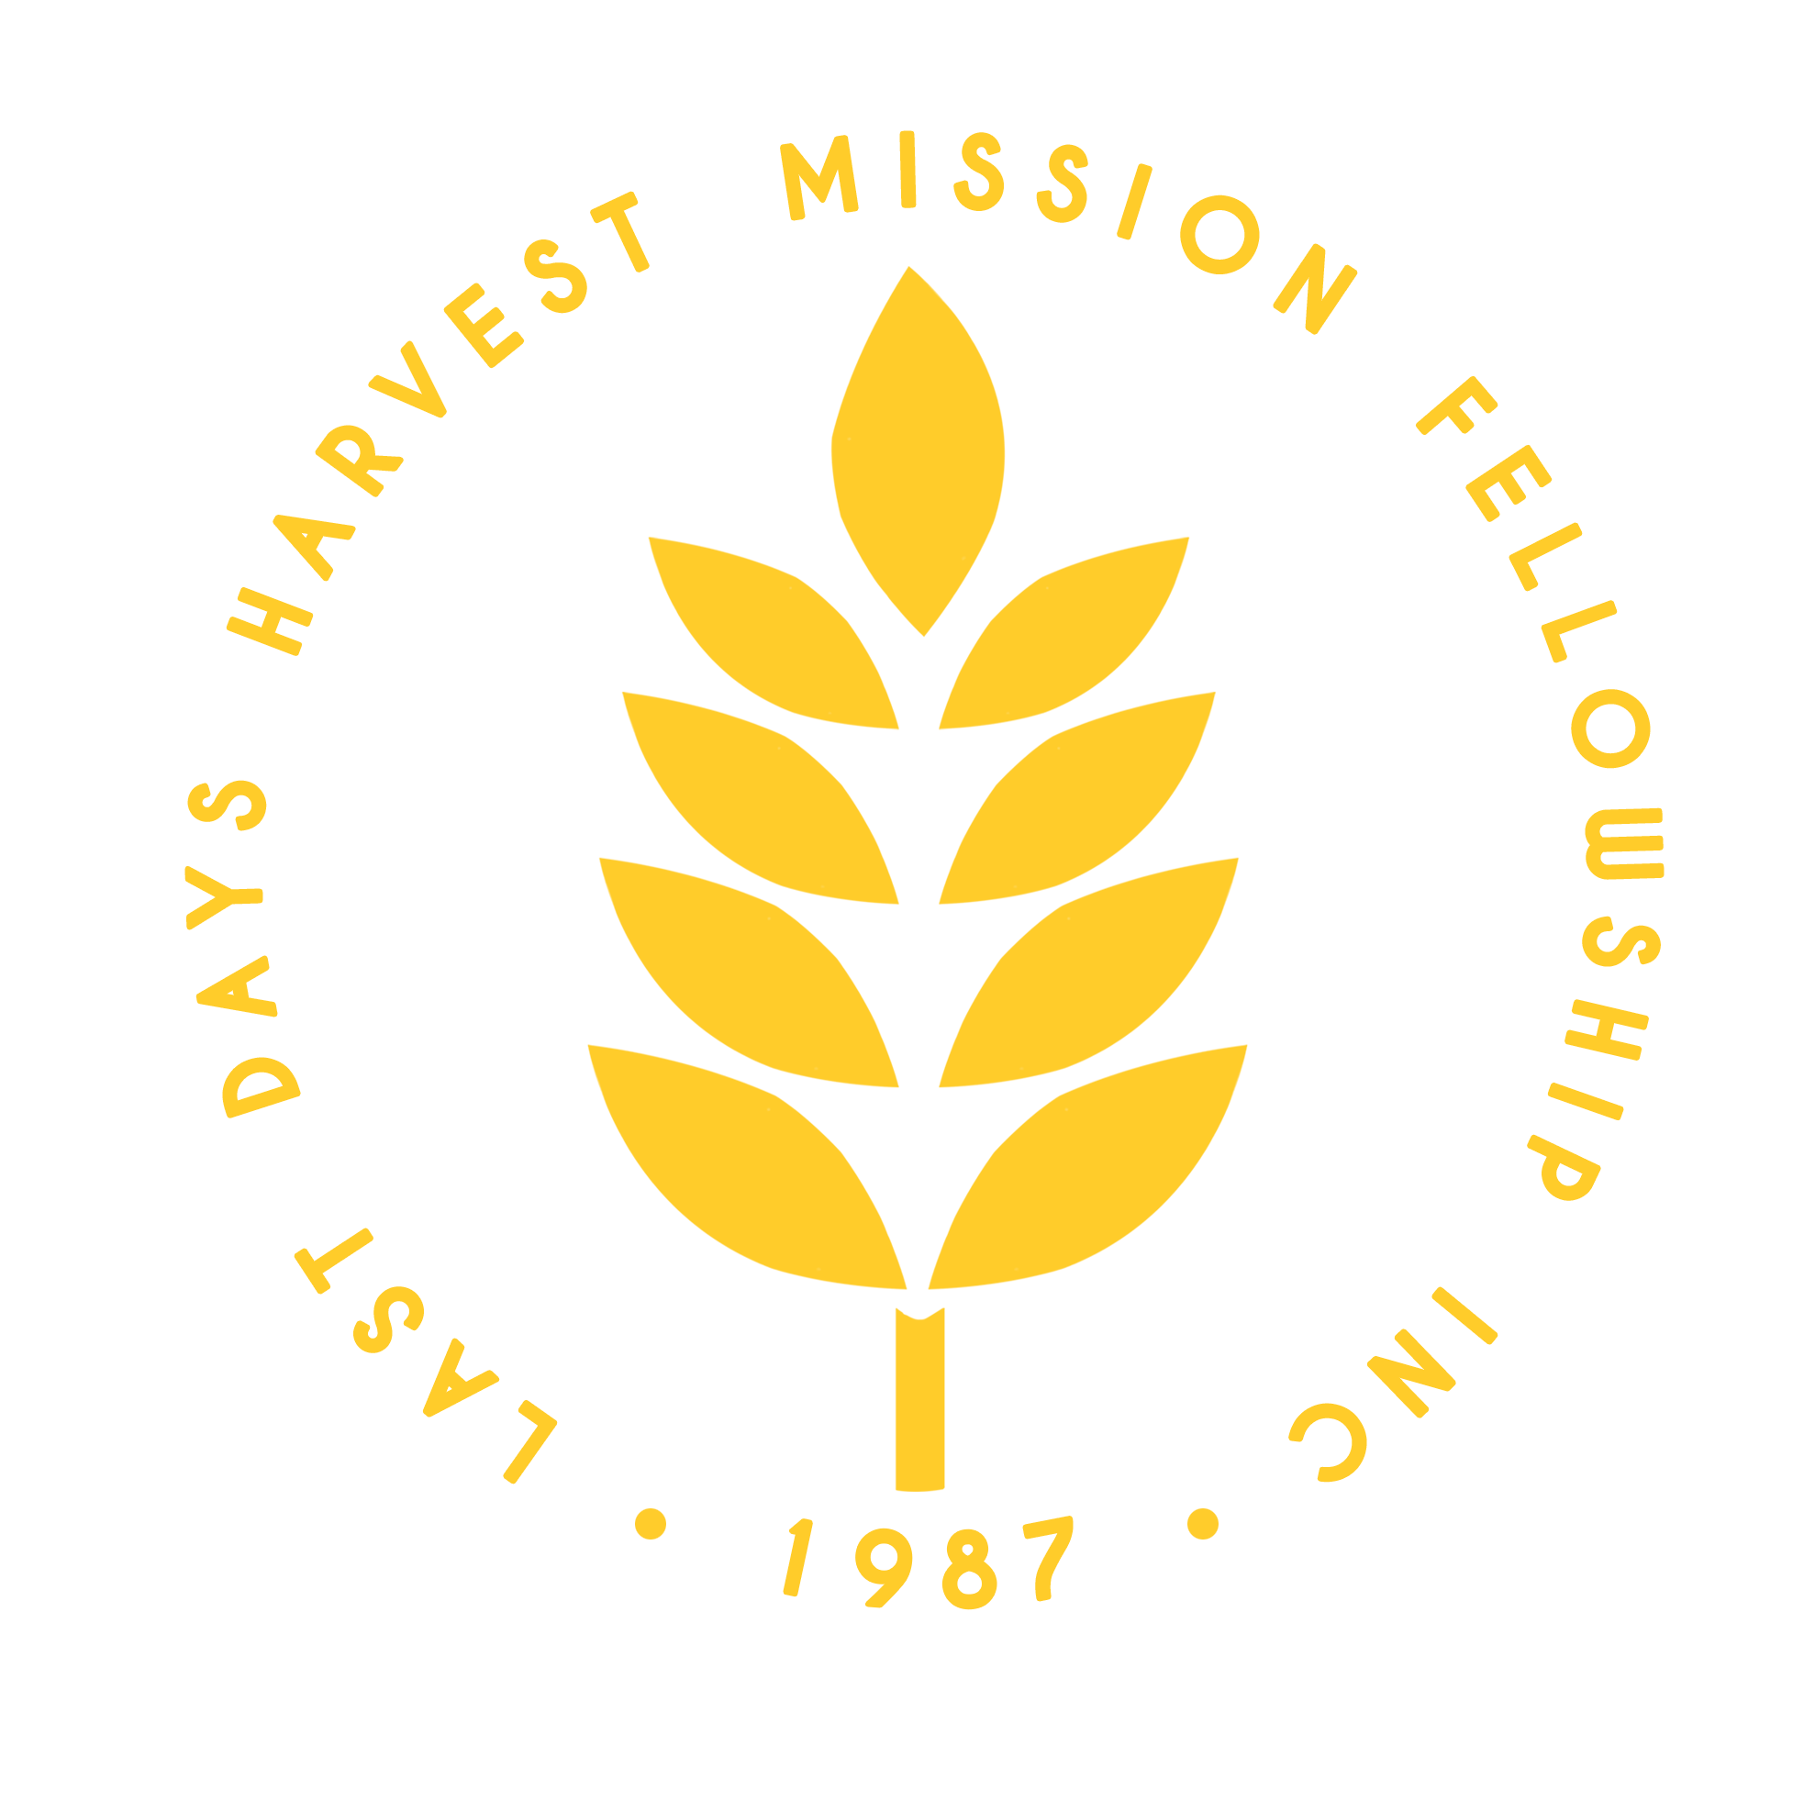 

To whom it may concern,

We, of the Last Days Harvest Mission Fellowship, are a faith-based organization that conducts feeding programs and is dedicated to imparting the goodness of God and educating children about God’s word through various activities. We are writing to you today to formally ask for your approval and assistance for our plan to conduct a feeding program in your area.

We would like to ask your permission to hold this event within your school premises, utilizing the gymnasium as the venue. The program is scheduled on December 21, 2024, Saturday, at 3:00 PM (Registration starts at 2:30 PM).

The feeding program will not only provide nourishment but will also be a day filled with joy and learning. We have prepared a series of fun activities, including dancing and singing, to engage the children. Additionally, we will present a play that brings to life some of the most cherished Bible stories, aiming to impart valuable lessons in a creative and entertaining manner.

We believe that this event will greatly benefit the students, not only physically but also spiritually and emotionally. Your support and cooperation in granting us the use of the gymnasium would be greatly appreciated.

We would be honored to have your school as a part of this activity for the glory of God. Your support in this endeavor would be greatly appreciated and would significantly contribute to the success of our mission.

Thank you for considering our request. We look forward to your positive response and are more than willing to discuss any further details or requirements you may have.

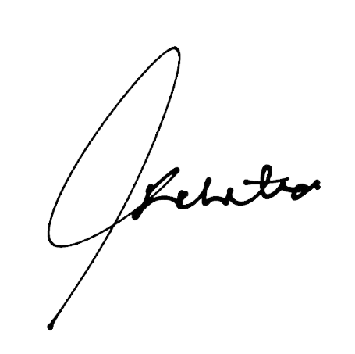Sincerely, Shekainah P. Gaceta

The Last Days Harvest Mission Fellowship

