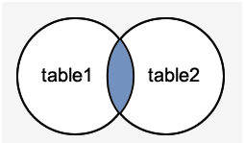 INNER JOIN finer(using/natural - crude )

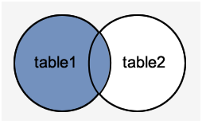 LEFT OUTER JOIN

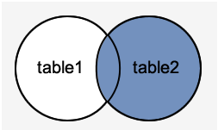RIGHT OUTER JOIN

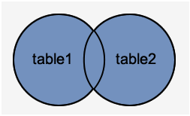 FULL OUTER JOIN