What is Schema Validation?
Schema validation is the process of verifying that the structure of a response (usually JSON or XML) from an API matches a predefined format or schema.
Why is it Important?
- Ensures data consistency between client and server.
- Helps catch unexpected changes in API responses.
- Validates required fields, data types, and formats.
In Rest Assured, schema validation is used to:
- Automatically check if the API response matches a JSON Schema or XML Schema (XSD).
- Fail the test if the response structure is incorrect.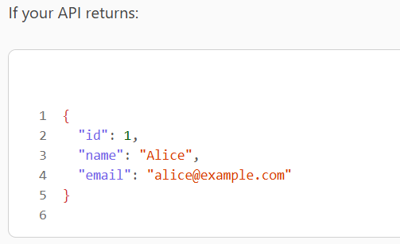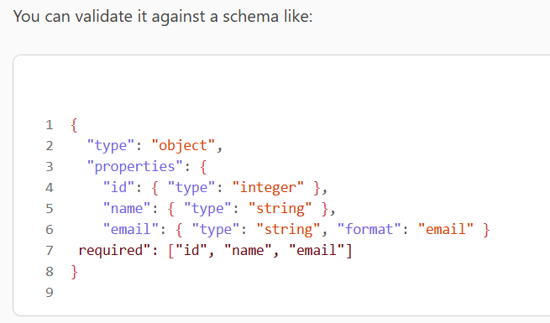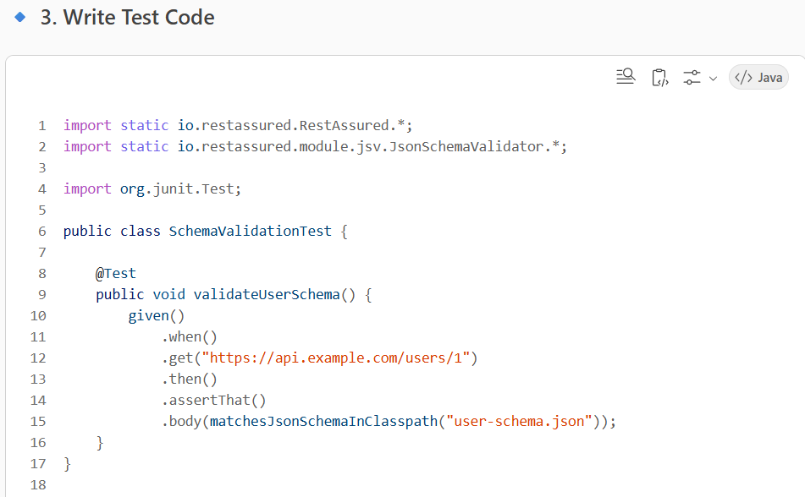
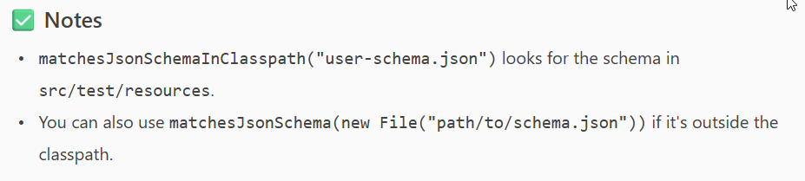

Authentication types in Rest assured

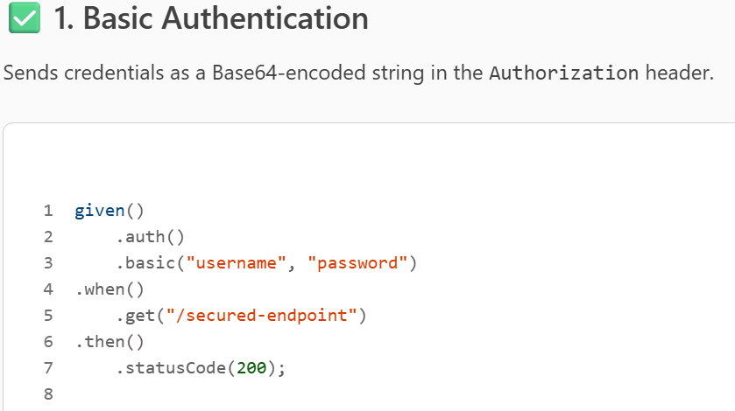
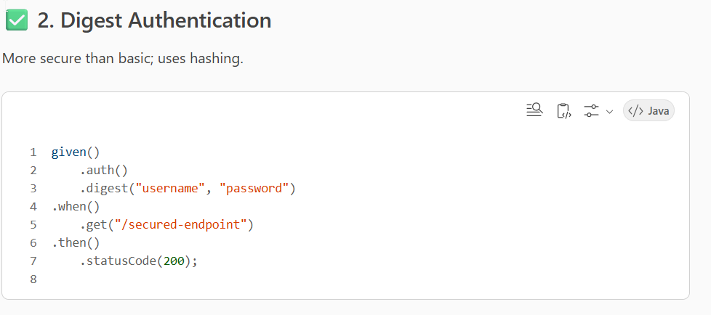
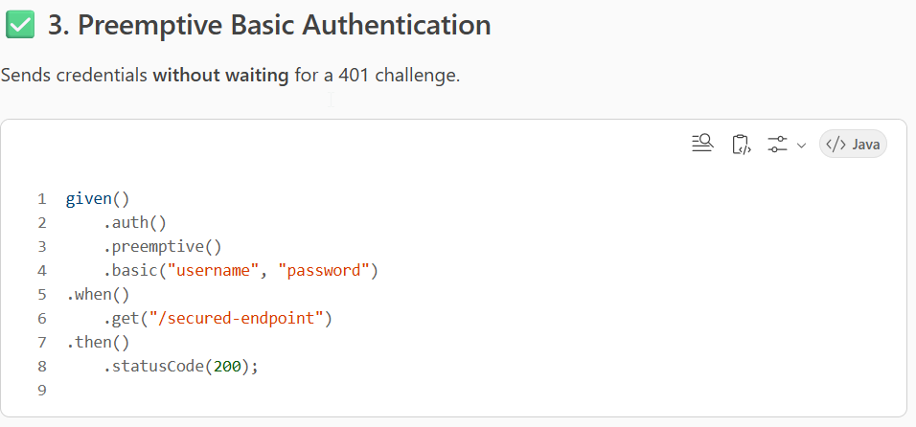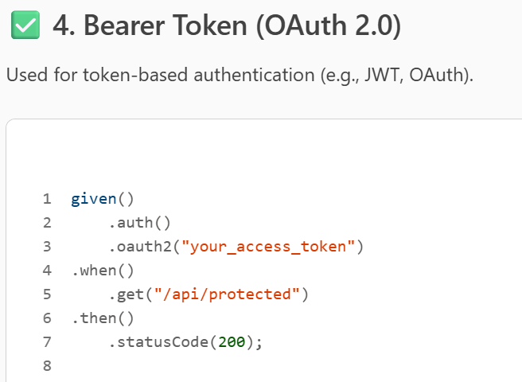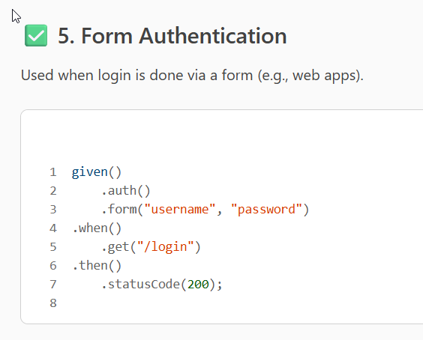
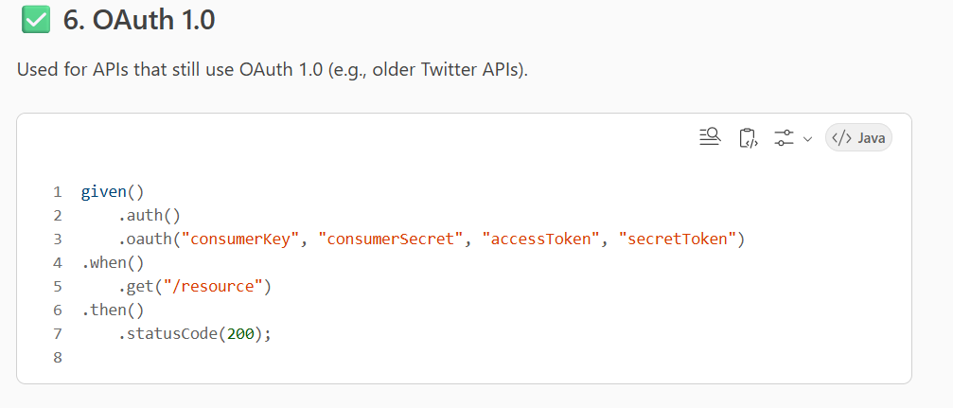

POJO CLASS
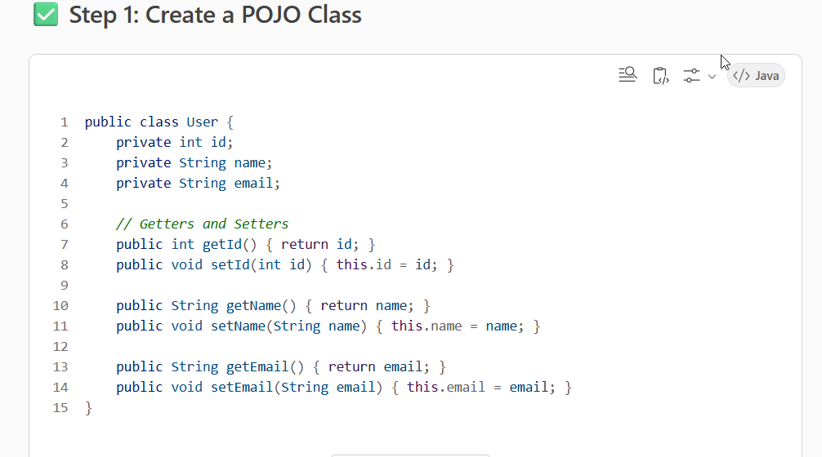

Serialization
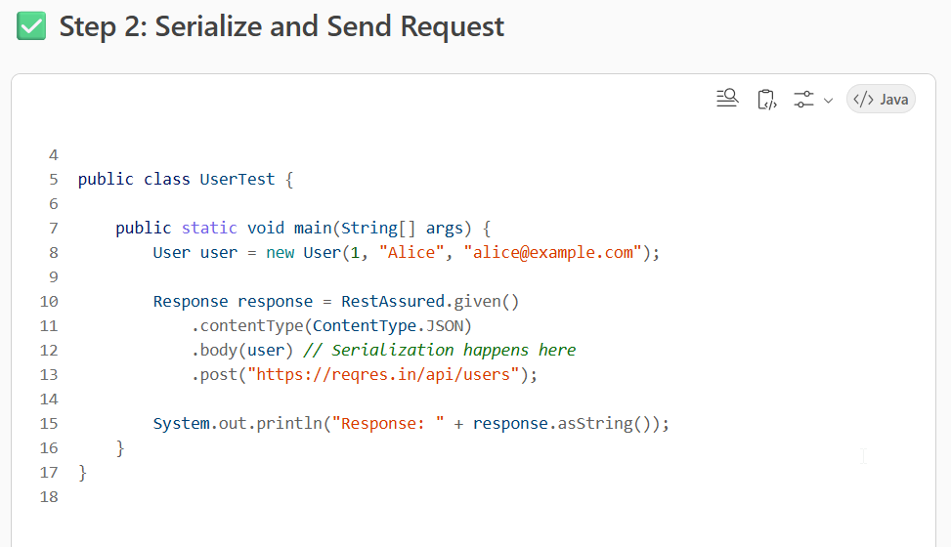

Deserialization
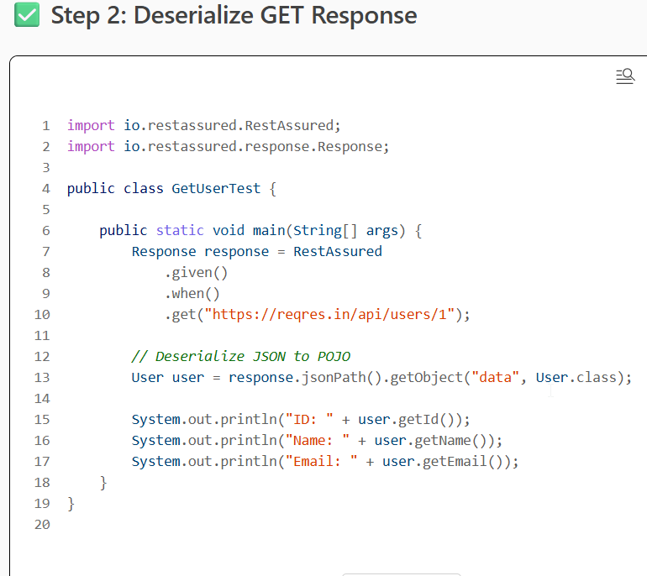

PUT VS PATCH

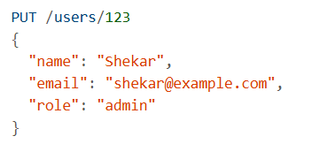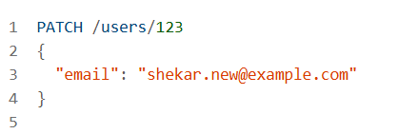

Jenkins job creation
1. Open Jenkins Dashboard
- Go to: http://localhost:8080 (or your Jenkins server URL)
- Login with your credentials.
2. Create a New Job
- Click “New Item”
- Enter a name for your job (e.g., SerenityBDD-Test)
- Choose:
  - Freestyle project – for simple builds
  - Pipeline – for scripted or declarative pipelines
- Click OK
🛠️ Freestyle Project Setup
🔸 General
- Optionally check “Discard old builds”
- Add a description if needed
🔸 Source Code Management
- Select Git
- Enter your repository URL
- Add credentials if needed
🔸 Build Triggers
- Choose how to trigger builds:
  - Build Periodically(Using Cron Expression)
  - Poll SCM (H/5 * * * *)(Using Cron Expression)
  - GitHub webhook
🔸 Build Environment
- Check “Delete workspace before build starts” (optional)
🔸 Build Steps
- Add “Invoke top-level Maven targets”
- Goals: clean verify or clean install
- POM: pom.xml
🔸 Post-build Actions
- Add “Publish JUnit test result report”
  - Test report XMLs: target/site/serenity/serenity-junit-results.xml
- Add “Publish Serenity Reports” (if plugin is installed)

🛠️ Pipeline Job Setup
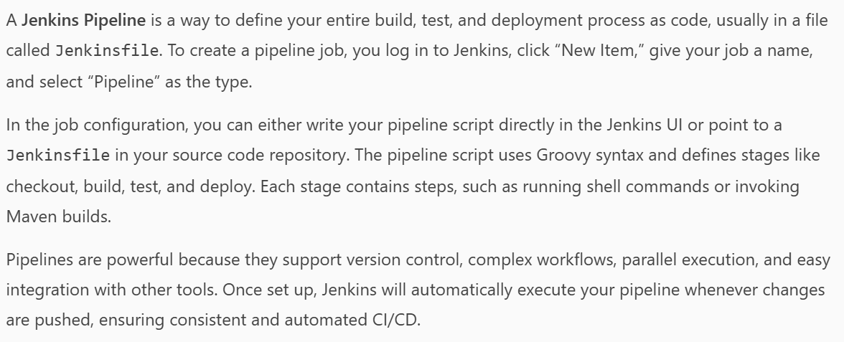
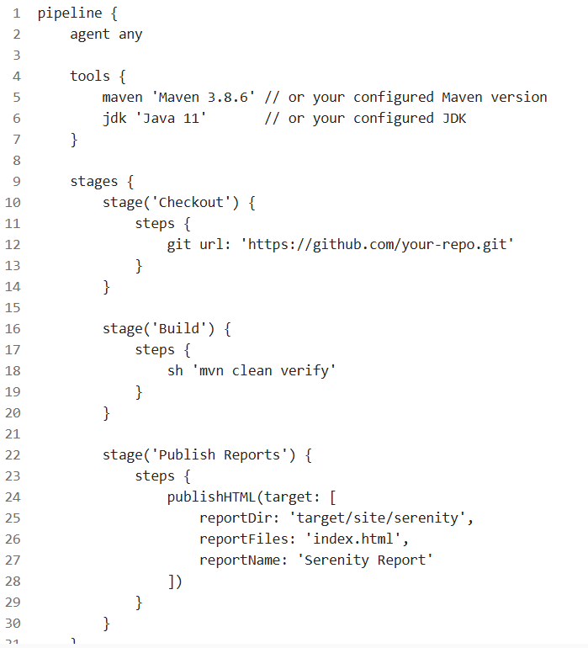
- Click Save
- Click Build Now to test the job
- View console output and Serenity reports

Types of jobs

1. Freestyle Project
- Use case: Simple build/test/deploy tasks.
- Features:
  - GUI-based configuration
  - Supports SCM (Git, SVN)
  - Build triggers (e.g., poll SCM, webhook)
  - Build steps (e.g., shell scripts, Maven, Gradle)

2. Pipeline
- Use case: Complex CI/CD workflows as code.
- Features:
  - Defined using a Jenkinsfile (Groovy DSL)
  - Supports stages, parallel execution, and shared libraries
  - Better version control and portability
3. Multibranch Pipeline
- Use case: Automatically create jobs for each branch in a repo.
- Features:
  - Scans Git repo for branches with Jenkinsfile
  - Automatically creates/deletes jobs per branch
  - Ideal for GitHub/GitLab integration
4. Folder
- Use case: Organize jobs into logical groups.
- Features:
  - Nest jobs and pipelines
  - Apply permissions and configurations at folder level
5. Matrix Project (Multi-Configuration)
- Use case: Run the same job with different parameters (e.g., OS, JDK).
- Features:
  - Define axes (e.g., environment, browser)
  - Jenkins runs all combinations
6. External Job
- Use case: Monitor jobs run outside Jenkins.
- Features:
  - Jenkins tracks execution and logs
  - No build steps inside Jenkins

7. Maven Project
- Use case: Maven-based Java projects.
- Features:
  - Auto-detects pom.xml
  - Handles build lifecycle
  - Deprecated in favor of Pipelines

Types of pipeline
1. Declarative Pipeline
🔹 Overview:
- Introduced to simplify pipeline creation.
- Uses a structured and readable syntax.
- Recommended for most users.
Example:
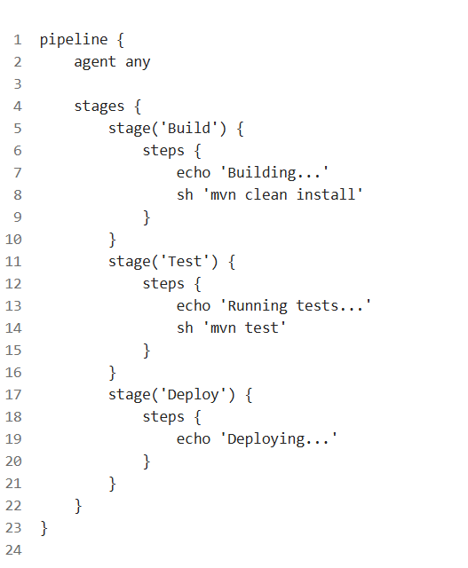

2. Scripted Pipeline
🔹 Overview:
- Based on traditional Groovy scripts.
- Offers more flexibility and control.
- Suitable for advanced users and dynamic logic.
Example:
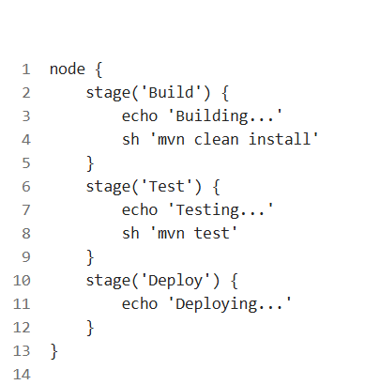

java collections
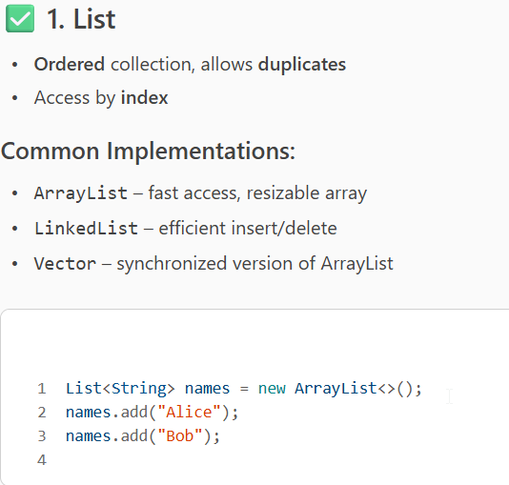

SET

MAP
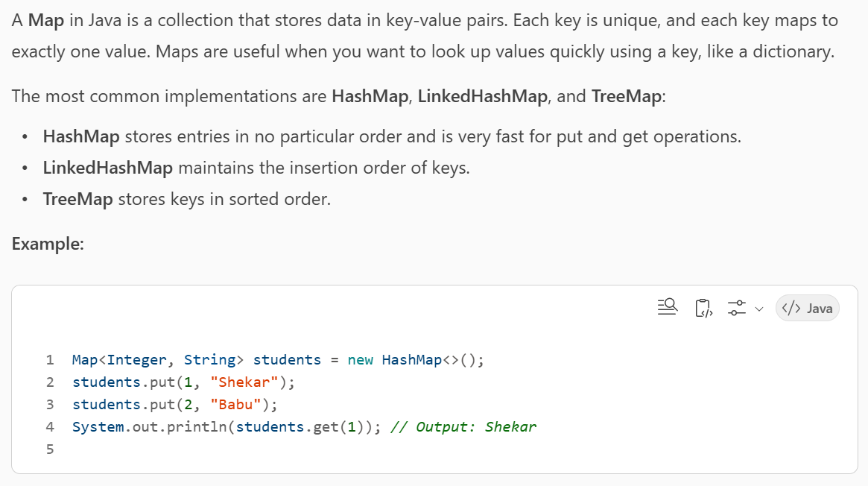

QUEUE

DEQUE
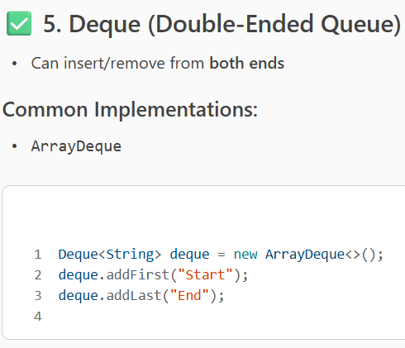

Hash Set VS Tree Set
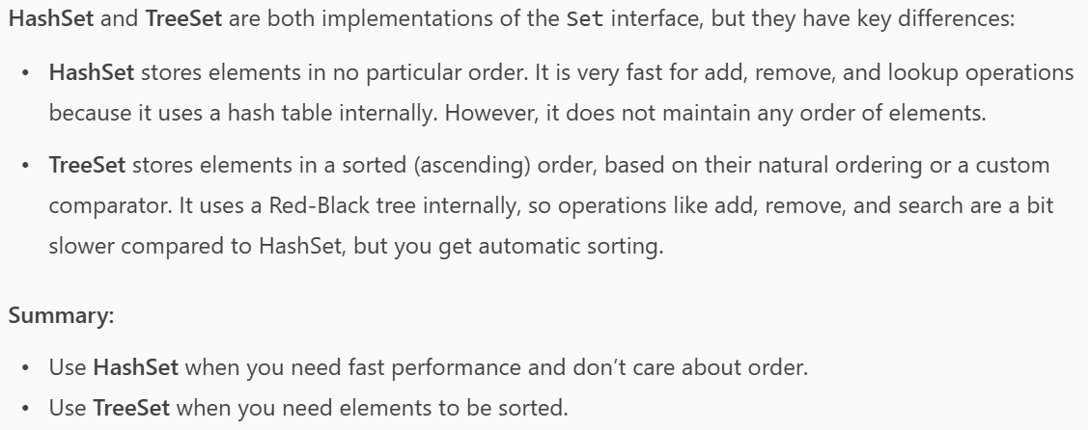

ArrayList vs LinkedList

HashSet VS HashMap
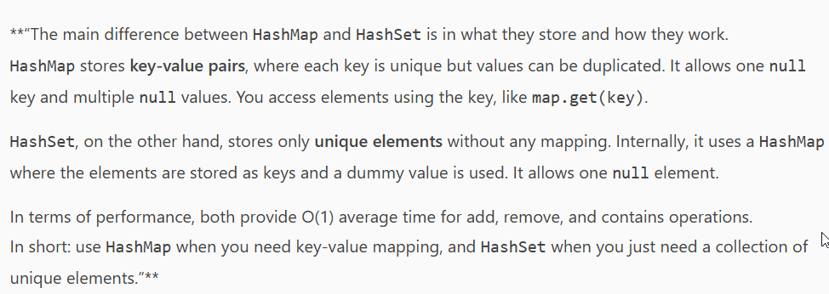

Framework explanation
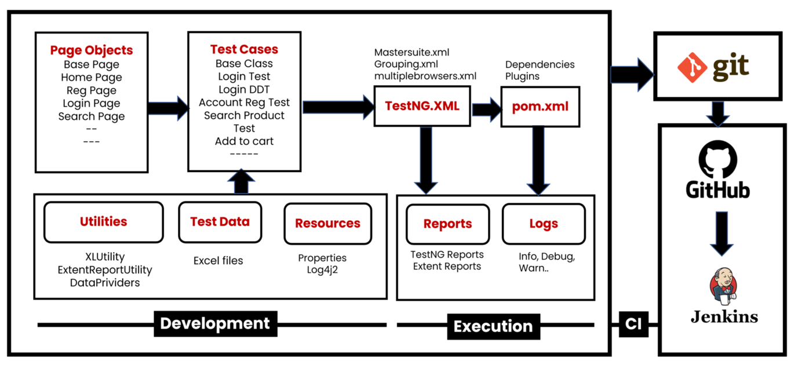
Architecture & Components
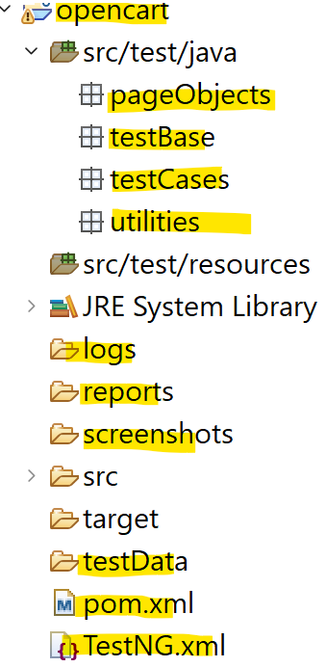

• Development Section(Src/test/java):
- Page Objects package: Classes for each web page (Home, Registration, Login, Search) to encapsulate locators and actions.
- Test Base package: Base Layer handles WebDriver setup and configuration management.
- Test Cases package: Test classes (like Login Test, Account Registration Test) inherit from a Base Class and cover different scenarios, including data-driven tests.
- Utilities package: Helper classes for Excel operations, reporting (ExtentReportUtility), and data providers.
- Test Data folder: Excel files store input data for tests.
- src/test/Resources: Configuration files (properties) and logging setup (Log4j2).
• Execution Section:
- TestNG XML: Suites for running tests (master suite, groupings, multi-browser).
- pom.xml: Manages dependencies and plugins with Maven.
- Reports: Generates TestNG and Extent Reports.
- Logs: Captures info, debug, and warning logs.
- ScreenShots: Screenshots will be stored.
• CI/CD Integration:
- Git & GitHub: Source code version control and repository hosting.
- Jenkins: Automates build, test execution, and reporting.

java oops

Abstraction VS Interface
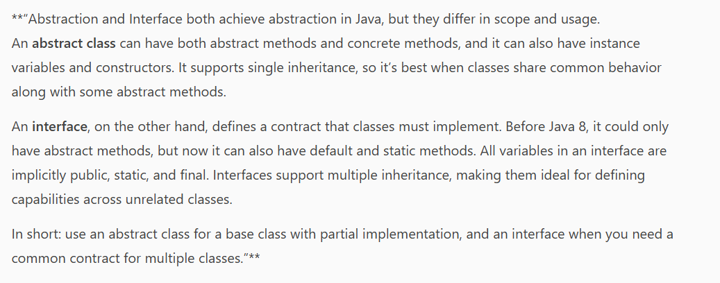

exception handling
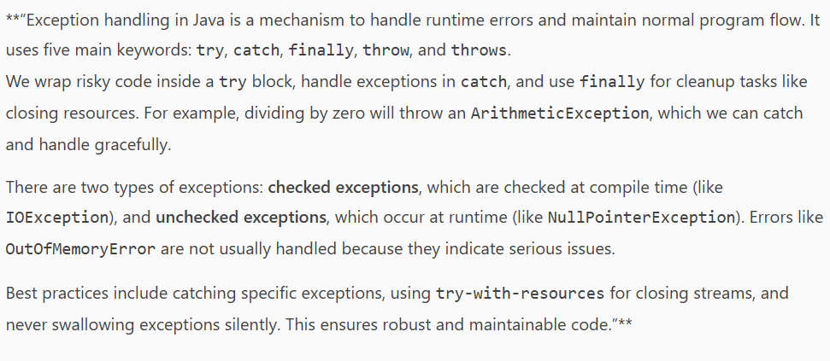

Design patterns
- Singleton Pattern
- Purpose: Ensures a single instance of WebDriver across tests.
- Benefits: Prevents multiple browser instances, manages resources.

- Factory Pattern
- Purpose: Creates different browser drivers dynamically.
- Benefits: Supports cross-browser testing easily.

- Page Object Model (POM) and Page Factory
- Purpose: Encapsulates web page elements and actions in separate classes. Page Factory Enhances POM by using annotations to initialize elements.
- Benefits: Cleaner code, lazy initialization of elements. Reduces code duplication, improves readability and maintainability.

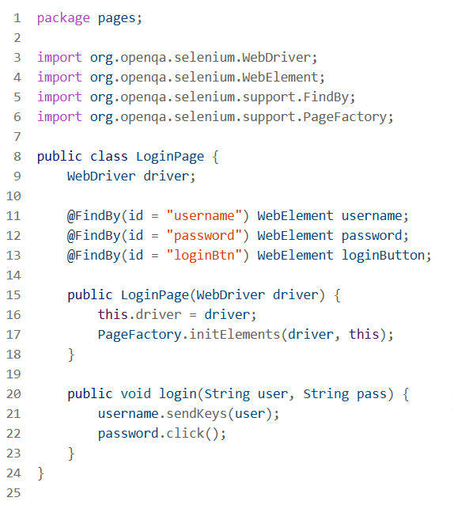

Clean Code Principles

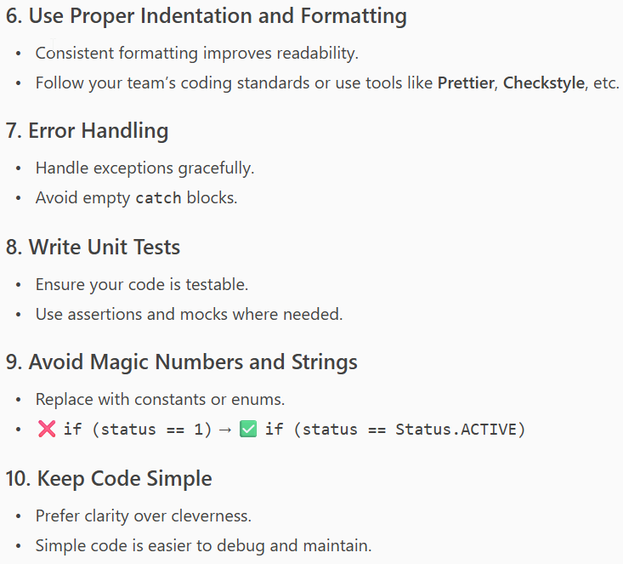

Action class

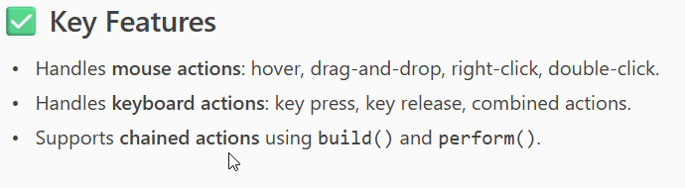

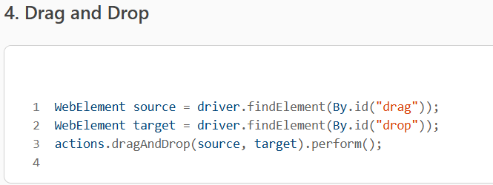

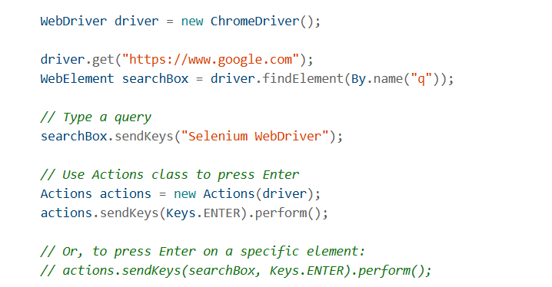

Locators
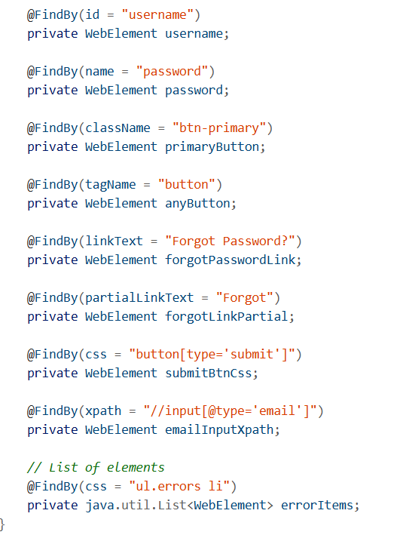

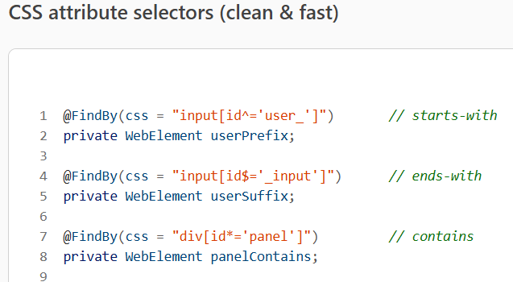

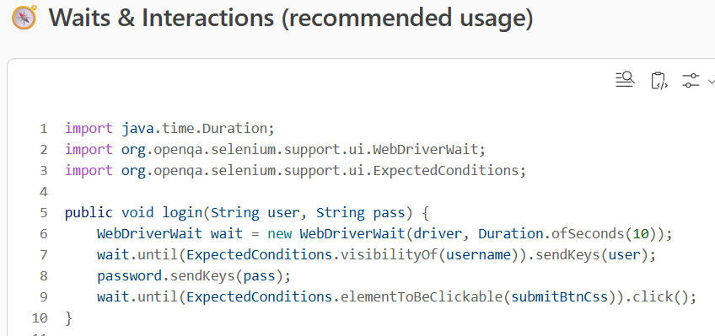

XPath Types in Selenium
XPath Type | Syntax / Function | Example | Description
Absolute XPath | / | /html/body/div[2]/div[1]/ul/li[3]/a | Full path from root to element. Fragile if DOM changes.
Relative XPath | // | //ul[@id='menu']/li[3]/a | Starts from anywhere in the DOM. More flexible.
Attribute XPath | [@attribute='value'] | //input[@name='username'] | Locates element using specific attribute.
Contains() | contains() | //button[contains(text(),'Login')] | Matches partial text or attribute value.
Starts-with() | starts-with() | //input[starts-with(@id,'user')] | Matches beginning of attribute value.
Text() | text() | //label[text()='Password'] | Matches exact visible text.
Logical Operators | and, or | //input[@type='text' and @name='email'] | Combines multiple conditions.
Indexing | [index] | (//div[@class='item'])[2] | Selects element by position in list.
Parent Axis | /..div or /parent::div | //span[@class='label']/parent::div  or  //span[@class='label']/.. | Selects parent of an element.
Following-Sibling | following-sibling::div | //h2[text()='Title']/following-sibling::p | Selects sibling element after the current one.
Preceding-Sibling | preceding-sibling::div | //p[@id='desc']/preceding-sibling::h2 | Selects sibling element before the current one.
Ancestor | /Ancestor::div | //tag[@attribute='value']/ancestor::tagname | ancestor axis is used to select all ancestor elements (parent, grandparent, etc.) of the current node.
Following | following::div | //h2[text()='Title']/following::p | Selects element after the current one.

get post code

selenium code

