THE AGENTIC ENTERPRISE
From software-assisted work to AI-orchestrated work
A Strategy Brief by DataStaqAI · 2026 · 48-slide companion deck

Thesis. Enterprise work is moving from software-assisted (per-seat SaaS) to AI-orchestrated (agentic). Value will accrue not to the commoditizing model nor the seat-defending incumbent, but to whoever delivers the orchestration — the agent wired into the customer's systems of record, governed and operated. Every category has split into incumbents and AI-natives, and both leave the mid-market done-for-you delivery layer unowned. DataStaqAI occupies that layer. All figures in this report are source-traceable to a competitive research base of 25 agentic use cases and 40+ named vendors; constructed financial figures are labeled illustrative.

Part I — Executive Thesis

Slide 1 — From software-assisted work to AI-orchestrated work — value accrues to whoever delivers the orchestration
This document is a strategy brief, not a product pitch. Its job is to establish, in eight chapters, why a done-for-you AI engineering firm is positioned to capture disproportionate value as enterprises move from software-assisted workflows to AI-orchestrated ones. Open on the central claim: the enterprise software era organised work around seats — humans operating tools. The agentic era reorganises work around agents that operate the tools on the human's behalf. That is not a feature upgrade; it is a change in who, or what, does the orchestration. The strategic question every operator now faces is where the value accrues in that shift. Our thesis is that it does not accrue primarily to the foundation model (rapidly commoditising), nor to the legacy per-seat platform (defending, not disrupting). It accrues to whoever can deliver a working agent wired into the customer's systems of record, governed, and operated — the orchestration layer. Chapter 1 makes the thesis and quantifies the opening; Chapters 2–5 prove it with market, function, competitor and white-space evidence; Chapters 6–8 turn it into DataStaqAI's strategy, revenue path and investment case. Tell the audience what standard of proof to expect: every number in this deck is source-traceable to named vendors, funding rounds, pricing pages and analyst market sizings gathered in our competitive research base of 25 agentic use cases across six functional clusters and 40-plus named vendors. Where a figure is not publicly disclosed, the cell is left blank rather than estimated. Set the tone: this is a partner-level read, designed to change the decision in the room, not to survey the category.

Slide 2 — Every function is crossing the same line — from tools humans operate to agents that operate the tools
This slide establishes the macro premise the rest of the document depends on: the transition from software-assisted to AI-orchestrated work is not a single-category event, it is happening across every enterprise function at once. Walk the audience left to right. On the left is the model that built the SaaS industry: a human sits in front of a tool and operates it, and the vendor charges per seat. The intelligence lives in the human; the software is a deterministic substrate of rules, dashboards, macros and playbooks. Critically, cost scales linearly — more work means more seats. On the right is the agentic model: the agent operates the tools on the human's behalf, reasoning over context to decide the next step, and value is increasingly billed per outcome (per resolution, per ticket, per investigation) rather than per seat. Cost decouples from headcount. The four examples on each side are deliberately drawn from different functions — support, data, security, sales — to make the point that this is synchronized, not isolated. Then bring the evidence: this is not speculative. The agentic sub-markets are compounding at rates that only happen when a transition is genuinely underway — the autonomous-SOC market at ~24.8% CAGR, AI customer-support at ~23.1%, AI code-review at ~20.2%, DAM and fraud in the mid-teens. Markets do not grow at those rates during incremental upgrades; they grow that way during platform shifts. Land the strategic implication at the bottom: the seat is the unit being dismantled. That is the single most important sentence in the chapter, because everything downstream — the competitive split, the white space, DataStaqAI's wedge — follows from it. Whoever re-orchestrates the work around agents, wired into the systems of record the enterprise already trusts, captures the budget the seat used to hold. Foreshadow the tension for slide 3: a shift this valuable attracts two very different kinds of players, and the way they compete leaves a structural gap.

Slide 3 — Each category has split into two camps — and both price the mid-market out
This is the structural heart of the thesis, so spend time here. The claim is that in every one of the 25 agentic use cases we studied, the market has bifurcated into two camps that compete in opposite directions and, in doing so, leave the same gap. On the left, the incumbents — Zendesk, Salesforce, Splunk, Workday, OutSystems, Looker and their peers — bolt AI onto the seat they already sell. They cannot lead the disruption because their revenue is the seat; cannibalising it is structurally irrational. Their moat is distribution and compliance, and their AI shows up as an add-on line item (Salesforce's Revenue Cloud at $200/seat is the archetype), not a re-architecture of the work. On the right, the AI-natives build genuinely excellent agents — but they go to market enterprise-first. The valuations make the strategy explicit: Sierra at $15.8B, Harvey $11B, Glean $7.2B, Decagon $4.5B, Vanta $4.15B are priced for winner-take-most enterprise capture, and the published entry floors follow — $360K/yr for legal, $150K for NL-analytics, $60K for agent-assist, $40K for enterprise search, plus the requirement that the buyer supply dedicated agent engineers or accept forward-deployed teams. The result is that both camps optimise for the Fortune 500. Now land the gold band: the hole is the mid-market — companies too large to keep running manual workflows but too small to afford a $50–360K/yr agent and the engineers to operate it. They can't afford the AI-native, the incumbent won't re-architect them, and they have no internal team to do the integration. Emphasise that this is not a niche; it is the structural by-product of how the entire category competes. Every subsequent chapter quantifies and attacks this gap. Pre-empt the obvious objection — 'won't the AI-natives just move down-market?' — and preview slide 4's answer: when they try, they bolt on services, which proves the gap rather than closing it.

Slide 4 — The white space is proven, not asserted — the agent-natives have already conceded it
The most common failure of a 'white space' argument is that it is asserted rather than demonstrated. This slide demonstrates it with four independent signals, each from a different part of the market, so the conclusion is triangulated rather than narrative. First signal: the AI-natives themselves are bolting on managed and done-for-you tiers, which is what you do when buyers cannot operate your product alone. Crescendo went so far as to run a BPO and acquire PartnerHero's 3,000-person CX workforce; Botpress and Maven advertise 'Managed' tiers; Decagon fields forward-deployed engineers; Sierra attaches six-figure implementation services. If the product were truly self-serve for the mid-market, none of that would exist. Second signal: the best-funded company using the leading next-gen method — Mechanical Orchard in legacy modernization — explicitly states its platform is 'built to be operated and delivered by system integrators,' and it serves only the Global 2000. The leading method therefore requires a delivery layer and ignores the middle by design. Third signal, and the most strategically important: when Anthropic shipped Claude legal plug-ins in early 2026, it wiped roughly $285B off incumbent software, financial-data and asset-management stocks in a single session — but the genuine data fortresses (Thomson Reuters' proprietary legal corpus, Glean's context graph) held their value. The lesson is precise: frontier models destroy thin wrappers, not systems with proprietary data and workflow. The strategic instruction that follows is to sell ON TOP of the customer's systems of record, never as a wrapper the next model release will eat. Fourth signal: price floors are collapsing toward $0.40–1.50 per resolution and $10/month travel agents, which means 'cheap' and even 'managed' are commoditising into table stakes. Close by stating the only defensible anchor that remains: integration depth, workflow ownership, governance, and the client owning the outcome. That is the position Chapter 6 will build DataStaqAI on.

Slide 5 — The opening is the mid-market integration gap — not another agent
This slide converts the thesis into four numbers and states the company's position, closing Chapter 1 on evidence rather than rhetoric. Take each stat deliberately. Twenty of twenty-five use cases resolve to an INTEGRATE+WORKFLOW posture — meaning the repeatable job across the portfolio is not inventing agents (the funded natives already did) and not reselling licenses, but wiring best-of-breed agents into the customer's systems of record and owning the workflow around them. Only two use cases are pure BUILD and three are DEPLOY-and-tune; the shape of the work is integration. Second, the price wedge: DataStaqAI's $24–60K/yr band (roughly $2–5k per month) sits below every published incumbent entry floor except GRC, where Sprinto already starts near $4K — so in GRC we compete on provenance and integration, not price, and everywhere else the mid-market affordability gap is real and quantified. Third, capital concentration: disclosed VC raised clusters in Security (~$1.9B) and Customer (~$1.0B), which tells us precisely where NOT to try to out-build or out-raise the natives, and instead to out-integrate them. Fourth, the two BUILD plays — legacy modernization and low-code escape — sit alone in the low-competitive-density lane, their deliverable is owned code no vendor can hand the client, and their funded rivals serve only the Global 2000; these are the highest-defensibility entry points and where we lead. Then deliver the positioning line as the chapter's conclusion: DataStaqAI is the delivery layer for the agent era — we wire the agents in, own the workflow and governance, run it, price it for the mid-market, and the client owns the outcome. Hand off to Chapter 2: having established the thesis and the size of the opening, the next chapter traces the market evolution in depth — how each functional market is moving, how fast, and which segments cross the line first — so the reader can see the timing, not just the shape, of the opportunity.

Part II — The AI Transformation

Slide 4 — Enterprise software re-platforms every ~15 years — each wave moved intelligence closer to the work
Open Chapter 2 by giving the audience a frame for change they already intuit: enterprise software re-platforms roughly every fifteen years, and each wave has moved intelligence one step closer to the actual work. The mainframe/ERP era centralized the record but kept intelligence in the IT department running batch jobs. The client-server and SaaS era put applications on every desk and made the seat the unit of value — but the intelligence still lived in the human operating the tool. The cloud/mobile/API era made everything accessible everywhere and turned integration into the dominant cost, but it did not change who did the thinking. The point of walking these three is to make the fourth feel inevitable rather than hyped. The agentic wave is categorically different from the first three because, for the first time, the intelligence moves past the human at the seat: the agent operates the tools itself, and value is billed per outcome rather than per seat. Stress the throughline — each wave moved intelligence closer to the work, and this one moves it through the human entirely. That is why it resets the budget: when the seat is no longer where the work happens, the spend that funded seats is in play. Close by setting up the rest of the chapter: if this is a genuine platform wave, we should expect to see it in the capability curve of AI itself (slide 5), in the limits of half-measures like copilots (slide 6), in a specific unsolved layer (slide 7), and in market data showing the inflection is now (slide 8). Keep the delivery deliberately calm and historical — you are earning the right to the sharper claims that follow by grounding them in a pattern the audience has lived through twice already.

Slide 5 — AI crossed from 'predict' to 'do' — orchestration, not the model, is the scarce layer
This slide reframes 'AI progress' as a capability staircase so the audience sees that the recent jump is qualitatively different, not just bigger. Step one, rules and RPA: deterministic if-this-then-that automation that is powerful but brittle and breaks the moment the environment changes. Step two, machine learning: forecasts and scores, a real leap, but dependent on clean labeled data and still only predicting, not acting. Step three, generative AI and copilots: the system can now draft and suggest in natural language, which felt revolutionary, but the human stays firmly in the loop and must accept, edit, and execute. Step four, agentic: the system reasons over context, decides the next step, acts across systems, and owns the outcome. The crucial teaching point is that the first three steps all kept the human as the actor; only the fourth makes the software the actor. That is why the jump from 'predict' to 'do' is the value inflection of the entire field. Now connect it to strategy, because this is where Chapter 2 starts doing real work for DataStaqAI: once agents can act, the foundation model becomes a commodity input — interchangeable, rapidly cheapening, and as we will show, unable to function reliably without governed context. What becomes scarce and defensible is the orchestration: wiring the agent into the real systems, giving it the governed context it needs, constraining it with policy, and operating it. Preview the proof that the model is not the moat, which lands harder in slide 7: on realistic enterprise data, frontier text-to-SQL accuracy collapses from ~87% on toy schemas to ~10%, and the accuracy that production systems do achieve comes from the semantic layer, not the raw model. End on the strategic inversion: the part everyone is racing to build — the model — is the part that commoditizes; the part almost no one is building — delivery — is the part that compounds.

Slide 6 — Copilots assist the seat — they don't remove it
This slide pre-empts the most common pushback an enterprise audience has: 'we already have copilots, isn't that the same thing?' The matrix answers it crisply by separating assistance from autonomy across five dimensions. A copilot does not trigger itself — a human must invoke it; an agent fires on an event. A copilot suggests the next step; an agent decides and executes it. A copilot cannot act across the systems of record; an agent does. A copilot does not own the outcome; an agent does, end to end. And the billing unit gives the game away: copilots are sold per seat, because they presuppose the seat, while agents are increasingly sold per outcome, because they replace it. The strategic significance is that copilots, by construction, cannot reset the budget — they make the existing seat faster, which is why they are an add-on line item rather than a re-architecture. Bring the field evidence to make this concrete and a little provocative: real contact-center audits show push-style agent-assist tools are used about one percent of the time; engineering teams describe AI code review as 'mostly noise' that trains reviewers to rubber-stamp; across the board the copilot adds a tab to an already-cluttered screen rather than removing the work. None of this is a knock on the technology — it is a statement about the ceiling of the form factor. Land the takeaway as the chapter's sharpest line so far: a copilot makes the seat faster, an agent makes the seat unnecessary, and only the second resets the budget. Then immediately set up slide 7's twist — making the second real (an agent that actually acts across a specific company's messy systems, safely) is not a model problem and not even an agent-platform problem; it is a delivery problem, and that is the layer nobody is serving for the mid-market.

Slide 7 — The model is solved and the agent exists — the unsolved layer is delivery
This is the pivotal slide of Chapter 2 — the one that names the company's reason to exist. Present the agentic value chain as four stages and force the audience to locate where the unsolved problem actually is. Stage one, the foundation model: solved and commoditizing, with frontier models converging in capability and falling in price; it is explicitly not the moat. Stage two, the agent platform: built and richly funded — Sierra, Harvey, Glean, Vanta and their peers have already produced excellent agents. Stage three, the delivery layer: integrating the agent into a specific company's systems of record, designing the workflow around it, governing it for safety and audit, and operating it in production — and this stage is essentially unowned for the mid-market. Stage four, the business outcome: the prize the buyer actually wants — resolved tickets, owned code, audit-ready evidence. The whole argument is that the industry has poured capital into stages one and two and almost none into stage three, even though stage three is what converts a demo into a deployed outcome. Marshal the evidence deliberately: twenty of our twenty-five use cases resolve to integration-and-workflow work rather than model or agent invention; production text-to-SQL accuracy comes from the semantic layer, not the model; 'automated' GRC evidence is frequently organized manual work that breaks silently; the best-funded legacy modernizer states its platform must be operated and delivered by system integrators; and surveys show roughly eighty percent of organizations still cannot fully automate, with integration complexity and skills — not appetite — as the blockers. Deliver the takeaway as the thesis of the entire book: everyone optimized the model and the agent; almost no one delivers them into the mid-market; that gap is the company. Then hand to slide 8: the gap is real, but is the timing right? The market data says the window is open now.

Slide 8 — The inflection is now — demand up, incumbents migrating, prices resetting
Close Chapter 2 by answering the timing question directly, because a real gap with the wrong timing is not an opportunity. The argument is that three independent forces have converged right now. First, demand: the chart shows the agentic sub-markets compounding at rates between roughly ten and twenty-five percent a year — autonomous SOC near 24.8%, AI customer support 23.1%, AI code review 20.2%, fraud and DAM in the mid-teens, even the slower modernization and low-code markets in double digits. Markets grow at these rates during platform transitions, not incremental upgrades. Second, a supply shock on the incumbent side: vendors are themselves forcing the disruption. Salesforce putting CPQ into End-of-Sale strands more than six thousand organizations into a $250–750K reimplementation decision; Anthropic shipping Claude legal plug-ins erased roughly $285B of incumbent market value in a single session. When incumbents destabilize their own installed base, buyers are forced into the market — and a forced buyer is the best buyer an integrator can have. Third, a price reset: outcome pricing is collapsing toward $0.40–1.50 per resolution and ten-dollar-a-month agents, which means the conversation is no longer 'can we afford AI' but 'who will make it work in our environment' — exactly the question delivery answers. Put the three together and the message is that the window to land the mid-market is open today, and it will not stay uncontested: as price ceilings fall and forced migrations peak, the buyers are in motion now. End by handing to Chapter 3: with the thesis set and the timing established, the next chapter goes function by function — Customer Operations, Sales, HR, Finance, Procurement, Security, Legal, Analytics, Engineering, Operations — showing the workflow today, the incumbent vendors, the AI disruption, the opportunity, and DataStaqAI's positioning for each. That is where the abstract thesis becomes a concrete, addressable map.

Part III — Business Use Cases

Slide 9 — Customer Operations: Customer Operations is the first function to cross from software-assisted to AI-orchestrated at scale
Customer Operations leads Chapter 3 because it is the function furthest along the transition and therefore the clearest proof of the thesis in production. Walk the current workflow: a ticket arrives, a human reads the knowledge base and customer history, applies a macro or drafts a reply, and either closes or escalates — a per-seat motion where cost scales with volume. The vendor landscape has split exactly as the thesis predicts: incumbents (Zendesk, Salesforce, Intercom, Freshdesk) defend the seat and bolt AI on, while AI-natives (Sierra at $15.8B, Decagon at $4.5B, Ada, Intercom Fin) sell the agent. The disruption is that grounded agents now resolve roughly 80% of tier-1 natively and bill per resolution at $0.40–1.50, so the seat count — not the system of record — is what collapses. The tell that the white space is real is that the AI-natives have bolted on managed and forward-deployed services because mid-market buyers cannot operate the agents alone. That is the opportunity: companies priced out of $50–150K platform floors and unable to staff agent engineers. DataStaqAI's position is INTEGRATE+WORKFLOW — wire a resolution-first agent into the helpdesk the customer already runs, bootstrap it off their ticket history so there is no cold-start, price it per ticket, and leave the ticketing system as the untouched system of record. The buyer keeps what they trust and gets the outcome — resolved tickets — without buying a second platform or a 1,000-ticket cold start. Use this slide to set the template the next nine follow: workflow today, who plays, what the agent changes, where the mid-market gap is, and how we deliver into it.

Slide 10 — Sales: Sales is splitting in two: agents take prospecting and quoting, humans keep the relationship
Sales is the cleanest example of a function splitting along a human/agent line. Today the motion is: build and enrich a list, research and personalize, run a sequence and follow up, then quote and close. The first three steps are SDR work; the last is closer work. The vendor split: incumbents Salesforce, HubSpot, Outreach, Salesloft and Gong own the sequencer and CRM, while AI-natives attack the SDR seat — 11x (Alice the outbound SDR, Julian the phone agent; ~$74M raised from Benchmark, a16z and HubSpot Ventures at a reported $350M valuation, customers like Xerox and Sage), Artisan's 'Ava,' Regie.ai, and Clay (~$46M) as the research layer. The disruption is that autonomous SDRs research, write, and book meetings without a human, reallocating the largest GTM line item — the ~$80K fully-loaded SDR seat — while on the quoting side conversational agents replace the record-by-record CPQ grid that reps abandon to Excel, made urgent by Salesforce CPQ's End-of-Sale. The opportunity is that the mid-market wants pipeline and quotes as an outcome, not a sprawling stack of an SDR tool plus a data vendor plus a warm-up tool that they must assemble and operate. DataStaqAI's position is INTEGRATE+WORKFLOW: wire prospecting and quoting agents into the CRM the company already runs, own the play design and the governance, and deliver pipeline and compliant quotes rather than another seat. Emphasize the boundary the slide draws — agents take the repeatable prospecting and quoting work; the human keeps the relationship and the close — because that boundary is what makes the pitch credible to a sales leader who fears being sold a robot that replaces their team.

Slide 11 — HR: HR's system of record is a database that can't act — onboarding is the agent wedge
HR makes the 'system of record vs system of action' distinction concrete. The onboarding workflow today is a human router problem: an offer is accepted, HR emails IT, Finance and the hiring manager, then spends days chasing tasks and links before the hire is provisioned and the org chart updated. Incumbents — Workday (around $48K/yr median), Rippling, BambooHR — are excellent databases but, as the research repeatedly shows, terrible action-takers; the provisioning layer (Okta/Entra via SCIM, Zluri) only partly closes the gap. The disruption is event-driven orchestration: an agent fired off the new-hire trigger turns a 5–8-hour, 15–25%-error manual process into minutes, and shifts HR from spending up to 60% of its time on data entry and 'professional nagging' to simply approving. The opportunity is precise: HRIS workflow modules store the record but do not execute across IT, Finance and the manager, and the mid-market feels this most acutely in the 'tooling chasm' between spreadsheets and a full Workday. DataStaqAI's position is INTEGRATE+WORKFLOW — a zero-touch onboarding orchestrator that raises IT provisioning tickets, collects hardware and software needs conversationally, monitors background checks, and updates the HRIS — while leaving the HRIS as the untouchable system of record and dropping the per-seat workflow modules that never actually took the action. The emotional hook for the buyer is the Day-5 new hire still without a laptop, and the HR person blamed for a broken cross-functional process they do not control; the agent removes the blame by doing the chasing. This is a RENEGOTIATE pattern: keep the system of record, strip the workflow seats, own the orchestration in between.

Slide 12 — Finance: Finance back-office is a headcount problem agents convert into a software problem
Finance is where the agent ROI is easiest to underwrite because the pain is measured in headcount. The workflow today: an invoice or transaction arrives, a clerk manually codes and keys it into the ERP, performs a three-way match and routes for approval, then reconciles and closes. Incumbents NetSuite, SAP, Oracle, QuickBooks and Bill.com own the ledger; AI-natives are attacking the manual layer on top of it. Ramp — now at a $44B valuation with over $1.5B run-rate revenue and an Accounting Agent that auto-codes transactions for real-time close — reports clean books three times faster and 40-plus hours saved per month; Maximor's audit-ready close agents cut one customer's close from 11 days to 3 with audit issues down over 90%; Rossum and OpenEnvoy attack template-free AP. The disruption framing is that AP keying, which today consumes the equivalent of 3.3–5 full-time staff at 2,000 invoices a month, becomes a software function. Crucially for our positioning, the leading agents layer on top of the ERP rather than replacing it (Maximor explicitly: 'no rip-and-replace'). The opportunity is the off-suite mid-market — companies on Dynamics, Sage or Intacct with diverse vendor formats who pay a consolidation tax to adopt a whole suite. DataStaqAI's position is INTEGRATE+WORKFLOW: wire a no-template AP and reconciliation agent into the existing ERP, explicitly positioned to rescue the failed OCR rollout, owning the three-way match, approval routing and audit trail while the ERP stays the system of record. Land the line from the research: AP should stop being a hiring problem.

Slide 13 — Procurement: Procurement's intake-to-pay friction is the back office's clearest agent ROI
Procurement is a back-office function with unusually clean agent ROI because its pain is the 'messy middle' — the approval choreography across legal, finance and risk that sits between an employee request and a paid invoice. The workflow today: intake a request, route it through legal/finance/risk, source and qualify a supplier, then issue a PO and pay. The vendor landscape has split sharply: incumbents Coupa (Navi agents on a $9.5T spend dataset), SAP Ariba (Joule, ~29% share) and Ivalua defend the suite, while a wave of orchestration-native players — Zip ($371M raised, 50+ AI agents, customers including T-Mobile and OpenAI, ~$6B savings unlocked) and ORO Labs ($100M, founded by ex-SAP Ariba executives, customers like Coca-Cola, automating up to 80% of manual review cycles) plus Levelpath and Opstream — rebuild procurement as an agentic orchestration layer. Ardent's survey shows 58% of procurement is now using or piloting AI, so the 'wait and see' era is over. The opportunity for DataStaqAI is the mid-market that wants this orchestration without ripping out Coupa or Ariba or buying a new suite. Our position is INTEGRATE+WORKFLOW: wire an intake-to-pay agent across the systems the company already runs, own the approval orchestration and the policy guardrails (every action logged and auditable), and leave the spend system of record in place. The strategic point to make is that even the AI-native orchestrators are enterprise-first and configuration-heavy; the mid-market needs the outcome delivered, which is the integrator's job, not another platform to administer.

Slide 14 — Security: SecOps is hiring to triage alerts it can't keep up with — the strongest deploy-an-agent signal
Security has the single strongest 'deploy an agent now' signal in the portfolio, because the buyers broadcast their pain by posting jobs. The workflow today: an alert fires — a typical SOC sees ~4,400 a day — an L1 analyst triages and gathers context, investigates or escalates, and remediates, with over 90% of alerts proving to be false positives and analysts investigating only a third. Incumbents Splunk, Microsoft Sentinel, Google SecOps and QRadar own the SIEM; AI-natives Prophet, Torq HyperSOC, Dropzone ($57M raised) and Radiant investigate autonomously, while Tines ($1.1B valuation) leads the SOAR-replacement motion as legacy playbooks are declared obsolete. The disruption is that agents investigate 100% of alerts end-to-end and analysts shift to validating completed investigations; notably the deployment often self-funds by letting teams cut SIEM ingest costs. The opportunity is that mid-market security teams and MSSPs cannot stand up and tune a Prophet or Torq deployment alone, and they are regulated and risk-averse. DataStaqAI's position is DEPLOY+TUNE: stand up and tune an investigation agent on the customer's existing SIEM, wire the cross-tool correlation, and frame it as KEEP/enrichment — the SIEM remains the system of record and the agent makes it finally keep up. The go-to-market instruction is to treat L1/Tier-1 SOC-analyst job postings as the lead list: every posting is an account drowning in alerts. And the business case writes itself twice — analyst time recovered plus a SIEM-ingest reduction that, in seven-figure SIEM estates, can exceed the cost of the engagement.

Slide 15 — Legal: Legal research is where a $20 tool already matches a $270 seat — the mid-firm wedge
Legal is the function where the price dislocation is most vivid. The workflow today: a legal question triggers a Westlaw or Lexis search — lawyers spend 5–15 hours a week on research, juniors more — followed by reading and assessing cases and drafting a memo or redline, with 25–30% of that research time written off or unbillable. Incumbents (Thomson Reuters' Westlaw/CoCounsel, LexisNexis' Lexis+ Protégé) hold the proprietary corpus and citator; AI-natives Harvey ($11B valuation, $1,200–2,000 per seat, ~$360K entry), Legora and Spellbook attack the research-and-draft loop. The disruption is twofold: the lookup-and-draft loop collapses, and the category was repriced overnight when Anthropic's Claude legal plug-ins triggered a roughly $285B selloff across legal-data and software stocks — but the data fortresses held, which is the strategic lesson: sell on top of the corpus, never as a thin wrapper. The opportunity is the 45–250-attorney mid-size firm priced out of Harvey's entry but needing more than a $20 consumer chat tool, and acutely exposed to hallucination risk (firms have been sanctioned for fake citations). DataStaqAI's position is INTEGRATE+WORKFLOW: a research-and-draft agent whose citations are verified against official reporters with a citator-verification pass, delivered at mid-firm price with the AI-use governance that keeps the firm out of the headlines, while the proprietary corpus and citator stay as a hybrid. The pitch line: a $20 tool now matches a $270 seat, but one bad citation gets you sanctioned — we deliver the verified, governed version.

Slide 16 — Analytics: Dashboards go unused; the agent answers the question — but only over a governed semantic layer
Analytics is where the agent both threatens and depends on the existing stack, which makes the delivery argument unusually strong. The workflow today is quietly broken: a stakeholder asks a question, an analyst writes SQL or builds a dashboard, the dashboard goes largely unused, and the stakeholder Slacks the analyst anyway — one team deleted 1,200 dashboards and nobody noticed, and dashboards account for as little as 5% of how data actually gets consumed. Incumbents Looker (~$150K/yr, dev-heavy), Power BI and Tableau own the BI seat; AI-natives Snowflake Cortex Analyst, Databricks Genie, ThoughtSpot, Hex and Julius offer natural-language querying. The disruption is that NL-to-SQL collapses the interface and answers in context — but the critical, defensible nuance is that accuracy falls from ~87% on toy schemas to ~10% on real enterprise schemas without a semantic layer, and the warehouse-native tools are locked to their own platform so cross-platform questions have no home. That nuance is the opportunity: the semantic and context layer is the unglamorous, high-value work, and nobody owns it for the mid-market. DataStaqAI's position is INTEGRATE+WORKFLOW, occasionally BUILD — construct the governed semantic layer and wire an ask-the-warehouse agent that returns verified answers with the metric definition attached, leaving the warehouse as the system of record. The pitch is that the model is not the moat and the dashboard is dead; the durable asset is governed context plus an agent that answers — and building and operating that is delivery, not a product the buyer can self-serve.

Slide 17 — Engineering: Engineering is where DataStaqAI builds, not integrates — owned-code modernization is the sharpest play
Engineering is the one cluster where DataStaqAI's posture flips from integrate to build, and it is the sharpest play in the entire portfolio. The painful workflow is modernization: a legacy or low-code application runs the business, the engineers who understand it retire, a manual rewrite is attempted and fails ~70% of the time, and the team maintains an unreadable system forever. Two sub-stories sit here. Code review is a commodity attach: incumbents (GitHub Copilot) and cheap, viral AI-natives (CodeRabbit, Greptile, Qodo) already do it well, so it is a DEPLOY+TUNE service, not a build. The real prize is modernization and low-code escape: incumbents are the cages themselves (OutSystems at $9.5B, Mendix, Retool at $3.2B), and AI-natives Mechanical Orchard and Replay pioneered behavior-grounded modernization that captures tribal knowledge from the running system and reverse-engineers low-code into owned React/Node in months rather than an 18-month rewrite. The decisive fact is that the leading modernizers are explicitly Global-2000-only — Mechanical Orchard even states its platform is built to be operated and delivered by system integrators — so the mid-market is unserved by design. DataStaqAI's position is BUILD: deliver owned, git-native code the client keeps, with no off-the-shelf substitute, using the same behavior-first method the leaders validated; and DEPLOY+TUNE a context-indexed review agent at commit time as an attach. This is where we sell delivery that cannot be bought as a subscription, which is the highest-defensibility position in the book — lead here.

Slide 18 — Operations: Operations is where enrichment wins — make the predictive and ITSM investment finally pay off
Operations closes the function tour on the KEEP/enrichment pattern, which matters because it shows DataStaqAI is not only a disruptor but an amplifier of investments the customer already made. Two operations sub-domains share a shape. In IT and employee support, the workflow today is incident-or-request, manual triage and ticketing, chase and resolve, repeat — and the market just consolidated dramatically: ServiceNow acquired Moveworks (Dec 2025) and launched an Autonomous Workforce with an out-of-the-box Level-1 Service Desk AI Specialist that resolves password resets, access and provisioning end-to-end, while Aisera (acquired by Automation Anywhere) reports 65–90% deflection. In industrial operations, predictive maintenance incumbents (Honeywell, GE Vernova, Siemens) and AI-natives (Augury, Uptake) ride proprietary sensor data, where the failure mode is alarm fatigue — false positives consume ~40% of wrench time and a real failure once went unnoticed for 11 days at a $340K cost. The disruption in both is the same: agents that fuse signals and emit a work order rather than another alert. The opportunity is that mid-market operations teams cannot run a Moveworks- or Augury-scale deployment alone. DataStaqAI's position is DEPLOY+TUNE under a KEEP framing: stand up and tune the agent on the customer's existing ITSM or sensor stack, build the trustworthy triage and work-order workflow, and let the platform remain the system of record — the agent makes the investment they already made finally pay off. For regulated, risk-averse operations buyers, that 'enrichment, not replacement' framing is the one that gets to yes, and it rounds out the function map ahead of Chapter 4's competitive deep-dive.

Part IV — Competitive Analysis (1/2)

Slide 19 — Enterprise AI ecosystem — value migrating to the unowned delivery layer
Open Chapter 4 with the map the rest of the chapter navigates: the enterprise AI stack has four layers, and the purpose of this slide is to show value migrating to the layer nobody serves for the mid-market. The top layer, foundation models, is commoditizing — OpenAI, Anthropic, Google, Meta and open models converge in capability and fall in price, so the model is an input, not a moat. The second layer, agent platforms, is richly funded — Sierra, Harvey, Glean, Decagon, Vanta, Torq, Rossum — and these are genuinely good products. The bottom layer, systems of record — Salesforce, Workday, SAP, Splunk, OutSystems, the ERPs — persists, because the proprietary data and workflow are the durable moat; agents ride on top of it rather than replacing it. The third layer, delivery, is the one this whole document is about: wiring the agent into the systems of record, designing the workflow, governing it, operating it. Today that layer is owned only by global systems integrators, and they serve only the Global 2000. For the mid-market it is unowned. Use the gold band to make the strategic claim unmissable: the model commoditizes, the system of record persists, the agent platform is funded — and the delivery layer is where the value accrues and where the competition is thinnest. Every subsequent slide in the chapter zooms into one part of this map: who the archetypes are, how the incumbents and AI-natives and SIs each compete, how pricing and funding have concentrated, and where the white space sits. Tell the audience to keep this four-layer picture in mind, because DataStaqAI's entire position is 'we own the delivery layer for the mid-market,' and this slide is the proof that such a layer exists and is empty.

Slide 20 — Market segmentation — the mid-market done-for-you cell is empty
This slide reduces a noisy market to a single 2x2 so the audience can see the hole rather than be told about it. Segment the market on two axes. The horizontal axis is buyer size: enterprise on the left, mid-market on the right. The vertical axis is who does the delivery: self-serve product at the top, done-for-you at the bottom. Now place the players. Top-left, enterprise buyers served by self-serve products: the funded AI-natives — Sierra, Glean, Harvey, Decagon, Vanta — who sell a powerful platform the enterprise's own engineers operate. Top-right, mid-market buyers served by self-serve products: the SMB point tools — Freshdesk Freddy, Botpress, eesel, Sprinto — cheap but self-operated and shallow. Bottom-left, enterprise buyers served done-for-you: the global systems integrators (Accenture, Deloitte) plus the AI-natives' own managed and BPO tiers (Crescendo). And bottom-right, mid-market buyers who need it done for them: empty. That empty cell is the entire thesis rendered as geography. The mid-market company is too small for the enterprise AI-native and its agent engineers, too complex for a self-serve SMB tool, and not worth a Global SI's time — so no one delivers the agent into their systems for them. DataStaqAI occupies that cell: wire it, own the workflow and governance, run it, at $2–5k/month. Make the closing point explicit — three of the four cells are crowded with well-funded competitors, and the fourth is structurally open, not because it lacks demand (Chapters 1–3 proved the demand) but because every existing archetype is optimized away from it. The next slide names those archetypes and shows precisely how each one is optimized away from this cell.

Slide 21 — Five competitor archetypes — each optimized away from the mid-market
This slide gives the audience a vocabulary that makes the rest of the chapter legible: five competitor archetypes, each with a play and, crucially, a structural reason it stops short of the mid-market outcome. The Incumbent Defender (Zendesk, Salesforce, Workday) bolts AI onto the seat it already sells and cannot cannibalise its own seat revenue, so its AI is an add-on, never a re-architecture. The AI-Native Point Solution (Sierra, Harvey, Glean) builds the best agent but goes enterprise-first, with six-figure floors and a requirement that the buyer supply agent engineers. The Managed/BPO Hybrid (Crescendo) will run it for you, but with people, so its economics scale with labor cost rather than engineering leverage. The Global Systems Integrator (Accenture, Deloitte, IBM) genuinely delivers, but only for the Global 2000, because their cost structure and sales motion are too slow and expensive for a mid-market shop. And the Horizontal Agent Platform (the build-your-own-agent toolkits) hands you primitives but leaves you to supply the delivery yourself. The pattern is the punchline: every archetype is optimized away from the same place — a mid-market company that wants the agent delivered into its systems with engineering economics and an owned outcome. DataStaqAI is best understood as a sixth archetype defined precisely by that gap: the mid-market delivery specialist, with engineering economics rather than labor, the outcome owned rather than a tool handed over, and pricing built for the middle. Stress that this is not a claim of being 'better' than the other five at their own game — it is a claim of occupying a different, empty position. The next three slides examine the three most important archetypes — incumbents, AI-natives, and systems integrators — in detail, because those are the ones a buyer will compare us against.

Slide 22 — Incumbents own distribution + SoR but can't disrupt the seat
Examine the incumbent camp honestly, because a buyer's default is to ask 'why not just wait for Salesforce or Zendesk to ship this?' The strengths are real and should be stated plainly: incumbents own distribution, the installed base, and procurement trust; they hold compliance, security, and the system-of-record data that is the durable moat; and they can ship AI as a low-friction add-on to a contract the customer already has. That is a strong hand. But the limits are structural, not temporary. An incumbent cannot lead the disruption because its revenue is the seat, and cannibalising the seat is irrational — so its AI arrives as a line item bolted onto the existing model rather than a re-architecture of the work, and its pricing stays per-seat (Agentforce at $200/seat, Zendesk's stack of add-ons, Looker's developer-heavy LookML). Roadmaps are committee-bound and slow. The strategic conclusion is the most important takeaway of the slide and a reframe of the whole competitive question: incumbents are not the battleground — they are the system of record DataStaqAI wires INTO. We do not displace Workday or Splunk; we make the agent layer on top of them work for the mid-market. That turns the most fearsome-looking competitor into a partner and an asset: their persistence is what makes the delivery layer necessary and durable. Tell the audience to hold this distinction, because it recurs in the business model — DataStaqAI's defensibility comes partly from being aligned with, not opposed to, the systems the customer will never rip out. The next slide turns to the AI-natives, who are the opposite case: genuinely disruptive, genuinely excellent, and genuinely unable to serve the middle.

Slide 23 — AI-natives build the best agents, priced for the Fortune 500
Give the AI-natives full credit, because over-claiming against them destroys credibility. Their strengths are genuine and formidable: best-in-class agent quality, extraordinary shipping velocity, and category-defining valuations and capital — Sierra at $15.8B, Harvey at $11B, Glean at $7.2B, Decagon at $4.5B, Vanta at $4.15B — which reflect a deliberate winner-take-most enterprise bet. DataStaqAI does not try to out-build these agents; it rides on them. The limits, again, are structural rather than fixable with a price cut. Their floors are six figures and they require the buyer to supply dedicated agent engineers or accept forward-deployed teams; their products sit on top of a separate system of record, so the integration total-cost-of-ownership lands on the buyer; and where a vendor lacks a proprietary data moat, it carries wrapper-risk as frontier models advance. The decisive evidence — and the reason this slide ends on a navy emphasis band — is that the AI-natives have already conceded the mid-market gap by shipping managed and forward-deployed services, because their own customers cannot operate the agents alone. That concession is DataStaqAI's validation: the delivery layer is not a 'nice to have' the natives could bolt on; it is a function they implicitly require and are bad at, because doing it at mid-market scale needs engineering economics and a services-light delivery model, not six-figure white-glove teams. Frame the relationship precisely: the AI-natives are suppliers and, occasionally, the agent we deploy — not the competitor we beat on agent quality. We beat them only on the question they don't want to answer: who makes this work, affordably, in a mid-market company's messy systems? The next slide addresses the one archetype that does answer that question — the systems integrators — and why they still miss the middle.

Slide 24 — The integrators that deliver serve only the Global 2000
This slide handles the most direct competitor to DataStaqAI's actual function — the systems integrators — and turns their existence into proof rather than threat. The global SIs (Accenture, Deloitte, IBM) have genuine delivery capability and deep enterprise trust; they are the only archetype that truly does the wiring, governance and operation that the delivery layer requires. But they do it as million-dollar-plus engagements on multi-quarter timelines, optimized for Global-2000 transformation programs. The most important external validation in the entire deck sits here: Mechanical Orchard — the best-funded company using the leading behavior-first modernization method — states its platform is 'built to be operated and delivered by system integrators,' and it serves only the Global 2000. In other words, the market's most advanced methods explicitly require a delivery layer and explicitly aim it at the largest enterprises. DataStaqAI is that same delivery layer, repriced and re-architected for the mid-market: engineering economics rather than billable armies — agents, subagents and thousands of MCP integrations at roughly $2–5k/month — delivering in weeks rather than quarters, with the client owning the outcome and, in the build plays, the code. The argument to land is that DataStaqAI is not inventing a new category; it is taking a proven, necessary role (systems integration for the agent era) and bringing it to a segment the incumbent SIs cannot economically serve. That is a far more credible and fundable story than 'a new kind of company,' because investors and buyers already understand SIs — the novelty is only the economics and the segment. With the three comparison archetypes covered, the next two slides quantify the competition with the pricing and funding data, before sub-iteration two moves to coverage, white space, SWOT, the disruption matrix and why DataStaqAI wins.

Slide 25 — Pricing bifurcated — DataStaqAI undercuts the floor
Now quantify the competition, starting with pricing, because price is where the mid-market gap is most legible to a buyer. The chart shows the published enterprise entry floors across the use cases that disclose them, sorted, with DataStaqAI's $24–60K/year band shaded. The story is in three parts. First, pricing has bifurcated into two worlds that do not meet in the middle: enterprise annual contracts running from roughly $50K to several million dollars a year, versus usage and outcome pricing at $0.40–1.50 per resolution. The model a buyer signs determines their unit economics for years, and neither world is built for a mid-market company that wants a delivered outcome at a predictable price. Second, the floor: legal AI starts around $360K/year, NL-analytics around $150K, agent-assist around $60K, enterprise search around $40K — these are the entry points, before the agent engineers the buyer must also supply. Third, DataStaqAI's band sits below every one of those floors except GRC, where Sprinto already starts near $4K — which is exactly why our position in GRC is to compete on integration and evidence provenance rather than price, and everywhere else to lead with mid-market affordability plus delivery. The strategic point is that this is not 'we're cheaper'; it is 'we're priced for a segment the floor structurally excludes, and we deliver the outcome the cheaper SMB tools don't.' Caution the audience that seventeen of twenty-five use cases lack a cleanly published floor, so this chart is the disclosed subset, not the whole market — but the disclosed subset is consistent and one-directional. The next slide pairs this with the funding picture, which tells us where to avoid head-on competition and where to enter under the radar.

Slide 26 — Capital concentrated in Security & Customer — out-integrate
Close sub-iteration one with the funding picture, which answers a question every operator and investor asks: if this opportunity is real, why won't the well-funded AI-natives simply take it? The chart shows disclosed venture capital raised by cluster across the 42 named vendors in our base: Security at roughly $1.9B, Creative around $1.2B, Customer around $1.0B, with Employee, Code and Data lower. Read alongside the valuation ceiling — Sierra $15.8B, Harvey $11B, Glean $7.2B — the message is that capital has concentrated heavily in a few lanes, and those are exactly the lanes where trying to out-build or out-raise the natives would be suicidal. But here is the strategic inversion that makes the funding picture an argument FOR DataStaqAI rather than against it: capital is not delivery. The billions raised fund model and agent development and enterprise go-to-market; almost none of it funds mid-market integration and operation, because that work has services-like economics that venture-scale product companies actively avoid. So the concentration of capital tells us precisely where to NOT fight head-on (build a better support agent than Sierra) and where to enter under the radar (deliver that agent into a mid-market company Sierra won't sell to). The play is to out-integrate, not out-raise. Note the honest limit: 32 of 42 vendors disclose totals, so the bars are a disclosed floor, not a census — but the directional concentration is unambiguous. That completes the competitive picture's supply side. Sub-iteration two builds on it: the coverage heat map showing which functions each archetype actually serves, the explicit white-space analysis, the SWOT, the disruption matrix, why competitors stop short, and finally why DataStaqAI wins — the synthesis the whole chapter has been building toward.

Part IV — Competitive Analysis (2/2)

Slide 27 — Coverage heat map — the mid-market row is the only one that lights up
This heat map is the single most efficient proof in the chapter: it shows, in one glance, that the mid-market is structurally unserved across every function. Read the rows as archetypes and the columns as the ten business functions, with each cell scored for how well that archetype serves a mid-market buyer in that function — solid means strong, half means partial, dash means none. The incumbent row is a uniform 'partial' because they bolt AI on as an add-on everywhere but re-architect nowhere. The AI-native row is a patchwork of partial-and-none because they go enterprise-first and skip the middle. The managed/BPO row lights up only in a couple of pockets like customer operations. The global-SI row is essentially all dashes for the mid-market, because they serve the Global 2000 by design. The horizontal-platform row is uniform 'partial' — a do-it-yourself toolkit that still leaves the buyer to deliver. And then the DataStaqAI row is the only one that is solid across the board, because done-for-you mid-market delivery is exactly the position the others vacate. The visual punch is intentional: the eye sees a cool, sparse grid with one hot row. Caution the audience that the scoring is judgment, not a measured index — but the pattern is robust and consistent with every prior slide's evidence. The strategic message is that DataStaqAI is not claiming to be better at any one function than the specialist who owns that column; it is claiming to be the only player serving the row — mid-market delivery — across all of them. That is a category position, not a feature race. The next slide names the specific white-space pockets this map implies and turns them into where-to-play priorities.

Slide 28 — White space is four reinforcing pockets → one category position
Convert the heat map into a concrete white-space thesis by naming four pockets and, crucially, showing they reinforce one another. Pocket one is the mid-market done-for-you cell from the segmentation 2x2: companies too big for self-serve SMB tools and too small for the AI-natives and global SIs. Pocket two is the delivery layer itself — integration, workflow, governance and operation — which is unowned below the Global 2000. Pocket three is governed context: the semantic layer that makes text-to-SQL accurate, the source-grounded provenance that makes GRC evidence real — the unglamorous work that determines whether an agent actually functions, and which no product ships for the mid-market. Pocket four is the owned-outcome BUILD plays — legacy modernization and low-code escape — where the deliverable is code the client owns, competitive density is lowest, and the rivals are Global-2000-only. The strategic move on this slide is the synthesis in the band: any one of these pockets, alone, is a niche a competitor could eventually contest. But together they are mutually reinforcing and form a category position. Mid-market focus makes the delivery economics work; delivery requires governed context; governed context plus delivery is exactly what the BUILD plays need; and all of it is aimed at the segment the funded players concede. No single competitor is built to occupy all four at once — the incumbent won't do delivery, the AI-native won't do mid-market, the SI won't do the economics, the platform won't do the outcome. That compounding is the moat. The next slide turns these pockets into a ranked where-to-play scorecard so the strategy is actionable, not just defensible.

Slide 29 — Where to play — scored by pain, gap, openness, fit
This is the chapter's actionable centerpiece: a where-to-play scorecard that ranks the ten functions on four factors and assigns a priority. The factors are pain intensity (how acute the problem is), mid-market gap (how unserved the middle is), competitive openness (inverse of how crowded the lane is), and our fit (how well DataStaqAI's model maps to the work). Cells are colored high-teal, medium-amber, low-grey, and the priority pill on the right synthesizes them. Engineering scores high on all four and earns the TOP priority, because it is the one BUILD play — low competitive density, owned-code outcome, acute pain, perfect fit. Finance, HR and Analytics come next at HIGH: severe pain, a wide mid-market gap, reasonable openness, and strong INTEGRATE fit. Procurement also rates HIGH on the strength of its mid-market gap. Security, Legal, Customer Ops and Sales rate MEDIUM — not because the pain is small (it is often acute) but because the lanes are crowded with funded natives, so they are land-on-signal rather than lead-with plays. Operations is MEDIUM as a KEEP/enrichment lane. Be explicit that this scoring is judgment derived from the research, labeled as such, not a measured index — that honesty is what makes it credible to a skeptical buyer or investor. The sequencing instruction in the band is the takeaway: lead with Engineering to establish delivery credibility you can't buy, land Finance, HR and Analytics for volume, and attach Security and Operations as fast deploy-and-tune wins. The next three slides stress-test this with a SWOT, a disruption matrix, and the explicit reasons competitors stop short, before the chapter closes on why DataStaqAI wins.

Slide 30 — SWOT — strengths/opportunities structural; threats time-based
Give an honest SWOT, because a deck that only lists strengths loses a sophisticated audience. The strengths are structural: engineering economics — agents, subagents and thousands of MCP integrations delivered at roughly $2–5k/month, which is a fundamentally different cost base than an SI's billable teams or an AI-native's white-glove services; ownership of the outcome, and in the BUILD plays the actual code; and depth in integration and governance while being aligned with, not opposed to, the systems of record. The weaknesses are equally real and worth naming first to build trust: delivery capacity scales with the team, giving the model a services flavor that must be engineered down with reusable agents and templates; brand and trust against Accenture-class incumbents is nascent and must be earned deal by deal; and reliance on third-party agents introduces supply risk if a key vendor changes terms. The opportunities restate the thesis as external forces: the empty mid-market done-for-you cell, incumbent-forced migrations like Salesforce CPQ's End-of-Sale, AI-natives conceding the gap through managed tiers, and the survey finding that ~80% of organizations cannot fully automate because of integration and skills gaps. The threats are the honest risks that justify urgency: AI-natives and SIs could push down-market over time, incumbents could bundle 'good enough' agents into existing contracts, and collapsing price floors could pressure margins. The strategic conclusion to deliver is that the strengths and opportunities are structural and durable while the threats are time-based — which is precisely why focus (lead with the BUILD plays) and speed (land the mid-market while the window is open) are the right responses. The disruption matrix on the next slide visualizes where that focus should go.

Slide 31 — Disruption matrix — lead where disruptability meets an open lane
The disruption matrix turns the where-to-play logic into a picture an executive can hold in memory. The horizontal axis is competitive openness, from crowded on the left to open lane on the right; the vertical axis is AI disruption readiness, from lower at the bottom to high at the top; each bubble is a function, sized by market size and colored by DataStaqAI posture — gold for BUILD, teal for INTEGRATE, amber for DEPLOY/KEEP. The shaded top-right quadrant is where to lead: high disruptability meeting low competition. Engineering sits there essentially alone, which is the visual restatement of why it is the TOP priority — a highly disruptable, owned-code opportunity in an open lane. Finance, HR, Procurement and Analytics cluster just inside the lead zone as strong INTEGRATE plays. The top-left holds the lanes that are highly disruptable but crowded with funded natives — Customer Ops, Legal, Sales, and Security — which is why they are land-on-signal rather than lead-with: enter when a specific buyer signal appears (a CPQ End-of-Sale, a SOC-analyst job posting, a legal 'which-tools' review) and win on integration and price rather than trying to out-build the category leader. The most important interpretive point, captured in the right-hand callouts, is that bubble size and openness are not correlated — the biggest markets (Customer Ops, Finance) are often the more crowded ones, so the discipline is to prioritize openness over raw size, because an open lane with engineering economics beats a giant crowded lane where you would be the sixth-best agent. This matrix and the scorecard agree, which is the point: two independent views converge on the same sequence. The final two slides explain why the competitors can't simply follow us into these lanes, and then synthesize why DataStaqAI wins.

Slide 32 — Why competitors stop short — business-model constraints, not capability
This slide answers the killer investor question — 'if this is such a good opportunity, why won't the well-funded competitors just take it?' — by showing that each is blocked by a business-model constraint, not a capability gap, which is the difference between a defensible position and a temporary head start. Incumbents are blocked because their revenue is the seat; self-disruption is irrational, so their AI stays an add-on no matter how good the technology gets. AI-natives are blocked because venture-scale economics demand large enterprise ACVs and winner-take-most capture; serving a mid-market company directly, with its messy systems and modest budget, is uneconomic for a company priced at fifteen billion dollars — so they hand it to partners or skip it. Managed and BPO players are blocked because their costs scale with labor, capping margins below what engineering economics achieve, so they cannot match DataStaqAI's price-for-outcome at scale. Global SIs are blocked because their cost base and sales motion are built for million-dollar Global-2000 transformation deals; a $2–5k/month mid-market engagement is below their floor. And horizontal platforms are blocked because they sell tools, not outcomes, so the delivery — the hard part — remains the buyer's problem. The unifying point, and the reason this is a durable thesis rather than a race, is that none of these barriers is fixed by a roadmap update or a price cut; each is woven into how the competitor makes money. That is what keeps the mid-market delivery cell open long enough for DataStaqAI to own it. The final slide of the chapter synthesizes the whole argument into why DataStaqAI wins.

Slide 33 — Why DataStaqAI wins — owns the delivery layer for the mid-market
Close the competitive chapter by synthesizing everything into four reasons DataStaqAI wins, stated as a position rather than a boast. First, it owns the empty cell: it is the only done-for-you player built for the mid-market, which is a category position — a place on the map — not a feature that can be copied. Second, engineering economics: delivering with agents, subagents and thousands of MCP integrations at roughly $2–5k/month undercuts the systems integrators on cost and the AI-natives on price simultaneously, a combination neither can match because of their own structures. Third, it rides rather than fights: by wiring best-of-breed agents into the customer's systems of record, it never has to out-build the funded natives or bet on a wrapper that the next model release will eat — it benefits from their R&D instead of competing with it. Fourth, it delivers owned outcomes and governed context: resolved tickets, owned code, audit-ready evidence, built on the semantic and provenance layer that the competitors underfund because it has services-like economics they avoid. Tie it together with the closing line — the competition optimized the model and the agent; DataStaqAI owns the delivery layer the mid-market cannot buy anywhere else. Remind the audience that this conclusion is earned, not asserted: the heat map showed the empty row, the segmentation showed the empty cell, the archetype analysis showed why each competitor vacates it, the scorecard and disruption matrix showed where to lead, and the stop-short slide showed the barriers are structural. That is the case the rest of the book now operationalizes — the business model in Chapter 5, the path to $5–10M in Chapter 6, and the investment thesis in Chapter 7.

Part V — Business Model

Slide 34 — ICP — mid-market, real SoR, measured pain owner, forced trigger
Open the business-model chapter by making the customer concrete, because a fuzzy ICP is the most common reason a delivery business fails to scale. The ideal customer is defined on three dimensions that must all be true. Firmographically, it is a mid-market company — roughly 200 to 2,000 employees and $50M to $1B in revenue — in a vertical where the agentic pain is acute: manufacturing and distribution, financial services, legal, healthcare-adjacent, and B2B SaaS. Critically, it already runs real systems of record — an ERP, CRM, HRIS or SIEM — but has no internal team to build and operate agents on top of them. The buyer side has an economic buyer (CFO, COO or CIO) and a functional champion who is measured on the broken workflow — a VP of Engineering, a RevOps lead, a controller, a head of CX, a CISO, or a legal-ops manager. The third dimension, and the one that makes outbound efficient, is an observable trigger: a Salesforce CPQ End-of-Sale forcing a migration, a low-code license re-pricing, a SOC-analyst job posting signaling alert overload, a failed OCR rollout in AP, a legal 'which-tools' evaluation, or onboarding and month-end pain. The disqualifiers matter as much as the qualifiers: a sub-50-person SMB is better served by a self-serve tool; a Global-2000 enterprise belongs to a Global SI or a direct AI-native deal; and a company with no real system of record has nothing to wire into. State the ICP in one sentence the team can repeat: a 200–2,000-person company with a real system of record, a measured pain owner, and a forced trigger, that can neither afford the enterprise tool nor staff the integration. Note clearly that the bands are illustrative starting parameters to be tightened with real win/loss data — but the shape is what makes the hunt (Chapter 6) efficient.

Slide 35 — Three productized service lines map to the three postures
The service portfolio operationalizes the three postures introduced earlier into three productized lines, which is the difference between a consultancy that reinvents every engagement and a scalable delivery firm with repeatable offers. The BUILD Studio delivers owned-code outcomes — legacy modernization, low-code escape, and bespoke agents where no off-the-shelf product exists — using the behavior-grounded method the leaders validated, with the client keeping the code; commercially it is a fixed-scope project plus a maintenance retainer, delivered in weeks to months, and it is the sharpest, highest-trust line. INTEGRATE & Operate is the volume engine: wire a best-of-breed agent into the customer's system of record, own the client-specific workflow and governance, and run it — across CPQ, AP, support, legal, search, fraud and GRC — sold as a monthly managed service that is recurring by construction, with a two-to-six-week standup. DEPLOY & Tune lands fast wins: stand up and tune a mature tool the client can't operate alone — SIEM investigation, predictive ops, code review, agent-assist — as an onboarding fee plus retainer, live in days to weeks. The strategic elegance, and the line to land, is that this is one sales motion with three fulfilment shapes, and the three feed each other: a BUILD engagement earns the trust and system access that make INTEGRATE deals easy; a DEPLOY win proves value fast and opens the door to INTEGRATE; and every INTEGRATE account is a land-and-expand base for more functions. Productizing matters because it lets junior delivery staff and reusable agent templates execute against a known scope, which is what converts a services business into one with software-like leverage — the subject of the delivery-model slide. Keep the framing that these are offers, not projects: named, scoped, repeatable, and priced — the next slide makes the pricing explicit.

Slide 36 — Pricing blends fixed build + managed monthly, below every floor
Pricing is where the mid-market position becomes a number, so present it as a deliberate structure rather than a rate card. The model blends two components: a recurring managed monthly that makes revenue predictable for DataStaqAI, and, for the BUILD line, a fixed project fee that funds delivery up front and de-risks cash flow. Four illustrative tiers express the land-and-expand motion. The Pilot/Land tier — a single INTEGRATE or DEPLOY use case at roughly $2–3k a month with a two-to-four-week standup — is the wedge: small enough to approve without a committee, fast enough to prove value. Growth — two to three use cases plus governance at roughly $5–8k a month — is the expansion most accounts settle into. Multi-Function — a cross-function managed program at roughly $10–15k a month — is the mature account. And the BUILD Project — owned-code modernization or low-code escape at roughly $40–150k fixed plus a retainer — is the high-trust, high-value engagement that often opens the relationship. The single most important framing, in the band, is the anchor against the competitive floor established in Chapter 4: incumbents start at $40k a year for search and run to $360k for legal, before the agent engineers the buyer must also supply. DataStaqAI's $24–60k/year band undercuts every one of those floors while delivering the outcome that the cheap self-serve SMB tools do not. That is the pricing thesis in one sentence: priced below the enterprise floor, scoped above the SMB tool. Be explicit that these tiers are illustrative and must be refined with real win/loss and cost-to-serve data; the point of the slide is the structure — recurring monthly plus fixed build, anchored below the floor, built for expansion — not the precise dollar figures. The delivery model next shows why these prices can be profitable.

Slide 37 — Delivery runs on engineering leverage — margin scales with reuse
This slide answers the toughest question about any delivery business: 'isn't this just a consultancy that scales with headcount?' The pipeline across the top — discover and qualify, wire or build using OpenHands with subagents and MCP integrations, govern with policy and provenance, operate and monitor, then expand — is the repeatable delivery motion. But the strategic content is below it: the leverage. Every engagement contributes reusable agents, connectors and workflow templates to a shared library, so each new client engagement starts further along and costs less to deliver than the last. That is the mechanism that separates DataStaqAI from a body-shop: a systems integrator scales revenue by adding billable hours, and its margin is capped by labor; DataStaqAI scales by adding reusable software assets, so gross margin trends upward toward software-like levels as the library matures, and junior delivery staff can execute against productized scope rather than every senior engineer reinventing each project. Reinforce that the pricing is outcome-based, not time-and-materials, which aligns incentives and protects margin as delivery gets more efficient. And make the defensibility point: the accumulated library — the wired integrations, the governance patterns, the function-specific agent templates — is a compounding moat that a competitor would have to rebuild client by client. Be candid about the honest tension surfaced in the SWOT: in the early stage, before the library is deep, delivery does carry a services flavor and capacity is real; the model bets that disciplined productization and reuse convert that into software economics over time. The investor translation, which Chapter 7 will make explicit, is that this is a services business with a software trajectory — which is exactly the profile that can reach the $5–10M target with healthy margins. The revenue model next shows how those engagements stack into recurring revenue.

Slide 38 — Revenue compounds: land → expand → recurring base (NRR>100%)
Close the business-model chapter by showing how individual engagements stack into durable, compounding revenue — the structure, with the actual three-year math reserved for Chapter 6. Revenue has three streams. Recurring managed, the largest at an illustrative ~70%, is the monthly INTEGRATE and DEPLOY retainers — predictable, compounding, and sticky because the agent is wired into the customer's system of record and governance, which raises switching costs. Build projects, ~30%, are the fixed-fee owned-code engagements that fund delivery up front, provide a high-trust entry point, and convert into managed retainers once the built system needs operating. Expansion is the growth engine and the reason net revenue retention can exceed 100%: land a single function, then expand the same account to three to five functions, cross-selling across BUILD, INTEGRATE and DEPLOY. The motion to emphasize is land, expand, compound: a pilot at $2–3k a month grows to a multi-function program at $10–15k a month, layered with build projects, producing a recurring base that grows from within even before new logos are added. The strategic payoff, and the bridge to Chapter 6, is that an expansion-led model needs surprisingly few logos to reach $5–10M, because each account compounds — which is why net revenue retention, not just new-logo acquisition, is the metric that matters. Frame the blended picture honestly: roughly 70% recurring plus 30% build, with NRR above 100%, is a services entry that compounds into software-like recurring revenue over time. Stress once more that the mix and percentages are illustrative and will be calibrated with real cohort data; the durable claim is the shape — a sticky recurring base, a high-trust build wedge, and expansion as the engine. Chapter 6 now turns this structure into a concrete path to $5–10M: acquisition, expansion, hiring, unit economics, and the execution roadmap.

Part VI — Path to $5–10M

Slide 39 — Acquisition — trigger-led outbound + proof-led referral
Open the path-to-scale chapter with acquisition, because the credibility of every later number depends on a believable way to win customers. The motion across the top is the funnel: a trigger signal, targeted outbound against it, a small pilot at $2–3k a month, a case study, and then referral and expansion. The key idea is that this reuses the hunt established in Chapter 4 — DataStaqAI does not need to generate demand from scratch; it monitors for in-market, forced buyers (a Salesforce CPQ End-of-Sale, a SOC-analyst job posting, a low-code re-pricing, a failed OCR rollout) and reaches them at the moment of pain. The four channels — trigger monitoring, vertical referrals and communities, the partner and agent-vendor ecosystem, and founder-led targeted content — are all low-cash, high-leverage for a small team. Why it is efficient: triggered buyers are already shopping, a small pilot clears approval without a committee, proof rather than promises sells the next deal, and each win seeds referrals within the same vertical, which compounds. On economics, be explicit that these are illustrative: founder-led selling means low cash CAC but real time cost; the target is CAC payback inside six to nine months, with pilots converting to managed retainers within a quarter or two and referral CAC approaching zero. The logos-needed callout is the slide's strategic punchline and the bridge to the rest of the chapter: roughly 40–50 accounts at about $120k a year gets you to $5–7M, and expansion (net revenue retention) reduces how many new logos you actually need, while high-trust BUILD wins punch above their headline ACV. The takeaway to land is that this is an acquisition motion a small, disciplined team can actually execute — not a venture-scale demand-gen machine — which is exactly right for a delivery business compounding toward $5–10M. Expansion, the real growth engine, is next.

Slide 40 — Expansion is the growth engine — NRR>130%
Expansion is the single most important mechanic in the path to $5–10M, so give it its own slide and make the compounding vivid. The step diagram shows one account's journey: a pilot on a single function at $2–3k a month, then a second function, a third, a multi-function program at $10–15k a month, and ultimately a BUILD project layered on top. Why accounts expand is structural, not hopeful: the first win creates trust and, just as importantly, the agent is already wired into the customer's systems, so the integration cost of the next use case is largely paid; the same buyer typically owns several adjacent broken workflows; the reusable library makes the second-through-fifth use case cheap to deliver; and switching cost rises as the agent embeds in the system of record, protecting the base. The math of net revenue retention is the strategic payoff: at NRR above 130%, the installed base grows in value before a single new logo is added, a cohort can roughly double over 24 months, and that expansion revenue carries near-zero incremental customer-acquisition cost because you are selling to an existing, happy buyer. Put the two together — few logos plus strong NRR — and you have a capital-efficient path to $5–10M that does not require a large sales organization. This is the answer to the skeptic who assumes a delivery business must grind out hundreds of logos: it does not, if each account compounds three-to-five-fold. Be explicit that the NRR figure and cohort doubling are illustrative targets, not promises, and that achieving them depends on delivery quality and the reusable library maturing as planned — which is exactly why the hiring and delivery model must be right, the subject of the next slide. The headline to leave in the room: growth comes mostly from within the installed base, which is the most capital-efficient growth there is.

Slide 41 — Hire delivery pods, not an army
Hiring is where a delivery business either earns software-like economics or collapses into a body-shop, so the model must be explicit. The unit of scaling is the pod, not the individual: a pod is one or two senior engineers plus the shared agent and MCP library, and — this is the leverage point — each pod runs several accounts rather than one engineer per client. Productized scope (the three service lines from Chapter 5) lets mid-level staff execute against a known playbook instead of every senior reinventing each engagement, and a new pod is added only when recurring ARR justifies it, keeping hiring disciplined and demand-led. The illustrative headcount ramp shows the shape: Year 1 is the founder plus two or three people, focused as much on building the first reusable library as on delivery; Year 2 is roughly six to ten — two or three pods plus go-to-market and operations; Year 3 is roughly fifteen to twenty-five to support $5–10M in revenue. The critical metric is revenue per head trending upward over time, because the library compounds and each engagement gets cheaper to deliver — the exact opposite of a systems integrator whose revenue and headcount rise together. Make the contrast explicit in the band: lean by design, headcount grows slower than revenue, and the agent library is the force multiplier. Be honest, echoing the SWOT, that in the early years before the library is deep, the model is more labor-intensive and the revenue-per-head advantage is a trajectory being built, not an instant property — which is why disciplined productization and pod leverage are non-negotiable rather than nice to have. The numbers are illustrative and will flex with delivery efficiency and deal mix; the durable claim is the structure — pods over armies, reuse over rework, hire behind ARR. The economics slide quantifies what this leverage produces.

Slide 42 — Unit economics — software-trending margin, fast payback
This slide quantifies what the model produces, and the framing must be disciplined: these are illustrative unit economics whose value is the shape, not the decimal places. The chart shows the ARR ramp — recurring managed revenue in teal stacking with build-project revenue in gold — climbing from under a million in Year 1 to roughly $2.5M in Year 2 and into the $5–10M target band by Year 3, with recurring becoming the dominant and compounding component. The unit economics on the right define the engine. Gross margin starts at a services-like 50–55% but trends toward software-like 65–70%-plus as the reusable library matures and each engagement requires less bespoke work — that upward margin trajectory is the whole bet. CAC payback under six-to-nine months reflects the trigger-led, founder-and-referral acquisition motion with low cash cost. LTV-to-CAC above four-to-five-times is driven by net revenue retention over 130% and low churn, because the agent is embedded in the system of record and expensive to rip out. And the roughly 70% recurring, 30% build mix gives durable, growing ARR rather than lumpy project revenue. State the assumptions plainly so the model is auditable: roughly $120k average account per year, NRR above 130%, around 40–50 accounts to reach the target, and margin rising with library reuse — and label every one of them illustrative, to be replaced with real cohort data. The strategic message is the investor one: this is a services business on a software trajectory — capital-efficient, recurring, margin-expanding — which is precisely the profile that can reach $5–10M without massive funding. The honest caveat to voice is that the margin expansion and NRR are earned through delivery discipline, not guaranteed by the model; the next slide lays out the execution roadmap that earns them phase by phase.

Slide 43 — Execution roadmap — prove → productize → expand → scale
Close the path-to-scale chapter with an execution roadmap that turns the model into a sequence anyone can hold accountable, each phase with one objective and a clear exit milestone. Phase 1, the first six months, is Prove: land the first BUILD win and two or three pilots, and — just as important — build the first reusable library; the exit milestone is three to five reference logos that make the next deals easier. Phase 2, months six to twelve, is Productize: harden the three service lines and the governance layer, templatize the top use cases, and reach repeatable margins at roughly $1M ARR; this is the phase that converts a consultancy into a scalable delivery firm. Phase 3, the second year, is Expand: drive land-and-expand across the installed base toward net revenue retention above 130%, add two or three delivery pods and a go-to-market function, and exit around $2.5–4M ARR. Phase 4, the third year, is Scale: codify vertical playbooks, open a partner channel, scale pods behind ARR, and reach the $5–10M target. The discipline to emphasize is that each phase is demand-led — you productize before you scale, you expand the base before you chase logos, and you add headcount behind recurring revenue, never ahead of it — which keeps the whole path capital-efficient. Note that the phases are illustrative and the timeline will flex with traction, but the ordering is deliberate and load-bearing: proving delivery must come before productizing, productizing before expanding, expanding before scaling. The sequence also de-risks the threats from the SWOT — by building the reusable library and embedding in systems of record early, the business raises switching costs and margin before larger competitors might push down-market. With acquisition, expansion, hiring, economics and roadmap established, the book has shown not just that the opportunity exists but that there is a credible, capital-efficient path to capture it. Chapter 7 closes with the investment thesis: why now, why DataStaqAI, and why this becomes a $5–10M company.

Part VII — Investment Thesis

Slide 44 — Why now — demand + supply shock + price reset; 12–24-mo window
Open the investment thesis with timing, because 'why now' is the question that separates a real opportunity from a good idea that is early or late. Three independent forces are open at the same moment. Demand: the agentic sub-markets are compounding at ten to twenty-five percent a year and the 'wait and see' era is demonstrably over — fifty-eight percent of procurement organizations alone are already using or piloting AI, and similar adoption is visible across every function in Chapter 3. Supply shock: the incumbents themselves are forcing buyers into the market — Salesforce putting CPQ into End-of-Sale strands over six thousand organizations into a reimplementation decision, and Anthropic's Claude legal plug-ins erased roughly $285B of incumbent value in a single session, destabilizing installed bases across categories. A forced buyer is the best buyer a delivery firm can have. Price reset: outcome pricing is collapsing toward $0.40–1.50 per resolution, which flips the buyer's question from 'can we afford AI' to 'who will make it actually work in our environment' — and that second question is precisely what delivery answers. The strategic conclusion, in the gold window band, is that these three forces are open simultaneously now and will not stay open: as price floors keep falling and forced migrations peak, and as the AI-natives and SIs eventually look down-market, the uncontested window to land the mid-market is on the order of twelve to twenty-four months. The investment implication is urgency without recklessness: the path in Chapter 6 is capital-efficient, so the bet is not 'spend huge to capture a land grab' but 'move decisively now while the buyers are in motion and the position is uncontested.' That timing argument sets up the next slide — why DataStaqAI specifically is the team built to capture this window.

Slide 45 — Why DataStaqAI — position + operating model + economics + moat align
This slide answers 'why this team' by showing that four things align on the exact same gap — and alignment, not any one feature, is the investment case. First, category position: DataStaqAI owns the empty mid-market done-for-you cell that the other five archetypes structurally vacate, which is a place on the map rather than a feature a competitor can copy. Second, the operating model is agent-native: the company delivers using the very technology it sells — OpenHands with subagents and thousands of MCP integrations — so it dogfoods its own leverage and improves its delivery engine every time it ships a client, a compounding advantage a traditional SI or a non-technical managed provider cannot replicate. Third, it is capital-efficient by design: a services entry on a software trajectory, where gross margin rises as the reusable library matures and where few logos plus net revenue retention above 130% reach $5–10M — meaning the company can grow without venture-scale burn, which de-risks the investment. Fourth, the moat compounds: the reusable agent and connector library plus embedding in the customer's system of record simultaneously raise switching costs for customers and lower delivery costs for DataStaqAI, so the position strengthens with every engagement. The synthesis to land, in the band, is that the position, the technology, the economics and the moat all point at the same gap — that is the rare alignment that makes a company the natural owner of a category rather than one competitor among many. Be candid that execution risk remains real (the SWOT named it), but frame the bet precisely: this is not a wager on a single product winning a feature race; it is a wager on a team structurally positioned, technically equipped, and economically built to occupy a gap the funded field concedes. The final slide translates that into the headline outcome — why this becomes a $5–10M company.

Slide 46 — Why $5–10M — capital-efficient, expansion-led, software trajectory
Close the book on the headline outcome, framed as arithmetic plus position rather than aspiration. The four numbers are the whole case. Roughly 40–50 accounts at about $120k a year reach the $5–10M band, and expansion reduces even that count — so this is not a business that needs hundreds of logos or a huge sales machine. Net revenue retention above 130% means growth comes mostly from within the installed base, which is the most capital-efficient growth there is and the reason the path does not require venture-scale funding. Gross margin rising from a services-like 50% toward a software-like 70% as the reusable library matures is the trajectory that makes the revenue valuable, not just large. And the 12–24-month window against a gap the funded field structurally concedes is the timing that makes now the moment. Tie it together with the closing statement, which is the thesis of the entire document compressed to three clauses: the model commoditizes, the agent is funded, and DataStaqAI owns the layer that turns them into outcomes — the mid-market delivery layer, a proven role (systems integration for the agent era) repriced and re-architected for a segment the incumbents, AI-natives and global SIs all leave open. Remind the audience that every claim was earned across the book: Chapters 1–2 established the shift and the timing, Chapter 3 mapped the function-level opportunity, Chapter 4 proved the white space and why competitors stop short, Chapters 5–6 showed the model and a capital-efficient path, and this chapter set the why-now, why-us and why-$5–10M. The ask, stated plainly to whatever audience is in the room — investor, partner, or hire — is to back the team building the delivery layer for the agent era while the window is open. End there: confident, evidence-backed, and specific.

Appendix — Figures
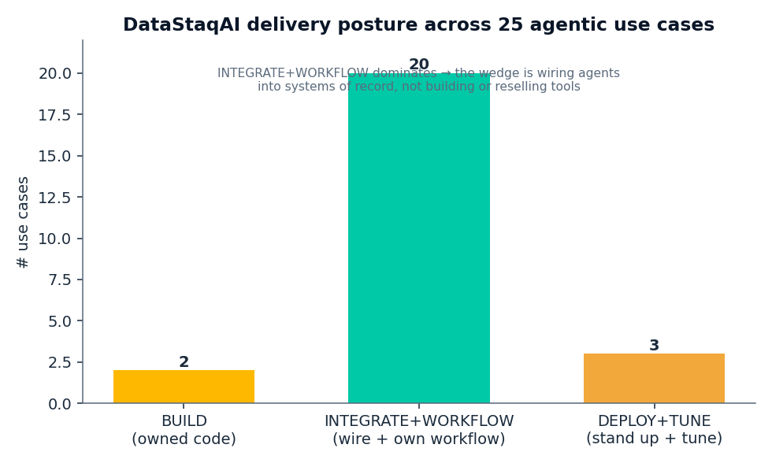
Figure: Delivery posture across 25 use cases

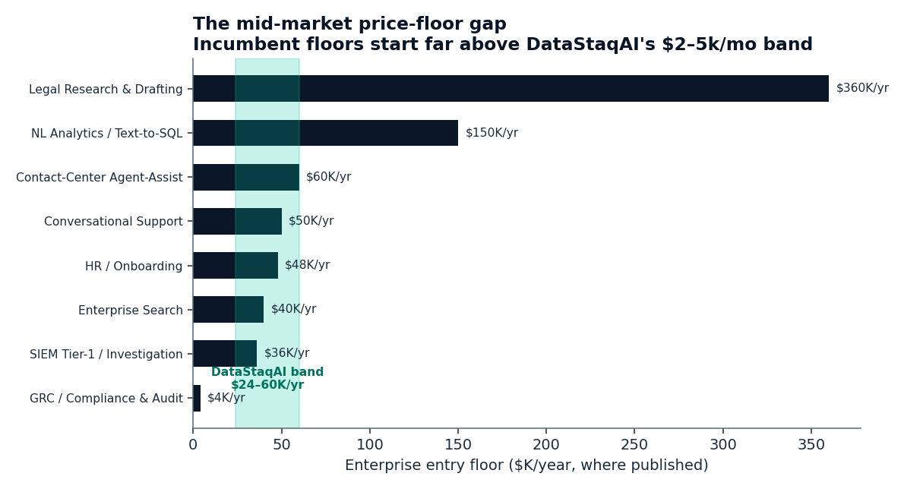
Figure: Mid-market price-floor gap

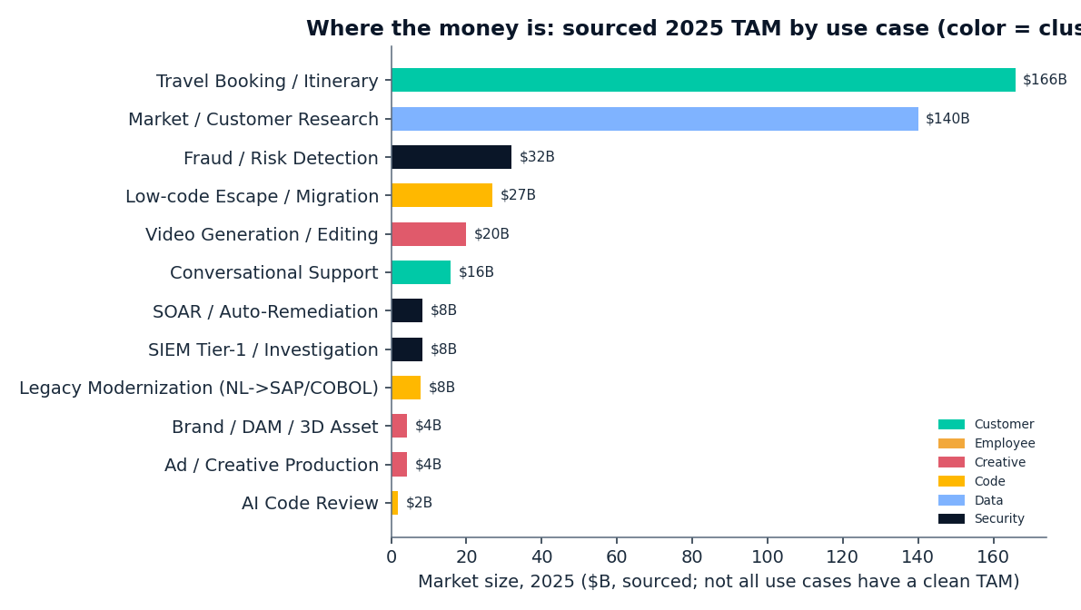
Figure: Sourced 2025 TAM by use case

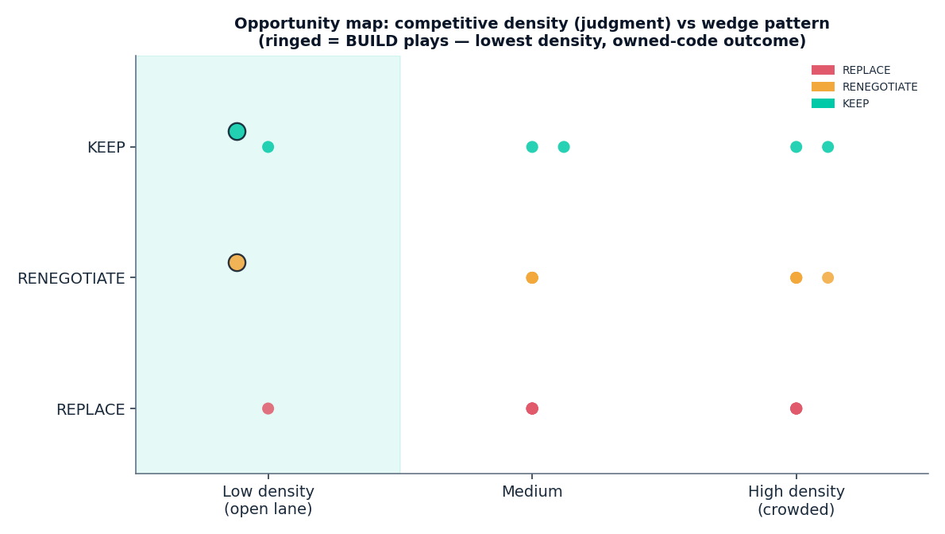
Figure: Opportunity map (density × pattern)

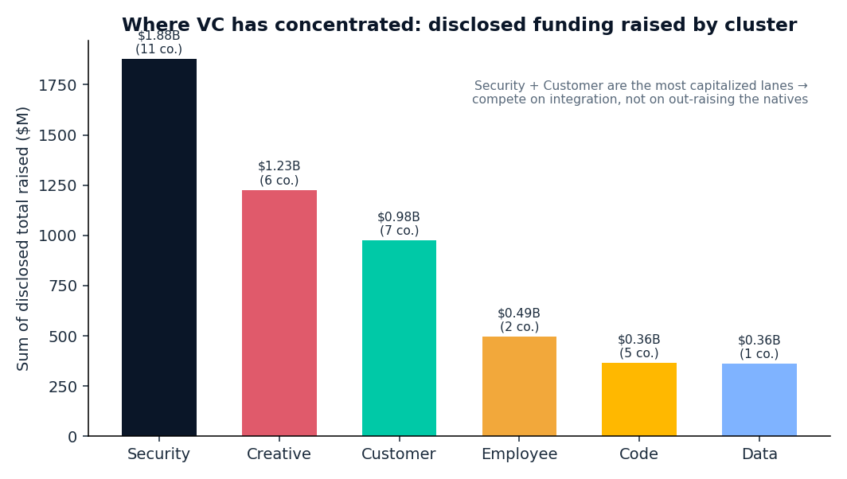
Figure: Disclosed funding by cluster

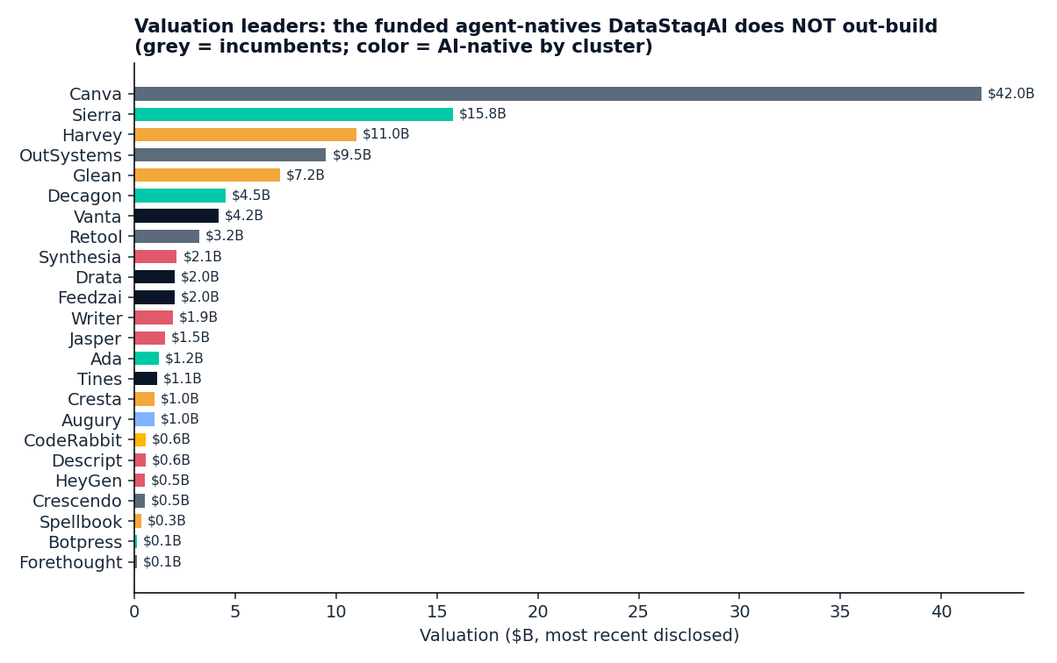
Figure: Valuation leaders

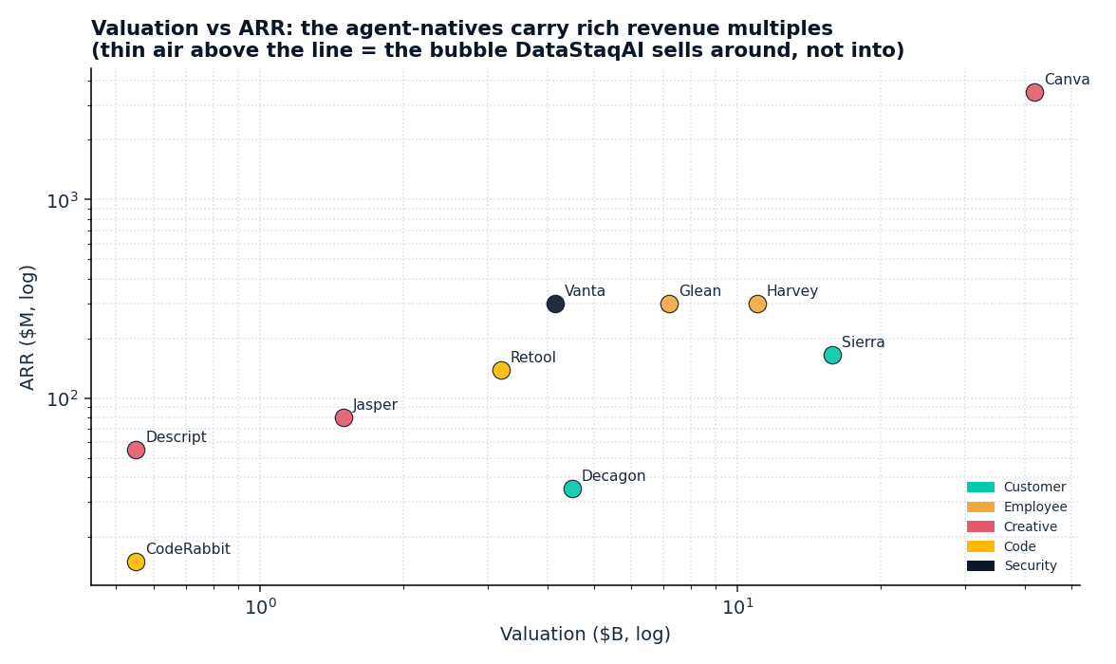
Figure: Valuation vs ARR

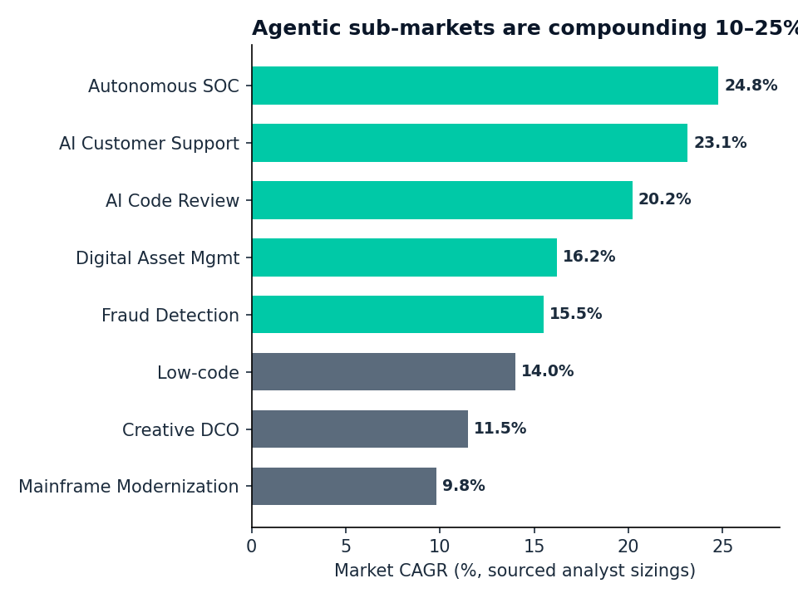
Figure: Agentic sub-market CAGRs

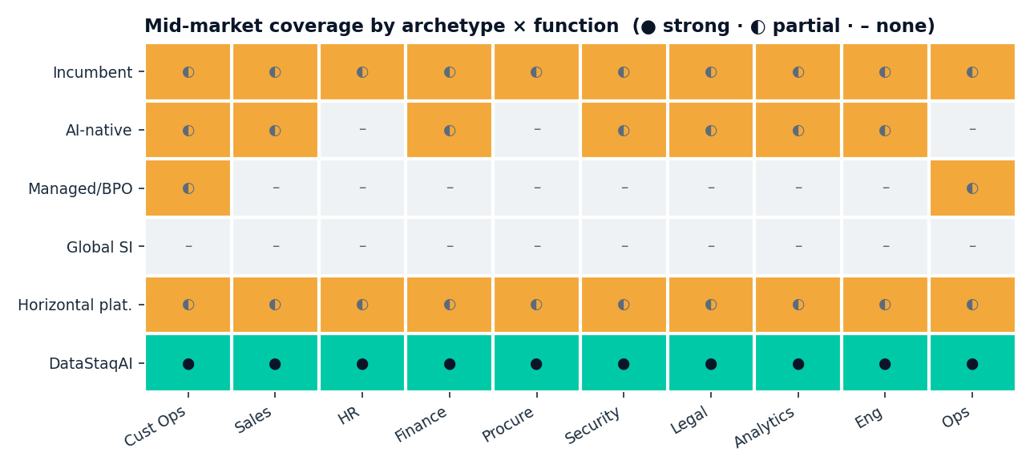
Figure: Mid-market coverage heat map

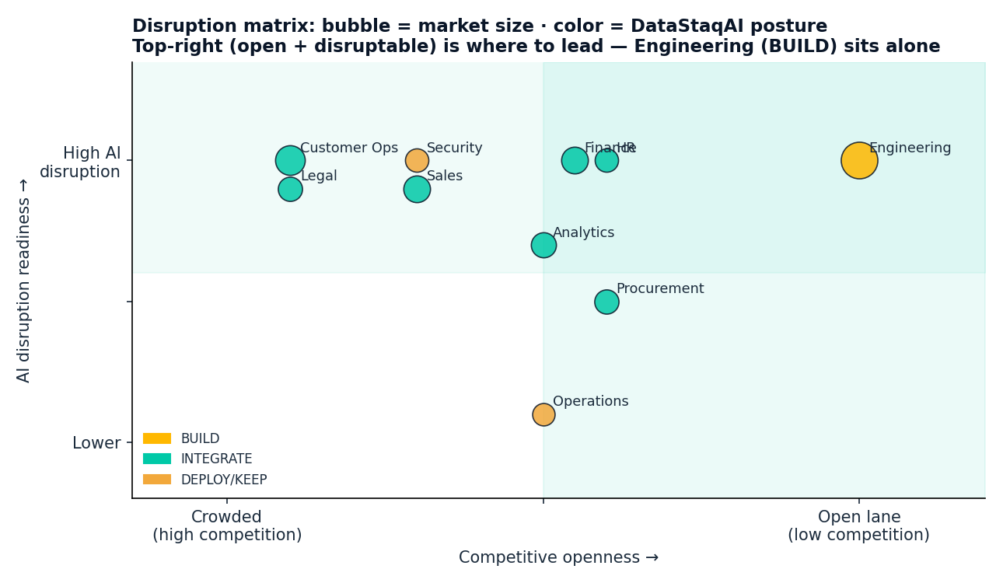
Figure: Disruption matrix

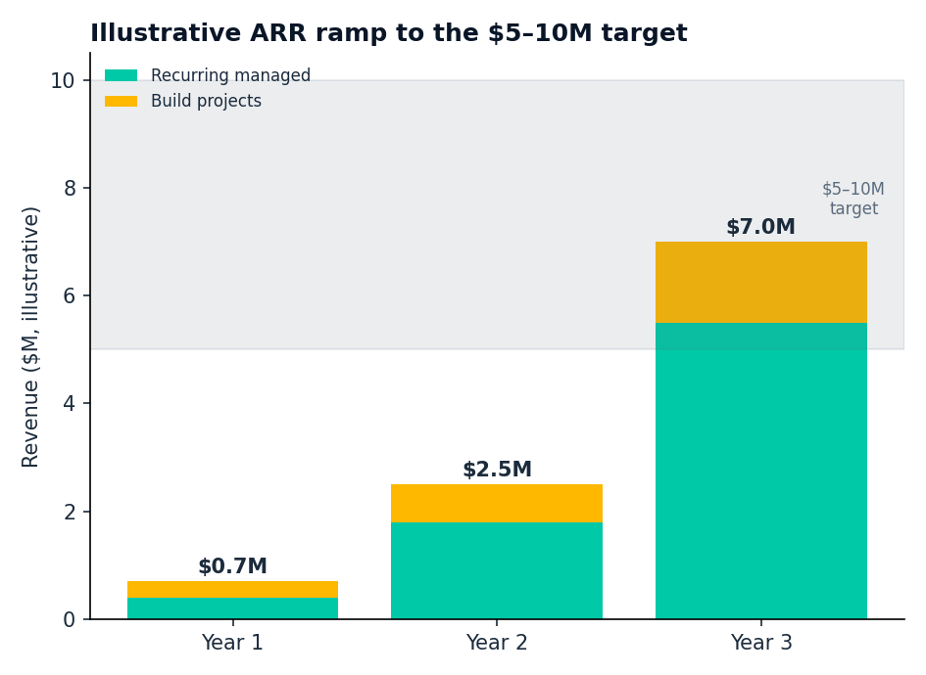
Figure: Illustrative ARR ramp to $5–10M

