***PRACTICAL: 1-A***

***AIM:*** Write a program to draw Line Plot

***CODE***

import matplotlib.pyplot as plt

x = [1, 2, 3, 4, 5]

y = [2, 4, 6, 8, 10]

plt.plot(x, y, marker='o', linestyle='-', color='b', label='Line')

plt.xlabel('X-axis')

plt.ylabel('Y-axis')

plt.title('48 - SHEKHAR SUMAN \n Line Plot Example')

plt.legend()

plt.show()

***OUTPUT***

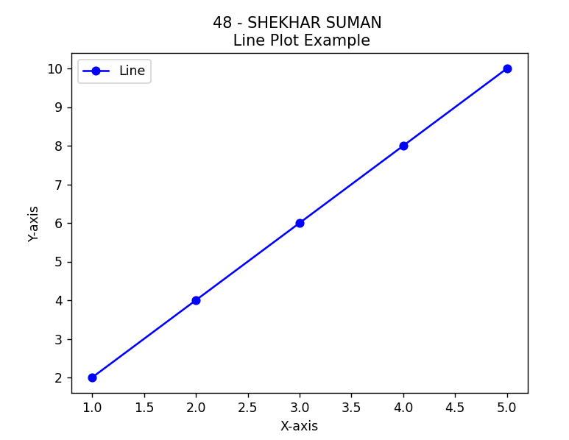

***PRACTICAL: 1-B***

***AIM:*** Write a program to Developed a Histogram chart

***CODE***

import matplotlib.pyplot as plt

import numpy as np

data = np.random.randn(1000)

plt.hist(data, bins=20, color='skyblue')

plt.xlabel('Values')

plt.ylabel('Frequency')

plt.title('48 - SHEKHAR SUMAAN \n Histogram Chart')

plt.show()

***OUTPUT***

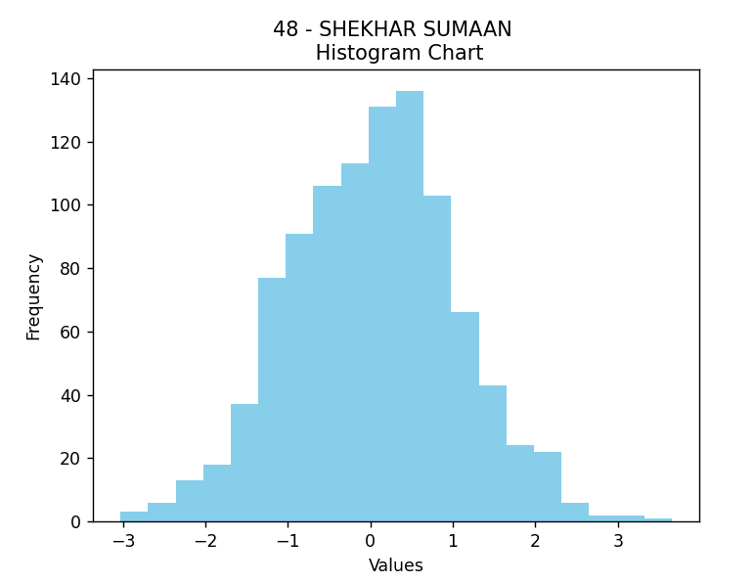

***PRACTICAL: 1-C***

***AIM:*** Write a program to developed Pie Chart

***CODE***

import matplotlib.pyplot as plt

sizes = [25, 30, 15, 20, 10]

labels = ['A', 'B', 'C', 'D', 'E']

plt.pie(sizes, labels=lables, autopct='%1.1f%%', startangle=90, colors=['red', 'green', 'blue', 'yellow', 'purple'])

plt.axis('equal')

plt.title('48 - SHEKHAR SUMAN \n Pie Chart')

plt.show()

***OUTPUT***

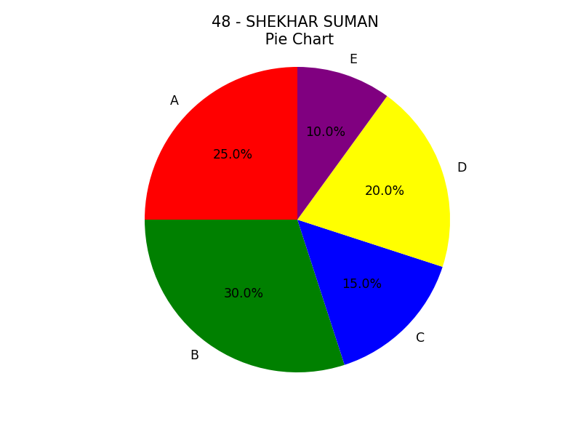

***PRACTICAL: 2-A***

***AIM:*** Draw a co-ordinate axis at the center of the screen.

***CODE***

import matplotlib.pyplot as plt

fig, ax = plt.subplots()

ax.set_xlim(-5, 5)

ax.set_ylim(-5, 5)

ax.axhline(0, color='black', lw=2)

ax.axvline(0, color='black', lw=2)

ax.set_xlabel('X-axis')

ax.set_ylabel('Y-axis')

ax.set_aspect('equal', adjustable='box')

plt.title('48 SHEKHAR SUMAN \n Co-ordinate axis at center')

plt.show()

***OUTPUT***

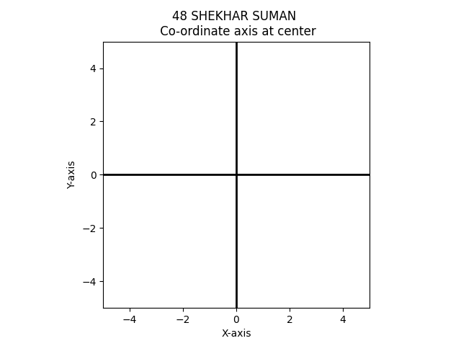

***PRACTICAL: 3-A***

***AIM:*** Write a program to draw basic shape.

***CODE***

import matplotlib.pyplot as plt

import matplotlib.patches as patches

fig, ax = plt.subplots()

circle = plt.Circle((0.5, 0.5), 0.4, edgecolor='black', facecolor='red')

ax.add_patch(circle)

rectangle = plt.Rectangle((0.2, 0.2), 0.6, 0.4, edgecolor='black', facecolor='green')

ax.add_patch(rectangle)

square = plt.Rectangle((0.2, 0.6), 0.4, 0.4, edgecolor='black', facecolor='blue')

ax.add_patch(square)

circle_outer = plt.Circle((0.8, 0.2), 0.2, edgecolor='black', facecolor='yellow')

circle_inner = plt.Circle((0.8, 0.2), 0.1, edgecolor='black', facecolor='orange')

ax.add_patch(circle_outer)

ax.add_patch(circle_inner)

ellipse = patches.Ellipse((0.5, 0.8), 0.4, 0.2, edgecolor='black', facecolor='purple')

ax.add_patch(ellipse)

line = plt.Line2D([0.2, 0.8], [0.8, 0.8], color='black', linewidth=2)

ax.add_line(line)

ax.set_xlim(0, 1)

ax.set_ylim(0, 1)

ax.set_aspect('equal', adjustable='box')

ax.axis('off')

plt.title('48 - SHEKHAR SUMAN \n BASIC SHAPES')

plt.show()

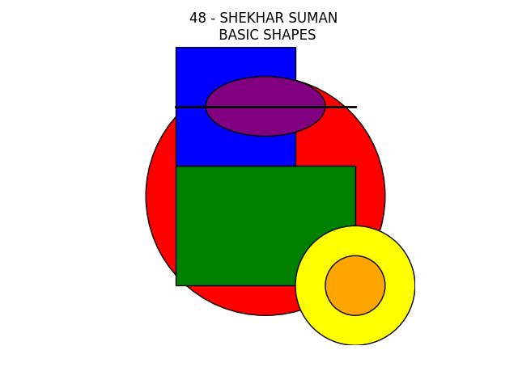***OUTPUT***

***PRACTICAL: 3-B***

***AIM:*** Write a program to draw a hut.

***CODE***

import matplotlib.pyplot as plt

import matplotlib.patches as patches

fig, ax = plt.subplots()

ax.add_patch(patches.Rectangle((0.1, 0.1), 0.8, 0.6, edgecolor='black', facecolor='tan'))

ax.add_patch(patches.Rectangle((0.35, 0.6), 0.3, 0.1, edgecolor='black', facecolor='saddlebrown'))

roof = plt.Polygon([(0.1, 0.7), (0.5, 1.0), (0.9, 0.7)], edgecolor='black', facecolor='firebrick')

ax.add_patch(roof)

ax.add_patch(patches.Rectangle((0.45, 0.1), 0.1, 0.3, edgecolor='black', facecolor='sienna'))

ax.add_patch(patches.Rectangle((0.2, 0.5), 0.2, 0.2, edgecolor='black', facecolor='lightblue'))

ax.add_patch(patches.Rectangle((0.6, 0.5), 0.2, 0.2, edgecolor='black', facecolor='lightblue'))

ax.set_xlim(0, 1)

ax.set_ylim(0, 1)

ax.axis('off')

plt.title('48 - SHEKHAR SUMAN \n DRAW A HUT')

plt.show()

***OUTPUT***

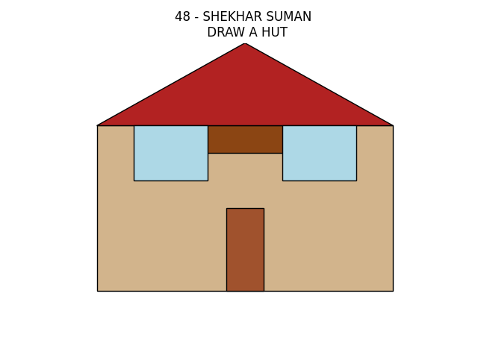

***PRACTICAL: 4-A***

***AIM:*** Write a program to developed **DDA Line drawing algorithm**

***CODE***

import matplotlib.pyplot as plt

def dda_line(x1, y1, x2, y2):

    dx = x2 - x1

    dy = y2 - y1

    steps = max(abs(dx), abs(dy))

    x_increment = dx / steps

    y_increment = dy / steps

    x, y = x1, y1

    x_points = [x]

    y_points = [y]

    for _ in range(steps):

        x += x_increment

        y += y_increment

        x_rounded = round(x)

        y_rounded = round(y)

        x_points.append(x_rounded)

        y_points.append(y_rounded)

    return x_points, y_points

x1, y1 = 2, 2

x2, y2 = 8, 5

x_points, y_points = dda_line(x1, y1, x2, y2)

plt.plot(x_points, y_points, marker='o', linestyle='-', color='b')

plt.title('48 - SHEKHAR SUMAN \n  DDA Line Drawing Algorithm')

plt.xlabel('X-axis')

plt.ylabel('Y-axis')

plt.grid(True)

plt.show()

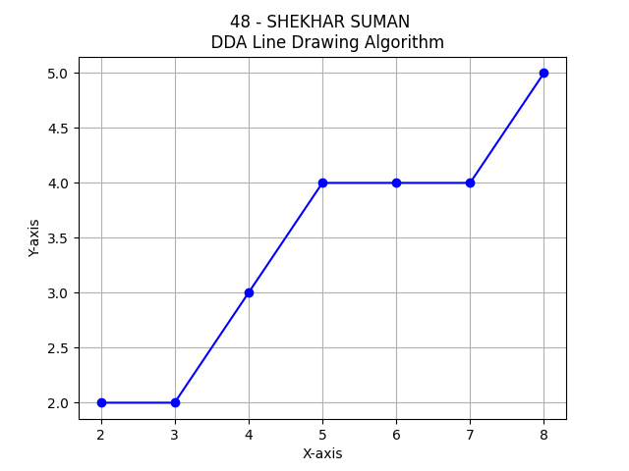***OUTPUT***

***PRACTICAL: 4-B***

***AIM:*** Write a program to developed **Bresenham's Line Drawing Algorithm**.

***CODE***

import matplotlib.pyplot as plt

def bresenham_line(x1, y1, x2, y2):

    dx = abs(x2 - x1)

    dy = abs(y2 - y1)

    sx = 1 if x1 < x2 else -1

    sy = 1 if y1 < y2 else -1

    x, y = x1, y1

    error = dx - dy

    x_points = [x]

    y_points = [y]

    while x != x2 or y != y2:

        x_points.append(x)

        y_points.append(y)

        error2 = 2 * error

        if error2 > -dy:

            error -= dy

            x += sx

        if error2 < dx:

            error += dx

            y += sy

    return x_points, y_points

x1, y1 = 2, 2

x2, y2 = 8, 5

x_points, y_points = bresenham_line(x1, y1, x2, y2)

plt.plot(x_points, y_points, marker='o', linestyle='-', color='b')

plt.title("48 - SHEKHAR SUMAN \n Bresenham's Line Drawing Algorithm")

plt.xlabel('X-axis')

plt.ylabel('Y-axis')

plt.grid(True)

plt.show()

***OUTPUT***

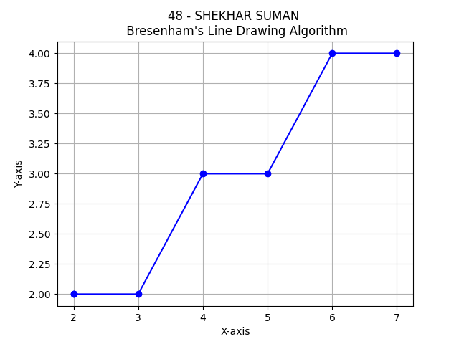

***PRACTICAL: 5-A***

***AIM:*** Write a program to developed **Midpoint Ellipse Drawing Algorithm**.

***CODE***

import matplotlib.pyplot as plt

def midpoint_ellipse(a, b):

    x, y = 0, b

    a_sqr = a**2

    b_sqr = b**2

    d1 = (b_sqr - (a_sqr * b) + 0.25 * a_sqr)

    dx = 2 * b_sqr * x

    dy = 2 * a_sqr * y

    x_points = []

    y_points = []

    plot_ellipse_points(x, y, x_points, y_points)

    while dx < dy:

        x += 1

        dx += 2 * b_sqr

        if d1 < 0:

            d1 += dx + b_sqr

        else:

            y -= 1

            dy -= 2 * a_sqr

            d1 += dx - dy + b_sqr

        plot_ellipse_points(x, y, x_points, y_points)

    d2 = b_sqr * (x + 0.5)**2 + a_sqr * (y - 1)**2 - a_sqr * b_sqr

    while y > 0:

        y -= 1

        dy -= 2 * a_sqr

        if d2 > 0:

            d2 += a_sqr - dy

        else:

            x += 1

            dx += 2 * b_sqr

            d2 += a_sqr + dx - dy

        plot_ellipse_points(x, y, x_points, y_points)

    return x_points, y_points

def plot_ellipse_points(x, y, x_points, y_points):

    x_points.extend([x, -x, x, -x])

    y_points.extend([y, y, -y, -y])

a, b = 5, 3

x_points, y_points = midpoint_ellipse(a, b)

plt.scatter(x_points, y_points, marker='.', color='b')

plt.title("48 - SHEKHAR SUMAN \n Midpoint Ellipse Drawing Algorithm")

plt.xlabel('X-axis')

plt.ylabel('Y-axis')

plt.axis('equal')

plt.grid(True)

plt.show()

***OUTPUT***

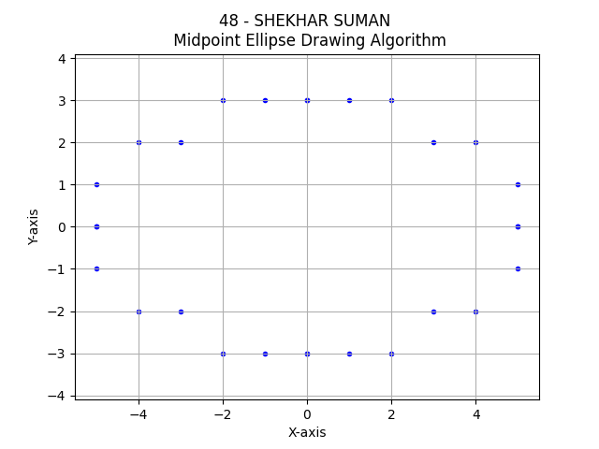

***PRACTICAL: 6-A***

***AIM:*** Write a program to developed **2D SCALING EXAMPLE**.

***CODE***

import matplotlib.pyplot as plt

def scale_2d(points, scale_factor):

    scaled_points = []

    for point in points:

        x, y = point

        scaled_x = x * scale_factor

        scaled_y = y * scale_factor

        scaled_points.append((scaled_x, scaled_y))

    return scaled_points

def plot_points(points, color='b', label=None):

    x, y = zip(*points)

    plt.scatter(x, y, color=color, label=label)

original_points = [(1, 1), (2, 3), (3, 2), (4, 4)]

scale_factor = 2

scaled_points = scale_2d(original_points, scale_factor)

plot_points(original_points, color='b', label='Original Points')

plot_points(scaled_points, color='r', label=f'Scaled Points (Factor: {scale_factor})')

plt.axis('equal')

plt.xlabel('X-axis')

plt.ylabel('Y-axis')

plt.title('48 - SHEKHAR SUMAN \n 2D SCALING EXAMPLE')

plt.legend()

plt.grid(True)

plt.show()

***OUTPUT***

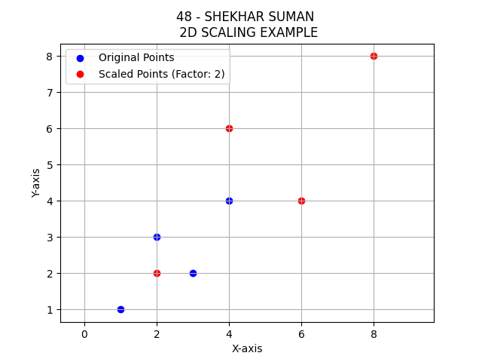

***PRACTICAL: 7-A***

***AIM:*** Write a program to developed **2D ROTATION EXAMPLE**.

***CODE***

import matplotlib.pyplot as plt

import numpy as np

def rotate_2d(points, angle_degrees, rotation_center=(0, 0)):

    angle_radians = np.radians(angle_degrees)

    cos_theta = np.cos(angle_radians)

    sin_theta = np.sin(angle_radians)

    rotated_points = []

    for point in points:

        x, y = point

        x_centered = x - rotation_center[0]

        y_centered = y - rotation_center[1]

        rotated_x = x_centered * cos_theta - y_centered * sin_theta

        rotated_y = x_centered * sin_theta + y_centered * cos_theta

        rotated_x += rotation_center[0]

        rotated_y += rotation_center[1]

        rotated_points.append((rotated_x, rotated_y))

    return rotated_points

def plot_points(points, color='b', label=None):

    x, y = zip(*points)

    plt.scatter(x, y, color=color, label=label)

original_points = [(1, 1), (2, 3), (3, 2), (4, 4)]

rotation_angle = 45

rotation_center = (2, 2)

rotated_points = rotate_2d(original_points, rotation_angle, rotation_center)

plot_points(original_points, color='b', label='Original Points')

plot_points(rotated_points, color='r', label=f'Rotated Points (Angle: {rotation_angle})')

plt.axis('equal')

plt.xlabel('X-axis')

plt.ylabel('Y-axis')

plt.title('48 - SHEKHAR SUMAAN \n 2D ROTATION EXAMPLE')

plt.legend()

plt.grid(True)

plt.show()

***OUTPUT***

