***PRACTICAL: 4***

**AIM:** Program using Temperature Sensors.

**Components Required:**

* **Arduino Uno** (Microcontroller Board)
* **2 Resistor(1 kΩ and 220 k Ω) (**220k **Ω** for protecting the LED, and 1k **Ω** for gas sensor**)**
* **Gas Sensor** (For Detecting the Gas)
* **LED (**For Blink when gas is detected)
* **Bread Board (**For Better Connection**)**

**CONNECTION:**

**Step 1: Connect the Gas Sensor**

1. Place the Gas Sensor on the breadboard.
2. Connect the VCC pin of the gas sensor to the 5V pin on the Arduino.
3. Connect the GND pin of the gas sensor to the GND pin on the Arduino.
4. Connect the Analog output (A0) of the gas sensor to Arduino’s Analog pin A0.
5. Connect a 1kΩ resistor between the A0 output pin and GND (this acts as a pull-down resistor for stable readings).

**Step 2: Connect the LED**

1. Place the LED on the breadboard (longer leg is anode (+), shorter leg is cathode (-)).
2. Connect the anode (long leg) of the LED to one end of the 220Ω resistor.
3. Connect the other end of the 220Ω resistor to Arduino digital pin 7.
4. Connect the cathode (short leg) of the LED to GND on the Arduino.

***DIAGRAM***

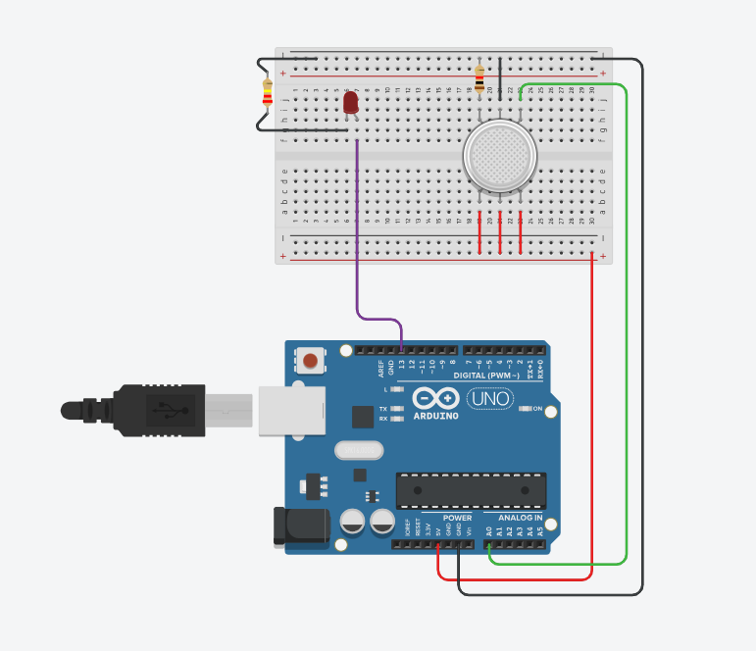

1. **In this diagram the gas is detected and the LED is turn ON.**

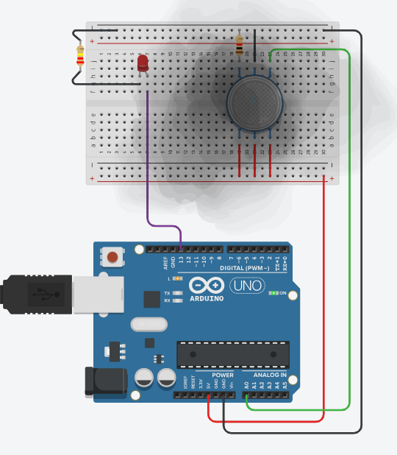

1. 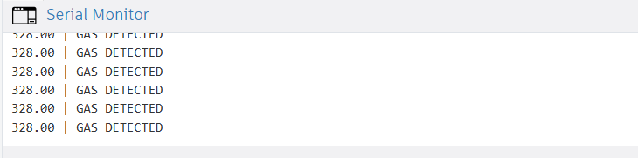**And the data is shown on the Serial monitor.**
2. **If the gas is little bit far from the gas sensor, then we can see the sensor value.**

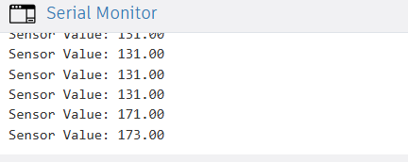

***CODE***

int LED = 13;

int MQ2pin = A0;

void setup() {

Serial.begin(9600);

pinMode(LED, OUTPUT);

}

void loop() {

float sensorValue;

sensorValue = analogRead(MQ2pin);

if (sensorValue >= 250) {

digitalWrite(LED, HIGH);

Serial.print(sensorValue);

Serial.println(" | GAS DETECTED");

} else {

digitalWrite(LED, LOW);

Serial.print("Sensor Value: ");

Serial.println(sensorValue);

}

delay(1000);

}