SMART DOOR LOCK

PRN No: Roll No: 45

- Name of the student: SHREYANSH SINGH
- Title of the project: SMART DOOR LOCK

- Name of the Guide: Mrs. Palak Agrawat

- Teaching experience of guide: 5 Years
- Is this your first submission? : Yes

Signature of Student Signature of Guide

Date: Date:

Signature of the Coordinator
Date:

SMART DOOR LOCK

A Project Report
Submitted in partial fulfillment of the Requirements for the award of the Degree of

BACHELOR OF SCIENCE (INFORMATION TECHNOLOGY)

By
SHREYANSH SINGH Roll No: - 45

Under the esteemed guidance of
Mrs. Palak Agrawat
(HOD of IT Department)



DEPARTMENT OF INFORMATION TECHNOLOGY
ST. ROCK’S COLLEGE OF ARTS, COMMERCE AND SCIENCE
(Affiliated to University of Mumbai) MUMBAI- 400092 MAHARASHTRA
2024-2025

ST. ROCK’S COLLEGE OF ARTS, COMMERCE AND SCIENCE
(Affiliated to University of Mumbai)
MUMBAI-MAHARASHTRA-400092

DEPARTMENT OF INFORMATION TECHNOLOGY

CERTIFICATE

This is to certify that the project entitled, "SMART DOOR LOCK", is bonafied work of SHREYANSH SINGH bearing Roll No: 45 submitted in partial fulfillment of the requirements for the award of degree of BACHELOR OF SCIENCE in INFORMATION TECHNOLOGY from University of Mumbai.

Internal Guide Coordinator

External Examiner

Date: College Seal

ABSTRACT
This project presents the design and development of an IoT-based Smart Door Lock System that combines multiple authentication methods for enhanced security and convenience. The system is powered by an Arduino Uno microcontroller and integrates an RFID module, keypad, and mobile phone application for door access control. Users can unlock the door using an RFID card or tag, by entering a secure passcode on the keypad, or remotely through a connected smartphone. Additionally, the system features a time-based access function that grants entry only during predefined hours—such as allowing domestic staff access at specific times—thereby preventing unauthorized use outside permitted periods. A servo motor is employed to control the door’s locking mechanism, while an LCD display provides real-time feedback on system status. By merging IoT connectivity, automation, and secure authentication, this project demonstrates an efficient and reliable solution for modern smart home security. Testing confirms its effective operation across all authentication modes and accurate enforcement of time-based restrictions.

TABLE OF CONTENTS
- Introduction 6
  - Background 6
  - Aim and Objectives 6
  - Purpose, scope and Applicability 8
    - Purpose 8
    - Scope 9
    - Applicability 10
- Survey of Technologies 11
  - Existing System 11
  - Proposed System (SMART DOOR LOCK) 12
- Requirements and Analysis 16
  - Problem Definition 16
  - Requirement Specification 17
    - Functional Requirement 8
    - Non Functional Requirement 9
  - Planning and Scheduling 18
    - Gant Chart 18
    - Pert Chart 18
  - Software and Hardware Requirement
    - Software Requirements 18
    - Hardware Requirements 18
  - Conceptual Model
    - Block Diagram 18
    - Class Diagram 18
    - Flow Chart
    - Circuit Diagram
- System Design 20
  - Basic Modules 20
  - Procedural Design
  - Algorithm Design

Chapter 1

Introduction

Background

The concept of home security has evolved rapidly with the rise of the Internet of Things (IoT), which enables everyday devices to communicate and be controlled remotely. Traditional door locking systems—based on physical keys or basic electronic locks—often fail to meet the growing need for smarter, more secure, and convenient access control. Such systems lack flexibility, remote accessibility, and intelligent monitoring capabilities, leaving homes and offices vulnerable to unauthorized access and manual tampering.
To address these limitations, modern security systems are integrating IoT technologies that combine multiple authentication methods and real-time monitoring. This project takes that step forward by developing a Smart Door Lock System that merges RFID, keypad, and mobile-based control on a single platform. Unlike conventional locks that rely on one access method, this system offers multi-level authentication, improving both convenience and security.
An additional innovation introduced in this project is time-based access control, designed for situations like granting entry to domestic staff or delivery personnel only during specific hours. By linking the system to real-time clocks and mobile communication, the door automatically restricts access outside predefined schedules—eliminating human error and enhancing safety.
Built around the Arduino Mega microcontroller, the system demonstrates how IoT and embedded technology can transform ordinary locks into intelligent, automated devices. The combination of hardware modules—RFID reader, keypad, servo motor, LCD, and Wi-Fi interface—enables a seamless, flexible, and reliable security solution. Ultimately, this project represents a step toward smarter living environments where technology provides both security and control at the user’s fingertips.

Aim and Objectives

The primary aim of this project is to design and implement a secure, intelligent, and IoT-enabled Smart Door Lock System using the Arduino Mega microcontroller. The system will integrate multiple authentication methods—RFID access, keypad entry, and smartphone-based remote unlocking—into a single cohesive platform. Additionally, it will incorporate time-based access control to restrict door operation to specific authorized hours. The ultimate goal is to create a reliable, user-friendly, and technologically advanced smart locking mechanism that enhances security, convenience, and automation in modern households and workplaces.

Objectives
The following objectives outline the steps necessary to achieve the project’s aim:
- Core System Integration:
To interface the Arduino Mega microcontroller with essential hardware components such as the RFID reader, keypad, servo motor, LCD display, and Wi-Fi module. To ensure seamless communication between all modules for smooth operation and data handling.
- Multi-Authentication Implementation:
To design and program the system to support three authentication methods—RFID card/tag verification, keypad password entry, and smartphone-based unlocking through an IoT connection. To establish a secure verification algorithm that accurately identifies authorized users.
- Time-Based Access Control:
To integrate a Real-Time Clock (RTC) module that enables the system to verify access attempts based on pre-defined time intervals. This ensures that specific users, such as domestic staff, can only unlock the door during their allotted time slots.
- IoT Connectivity and Remote Access:
To enable mobile-based unlocking via Wi-Fi or internet connection, allowing authorized users to control the door remotely. To implement secure communication between the mobile interface and the Arduino system for real-time monitoring and operation.

- System Monitoring and User Feedback:
To utilize an LCD display for providing real-time system status messages, such as access granted/denied, and to ensure the user is constantly informed of the lock’s operational state.
- Testing, Validation, and Security Optimization:
To conduct systematic testing of all authentication methods, verifying reliability, response time, and accuracy under various conditions. To strengthen system security by implementing safeguards against unauthorized access and ensuring consistent performance of the servo locking mechanism.

Purpose, scope and Applicability

Purpose

The main purpose of this project goes beyond assembling a basic locking mechanism; it is to design, implement, and validate a fully functional IoT-based Smart Door Lock System that demonstrates advanced features of automation, security, and remote accessibility. This prototype aims to achieve and showcase three essential outcomes in modern smart security systems:

- Demonstrating Multi-Mode Secure Access:
The project integrates three authentication modes for unlocking the door—RFID card/tag scanning, keypad-based password entry, and smartphone-controlled remote access. These methods collectively ensure convenience, security, and flexibility, allowing users to choose their preferred mode of operation while maintaining robust access control.

- Enhancing Intelligent Time-Based Access Management:
The system introduces a time-restricted access feature, where specific users—such as domestic workers—are permitted entry only during predefined hours. This ensures the lock functions intelligently, granting access solely when authorized and automatically denying it outside the scheduled time window.

- Advancing Smart Home Integration and IoT Learning:
This project not only functions as a secure home automation prototype but also serves as a valuable educational tool for understanding IoT concepts, real-time control, and embedded systems integration. It provides hands-on experience with microcontroller interfacing, sensor communication, and cloud-based connectivity.

Scope

The scope of this project has been carefully defined to ensure all objectives are realistic within the constraints of time, resources, and hardware limitations of the Arduino platform. The implementation and results are limited to the following functional domains:

Hardware and Platform Constraints:
The system is entirely built around the Arduino Mega microcontroller, which restricts the project to basic embedded-level computing. Hardware components include an RFID module, keypad, servo motor, LCD display, and a Wi-Fi module for IoT connectivity. The servo motor is designed to operate a small-to-medium locking mechanism and is not intended for heavy-duty or commercial door locks.

Connectivity and Control Constraints:
The IoT control functionality is achieved through Wi-Fi communication between the Arduino and a smartphone interface or cloud platform. Remote unlocking is limited to authenticated users within the same network or via a secure internet connection. Advanced features like fingerprint scanning, facial recognition, or encrypted cloud databases are beyond the scope of this prototype.

Access and Functional Constraints:
The time-based access feature is limited to fixed, pre-programmed schedules stored in the Arduino’s memory or updated through a basic mobile interface. The project does not include automatic user registration, dynamic cloud synchronization, or large-scale data management. It focuses on demonstrating reliable local validation of credentials and time-bound access control.

Applicability

The SMART DOOR LOCK system holds significant applicability across multiple domains of daily life and professional use. In residential settings, it offers enhanced security, convenience, and automation by allowing homeowners to monitor and control door access remotely. In commercial and institutional environments, it can be used to manage employee entry during working hours or restrict access to sensitive areas.
From an educational perspective, this project provides an excellent foundation for students to learn about IoT integration, embedded programming, and access control systems. It bridges theoretical learning with real-world implementation of microcontrollers and smart technologies. Professionally, the same concept can be scaled for industrial automation, smart office entry systems, and secure facility management where multi-authentication and time-based access are essential. Its modular design and IoT capability make it a versatile, expandable solution for future innovations in smart home and security automation.

Chapter 2

Survey of Techonologies

Existing System

Currently, most door locking mechanisms used in homes and offices rely heavily on traditional mechanical locks, keypad-based electronic locks, or RFID-enabled systems. While these methods provide a certain level of convenience, they still suffer from several limitations that restrict flexibility, monitoring, and overall security. Many existing systems operate as standalone units without any form of IoT integration, which prevents remote control and real-time alerts.
- Lack of Remote Monitoring and Control:
Traditional locks and even some electronic systems do not provide users with the ability to monitor or control door access remotely. In case the user forgets to lock the door or wants to provide access to someone while away, such systems offer no remote operability.
- Limited Security and Alert Mechanisms:
Existing door locks generally lack intrusion detection and alert capabilities. If unauthorized access occurs, users are not immediately informed. There is no provision for sending notifications or triggering alarms during suspicious activity, which compromises security.
- Dependence on Single Authentication Methods:
Most existing systems rely solely on one form of authentication—such as a key, password, or RFID tag. This single-layer security approach makes the system vulnerable to duplication, hacking, or loss of access credentials.

Proposed System (SMART DOOR LOCK)

The proposed SMART DOOR LOCK system addresses the limitations of existing technologies by integrating secure authentication, real-time monitoring, and wireless control into a single, cost-effective, and user-friendly platform. Built around an ESP8266 (NodeMCU) microcontroller, this system leverages Internet of Things (IoT) technology to enable users to control and monitor door access from anywhere using a smartphone or web-based application.

- IoT-Enabled Remote Access and Control:
The system connects to a cloud platform via Wi-Fi, allowing users to lock or unlock the door remotely through a mobile application (e.g., Blynk or ThingSpeak). Users can monitor door status in real-time and receive alerts about any unauthorized attempts or forced entries.

- Enhanced Security through Multi-Authentication:
To strengthen access control, the system supports multiple authentication methods such as keypad password input, RFID scanning, or fingerprint verification. This ensures that only authorized users can gain entry, significantly improving overall security.

- Real-Time Alerts and Data Logging:
Whenever an access event occurs, the system instantly sends a notification or alert message to the registered user’s smartphone. It also maintains a record of access logs (time, date, and type of user access) for future reference, making the system both secure and transparent.

- User-Friendly and Cost-Effective Design:
The project utilizes open-source hardware and software, making it affordable for students, hobbyists, and small institutions. The interface is designed to be intuitive, requiring minimal technical knowledge to operate. Additionally, the modular structure allows easy customization and expansion, such as integrating additional sensors or linking with a home automation system.

- Scalability and Real-World Applicability:
The design concept can be easily extended for smart home applications, office access management, and industrial automation systems. Its scalable architecture enables future enhancements like voice control, biometric recognition, and AI-based intrusion detection, ensuring adaptability to future technological advancements.

Chapter 3

Requirements and Analysis

3.1 Problem Definition

The growing demand for smart home security has created the need for an advanced, reliable, and flexible door locking system that provides both security and remote accessibility. Traditional mechanical locks and basic electronic systems often fail to deliver convenience, monitoring, and authentication control. Therefore, the central problem is to design and develop a cost-effective IoT-enabled door lock that combines RFID, keypad access, and mobile app control, along with time-based authorization for specific users such as housekeepers or maintenance staff.

The main challenge lies in integrating multiple authentication methods, ensuring secure communication between devices, and maintaining system reliability and responsiveness while operating in real-time.

Key Research Challenges Addressed

Multi-Authentication Integration and Synchronization:
The system must efficiently manage multiple access methods — RFID cards, keypad passwords, and mobile-based control — ensuring that each input is processed securely and accurately without delay. Synchronizing these modules on a single microcontroller while avoiding processing conflicts is a significant challenge.

IoT-Based Remote Control and Monitoring:
Implementing Wi-Fi-based connectivity to allow users to control and monitor the lock remotely through a mobile application requires secure, real-time data transmission to prevent unauthorized access or hacking attempts.

Time-Based Access Authorization:
Developing a time-controlled authentication system for specific users (e.g., maid or delivery personnel) is crucial. The challenge is to design an accurate time-checking algorithm that allows unlocking only during predefined schedules and restricts access outside those hours.

Security and Data Integrity:
Ensuring that data communication between the microcontroller, server, and mobile application remains encrypted and protected from cyber threats. Preventing unauthorized duplication of RFID tags or guessing of passcodes is vital.

Power Efficiency and System Reliability:
The system must operate reliably even under fluctuating power conditions. Designing efficient power management and backup options ensures continuous operation without compromising security.

Requirement Specification

3.2.1 Functional Requirements

- RFID-Based Access Control:
The system must recognize registered RFID tags/cards and unlock the door when an authorized tag is presented. Unauthorized tags must be denied access with an alert on the display or mobile app.
- Keypad Authentication:
Users must be able to unlock the door by entering a correct numeric password on the keypad. Multiple incorrect attempts should trigger a security alert or lockout period.
- Mobile App Control via IoT:
Users can remotely lock/unlock the door using a mobile application connected through Wi-Fi. The app should display door status (Locked/Unlocked) in real-time.
- Time-Based Access Management:
The system must allow predefined access schedules for specific users (like maids or maintenance staff). If access is requested outside the allowed time frame, the system must reject it automatically.
- LCD Display Feedback:
The LCD should display the current system status — “Door Locked,” “Access Granted,” “Access Denied,” or “Invalid Input.”
- Data Logging and Alerts:
Every access attempt should be recorded with a timestamp and user ID. Alerts should be sent to the owner’s smartphone in case of unauthorized access attempts.
- Servo Motor Operation:
The servo motor should rotate to open or close the door latch when access is granted, and return to its locked position after a short delay.

3.2.2 Non-Functional Requirements

- Performance:
The system must respond to any authentication request (RFID, keypad, or app) within 1 second. The Wi-Fi connection should remain stable within a 10-meter range indoors.
- Reliability:
The smart lock should operate continuously without malfunction for at least 48 hours of active usage. It must remain functional even during short power interruptions through a backup source.
- Usability:
The system should feature an easy-to-use mobile app and a clear LCD interface, allowing operation by users with minimal technical skills.
- Security:
All communication between the IoT device and the cloud/mobile app must use secure encryption protocols. Access data must be stored securely to prevent tampering or unauthorized modification.
- Cost Efficiency:
The system should be designed using readily available and low-cost components such as Arduino Mega, RFID module, and servo motor while maintaining durability and performance.
- Maintainability and Scalability:
The software code should be modular to allow easy updates and the addition of new features, such as fingerprint sensors or camera integration, in the future.
By meeting these requirements, the proposed system ensures an optimal balance of security, flexibility, affordability, and reliability for modern smart home applications.

Planning and Scheduling

Proper planning and scheduling are essential for developing a well-functioning IoT-based smart door lock. The process is divided into stages covering system design, coding, integration, and testing

Gantt Chart
A Gantt chart visually represents the timeline of the project, including key tasks such as hardware setup, software programming, integration, testing, and documentation.
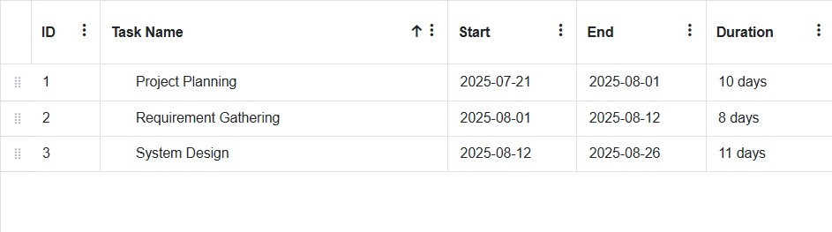
Figure 1: Gantt Chart 1

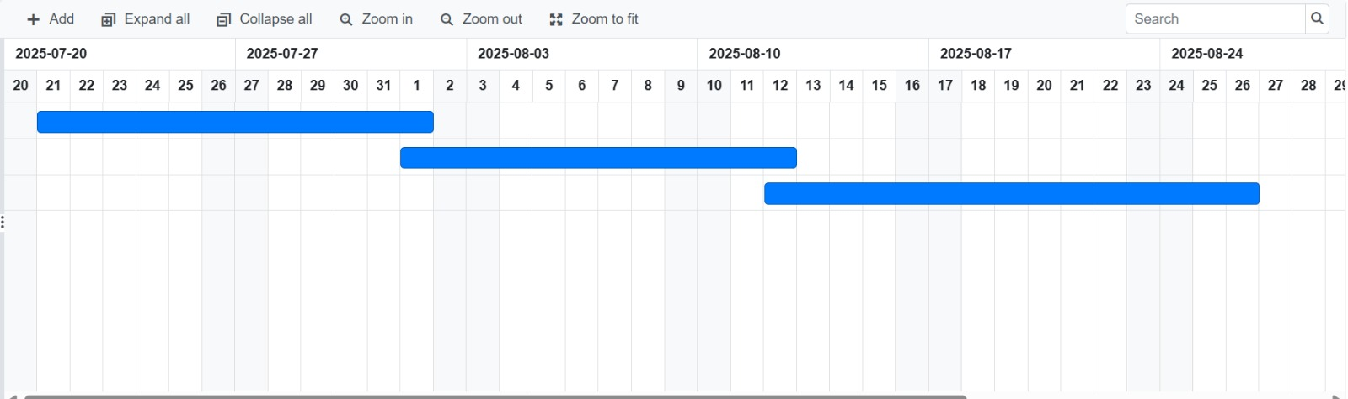
Figure 2: Gantt Chart 2

Pert Chart

A PERT (Program Evaluation and Review Technique) chart illustrates the project’s workflow, dependencies, and task completion order. It ensures systematic progress and efficient time management.

Software and Hardware Requirements

Software Requirements

Programming Environment: Arduino IDE (for coding and uploading to Arduino Mega)

Programming Language: Embedded C/C++ (Arduino Sketch)

IoT Platform: Blynk / ThingSpeak / Firebase (for remote access and data logging)

Communication Protocols: MQTT / HTTP (for IoT connectivity)

Mobile Application: Blynk App or custom Android App (for lock/unlock and monitoring)

Hardware Requirements

Microcontroller: Arduino Mega (main controller for the system)

Wi-Fi Module: ESP8266 / NodeMCU (for IoT connectivity and cloud communication)

RFID Module: RC522 (for card and tag scanning)

RFID Tags/Cards: For registered user access

Keypad: 4x4 Matrix Keypad (for password entry)

Servo Motor: SG90 or MG996R (for door locking/unlocking mechanism)

LCD Display: 16x2 LCD (for displaying status and messages)

Buzzer: For alert signals (invalid access or lock errors)

Power Supply: 12V DC adapter or rechargeable battery (with backup)

Jumper Wires and Breadboard: For prototyping and connections

Conceptual Model

Block Diagram

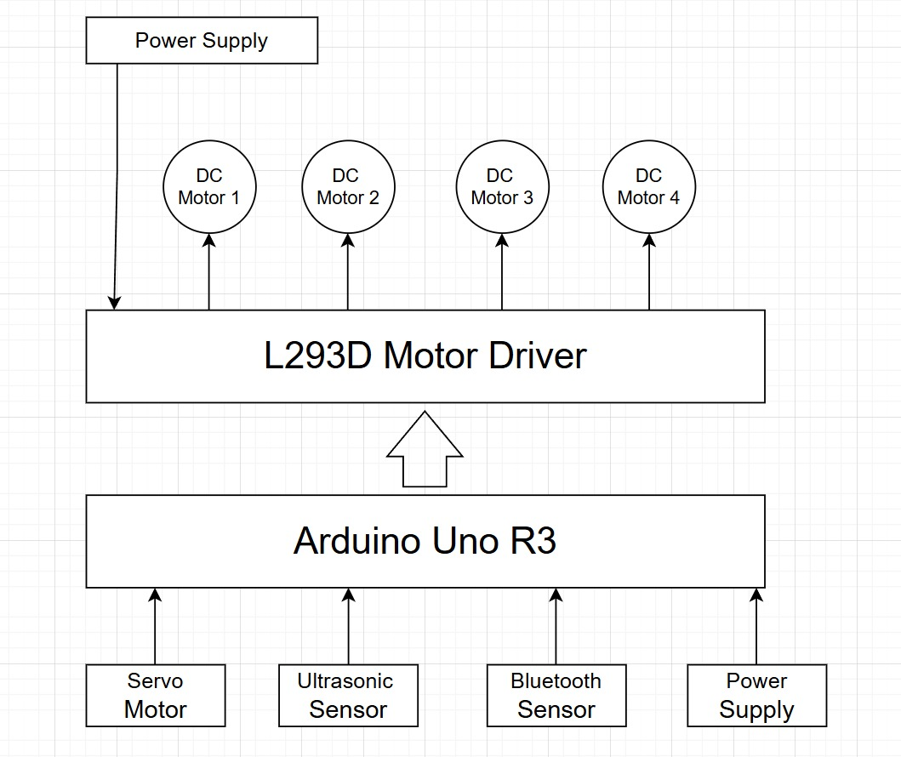

Class Diagram
Figure 4: Block Diagram

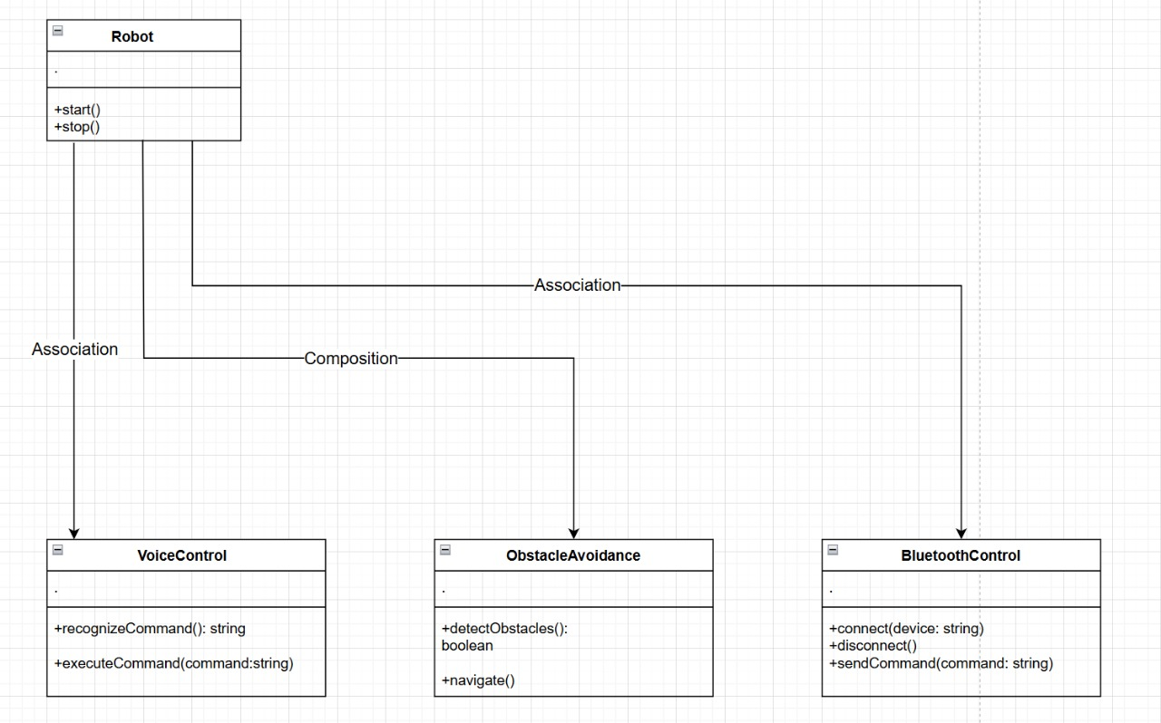

Figure 5: Class Diagram

Flow Chart

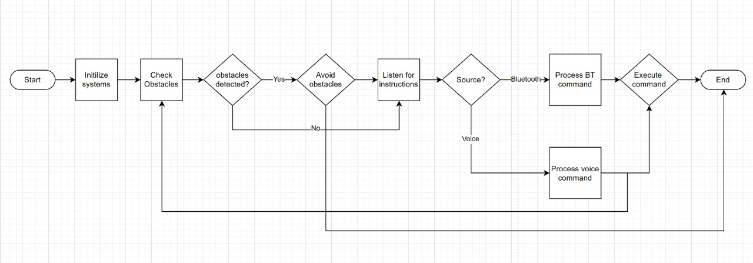

Figure 6: Flow Chart

Circuit Diagram

Chapter 4

System Design

The system design phase translates the conceptual model into a detailed framework that defines how software and hardware components interact to achieve the intended functionality of the IoT-based Smart Door Lock system. It focuses on the architecture, module division, and algorithms used to ensure secure, reliable, and efficient door access control.

4.1 Basic Modules

The Smart Door Lock system is divided into several interdependent modules. Each module performs a specific function that collectively ensures system stability, security, and user convenience.

1. Authentication Module

Function: Verifies user identity before granting access.

Description:
This module uses IoT integration (via mobile app or web dashboard) to authenticate users through credentials such as passwords, RFID cards, or fingerprint sensors. Data is verified against pre-stored credentials in the microcontroller’s memory or cloud database.

Inputs: User credentials (RFID tag, fingerprint, password, or mobile app command).

Outputs: Authentication result (Access Granted / Access Denied).

2. Lock Control Module

Function: Controls the physical locking/unlocking mechanism.

Description:
Once authentication is successful, this module drives the servo motor or solenoid lock to physically open or close the door. It receives a signal from the controller based on authentication results and executes the action.

Inputs: Authentication success signal.

Outputs: Mechanical lock actuation (open/close).

3. IoT Communication Module

Function: Provides wireless connectivity between the system and the user’s smartphone.

Description:
This module uses a Wi-Fi module (like ESP8266/ESP32) or Bluetooth module (HC-05) to connect to a mobile app or cloud server. It transmits door status, logs, and alerts, and receives open/close commands from the user in real time.

Inputs: Commands from smartphone / cloud server.

4. Monitoring and Alert Module

Function: Monitors door activity and provides security notifications.

Description:
The system keeps a log of door usage (who accessed and when) and triggers alerts during unauthorized access attempts. Notifications can be sent to the user’s mobile app or email via IoT cloud services like Blynk, ThingSpeak, or Firebase.

Inputs: Access logs, intrusion signals (from sensors).

Outputs: Real-time alerts and logs.

5. Power and Safety Module

Function: Ensures reliable power supply and safe operation.

Description:
The module provides stable DC voltage to the system using adapters or rechargeable batteries. A backup battery ensures operation during power failures. It may include a voltage regulator circuit for protection.

Inputs: 12V DC input.

Outputs: 5V regulated output to microcontroller and peripherals.

4.2 Procedural Design

The procedural design defines the step-by-step functioning of the Smart Door Lock system from initialization to operation. It highlights how different modules interact during the authentication and control process.

Step 1: System Initialization

Power is supplied to the system.

The microcontroller (e.g., Arduino UNO or ESP32) initializes all sensors, Wi-Fi modules, and the locking mechanism.

The system connects to the local Wi-Fi network or Bluetooth-enabled device.

Step 2: User Authentication

The user attempts to unlock the door using one of the following:

Mobile app (IoT command)

RFID card

Fingerprint scanner

Keypad password entry

The input data is read and verified against the stored credentials in memory or the IoT cloud database.

Step 3: Decision and Access Control

If the credentials match, the system sends a signal to the servo/solenoid lock to unlock the door.

If verification fails, an access denied message is displayed or sent to the user.

Step 4: Monitoring and Logging

Each access event (successful or failed) is logged with a timestamp.

If multiple failed attempts occur, the system triggers an intrusion alert.

Step 5: Remote IoT Control

The user can check the lock status and remotely operate it via the IoT platform.

The system regularly sends data (lock status, power level, and event logs) to the cloud.

Step 6: Safety and Power Management

The system continuously monitors voltage levels and switches to backup power when needed.

If no user activity is detected for a specific duration, it enters low-power mode.

4.3 Algorithm Design

The following algorithm outlines the logical flow of operations in the IoT-based Smart Door Lock system.

Algorithm: Smart Door Lock Operation

Step 1: Start the system.
Step 2: Initialize microcontroller, Wi-Fi/Bluetooth module, and input sensors.
Step 3: Establish network connection (to mobile app or IoT cloud).
Step 4: Wait for user input (RFID, password, or mobile command).
Step 5:
If input received → proceed to authentication.
Else → continue monitoring.
Step 6: Compare input with stored authorized credentials.
- If credentials match, go to Step 7.
- Else, display “Access Denied” and trigger alert (if configured).
Step 7: Send unlock signal to servo/solenoid.
Step 8: Unlock door → Display/Send “Access Granted” message.
Step 9: Wait for preset timeout (e.g., 10 seconds).
Step 10: Lock the door automatically and update system status.
Step 11: Log event in memory or send to cloud.
Step 12: Return to monitoring mode and repeat from Step 4.

Algorithm for Intrusion Alert

Step 1: Monitor unauthorized access attempts.
Step 2: If failed attempts ≥ 3:
→ Activate buzzer or alarm.
→ Send intrusion alert via IoT notification (e.g., Blynk or Firebase).
Step 3: Log event for user review.
Step 4: Reset counter after user verification.

