Linux Basics Assignment
Name: Chander Shekhar
Course: DEVOPS

Task 1: Creating and Renaming Files/Directories
Command:
mkdir test_dir
touch test_dir/example.txt
mv test_dir/example.txt test_dir/renamed_example.txt

Explanation:
Created a directory, created an empty file and renamed it using mv.
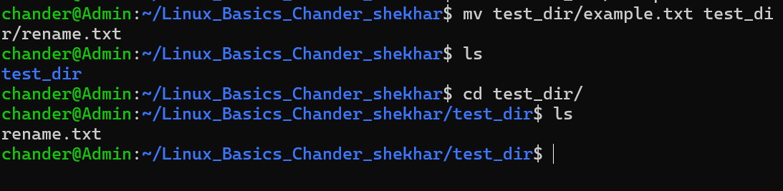

Task 2: Viewing File Contents

Command:
cat /etc/passwd
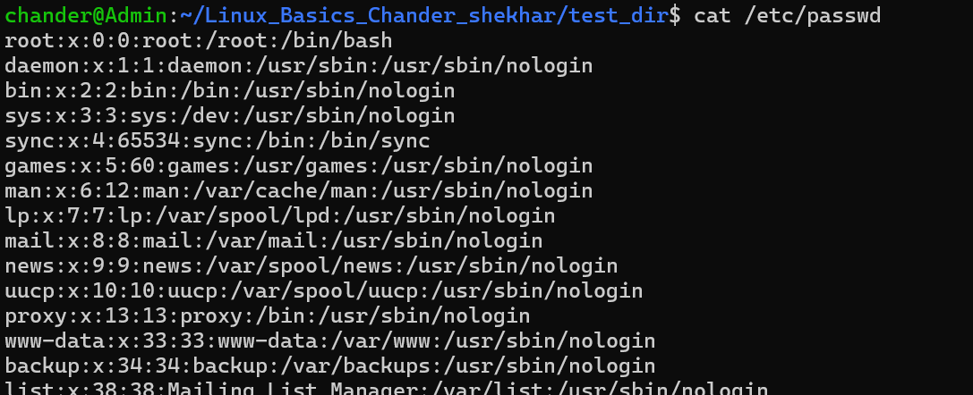

Command:
head -n 5 /etc/passwd

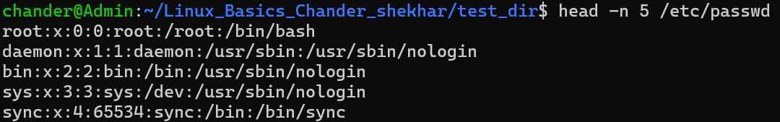

Command:
tail -n 5 /etc/passwd

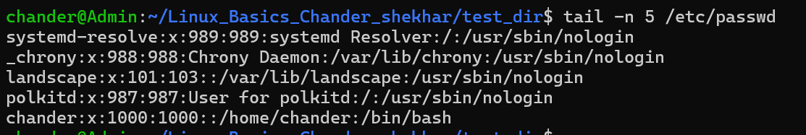

Task 3: Searching for Patterns

Command:
grep "root" /etc/passwd

Explanation:
Used grep to find lines containing the word root.

Task 4: Zipping and Unzipping

Command:
zip -r test_dir.zip test_dir

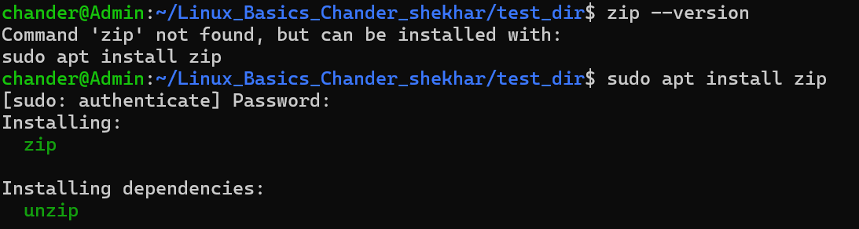
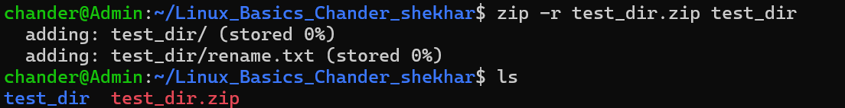

Command:
unzip test_dir.zip -d unzipped_dir

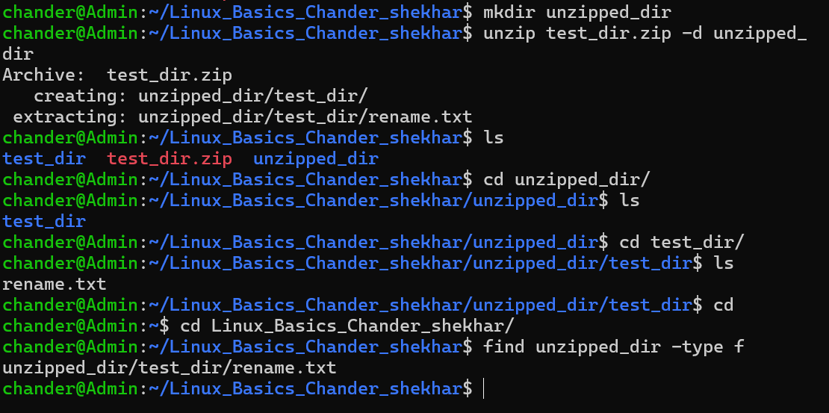

Task 5: Downloading Files

Command:
wget https://gist.github.com/Talha-Altair/b8a27d2b45add1dd7658fd34fa1968db

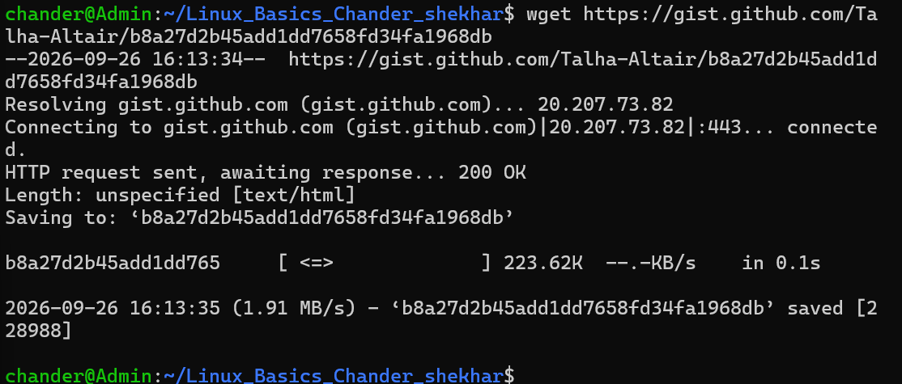

Task 6: Changing Permissions

Command:
chmod 444 secure.txt
ls -l secure.txt

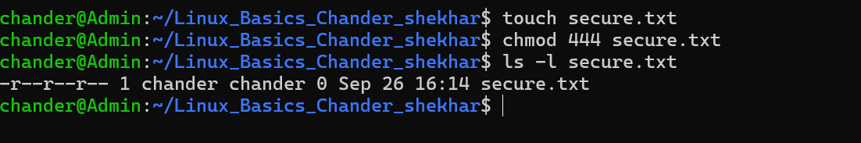

Task 7: Environment Variables

Command:
export MY_VAR="Hello, Linux!"
echo $MY_VAR

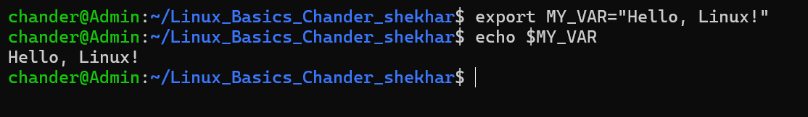

GitHub Repository: https://github.com/shekhar057/Linux

