Data Processing :

DATA :The information that you collect from an experiment, survey, or archival source is referred to as your data. Most generally, data can be defined as a list of numbers possessing meaningful relations. A data set is a representation of data, defining a set of variables that are measured on a set of cases.

VARIABLE :A variable is any characteristic of an object that can be represented as a number. The values that the variable takes will vary when measurements are made on different objects or at different times.

Data PROCESSING:It most often refers to processes that convert data into information or knowledge.

Methods to be applied:
1.Importing the Data Set : reading data from files.
2.Handling Missing Data : mean/median/most frequent data.
3.Handling Categorical Data.
4.Splitting the data into training set, test set.
5.Feature Scaling (to minimise the dominance of one data over another).

Data Processing Template:

# Importing the libraries
import numpy as np
import matplotlib.pyplot as plt
import pandas as pd

# Importing the dataset
dataset = pd.read_csv('Data1.csv')
X = dataset.iloc[:, :-1].values
y = dataset.iloc[:, 3].values

# Splitting the dataset into the Training set and Test set
from sklearn.model_selection import train_test_split
X_train, X_test, y_train, y_test = train_test_split(X, y, test_size = 0.2, random_state = 0)

# Feature Scaling
from sklearn.preprocessing import StandardScaler
sc_X = StandardScaler()
X_train = sc_X.fit_transform(X_train)
X_test = sc_X.transform(X_test)
sc_y = StandardScaler()
y_train = sc_y.fit_transform(y_train)

Linear Regression :

Linear regression, also known as simple linear regression or bivariate linear regression, is used when we want to predict the value of a dependent variable based on the value of an independent variable.
Dependent and independent variable should be measured at continuous level.
There needs to be a linear relationship between the dependent and independent variables and outliers should be avoided.

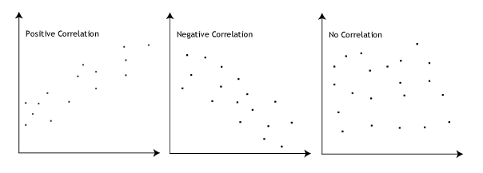

Linear Regression is a very powerful statistical technique and can be used to generate insights on consumer behaviour, understanding business and factors influencing profitability.Linear regressions can be used in business to evaluate trends and make estimates or forecasts.

For example, if a company’s sales have increased steadily every month for the past few years, by conducting a linear analysis on the sales data with monthly sales, the company could forecast sales in future months.

In python:

#simple linear regression
import pandas as pd
import matplotlib.pyplot as plt
import numpy as np

#dataset creation
dataset = pd.read_csv('Salary_Data.csv')
x = dataset.iloc[:,:-1].values
y = dataset.iloc[:,1].values

#splitting the data into training and test date
from sklearn.model_selection import train_test_split
x_train, x_test, y_train, y_test = train_test_split(x, y, test_size = 0.3, random_state = 0 )
from sklearn.linear_model import LinearRegression
regressor = LinearRegression()
regressor.fit(x_train, y_train)

#predicting the test set
from sklearn.utils.validation import check_array
y_pred = regressor.predict(4.5)

#visualising test set results
plt.scatter(x_test, y_test, color = 'red')
plt.plot(x_train, regressor.predict(x_train), color = 'blue' )
plt.title('Salary and Ex perience')
plt.xlabel('Years of Experience')
plt.ylabel('Salary')
plt.show()
print y_pred

Plot:

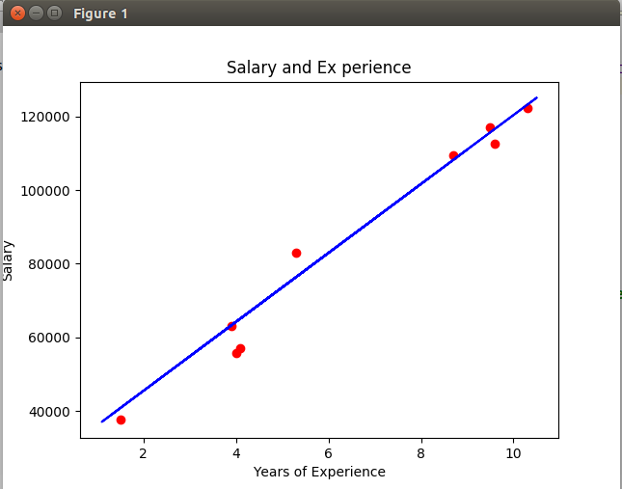

Multiple Regression :

Multiple linear regression is the most common form of linear regression analysis. As a predictive analysis, the multiple linear regression is used to explain the relationship between one continuous dependent variable and two or more independent variables. The independent variables can be continuous or categorical (dummy coded as appropriate).
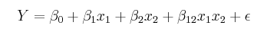

The selling price of a house can depend on the desirability of the location, thenumber of bedrooms, the number of bathrooms, the year the house was built,the square footage of the lot and a number of other factors.

The height of a child can depend on the height of the mother, the height of the father, nutrition, and environmental factors.
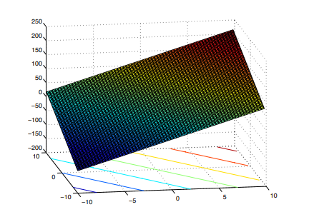

1.Linear relationship: The model is a roughly linear one.

2.No Multicollinearity: Multicollinearity exists when two or more of the explanatory variables are highly correlated.

3.Homoscedasticity: We can check that residuals do not vary systematically with the predicted values by plotting the residuals against the values predicted by the regression model.

4.Outliers/influential cases: As with simple linear regression, it is important to look out for cases which may have a disproportionate influence over your regression model.

In Python:

import pandas as pd
import matplotlib.pyplot as pt
import numpy as np
#dataset creation
dataset = pd.read_csv('50_Startups.csv')
x = dataset.iloc[:,:-1].values
y = dataset.iloc[:,4].values
#encoding categorical data
from sklearn.preprocessing import LabelEncoder, OneHotEncoder
labelencoder_x = LabelEncoder()
x[:,3]=labelencoder_x.fit_transform(x[:,3])
onehotencoder = OneHotEncoder(categorical_features = [3])
x = onehotencoder.fit_transform(x).toarray()
#Avoiding the dummy varibale error
x = x[:, 1:]
#splitting the data into training and test date
from sklearn.model_selection import train_test_split
x_train, x_test, y_train, y_test = train_test_split(x, y, test_size = 0.2, random_state = 0 )
#fitting
from sklearn.linear_model import LinearRegression
regressor = LinearRegression()
regressor.fit(x_train, y_train)
#predicting
y_pred = regressor.predict(x_test)
# Backward Elimination
import statsmodels.formula.api as sm
x = np.append(arr = np.ones((50, 1)).astype(int), values = x, axis = 1)
#removing the column with max P (>0.05)
x_opt = x[:, [0, 1, 2, 3, 4, 5]]
regressor_ols = sm.OLS(endog = y, exog = x_opt).fit()
regressor_ols.summary()
x_opt = x[:, [0, 1, 3, 4, 5]]
regressor_ols = sm.OLS(endog = y, exog = x_opt).fit()
regressor_ols.summary()
x_opt = x[:, [0, 3, 4, 5]]
regressor_ols = sm.OLS(endog = y, exog = x_opt).fit()
regressor_ols.summary()
x_opt = x[:, [0, 3, 5]]
regressor_ols = sm.OLS(endog = y, exog = x_opt).fit()
regressor_ols.summary()
x_opt = x[:, [0, 3]]
regressor_ols = sm.OLS(endog = y, exog = x_opt).fit()
print regressor_ols.summary()
#only one independent varibale remains

Polynomial Regression :

Polynomial models are useful in situations where the analyst knows that curvilinear effects are present in the true response function.
Polynomial models are also useful as approximating functions to unknown and possible very complex nonlinear relationship. A kth order :
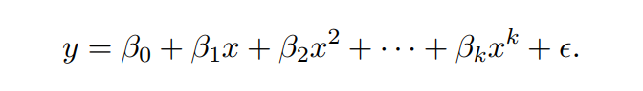

Model Building Strategy: Various strategies for choosing the order of an approximating polynomial have been suggested. Two procedures: forward selection and backward elimination.

In Python:

# Importing the libraries
import numpy as np
import matplotlib.pyplot as plt
import pandas as pd
# Importing the dataset
dataset = pd.read_csv('Position_Salaries.csv')
x = dataset.iloc[:, 1:2].values
y = dataset.iloc[:, 2].values
#Fitting LInear
from sklearn.linear_model import LinearRegression
lin_reg = LinearRegression()
lin_reg.fit(x, y)
#fitting POlynomial
from sklearn.preprocessing import PolynomialFeatures
poly_reg = PolynomialFeatures(degree = 4)
x_poly = poly_reg.fit_transform(x)
lin_reg2 = LinearRegression()
lin_reg2.fit(x_poly, y)
#For Linear Regression
plt.scatter(x, y, color = 'red')
plt.plot(x, lin_reg.predict(x), color = 'blue')
plt.title('Check')
plt.xlabel('Position Level')
plt.ylabel('Salary')
plt.show()
#for Polynomial Regressions
plt.scatter(x, y, color = 'red')
plt.plot(x, lin_reg2.predict(poly_reg.fit_transform(x)), color = 'blue')
plt.title('Check')
plt.xlabel('Position Level')
plt.ylabel('Salary')
plt.show()
#prediction with linear
print lin_reg.predict(6.5)
#prediction with Polynomial
print lin_reg2.predict(poly_reg.fit_transform(6.5))

Comaprison:

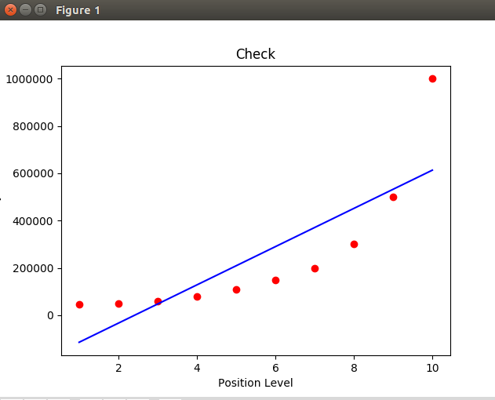

Fitting A Linear Curve
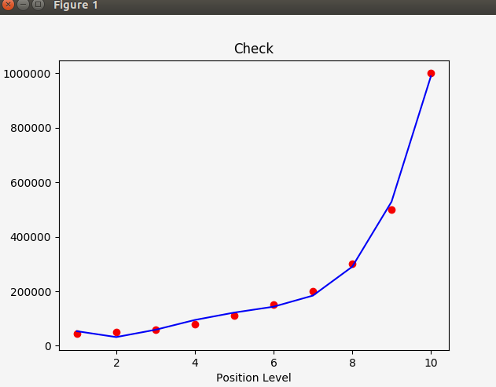

Fitting A non -linear curve

Support Vector Machine

“Support Vector Machine” (SVM) is a supervised machine learning algorithm which can be used for both classification or regression challenges. However, it is mostly used in classification problems.
In this algorithm, we plot each data item as a point in n-dimensional space (where n is number of featuresyou have) with the value of each feature being the value of a particular coordinate. Then, we perform classification by finding the hyper-plane that differentiate the two classes very well.

In Python:

# Support Vector Machine (SVM)
# Importing the libraries
import numpy as np
import matplotlib.pyplot as plt
import pandas as pd
# Importing the dataset
dataset = pd.read_csv('Social_Network_Ads.csv')
X = dataset.iloc[:, [2, 3]].values
y = dataset.iloc[:, 4].values
# Splitting the dataset into the Training set and Test set
from sklearn.model_selection import train_test_split
X_train, X_test, y_train, y_test = train_test_split(X, y, test_size = 0.25, random_state = 0)
# Feature Scaling
from sklearn.preprocessing import StandardScaler
sc = StandardScaler()
X_train = sc.fit_transform(X_train)
X_test = sc.transform(X_test)
# Fitting SVM to the Training set
from sklearn.svm import SVC
classifier = SVC(kernel = 'linear', random_state = 0)
classifier.fit(X_train, y_train)
# Predicting the Test set results
y_pred = classifier.predict(X_test)
# Making the Confusion Matrix
from sklearn.metrics import confusion_matrix
cm = confusion_matrix(y_test, y_pred)
# Visualising the Training set results
from matplotlib.colors import ListedColormap
X_set, y_set = X_train, y_train
X1, X2 = np.meshgrid(np.arange(start = X_set[:, 0].min() - 1, stop = X_set[:, 0].max() + 1, step = 0.01),
np.arange(start = X_set[:, 1].min() - 1, stop = X_set[:, 1].max() + 1, step = 0.01))
plt.contourf(X1, X2, classifier.predict(np.array([X1.ravel(), X2.ravel()]).T).reshape(X1.shape),
alpha = 0.75, cmap = ListedColormap(('red', 'green')))
plt.xlim(X1.min(), X1.max())
plt.ylim(X2.min(), X2.max())
for i, j in enumerate(np.unique(y_set)):
plt.scatter(X_set[y_set == j, 0], X_set[y_set == j, 1],
c = ListedColormap(('red', 'green'))(i), label = j)
plt.title('SVM (Training set)')
plt.xlabel('Age')
plt.ylabel('Estimated Salary')
plt.legend()
plt.show()
# Visualising the Test set results
from matplotlib.colors import ListedColormap
X_set, y_set = X_test, y_test
X1, X2 = np.meshgrid(np.arange(start = X_set[:, 0].min() - 1, stop = X_set[:, 0].max() + 1, step = 0.01),
np.arange(start = X_set[:, 1].min() - 1, stop = X_set[:, 1].max() + 1, step = 0.01))
plt.contourf(X1, X2, classifier.predict(np.array([X1.ravel(), X2.ravel()]).T).reshape(X1.shape),
alpha = 0.75, cmap = ListedColormap(('red', 'green')))
plt.xlim(X1.min(), X1.max())
plt.ylim(X2.min(), X2.max())
for i, j in enumerate(np.unique(y_set)):
plt.scatter(X_set[y_set == j, 0], X_set[y_set == j, 1],
c = ListedColormap(('red', 'green'))(i), label = j)
plt.title('SVM (Test set)')
plt.xlabel('Age')
plt.ylabel('Estimated Salary')
plt.legend()
plt.show()

Plot:
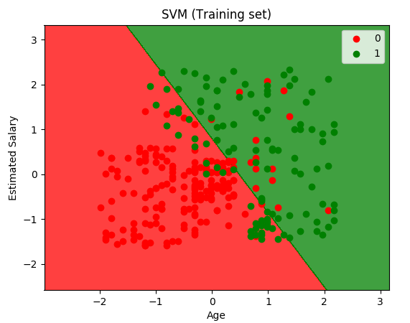

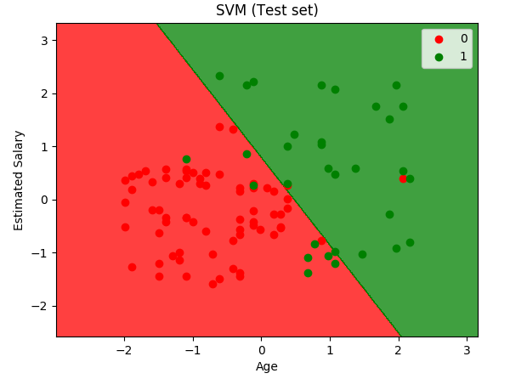

Decision Tree Regression :

Decision tree builds regression or classification models in the form of a tree structure. It brakes down a dataset into smaller and smaller subsets while at the same time an associated decision tree is incrementally developed. The final result is a tree with decision nodes and leaf nodes. A decision node (e.g., Outlook) has two or more branches (e.g., Sunny, Overcast and Rainy), each representing values for the attribute tested. Leaf node (e.g., Hours Played) represents a decision on the numerical target. The topmost decision node in a tree which corresponds to the best predictor called root node. Decision trees handle both categorical and numerical data.

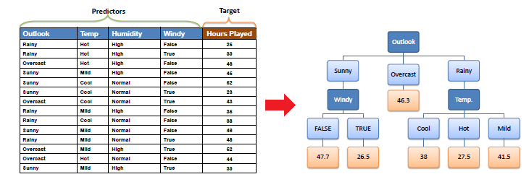

In Python:
# Importing the libraries
import numpy as np
import matplotlib.pyplot as plt
import pandas as pd
# Importing the dataset
dataset = pd.read_csv('Position_Salaries.csv')
x = dataset.iloc[:, 1:2].values
y = dataset.iloc[:, 2:3].values
#Fitting DTR
from sklearn.tree import DecisionTreeRegressor
regressor = DecisionTreeRegressor(random_state=0)
regressor.fit(x, y)
#predicting a new result
y_pred = regressor.predict(6.5)
#Visualising
x_grid = np.arange(min(x), max(x), 0.01)
x_grid = x_grid.reshape((len(x_grid), 1))
plt.scatter(x, y, color = 'red')
plt.plot(x_grid, regressor.predict(x_grid), color = 'blue')
plt.title('SVR')
plt.xlabel('Level')
plt.ylabel('Salary')
plt.show()
print y_pred

Plot:

