sql

DDL(Data Defination lang)

Create,Alter,Drop,Truncate

DML(Data Manupulation Lang)

Insert,Update,Delete,Merge

Dql(Data Query Language)

Select

TCL(Transaction control Language)

Commit,Rollback,savepoint,setTransaction

**Joins**

**1)Equi Joins(inner Join)**

**2)Outer Join🡪 There are 3 types**

**1)Left outer join**

**2)right Outer Join**

**3)Full outer Join**

**3)Non Equi join**

**4)Cross Join**

**Equi Join**

**🡪Between two fields but common fields is mandatory**

**->Common field based on Data not for field name**

**🡪To perform Equi join between two tables there must be a common field and name of the common field and name of the common field need not be same**

create database SQL4PM

CREATE TABLE EMP

(

EMPNO INT ,

ENAME VARCHAR(10),

JOB VARCHAR(9),

MGR INT,

HIREDATE DATE,

SAL MONEY,

COMM MONEY,

DEPTNO INT

);

INSERT INTO EMP VALUES(7369,'SMITH','CLERK',7902,'1980-12-17',800, NULL, 20);

INSERT INTO EMP VALUES(7499,'ALLEN','SALESMAN',7698,'1981-02-20',1600,300,30);

INSERT INTO EMP VALUES(7521,'WARD','SALESMAN',7698,'1981-02-22',1250,500,30);

INSERT INTO EMP VALUES(7566,'JONES','MANAGER',7839,'1981-04-02',2975,NULL,20);

INSERT INTO EMP VALUES(7654,'MARTIN','SALESMAN',7698,'1981-09-28',1250,1400,30);

INSERT INTO EMP VALUES(7698,'BLAKE','MANAGER',7839,'1981-05-01',2850,NULL,30);

INSERT INTO EMP VALUES(7782,'CLARK','MANAGER',7839,'1981-06-09',2450,NULL,10);

INSERT INTO EMP VALUES(7788,'SCOTT','ANALYST',7566,'1982-12-09',3000,NULL,20);

INSERT INTO EMP VALUES(7839,'KING','PRESIDENT',NULL,'1981-11-17',5000,NULL,10);

INSERT INTO EMP VALUES(7844,'TURNER','SALESMAN',7698,'1981-09-08',1500,0,30);

INSERT INTO EMP VALUES(7876,'ADAMS','CLERK',7788,'1983-01-12',1100, NULL,20);

INSERT INTO EMP VALUES(7900,'JAMES','CLERK',7698,'1981-12-03',950,NULL,30);

INSERT INTO EMP VALUES(7902,'FORD','ANALYST',7566,'1981-12-03',3000,NULL,20);

INSERT INTO EMP VALUES(7934,'MILLER','CLERK',7782,'1982-01-23',1300,NULL,10);

CREATE TABLE DEPT

(

DEPTNO int,

DNAME VARCHAR(14),

LOC VARCHAR(13)

);

INSERT INTO DEPT VALUES (10,'ACCOUNTING','NEW YORK');

INSERT INTO DEPT VALUES (20,'RESEARCH','DALLAS');

INSERT INTO DEPT VALUES (30,'SALES','CHICAGO');

INSERT INTO DEPT VALUES (40,'OPERATIONS','BOSTON');

select *from emp

select *from DEPT

select *from SALGRADE

select empno,ename,dname,loc

from emp,dept

where emp.DEPTNO=dept.DEPTNO

select e.empno,e.ename,d.deptno,d.dname,d.loc

from emp e,dept d

where e.DEPTNO=d.DEPTNO

select e.ename,d.deptno,d.dname

from emp e,dept d

where e.DEPTNO=d.DEPTNO

select e.ename,d.dname,d.loc

from emp e, dept d

where e.DEPTNO=d.DEPTNO

and

d.loc='new york'

1.Equi join(Inner join)

2.Outer Join

These are three types

1)Left outer

2)Right Outer

3)Full outer

3)Non equi join

4)Self Join

5)Cross join or cartisean Join

EQUI JOIN:

Between two tables but common field is mandatory

Common fields based on Data not for field name

To Perform Equi join between two tables there must be a common filed and a name of the common field need not to same

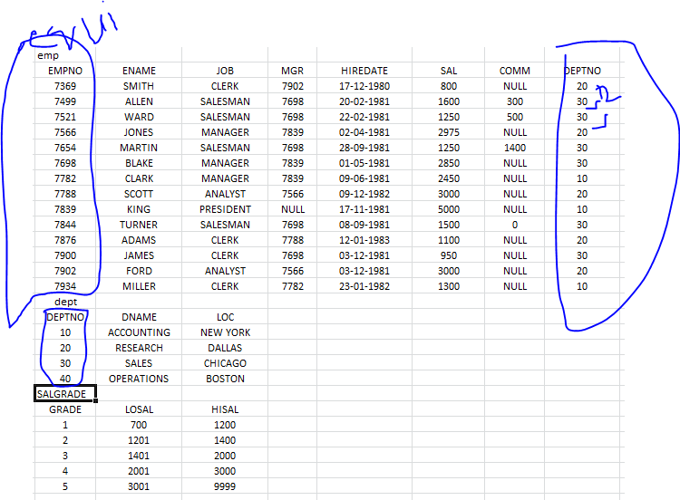

1. Display Empno Ename,Dname
2. select empno,ename,dname,loc
3. from emp,dept
4. where emp.DEPTNO=dept.DEPTNO

select e.empno,e.ename,d.deptno,d.dname,d.loc

from emp e,dept d

where e.DEPTNO=d.DEPTNO

note: In join query Declare table alias and prefix column names with table alias for two reasons

1)to avoid ambiguity and Faster Execution

1) select e.ename,d.deptno,d.dname

from emp e,dept d

where e.DEPTNO=d.DEPTNO

* Display employee working at new york loc?

select e.ename,d.dname,d.loc

from emp e, dept d

where e.DEPTNO=d.DEPTNO

and

d.loc='new york'

Left outer

---------

Return all rows(matched+unmatched) from left side table amd matching row from right side table

Outer join is possible in ANSI style not possible in Native Style

select ename,dname,loc,COMM

from EMP e

Left outer join DEPT d

on e.DEPTNO=d.DEPTNO

Right outer

Return all Rows(Matched+unmatched) right side table and matching rows from left side table

select ename,dname,loc,COMM

from EMP e

Right outer join DEPT d

on e.DEPTNO=d.DEPTNO

Full Outer:

Return all rows from both tables

select ename,dname,loc,COMM

from EMP e

Right outer join DEPT d

on e.DEPTNO=d.DEPTNO

Non Equi joins:

Non equi join is performed when table are not sharing a common field

Here Join Condition not based on “ =” operator it is based on > < between Operator

Emp Salgrade

Empno Ename Sal Grade Losal Hisal

1 A 3000 1 700 1000

2 b 15000 2 1001 2000

3 c 4000 3 2001 3000

4 d 25000 4 3001 4000

5 e 1000 5 4001 9999

1. Display Ename sal Grade?

Select e.ename,e.sal,s.grade

from Emp e slagrade s

Where e.sal Between s.Losal and s.Hisal

1. Display ename ,dname,Grade

Select e.ename,d.dname,s.grade

From Emp e slagrade s

Where e